Q1.

Creating the tss folder In / and three subfolders using single command

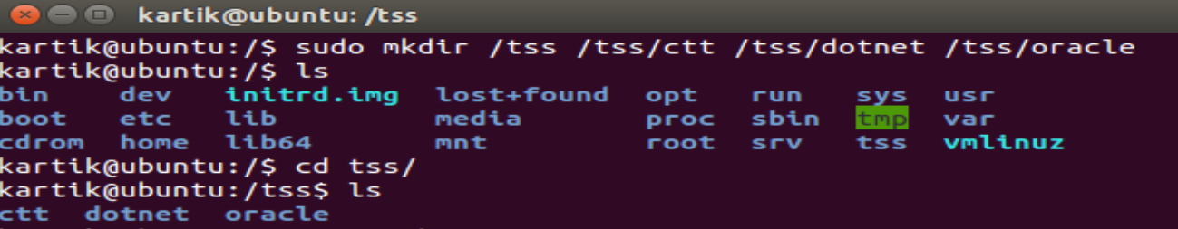

Creating the three empty files as



Checking the output if created successfully or not

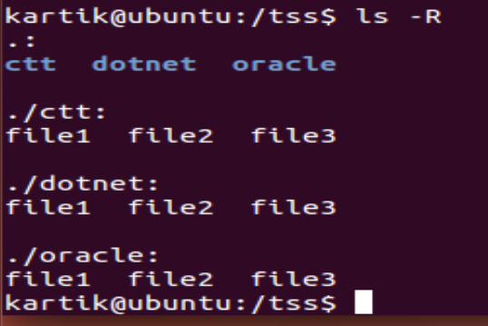

Renaming the files as given and checking

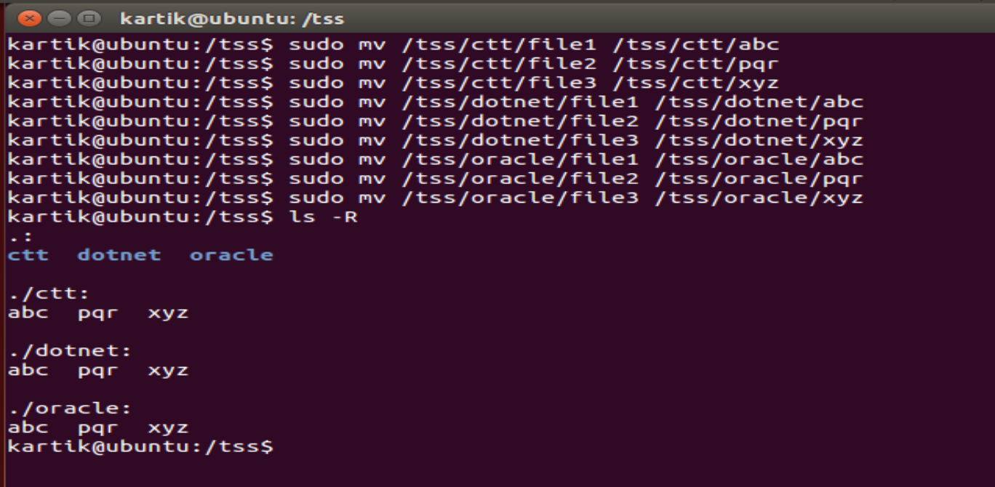

Move pqr and xyz to ctt subfolder

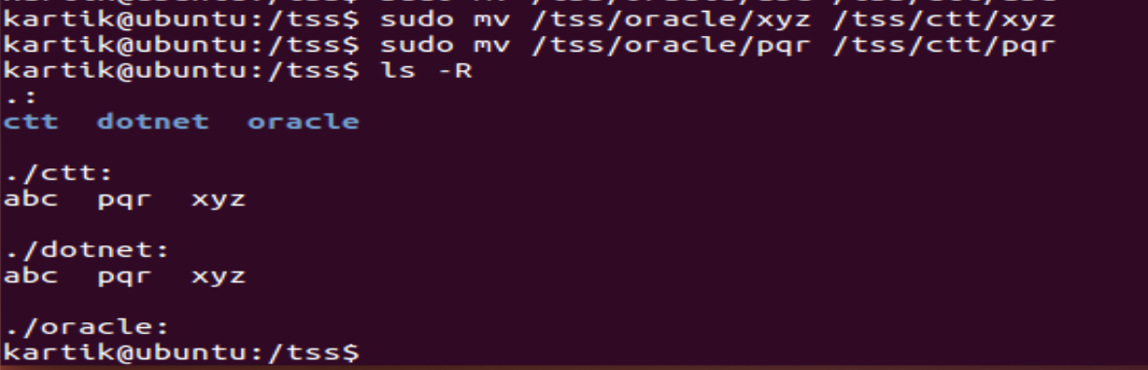

Copy all the files to dotnet and oracle subfolders

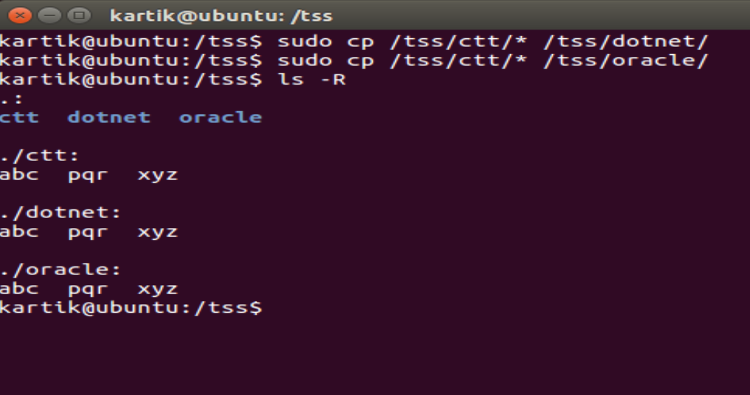

Combining the data of file 1 and file2 into /test directory file3

