Q3.

Taking the backup using tar into a fle name comp.tar.gz

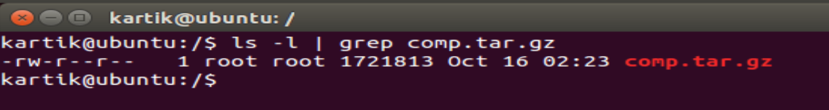

Extracting the file at /home and verify

