ASSIGNMENT-1
COMPUTER NETWORKS – ENCS304

Name : Kartikay Gautam
Roll Number : 2301010137
Programme : Btech CSE – C
Date : 27th February 2026

Basic Network Topologies Using Switches and Hubs
Experiment Objectives:
In this experiment, we will create three small LAN designs in Cisco Packet Tracer to understand how network topology influences connectivity, fault tolerance, and performance. Students will configure end devices with IPv4 addressing and verify communication using ICMP.

- Star Topology:
The star topology is one of the most widely used network layouts in modern Local Area Networks (LANs). In this design, all end devices are connected to a central networking device, typically a switch. The central device manages communication between connected nodes and forwards data only to the intended destination, improving efficiency and reducing unnecessary traffic.
This topology offers ease of management, simple fault detection, and improved performance compared to shared-medium designs. However, the central device represents a single point of failure. In this experiment, a switch-based star topology is implemented to observe structured communication, IP configuration, and successful ICMP connectivity between devices.
We connect 4 PCs with a switch and establish the ip connection on each pc.
The ip address of each pc is configured as follows:
192.168.0.1
192.168.0.2
192.168.0.3
192.168.0.4
The working of this connection is given below:
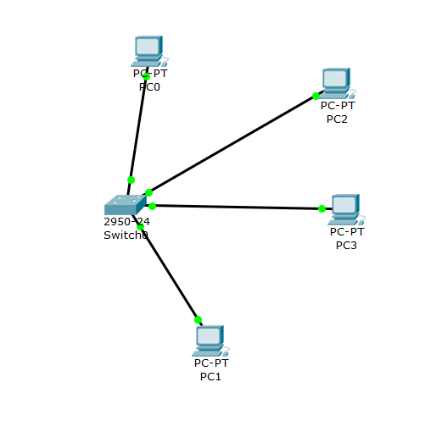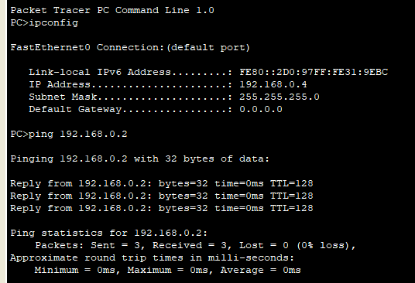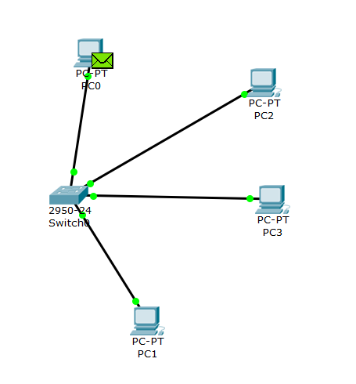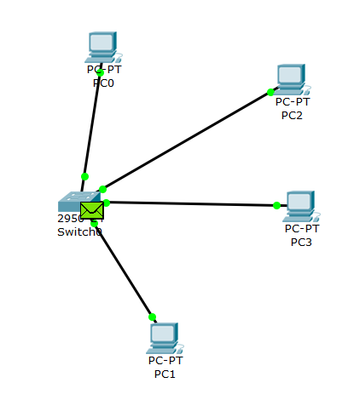
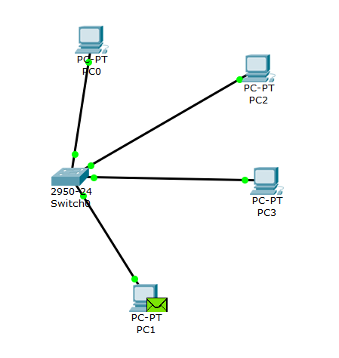
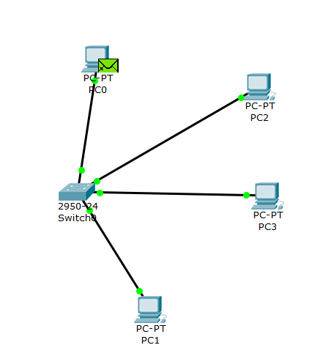
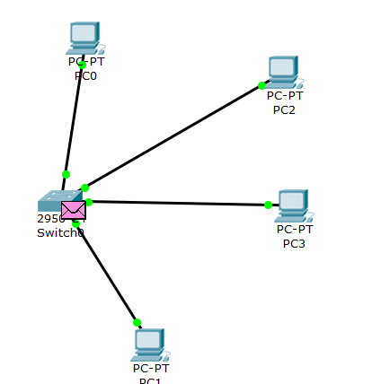

- Bus Topology:
The bus topology is a shared-medium network design in which all devices communicate over a common transmission channel. In modern simulations, this behavior can be replicated using a hub, which broadcasts incoming frames to all connected devices. Unlike switches, hubs do not intelligently forward traffic, resulting in higher collision probability and lower overall efficiency.
Although simple and inexpensive to implement, bus-like networks suffer from scalability and performance limitations. This experiment demonstrates how hub-based communication differs from switch-based communication by observing packet flow, broadcast behavior, and simultaneous ICMP transmission effects.

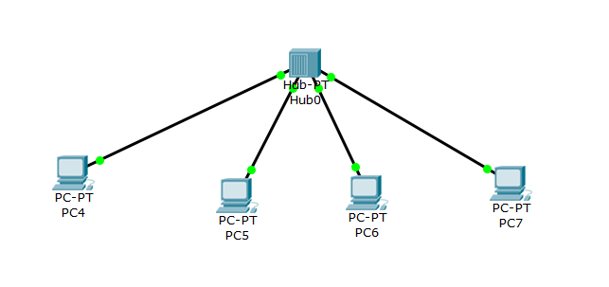
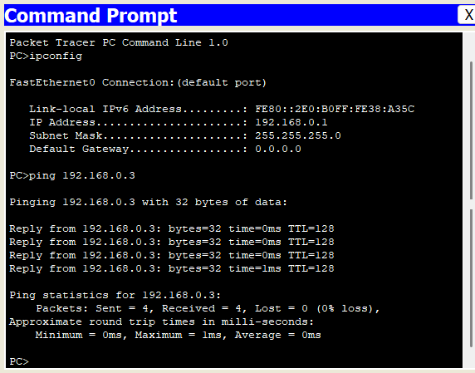
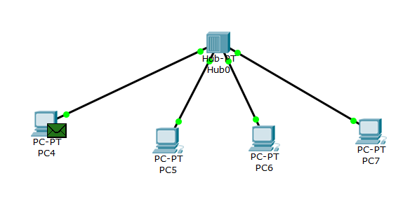

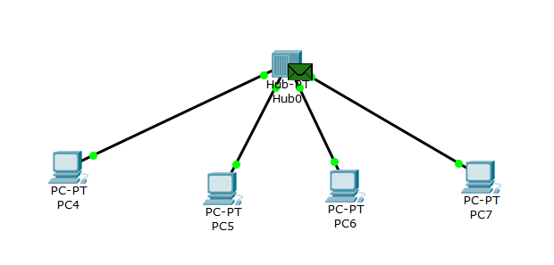
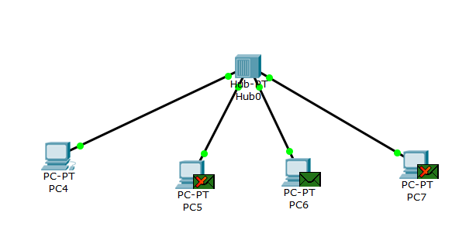
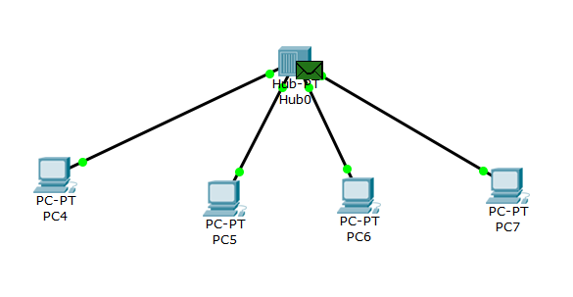
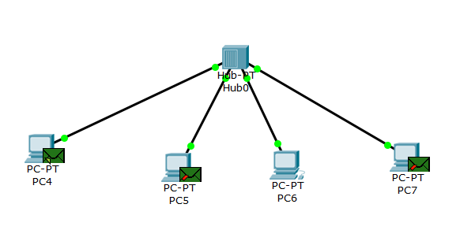
- Ring Topology:
The ring topology connects multiple networking devices in a closed-loop structure, where each device is connected to two others, forming a circular path. Data can travel through intermediate devices before reaching its destination. While this layout can provide alternative communication paths, it may also introduce risks such as broadcast storms or loops if not properly managed.
In this experiment, multiple switches are connected in a loop to analyze inter-switch communication and observe how network behavior changes when a link failure occurs. This setup helps in understanding redundancy, fault tolerance, and the importance of loop prevention mechanisms in network design.
IP connections are configured from 192.168.0.1 to 192.168.0.8.
The working is denoted as follows :

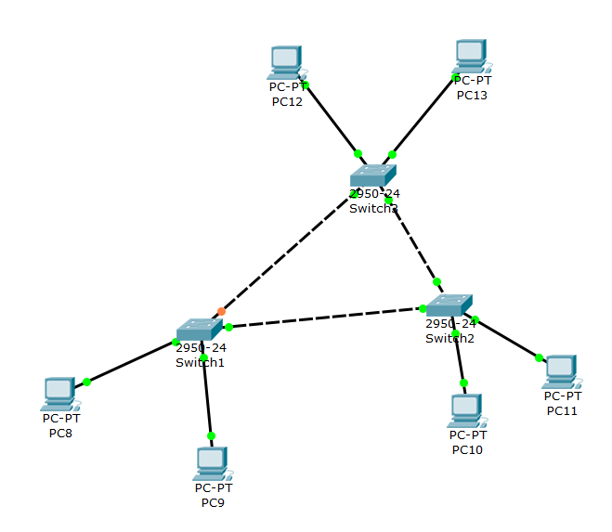
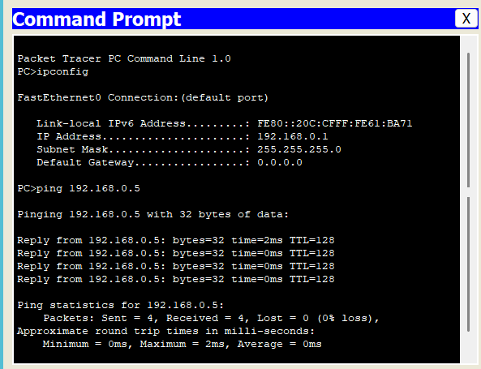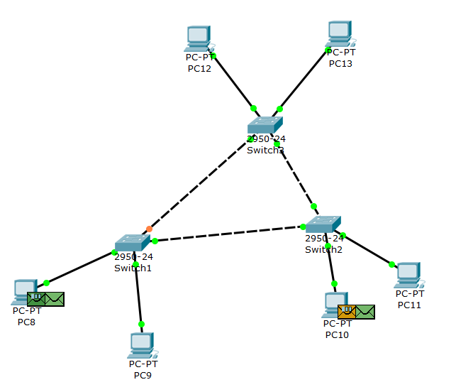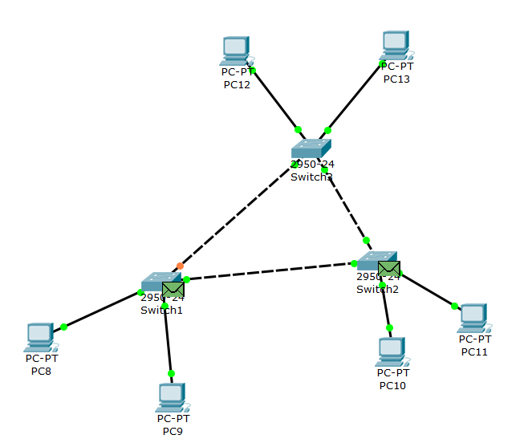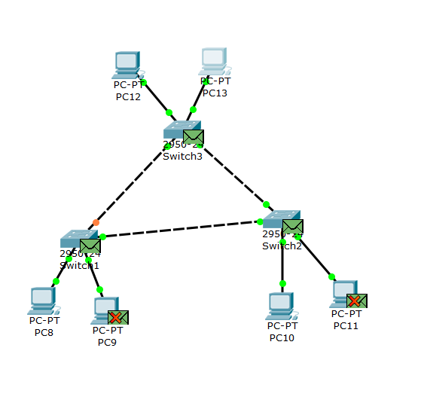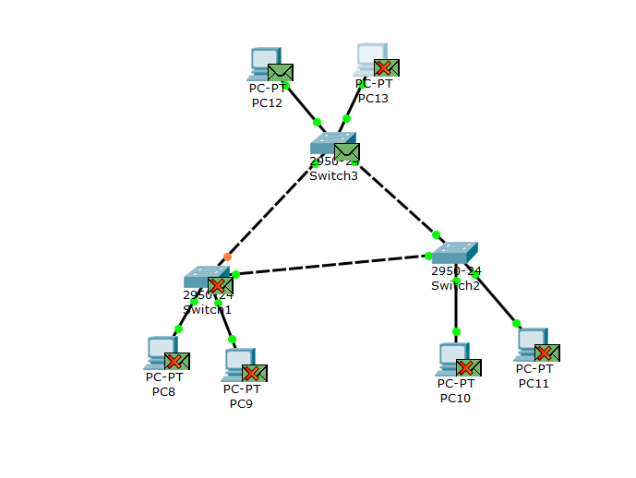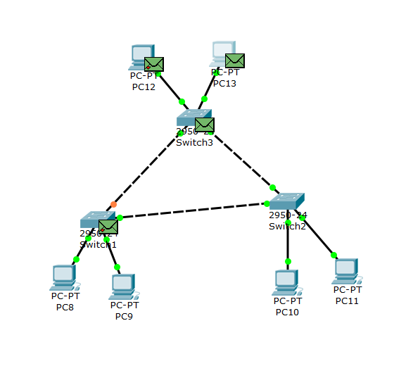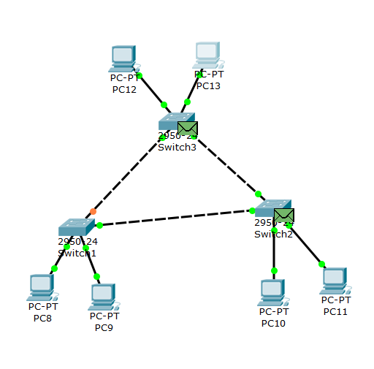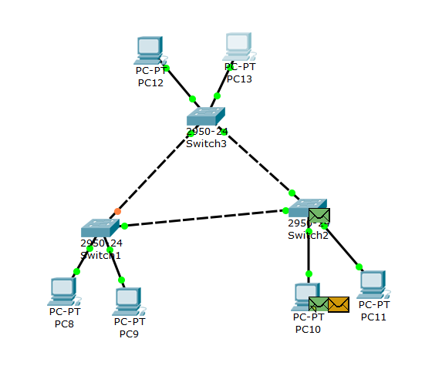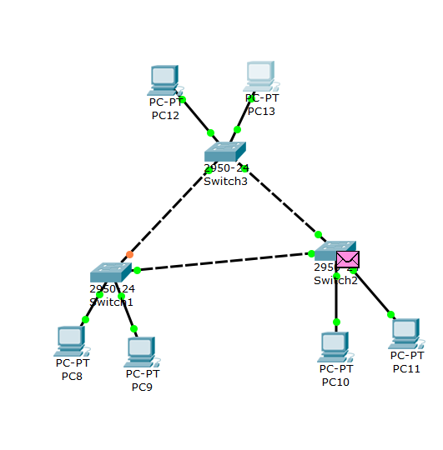
Failure test
Introduction – Failure Test (Link Failure Analysis)
The failure test is conducted to examine how different network topologies respond when a physical connection is disrupted. Network reliability and fault tolerance are critical aspects of LAN design, as link failures can impact communication between devices. By intentionally disconnecting one link in the ring-like topology, the experiment evaluates whether data transmission continues or is interrupted.
This test helps in understanding redundancy, single points of failure, and the impact of physical topology on network availability. Observing ICMP ping results before and after disconnecting the link provides practical insight into how network structure influences resilience and performance.

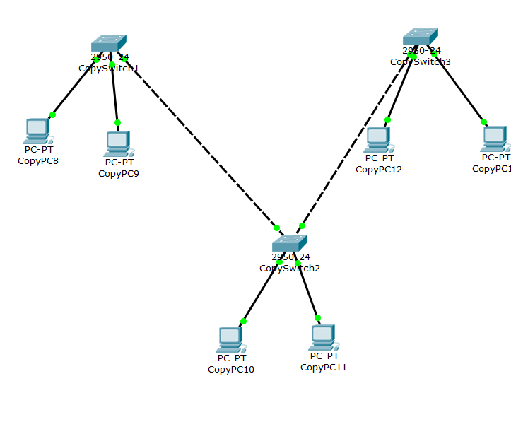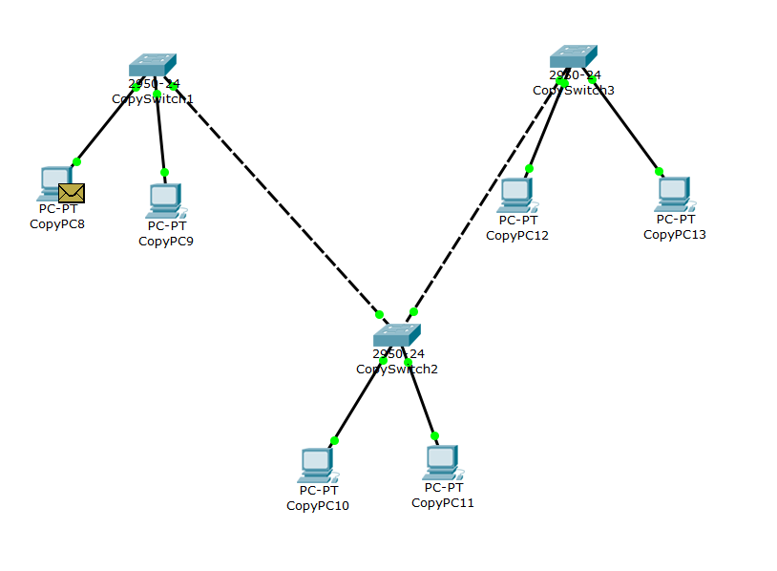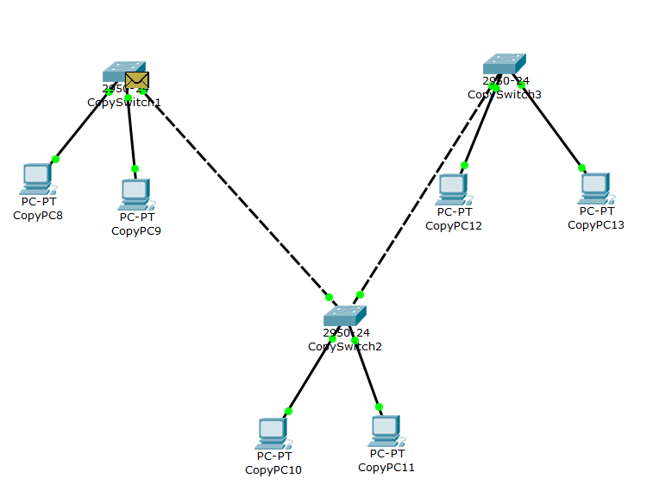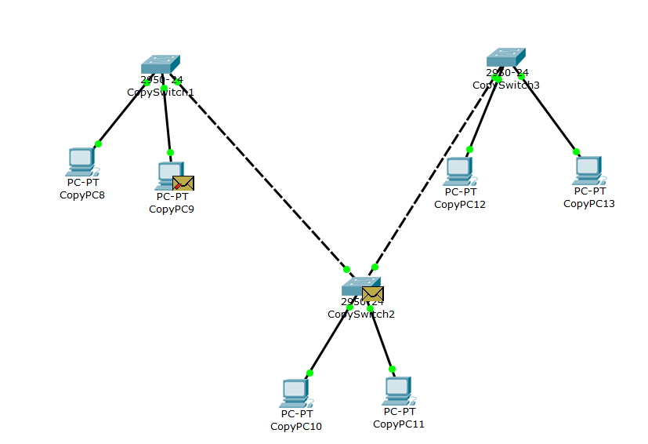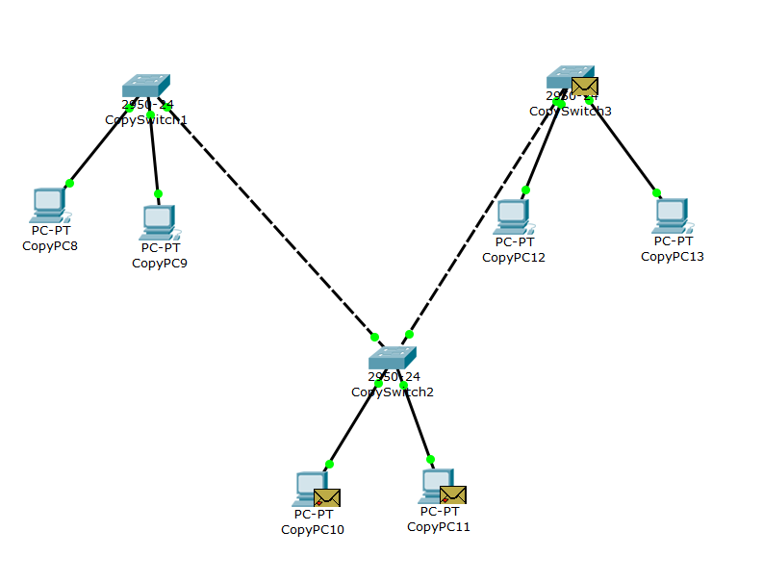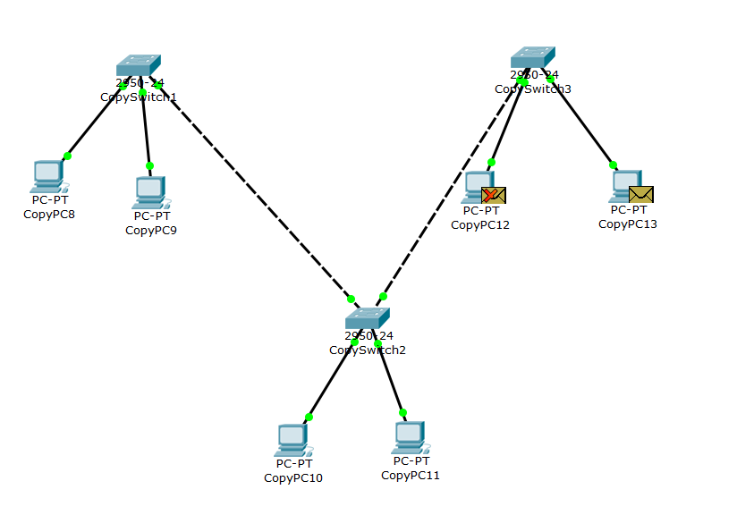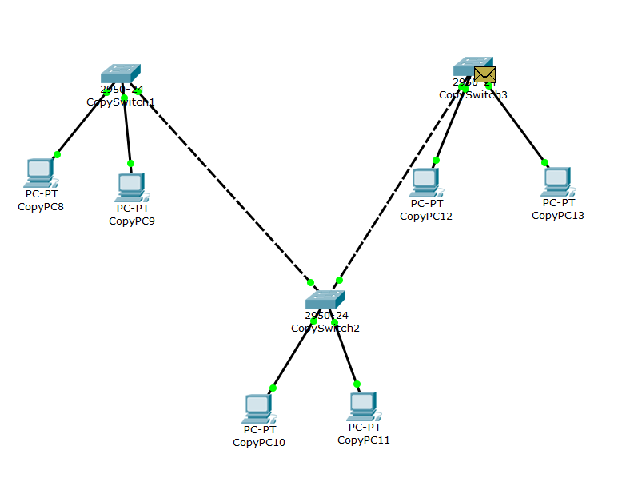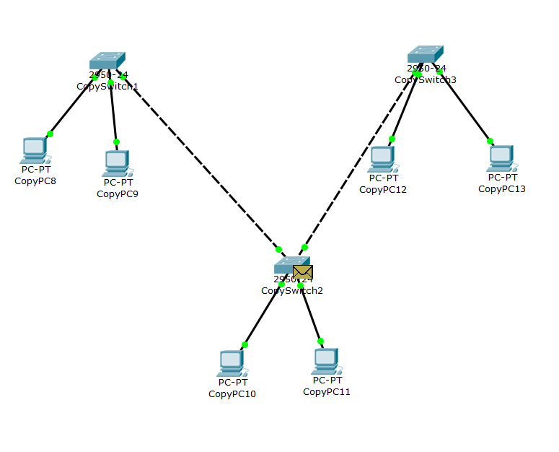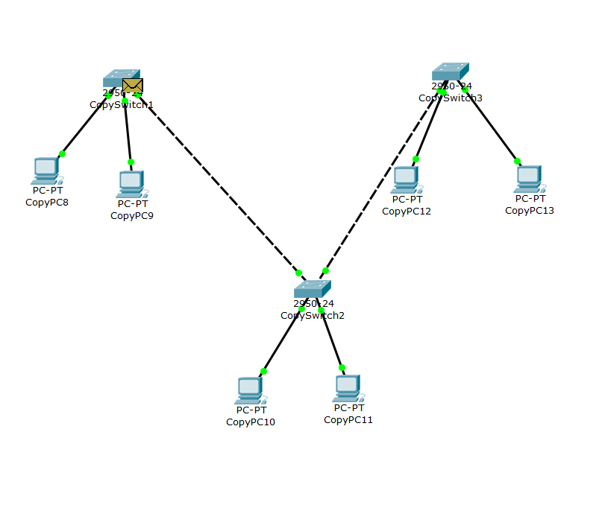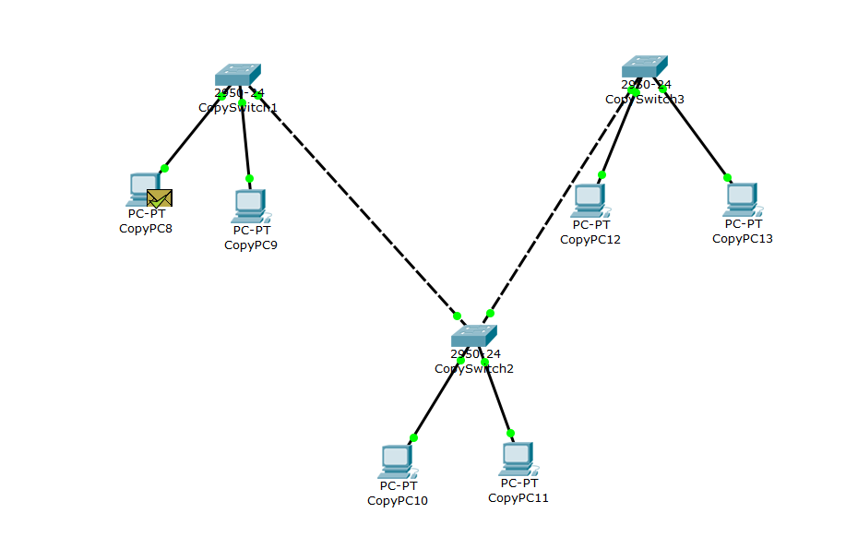

Observations – Comparison of Message Transfer in Different Topologies
Feature / Parameter | Star Topology (Switch) | Bus-like Topology (Hub) | Ring-like Topology (Loop of Switches)
Packet Forwarding Method | Switch forwards frame only to the destination port (MAC-based forwarding). | Hub broadcasts frame to all connected ports. | Frame is forwarded across switches based on MAC table entries.
Traffic Type Observed in Simulation Mode | Mostly unicast traffic after ARP resolution. | Continuous broadcast traffic to all devices. | Traffic flows through intermediate switches before reaching destination.
Collision Behavior | No collisions (separate collision domains per port). | High chance of collisions (single shared collision domain). | No collisions (switch-based), but possible loop-related broadcast issues.
Bandwidth Usage | Efficient utilization; only intended device receives data. | Inefficient; all devices receive every frame. | Moderate efficiency; depends on path and loop behavior.
ARP Behavior | Initial ARP broadcast, then direct unicast communication. | ARP broadcast visible on all ports. | ARP broadcast propagates across switches in the loop.
Ping Performance | Fast and stable responses. | Slower if multiple devices transmit simultaneously. | Stable unless loop causes excessive broadcast traffic.
Fault Tolerance | Failure of switch disconnects entire network. | Failure of hub disconnects entire network. | If one link is removed, communication may still continue through alternate path (depending on design).
Broadcast Storm Risk | Low | Low | High if loop is not controlled (no STP).
Overall Network Efficiency | High | Low | Moderate to High (but risky without loop control).

General Observations from Simulation Mode
- In the switch-based star topology, packets are forwarded intelligently, and only the target device processes the frame.
- In the hub-based topology, every device receives the transmitted frame, even if it is not the intended recipient.
- In the ring-like topology, packets may traverse multiple switches before reaching the destination, and loops can cause repeated frame circulation if not controlled.
- During the failure test, disconnecting one link in the loop demonstrates whether redundancy exists or whether communication is interrupted.

