LAB ASSIGNMENT 2
School of Engineering and Technology
Course Code & Name: ENCS304 Computer Networks
Program Name: B.Tech CSE, AI ML, Data Science, Cyber, FSD, UX/UI

Name: Kartikay Gautam
Roll Number: 2301010137
Section: C

Assignment 2: Packet Flow Visualization Using Simulation Mode
Experiment Objectives
Students will use Packet Tracer Simulation Mode to observe how packets move between devices, how switches learn MAC addresses, and how ICMP echo request/reply travels through a small network.
Learning Outcomes
- Use Simulation Mode effectively
- Observe ARP + ICMP behavior
- Understand switch MAC learning behavior
- Interpret packet event list timeline
Concepts Used
- Simulation Mode
- ICMP ping
- ARP resolution
- Switch MAC address table learning

Objective
The objective of this experiment is to understand how packets travel across a network using Simulation Mode in Cisco Packet Tracer. It also demonstrates ARP resolution, ICMP communication, and how switches learn MAC addresses.

Task 1: Building a Simple LAN
A simple Local Area Network (LAN) was created using:
- 1 Switch
- 3 PCs
IP Configuration
- PC1 → 192.168.20.1 /24
- PC2 → 192.168.20.2 /24
- PC3 → 192.168.20.3 /24
All devices were connected to the switch using straight-through cables.

Task 2: First Ping Observation (PC1 → PC2)
Simulation Mode was enabled and a ping was sent from PC1 to PC2.
Observed Behavior
- ARP Request
  - PC1 did not know the MAC address of PC2.
  - It sent an ARP Request (broadcast) to all devices in the network.
  - The switch forwarded this broadcast frame to all ports except the source port.
- ARP Reply
  - PC2 responded with its MAC address using an ARP Reply (unicast) to PC1.
  - The switch forwarded this reply directly to PC1.
- ICMP Echo Request
  - After ARP resolution, PC1 sent an ICMP Echo Request (ping) to PC2.
- ICMP Echo Reply
  - PC2 responded with an ICMP Echo Reply.
  - Communication was successfully completed.
Switch Behavior
- The switch learned MAC addresses by observing incoming frames.
- It stored:
  - PC1 MAC → Port X
  - PC2 MAC → Port Y

Task 3: Second Ping Observation (PC1 → PC2)
A second ping was sent from PC1 to PC2.
Observed Behavior
- No ARP request was generated.
- Only:
  - ICMP Echo Request
  - ICMP Echo Reply
Reason
- PC1 already had PC2’s MAC address stored in its ARP cache.
- The switch also had MAC entries in its MAC address table.
Conclusion
- The second ping was faster and involved fewer packets.

Task 4: MAC Address Table Observation
The switch MAC address table was checked (or inferred through simulation events).
Observations
- The switch dynamically learned MAC addresses of connected PCs.
- Entries included:
  - MAC address of PC1 mapped to its port
  - MAC address of PC2 mapped to its port
Learning Mechanism
- When a frame arrives, the switch records:
  - Source MAC address
  - Incoming port

Screenshots
setup
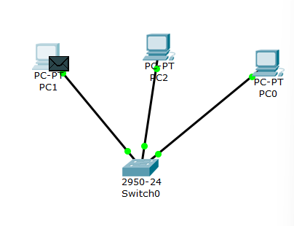
ping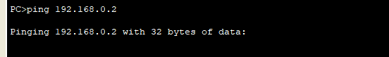

transmission chronology
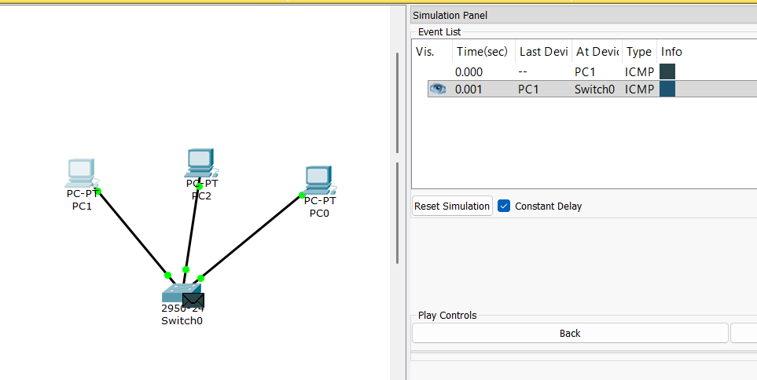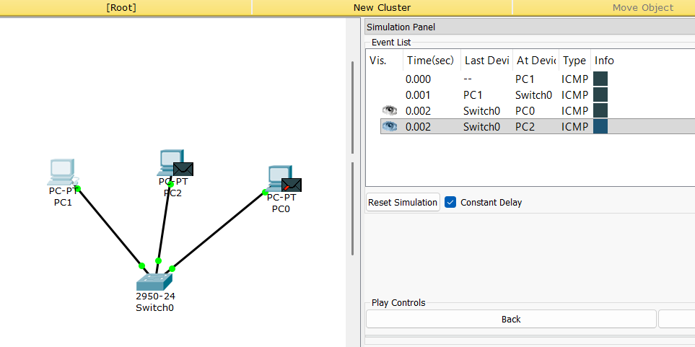
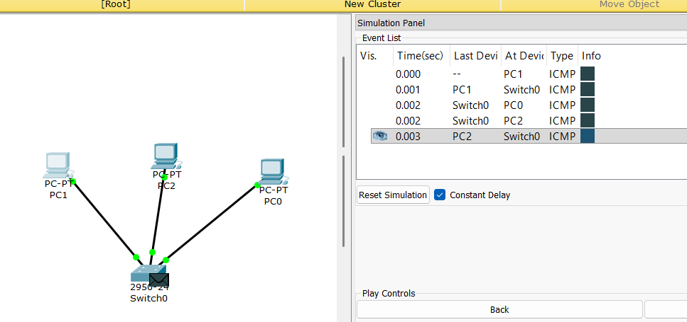
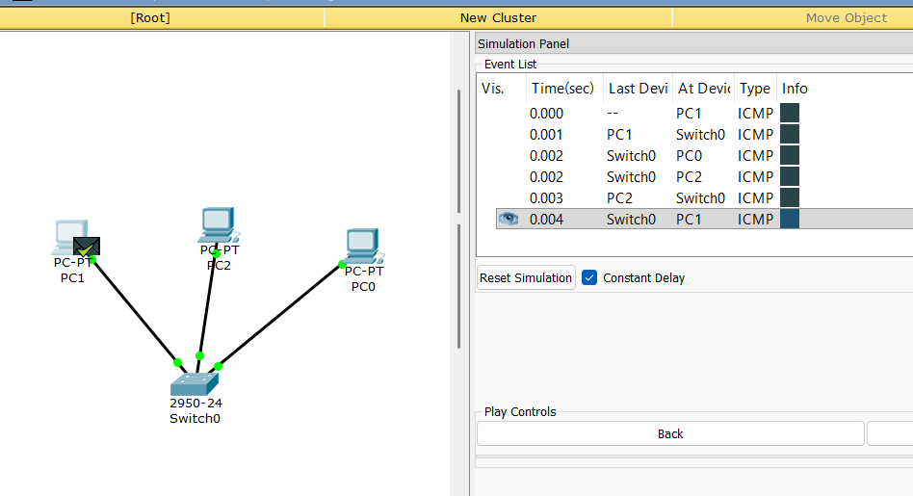
Packet recieved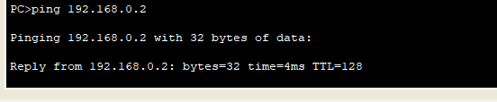

Sending packet again after caching

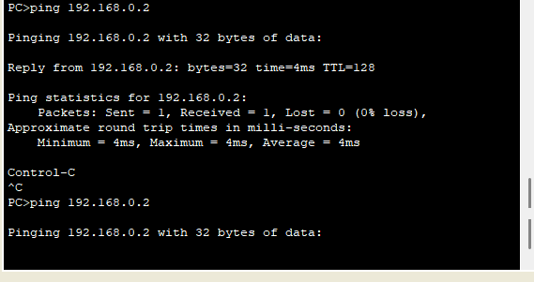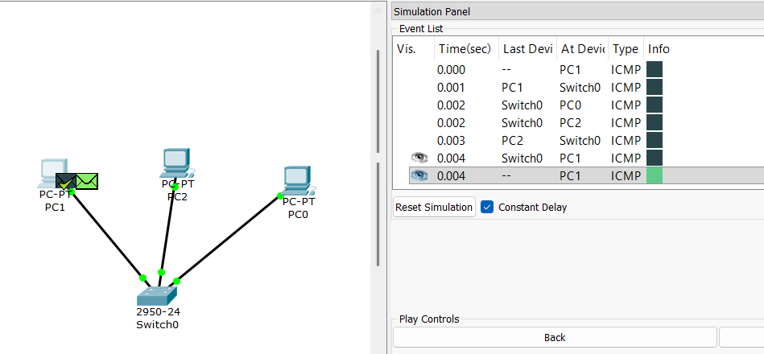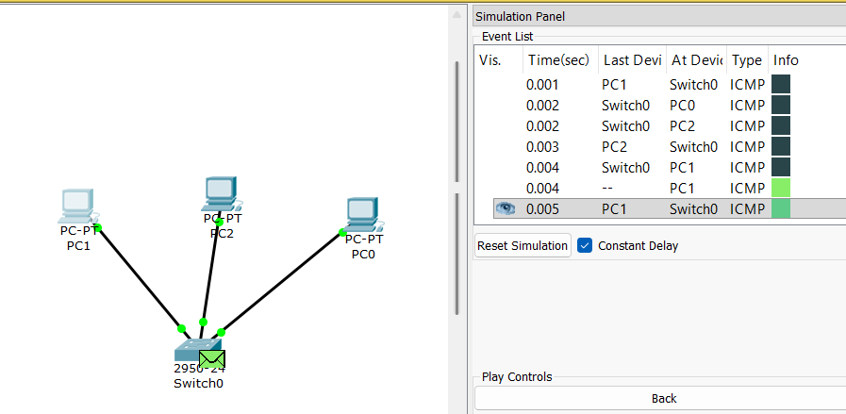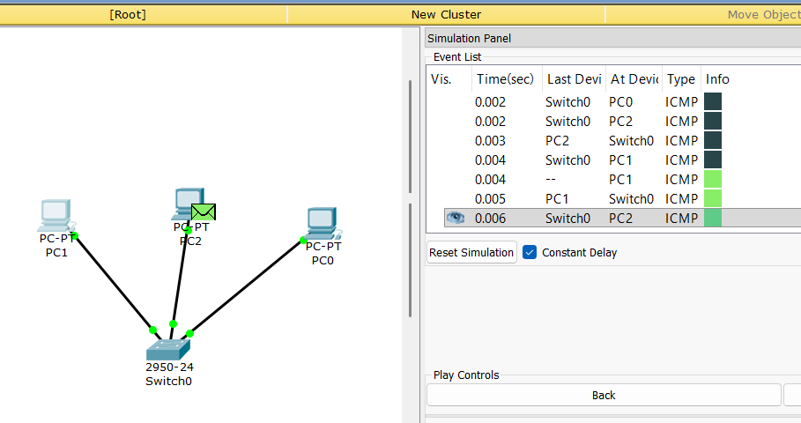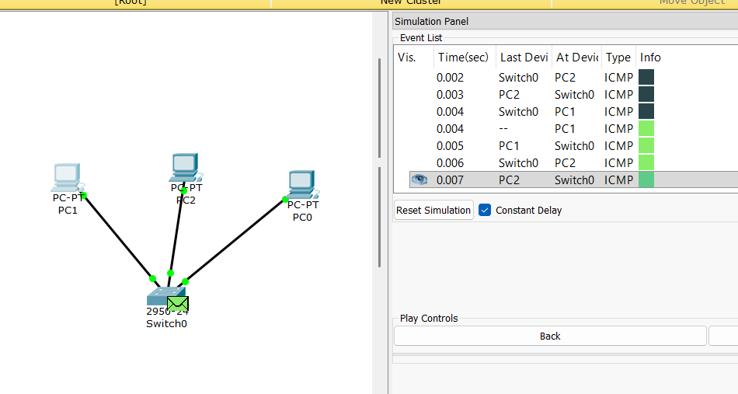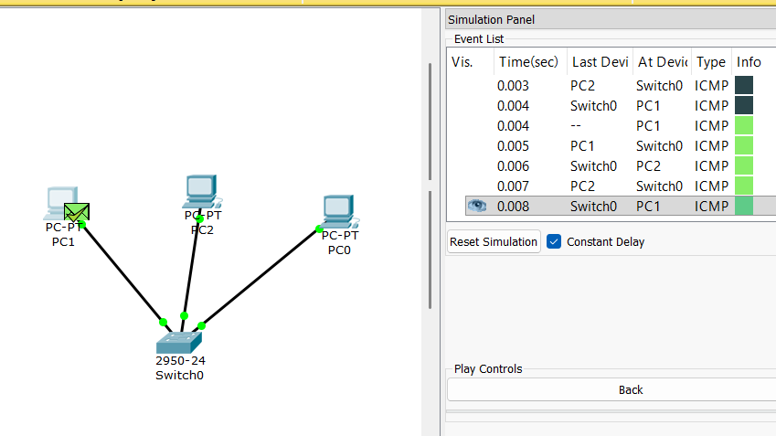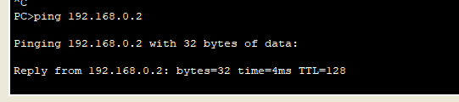
Packet received
Switch table (after caching)
