**LAB – 5**

**1. Initialize Git Repository**: Run git init in your project directory to initialize a new Git repository.

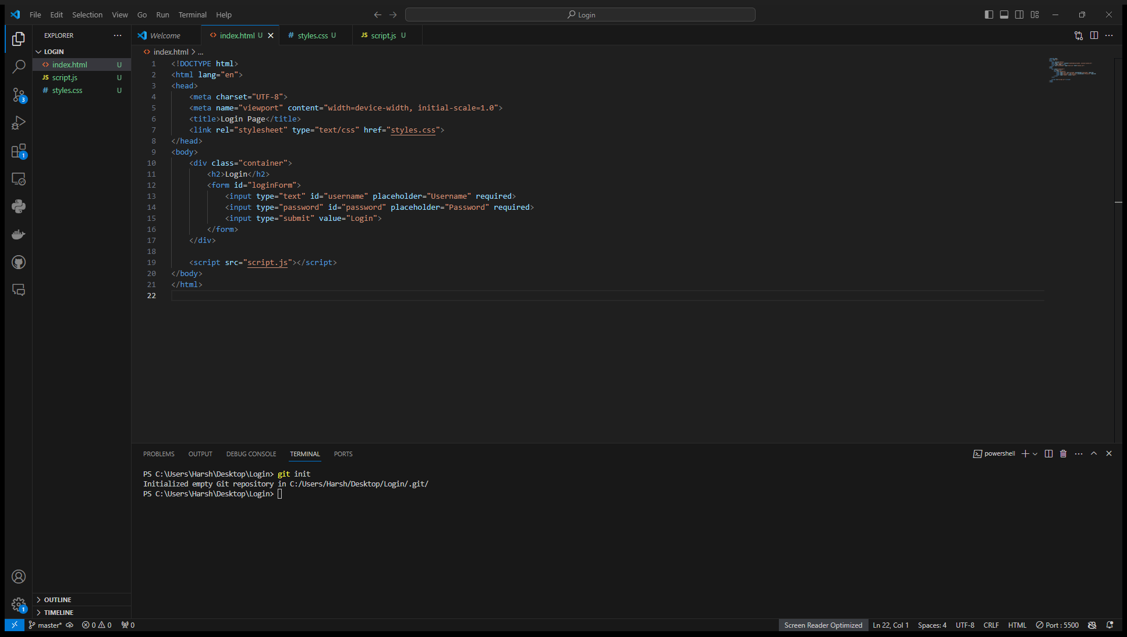

**2. Create a Feature Branch**:

Create a new branch for your login page feature using *git checkout -b feature/login-page*.

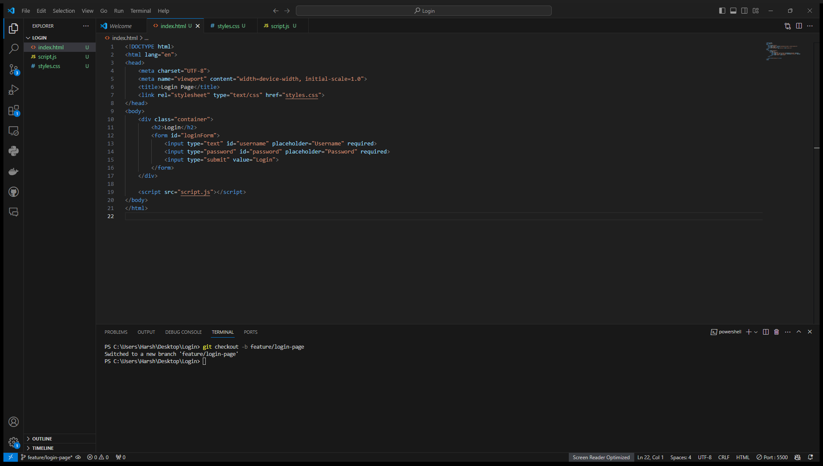

Implement the basic login page changes and commit them.

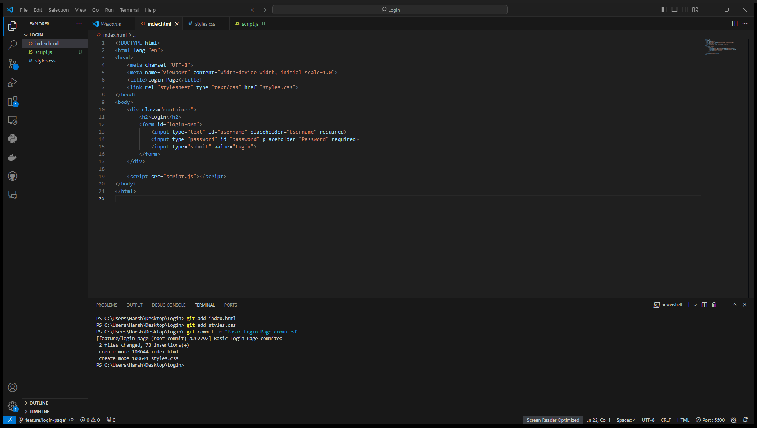

**3. Merge Feature Branch**:

Switch back to the main branch using *git checkout main*.

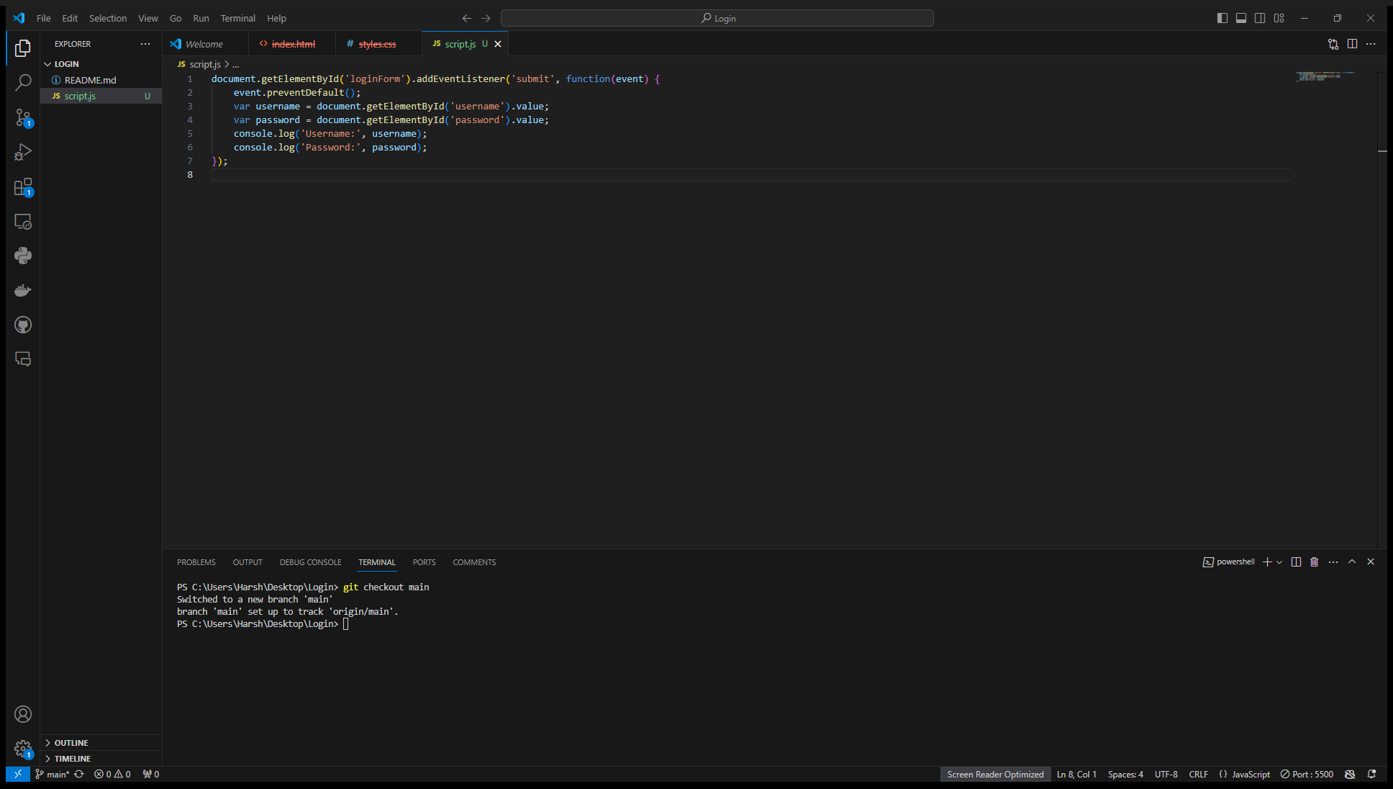

Merge the feature branch into the main branch with *git merge feature/login-page*.

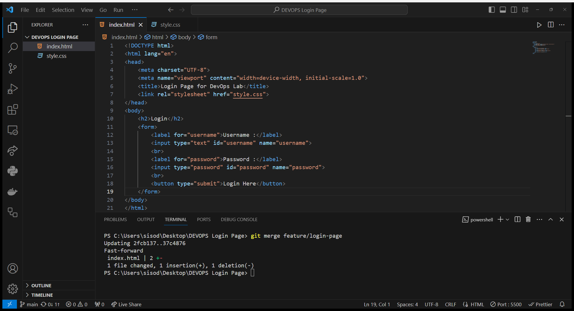

4. **Commit Changes**: Make additional changes (e.g., improve styling) and commit them to the main branch.

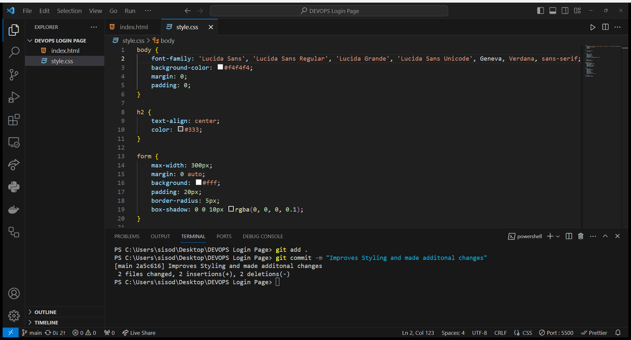

**5. Create and Switch to a Bugfix Branch**:

Create a new branch for a bugfix using *git checkout -b bugfix/fix-login-bug*.

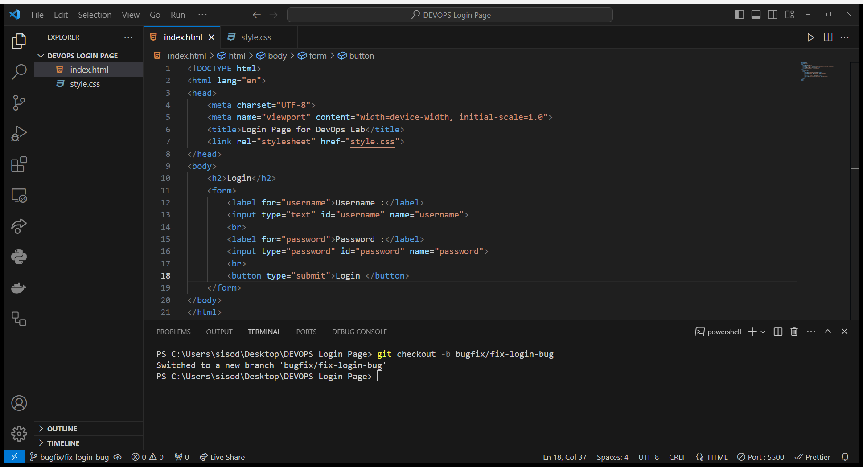

Fix any issues with the login page and commit the changes.

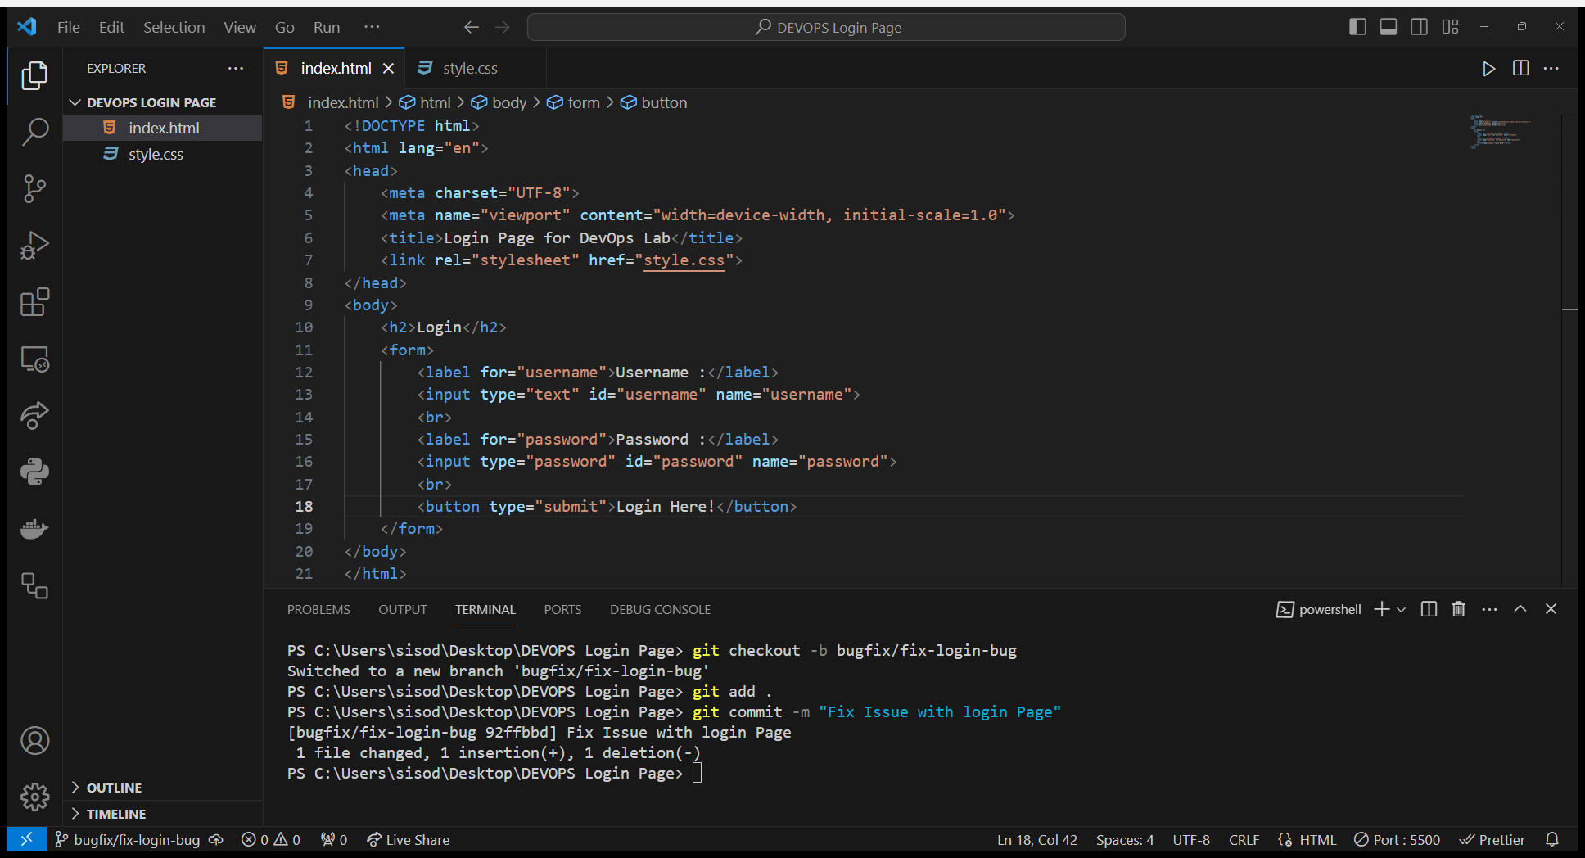

**6. Merge Bugfix Branch**:

Switch back to the main branch using *git checkout main*.

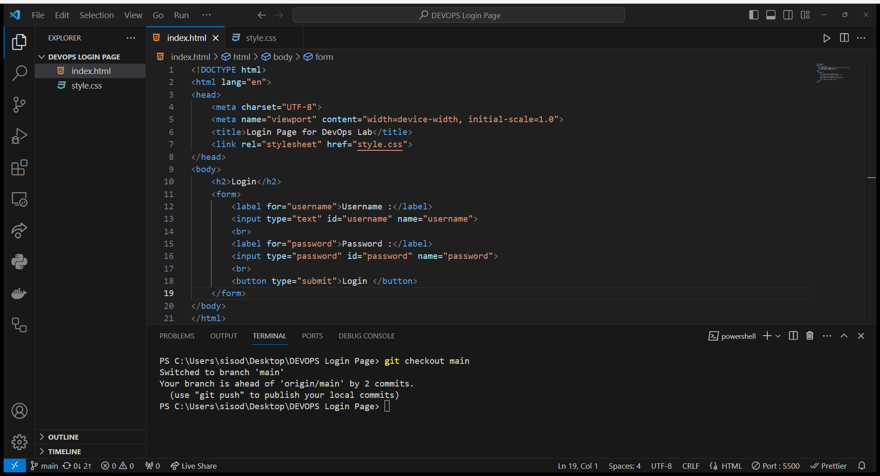

Merge the bugfix branch into the main branch with git merge bugfix/fix-login-bug.

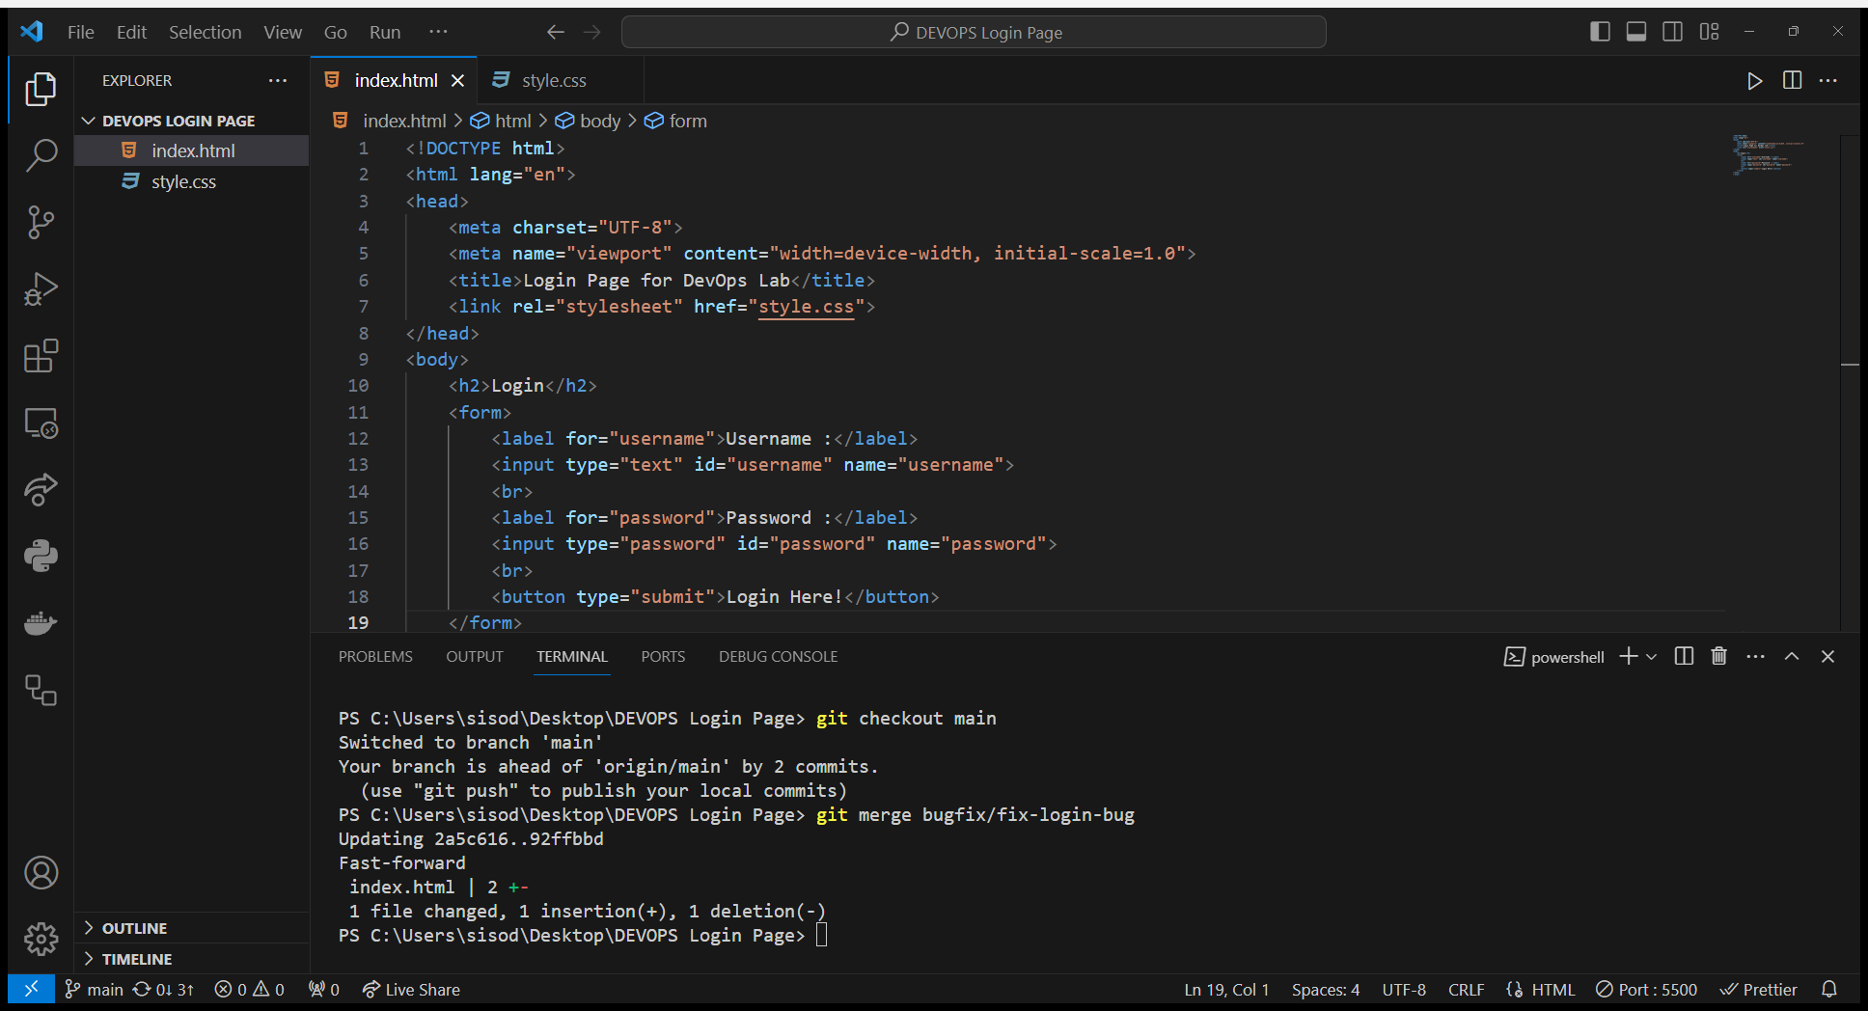

**7. Push Changes to Remote Repository**: Push the changes from the main branch to the remote repository using *git push origin main*.

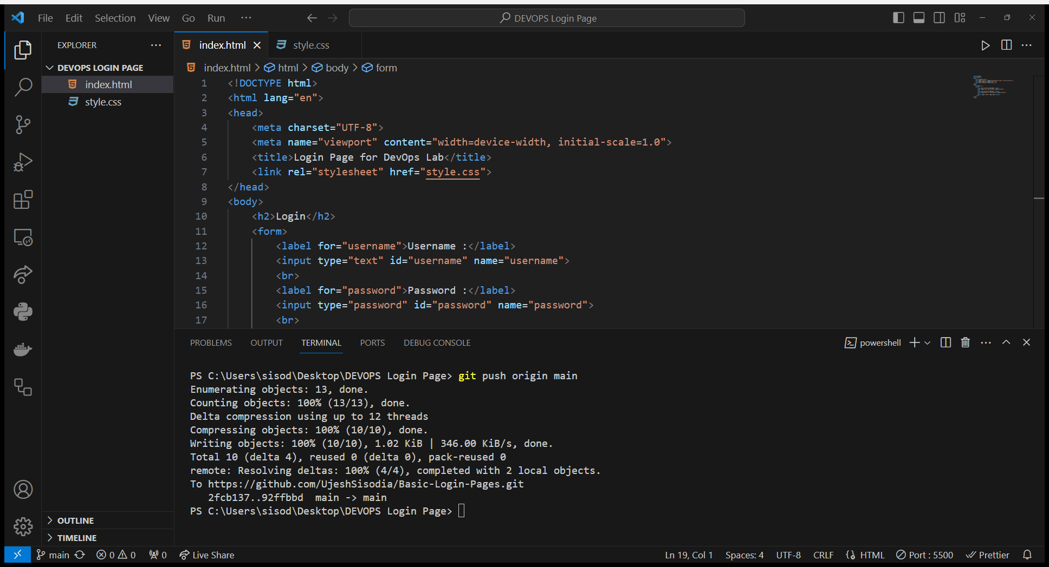

**8. Revert Changes**:

Identify a commit that introduced a bug using *git log*.

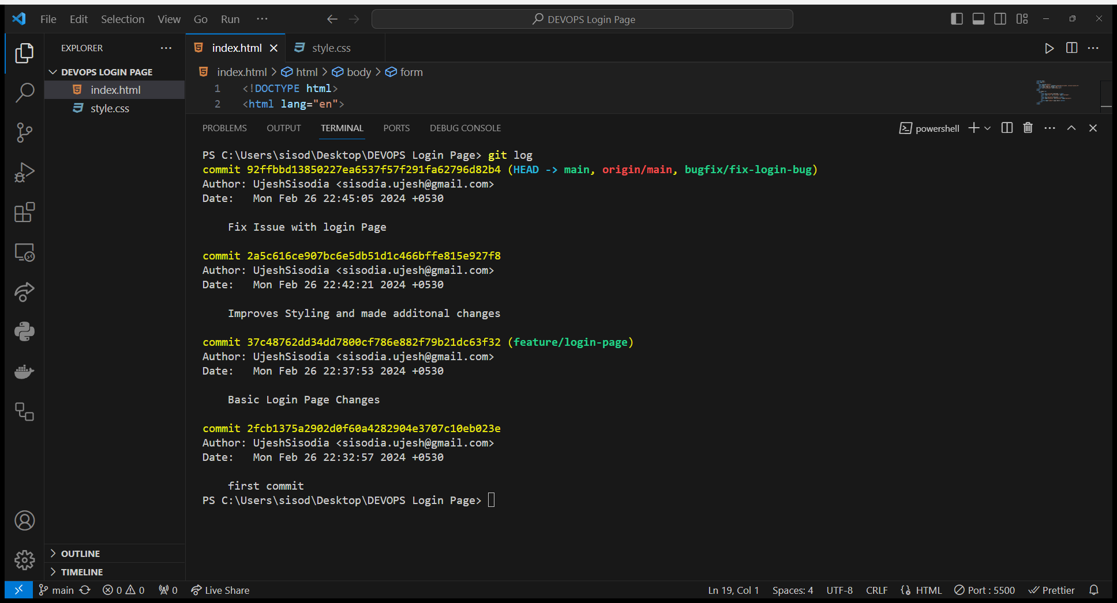

Use *git revert* to create a new commit that undoes the changes introduced by the specified commit.

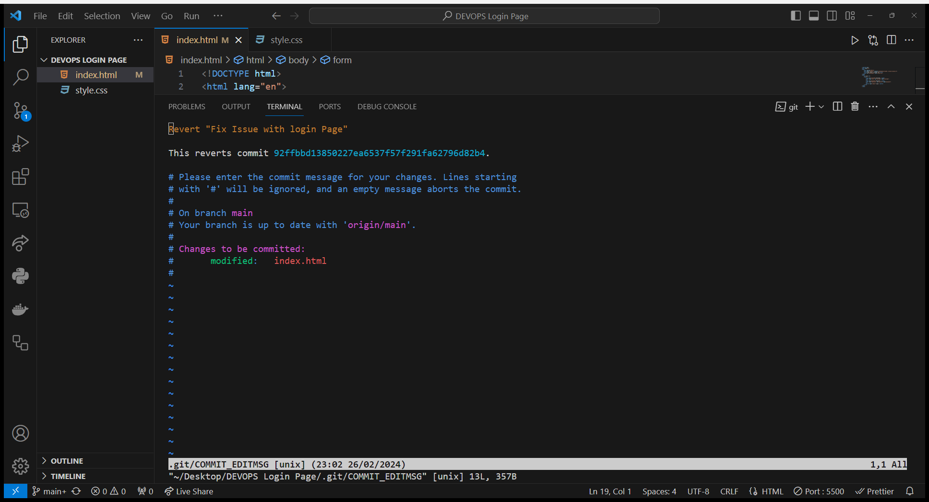

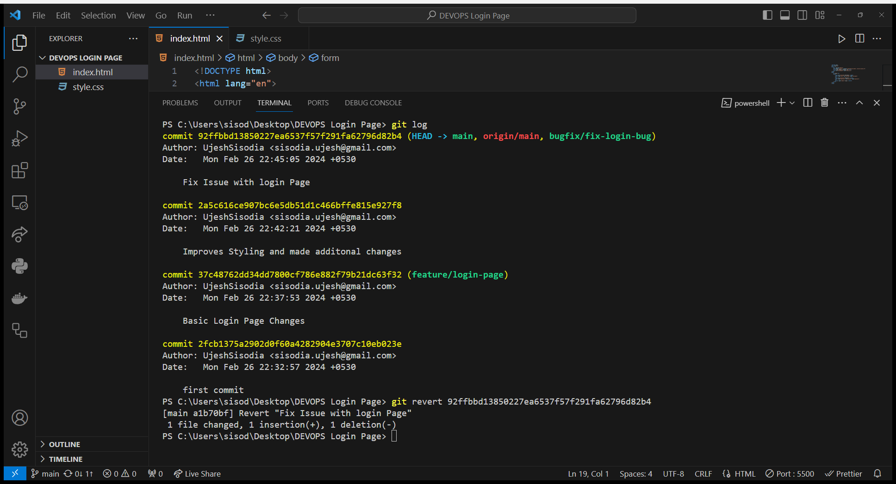

**9. Undo Changes (Hard Reset):** If you want to completely discard the last few commits, use *git reset --hard HEAD~.*

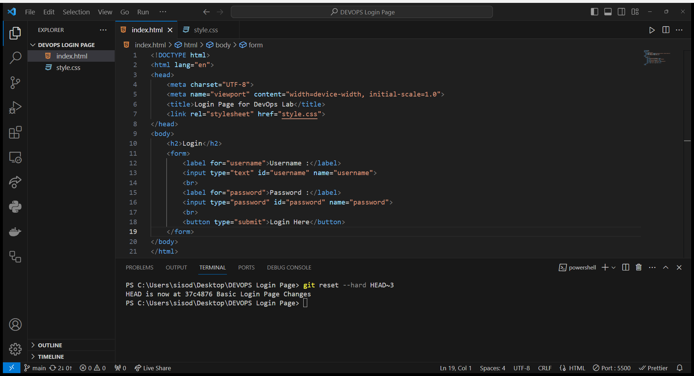

**10. Branch Cleanup**:

Delete the feature and bugfix branches locally using *git branch -d feature/login-page* and *git branch -d bugfix/fix login-bug*.

