This exercise will be in three phases

1. So first of all we're going to use cloud formation to create an ec2 instance.

2. We're going to upload version 1 of our application into an S3 Buckets and then we're going to deploy our application to our ec2 instance using code deploy.

3. Then in the next stage we're going to build a code pipeline and manually trigger code deploy it to update our application to version 2 and then finally we are going to configure an automated pipeline which is going to be triggered when we add a new version of our code to the S3 bucket.

4. So that's automatically going to trigger a cloud watch event which is going to trigger code pipeline to redeploy the code to our ec2 instance using code deploy.

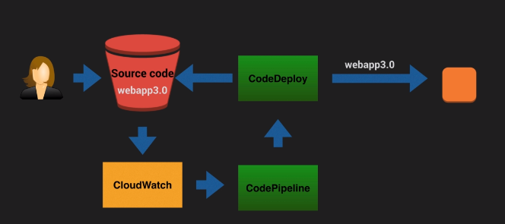



Please use file CF-Template.json which is a cloud formation template, So basically it creates your ec2 instance and it allows you to tag your instance so that you can easily identify it later on when we come to use the code deploy it also Associates an existing SSH key pair name as well and it sets up a security group which will allow you to log onto the ec2 instance once it has been launched. And if we scroll down here to the mapping section you'll see that this template is going to allow you to launch instances in one of these four regions. So you have a choice of either U.S. East 1 U.S. West to EU West one or AP southeast too.

So for this particular lab you can only work in one of these four regions.

So pick the region that you want to work in and just make sure that everything that you do within this lab is done in the same region that you select.

Now in order to use this cloud formation template we're going to need to store it in an S3 bucket because cloud formation always sources its templates from S3. So I'm going to return it to the console come to services and click on S3 and I'm going to create a new bucket, check the region is where you want to be working.

Now run below command and please change template URL in below command and also change key-pair name.

Before firing this command please configure a user who will be having access of below services.

Codedeployfullaccess

S3fullaccess

Cloudformationfullaccess

Iamfullaccess

Ec2fullaccess

And then fire below command(document also attached above)

**aws cloudformation create-stack --stack-name CodeDeployDemoStack \**

**--template-url http://s3-eu-west-1.amazonaws.com/cftemplates/CF_Template.json \**

**--parameters ParameterKey=InstanceCount,ParameterValue=1 \**

**ParameterKey=InstanceType,ParameterValue=t2.micro \**

**ParameterKey=KeyPairName,ParameterValue=irkp \**

**ParameterKey=OperatingSystem,ParameterValue=Linux \**

**ParameterKey=SSHLocation,ParameterValue=0.0.0.0/0 \**

**ParameterKey=TagKey,ParameterValue=Name \**

**ParameterKey=TagValue,ParameterValue=CodeDeployDemo \**

**--capabilities CAPABILITY_IAM**

this command will create a ec2-instace

after some time you can check the status of your stack by below command

**aws cloudformation describe-stacks --stack-name CodeDeployDemoStack --query "Stacks[0].StackStatus" --output text**

Now create s3 bucket where in we store our applications, it should be in same region where you are creating all infra. Also enable versioning on it.



Upload version 1 of your app. It should be zip file of version 1 app of

Mywebapp version 1

Then login to ec2 instance which has been created as a part of cloud formation template.

And check your code deploy agent has been installed correctly

**sudo service codedeploy-agent status**

(it can be installed using below commands)

#Install CodeDeploy agent on your EC2 instance:

**sudo yum update**

**sudo yum install ruby**

**sudo yum install wget**

**cd /home/ec2-user**

**wget https://aws-codedeploy-eu-central-1.s3.amazonaws.com/latest/install**

**chmod +x ./install**

**sudo ./install auto**

**sudo service codedeploy-agent status**

Now goto code deploy service from AWS GUI, click on get started 🡪 create application 🡪give application name🡪give platform as EC2/onprem and click create application

Now hit **create deployment group🡪enter deployment group name🡪Choose Service Role which you have created in code deploy lab🡪select deployment type as inplace🡪select enviroment configuration as Amazon EC2 Instances🡪give tags to identify EC2 Intance🡪uncheck load balancer option and hit create deployment group**

**Now hit create deployment🡪select recently created deployment group🡪In revision location provide path of s3 where you have uploaded webapp.zip and hit create deployment**

**Wait for while till it get succeeded, grab public ip and check. Youe ip should resolve**

Now upload next version of your app and then goto codepipleine service from AWS GUI🡪getting started🡪create pipeline🡪give a name of pipeline🡪select new service role in Service role option🡪keep rest of the defaults🡪 next🡪give source provider as s3, bucket name and s3 object key as name of zip folder(mywebapp.zip) 🡪 in change detection options select Amazon cloud watch events🡪 next🡪click skip build stage option🡪in deployment provider select AWS code deploy🡪select correct region🡪select application name 🡪select deployment group🡪next and create pipeline

Now deployment has succeeded and upload new versions and check it should deployed without manually build the app.