Game Design Document:

Wobble Bomb

A. Concept / Gameplay Story

Theme-A goofy physics laboratory where “Wobblers” — clumsy, floppy, ragdoll-like test subjects — are part of an experiment gone wrong. Everything inside the lab is unstable: the walls, the teleporters, and especially the bombs.

Narrative-A containment failure has locked two rival teams of Wobblers in undefined area.
Their only way out: defeat the other test team using bombs.Because every character moves like a drunk noodle, the drama of competitive elimination constantly clashes with slapstick humor — players slip, bounce, fall over walls, trip into teleporters, and accidentally blow themselves up.

Map Look & Feel
- Bright, colorful, toy-like arena
- Soft primary colors (blue, orange, green, yellow)
- Rounded edges, simple low-poly shapes
- Clean floor tiles to emphasize movement
- Obstacles resemble wall, bushes, foam wedges
The world is intentionally silly and “over-safe,” making every mistake look funny.

Environmental Style
- Low-poly
- Highly physics-reactive
- Exaggerated ragdoll motion
- Teleporters resemble big, bouncy funnels that “splort” players out with a wobble
- Every collision looks like it came straight from a cartoon physics engine

B. Mode Objective & Core Systems

Mode Name-Wobble Bomb

Core Gameplay LoopAcquire → Prime → Throw → Push/Flail → Survive
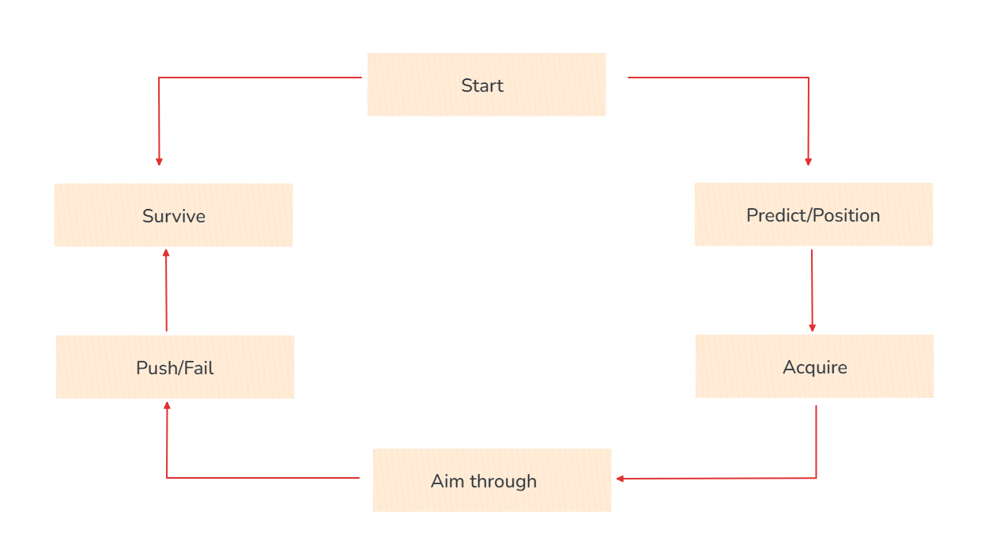
Players rush toward bombs, panic as the fuse counts down, try to aim while wobbling, and use the Flail ability to shove enemies into danger zones or mess up their throws.
Team Goal-Eliminate all 5 enemies or survive longer than them within the 90-second round timer.

Win Condition-A round ends when: One team is fully eliminated

Respawn Rules-No respawns during the round.Eliminated players become an adorable floppy ragdoll pile until the next round begins(can rome anywhere in ghost mode but can’t be seen by alive players)

Key Gameplay Systems
Bomb Health System
- Players have 3 total hit points
- Standard bomb hit = 1 damage
- Charged bomb hit = 2 damage
Bomb Rules
- Picking up any bomb starts a 5-second fuse
- Player must throw it — holding too long = self-detonation
- Bombs explode on impact with walls, floor, or players
- Small AoE radius allows multi-hits and chaos
The Push Ability
- 12-second cooldown
- Short-range, high-impact knockback
- Great for:
  - Pushing bomb carriers
  - Knocking players into blast zones
  - Interrupting throws
  - Creating last-second saves
Using the push briefly throws the player into an uncontrollable wobble.
Teleporters (Funnel Pads)
- Instantly transport players between two paired locations
- On exit, players stumble and wobble for 0.5 seconds
- Useful for repositioning, ambushing, escaping
Poison Cloud Shrink
- After 60 seconds, the arena begins to shrink
- Encourages final fights
- Prevents long stalling or corner camping

Dynamic Bomb Tier System

Player Count | Active Bomb Limit | Description
9–10 players | 7 bombs | High chaos, encourages early action
6–8 players | 5 bombs | Balanced mid-game pressure
4–5 players | 4 bombs | Smaller skirmishes, more tactical
2–3 players | 3 bombs | Final duel; controlled chaos

C. Player Roles & Team Dynamics
Overall Behavior
The gameplay leans into coordinated chaos. Teams attempt to stay organized, but physics constantly sabotages them.
Good plans fall apart instantly when someone slips, bumps a teammate, or teleports in the wrong direction.
Role Fluidity
There are no locked roles. Players shift between:
- Attacker (holding a bomb, trying to approach)
- Defender (protecting bomb carrier, pushing enemies)
- Disruptor (using Flail to ruin enemy timing)
- Evader (dodging explosions, creating distance)

Expected Team Strategies

1. Flail Denial
Use the Flail at the perfect moment:
- To stop an enemy from grabbing a bomb
- To push an enemy into an explosion
- To make a bomb carrier stumble and mis-throw

2. Bomb Pass Combo
A risky but high-skill tactic:
- Teammates pass the bomb around repeatedly
- Reduce the fuse from 5s → 1s
- Final player throws a nearly-dead bomb for a near-unavoidable hit

3. Teleporter Ambush
A player teleports behind the enemy team,
→ exits in a wobble,
→ instantly Flails enemies into the path of an incoming throw.
Funny, flashy, effective.

D. Fun & Balancing Explanation

Why It’s Fun
Contrast:
High-stakes elimination + characters that move like wet noodles.
Even beginners create funny moments:
- Tripping into a bomb
- Throwing wildly sideways
- Flailing teammates by accident
- Misusing teleporters
But skilled players can use movement, timing, spacing, and push mechanics to dominate.
This creates:
- Low skill floor (fun instantly)
- High skill ceiling (competitive depth)

Fair & Balanced Map
- Symmetrical layout = equal start
- Randomized bomb circles
- Bomb tiers = consistent pressure
- Poison Cloud = forced action, controlled match pacing
Every system ensures:
- No stalling
- Constant movement
- Constant decision-making

Map


