**Diagnosis of Alzheimer**’**s Disease**

**INDEX**

1. **INTRODUCTION**
2. **LITERATURE SURVEY**
3. **PROBLEM STATEMENT**
4. **METHODOLOGY**
5. **TOOLS**
6. **IMPLEMENTATION**
7. **RESULTS AND ANALYSIS**
8. **CONCLUSION AND FUTURE SCOPE**
9. **REFERENCES AND APPENDIX**

**INTRODUCTION**

Alzheimer’s disease (AD) is one of the most common neurogenerative diseases. A progressive disease that destroys memory and other important mental functions.

No cure exists, but medication and management strategies may temporarily improve symptoms.

Alzheimer's dementia results from the progressive loss (degeneration) of brain cells. This degeneration may show up in a variety of ways in brain scans.

However, these scans alone aren't enough to make a diagnosis. Scans aren't used to diagnose the condition because there is overlap in what doctors consider normal age-related change in the brain and abnormal change.

Our project attempts to construct a system where by using brain scans(MRI) we try to diagnose the presence of Alzheimer’s disease in a patient using image processing and machine learning

2-D MRI scan images from oasis dataset repository were collected and image processing was performed on these before training our convolutional neural network models

The feature extraction was then used to perform classification of 4 classes

**LITERATURE SURVEY**

**Yechong Huang, Xiahai Zhuang, Tong Tong, Yuncheng Zhou “Diagnosis of Alzheimer**’**s Disease via Multi-Modality 3D Convolutional Neural Network”,Jiahang Xu-School of Data Science, Fudan University, Shanghai, China,2019**

This paper indicates that the hippocampal area with no segmentation can be chosen as the input since CNN is able to learn useful features without labeling the voxels. In addition, features from the region out of the hippocampi also provide further information to separate AD patients from normal ones.

**Silvia Basaiaa , Federica Agosta “Automated classification of Alzheimer's disease and mild cognitive impairment using a single MRI and deep neural networks”–San Raffaele Scientific Institute,Milan,Italy,2019**

This research paper applies 3-D CNN on MRI images and managed to achieve an accuracy of 99% for classification of AD(Alzheimer’s disease) vs HC(healthy controls) classes

**Marcia Hon and Naimul Mefraz Khan “Towards Alzheimer’s Disease Classification through Transfer Learning”, Ryerson University ,Toronto, ON,2017**

This research paper applies CNN to oasis 2 dataset and achieves an accuracy of 96% accuracy on test dataset .This paper for referred to observe optimal batch size and hyper-parameter settings

**PROBLEM STATEMENT**

Performing image processing and deep learning on 2-d MRI images obtained from oasis-3 dataset and classifying the images into 4 classes -MildDemented, Moderate demented, NonDemented and VeryMildDemented.

**Source for dataset**: <https://www.oasis-brains.org/>

**Dataset description:** The dataset chosen consisted of 2D-MRI images taken in longitudinal orientation and consisted of 6300 images (training-5121,testing-1279)

**METHODOLOGY**

We construct a 2D VGG-variant CNN to implement a single modality AD diagnosis.

Among numerous bio markers, the shrinkage of the hippocampi is the best-established MRI biomarker to stage the progression of AD.

We have not used segmentation of hippocampi as this is not a pre-requisite of CNN based classification.

VGG-16 was chosen as the pretrained model, but the weights were not frozen and were included in trainable parameters

CNNs are used to learn general features automatically. CNNs are trained with a back propagation algorithm while it usually consists of multiple convolutional layers, pooling layers and fully connected layers and connects to the output units through fully connected layers or other kinds of layers.

Augmentation was also performed on the images obtained from dataset.

**TOOLS**

Programming language-python

Image processing and machine learning libraries-Keras,Tensorflow

**IMPLEMENTATION**

**Architecture:**

**VGG-16 Architecture**

Input. VGG takes in a 224x224 pixel RGB image.

Convolutional Layers. The convolutional layers in VGG use a very small receptive field (3x3, the smallest possible size that still captures left/right and up/down).

Fully-Connected Layers. VGG has three fully-connected layers: the first two have 4096 channels each and the third has 1000 channels, 1 for each class.

All of VGG’s hidden layers use ReLU (a huge innovation from AlexNet that cut training time). VGG does not generally use Local Response Normalization (LRN), as LRN increases memory consumption and training time with no particular increase in accuracy.

In our model the fully connected layer the fully connected layer after the last convolutional layer was removed .

Instead another two hidden layer of neurons were added consisting of 250 neurons and 4 neurons respectively . A dropout layer was also added for regularization .

**Block Diagram:**

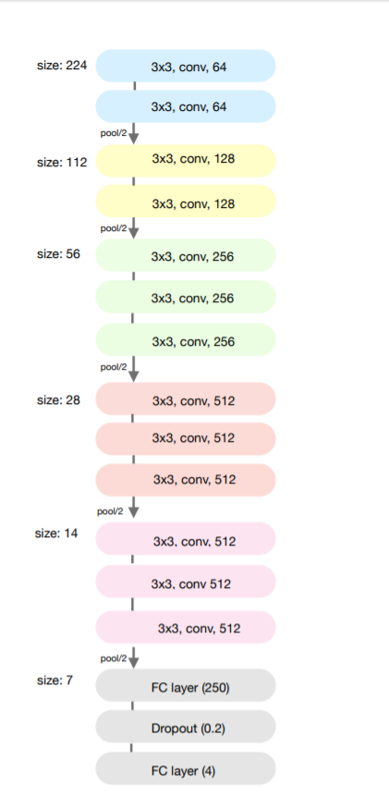

In the above diagram the last 3 Fully connected layer replaced the last few fully connected layers of traditional VGG model. A dropout layer was added between the 2 fully connected layers to randomly drop 20 percent of neurons from previous layer.

**Pre-processing**

Images of dimensions 176X208 were used

The 4 classes of images in the dataset were found to be imbalanced ,hence the class with fewer images was first augmented.

Keras’s ImageDataGenerator and .flow_from_directory functions were used to perform augmentation with images being horizontally flipped , zoomed, rescaled.

The transformation was performed for every class in the above case

On testing dataset only rescaling was performed

**Training**

Batch-size: a batch size of 13 was the maximum batches of images the model could handle with one epoch.

Epochs: 13 epochs were observed to produce the most robust model, increasing no of epochs beyond 13 would cause overfitting

Optimizer: Adam optimizer was chosen with a learning rate of 0.0001 and other hyperparameter settings of beta1=0.9 ,beta2=0.999 and epsilon=0.00001

Loss-function: Categorical cross entropy was used. The target vector was found to be of form [0 0 1 0] or [1 0 0 0] etc . In this cross entropy as the loss function instead of squared error function was found to be more suitable as we are able to model the two vectors as distributions and then find the difference between them using the entropy formula

In other layers back propagation is used to train.

**RESULTS AND ANALYSIS**

Training accuracy achieved:96.4%

Highest testing accuracy achieved:74.4%

SGD with momentum was also tried as learning technique but highest validation accuracy achieved was only 69.9%

The pretrained network(VGG-16) was also frozen and only the neural networks were trained but a training accuracy of only 74% after 13 epochs was achieved and accuracy was observed to increase very slowly.

After augmentation of under represented class was performed the model’s accuracy increased but not substantially .

Images from test dataset

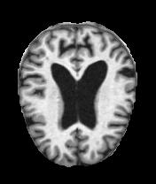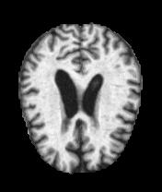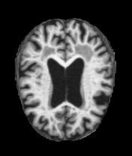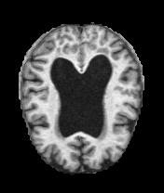

[Images are in order(L-R): Mild demented, moderate demented, non -demented, very mild demented]

Classification Report

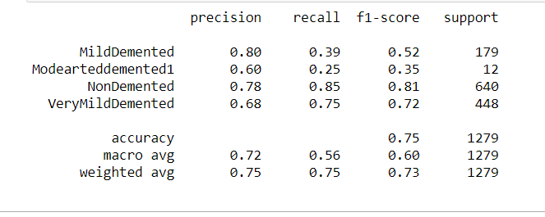

**CONCLUSION AND FUTURE SCOPE**

A higher batch size can improve the accuracy, as the batch size was increased from 10 to 13 the accuracy was also observed to increase from 87% to 96%.

But due to the limitations of the machine and processing power the batch size could not be improved further.

In research paper “Towards Alzheimer’s Disease Classification through Transfer Learning by Marcia Hon and Naimul Mefraz Khan, Ryerson University ,Toronto, ON” the batch size of 40 and 100 epochs was found to optimal for achieving accuracy of 96% on testing dataset.

Increasing the dataset will only make this model better.

A 3-D CNN is observed to perform better in case of MRI images classification.

In 3-D CNN slices of image that contain more information are extracted and then passed to the convolutional network.

This extraction is performed using auto-encoders and image entropy function.

**REFERENCES**

1. Yechong Huang, Xiahai Zhuang, Tong Tong, Yuncheng Zhou “Diagnosis of Alzheimer’s Disease via Multi-Modality 3D Convolutional Neural Network”, Jiahang Xu-School of Data Science, Fudan University, Shanghai, China,2019
2. Silvia Basaiaa , Federica Agosta “Automated classification of Alzheimer's disease and mild cognitive impairment using a single MRI and deep neural networks” , San Raffaele Scientific Institute,Milan,Italy,2019
3. Marcia Hon and Naimul Mefraz Khan “Towards Alzheimer’s Disease Classification through Transfer Learning”, Ryerson University ,Toronto, ON,2017
4. <https://www.pyimagesearch.com/>

<https://keras.io/>

**APPENDIX:**

**Code:**



