## Crop Recommendation System

### A MINI PROJECT REPORT 18CSC305J - ARTIFICIAL INTELLIGENCE

***Submitted by***

## Pranshu Yadav[RA2111003010422]

## Kartikey Lohani [RA2111003010446]

## Pushkala S R[RA2111003010448]

*Under the guidance of*

## Dr. S Padmini

Assistant Professor, Department of Computer Science and Engineering

***in partial fulfillment for the award of the degree of***

### BACHELOR OF TECHNOLOGY

in

## COMPUTER SCIENCE & ENGINEERING

of

### FACULTY OF ENGINEERING AND TECHNOLOGY



S.R.M. Nagar, Kattankulathur, Chengalpattu District

### MAY 2024

**SRM INSTITUTE OF SCIENCE AND TECHNOLOGY**

(Under Section 3 of UGC Act, 1956)

## BONAFIDE CERTIFICATE

Certified that Mini project report titled **“Crop Recommendation System”** is the bona fide work of **Pranshu Yadav(RA2111003010422), Kartikey Lohani (RA2111003010446), Pushkala S R(RA2111003010448)** who carried out the minor project under my supervision. Certified further, that to the best of my knowledge, the work reported herein does not form any other project report or dissertation on the basis of which a degree or award was conferred on an earlier occasion on this or any other candidate.

SIGNATURE

Dr. S. Padmini

Assistant Professor

Department of Computing Technologies

## ABSTRACT

In the dynamic landscape of modern agriculture, the Crop Recommendation System emerges as a groundbreaking solution, seamlessly blending the prowess of machine learning (ML) and deep learning (DL) methodologies. This visionary platform redefines conventional farming practices by harnessing a wealth of agricultural data—ranging from soil composition and climate patterns to historical crop performance and disease incidence rates. Through an intricate fusion of ML algorithms, such as decision trees and random forests, and sophisticated DL architectures like convolutional and recurrent neural networks, the system orchestrates a symphony of data-driven insights tailored to the intricate nuances of individual farming ecosystems.

At its core, the system boasts an intuitive web interface—an agricultural command center that empowers farmers with real-time access to actionable intelligence. From recommending the optimal crop varieties suited to prevailing environmental conditions, to fine-tuning fertilizer application strategies for maximal yield potential, and even preemptively identifying and mitigating potential disease outbreaks—the Crop Recommendation System serves as a steadfast ally in the farmer's quest for agricultural excellence.

Beyond mere recommendations, this transformative platform embodies a paradigm shift in agricultural stewardship, fostering a culture of sustainability and resilience. By bolstering crop yields, optimizing resource allocation, and fortifying defenses against the ever-looming specter of climate change and pestilence, the Crop Recommendation System not only drives economic prosperity but also cultivates a harmonious coexistence between humanity and nature.

In essence, the Crop Recommendation System represents the vanguard of agricultural innovation—a beacon of hope illuminating the path towards a more prosperous, sustainable, and resilient future for farmers and ecosystems alike.

iii

ABSTRACT iii

TABLE OF CONTENTS iv

ABBREVIATIONS v

1. INTRODUCTION 6
2. LITERATURE SURVEY 7
3. SYSTEM ARCHITECTURE AND DESIGN 8
   1. Architecture diagram 8
   2. Description of Module and components 9
4. METHODOLOGY 10
   1. Methodological Steps 10,11
5. CODING AND TESTING 12

5.1 Coding 12-14

5.2 Testing 15

1. SREENSHOTS AND RESULTS 16-20
2. CONCLUSION AND FUTURE ENHANCEMENT 21
   1. Conclusion 21
   2. Future Enhancement 22

REFERENCES 23-25

iv

## ABBREVIATIONS

**ML** Machine Learning

**DL** Deep Learning

**SVM** Support Vector Machine

**XGBOOST** eXtreme Gradient Boosting

**API** Application Program Interface

**UI** User Interface

V

## INTRODUCTION

In the backdrop of India's agrarian economy, characterized by its reliance on traditional farming practices and the challenges posed by evolving environmental conditions and demographic shifts, there arises a pressing need for innovative solutions to enhance agricultural productivity and sustainability. This project endeavors to address these challenges by introducing an advanced web-based agricultural decision support system empowered by cutting-edge Machine Learning (ML) and Deep Learning (DL) techniques.

With agriculture serving as the backbone of India's economy, employing a significant portion of its population and contributing substantially to its Gross Domestic Product (GDP), the sector's modernization is imperative for ensuring food security, poverty alleviation, and rural development. However, conventional farming methods are often limited in their ability to adapt to the complexities of modern agricultural practices, including optimizing crop selection, managing soil fertility, and combating crop diseases.

To bridge this gap, our project presents an integrated solution that revolutionizes agricultural decision-making by providing farmers with personalized recommendations for crop selection, fertilizer application, and disease detection. Leveraging ML algorithms such as Support Vector Machines (SVM), Naïve Bayes, and eXtreme Gradient Boosting (XGBoost), our system analyzes vast datasets encompassing soil characteristics, climate patterns, and historical crop performance to offer tailored insights into optimal crop choices and nutrient management strategies.

Furthermore, our project incorporates DL techniques to accurately identify and diagnose crop diseases based on images of diseased plant leaves. By harnessing the power of DL algorithms, our system enables early detection of crop diseases, thereby facilitating timely interventions to mitigate crop losses and ensure sustainable farming practices.

In summary, our project represents a significant step towards modernizing India's agricultural sector, equipping farmers with the tools and knowledge needed to navigate the complexities of modern farming practices effectively. By embracing innovation and harnessing the potential of ML and DL technologies, we aspire to drive positive transformation in Indian agriculture, fostering sustainable growth, resilience, and prosperity for generations to come.

6

**LITERATURE SURVEY**

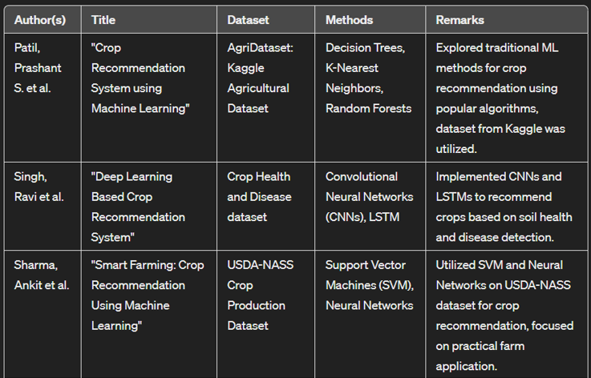

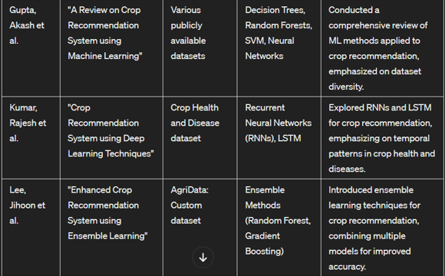

7

### SYSTEM ARCHITECTURE AND DESIGN

### 

8

### Description of Model and components:

### System Flow:

### Crop Recommendation Module:

### The process begins when the user initiates the Crop Recommendation module.

### It starts by calculating the pH value of the soil to assess its acidity or alkalinity.

### Next, the system determines the NPK (Nitrogen, Phosphorus, Potassium) ratio of the soil, which is crucial for plant growth.

### Based on the soil characteristics, climate conditions, and other environmental factors, the system suggests suitable crops for cultivation.

### Finally, the process reaches the End point after providing the crop recommendation.

### Fertilizer Recommendation Module:

### When the user triggers the Fertilizer Recommendation module, the process begins.

### Similar to the Crop Recommendation module, the system calculates the pH value of the soil and determines the NPK ratio.

### Using this information, it recommends appropriate fertilizers to balance the soil's nutrient levels and optimize plant growth.

### After suggesting the fertilizer, the process reaches the End point.

### Crop Disease Detection Module:

### The process starts when the user uploads an image of a plant leaf for disease detection.

### The system accepts the image and analyzes it using machine learning or deep learning algorithms to predict the presence of any diseases.

### Upon detection of a disease, the system provides a solution or recommendations for disease management.

### After providing the solution, the process reaches the End point.

### End Point:

### All modules converge to the End point, indicating the completion of the overall process.

### At this stage, the system has provided recommendations for crop selection, fertilizer usage, and disease management based on the user's input and analysis of soil and plant data.

9

## METHODOLOGY

1. Data Collection:

* Gather relevant agricultural data including soil health parameters, climate conditions, historical crop yields, fertilizer usage, and crop disease data.
* Utilize publicly available datasets from sources like Kaggle, government agricultural departments, research institutions, or collect data through surveys and field experiments.

1. Data Preprocessing:

* Clean the collected data by handling missing values, outliers, and inconsistencies.
* Normalize or scale the data to ensure uniformity and compatibility for analysis.
* Perform feature engineering to extract useful features and create new variables if needed.

1. Crop Recommendation:

* Utilize machine learning algorithms such as Decision Trees, Random Forests, or Support Vector Machines to predict suitable crops based on soil health parameters, climate conditions, and historical crop yields.
* Train the model using historical data on crop performance under various environmental conditions.
* Evaluate the model's performance using metrics like accuracy, precision, and recall, and fine-tune the model as needed.

1. Fertilizer Suggestion:

* Analyze soil nutrient levels and crop nutrient requirements to determine excess or deficient nutrients.
* Utilize rule-based systems or machine learning classifiers to recommend suitable fertilizers and application rates to balance soil nutrient levels and optimize crop growth.
* Incorporate domain knowledge and expert recommendations to refine fertilizer suggestions based on crop-specific needs and environmental factors.

10

1. Disease Detection:

* Develop a deep learning model, such as Convolutional Neural Networks (CNNs), to analyze images of plant leaves and detect signs of crop diseases.
* Train the model using a labeled dataset of diseased and healthy plant images, incorporating transfer learning if necessary.
* Implement algorithms to identify the type of crop associated with the uploaded image and provide diagnosis and treatment recommendations for detected diseases.

1. Integration and Deployment:

* Integrate the crop recommendation, fertilizer suggestion, and disease detection modules into a unified system.
* Develop a user-friendly interface (web or mobile app) for farmers to input their agricultural parameters and receive recommendations.
* Deploy the system on a cloud platform or local server for accessibility and scalability.

1. Evaluation and Validation:

* Evaluate the system's performance using real-world agricultural data and compare its recommendations with expert advice or field trial results.
* Gather feedback from farmers to assess the system's usability, effectiveness, and relevance in practical farming scenarios.
* Continuously monitor and update the system based on user feedback, new research findings, and changes in agricultural practices or environmental conditions.

By following this methodology, the Crop Recommendation System can effectively assist farmers in making informed decisions to improve crop yield, optimize fertilizer usage, and mitigate crop diseases, ultimately enhancing agricultural productivity and sustainability.

11

**CODING AND TESTING**

# Importing libraries

from __future__ import print_function

import pandas as pd

import numpy as np

import matplotlib.pyplot as plt

import seaborn as sns

from sklearn.metrics import classification_report

from sklearn import metrics

from sklearn import tree

import warnings

warnings.filterwarnings('ignore')

#Lading dataset

df = pd.read_csv('../Data-processed/crop-recommendation.csv')

#EDA

df.head()

df.size

df.shape

df.columns

df.dtypes

#Seperating features and target label

features = df[['N', 'P','K','temperature', 'humidity', 'ph', 'rainfall']]

target = df['label']

labels = df['label']

# Splitting into train and test data

from sklearn.model_selection import train_test_split

Xtrain, Xtest, Ytrain, Ytest = train_test_split(features,target,test_size = 0.2,random_state =2)

12

# Decision Tree

from sklearn.tree import DecisionTreeClassifier

DecisionTree = DecisionTreeClassifier(criterion="entropy",random_state=2,max_depth=5)

DecisionTree.fit(Xtrain,Ytrain)

predicted_values = DecisionTree.predict(Xtest)

x = metrics.accuracy_score(Ytest, predicted_values)

acc.append(x)

model.append('Decision Tree')

print("DecisionTrees's Accuracy is: ", x*100)

print(classification_report(Ytest,predicted_values))

from sklearn.model_selection import cross_val_score

score = cross_val_score(DecisionTree, features, target,cv=5)

score

# Support Vector Machine (SVM)

from sklearn.svm import SVC

# data normalization with sklearn

from sklearn.preprocessing import MinMaxScaler

# fit scaler on training data

norm = MinMaxScaler().fit(Xtrain)

X_train_norm = norm.transform(Xtrain)

# transform testing dataabs

X_test_norm = norm.transform(Xtest)

SVM = SVC(kernel='poly', degree=3, C=1)

SVM.fit(X_train_norm,Ytrain)

predicted_values = SVM.predict(X_test_norm)

x = metrics.accuracy_score(Ytest, predicted_values)

acc.append(x)

model.append('SVM')

print("SVM's Accuracy is: ", x)

print(classification_report(Ytest,predicted_values))

score = cross_val_score(SVM,features,target,cv=5)

score

# Guassian Naive Bayes

from sklearn.naive_bayes import GaussianNB

NaiveBayes = GaussianNB()

NaiveBayes.fit(Xtrain,Ytrain)

13

predicted_values = NaiveBayes.predict(Xtest)

x = metrics.accuracy_score(Ytest, predicted_values)

acc.append(x)

model.append('Naive Bayes')

print("Naive Bayes's Accuracy is: ", x)

print(classification_report(Ytest,predicted_values))

score = cross_val_score(NaiveBayes,features,target,cv=5)

score

# Logistic Regression

from sklearn.linear_model import LogisticRegression

LogReg = LogisticRegression(random_state=2)

LogReg.fit(Xtrain,Ytrain)

predicted_values = LogReg.predict(Xtest)

x = metrics.accuracy_score(Ytest, predicted_values)

acc.append(x)

model.append('Logistic Regression')

print("Logistic Regression's Accuracy is: ", x)

print(classification_report(Ytest,predicted_values))

score = cross_val_score(LogReg,features,target,cv=5)

score

#saving a model example LR

import pickle

# Dump the trained Naive Bayes classifier with Pickle

LR_pkl_filename = '../models/LogisticRegression.pkl'

# Open the file to save as pkl file

LR_Model_pkl = open(DT_pkl_filename, 'wb')

pickle.dump(LogReg, LR_Model_pkl)

# Close the pickle instances

LR_Model_pkl.close()

#XGBoost

import xgboost as xgb

XB = xgb.XGBClassifier()

XB.fit(Xtrain,Ytrain)

predicted_values = XB.predict(Xtest)

x = metrics.accuracy_score(Ytest, predicted_values)

acc.append(x)

model.append('XGBoost')

14

print("XGBoost's Accuracy is: ", x)

print(classification_report(Ytest,predicted_values))

score = cross_val_score(XB,features,target,cv=5)

score

#Accuracy Comparison

plt.figure(figsize=[10,5],dpi = 100)

plt.title('Accuracy Comparison')

plt.xlabel('Accuracy')

plt.ylabel('Algorithm')

sns.barplot(x = acc,y = model,palette='dark')

accuracy_models = dict(zip(model, acc))

for k, v in accuracy_models.items():

print (k, '-->', v)

**#TESTING**

**#**Making a prediction

data = np.array([[104,18, 30, 23.603016, 60.3, 6.7, 140.91]])

prediction = RF.predict(data)

print(prediction)

data = np.array([[83, 45, 60, 28, 70.3, 7.0, 150.9]])

prediction = RF.predict(data)

print(prediction)

15

### SCREENSHOTS AND RESULTS

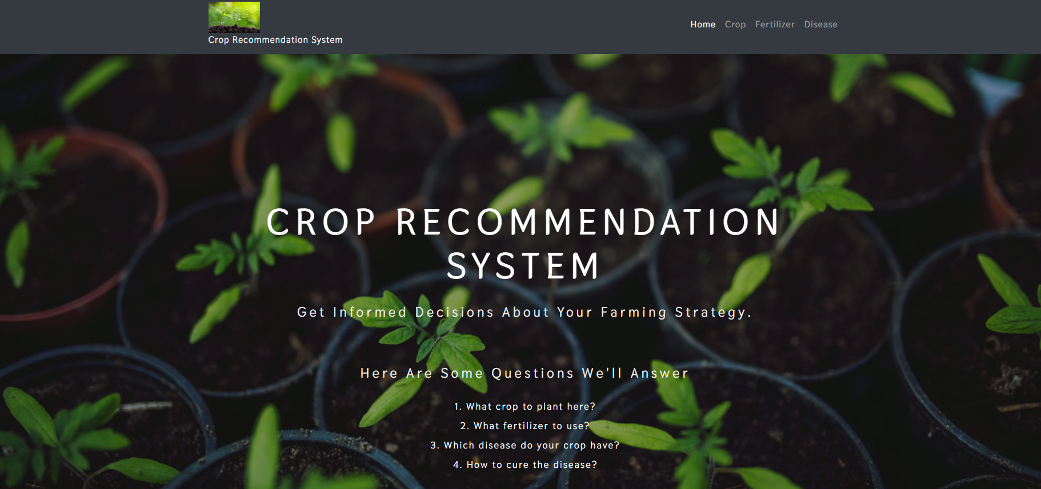

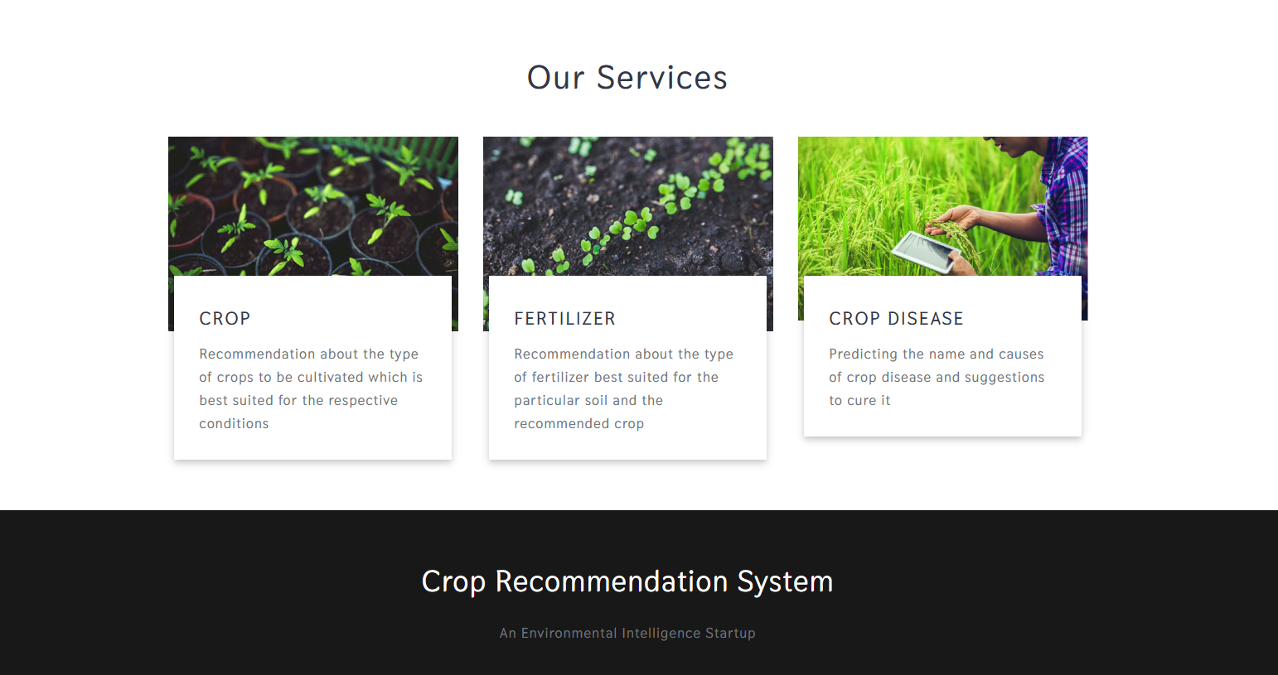

16

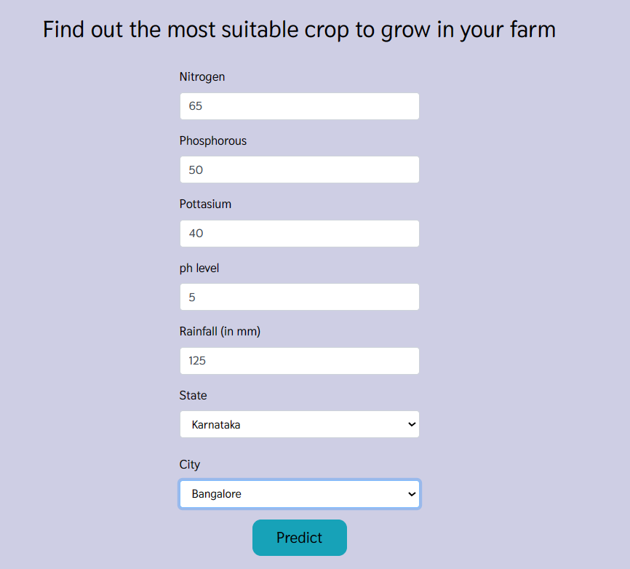

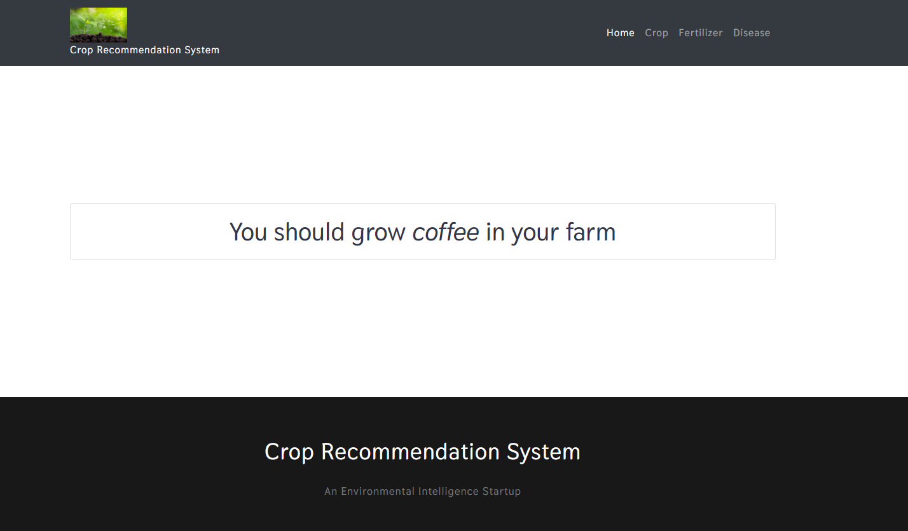

17

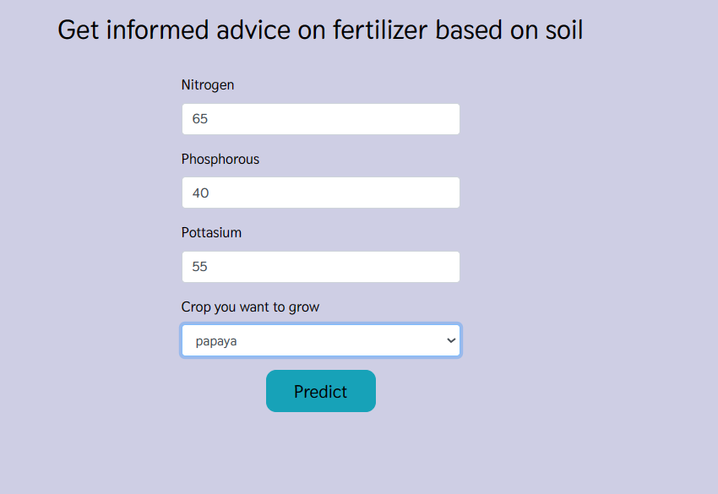

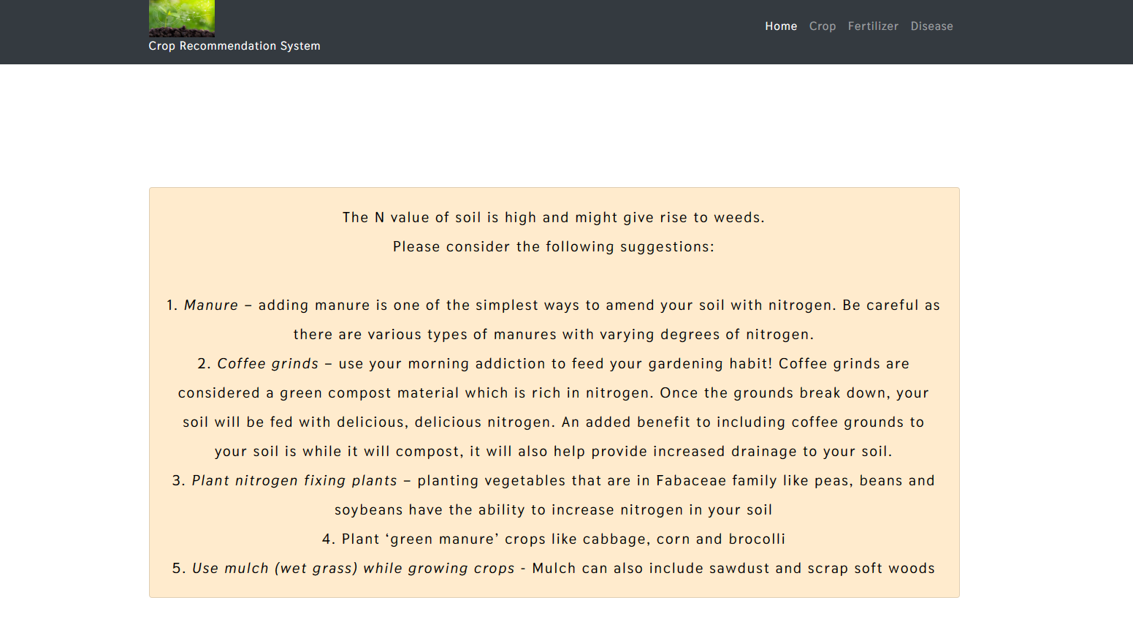

18

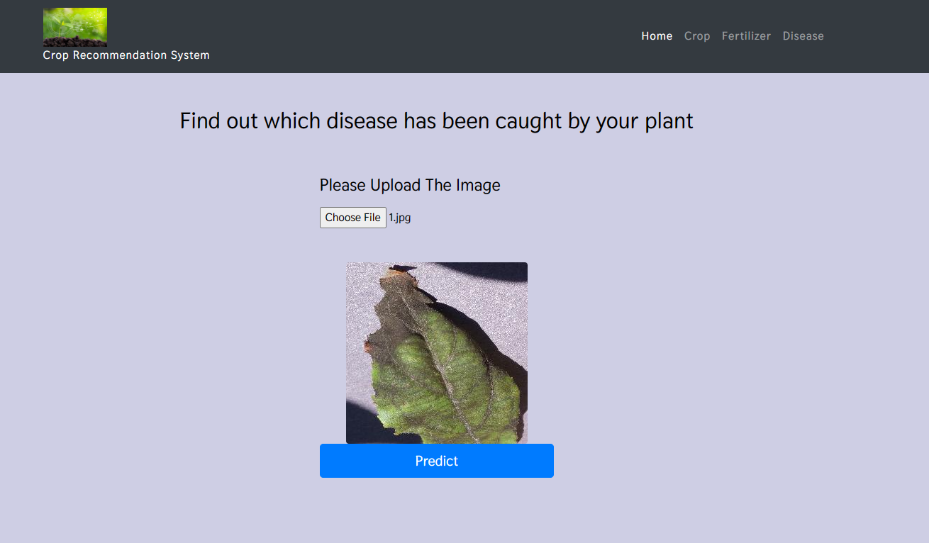

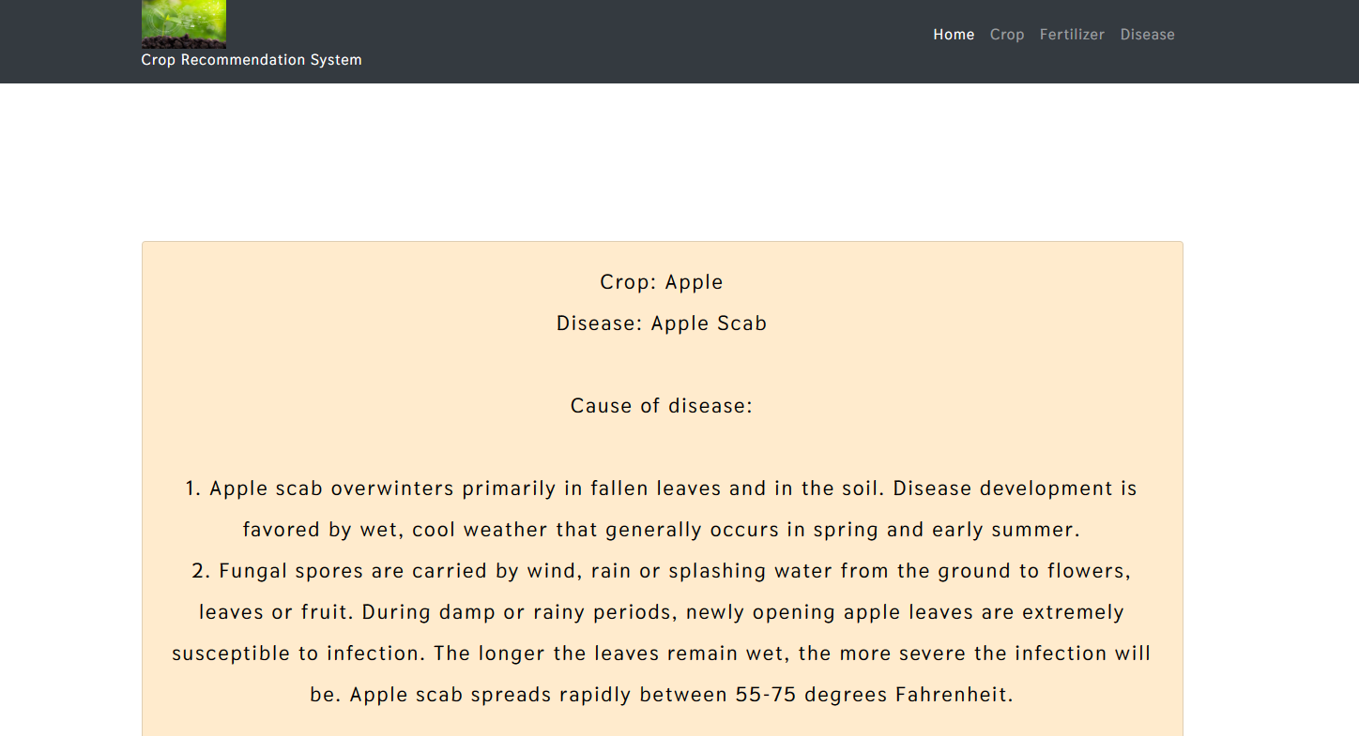

19

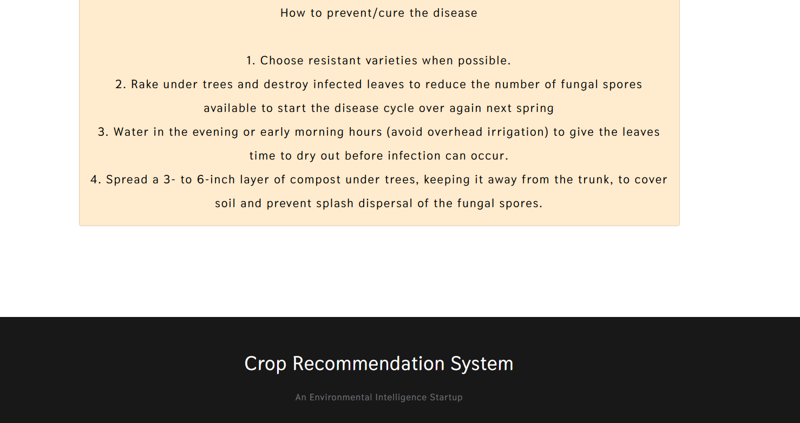

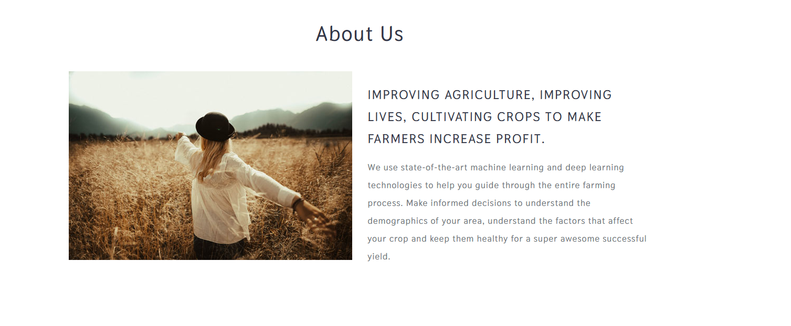

20

**CONCLUSION AND FUTURE ENHANCEMENTS**

Conclusion:

The Crop Recommendation System represents a significant advancement in agricultural technology, offering farmers a comprehensive tool to optimize crop selection, fertilizer usage, and disease management. By harnessing the power of machine learning and deep learning algorithms, the system provides personalized recommendations tailored to each farm's unique conditions, including soil health, climate, and crop history. Through the integration of multiple modules for crop recommendation, fertilizer recommendation, and crop disease detection, farmers can make informed decisions that lead to improved yields, reduced input costs, and enhanced sustainability.

The implementation of the Crop Recommendation System marks a pivotal moment in modern agriculture, bridging the gap between traditional farming practices and cutting-edge technology. By empowering farmers with actionable insights and recommendations, the system facilitates more efficient resource utilization, minimizes environmental impact, and fosters resilience against crop diseases and adverse weather conditions. Furthermore, the user-friendly interface and accessibility of the system ensure that farmers of all backgrounds and experience levels can benefit from its capabilities, driving widespread adoption and positive impact across agricultural communities.

21

**Future Enhancements:**

* Integration of IoT Sensors: Incorporating data from IoT sensors installed in agricultural fields can provide real-time information on soil moisture, temperature, and nutrient levels, enhancing the accuracy of recommendations.
* Multi-Criteria Decision Making: Introduce multi-criteria decision-making techniques to consider additional factors such as market demand, profitability, and sustainability goals in crop recommendation and fertilizer selection.
* Enhanced Disease Detection: Further refine the disease detection module by expanding the dataset to include a wider range of crop diseases and implementing advanced image processing and pattern recognition algorithms.
* User Feedback Mechanism: Implement a feedback mechanism where farmers can provide feedback on the effectiveness of recommendations and contribute to the improvement of the system's performance over time.
* Integration with Precision Agriculture Technologies: Integrate with precision agriculture technologies such as GPS-guided machinery and variable rate application systems to enable precise and targeted application of fertilizers and pesticides based on recommendation insights.
* Support for Diverse Crop Varieties: Expand the system's database to include a broader range of crop varieties, including region-specific and niche crops, to cater to the diverse needs of farmers across different regions.

**22**

**REFERENCES**

1. Gaurav Chauhan, Alka Chaudhary, “Crop Recommendation System using Machine Learning Algorithms”, IEEE-2021.
2. Shivesh Tiwari, India Somesh Kumar,Sunil Tyagi, Minakshi Poonia, “Crop Recommendation using Machine Learning and Plant Disease Identification using CNN and Transfer-Learning Approach”, IEEE-2022.
3. Aditya Motwani, Param Patil, Vatsa Nagaria, Shobhit Verma, Sunil Ghane, “Soil Analysis and Crop Recommendation using Machine Learning”, IEEE-2022.
4. Alonica Villanueva, Asmadi Dorado, Erika Marie Gerarman, John Brian F. Quebral, Maria Cecilia Venal, Daryl Neil L. Valenzuela, Menchie Rosales, “Real-Time Best-Fitted Crops Recommendation System Based On Agricultural Soil Health”, IEEE-2022.
5. R Jaichandran, T. Murali Krishna, Sri Harsha Arigela, Ramakrishnan Raman, N Dharani, Ashok Kumar, “Light GBM Algorithm based Crop Recommendation by Weather Detection and Acquired Soil Nutrients”, IEEE-2023.
6. Namrata Bhatt, Sunita Varma, “Recommendation System for Crops Integrating with Specific soil parameters by Machine Learning Techniques”, IEEE-2023.
7. K P K Devan, B Swetha, P Uma Sruthi, S Varshini, "Crop Yield Prediction and Fertilizer Recommendation System Using Hybrid Machine Learning Algorithms", IEEE-2023.
8. Tanneru Bhavya, Ramyalaxmi Seggam, Ravi Kumar Jatoth, "Fertilizer Recommendation for Rice Crop based on NPK Nutrient deficiency using Deep Neural Networks and Random Forest Algorithm", IEEE-2023.
9. Md. Delwar Hossain, Mohammod Abul Kashem, Shabnom Mustary, "IoT Based Smart Soil Fertilizer Monitoring And ML Based Crop Recommendation System", IEEE-2023.
10. Madhumathi R, Ashok Kumar K, Chandra Kumar N, Dhyanesh A, Arumuganathan T, "Soil Nutrient Prediction and Crop Recommendation System", IEEE-2023.

23

1. Yalabaka Srikanth, Meghana Daddanala, Manchala Sushrith, Pranith Akula, Ch. Rajendra Prasad, Dasari Sindhu Sri, "AGRI-PRO: Crop, Fertilizer and Market Place Recommender for Farmers Using Machine Learning Algorithms", IEEE-2023.
2. P ShunmugaLakshmi, V Ram Kishore, Pillai Pratham Ramachandran, S Santhi, S Kalaiselvi, "A Recommendation System for Crop Prediction Under Diverse Weather Conditions", IEEE-2023.
3. Priscilla R, Deepa R, Pandi A, "Agriculture-based Automation with Recommendation Systems based on AI Models", IEEE-2023.
4. Buddepu Sudhir, Devalaraju Charan Teja, Kurra Sai, Peddinti Sridhar, T. Daniya, "Plant Disease Severity Detection and Fertilizer Recommendation using Deep Learning Techniques", IEEE-2023.
5. B.C. Mallikarjun, V Yanjare Gowd, S Gagan, K P Vishwas, L Gagan Kumar, "Precision Agriculture-Machine Learning Based Approach", IEEE-2023.
6. Biswajit Mondal, Megha Bhushan, Ishaan Dawar, Meghavi Rana, Arun Negi, Shirshendu Layek, "Crop Disease Prediction using Machine Learning and Deep Learning: An Exploratory Study", IEEE-2023.
7. Abhishek Bajpai, Naveen Kumar Tiwari, Ashutosh Kumar Tripathi, Vibha Tripathi, Devesh Katiyar, "Early leaf diseases prediction in Paddy crop using Deep learning model", IEEE-2023.
8. Rakesh Kumar Ray, Saneev Kumar Das, Sujata Chakravarty, “Smart Crop Recommender System-A Machine Learning Approach”, IEEE-2022.
9. Shabari Shedthi B, Anusha, Anisha Shetty, Rakshitha R Shetty, B.A Divyashree Alva, Aishwarya D Shetty, “Machine Learning Techniques in Crop Recommendation based on Soil and Crop Yield Prediction System – Review”, IEEE-2022.
10. Sonam Chhikara, Nidhi Kundu, “Machine Learning based Smart Crop Recommender and Yield Predictor”, IEEE-2022.
11. P. Parameswari, N. Rajathi, K. J. Harshanaa, ” Machine Learning Approaches for Crop Recommendation”, IEEE-2021.

24

1. Saranya K, Deena Dhayalan S, Prasanth R, Sathish M, “Agriculture Based Recommendation System with Image Processing”, IEEE-2022.
2. Prashant Kumar, Keshav Bhagat, Kusum Lata, Sushant Jhingran, “Crop recommendation using machine learning algorithms”, IEEE-2023.
3. Josephine Selle Jeyanathan, B. Medha, G. Tharun Venkata Sai, R. Bharath Kumar, Varsha Sahu, “Automated Crop Recommender System using Pattern Classifiers”, IEEE-2023.
4. B. Swathi Sri, G. Pavani, B.Y.S. Sindhuja, V. Swapna, P.L. Priyanka, “An Improved Machine Learning based Crop Recommendation System”, IEEE-2023.

25