#1Brand

1. GetAllBrand

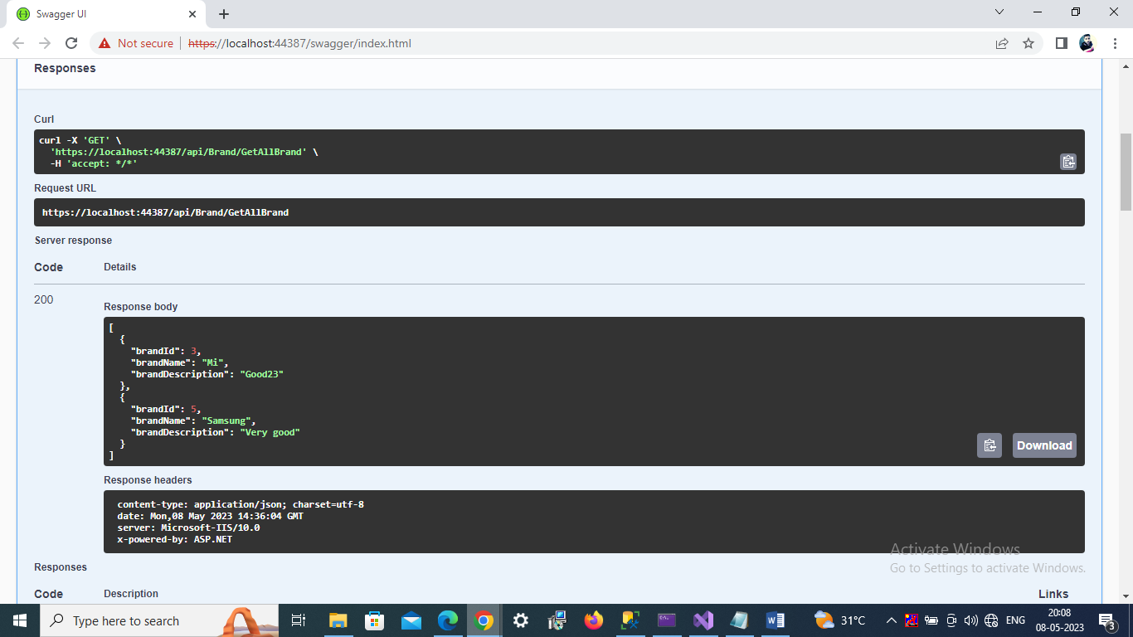

2. GetBrandById

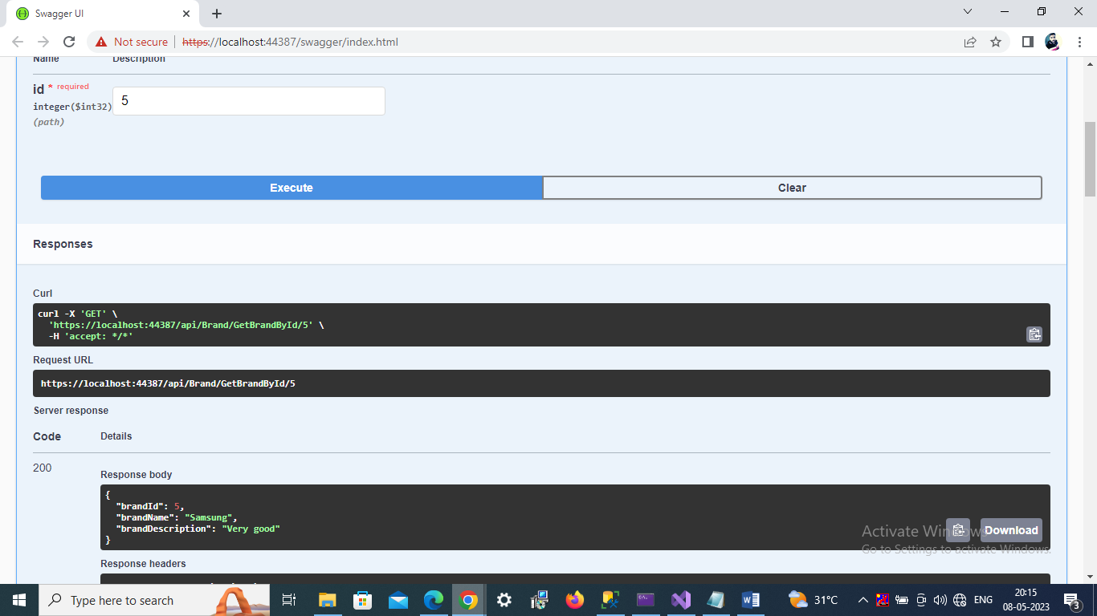

3. Add brand(Post)

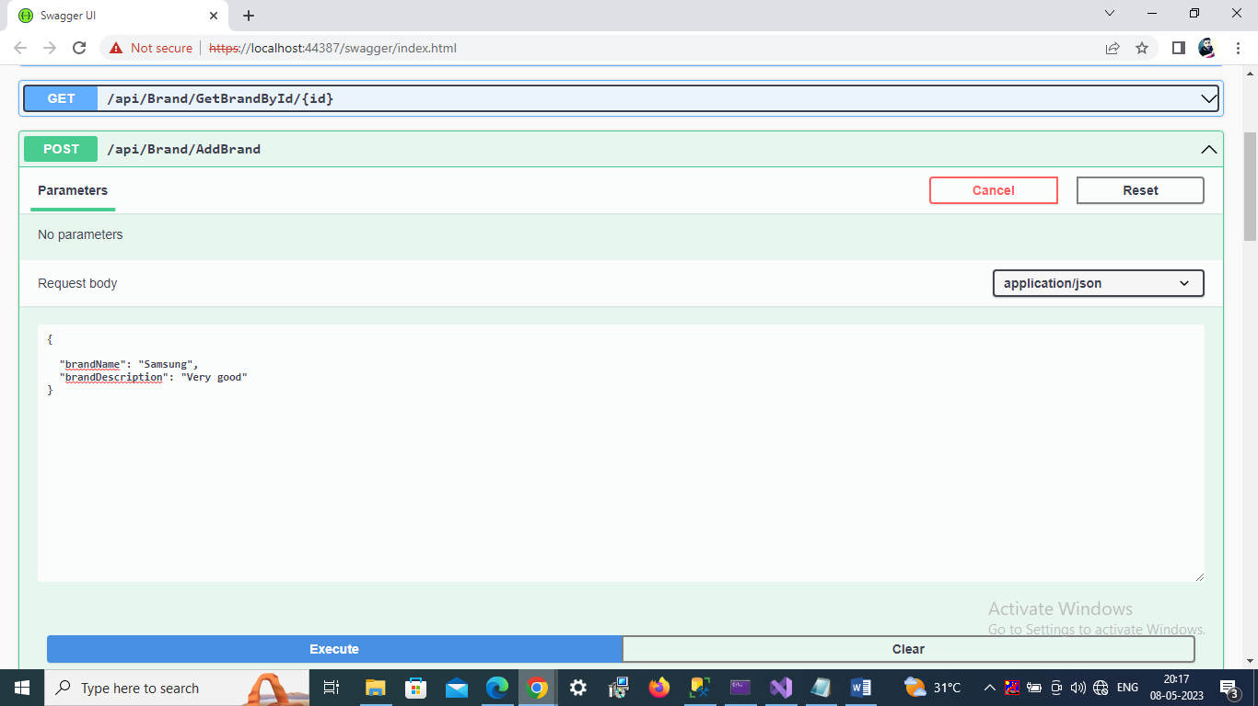

4. Update brand

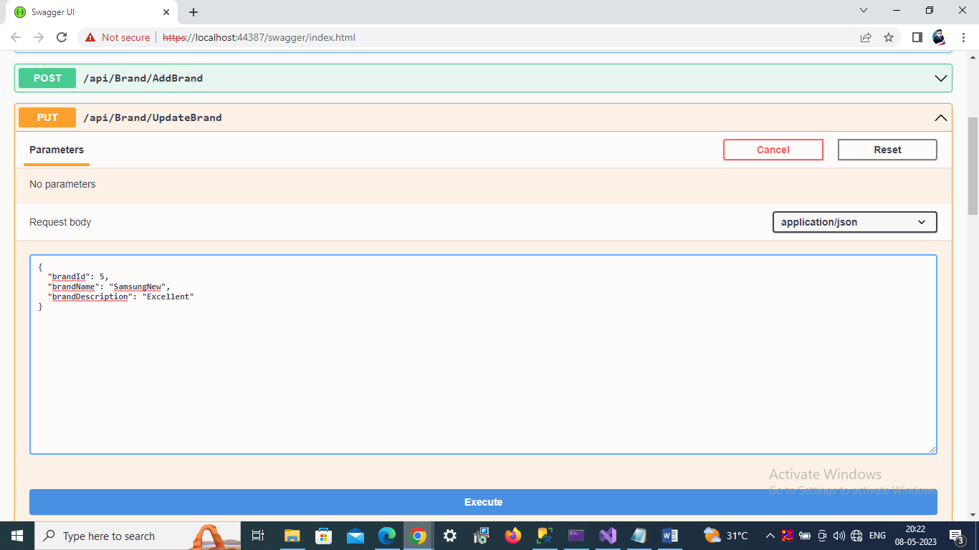

5. delete brand

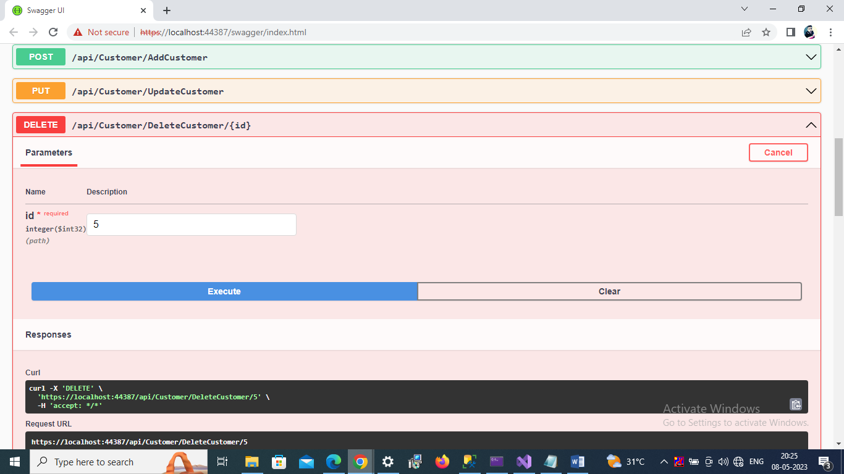

#2Customer

1. GetAllCustomer

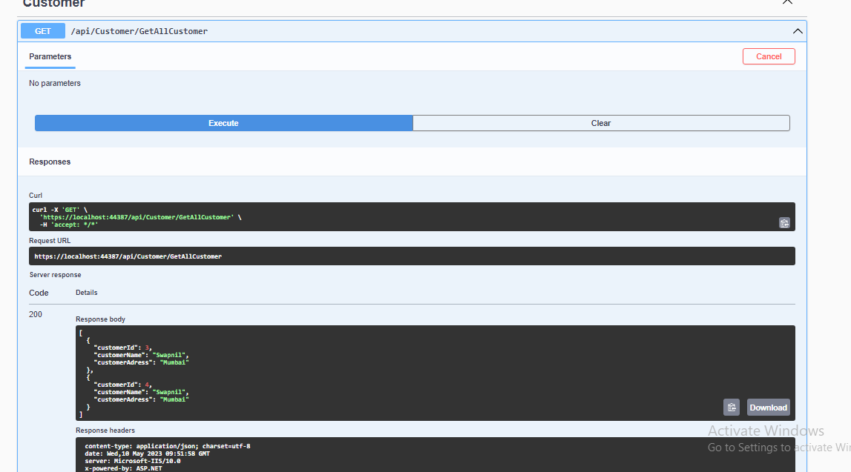

2. GetCustomerById

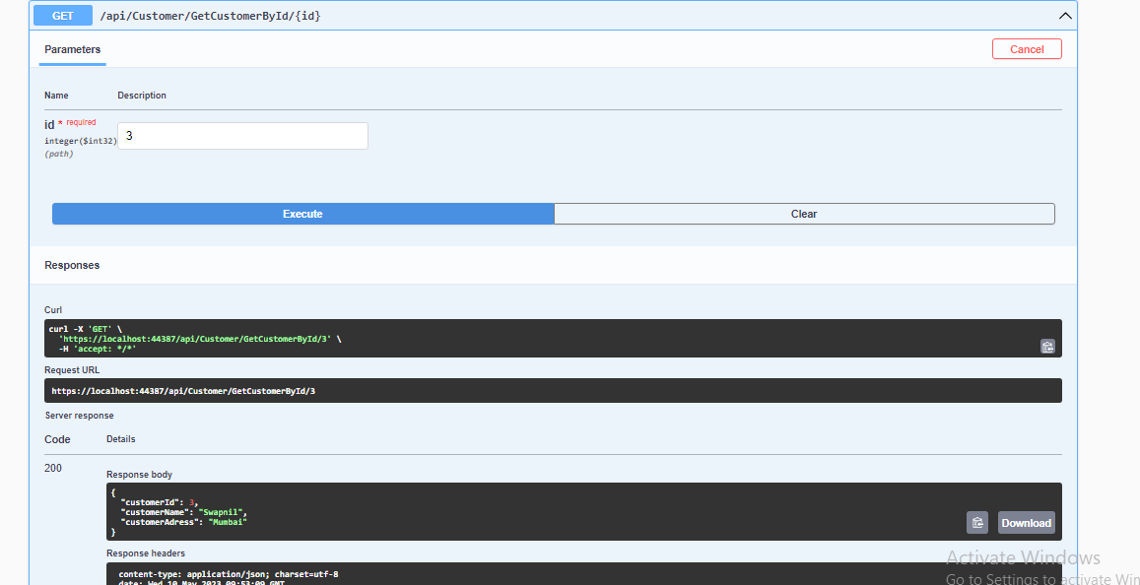

3.AddCustomer

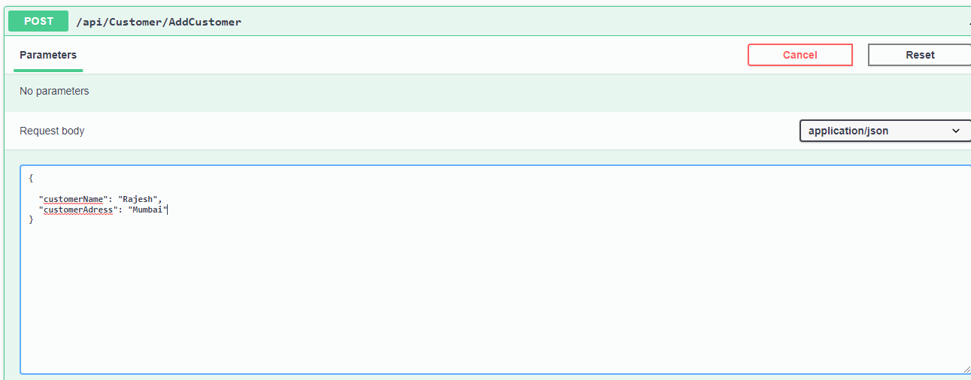

4. UpdateCustomer

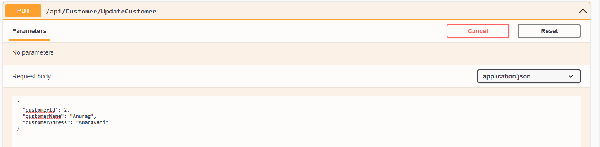

5. DeleteCustomer

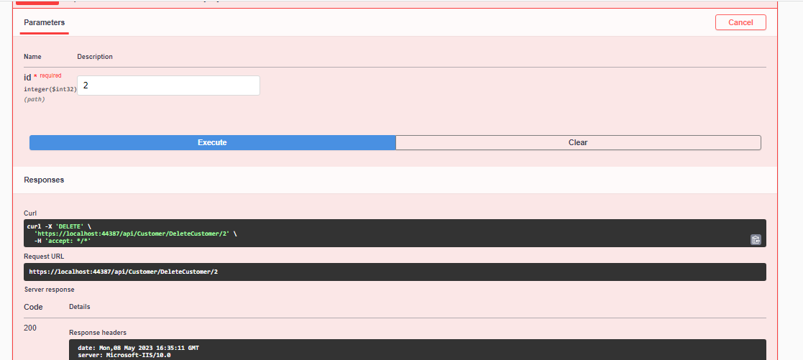

#3Mobile

1. GetAllMobile

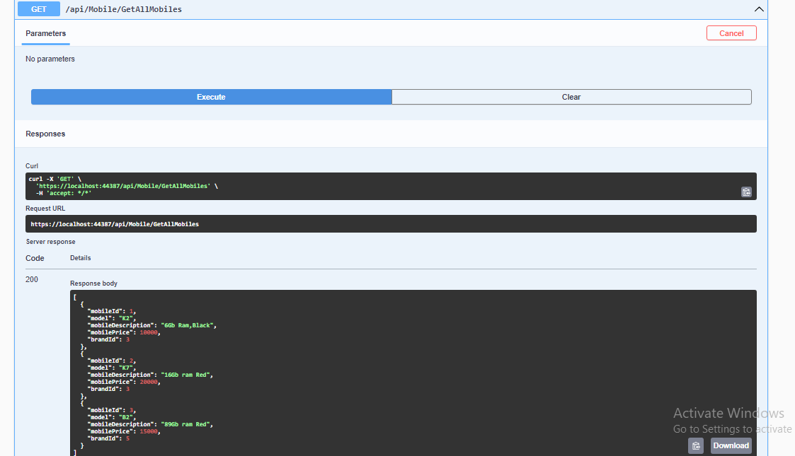

2. GetMobileById

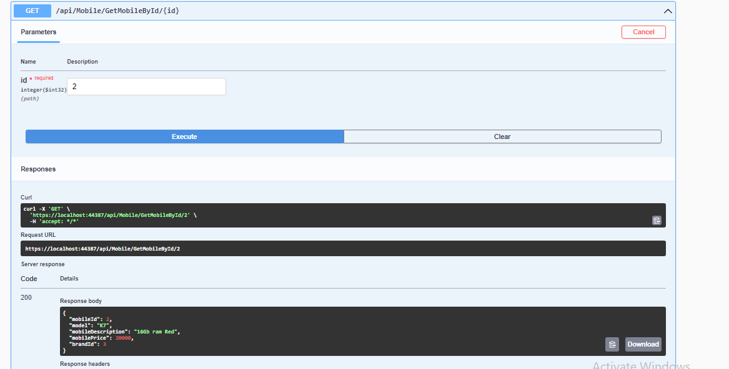

3.AddMobile

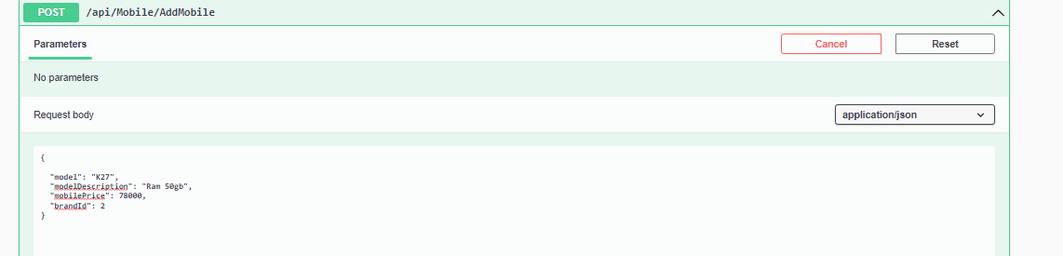

4. UpdateMobile

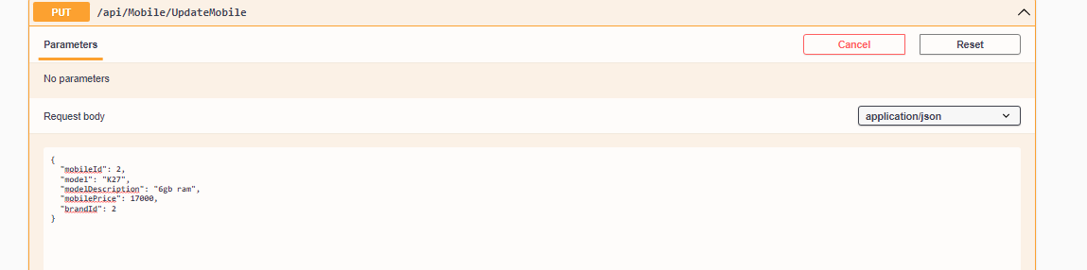

5. DeleteMobile

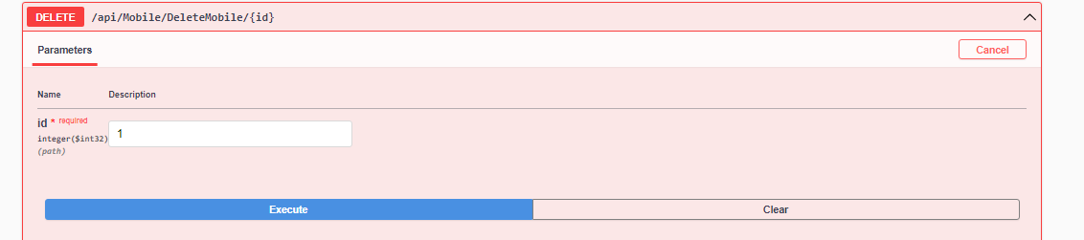

#3Sale

1. GetAllSalesDetails

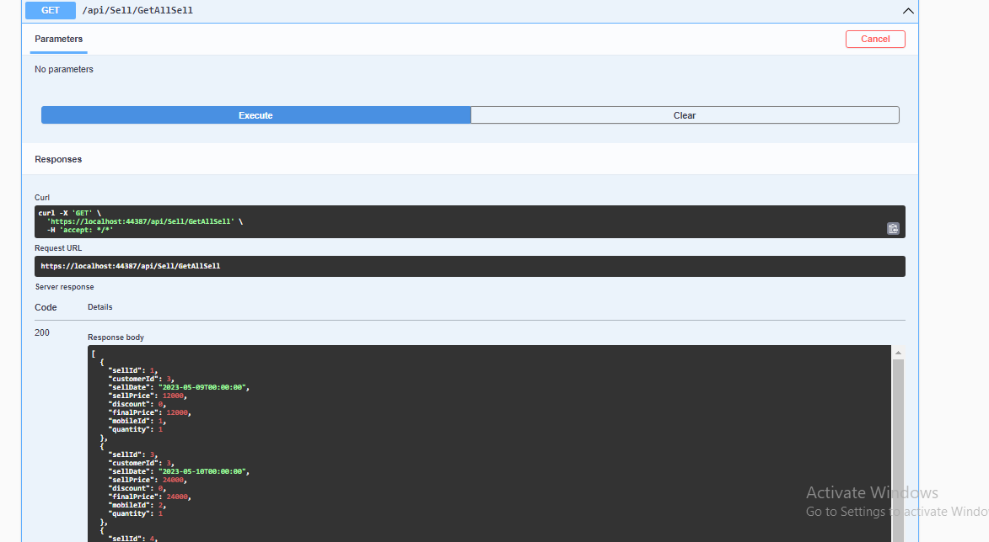

2. GetSaleById

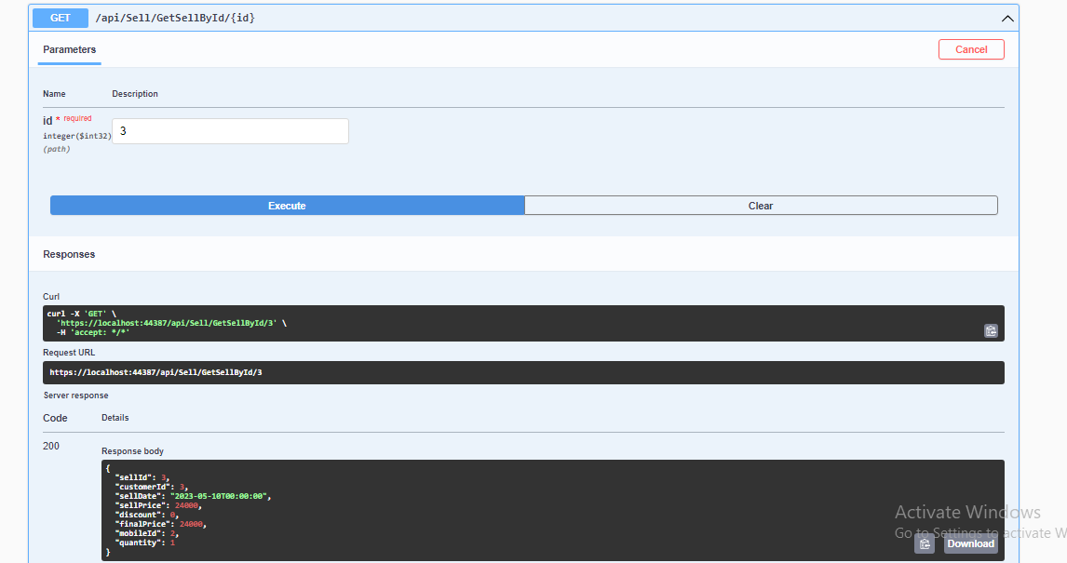.

3.SaleProduct (post)

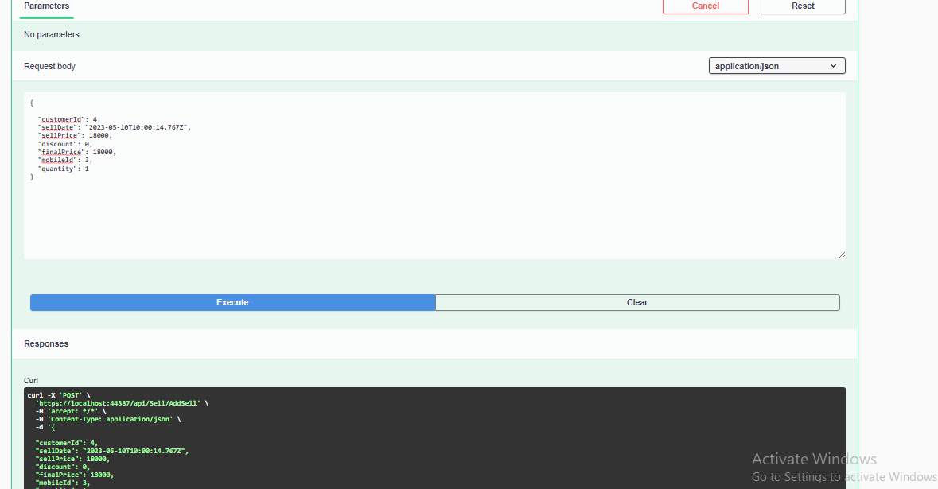

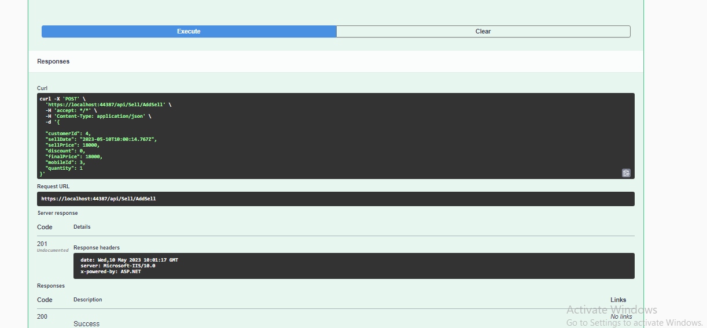

4. Updatesale

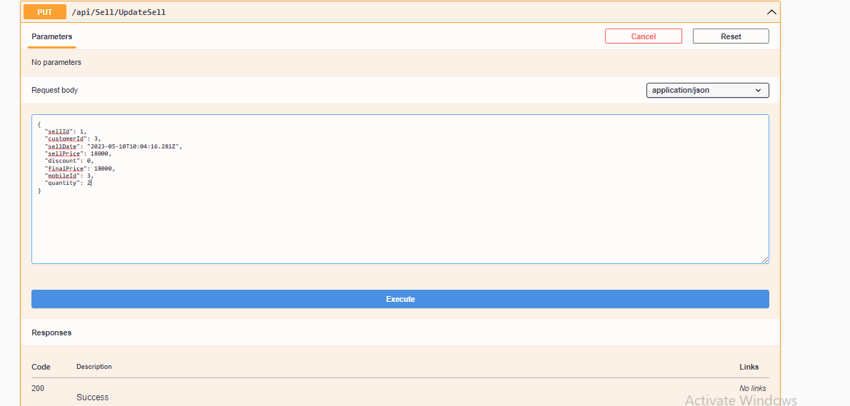

5. DeleteSaleRecord

Delete the record successfully

#ProfitLoss

If we want to see Loss and profit from any particular date to another particular date

Get all Sale product with profit and loss

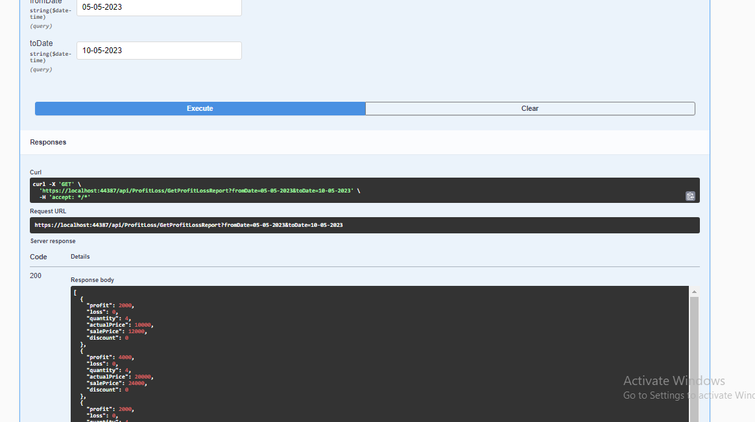

#GetMonthlySaleReport

Application gives all sale product details

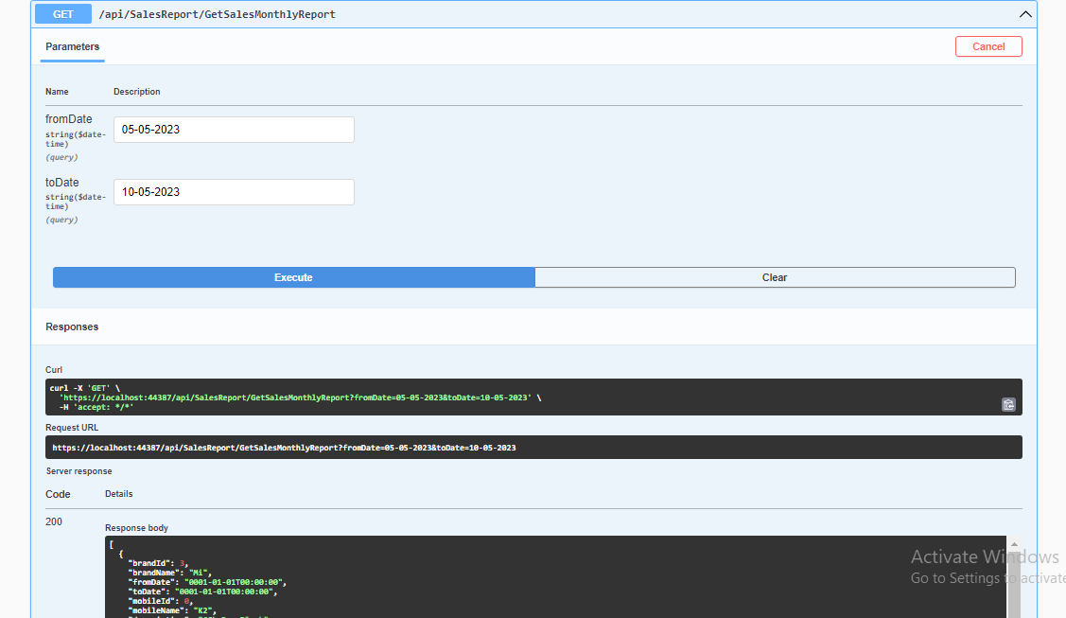

#BrandWiseMobileReport

With a particular date to another date

Application gives how many mobile in particular brand is sale

With their quantity

