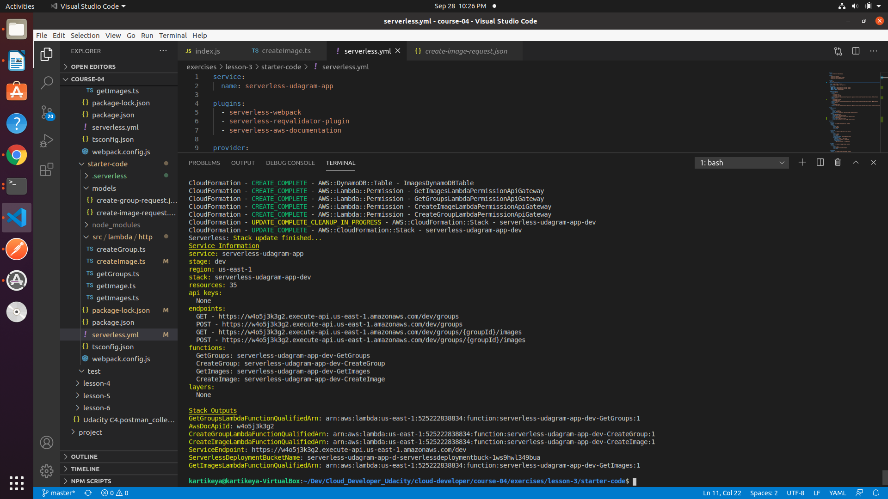
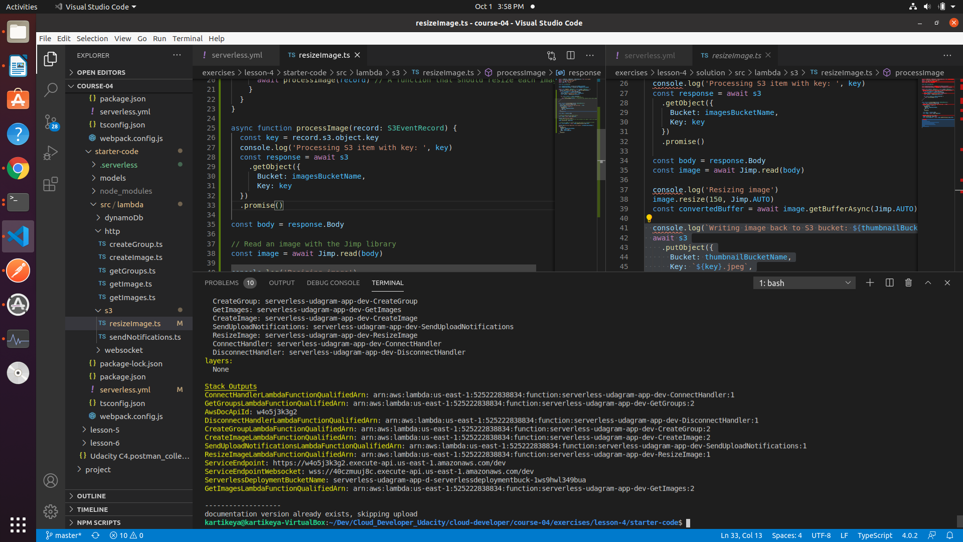
-----BEGIN CERTIFICATE-----
MIIDDTCCAfWgAwIBAgIJRmHGr3jfvvgvMA0GCSqGSIb3DQEBCwUAMCQxIjAgBgNV
BAMTGWRldi1mYWRkZno0di51cy5hdXRoMC5jb20wHhcNMjAxMDAzMDY1NTU4WhcN
MzQwNjEyMDY1NTU4WjAkMSIwIAYDVQQDExlkZXYtZmFkZGZ6NHYudXMuYXV0aDAu
Y29tMIIBIjANBgkqhkiG9w0BAQEFAAOCAQ8AMIIBCgKCAQEAzVzV9g9dlZN4CTSs
eNBnx0pW7ao9lNDprFCgYkY0BLW4JvEjs/2cMqLMPRj1ix8+k5x5cPrwKLtgRhQp
pqDRYLweUlLo0btoPFecIHYLGUokMHOBF6wWiQ7xduQQlKtBuWJlMwb/TgcYsZQj
Dwu4YTxAYBKjt6Af+LYN46MfMVbV7HHz7VEaY1TAz7tl85ldheu+2asidUTOlYcT
kcBto0kYAD8mJu1SIXfz4ybGFPCmc1UFOq/uS9i6DNc/x3FO4pCWN/oDoarAGxgL
4tpuDag2g47N4iCjK1YMgyBj9fvGFopgJ58suAg0rdEQDEcCgmcIBQqotih8Or7T
I4KpsQIDAQABo0IwQDAPBgNVHRMBAf8EBTADAQH/MB0GA1UdDgQWBBSUJ0t26H25
bOh9TZs7nOKibAspuTAOBgNVHQ8BAf8EBAMCAoQwDQYJKoZIhvcNAQELBQADggEB
AB2Rt9uqRTbIfKmXdM0xOi9QWkYc3vmZcqk5Cgfft6zHw7XPRIdxyNSB4fdgxXiv
sUUvaVxPpjk35CghmXqUrxnFhH2SaOO2HMnHTSyX1EHlV4VlVAhVQ6ASuGGHHY0D
XtKGSrsyHZ0NkH6/eSb2VrRPyZ/cprfBOAtHm3U3rx2/Qnz7w5pbh150ZdVn7dJn
NXD0GHqECEfK9VJLqSgxDMou/DbYHuCbYSsVroRBDfqIR8Ugzv7zgjrWiHSkKFYC
iMQmSM8OH4QLc6S3kKtIY+78JA/Y/mx4sqZ4SZ8TaZfT074aSEhq6El52tVdP1SU
ivPZG7/qf4h7Hhlw2pO8xAI=
-----END CERTIFICATE-----

