Course3: Refactor Udagram App into Microservices and Deploy

1. CI/CD, Github
- Git hub repository: https://github.com/kartikeyashell/nd9990-c3-microservices-v1

2. Container
- Docker files
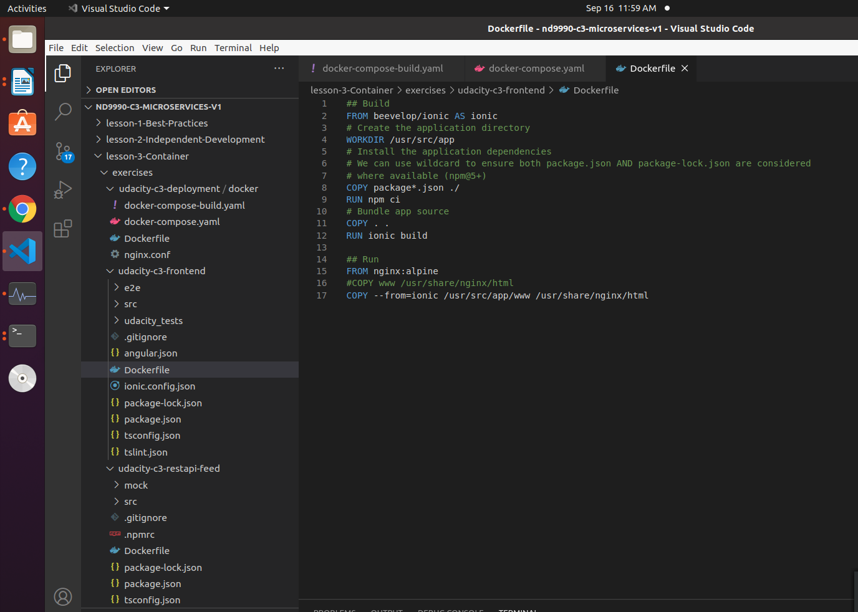
- Docker hub screenshot: All images pushed

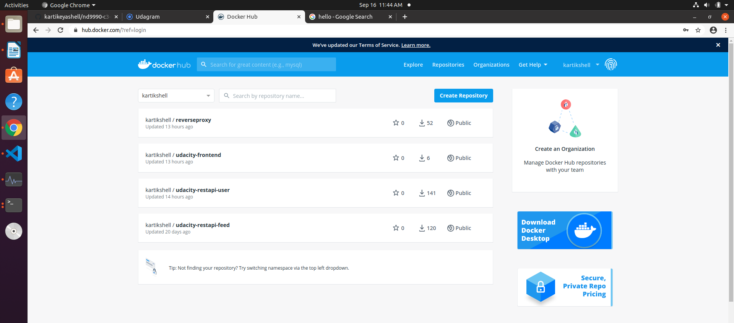
3. Deployment
- Kubernetes deployments, pods
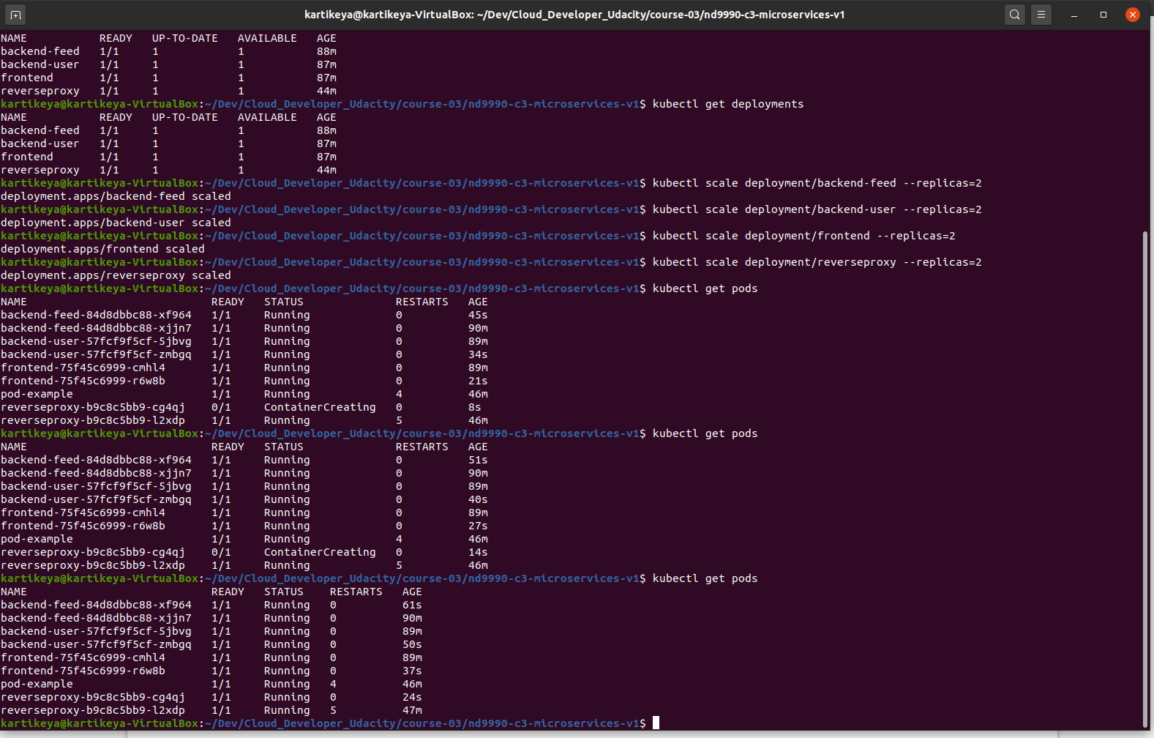

- Port forwarding

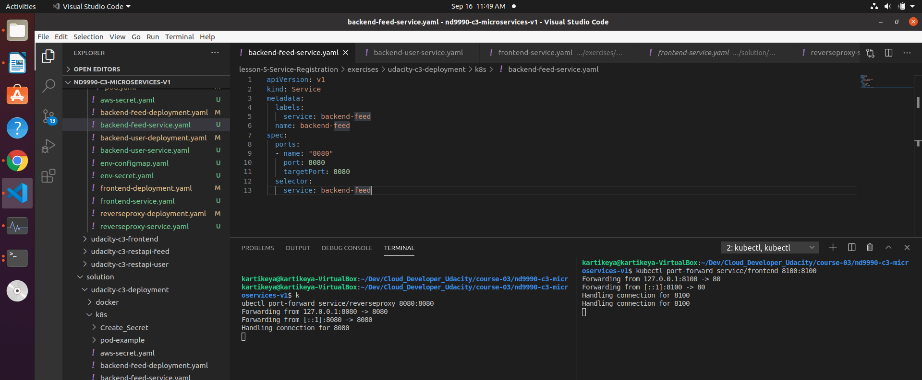

- Application
