**JSS MAHAVIDYAPEETHA**



**Mini Project / Internship Assessment**

|  |
| --- |
| **Subject Name: Mini project / Internship Assessment**  **Subject Code : KCS-354** |

COURSE: B.Tech. SEMESTER: IIIrd

**By**

**KARTIKEYEA SINGH (1900910100077)**

**Department of Computer Science and Engineering**

**JSS ACADEMY OF TECHNICAL EDUCATION**

**C-20/1, SECTOR-62, NOIDA**

**VISION AND MISSION**

**VISION OF THE INSTITUTE**

**JSS** **A**cademy of **T**echnical **E**ducation Noida aims to become an Institution of excellence in imparting quality **O**utcome **B**ased **E**ducation that empowers the young generation with **K**nowledge, **S**kills, **R**esearch, **A**ptitude and **E**thical values to solve **Contemporary Challenging Problems.**

**MISSION OF THE INSTITUTE**

**D**evelop a platform for achieving globally acceptable level of intellectual acumen and technological competence

**C**reate an inspiring ambience that raises the motivation level for conducting quality research

**P**rovide an environment for acquiring ethical values and positive attitude

**VISION OF THE DEPARTMENT**

“To spark the imagination of the Computer Science Engineers with values, skills,

and creativity to solve the real-world problems.”

**MISSION OF THE DEPARTMENT**

To inculcate creative thinking and problem-solving skills through effective teaching, learning and research.

To empower professionals with core competency in the field of Computer Science and Engineering.

To foster independent and lifelong learning with ethical and social responsibilities.

**PROGRAM OUTCOMES (POs)**

**Engineering Graduates will be able to:**

**PO1: Engineering knowledge**: Apply the knowledge of mathematics, science, engineering fundamentals, and an engineering specialization to the solution of complex engineering problems.

**PO2: Problem analysis**: Identify, formulate, review research literature, and analyze complex engineering problems reaching substantiated conclusions using first principles of mathematics, natural sciences, and engineering sciences.

**PO3: Design/development of solutions**: Design solutions for complex engineering problems and design system components or processes that meet the specified needs with appropriate consideration for the public health and safety, and the cultural, societal, and environmental considerations.

**PO4: Conduct investigations of complex problems**: Use research-based knowledge and research methods including design of experiments, analysis and interpretation of data, and synthesis of the information to provide valid conclusions.

**PO5: Modern tool usage**: Create, select, and apply appropriate techniques, resources, and modern engineering and IT tools including prediction and modelling to complex engineering activities with an understanding of the limitations.

**PO6: The engineer and society**: Apply reasoning informed by the contextual knowledge to assess societal, health, safety, legal and cultural issues and the consequent responsibilities relevant to the professional engineering practice.

**PO7: Environment and sustainability**: Understand the impact of the professional engineering solutions in societal and environmental contexts, and demonstrate the knowledge of, and need for sustainable development.

**PO8: Ethics**: Apply ethical principles and commit to professional ethics and responsibilities and norms of the engineering practice.

**PO9: Individual and team work**: Function effectively as an individual, and as a member or leader in diverse teams, and in multidisciplinary settings.

**PO10: Communication**: Communicate effectively on complex engineering activities with the engineering community and with society at large, such as, being able to comprehend and write effective reports and design documentation, make effective presentations, and give and receive clear instructions.

**PO11: Project management and finance**: Demonstrate knowledge and understanding of the engineering and management principles and apply these to one’s own work, as a member and leader in a team, to manage projects and in multidisciplinary environments.

**PO12: Life-long learning**: Recognize the need for, and have the preparation and ability to engage in independent and life-long learning in the broadest context of technological change.

**PROGRAM EDUCATIONAL OUTCOMES (PEOs)**

**PEO1**: To empower students with effective computational and problem-solving skills.

**PEO2:** To enable students with core skills for employment and entrepreneurship.

**PEO3**: To imbibe students with ethical values and leadership qualities.

**PEO4:** To foster students with research-oriented ability which helps them in analyzing and solving real life problems and motivate them for pursuing higher studies.

**PROGRAM SPECIFIC OUTCOMES (PSOs)**

PSO1: An ability to apply foundation of Computer Science and Engineering, algorithmic principles and theory in designing and modeling computation-based systems.

PSO2: The ability to demonstrate software development skills.

**COURSE OUTCOMES (COs)**

|  |  |
| --- | --- |
| **C224.1** | Undertake problem identification, formulation and design a solution |
| **C224.2** | Solve the real-world problems effectively and adapt with real life working environment. |
| **C224.3** | Acquire skills and knowledge on latest tools and technologies |
| **C224.4** | Develop effective communication skills for presentation of project related activities |
| **C224.5** | Effectively communicate solution to problems through technical reports |

**CO-PO-PSO MAPPING**

|  |  |  |  |  |  |  |  |  |  |  |  |  |  |  |
| --- | --- | --- | --- | --- | --- | --- | --- | --- | --- | --- | --- | --- | --- | --- |
|  | **PO1** | **PO2** | **PO3** | **PO4** | **PO5** | **PO6** | **PO7** | **PO8** | **PO9** | **PO 10** | **PO 11** | **PO 12** | **PSO1** | **PSO2** |
| **C224.1** | 3 | 3 | 3 | 3 | 2 | 3 | 3 | 3 | 3 | 3 | 2 | 3 | 3 | 3 |
| **C224.2** | 3 | 3 | 3 | 3 | 3 | 3 | 3 | 3 | 3 | 2 | 3 | 3 | 3 | 3 |
| **C224.3** | 2 | 2 | 3 | 3 | 3 | 2 | 3 | 3 | 3 | 1 | 2 | 3 | 3 | 3 |
| **C224.4** | 2 | 2 | 2 | 2 | 2 | 2 | 2 | 2 | 2 | 3 | 2 | 3 | 2 | 2 |
| **C224.5** | 2 | 2 | 2 | 2 | 2 | 2 | 2 | 2 | 2 | 3 | 2 | 3 | 2 | 2 |
| **C224** | 2.40 | 2.40 | 2.60 | 2.60 | 2.40 | 2.40 | 2.60 | 2.60 | 2.60 | 2.40 | 2.20 | 3.00 | 2.60 | 2.60 |

## CERTIFICATE

## This is to certify that Mini Project/Internship Assessment Report entitled “ROCK PAPER SCISSORS WEB GAME” which is submitted by KARTIKEYEA SINGH in partial fulfilment of the requirement for the award of degree B. Tech., in Department of Computer Science and Engineering of Dr. APJ Abdul Kalam Technical University, Lucknow, Uttar Pradesh is a record of the candidate’s own work carried out by him/her under my supervision. The matter embodied in this report is original and has not been submitted for the award of any other degree.

## Supervisor: Ms Sonali Mathur

**Date: 2 Jan, 2021**

**DECLARATION**

I hereby declare that this submission is my own work and that, to the best of my knowledge and belief, it contains no material previously published or written by another person nor material which to a substantial extent has been accepted for the award of any other degree or diploma of the university or other institute of higher learning, except where due acknowledgment has been made in the text.

Signature: Kartikeyea

Name : Kartikeyea Singh

Roll No.: 1900910100077

Date : 20/11/2020

**ACKNOLEDGEMENT**

With immense please I, **MR. KARTIKEYEA SINGH** present “**ROCK PAPER SCISSORS WEB GAME**” report as part of the **Mini Project Assessment** of ‘B.Tech in Computer Science and Engineering’. I wish to thank all the people who gave me unending support.

I express my profound thanks to **Ms Sonali Mathur** supervisor of mini project. And all those who have indirectly guided and helped me in preparation of this mini project.

Kartikeyea Singh

1900910100077

CS2-B1

**ABSTRACT**

My project is **Rock Paper Scissors Web Game**. This is a game that involves fast thinking and lots of fun. Here the participant compete with the computer which plays its chance using efficient algorithm. Computer generates a simultaneous move with the participant using its algorithm trying to win the game. This web game is implemented using Python, HTML, CSS and JavaScript.

This technical report identifies all features and lists out the functionalities and working environment in which the Rock Paper Scissors web game can be executed. This report lists the overall description of the game with essential features and drawbacks in the application. This project gives an insight into the different aspects of web development essentials.

**Table of Contents**

1. Cover Page
2. Vision and mission
3. Certificate by Company/Industry/Institute
4. Declaration by student
5. Acknowledgement
6. Abstract
7. Introduction
   1. History
   2. Rules
   3. Methods used in the project
   4. Objective and project goals
8. Tools and technology used
9. History and features of the technology

10. References

11. Plagiarism report

**INTRODUCTION**

**Rock Paper Scissors** is the classic ‘stone paper scissors’ game converted into a fun online single player game. Select one out of the three preference- and see if you can overpower the data processor. Will you procure or forfeit? The chance is random! In this game player and computer simultaneously select one of three shapes i.e. rock, paper or scissors which are represented by a closed fist, a flat hand and a V, formed with a fist by extending the index finger and middle finger.

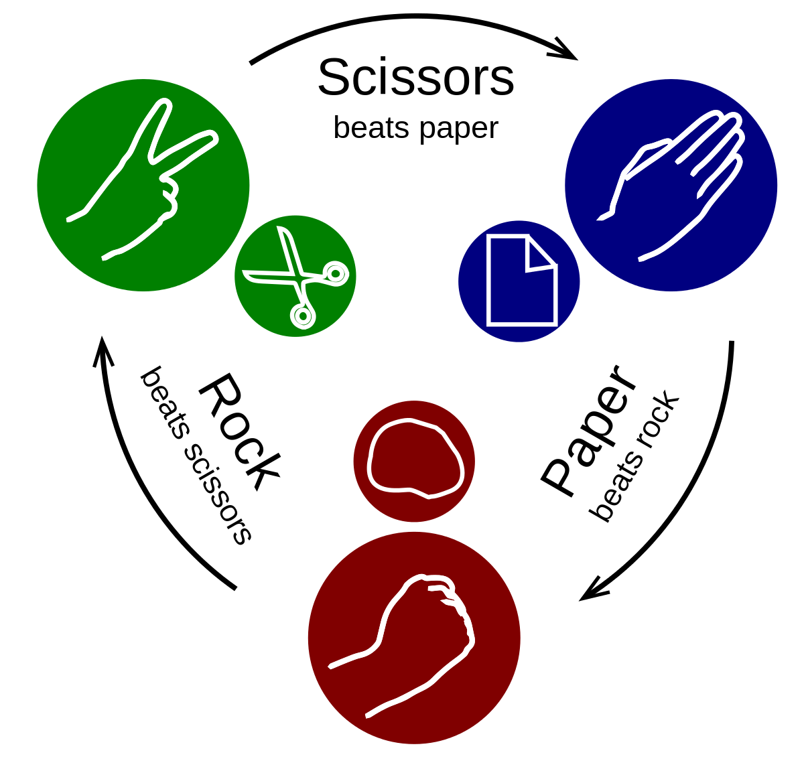

**History-**

Rock paper scissors was first created in China at the time of Christ, but stayed there for hundreds of years. It wasn’t until the 1700 that it made its way over to Japan and was known as ‘Janken’ and then spread to west. This game was not just played to decide who should get a favour in a situation but also to remove the boredom.

**Rules-**

The rules remain the same as the original game: Rock breaks scissors, paper covers rock and scissors cut paper. If both players chose the same shape than that round is tied.

**Methods used in the project-**

Agile methodology and principles were used in this project. Which includes discussion, analysis, strategy, execution, and finally testing of the model.

Discussion was made with my superiors and friends about the project idea, than topics and skills required for the project were analysed. Strategy was made in accordance with it. Finally knowledge gathered from different sources was executed to complete the project and at last testing of the game was done on different search engines and OS.

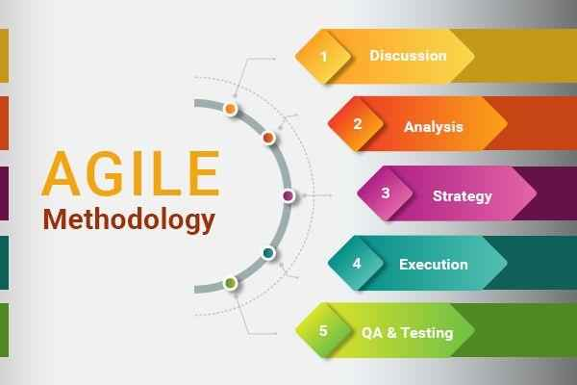

**Objectives and project goal-**

Objective of this project was to have an overview of the web development and learn its basic skills. A game was build using few web development languages. This gave me knowledge about the working of web pages and how they are created. Goal of the project was to construct a working web game which can be accessed through python and this was successfully achieved.

**Tools & Technology Used**

**Sublime Text 3**

Sublime Text 3 is one of the most used, fastest and easy to write text editor. It basically allows us to create and edit a large range of programing language files on your computer. Code is first written in sublime text and saved with its respective extension, then is run. Sublime Text helps in indentation of the text.

**HTML (Hyper Text Markup Language)**

The Hyper Text Markup Language or commonly known as HTML, is a markup language which is frequently used to create web pages. This is the language that computers use to communicate with each other on the web. The content of Hyper Text Markup Language is displayed on the browser. Browsers have their own mechanism for recognizing web languages and HTML is considers as its backbone. HTML is used to define the structural framework of a web page.

HTML uses tags to create HTML elements. In simple language tags are predefined keywords. An HTML element is initialised by a start tag (format: <abc>), some content and an end tag (format: </abc>).

Basic framework of an HTML Page-

<! DOCTYPE html> - This tag is used to specify the language HTML 5.

<html> - This tag signals that from here we are going to write in HTML code.

<head> - In this metadata is stored.

<title> - It contains page name that will appear on the top of browser window or tab.

<body> - Here all the content is written.

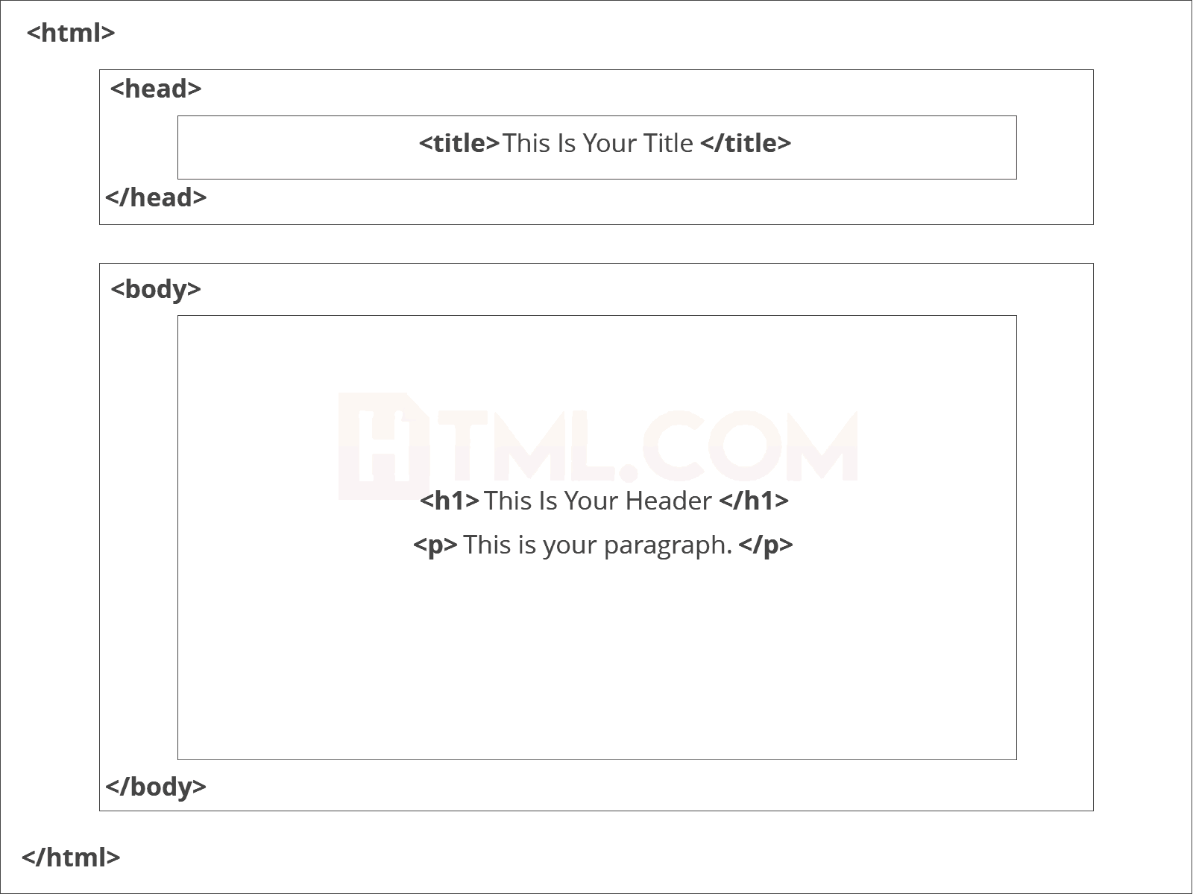

Visual structure of an average HTML page.

**CSS (Cascading Style Sheets)**

CSS stands for Cascading Style Sheets. CSS describes how HTML elements are to be displayed (look and feel as part of a web page) on the screen, paper or in other media. CSS code can be called many times again and again in same or different HTML files which saves lots of space and time. CSS is smooth to learn and understand style sheet language that imparts a powerful edge over the presentation of an HTML document. There are three ways to declare CSS to HTML file: Inline, internal and external.

Inline styles are written straight into the HTML tags using the style attribute. Internal styles are used for the whole page. Inside the head element, the style tags encapsulate all of the styles for the page. While the external styles are used for the whole, multiple page website. This is a separate CSS file which is saved as “.css” in the same directory as your HTML page. Then it is linked to the desired HTML page.

**JavaScript**

JavaScript is one of the most used and fast growing client-side scripting language. It is used to write the logic of a website. JavaScript is the only programing language to write a frontend code and can be used to develop web page, mobile apps and even games. It is dynamic language and has many in built libraries that contain functions of a real world problem and can be used by the programmers to ease their work. We can either write a JavaScript code in a HTML file using a script tag to separate javasipt code from a HTML code, or another way is by writing and saving a script in another external text file using extension ‘.js’ extension. We can then call it from the HTML code using the src attribute of the opening script tag.

**Java VS JavaScript**

Java is an OOP programing language which runs on a virtual machine or browser. Its code is compiled before execution and most important Java is a Static type language. Whereas JavaScript is an OOP scripting language that runs only on a browser code is interpreted during run time and JavaScript is a dynamic language.

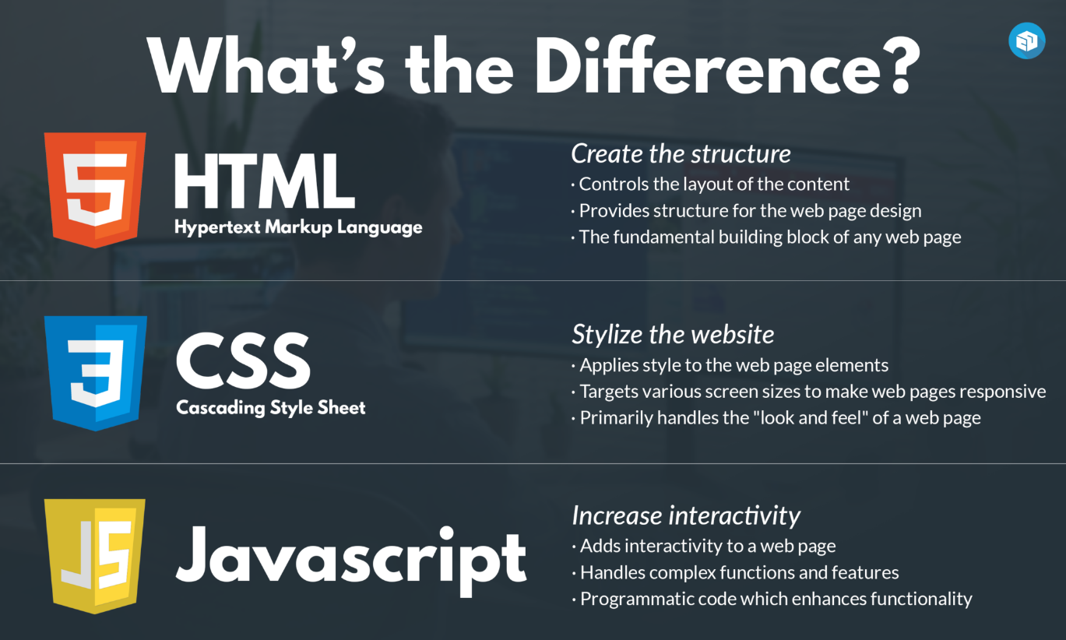

**Python (using Anaconda Navigator)**

Python is a popular high level, interpreted and general purpose programming language. While anaconda is a distribution of the python that aims to simplify package management and deployment. Here python is used to call the HTML script and run the program in the browser.

**Web Search**

Web Search is done using search engine. A search engine helps to organize the data on the internet. A lot of searches were made during this project to learn different skills for the project and knowledge. Online searches are fast, cheaper and easy to find and use.

**Alternative for technology used**

Yes there are many alternatives for different technologies that have been used here. Elm is a language that replaces all the three HTML, CSS and JavaScript. It is easier to use and learn but main drawback is that some of its functions are unsupported on few search engines as they are under development.

Instead of using JavaScript we can also use PureScript and ClojureScript that is fun to use. But I have not used it as they are not very common among college students and for beginners.

Visual Studio is an IDE (Integrated Development Environment) that is used for developing web sites, web applications, web services and programs for Windows. We can use Visual Studio, Notepad++, Jupyter Notebook, Spyder and many more apps to edit text as an alternative for Sublime Text 3.

Books (on the topics- web development, HTML, CSS and JavaScript) are the best alternative for web search as they give us a deep description on the history, working and logic behind these programing languages and subjects.

**Why the technology was preferred?**

For gathering information and skills for the completion of my mini project, I preferred to do my research on web instead of much looking into books as web searches were fast and I was able to understand them through online lectures, you tube and articles on the internet. It was also cheap and I could clear many of my doubt through one click.

As I have used Sublime Text as a text editor for writing the code of my programmes for a long time, so now I am comfortable with its UI (User Interface) that is why I went with it instead of using other text editors.

For developing the game I chose HTML, CSS, JavaScript and Python as there were many online resources available on these languages and were also easy to understand for me. Moreover these languages are now a days in trend among the web designers in many companies for web development.

**History and features of the technology**

**History of the technology used**

Sublime Text was an imaginative work done by Jon Skinner who left his job as a software engineer at Google in order to pursue his dream to build a better text editor. On January 18, 2008 the initial version of Sublime Text was released.

In 1993 Tim Berners-Lee created the first version of HTML. After that many different versions of HTML have been created of which HTML 4.01 was most extensively used all over the world and become an official standard in December 1999.

CSS was proposed to bring forth the issue of style sheets for the web. It was first proposed by Hakon Wium Lie on October 10, 1994.

In September 1995, a Netscape programmer named Brandan Eich developed a new scripting language in just 10 days. It was at first named Mocha, but post haste became known as LiveScript and later JavaScript.

Python implementation first began in December of 1989. It was formulated at Centrum Wiskunde and Infromatica in Netherlands by Guido van Rossum as a successor of ABC programming language.

**Features of the technology used**

**Sublime Text**

Go to anything and any definition.

Multiple selections.

Command palette.

Powerful API and package ecosystem.

Cross platform.

Fast speed and better indentation.

**HTML 5**

Video and Audio tags.

It requires less effort to learn and use.

Placeholders.

It is platform independent.

**CSS**

The framework of a web page is better handeled.

It has better device compatibility.

Ability to Re-Position.

Style (CSS) kept separate from structure (HTML), means smaller file size.

**JavaScript**

Object-Centred Script Language.

Client edge Technology.

Validation of User's Input.

Else and If Statement.

Interpreter Centred.

Ability to perform In Built Function.

Case Sensitive format.

Light Weight and delicate.

**Python (using anaconda navigator)**

Compiled with latest python release (anaconda).

Python is object oriented language.

It is high level portable language.

New and wide range of packages.

**Industrial Relevance of the Technology used**

All the technologies used here have a very crucial role in the Industries. They can be used in Web development services. These services help the company to increase product knowledge, maintain communication between them and potential clients, sell their products or services and increase the popularity of the company. These languages are also used in Artificial Intelligence and Machine Learning which have a very vast area of scope. Sites, apps and online services can be made by using HTML, CSS and JavaScript. Online games and apps are made by the companies and are published on different app stores for customers. Websites help in making people aware about the services and products one is offering and also helps in customer feedback using online surveys as they are two-third time faster than conventional method of taking surveys. Industries use many applications to for getting desired employees. Many web applications are used to store data in cloud storage, for communication and also for data management and attendance.

**Societal Relevance and Impact of the Project**

As we know that there is a very large scope for web developers and programmers in today’s world, learning these skills can be very beneficial for people. From my project people will get to know how easy and interesting this topics are. This will spread awareness in society about the emerging fields and job opportunities in the IT sector.

**Future Scope of the Project**

This ‘Rock Paper Scissors’ game can be further improved by using more advanced graphics and can be customised for different devices and OS, then we can register this game on different app stores and do its monetization. In future, I will try to build more such games and then integrate them all together under one single app or website.

**Screenshots of the project**

Game interface as it starts.

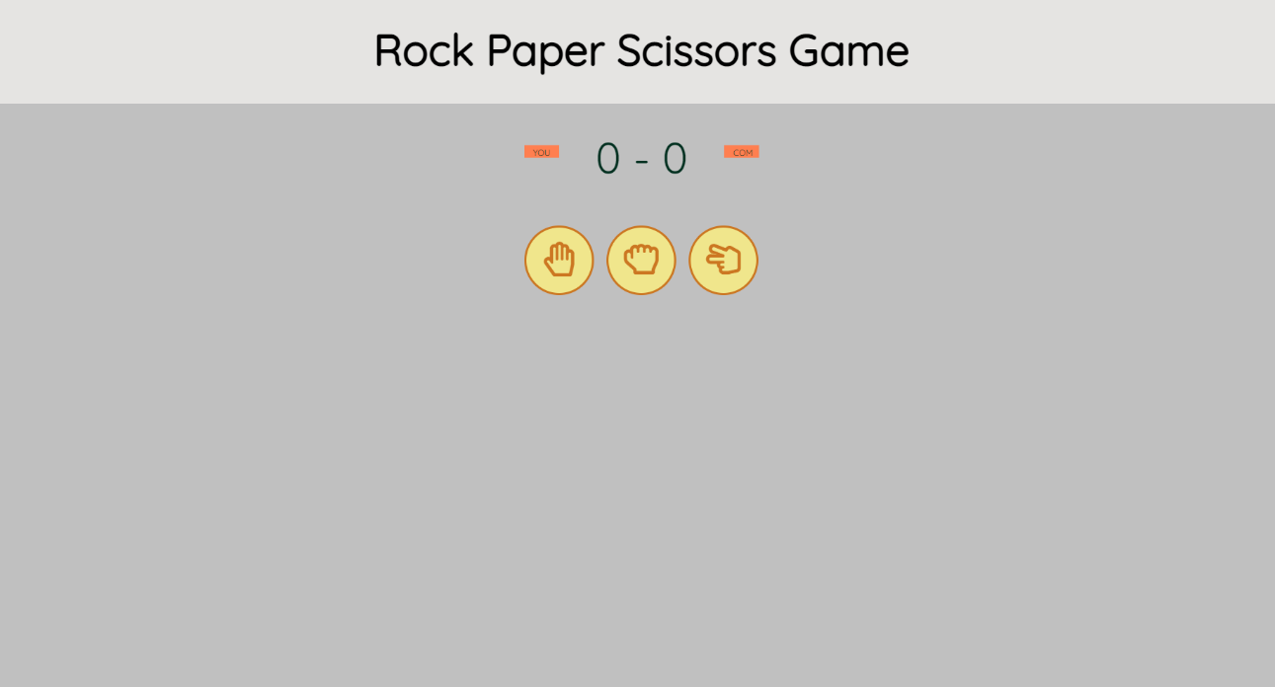

When mouse pointer is above any shape, icon turns blue.

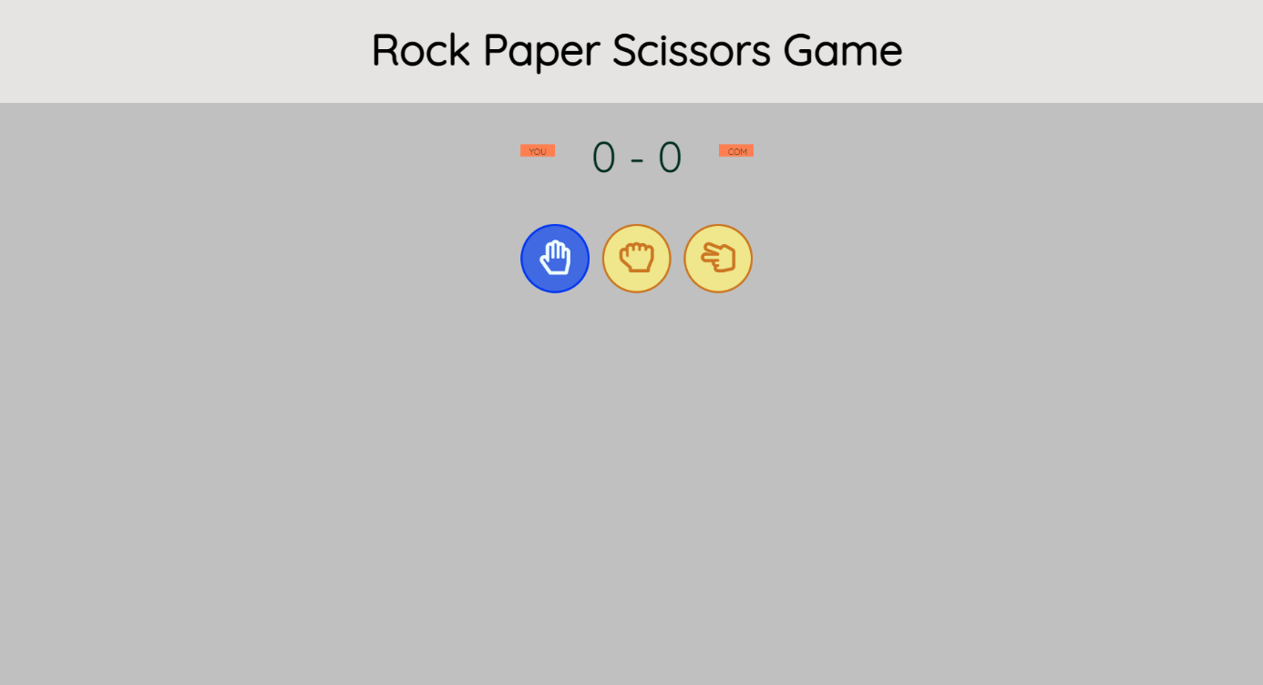

Interface indicating user wins.

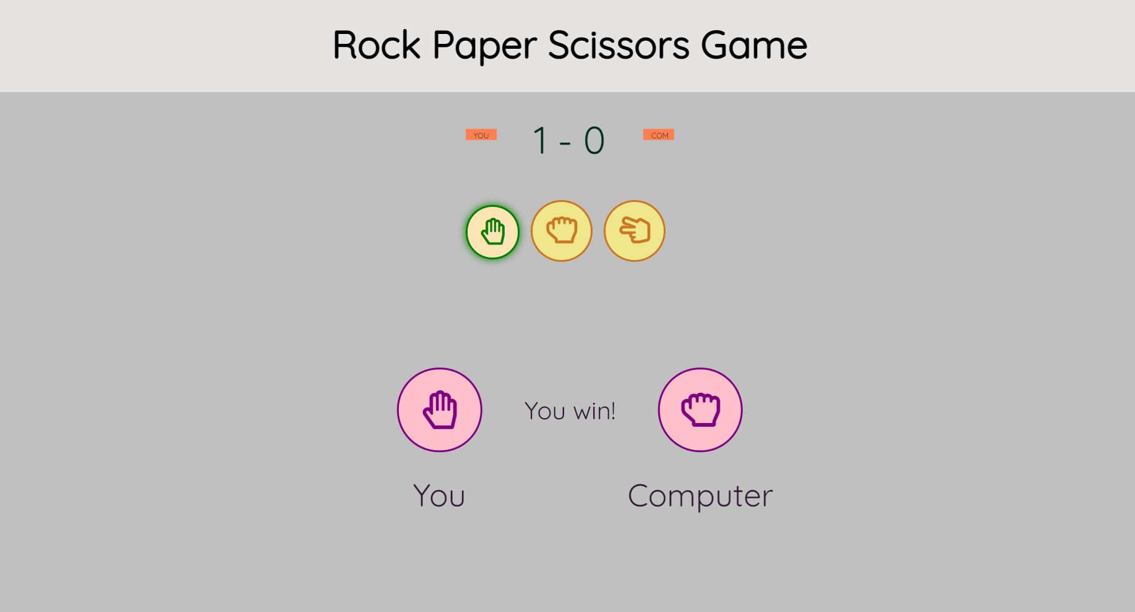

Interface when user loses.

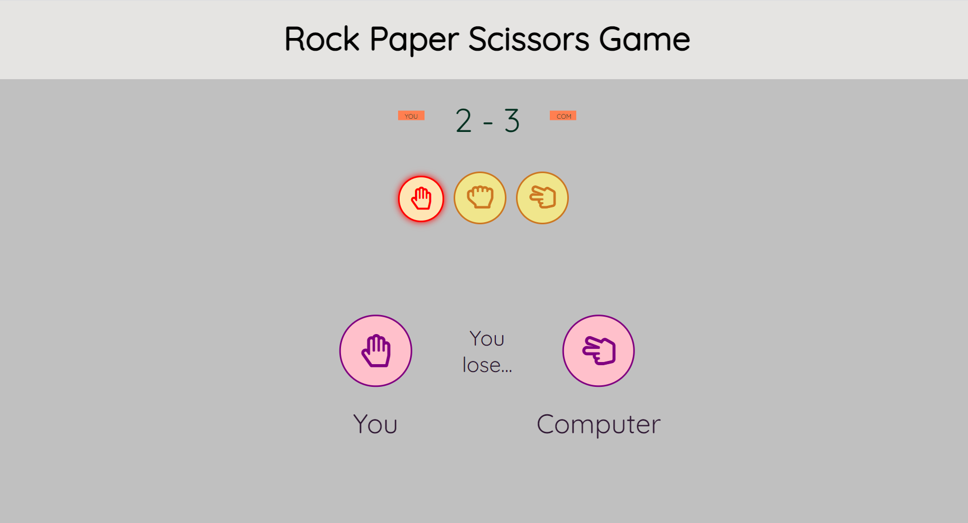

Interface showing a draw.

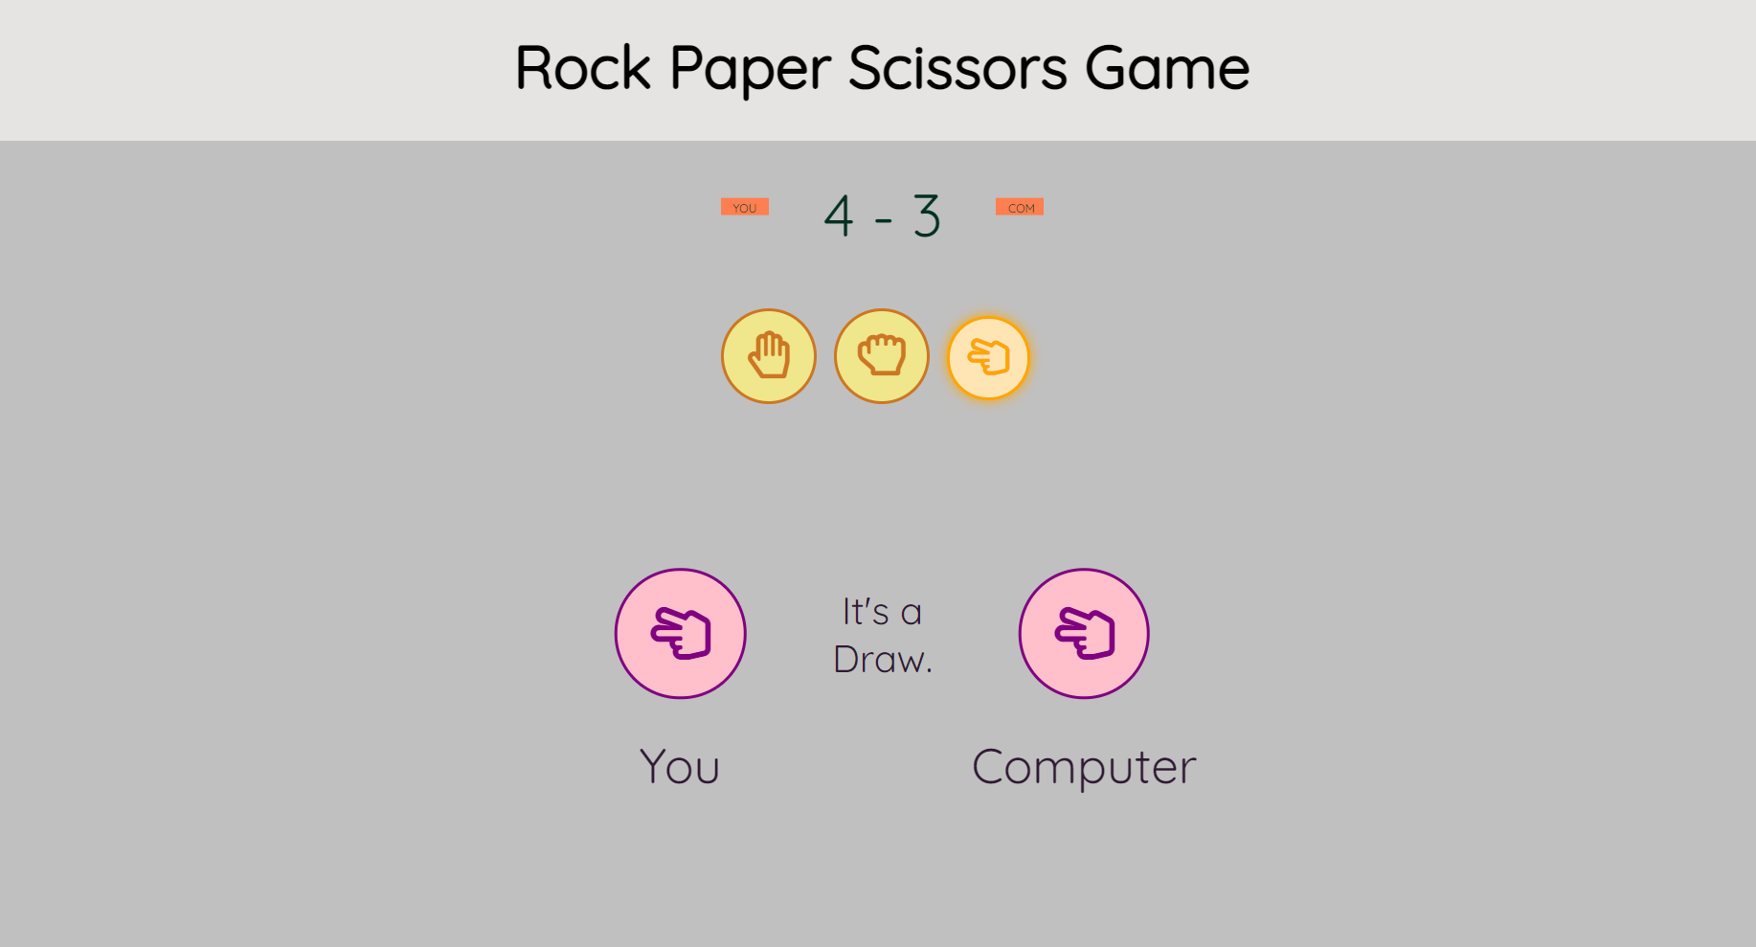

**References**

<https://www.w3schools.com/html/>

<https://www.w3schools.com/js/DEFAULT.asp>

<https://www.youtube.com/watch?v=yfoY53QXEnI&ab_channel=TraversyMedia>

<https://www.youtube.com/watch?v=W6NZfCO5SIk&ab_channel=ProgrammingwithMosh>

<https://www.geeksforgeeks.org/building-and-visualizing-sudoku-game-using-pygame/>

<https://docs.anaconda.com/anaconda/user-guide/getting-started/>

**Plagiarism report**

**Total characters = 12502**

**Plagiarism = 4.58%**

**Unique = 96.42%**

**Total plagiarized sentences = 4**

**Total unique sentences = 88**

For first half of the report:

Characters = 6128

Plagiarism = 0%

Unique = 100%

Plagiarized sentences = 0

Unique sentences = 49

For second half of the report:

Characters = 6374

Plagiarism = 9%

Unique = 91%

Plagiarized sentences = 4

Unique sentences = 39



