**Lab -4**

***Q-3***

***Part 1***

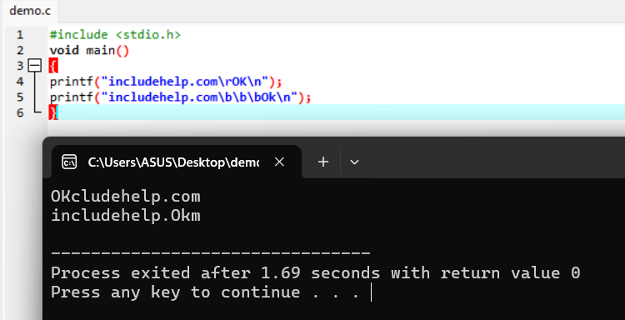

**1.)**

* Prints includehelp.com.
* \r moves the cursor to the start of the line.
* OK overwrites the beginning of the line.
* Output: OK (because includehelp.com is replaced by OK).

**2.)**

* Prints includehelp.com.
* \b\b\b backspaces over the last three characters (com), erasing them.
* Ok replaces the erased characters.
* Output: includehelp.Ok.

***Part 2***

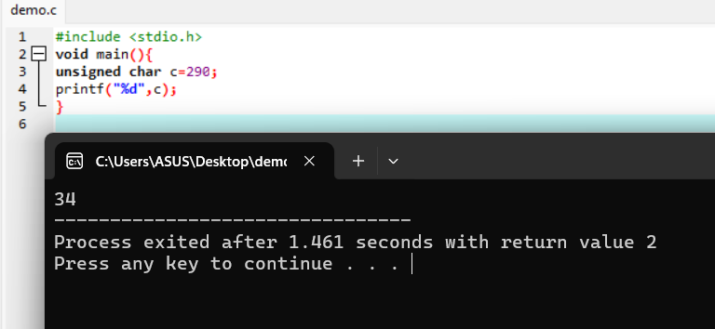

**Explanation :**

**290 is beyond the range of unsigned char. Its corresponding value printed is: (290 % (UINT_MAX +1) where UINT_MAX represents highest (maximum) value of UNIT type of variable.**

**Here it's character type and thus UINT_MAX=255**

**Thus it prints 290 % (UINT_MAX +1)=34**

***Part 3***

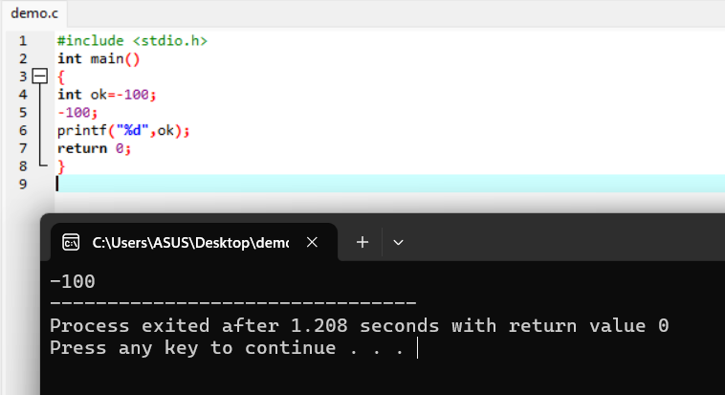

**Explanation**

Variable Initialization: int ok = -100; initializes the integer variable ok with the value -100.

No-Op Statement: -100; is an expression that is evaluated but not used. In C, an expression that is not assigned to a variable or used in some operation has no effect. This line can be safely removed without changing the behavior of the program.

Print Statement: printf("%d", ok); prints the value of ok to the standard output. Since ok is -100, the output will be -100.

Return Statement: return 0; indicates that the program executed successfully.