Customer Purchase & Behaviour Analysis
Item | Detail
Prepared by | Kartik
Data source | padanjaly-order export cleaned (WooCommerce-style order export)
Period covered | 10 Jan 2023 – 14 Jul 2026
Currency | Indian Rupee (INR)
Tool | Microsoft Power BI (DAX measures, interactive slicers)

1. Executive Summary
This report documents the Customer Purchase & Behaviour Analysis dashboard and summarises what it shows about how customers buy. The dataset contains 690 orders. 323 of the buyers are identifiable registered customers and 340 orders were placed as guests.
Three findings matter most for the business:
- Retention is the biggest gap. Only 21 of 323 registered customers (6.5%) have bought more than once. 302 (93.5%) bought a single time.
- Repeat customers are far more valuable. They generate about ₹0.2M from 6.5% of customers, which is roughly 2.4 times the revenue per customer of one-time buyers (₹1.2M across 302 customers).
- Half of buying behaviour is invisible. Guest checkouts make up 49% of orders, so these purchases cannot be linked to a customer or analysed for repeat behaviour.

Headline recommendation: Convert more first-time buyers into second-time buyers, and encourage guest shoppers to register. Both actions increase revenue per customer and improve the quality of future analysis.

2. Objective and Scope
The dashboard was built to answer four business questions:
- Where are our customers and guest buyers located?
- How many customers buy once, and how many come back?
- How much revenue do repeat customers contribute compared with one-time customers?
- How has order volume changed over time?
Users can filter every visual by order date, customer type, product name and country using the slicers on the left of the dashboard.

3. Dashboard Overview
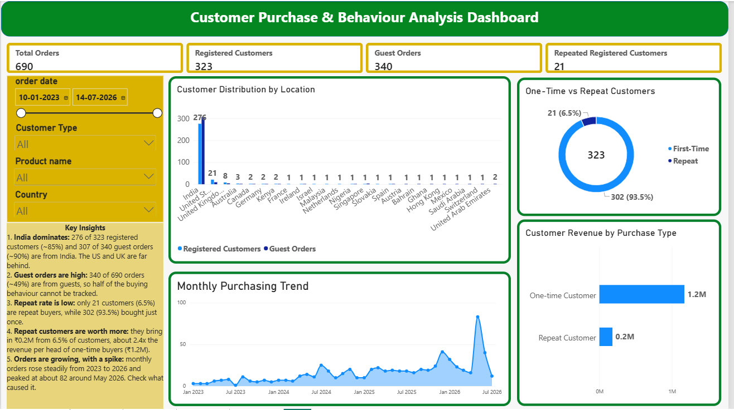
Figure 1. Customer Purchase & Behaviour Analysis dashboard

4. KPI Cards and DAX Measures
The dashboard has four KPI cards. Each is driven by one DAX measure on the cleaned order table.
KPI card | Value | Definition
Total Orders | 690 | Number of unique order IDs.
Registered Customers | 323 | Unique customer IDs, excluding guests (customer_id of 0 or blank).
Guest Orders | 340 | Unique order IDs where Customer Type is “Guest”.
Repeated Registered Customers | 21 | Registered customers with more than one order.

Consistency check: 690 total orders less 340 guest orders leaves 350 orders from 323 registered customers, which is consistent with 21 customers placing repeat orders.

4.1 Measure code
Total Orders
Total Orders =
DISTINCTCOUNT ( 'padanjaly-order export cleaned'[order_id] )

Guest Orders
Guest Orders =
CALCULATE (
DISTINCTCOUNT ( 'padanjaly-order export cleaned'[order_id] ),
'padanjaly-order export cleaned'[Customer Type] = "Guest"
)

Registered Customers
Registered Customers =
CALCULATE (
DISTINCTCOUNT ( 'padanjaly-order export cleaned'[customer_id] ),
'padanjaly-order export cleaned'[customer_id] <> 0,
NOT ISBLANK ( 'padanjaly-order export cleaned'[customer_id] )
)

Repeated Registered Customers
Repeated Registered Customers =
COUNTROWS (
FILTER (
VALUES ( 'padanjaly-order export cleaned'[customer_id] ),
'padanjaly-order export cleaned'[customer_id] <> 0
&& CALCULATE ( [Total Orders] ) > 1
)
)

Customer Count and Total Customer Revenue (INR)
Customer Count =
CALCULATE (
DISTINCTCOUNT ( 'padanjaly-order export cleaned'[customer_id] ),
'padanjaly-order export cleaned'[customer_id] <> 0,
NOT ISBLANK ( 'padanjaly-order export cleaned'[customer_id] )
)

Total Customer Revenue (INR) =
CALCULATE (
SUM ( 'padanjaly-order export cleaned'[order_subtotal_INR] ),
'padanjaly-order export cleaned'[customer_id] <> 0,
NOT ISBLANK ( 'padanjaly-order export cleaned'[customer_id] )
)

5. Visual Specifications
Visual | Type | Fields
Customer Distribution by Location | Clustered column chart | Axis: billing_country_clean. Values: Registered Customers, Guest Orders.
One-Time vs Repeat Customers | Donut chart | Legend: Customer Type. Values: distinct customer count.
Customer Revenue by Purchase Type | Bar / column chart | Axis: Purchase Type. Values: Total Customer Revenue (INR). Tooltips: Customer Count, Total Orders.
Monthly Purchasing Trend | Area / line chart | X-axis: order date (month and year). Y-axis: count of order ID.

Purchase Type must correctly classify each registered customer as “One-time Customer” or “Repeat Customer”. This classification drives both the donut chart and the revenue comparison.

6. Key Findings

6.1 Geography: India dominates
276 of 323 registered customers (about 85%) and 307 of 340 guest orders (about 90%) come from India. The United States and United Kingdom are the next largest markets, with 21 and 8 registered customers, and the remaining countries each have 3 or fewer.
Metric | India | All markets | Share
Registered customers | 276 | 323 | ≈ 85%
Guest orders | 307 | 340 | ≈ 90%

6.2 Guest orders are high
340 of 690 orders (about 49%) come from guests. For these orders the business cannot see repeat purchases, lifetime value or loyalty, so almost half of buying behaviour is untracked.

6.3 Repeat rate is low
Customer type | Customers | Share
One-time | 302 | 93.5%
Repeat | 21 | 6.5%
Total registered | 323 | 100%

6.4 Repeat customers are worth more
Customer type | Revenue | Customers | Approx. revenue per customer
One-time | ₹1.2M | 302 | ≈ ₹4,000
Repeat | ₹0.2M | 21 | ≈ ₹9,500

Repeat customers earn roughly 2.4 times more revenue per head than one-time customers. They are 6.5% of registered customers but contribute about 14% of registered-customer revenue. Figures are based on the rounded values shown on the dashboard, so per-customer amounts are approximate.

6.5 Orders are growing, with a spike
Monthly orders rose steadily from early 2023 to 2026. They peaked at about 82 around May 2026, well above the typical level of roughly 10 to 40 orders per month. The sharp fall at the end of the chart is likely because July 2026 is only a partial month (the data ends on 14 July 2026).

