Product Performance & Demand Analysis

1. Executive Summary
This report presents a product-level analysis of sales performance and customer demand across 11 products. The analysis is built in Power BI and covers quantity sold, revenue contribution, yearly revenue trend and the number of orders per product.
Key finding: Agnijith 90 gms is the clear market leader, selling 508 units and generating approximately ₹1.24M in revenue. Revenue grew from ₹0.30M in 2023 to a peak of ₹0.97M in 2025, then declined to ₹0.65M in 2026. The 2026 figure covers data only up to 14 July 2026, so it is a part-year total and the decline should be read with that in mind.

2. Dashboard Overview
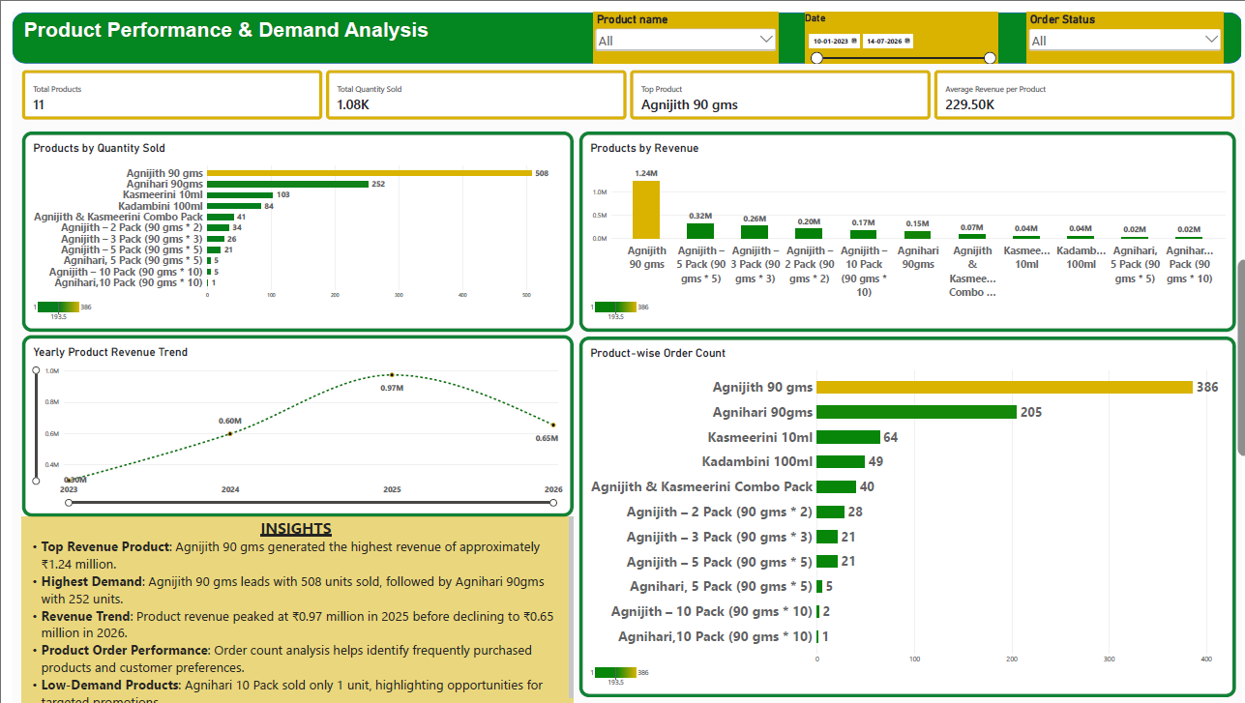

The dashboard combines three slicers (Product name, Date range and Order Status), four KPI cards, three comparison charts, a yearly revenue trend line and an insights panel so that stakeholders can understand product performance on a single page. The date slicer is set from 10-01-2023 to 14-07-2026, which is the period covered by every figure in this report.

3. Key Performance Indicators (KPIs)
KPI | Value | Description
Total Products | 11 | Distinct count of products sold
Total Quantity Sold | 1.08K units | Sum of quantity across all products
Top Product | Agnijith 90 gms | Highest revenue product
Average Revenue per Product | 229.50K | Total revenue divided by the number of products

DAX Measures Used
Total Quantity Sold – calculates the total recorded quantity sold across products.
Total Quantity Sold =
SUM('Book12'[Quantity])

Total Products – counts the unique products in the dataset.
Total Products =
DISTINCTCOUNT('Book12'[Product_name])

Top Product – returns the product with the highest total revenue.
Top Product =
CONCATENATEX(
TOPN(1, VALUES(products[Product_name]),
[Total Revenue (products)], DESC),
products[Product_name], ", ")

Average Revenue per Product – divides total product revenue by the number of distinct products.
Average Revenue per Product =
DIVIDE(
[Total Revenue (products)],
[Total Products],
0)

4. Visual Analysis

4.1 Products by Quantity Sold
Agnijith 90 gms leads with 508 units, followed by Agnihari 90gms (252), Kasmeerini 10ml (103) and Kadambini 100ml (84). Multipack variants and the combo pack sell far fewer units, and Agnihari 10 Pack records only 1 unit.
Product | Units Sold | Observation
Agnijith 90 gms | 508 | Best seller by a wide margin
Agnihari 90gms | 252 | Strong second; consistent demand
Kasmeerini 10ml | 103 | Mid-level performer
Kadambini 100ml | 84 | Mid-level performer
Agnijith & Kasmeerini Combo Pack | 41 | Moderate bundle uptake
Agnijith – 2 / 3 / 5 / 10 Packs | 34 / 26 / 21 / 5 | Demand drops as pack size grows
Agnihari 5 Pack / 10 Pack | 5 / 1 | Lowest demand in the range

4.2 Products by Revenue
Revenue follows the volume ranking. Agnijith 90 gms contributes ₹1.24M, which is far ahead of the next best product, Agnijith 5 Pack (₹0.32M). Notably, the Agnijith multipacks (5, 3, 2 and 10 packs) rank 2nd to 5th by revenue despite low unit counts, because of their higher price points. Agnihari 90gms earns ₹0.15M from 252 units, which suggests a lower price per unit.

4.3 Yearly Product Revenue Trend
Year | Revenue | Movement
2023 | ₹0.30M | Starting point
2024 | ₹0.60M | Revenue doubled
2025 | ₹0.97M | Peak performance
2026 | ₹0.65M | Decline from peak (about 33% lower)

Revenue has grown strongly for two years but fell in 2026. The dashboard date filter ends on 14 July 2026, so the 2026 figure covers only about six and a half months of data and is not directly comparable with the full years 2024 and 2025. The apparent decline should be confirmed against a like-for-like period before drawing conclusions.

4.4 Product-wise Order Count
The clustered bar chart counts the distinct orders in which each product appears, which shows how often customers buy a product rather than how many units they buy. Agnijith 90 gms leads with 386 orders, followed by Agnihari 90gms (205), Kasmeerini 10ml (64), Kadambini 100ml (49) and the Agnijith & Kasmeerini Combo Pack (40). The Agnijith 2, 3 and 5 packs have 28, 21 and 21 orders, while Agnijith 10 Pack has 2 orders and Agnihari 10 Pack has just 1.
Chart fields – Y-axis: Product_name; X-axis: [Orders per Product]; Tooltips: [Total Revenue (Products)], [Total Quantity Sold].
Orders per Product – counts the distinct order IDs for each product.
Orders per Product =
DISTINCTCOUNT(
'products'[order_id]
)

Agnijith 90 gms accounts for 386 of the 822 product-level orders (about 47%). Its 508 units over 386 orders is roughly 1.3 units per order, so most customers buy it in small quantities. Kasmeerini 10ml (103 units over 64 orders) and Kadambini 100ml (84 over 49) show about 1.6 to 1.7 units per order, a slightly larger basket. The multipacks and Agnihari packs have very few orders, so low demand there is a lack of buyers, not only small quantities.

5. Key Insights
- Top-Performing Product: Agnijith 90 gms leads sales with 508 units and about ₹1.24M in revenue.
- Total Product Sales: The business offers 11 products, with approximately 1.08K units sold in total.
- Second-Best Product: Agnihari 90gms ranks second with 252 units, indicating strong customer demand.
- Revenue Trend: Revenue rose from ₹0.30M in 2023 to ₹0.97M in 2025, before declining to ₹0.65M in 2026 (a part-year figure, as the data runs only to 14 July 2026).
- Product Order Performance: Agnijith 90 gms has the most orders (386), followed by Agnihari 90gms (205). Order count shows which products customers buy repeatedly and how popular each product is beyond unit totals.
- Low-Demand Products: Agnihari 10 Pack sold only 1 unit (1 order) and Agnihari 5 Pack sold 5 units, showing opportunities for targeted promotions.

6. Power BI Chart Configuration
Chart | Visual Type | Axis / Fields
Products by Quantity Sold | Clustered bar | Y: Product_name; X: [Total Quantity Sold]
Products by Revenue | Clustered column | X: Product_name; Y: [Total Revenue (Products)]
Yearly Product Revenue Trend | Line chart | X: Order Date (Year); Y: [Total Revenue (Products)]
Product-wise Order Count | Clustered bar | Y: Product_name; X: [Orders per Product]; Tooltips: [Total Revenue (Products)], [Total Quantity Sold]

7. Conclusion
Sales are concentrated in a small number of products, led by Agnijith 90 gms. The business grew rapidly until 2025 but saw a decline in 2026. Focusing on stock availability for top sellers, promoting profitable multipacks and improving the visibility of low-demand products will help build a more balanced and resilient product portfolio.

