PADANJALY GEOGRAPHICAL SALES PERFORMANCE REPORT

1. Executive Summary
This report presents the geographical sales performance of Padanjaly, based on the Power BI dashboard built on the cleaned order export. It covers where orders come from (countries, states and cities), how sales are distributed, and where the largest opportunities and risks lie.
Orders were placed from 269 cities across 73 states or regions in 24 countries. India is the main market, with the leading country generating ₹1.35M in sales. Within India, the business is highly concentrated in Kerala, while a small number of high-value overseas orders (Singapore, England, Georgia and Texas) add a disproportionately large share of sales.
A total of 690 orders were analysed. 88.3% (609 orders) were shipped within India and 11.7% (81 orders) went abroad, yet international orders account for 46.5% of total order value, with an average order value of ₹14,488 against ₹2,218 for domestic orders. Delivery behaviour is highly consistent: 98.84% of orders (682 of 690) were shipped to the same city as the billing address.
Total Cities  269 | Total States  73 | Total Countries  24 | Top Country Sales  ₹1.35M

2. Dashboard Overview
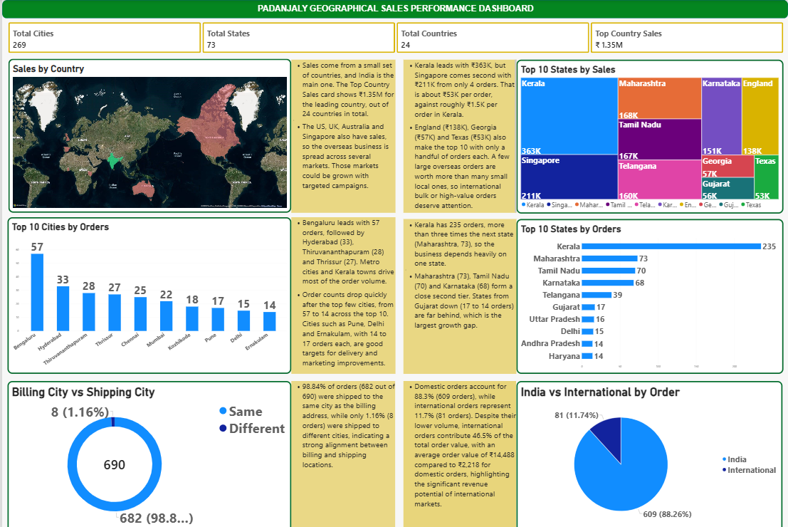

The dashboard contains four KPI cards and six visuals, each paired with a short insight note, so management can move from headline numbers to detail on a single page. The two newest visuals compare billing and shipping cities and split orders between India and international markets.

3. KPI Definitions
All KPIs are calculated on the cleaned dataset (table: padanjaly-order export cleaned) using DAX measures.
KPI Card | Purpose | DAX Logic
Total Countries | Number of countries where orders were placed | Total Countries =  DISTINCTCOUNT(  'padanjaly-order export cleaned'[billing_country_clean]  )
Total States | Number of unique states or regions | Total States =  DISTINCTCOUNT(  'padanjaly-order export cleaned'[billing_state_clean]  )
Total Cities | Number of unique cities | Total Cities =  DISTINCTCOUNT(  'padanjaly-order export cleaned'[billing_city_clean]  )
Top Country Sales | Highest sales value among all countries | Top Country Sales =  MAXX(  VALUES(  'padanjaly-order export cleaned'[billing_country_clean]  ),  CALCULATE([Total sales])  )

4. Visual Configuration
# | Visual | Chart Type | Fields and Filters
1 | Sales by Country | Filled map | Location: billing_country; Size: Total Sales
2 | Sales by State | Treemap | Group: billing_state_clean; Values: Total Sales; Top N filter = 10
3 | Top 10 Cities | Clustered column chart | X: billing_city; Y: Total Orders; Top N filter = 10
4 | Top 10 States | Clustered bar chart | Y: billing_state_clean; X: Total Orders; Top N filter = 10
5 | Billing City vs Shipping City | Donut chart | Legend: city_match; Values: Total Orders
6 | India vs International by Order | Pie chart | Legend: Region Type; Values: Total Orders

5. Calculated Columns
Two calculated columns were added to the cleaned dataset (table: padanjaly-order export cleaned) to drive the billing versus shipping and India versus international visuals. Unlike the KPI measures above, these are row-level columns that label every order.
Calculated Column | Purpose | DAX Logic
city_match | Flags whether an order was shipped to the same city as its billing address | city_match =  IF(  'padanjaly-order export cleaned'[billing_city_clean1] =  'padanjaly-order export cleaned'[shipping_city_clean1],  "Same",  "Different"  )
Region Type | Classifies each order as domestic (India) or international based on the shipping country | Region Type =  IF(  'padanjaly-order export cleaned'[shipping_country_clean] = "India",  "India",  "International"  )

6. Business Insights
6.1 Sales by Country (Map)
- Sales come from a small set of countries, and India is the main one. The Top Country Sales card shows ₹1.35M for the leading country, out of 24 countries in total.
- The US, UK, Australia and Singapore also have sales, so the overseas business is spread across several markets. Those markets could be grown with targeted campaigns.
6.2 Top 10 States by Sales (Treemap)
- Kerala leads with ₹363K, but Singapore comes second with ₹211K from only 4 orders. That is about ₹53K per order, against roughly ₹1.5K per order in Kerala.
- England (₹138K), Georgia (₹57K) and Texas (₹53K) also make the top 10 with only a handful of orders each. A few large overseas orders are worth more than many small local ones, so international bulk or high-value orders deserve attention.
6.3 Top 10 Cities by Orders
- Bengaluru leads with 57 orders, followed by Hyderabad (33), Thiruvananthapuram (28) and Thrissur (27). Metro cities and Kerala towns drive most of the order volume.
- Order counts drop quickly after the top few cities, from 57 to 14 across the top 10. Cities such as Pune, Delhi and Ernakulam, with 14 to 17 orders each, are good targets for delivery and marketing improvements.
6.4 Top 10 States by Orders
- Kerala has 235 orders, more than three times the next state (Maharashtra, 73), so the business depends heavily on one state.
- Maharashtra (73), Tamil Nadu (70) and Karnataka (68) form a close second tier. States from Gujarat down (17 to 14 orders) are far behind, which is the largest growth gap.
6.5 Billing City vs Shipping City (Donut Chart)
- 98.84% of orders (682 out of 690) were shipped to the same city as the billing address, while only 1.16% (8 orders) were shipped to different cities, indicating a strong alignment between billing and shipping locations.
- Because billing and shipping almost always match, billing-city data can be used with confidence for delivery planning and city-level marketing. The 8 mismatched orders (for example gift or third-party deliveries) are too few to affect logistics.
6.6 India vs International by Order (Pie Chart)
- Domestic orders account for 88.3% (609 orders), while international orders represent 11.7% (81 orders). Despite their lower volume, international orders contribute 46.5% of the total order value, with an average order value of ₹14,488 compared to ₹2,218 for domestic orders, highlighting the significant revenue potential of international markets.
- An international order is worth about 6.5 times a domestic one on average, so winning even a small number of additional overseas orders has an outsized effect on total revenue.
7. Recommendations
- Diversify the state mix. Reduce dependence on Kerala by running targeted campaigns in the second-tier states (Maharashtra, Tamil Nadu, Karnataka and Telangana).
- Nurture international high-value orders. Offer bulk-order pricing, dedicated shipping options and follow-up for Singapore, England and US buyers, since a few orders carry high value.
- Grow mid-tier cities and states. Improve delivery times and promotions in Pune, Delhi and Ernakulam, and lift lower-tier states such as Gujarat, Uttar Pradesh, Andhra Pradesh and Haryana.
- Build overseas markets. Expand campaigns in the US, UK and Australia, tracking order value and repeat purchases by country.
- Scale the international channel. International orders are 11.7% of volume but 46.5% of value. Set order-volume and revenue targets for overseas markets and track average order value by country.
- Keep fulfilment simple for domestic orders. With 98.84% of orders shipped to the billing city, maintain the current single-address checkout and review the 8 mismatched orders periodically to catch address errors early.
8. Conclusion
Padanjaly has a strong home base in Kerala and a metro-driven order flow, supported by valuable but thin overseas demand. The biggest gains lie in broadening the domestic footprint beyond the top four states and converting high-value international orders into a repeatable channel. Billing and shipping cities align in 98.84% of orders, so delivery planning is reliable, while international customers, at 11.7% of orders but 46.5% of value, represent the clearest revenue opportunity.

