Product Performance & Demand Analysis

1. Executive Summary
This report presents a product-level analysis of sales performance and customer demand across 11 products. The analysis is built in Power BI and covers quantity sold, revenue contribution, monthly revenue trend and the relationship between volume and revenue.
Key finding: Agnijith 90 gms is the clear market leader, selling 508 units and generating approximately ₹1.24M in revenue. Revenue grew from ₹0.30M in 2023 to a peak of ₹0.97M in 2025, then declined to ₹0.65M in 2026, which needs attention.

2. Dashboard Overview
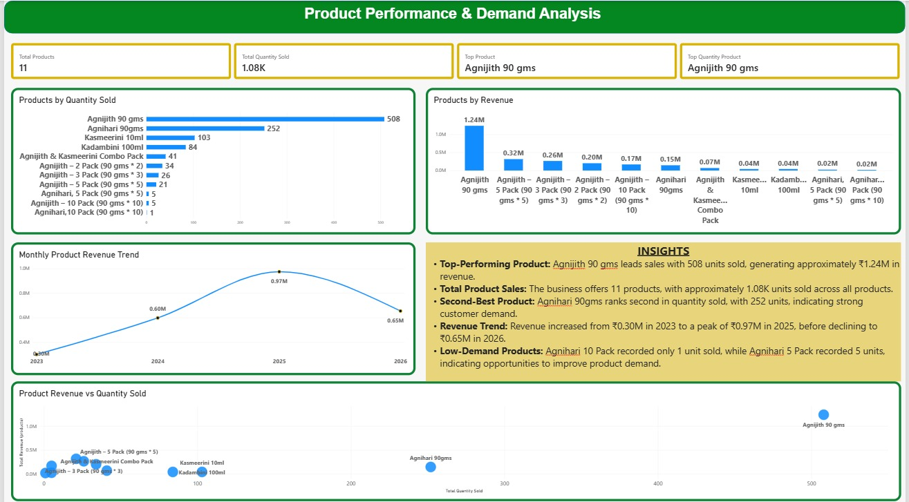

The dashboard combines four KPI cards, three comparison charts, a revenue trend line and an automated insights panel so that stakeholders can understand product performance on a single page.

3. Key Performance Indicators (KPIs)
KPI | Value | Description
Total Products | 11 | Distinct count of products sold
Total Quantity Sold | 1.08K units | Sum of quantity across all products
Top Product | Agnijith 90 gms | Highest revenue product
Top Quantity Product | Agnijith 90 gms | Highest units sold product

DAX Measures Used
Total Quantity Sold – calculates the total recorded quantity sold across products.
Total Quantity Sold =
SUM('Book12'[Quantity])

Total Products – counts the unique products in the dataset.
Total Products =
DISTINCTCOUNT('Book12'[Product_name])

Top Product – returns the product with the highest total revenue.
Top Product =
CONCATENATEX(
TOPN(1, VALUES(products[Product_name]),
[Total Revenue (products)], DESC),
products[Product_name], ", ")

Top Quantity Product – returns the product with the highest units sold.
Top Quantity Product =
MAXX(
TOPN(1, VALUES(products[Product_name]),
[Total Quantity Sold], DESC),
products[Product_name])

4. Visual Analysis

4.1 Products by Quantity Sold
Agnijith 90 gms leads with 508 units, followed by Agnihari 90gms (252), Kasmeerini 10ml (103) and Kadambini 100ml (84). Multipack variants and the combo pack sell far fewer units, and Agnihari 10 Pack records only 1 unit.
Product | Units Sold | Observation
Agnijith 90 gms | 508 | Best seller by a wide margin
Agnihari 90gms | 252 | Strong second; consistent demand
Kasmeerini 10ml | 103 | Mid-level performer
Kadambini 100ml | 84 | Mid-level performer
Agnijith & Kasmeerini Combo Pack | 41 | Moderate bundle uptake
Agnijith – 2 / 3 / 5 / 10 Packs | 34 / 26 / 21 / 5 | Demand drops as pack size grows
Agnihari 5 Pack / 10 Pack | 5 / 1 | Lowest demand in the range

4.2 Products by Revenue
Revenue follows the volume ranking. Agnijith 90 gms contributes ₹1.24M, which is far ahead of the next best product, Agnijith 5 Pack (₹0.32M). Notably, the Agnijith multipacks (5, 3, 2 and 10 packs) rank 2nd to 5th by revenue despite low unit counts, because of their higher price points. Agnihari 90gms earns ₹0.15M from 252 units, which suggests a lower price per unit.

4.3 Monthly Product Revenue Trend
Year | Revenue | Movement
2023 | ₹0.30M | Starting point
2024 | ₹0.60M | Revenue doubled
2025 | ₹0.97M | Peak performance
2026 | ₹0.65M | Decline from peak (about 33% lower)

Revenue has grown strongly for two years but fell in 2026. This should be checked against the data period (whether 2026 is a full year) and seasonality before drawing conclusions.

4.4 Revenue vs Quantity Sold
The scatter chart shows Agnijith 90 gms as a high-volume, high-revenue outlier in the top right. Agnihari 90gms sits in the middle with high volume but low revenue. All other products cluster in the bottom left with low volume and low revenue, so the business depends heavily on one product.

5. Key Insights
- Top-Performing Product: Agnijith 90 gms leads sales with 508 units and about ₹1.24M in revenue.
- Total Product Sales: The business offers 11 products, with approximately 1.08K units sold in total.
- Second-Best Product: Agnihari 90gms ranks second with 252 units, indicating strong customer demand.
- Revenue Trend: Revenue rose from ₹0.30M in 2023 to ₹0.97M in 2025, before declining to ₹0.65M in 2026.
- Low-Demand Products: Agnihari 10 Pack sold only 1 unit and Agnihari 5 Pack sold 5 units, showing room to improve demand.

6. Power BI Chart Configuration
Chart | Visual Type | Axis / Fields
Products by Quantity Sold | Clustered bar | Y: Product_name; X: [Total Revenue (Products)]
Products by revenue | Stacked bar | Y: Product_name; X: product-specific quantity measure
Monthly Revenue Trend | Line chart | X: Order Date (Month, Year); Y: [Total Revenue (Products)]
Product Revenue vs Quantity Sold | Scatter chart | X: [Quantity by Product]; Y: [Total Revenue (Products)]; Values: Product_name

8. Conclusion
Sales are concentrated in a small number of products, led by Agnijith 90 gms. The business grew rapidly until 2025 but saw a decline in 2026. Focusing on stock availability for top sellers, promoting profitable multipacks and improving the visibility of low-demand products will help build a more balanced and resilient product portfolio.

