Customer Purchase & Behaviour Analysis
Power BI dashboard report | Orders from 10 Jan 2023 to 14 Jul 2026 | Currency: INR (₹)

1. Executive Summary
This report presents an analysis of customer purchase behaviour across 690 orders. The analysis is built in Power BI and covers customer distribution by location, guest versus registered buying, one-time versus repeat customers, revenue by purchase type and the monthly purchasing trend.
Key finding: Only 21 of 323 registered customers (6.5%) have bought more than once, yet they generate about ₹0.2M, roughly 2.4 times the revenue per customer of one-time buyers. Almost half of all orders (340 of 690) come from guests, so a large share of buying behaviour cannot be tracked. India accounts for about 85% of registered customers, and monthly orders peaked at about 82 around May 2026.

2. Dashboard Overview
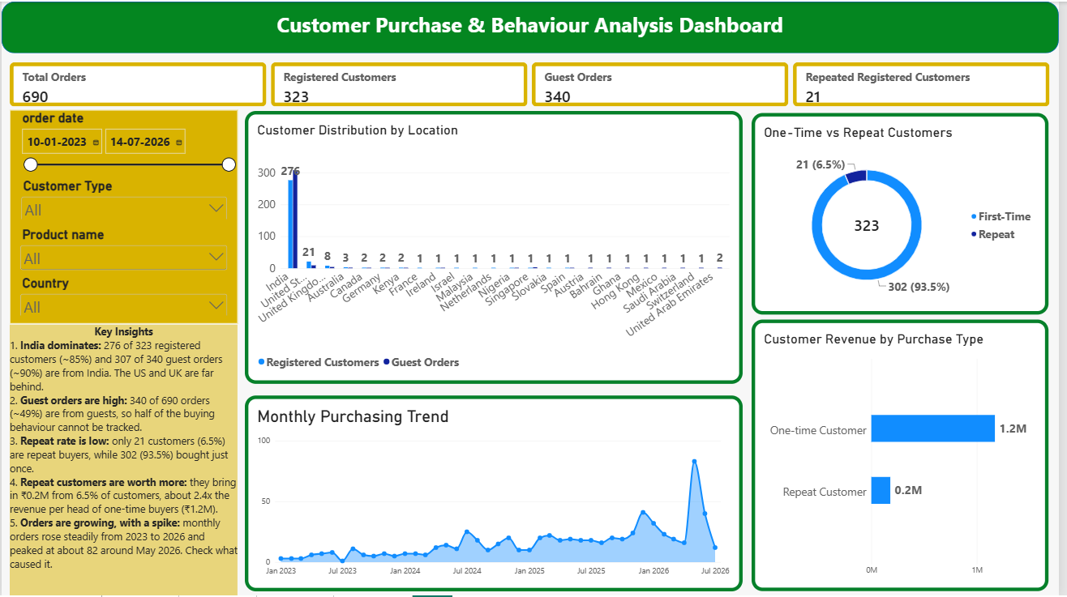
The dashboard combines four KPI cards, filters for order date, customer type, product name and country, three comparison charts, a monthly trend line and an automated key-insights panel, so stakeholders can understand customer behaviour on a single page.

3. Key Performance Indicators (KPIs)
KPI | Value | Description
Total Orders | 690 | Distinct count of order IDs
Registered Customers | 323 | Distinct customers with a valid customer ID (not 0 or blank)
Guest Orders | 340 | Distinct orders placed with Customer Type = Guest
Repeated Registered Customers | 21 | Registered customers with more than one order

DAX Measures Used
Total Orders – counts the unique orders in the dataset.
Total Orders =
DISTINCTCOUNT(
'padanjaly-order export cleaned'[order_id]
)

Registered Customers – counts unique customers, excluding guest records where the customer ID is 0 or blank.
Registered Customers =
CALCULATE(
DISTINCTCOUNT(
'padanjaly-order export cleaned'[customer_id]
),
'padanjaly-order export cleaned'[customer_id] <> 0,
NOT ISBLANK(
'padanjaly-order export cleaned'[customer_id]
)
)

Guest Orders – counts the unique orders placed by guest customers.
Guest Orders =
CALCULATE(
DISTINCTCOUNT(
'padanjaly-order export cleaned'[order_id]
),
'padanjaly-order export cleaned'[Customer Type] = "Guest"
)

Repeated Registered Customers – counts registered customers who have placed more than one order.
Repeated Registered Customers =
COUNTROWS (
FILTER (
VALUES ( 'padanjaly-order export cleaned'[customer_id] ),
'padanjaly-order export cleaned'[customer_id] <> 0
&& CALCULATE ( [Total Orders] ) > 1
)
)

4. Visual Analysis

4.1 Customer Distribution by Location
India dominates the customer base with 276 of 323 registered customers (about 85%) and 307 of 340 guest orders (about 90%). The United States (21 registered customers) and the United Kingdom (8) are far behind, followed by Australia (3), Canada, Germany and Kenya (2 each). The remaining countries have only one or two customers each, so the business is heavily concentrated in a single market.
Metric | India share | Observation
Registered customers | 276 of 323 (~85%) | Overwhelming majority of identifiable customers
Guest orders | 307 of 340 (~90%) | Guest buying is even more India-centred
Other countries | 47 of 323 (~15%) | US and UK lead; the rest are single-digit

4.2 One-Time vs Repeat Customers
Of the 323 identifiable customers, 302 (93.5%) purchased only once and 21 (6.5%) purchased again. This makes second-purchase conversion the clearest retention opportunity in the data.
Customer Type | Count | Share
One-time | 302 | 93.5%
Repeat | 21 | 6.5%

4.3 Customer Revenue by Purchase Type
Registered customers are classified as One-Time or Repeat. Repeat customers contribute about ₹0.2M from only 21 customers, while one-time customers contribute about ₹1.2M from 302 customers. On a per-customer basis, a repeat customer is worth roughly 2.4 times a one-time customer. Per-customer values in the table are derived from the rounded revenue figures shown on the dashboard.
Purchase Type | Customers | Revenue (approx.) | Revenue per customer (approx.)
One-time Customer | 302 | ₹1.2M | ₹4.0K
Repeat Customer | 21 | ₹0.2M | ₹9.5K

4.4 Monthly Purchasing Trend
Monthly orders rose steadily from early 2023 to mid-2026. Volumes stayed mostly below 25 orders per month through 2024 and 2025, with a smaller rise to about 41 around January 2026, followed by a sharp spike to about 82 around May 2026. Orders then fell back quickly. The latest month (July 2026) is only a partial month because the data ends on 14 July 2026, so the drop at the end of the line should not be read as a real decline.

5. Key Insights
- India dominates: 276 of 323 registered customers (~85%) and 307 of 340 guest orders (~90%) are from India. The US and UK are far behind.
- Guest orders are high: 340 of 690 orders (~49%) are from guests, so half of the buying behaviour cannot be tracked.
- Repeat rate is low: only 21 customers (6.5%) are repeat buyers, while 302 (93.5%) bought just once.
- Repeat customers are worth more: they bring in about ₹0.2M from 6.5% of customers, roughly 2.4 times the revenue per head of one-time buyers (₹1.2M in total).
- Orders are growing, with a spike: monthly orders rose steadily from 2023 to 2026 and peaked at about 82 around May 2026. The cause of this spike should be investigated.

6. Power BI Chart Configuration
Chart | Visual Type | Axis / Fields
Customer Distribution by Location | Clustered bar chart | Y: billing_country_clean; X: [Registered Customers], [Guest Orders]
One-Time vs Repeat Customers | Donut chart | Legend: Customer Type; Values: Distinct Customer Count
Customer Revenue by Purchase Type | Clustered column chart | X: Purchase Type; Y: [Total Customer Revenue (INR)]; Tooltips: [Customer Count], [Total Orders]
Monthly Purchasing Trend | Line / area chart | X: order_date (Month, Year); Y: Count of order_id

Supporting DAX Measures
Total Customer Revenue (INR) – sums order subtotal for registered customers only. This assumes the order table holds one row per order, and that Purchase Type correctly classifies registered customers as One-Time Customer or Repeat Customer.
Total Customer Revenue (INR) =
CALCULATE(
SUM(
'padanjaly-order export cleaned'[order_subtotal_INR]
),
'padanjaly-order export cleaned'[customer_id] <> 0,
NOT ISBLANK(
'padanjaly-order export cleaned'[customer_id]
)
)

Customer Count – counts distinct registered customers and is used in the revenue chart tooltip.
Customer Count =
CALCULATE(
DISTINCTCOUNT(
'padanjaly-order export cleaned'[customer_id]
),
'padanjaly-order export cleaned'[customer_id] <> 0,
NOT ISBLANK(
'padanjaly-order export cleaned'[customer_id]
)
)

7. Recommendations
- Drive second purchases: run a targeted follow-up campaign with relevant product recommendations for one-time customers, and compare second-purchase conversion before and after the campaign.
- Reward repeat buyers: because repeat customers are worth about 2.4 times more per head, offer them loyalty rewards and personalised promotions.
- Reduce guest checkout: encourage guests to register, for example through account-based offers, so that half of the order base becomes trackable.
- Look beyond India: test targeted marketing in the US and UK, which already show early customer activity.
- Explain the May 2026 spike: check campaigns, promotions or one-off events around that month so that the cause can be repeated or avoided.

8. Conclusion
The business has a growing but narrow customer base: it is concentrated in India, depends on one-time buyers, and loses visibility on about half of its orders through guest checkout. Repeat customers are few but clearly more valuable. Improving registration, encouraging second purchases and understanding the May 2026 spike will help build a more loyal and measurable customer base.

