PADANJALY GEOGRAPHICAL SALES PERFORMANCE REPORT

1. Executive Summary
This report presents the geographical sales performance of Padanjaly, based on the Power BI dashboard built on the cleaned order export. It covers where orders come from (countries, states and cities), how sales are distributed, and where the largest opportunities and risks lie.
Orders were placed from 269 cities across 73 states or regions in 24 countries. India is the main market, with the leading country generating ₹1.35M in sales. Within India, the business is highly concentrated in Kerala, while a small number of high-value overseas orders (Singapore, England, Georgia and Texas) add a disproportionately large share of sales.
Total Cities  269 | Total States  73 | Total Countries  24 | Top Country Sales  ₹1.35M

2. Dashboard Overview
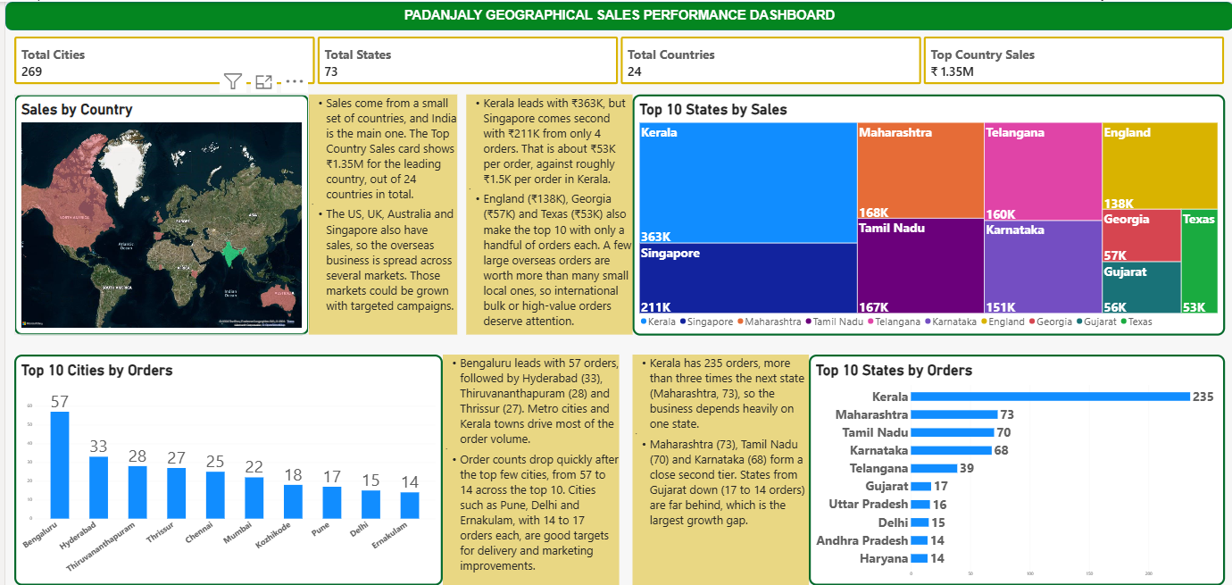

The dashboard contains four KPI cards and four visuals, each paired with a short insight note, so management can move from headline numbers to detail on a single page.

3. KPI Definitions
All KPIs are calculated on the cleaned dataset (table: padanjaly-order export cleaned) using DAX measures.
KPI Card | Purpose | DAX Logic
Total Countries | Number of countries where orders were placed | Total Countries =  DISTINCTCOUNT(  'padanjaly-order export cleaned'[billing_country_clean]  )
Total States | Number of unique states or regions | Total States =  DISTINCTCOUNT(  'padanjaly-order export cleaned'[billing_state_clean]  )
Total Cities | Number of unique cities | Total Cities =  DISTINCTCOUNT(  'padanjaly-order export cleaned'[billing_city_clean]  )
Top Country Sales | Highest sales value among all countries | Top Country Sales =  MAXX(  VALUES(  'padanjaly-order export cleaned'[billing_country_clean]  ),  CALCULATE([Total sales])  )

4. Visual Configuration
# | Visual | Chart Type | Fields and Filters
1 | Sales by Country | Filled map | Location: billing_country; Size: Total Sales
2 | Sales by State | Treemap | Group: billing_state_clean; Values: Total Sales; Top N filter = 10
3 | Top 10 Cities | Clustered column chart | X: billing_city; Y: Total Orders; Top N filter = 10
4 | Top 10 States | Clustered bar chart | Y: billing_state_clean; X: Total Orders; Top N filter = 10

6. Business Insights
6.1 Sales by Country (Map)
- Sales come from a small set of countries, and India is the main one. The Top Country Sales card shows ₹1.35M for the leading country, out of 24 countries in total.
- The US, UK, Australia and Singapore also have sales, so the overseas business is spread across several markets. Those markets could be grown with targeted campaigns.

6.2 Top 10 States by Sales (Treemap)
- Kerala leads with ₹363K, but Singapore comes second with ₹211K from only 4 orders. That is about ₹53K per order, against roughly ₹1.5K per order in Kerala.
- England (₹138K), Georgia (₹57K) and Texas (₹53K) also make the top 10 with only a handful of orders each. A few large overseas orders are worth more than many small local ones, so international bulk or high-value orders deserve attention.
6.3 Top 10 Cities by Orders
- Bengaluru leads with 57 orders, followed by Hyderabad (33), Thiruvananthapuram (28) and Thrissur (27). Metro cities and Kerala towns drive most of the order volume.
- Order counts drop quickly after the top few cities, from 57 to 14 across the top 10. Cities such as Pune, Delhi and Ernakulam, with 14 to 17 orders each, are good targets for delivery and marketing improvements.
6.4 Top 10 States by Orders
- Kerala has 235 orders, more than three times the next state (Maharashtra, 73), so the business depends heavily on one state.
- Maharashtra (73), Tamil Nadu (70) and Karnataka (68) form a close second tier. States from Gujarat down (17 to 14 orders) are far behind, which is the largest growth gap.
7. Recommendations
- Diversify the state mix. Reduce dependence on Kerala by running targeted campaigns in the second-tier states (Maharashtra, Tamil Nadu, Karnataka and Telangana).
- Nurture international high-value orders. Offer bulk-order pricing, dedicated shipping options and follow-up for Singapore, England and US buyers, since a few orders carry high value.
- Grow mid-tier cities and states. Improve delivery times and promotions in Pune, Delhi and Ernakulam, and lift lower-tier states such as Gujarat, Uttar Pradesh, Andhra Pradesh and Haryana.
- Build overseas markets. Expand campaigns in the US, UK and Australia, tracking order value and repeat purchases by country.
8. Conclusion
Padanjaly has a strong home base in Kerala and a metro-driven order flow, supported by valuable but thin overseas demand. The biggest gains lie in broadening the domestic footprint beyond the top four states and converting high-value international orders into a repeatable channel.

