ShopEZ : E-Commerce Application
Functional Specification & Technical Design Report

INTRODUCTION:
Welcome to ShopEZ – a full-stack MERN (MongoDB, Express.js, React.js, Node.js) stock trading platform where exploring the markets, executing trades, and managing an investment portfolio is simple, transparent, and accessible to everyone.
Whether you are a first-time investor or an experienced trader, ShopEZ gives you everything you need: live stock listings, real-time price updates, a virtual trading balance to practice risk-free, and a portfolio dashboard that tracks your profit and loss as it happens.
With a clean, user-friendly interface, you can search stocks, view detailed company information and price charts, place buy/sell orders, and monitor your holdings – all from your phone, tablet, or computer.
Secure JWT-based authentication protects every account, and a dedicated admin panel lets platform administrators manage stock listings, approve trades, and monitor overall activity – delivering a complete, trustworthy trading experience for investors and administrators alike.

SCENARIO Based Case Study:
Background
“ShopEZ” is a full-stack stock trading application designed to make market participation simple, transparent, and data-driven. With a growing base of retail investors, ShopEZ offers live market data, simulated trading with a virtual balance, and portfolio analytics that help users understand and grow their investments with confidence.
Scenario
User Persona:
• Name: Rohan Deshmukh
• Age: 29
• Profession: Software Engineer
• Goal: Learn to trade stocks and build a diversified investment portfolio without risking real money while learning.
• Challenges: Limited market knowledge, no access to a safe practice environment, difficulty tracking profit/loss across multiple trades.
The Challenge
Rohan had tried a few brokerage apps before but found them either intimidating for beginners or too focused on real-money trades. He needed a platform that could:
• Let him practice trading with a virtual balance, risk-free
• Show live market movement and stock trends clearly
• Track his holdings and profit/loss automatically
• Work seamlessly across desktop and mobile
Solution: How ShopEZ Helped
When Rohan signed up on ShopEZ, he was greeted with a starting virtual balance and a live market dashboard. The platform's search and stock detail pages let him research companies before trading, and the trade engine let him:
• Buy and Sell Simulated Trades: Execute virtual buy/sell orders instantly against live-polled prices.
• Portfolio Dashboard: Real-time holdings, balance, and profit/loss visualization kept him informed and motivated.
Within a month, Rohan had built a diversified virtual portfolio across five sectors and grew comfortable enough to plan his first real-money brokerage account.

SYSTEM REQUIREMENTS:
To ensure smooth development, deployment, and usage of the ShopEZ web application, certain system prerequisites must be met. These requirements are categorized into software and hardware specifications, all of which contribute to building a robust and scalable trading platform.

1. Software Requirements
These are the essential tools and platforms required to develop, test, and run the application efficiently.
• Operating System: Windows 10/11, macOS, or Linux – supports cross-platform development and testing.
• Node.js (v18 or above): Provides the runtime environment for building and managing frontend logic, and powers the server-side logic and API routing.
• npm (v8 or above): Package manager required to install dependencies for React and related libraries.
• React.js: JavaScript library for building the dynamic, responsive trading UI.
• Browser: Google Chrome / Firefox (latest version) – for rendering and testing the UI in real time.
• Express.js: Lightweight web framework for building the RESTful trading API.
• MongoDB: NoSQL database used to store users, stocks, transactions, and portfolio data.
• Postman: Tool for testing API endpoints during development.
• Visual Studio Code: Preferred code editor with built-in Git and terminal support.

2. Hardware Requirements
Describes the minimum and recommended specifications needed to support development and usage of the application.
• Processor: Intel Core i5 (8th Gen or above) / AMD Ryzen 5 or better – ensures fast compilation and multitasking during development.
• RAM: Minimum 8 GB (16 GB recommended) – for handling development servers, IDEs, and browser testing simultaneously.
• Storage: At least 1 GB free space – required for package installations, MongoDB setup, and local project files.
• Display: 1366x768 or higher – recommended for optimal coding experience and dashboard layout visualization.

TECHNICAL ARCHITECTURE:
User Interface | → | Web Server | → | API Gateway

Auth Service | → | Trading Service | → | Market Data Service

Database | → | Portfolio Service | → | Admin Service

Technical Architecture Overview
The ShopEZ application is built on a robust, scalable architecture designed to deliver a fast and reliable trading experience.
User Interface (UI):
A clean, intuitive interface enables users to search stocks, view charts, and place trades. It is designed to stay responsive even during frequent live price updates.
Web Server:
Hosts the UI and handles user requests, delivering dynamic, personalized dashboard content while ensuring smooth performance and quick response times.
API Gateway:
Acts as the central entry point for all client requests, routing traffic to the appropriate service and ensuring efficient data flow across the system.
Authentication Service:
Secures user access through JWT-based authentication and role-based authorization, protecting user data and trading actions.
Market Data Service:
Polls and serves live stock prices, historical data, and daily statistics that power the dashboard and stock detail pages.
Trading Service:
Executes buy/sell orders against the user's virtual balance, validates trade requests, and records each transaction.
Portfolio Service:
Aggregates a user's holdings and transaction history to calculate real-time balance and profit/loss.
Database:
Stores users, stocks, transactions, and portfolio records, enabling accurate, real-time trading and reporting.
Together, these components create a powerful ecosystem that supports a dynamic, secure, and scalable stock trading experience for users and administrators.

ER DIAGRAM:

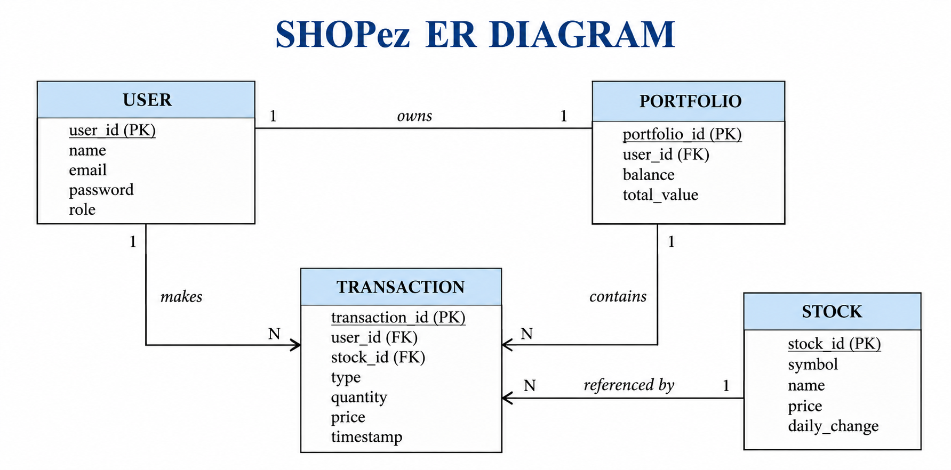

Entities and Relationships
1. User
• Represents investors and administrators using the platform.
• Each user has a unique profile with credentials, role (USER / ADMIN), and balance.
• Relationships:
○ Owns → Portfolio: A user's holdings and balance summary are tracked in their portfolio.
○ Makes → Transaction: Users place buy/sell orders that are logged as transactions.
2. Stock
• Represents a tradable instrument with symbol, name, price, and historical data.
• Relationships:
○ Referenced by → Transaction: Each transaction is linked to the stock being traded.
○ Held in → Portfolio: A stock can appear across many users' portfolios.
3. Transaction
• Represents an individual buy or sell order – quantity, price, and timestamp.
• Relationships:
○ Belongs to → User: Every transaction is tied to the user who placed it.
○ Updates → Portfolio: A completed transaction updates the user's holdings and balance.
4. Portfolio
• Aggregates a user's current holdings, cash balance, and profit/loss summary.
• Relationships:
○ Tracks → User: One portfolio record per user, recalculated after each transaction.

Key Features:

1. User Management
• User Registration and Authentication: Allows users to register, securely log in via JWT, and access personalized trading content.

2. Market & Stock Management
• Stock Listings: Displays a comprehensive catalog of tradable stocks with symbol, price, daily stats, and historical charts.

3. Trading & Portfolio Tracking
• Buy/Sell Simulation: Executes trades against a virtual balance with instant confirmation.
• Portfolio Tracking: Tracks holdings, balance, and profit/loss with real-time visualization.

ROLES AND RESPONSIBILITIES:
User:-
Registration: Users are responsible for creating an account on ShopEZ by providing necessary details like name, email, and password.
Profile Management: Users can manage their profile, allowing them to update information such as email, name, and password.
Stock Exploration: Users can explore available stocks, check price charts and company details to make informed trading decisions.
Trading: Users can buy and sell stocks, specifying quantity and reviewing the impact on their virtual balance.
Portfolio Review: Users can view their holdings, transaction history, and profit/loss at any time.
Logout: Finally, they can log out of the ShopEZ application.
Admin:-
User Management: Admins are responsible for managing user accounts, including creating, updating, and deleting accounts as needed.
Stock Management: Admins oversee the stock catalog – adding new listings, updating prices/details, or removing stocks no longer traded.
Trade Moderation: Admins review and approve flagged trades, and can suspend suspicious trading activity.
Monitoring Activity: Admins monitor user activity, trade volume, and platform performance to improve reliability.
User Support: Admins respond to user inquiries and resolve issues that arise on the platform.
Reporting and Analytics: Admins generate reports on trading volume, active users, and platform metrics to guide improvements.
App Maintenance and Updates: Admins oversee the maintenance of the app, including regular updates to enhance performance and security.

User Flow:
Start | → | Login/Signup | → | Dashboard

Search Stock | → | View Stock Detail | → | Buy / Sell

Portfolio Update | → | Track P/L | → | End

Start: The user opens the ShopEZ application.
Login/Signup: The user logs in or registers a new account.
Dashboard: The user views the live market overview and featured stocks.
Search Stock: The user searches for a stock by symbol or company name.
View Stock Detail: The user reviews the price chart, company info, and trading form.
Buy / Sell: The user places a buy or sell order using their virtual balance.
Portfolio Update: The trade updates the user's holdings and balance in real time.
Track P/L: The user reviews profit/loss and transaction history on the Portfolio page.
End: The user logs out or exits the ShopEZ application.

MVC PATTERN:
Database | → | Model | → | Controller

User | → | Controller | → | View / Routes
The ShopEZ application follows the Model-View-Controller (MVC) architectural pattern, a software design approach that separates an application into three interconnected layers. This separation allows for modularity, easier maintenance, and scalability.
Model Layer (Data Layer)
The Model layer is responsible for handling all data-related logic. This includes the definition of data schemas (User, Stock, Transaction, Portfolio) and the operations performed on the database using those schemas. Models are implemented using Mongoose, which provides a schema-based solution to model application data for MongoDB.
Controller Layer
The Controller layer acts as an intermediary between the view (routes) and the model. It receives incoming trading requests, processes the input (validation, balance checks), calls the appropriate model methods, and returns a response to the client.
View Layer (Routing Layer)
In the context of a backend REST API, the View is implemented as the routing layer, where endpoints for authentication, stocks, trades, portfolio, and admin actions are defined. These endpoints determine how the backend responds to different HTTP requests (GET, POST, PUT, DELETE).
Advantages of Using MVC in This Project
• Separation of Concerns: Each layer has a clearly defined responsibility, improving readability and maintainability.
• Scalability: New features (e.g. new order types) can be added easily by creating new routes, controllers, and models.
• Reusability: Logic in controllers and models can be reused across multiple parts of the application.
• Testing: Each layer can be tested independently, especially the trading controllers and models.
• Collaboration-Friendly: Multiple developers can work simultaneously on different layers without conflict.

Project Setup And Configuration.
• Creating project folder
○ Create a new folder with your project name.
○ Inside that folder create two new folders.
○ Name one as Client.
○ Name another one as Server.
○ Now open that folder in VS Code.
• Client setup (installing react app)
○ Open the Client folder in the terminal of VS Code.
○ npm create vite@latest . -- --template react
○ Select React framework, then JavaScript variant.
○ cd client
○ npm install
○ npm run dev
• Server setup (npm init)
○ Open Server folder in terminal of VS Code.
○ npm init -y
○ Create file: server.js
○ Create folders: models, controllers, middlewares, routes

BACKEND DEVELOPMENT:
Backend Reference Video:
[Add backend walkthrough video link here]
Backend Structure:
SHOPEZ
└─ Backend/
├─ config/
│ └─ db.js
├─ controllers/
│ ├─ userController.js
│ ├─ stockController.js
│ ├─ tradeController.js
│ └─ portfolioController.js
├─ middlewares/
│ └─ authMiddleware.js
├─ models/
│ ├─ User.js
│ ├─ Stock.js
│ ├─ Transaction.js
│ └─ Portfolio.js
├─ routes/
│ ├─ authRoutes.js
│ ├─ stockRoutes.js
│ ├─ tradeRoutes.js
│ ├─ portfolioRoutes.js
│ └─ adminRoutes.js
├─ .env
├─ package.json
└─ server.js
Backend/
config/
db.js – Sets up and connects your backend to the database (MongoDB).
controllers/
• userController.js – Handles user-related logic like signup, login, and profile operations.
• stockController.js – Handles stock-related logic like listing, searching, and fetching stock details.
• tradeController.js – Handles buy/sell trade execution and balance validation.
• portfolioController.js – Handles fetching and updating a user's holdings and profit/loss.
middlewares/
• authMiddleware.js – Verifies JWT tokens and protects routes that require authentication or admin access.
models/
• User.js – Defines the Mongoose schema/model for user accounts.
• Stock.js – Defines the Mongoose schema/model for tradable stocks.
• Transaction.js – Defines the Mongoose schema/model for buy/sell transactions.
• Portfolio.js – Defines the Mongoose schema/model for user holdings and balance.
routes/
• authRoutes.js – Defines all authentication-related API routes (login/signup).
• stockRoutes.js – Defines routes for browsing and searching stocks.
• tradeRoutes.js – Defines routes for placing buy/sell trades.
• portfolioRoutes.js – Defines routes for fetching portfolio and profit/loss data.
• adminRoutes.js – Defines admin-only routes for managing stocks, users, and trades.
server.js – Entry point of the backend; sets up the Express server, middleware, and routes.

DATABASE DEVELOPMENT:
1. Configure MongoDB:
• Install Mongoose. In your Node.js project directory, run: npm install mongoose
• Create database connection.
• Create Schemas & Models.
Create Database connection:
Now, make sure the database is connected before performing any of the actions through the backend. The connection code looks similar to the one provided below:
const mongoose = require('mongoose');
const dotenv = require('dotenv');
dotenv.config();

const connectDB = async () => {
try {
await mongoose.connect(process.env.MONGO_URI, {
useNewUrlParser: true,
useUnifiedTopology: true,
});
} catch (error) {
process.exit(1);
}
};

module.exports = connectDB;
Create Schemas:
Firstly, configure the Schemas for the MongoDB database to store data in a consistent structure. Use the ER diagram above to create the schemas. The schemas for this application look similar to the ones provided below.
Stock.js – Defines the Mongoose schema/model for stocks stored in the database.
const mongoose = require('mongoose');

const stockSchema = new mongoose.Schema({
symbol: { type: String, required: true, unique: true },
name: { type: String, required: true },
price: { type: Number, required: true },
dayHigh: Number,
dayLow: Number,
history: [{ date: Date, close: Number }],
});

const Stock = mongoose.model('Stock', stockSchema);
module.exports = Stock;
User.js – Defines the Mongoose schema/model for user accounts.
const mongoose = require('mongoose');

const UserSchema = new mongoose.Schema({
name: String,
email: { type: String, unique: true },
password: String,
role: { type: String, enum: ['USER', 'ADMIN'], default: 'USER' },
balance: { type: Number, default: 10000 },
});

module.exports = mongoose.model('User', UserSchema);

FRONT-END DEVELOPMENT:
Frontend Reference Video:
[Add frontend walkthrough video link here]
Frontend Structure:
Frontend/
└─ src/
├─ assets/
├─ common/
│ ├─ Home.jsx
│ ├─ Login.jsx
│ ├─ Signup.jsx
│ ├─ Navbar.jsx
│ └─ Footer.jsx
├─ components/ui/
├─ context/
│ ├─ AuthContext.jsx
│ └─ PortfolioContext.jsx
├─ services/
│ └─ api.js
├─ routes/
│ └─ ProtectedRoute.jsx
├─ User/
│ ├─ Dashboard.jsx
│ ├─ StockDetail.jsx
│ ├─ Portfolio.jsx
│ └─ TradeForm.jsx
├─ Admin/
│ └─ AdminDashboard.jsx
├─ App.jsx
├─ App.css
├─ main.jsx
├─ index.css
└─ .env
Frontend/
src/
assets
Stores images, icons, and other static frontend resources.
common/
• Home.jsx – Renders the landing/home page UI.
• Login.jsx – Form and logic for user login.
• Signup.jsx – Form and logic for new user registration.
• Navbar.jsx – Top navigation bar for the app.
• Footer.jsx – Displays the site footer.
components/ui
Reusable UI components (buttons, cards, inputs, etc.).
context/
• AuthContext.jsx – Provides global user authentication state across the app.
• PortfolioContext.jsx – Stores and manages live portfolio state globally.
User/
• Dashboard.jsx – UI for the live market overview and featured stocks.
• StockDetail.jsx – Displays a stock's price chart, company info, and trade form.
• Portfolio.jsx – Shows the user's holdings, balance, and profit/loss.
• TradeForm.jsx – Handles buy/sell order submission.
Admin/
• AdminDashboard.jsx – UI for managing users, stock listings, and trade approvals.
Root Files/
• App.css – Main stylesheet for the entire app.
• App.jsx – Main component that holds routes and global layout.
• index.css – Global CSS applied to the whole React project.
• main.jsx – Entry point that renders the App component into the DOM.
• .env – Stores frontend environment variables (API URL, keys).

Output ScreenShots:
Landing Page:
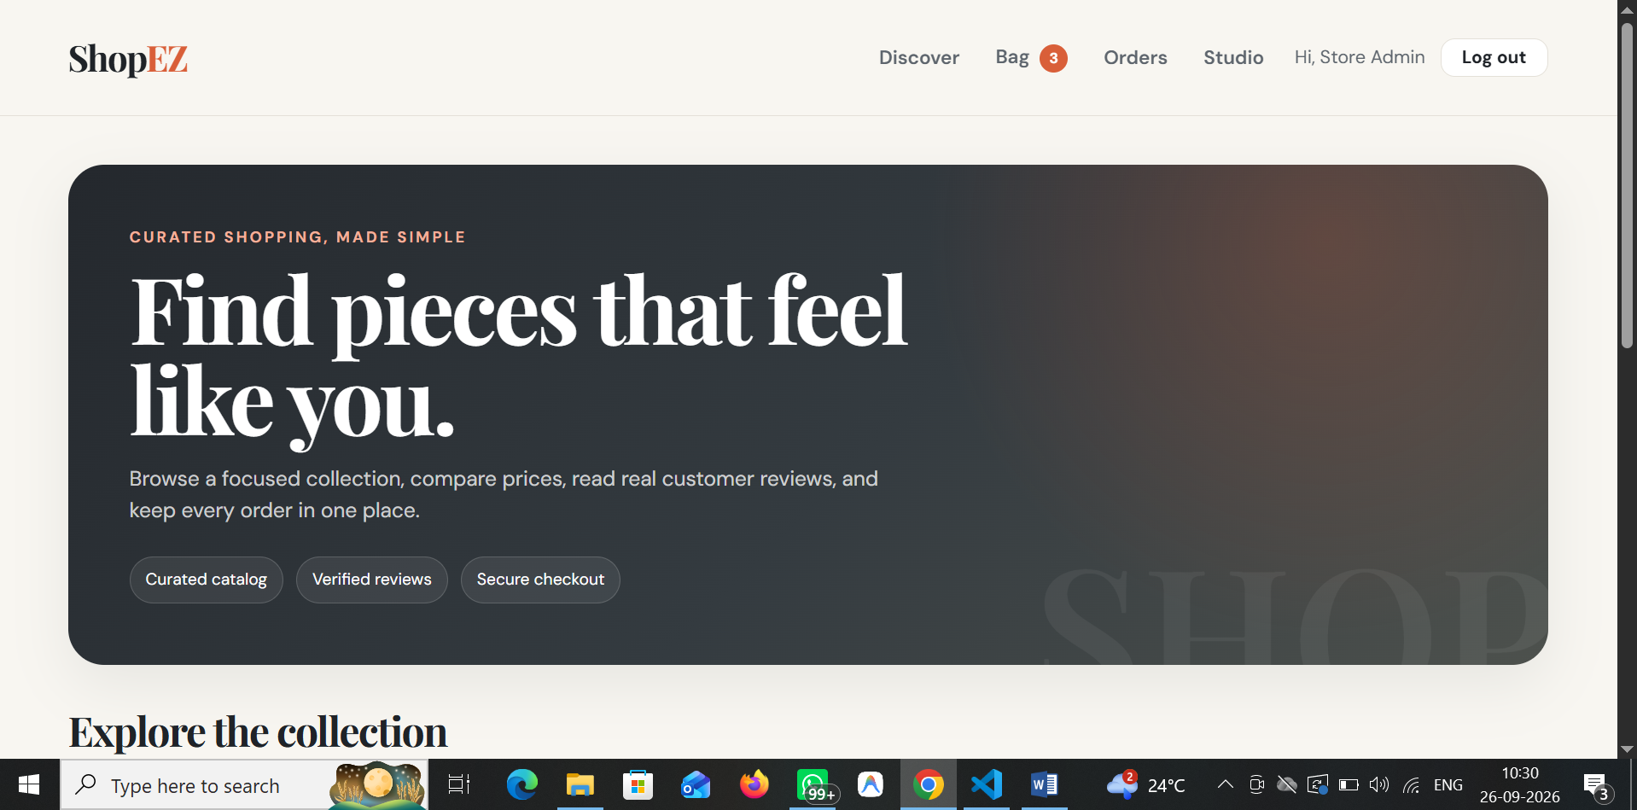

Signup Page:
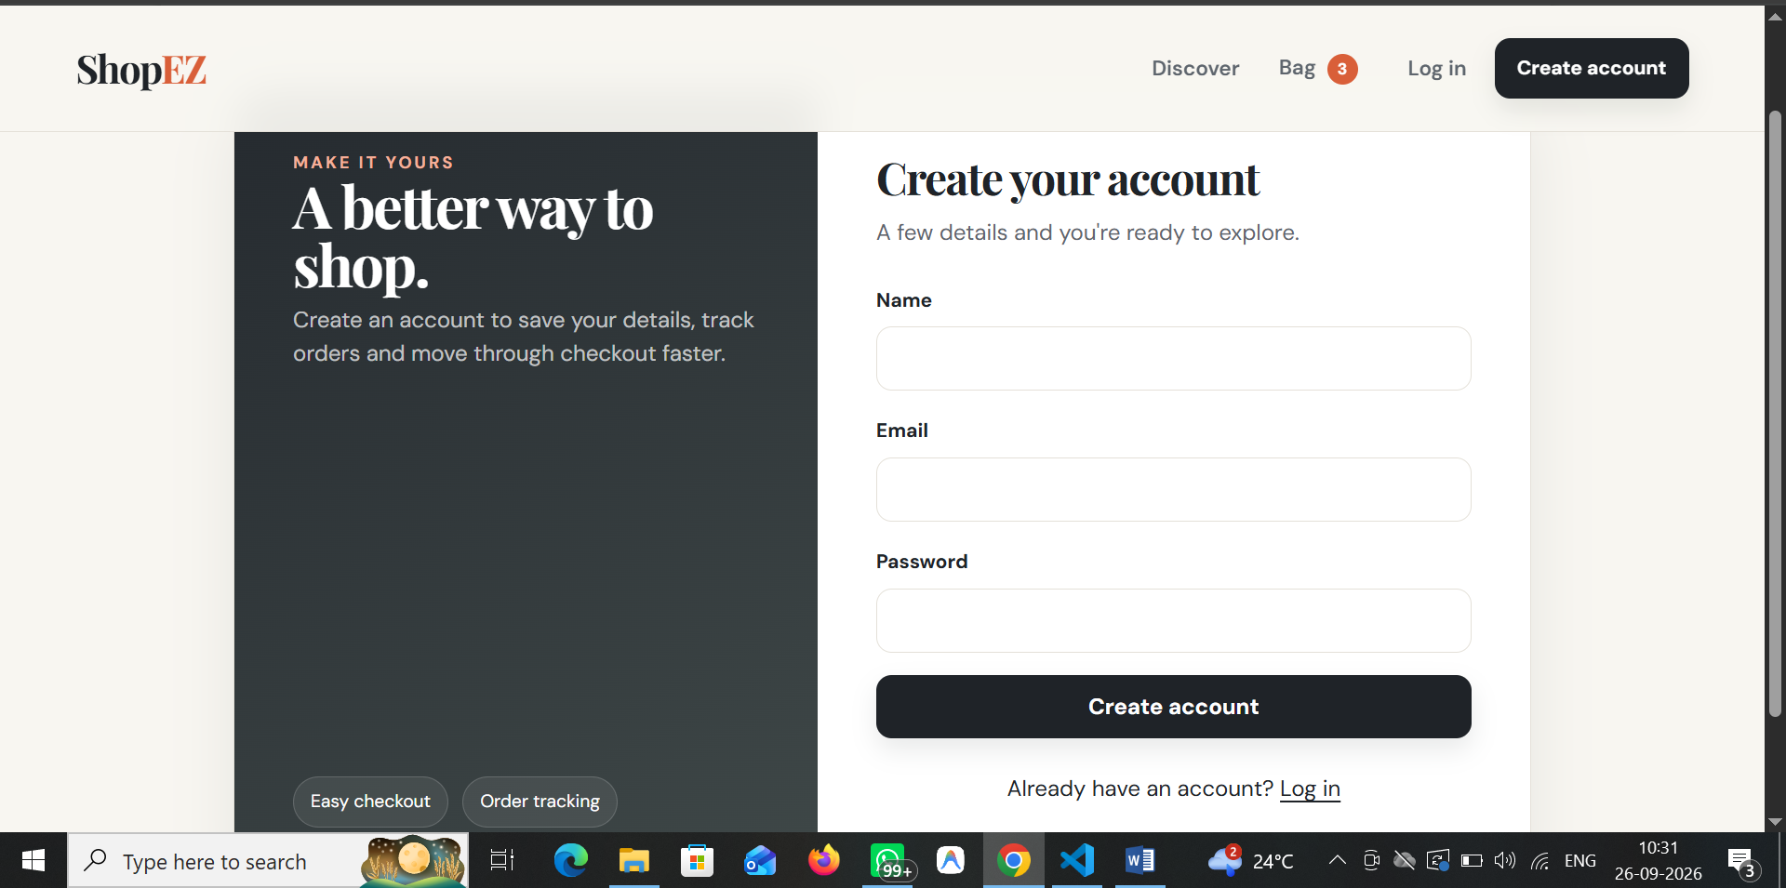
Login Page:
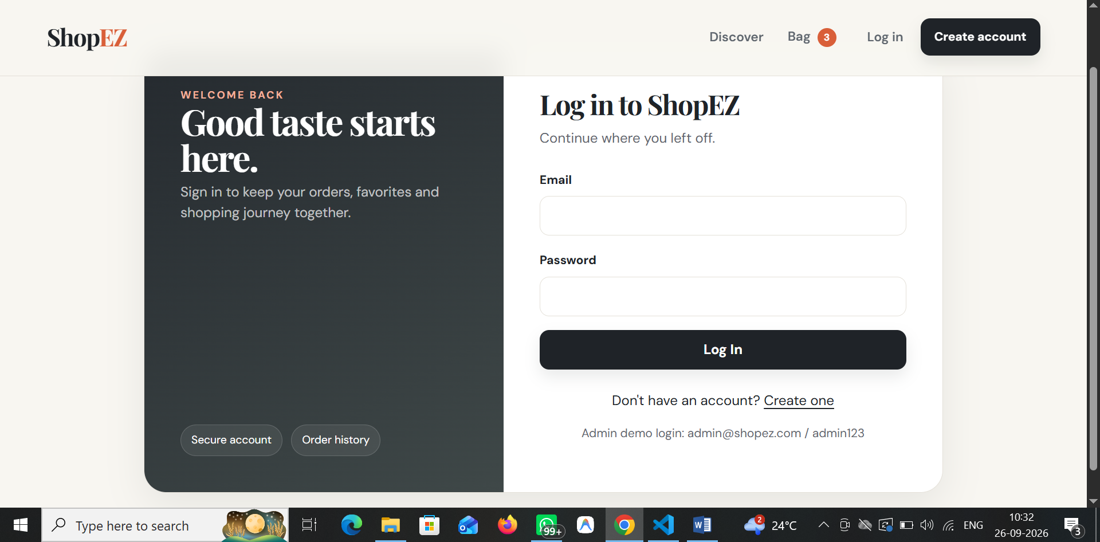

Dashboard:
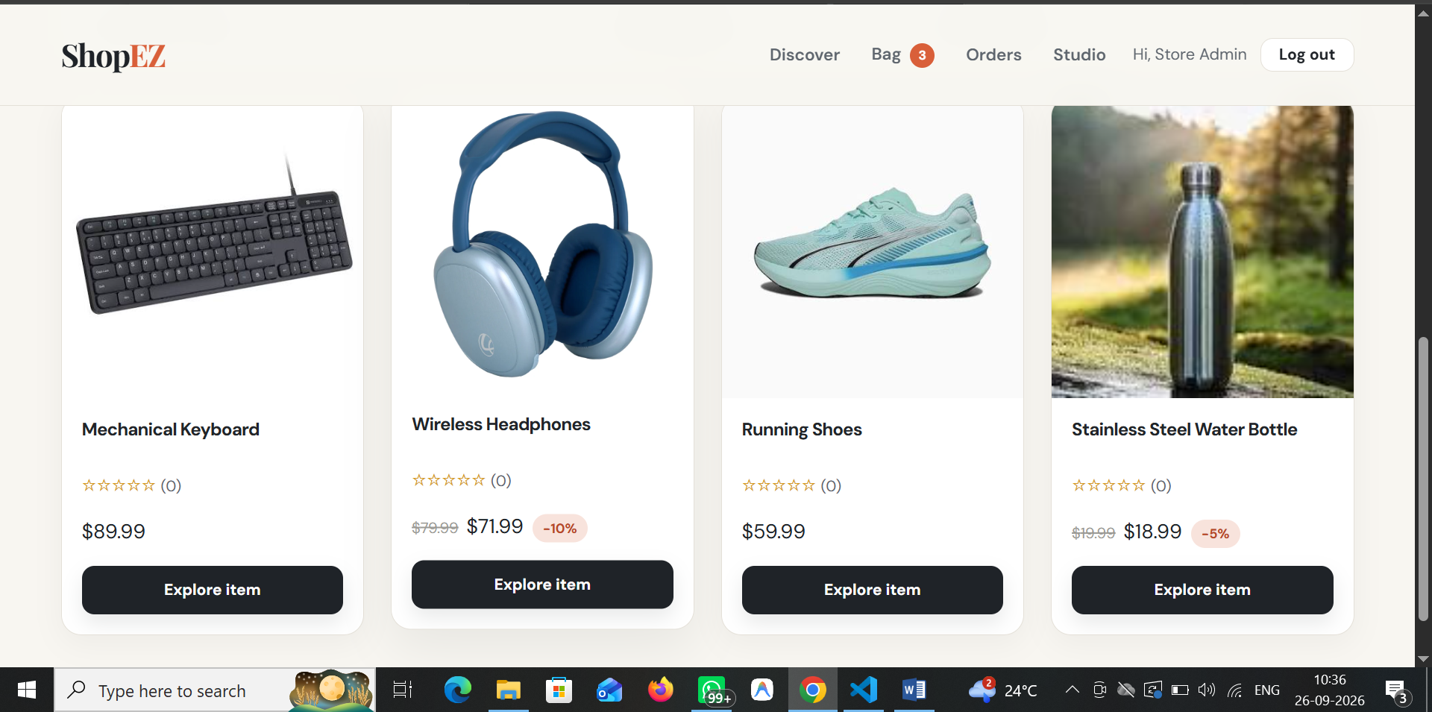
Stock Detail Page:
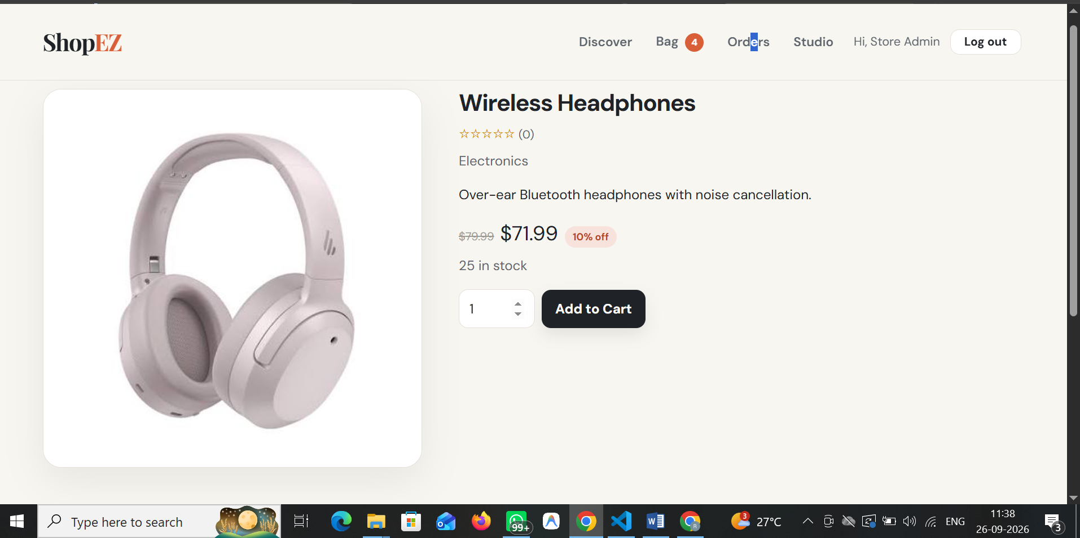
Portfolio Page:
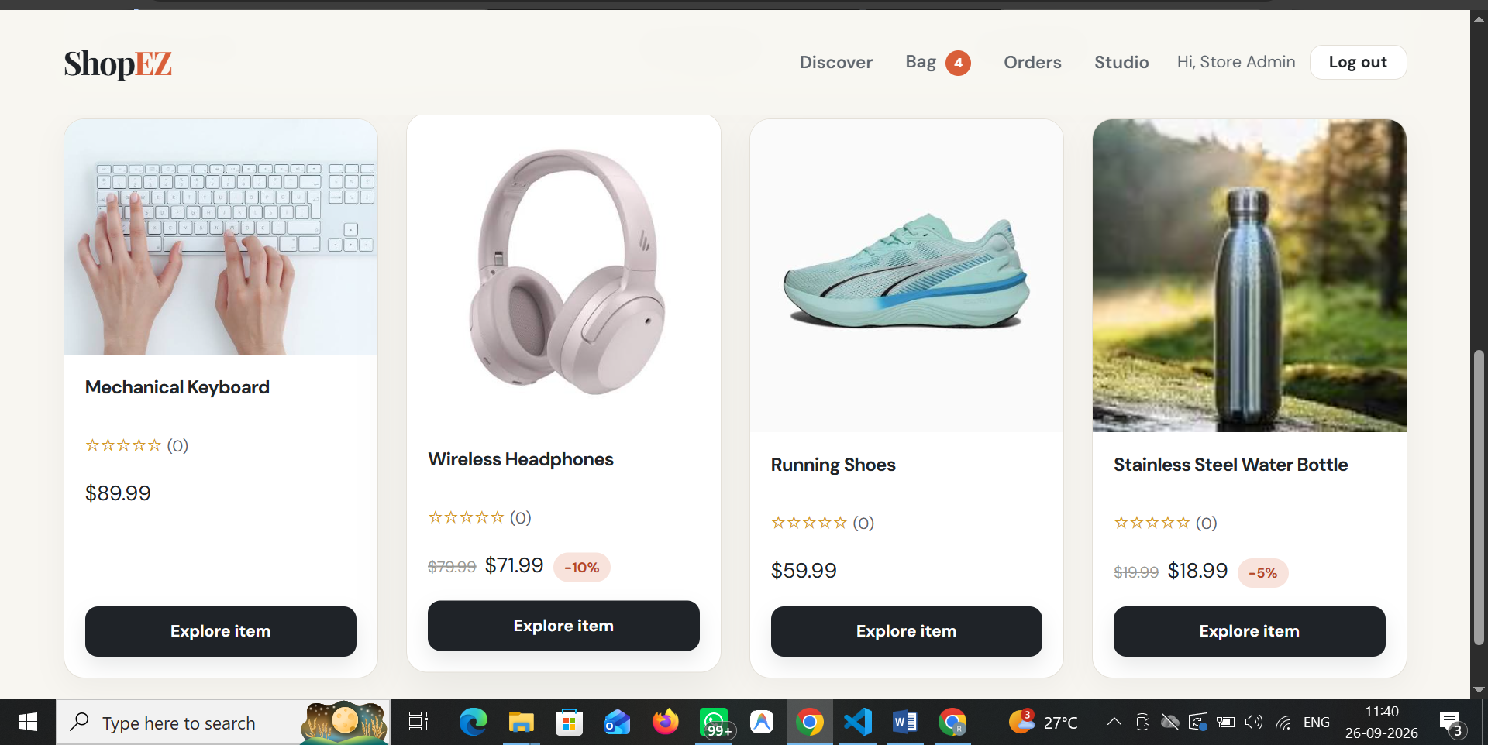
Admin Dashboard:
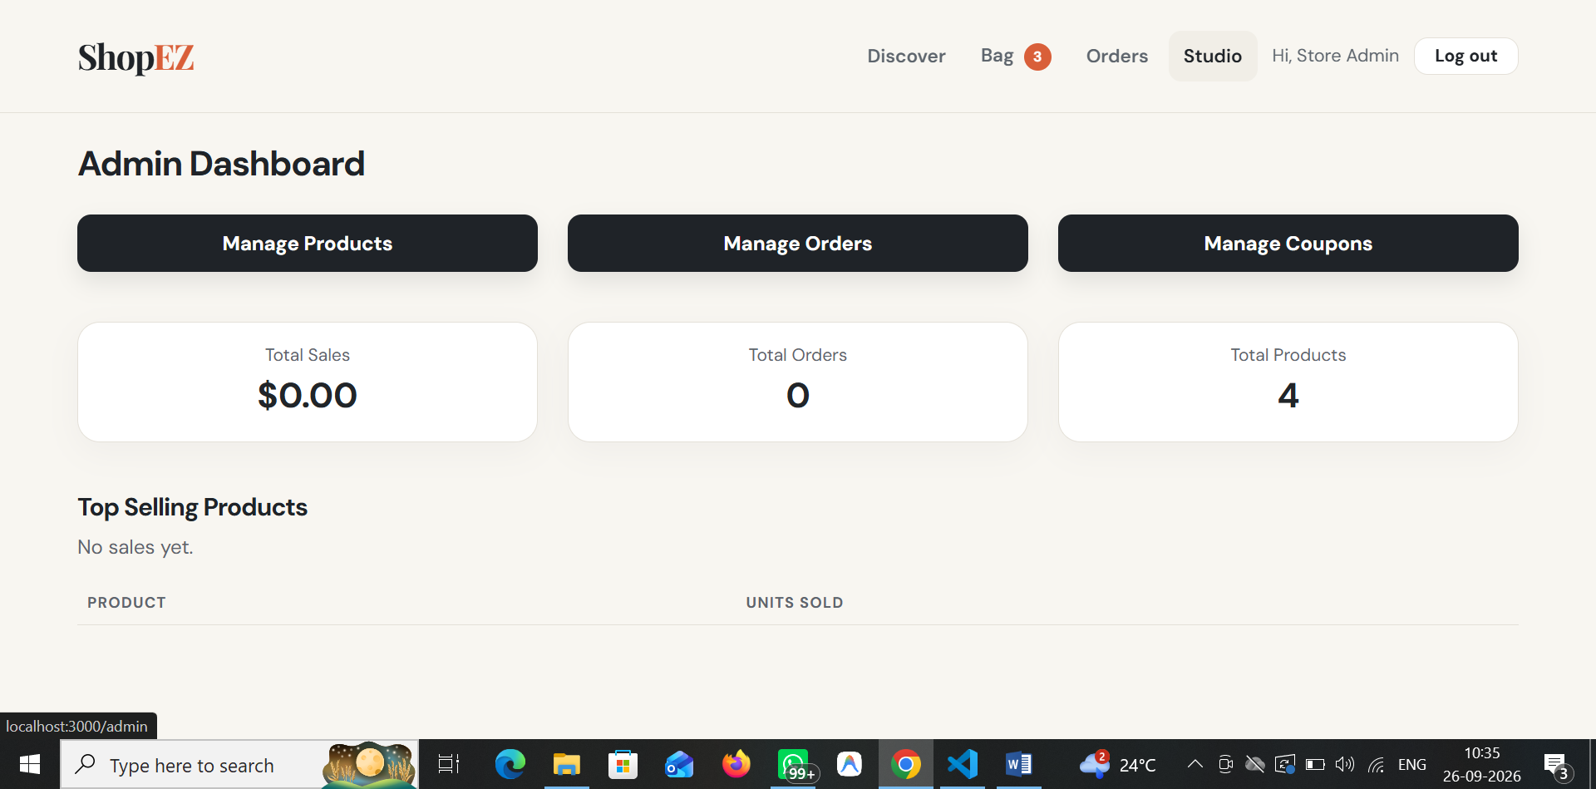

Demo Video Link: [Add demo video link here]
Code Drive Link: [Add code repository / drive link here]

