**Results of the project**

**Result after first operation:** Creation of array list.

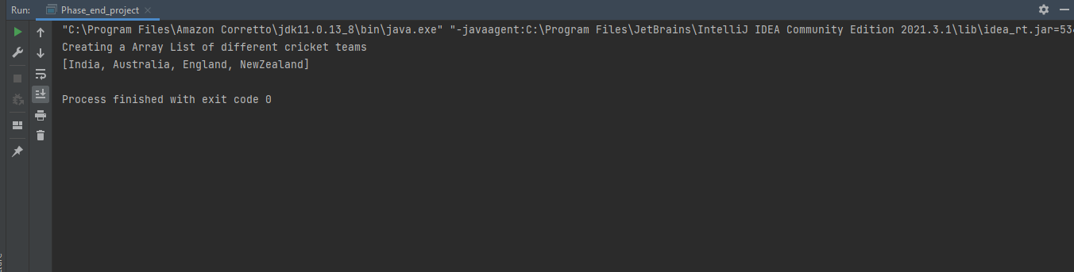

**Result after second operation:** Adding another element into the list

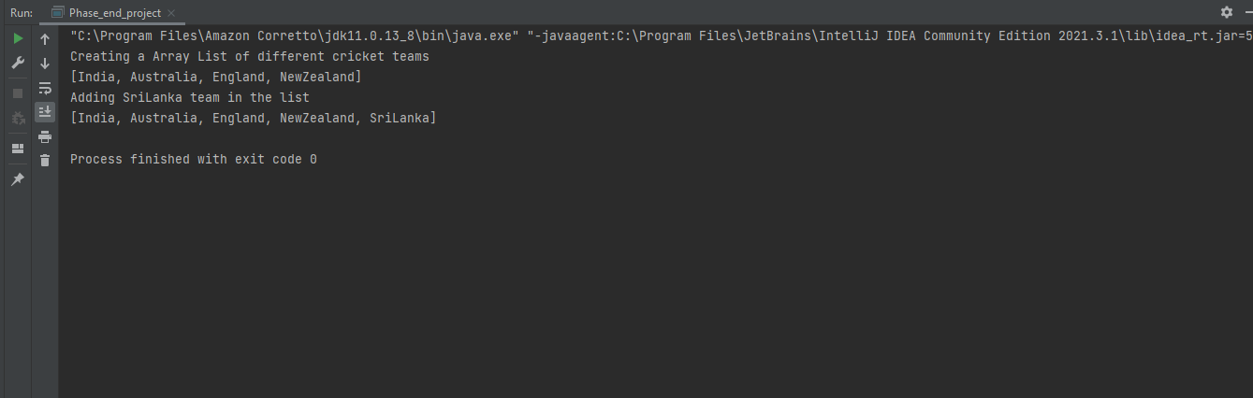

**Result after third operation:** Deletion of an element from the list

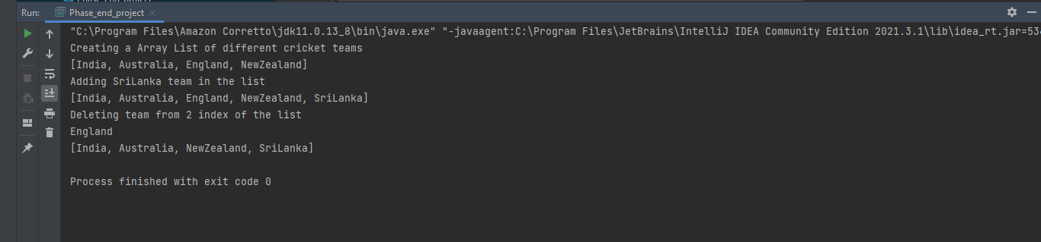

**Result after fourth operation:** Searching of an element in the list and return true or false as a result. In this operation program checks England is in list or not result shows false hence it is not in list.

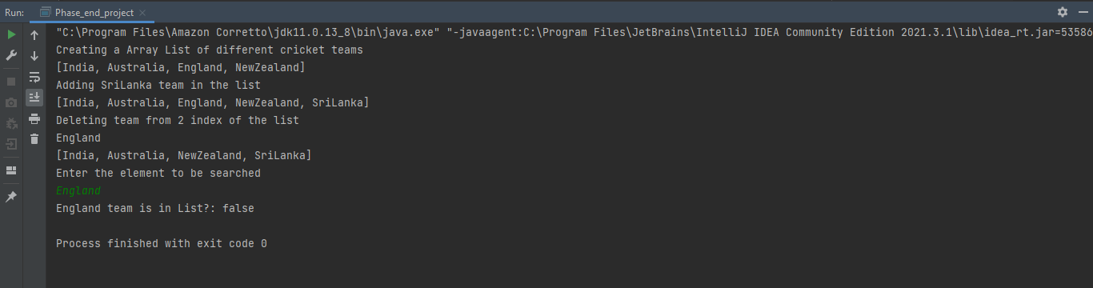

**Result after fifth operation:** Sorting of list in Ascending order.

