School of Computer Science and Engineering

Contents

- 1. Literature Survey and Requirement Analysis
- 2. System and Detailed Design
- 3. Implementation and Functionality
- 4. Testing, Debugging and Integration
- 5. Documentation, Phase-2 Plan and Viva Readiness
- Declaration
- Appendix A. Diagrams
- Appendix B. How to reproduce the evidence

1. Literature Survey and Requirement Analysis
1.1 Problem statement
Local businesses such as cafes, salons and bakeries have idle capacity and surplus stock but no affordable, trustworthy way to sell time-limited offers to people nearby, and nearby customers cannot find verified offers or pay for them safely. NextTo is a hyperlocal deals marketplace: merchants publish offers, customers discover them by distance, pay by UPI, receive a single-use QR voucher and redeem it in person. It matters because money and footfall stay local and every payment, refund and approval is recorded. Success is measured by a purchase journey that never double-charges, never double-redeems and can be audited end to end (21-step journey and 77 automated tests pass).
1.2 Literature survey
Paper (author, year, venue) | Approach / technique | Strength | Limitation
Vas et al., 2023, ICAC3N | Conceptual hyperlocal marketplace; stakeholder use cases; phased roadmap | Defines the full stakeholder set (suppliers, customers, admin) | No data model, security or payment design; no appointment or voucher deals
Chang, 2010, 3PGCIC | SaaS reference architecture, 10 functional blocks, private-label multi-tenancy | One shared core serving many branded marketplaces | Dated; app-store domain; no location or in-person redemption
Satrio et al., 2022, ICoICT | Customer-development interviews (BMC, VPC, Kano) in two cities | 36 buyer + 35 seller MVP features validated with real users | Generic local commerce; no QR redemption or booking tested
Kohli et al., 2024, ISCS | Flask microservices on Kubernetes with CI/CD, load tested | Independent scaling; over 90% satisfaction; pod-failure recovery | Generic e-commerce; no roles, payments, vouchers or geolocation
de O. Junior et al., 2022, ICCE | OAuth/JWT secured microservices behind an API gateway | Single central Auth Service as entry point | No benchmark; no payment or voucher services
Sharma and Kaur, 2015, ICCCA | RuleML user-written rules, pre-filtering, weighted ranking | Clear weighted-ranking structure (distance, priority, rating) | Manual rule authoring; does not scale to many time-bound deals
Lin and Hsu, 2018, IC3 | Five-module AHP pipeline using social events and mobility | Combines several weighted factors into one score | Conceptual only; needs a social graph the MVP lacks
Tong et al., 2017, Big Data Analysis | Logistic regression with time decay and geohash location imputation | Handles missing location; F1 11.15% vs 9.00% baseline | Low absolute F1; geohash trades precision for privacy
Cecil et al., 2024, ICC-ROBINS | Smart-cart dwell time with decision trees, CF, CBF, FP-Growth | Measured revenue and dwell-time gains in stores | Needs in-store hardware; no online purchase or voucher flow
Lingareddy et al., 2025, GINOTECH | DQN + XGBoost UPI fraud detection on a Kaggle dataset | 98.7% accuracy, 1.2% false positives, 45 ms inference | Public data, not live UPI; latency excludes gateway round trip
1.3 Literature gaps
- Gap 1: no reviewed work combines vouchers, single-use QR redemption and appointment-based deals in one marketplace.
- Gap 2: recommenders need rules, social graphs or purchase history, which a new marketplace does not have (cold start).
- Gap 3: fraud-detection results were measured on public datasets only and ignore the gateway round trip.
Gap addressed by this project: Gaps 1 and 2. NextTo implements purchase, signed-callback payment, single-use QR vouchers and bookings in one tested system, and ranks deals with a simple explainable score that works from the first day. Gap 3 is handled only by design: a RiskScorer interface lets a model be attached later.
1.4 Requirements
ID | Requirement | Type (functional / non-functional) | Priority
R1 | A consumer can buy a deal; an order is created once per request (idempotent), stock is reserved, and payment is accepted only through a verified signed callback (FR-C3, FR-P1) | Functional | High
R2 | A voucher is issued as a signed QR and can be redeemed exactly once, only by the owning merchant, within its validity (FR-C4, FR-M3) | Functional | High
R3 | Nearby deals are ranked by distance, category, recency and urgency, with fallbacks when location or history is missing (FR-C2, FR-D1, FR-D2, NFR-6, NFR-7) | Functional | High
R4 | Email and password sign-up and login; consumer, merchant and admin roles are separated at the API (FR-C1, FR-M1, NFR-3, NFR-4) | Functional | High
R5 | Merchants submit deals; an admin approves or rejects; editing a live deal returns it to review (FR-M2, FR-A1) | Functional | High
R6 | Refunds: consumer request, admin decision, provider call with retry, stock and points restored (FR-A1, FR-P1) | Functional | Medium
R7 | Appointment booking for service deals with guarded capacity and cancellation (FR-C6, FR-M4) | Functional | Medium
R8 | Reward points credited at redemption and redeemable at checkout; reviews and tips after redemption (FR-C5, FR-C7) | Functional | Medium
R9 | Every administrative and financial state change is written to an append-only audit log; admin and merchant dashboards, payouts (NFR-9, FR-A3, FR-M5) | Non-functional | Medium
R10 | Voucher validation completes in under about 200 ms of application time (NFR-1) | Non-functional | Medium
R11 | Payment provider and fraud scorer sit behind replaceable interfaces (NFR-5) | Non-functional | Medium
R12 | One API contract serves the phone-width and desktop layouts of the same web app (FR-P3, NFR-10) | Non-functional | Medium
Evidence: quiz result and survey papers with gaps identified (Week 2).
Mapping note: R1 to R12 group the project’s original identifiers (FR-C1 to C8, FR-M1 to M5, FR-A1 to A3, FR-D1 to D2, FR-P1 to P3, NFR-1 to NFR-10) from the Literature Survey and Requirements document; the identifiers are given in brackets. Not built in this phase: FR-C8 (saved searches and alerts) and NFR-8 (per-merchant branding).
2. System and Detailed Design
2.1 System design
NextTo has three tiers. The client tier is one React + Vite + TypeScript web app with a phone-width layout for consumers and a wide desktop layout for merchants and administrators. The API tier is FastAPI, split into domain modules (auth, deals and discovery, orders and payments, vouchers, bookings and rewards, admin) that share one JWT login whose app_role claim is read by every role guard. The data tier is SQLite. Every operation that changes money, stock or voucher state runs in one BEGIN IMMEDIATE transaction; payments go through a PaymentProvider interface and a RiskScorer interface, so a gateway or fraud model can be replaced in one class. Clients never write payment or voucher state: only the signature-verified webhook marks an order paid. The architecture diagram is Figure A1 in Appendix A.
Alternatives rejected: separate microservices (too heavy for one developer; the modular monolith keeps the same domain boundaries), and trusting the client to confirm payment (unsafe).
2.2 Detailed design: diagrams included
Diagram | Shows
Flowchart | Order creation and the payment webhook decision flow (Figure 2.1)
UML (class / sequence / use case) | Sequence of purchase, payment and redemption (Figure 2.2); class / ER diagram of the core tables (Figure 2.3)
DFD (level 0 and 1) | Context diagram and decomposition into six processes and five data stores (Figures 2.4 and 2.5)

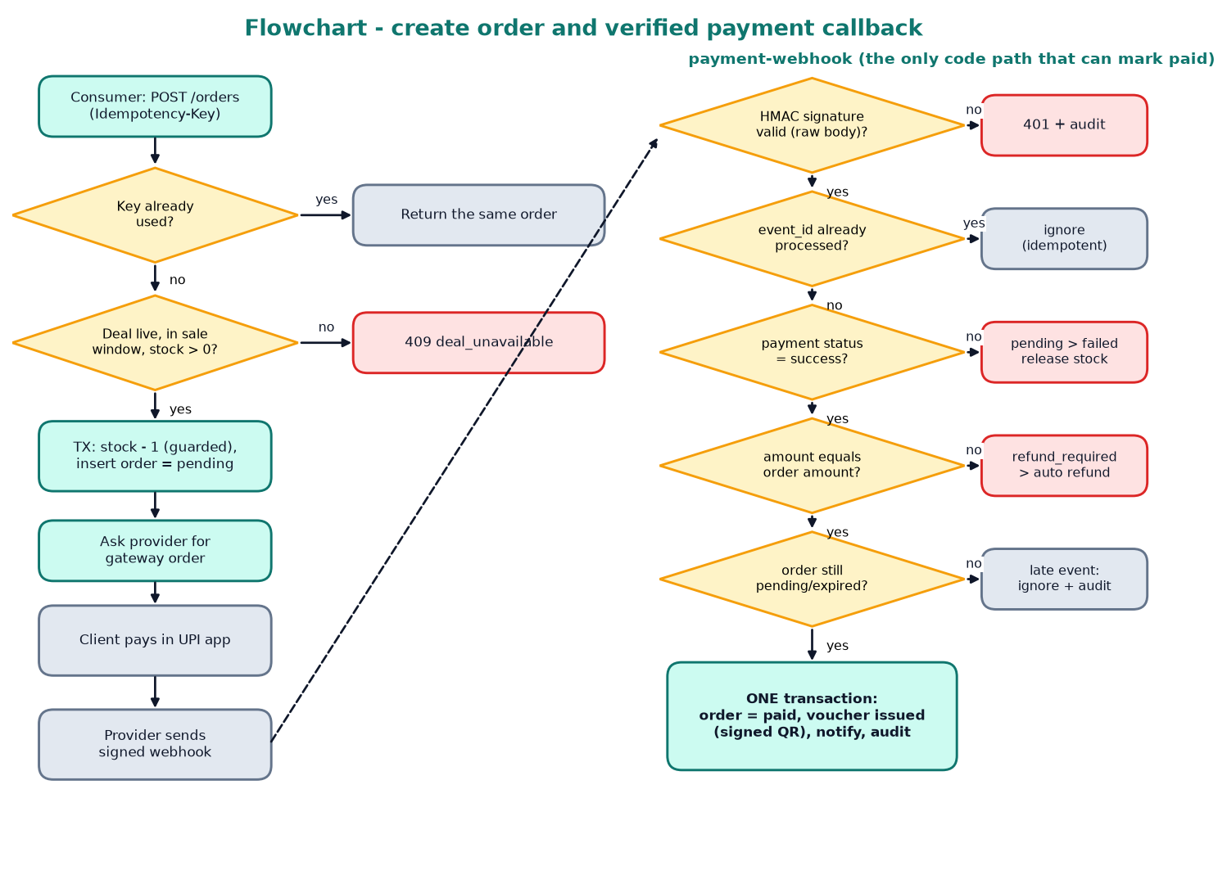
Figure 2.1 Flowchart: create order and verified payment callback (traces to R1).
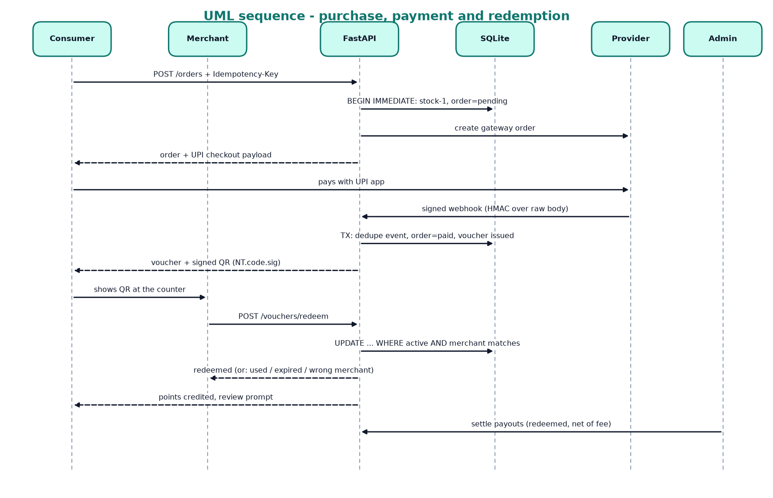
Figure 2.2 UML sequence: purchase, payment and redemption (R1, R2).
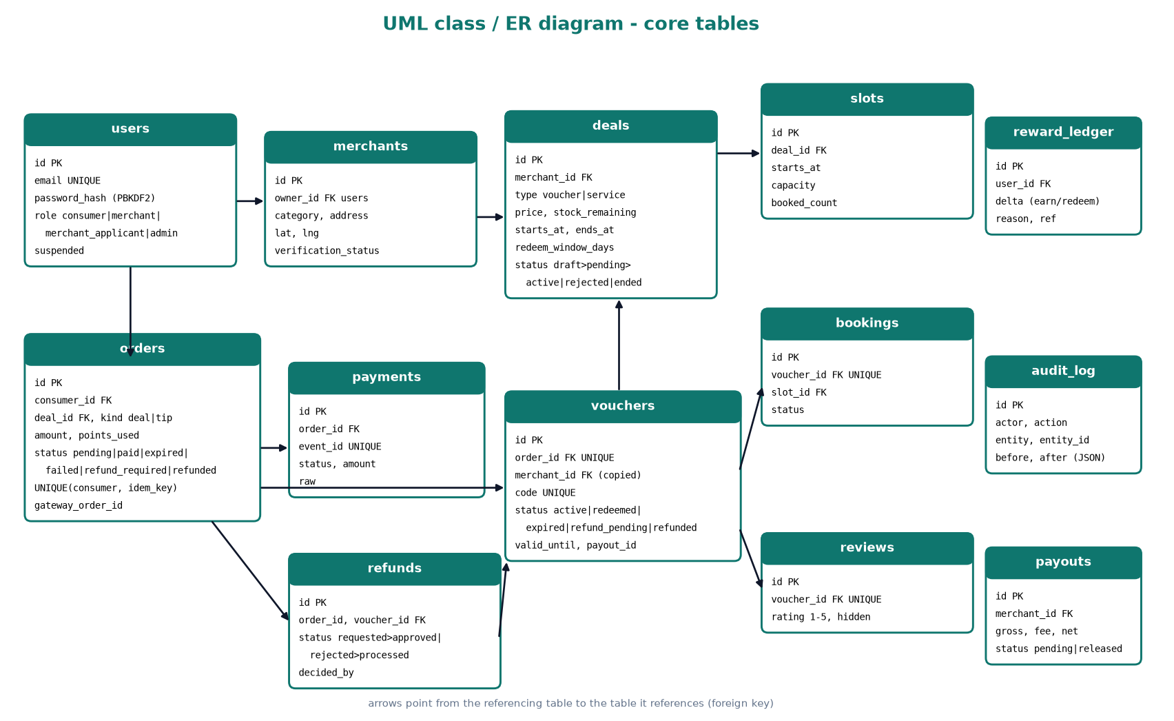
Figure 2.3 UML class / ER diagram of the core tables (R1 to R9).
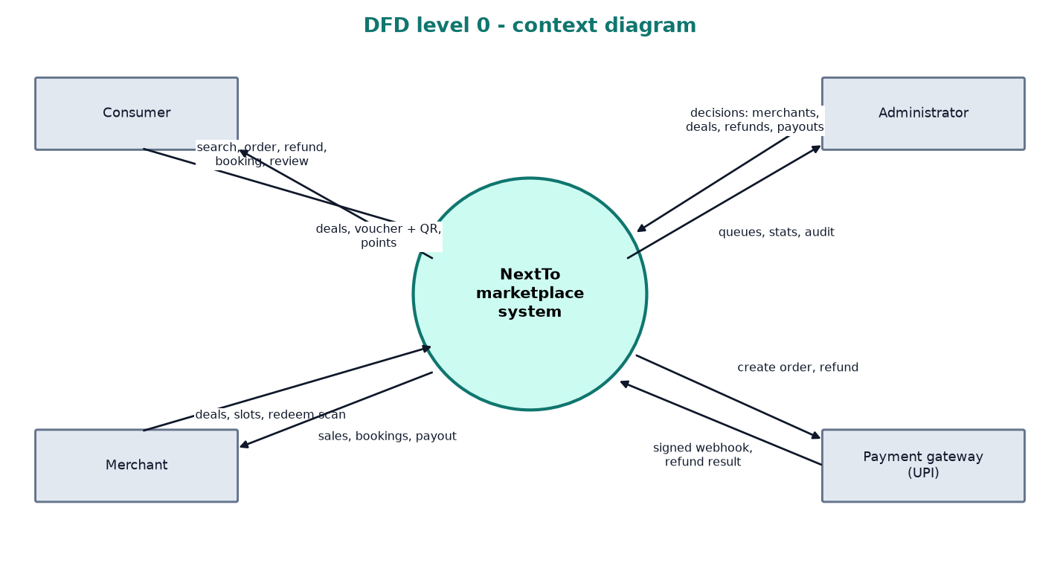
Figure 2.4 DFD level 0: context diagram.
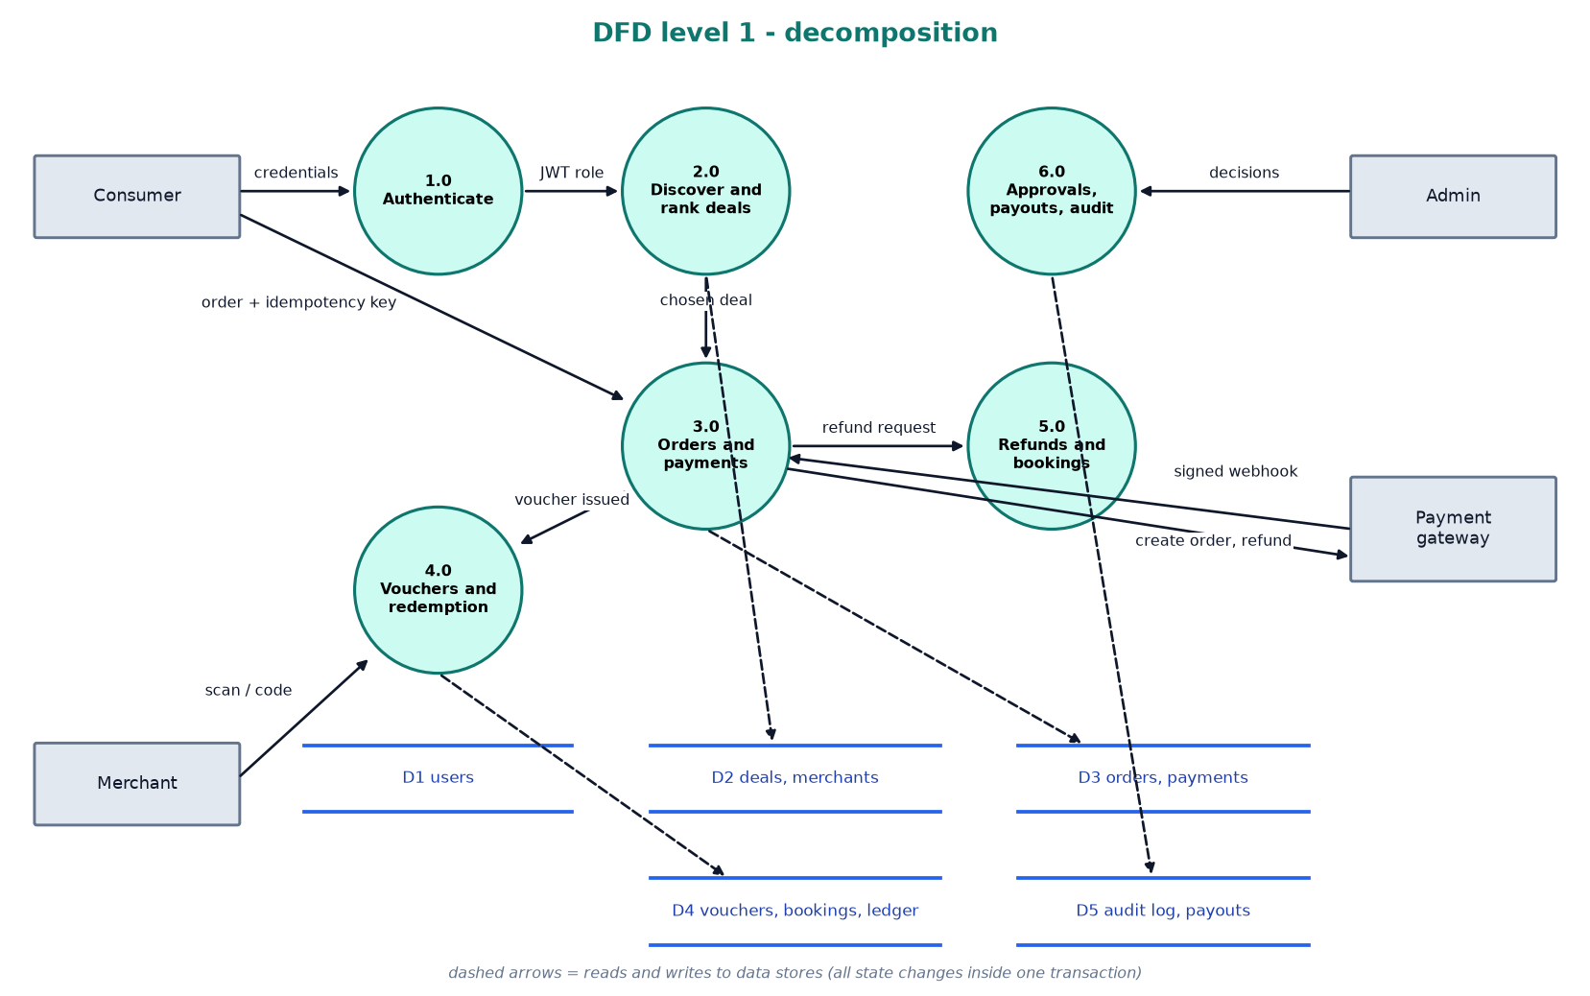
Figure 2.5 DFD level 1: processes and data stores.
2.3 Design decisions
- Idempotent, transactional purchase (algorithm and data model). The order is saved before the gateway is called, keyed by (consumer, Idempotency-Key), and stock is reserved in the same transaction. Alternative rejected: decrement stock at payment time, which allows overselling between payment and confirmation.
- Webhook as the only proof of payment (security). HMAC-SHA256 over the raw body, event-id de-duplication and an amount check, then one transaction for order, voucher and stock. Alternative rejected: trusting the client’s “payment done” signal.
- Ranking by a transparent weighted score (algorithm). 0.50 distance, 0.25 category, 0.15 recency, 0.10 urgency, with SQL bounding-box filtering first. Alternative rejected: a machine-learning recommender, which needs interaction history a new marketplace does not have.
- FastAPI with SQLite instead of the planned Supabase stack (technology): runnable and demonstrable anywhere with no accounts; see 3.4.
2.4 Traceability
Requirement ID | Design element that satisfies it
R1 | backend/app/services.py create_order, handle_webhook, settle_payment; providers.py PaymentProvider; UNIQUE(consumer_id, idempotency_key); flowchart in 2.2
R2 | services.py redeem_voucher (one conditional UPDATE); core.py qr_sign / qr_parse; UNIQUE vouchers.code
R3 | ranking.py score_deal; routers/consumer.py deals_nearby (bounding-box SQL, then haversine and score); AREAS fallback; radius widening
R4 | routers/auth.py; core.py PBKDF2 hashing, JWT with app_role claim, require() role guards
R5 | routers/merchant.py deal_create / deal_submit / deal_update; routers/admin.py deal_decision
R6 | services.py request_refund, decide_refund; voucher state refund_pending; routers/admin.py refunds
R7 | services.py create_booking, cancel_booking (guarded UPDATE on slots.booked_count)
R8 | services.py redeem_voucher credits reward_ledger; create_order use_points; routers/consumer.py review_create
R9 | db.py audit(); routers/admin.py audit_log, stats, run_payouts; merchant stats
R10 | single indexed lookup on vouchers.code plus one UPDATE; measured in 4.2
R11 | providers.py PaymentProvider, SimulatedProvider, RazorpayProvider, RiskScorer
R12 | frontend/src/api.ts and one React app: phone-width shell (consumer, merchant) and wide admin shell
Evidence: system design document (Week 4), detailed design document with all three diagram types (Week 6).
3. Implementation and Functionality
3.1 Progress against checkpoints
Checkpoint | Target | What is working (features) | Honest completion (%)
Core implementation (Week 8) | about 30% | Orders and Payments prototype: idempotent order, signed callback, voucher issue, refund, reconciliation; simulated provider; 69 tests (Node prototype, in-memory store) | 30%
Complete, refine and debug (Week 10) | about 55% | Rebuilt on FastAPI + SQLite: auth and roles, ranking and discovery, stock reservation, vouchers and redemption, refunds, bookings, rewards, payouts, audit log; automated tests | 55%
Consolidation, Phase-1 (Week 14) | about 70% | React app (consumer, merchant, admin) integrated with the API; 77 backend tests and a 21-step end-to-end journey pass; report, diagrams and demo data | 80%

Honest status: the planned MVP functionality (discovery, UPI-style payment, QR vouchers, bookings, rewards, refunds, payouts, audit, three role-based screens) is implemented and tested on the stack in 3.4 (77 automated tests, 21-step end-to-end journey). Overall completion is about 80% of the planned project scope; the checkpoint targets (30%, 55%, 70%) are the RIO schedule's, and the project is ahead of the Week 14 target. This is measured against the planned scope, not against a production system. The remaining work (about 20%) is the Phase-2 plan in 5.2: live gateway test, notifications, CI, PostgreSQL/Supabase migration, native apps, pilot and ML fraud scoring. Percentages are to be confirmed with the faculty guide.
3.2 Key features implemented
Idempotent order creation with stock reservation: Validates key, re-checks inside one transaction, reserves stock with a guarded UPDATE, then asks the provider for a gateway order (retry-safe). (services.py create_order, _resume)
Signed payment webhook: HMAC verification, event de-duplication, amount check; one transaction pays the order and issues the voucher; handles failure, late and out-of-order events. (services.py handle_webhook, settle_payment; providers.py)
Expiry and reconciliation jobs: Unpaid reservations expire after 10 minutes and return stock; a job asks the provider about stuck orders so a lost callback cannot cost a customer. (services.py expire_pending, reconcile; main.py scheduler)
Signed QR vouchers and single-use redemption: QR payload NT.code.signature; one conditional UPDATE enforces single use, expiry and the owning merchant; points credited at redemption. (services.py redeem_voucher; core.py qr_sign)
Discovery and ranking: Bounding-box SQL filter, haversine distance, weighted explainable score, area fallback when GPS is denied, automatic radius widening, list and Leaflet map. (ranking.py; routers/consumer.py; Home.tsx)
Refunds, bookings, rewards, reviews and tips: Refund state machine with provider retry; capacity-guarded slots; points ledger and checkout discount; one review per redeemed voucher; tip is an order of kind tip. (services.py; routers/consumer.py)
Merchant tools: Deal builder with approval workflow, QR camera scan or manual code, bookings view, sales dashboard and payouts. (routers/merchant.py; pages/merchant/*)
Admin dashboard: Merchant and deal approval queues, refund decisions, payout settlement, review moderation, user suspension, audit log viewer, job triggers. (routers/admin.py; pages/admin/*)
3.3 Code quality and optimization
Structure: the API is split by domain (routers/ for HTTP, services.py for transactional rules, providers.py and ranking.py for replaceable logic, db.py for schema and helpers). Errors share one JSON shape {error:{code,message}}; inputs are validated with Pydantic and explicit checks; every state change is audited.
One improvement (readability and performance): nearby search first filters candidates in SQL with a latitude/longitude bounding box and only then computes haversine distance and score in Python, instead of scoring every deal. Before: score all active deals; after: score only deals inside the radius box. The measured average for a search over the nine seeded deals is 6.3 ms (in-process); no before measurement exists, so no speed-up figure is claimed.
3.4 Deviations from the design
- Stack: the system design specified Supabase (PostgreSQL, Auth, Edge Functions, Realtime), Expo mobile apps and Vite web apps. The built system is FastAPI with SQLite and one React + Vite app. Reason: a single runnable stack that could be built and demonstrated within the time available, with no cloud account or SMS provider needed.
- Mobile: separate Expo consumer and merchant apps became a mobile-first responsive web app. Consumer screens use a phone-width layout that fills the screen on a phone in Chrome; the merchant and admin dashboards are desktop web layouts with a sidebar. A shopper-only Android APK (a Capacitor wrapper that opens the hosted app) is built and downloadable; true native apps move to Phase 2.
- One web app serves consumer, merchant and admin, switched by role, instead of separate apps. Reason: shared API client and components, less duplication.
- Sign-in: phone OTP was replaced by email and password (PBKDF2-hashed). Reason: no SMS provider selected; OTP stays in Phase 2.
- Atomicity: the design put each atomic operation in a PostgreSQL function called with rpc(). Here each runs in one SQLite BEGIN IMMEDIATE transaction in services.py, which serialises writers. The guarded UPDATE statements are the same ones the design describes.
- Row-level security was replaced by role guards at the API (a signed JWT carries app_role, and the role is granted server-side only after admin approval). Direct database access by clients does not exist.
- Payments: the provider is simulated (real HMAC-SHA256 signing and verification). A Razorpay adapter is written but has not been run against Razorpay because no keys were available.
- Notifications: in-app notification rows only; push and email delivery are not implemented. Payouts are computed by an admin action and released manually, as in the design.
- Behaviour added beyond the design: provider-outage retry with the same key, refund retry, late-event handling, paid-but-sold-out auto-refund, and points restored on refund.
Evidence: screenshots of core output (Week 8), completed and refined output (Week 10), integrated modules and change screenshots (Week 14).
Screenshots from the running application (local run and the hosted demo at https://nextto.vercel.app, demo data): consumer discovery, checkout, voucher QR and redeemed voucher; merchant dashboard, redeem screen and deals; admin overview and audit log.
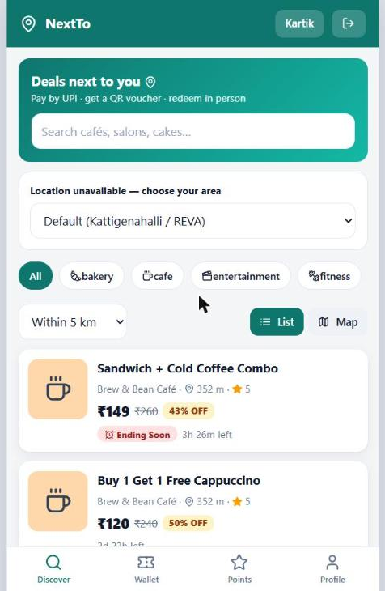 | 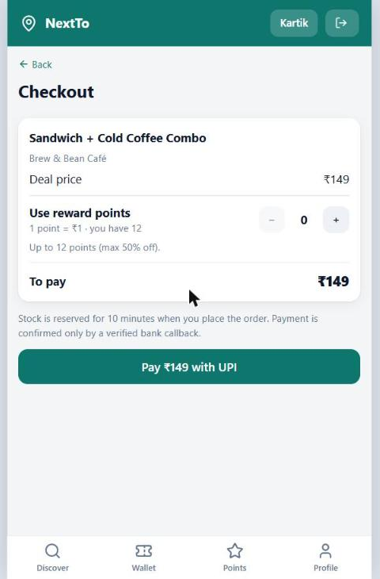 | 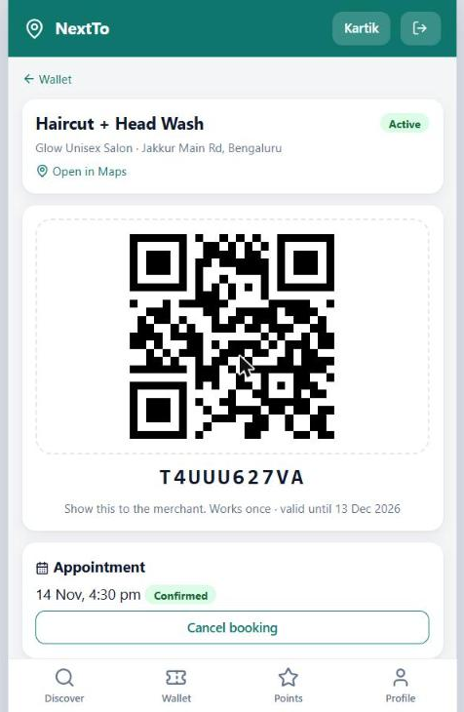
Discover (ranked, with location fallback) | Checkout with reward points | Active voucher with signed QR and booking
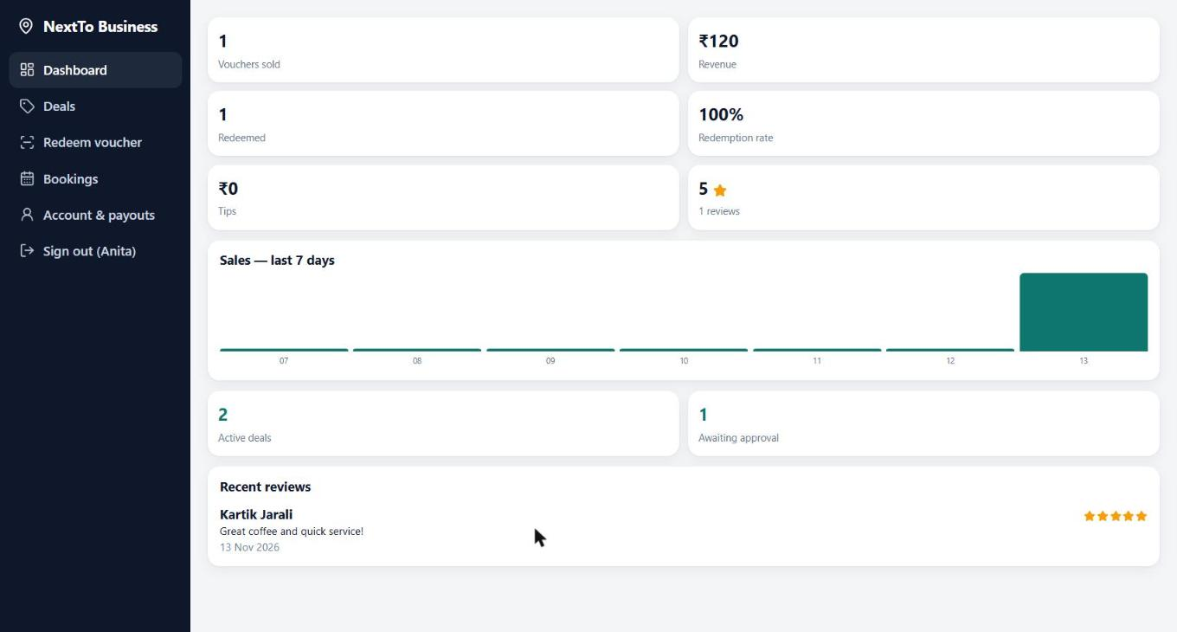
Merchant dashboard
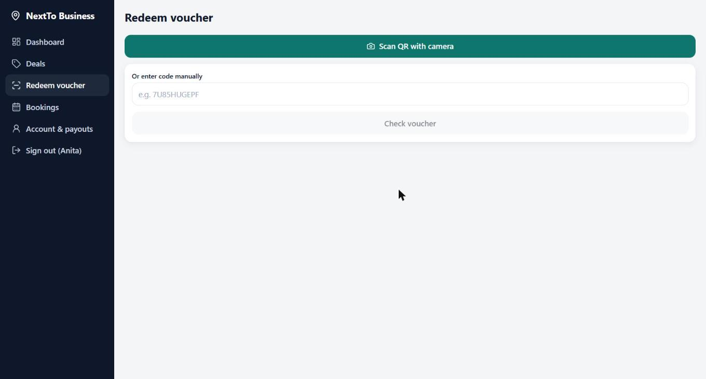
Merchant redeem screen (camera or code)
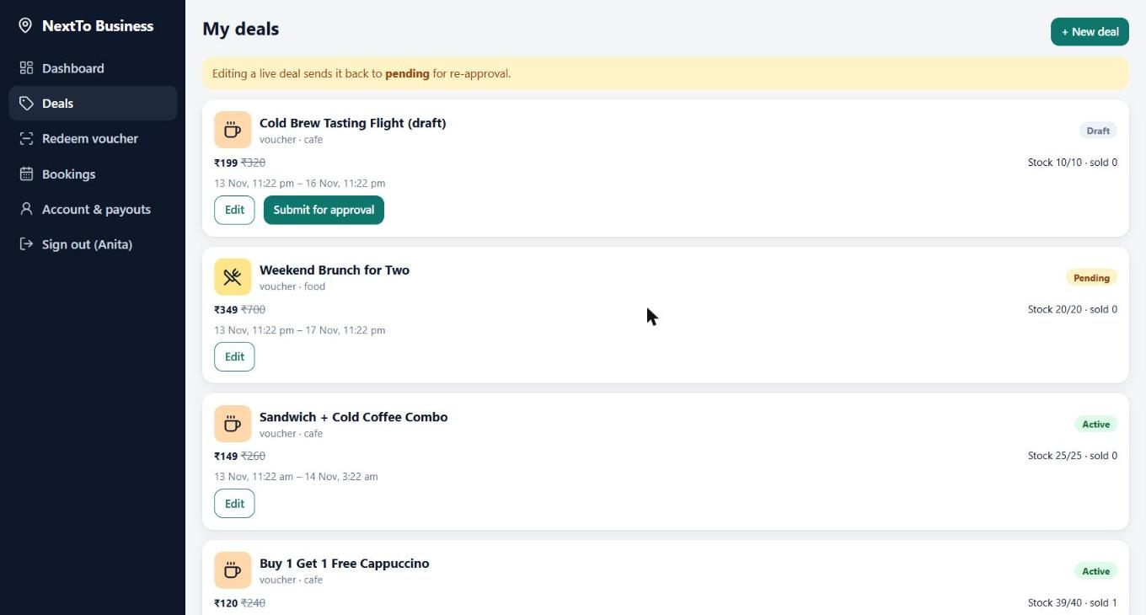
Merchant deal list with approval states
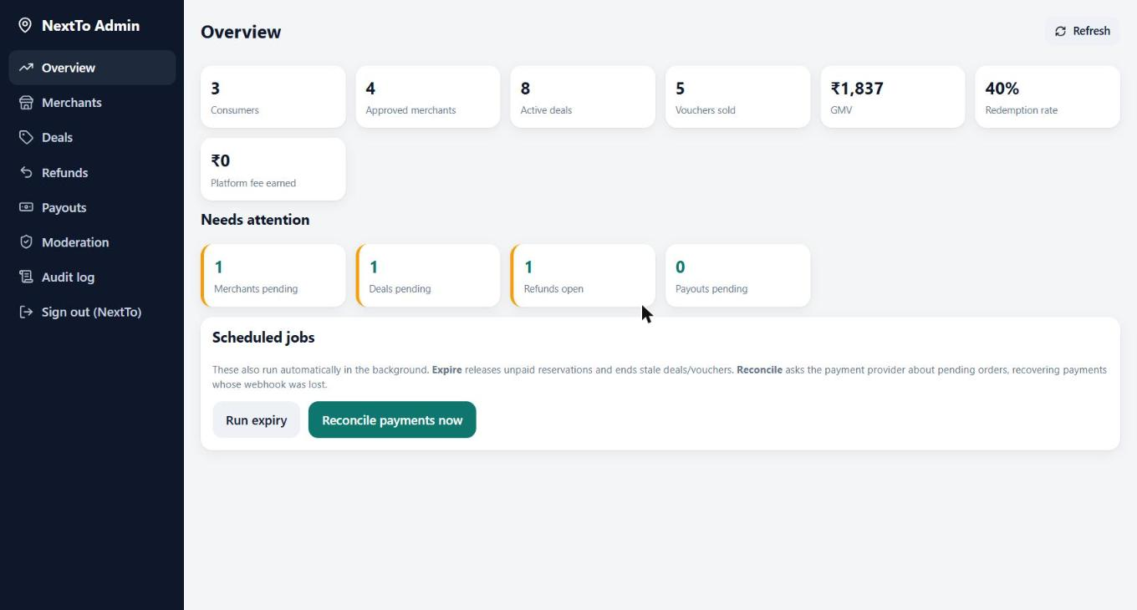
Admin overview: platform statistics, pending queues and scheduled jobs.
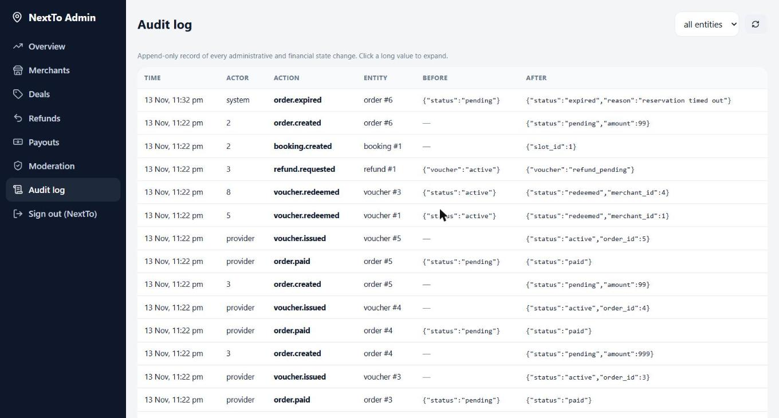
Admin audit log: append-only record of financial and administrative changes (before and after).
Week 8 and Week 10 screenshots: [screenshot to add from the earlier checkpoints if required]; the figures above are from the Week 14 consolidated build.
4. Testing, Debugging and Integration
4.1 Testcase design
Test ID | Feature / requirement | Input | Expected output | Actual output | Pass / fail
T1 | R1 create order | POST /orders, deal stock 5, price 100 | Order pending, amount 100, stock 4, no voucher | Order pending, amount 100, stock 4, no voucher | Pass
T2 (boundary) | R1 last unit | 6 buyers race for the single remaining unit (threads) | Exactly 1 order created, stock 0 | 1 pending order, 5 rejected, stock 0 | Pass
T3 (negative) | R1 idempotency | Missing or 5-character Idempotency-Key | 400 | 400 for both | Pass
T4 | R1 retry | Same Idempotency-Key sent twice | Same order id, one row, stock reserved once | Same id, 1 row, stock 4 | Pass
T5 (negative) | R1 forged webhook | Callback with wrong signature, and one with no signature | 401, order stays pending, no voucher | 401 twice, pending, 0 vouchers, 2 audit rows | Pass
T6 (negative) | R1 tampered body | Signed body amount changed to 1.0 after signing | 401 | 401 | Pass
T7 | R1 duplicate event | Same event_id delivered twice | Second ignored, one voucher | status duplicate, 1 voucher | Pass
T8 | R1 out of order | Failure event after success event | Order remains paid | Ignored, order paid | Pass
T9 (negative) | R1 amount check | Signed success with amount 1 higher than order | No voucher, auto refund, stock restored | refunded, no voucher, stock 5 | Pass
T10 | R1 late payment | Payment after reservation expired and the unit was sold | Auto refund | refunded, no voucher | Pass
T11 | R1 lost callback | Payment succeeds at provider, no callback; run reconcile | Order becomes paid with voucher | paid 1, voucher active | Pass
T12 | R2 redeem | Merchant redeems an active voucher (price 100) | Redeemed; 10 points at redemption, none at purchase | 10 points awarded at redemption, 0 at purchase | Pass
T13 (negative) | R2 double scan | Second scan of the same voucher | 409 already_redeemed, points not doubled | 409, points still 10 | Pass
T14 (boundary) | R2 simultaneous scans | 5 simultaneous scans of one voucher | Exactly one succeeds | 1 redeemed, 4 already_redeemed | Pass
T15 (negative) | R2 forged QR | QR payload with a wrong signature | 400 bad_qr | 400 bad_qr | Pass
T16 (negative) | R2 expiry | valid_until set to yesterday | 409 expired | 409 expired | Pass
T17 (boundary) | R7 capacity | Two buyers book a capacity-1 slot; first cancels | Second gets 409 slot_full; after cancel it succeeds | 409 slot_full, then 200 | Pass
T18 (boundary) | R8 points cap | Use 51 points on a 100 rupee deal, then 50 | 51 rejected (bad_points); 50 gives amount 50 | 400 then amount 50 | Pass
T19 | R6 refund retry | Provider refund API down, admin approves, then retries | 502 then processed; order paid in between | 502, refund approved, order paid; retry processed | Pass
T20 (negative) | R4 roles | Consumer token on admin API; token forged with app_role=admin | 403 and 401 | 403 and 401 | Pass
T21 | End to end | scripts/e2e_demo.py: apply, approve, create deal, approve, buy, pay, redeem, review, tip, payout | 21 steps pass | 21 of 21 steps passed on the live server | Pass
4.2 Test summary
Total: 77 automated pytest tests, 77 passed, 0 failed (run on 13 Nov 2026, about 80 s). By file: test_auth_admin_access.py: 23, test_orders_payments.py: 21, test_ranking_discovery.py: 9, test_vouchers_refunds_bookings.py: 24. Plus the 21-step end-to-end script, which passed on the live server. The suite covers every business rule and endpoint group (auth, role matrix, discovery and ranking, orders, webhook, expiry, reconciliation, vouchers, refunds, bookings, reviews, tips, payouts, audit). Line coverage was not measured (a coverage tool is not installed yet; it is a Phase-2 item). Performance check (in-process, no network): voucher redemption median 9.1 ms, 95th percentile 12.8 ms over 20 redemptions, against the 200 ms target (R10); a nearby search averaged 6.3 ms. Table 4.1 lists 21 representative cases, each backed by the named test or script.
4.3 Bugs found and fixed
Bug | Root cause (one line) | Fix | Evidence
Two simultaneous requests with one idempotency key could both pass the look-up and create two orders | Look-up and insert were not one atomic step (a window opened by an await) | Re-check inside a BEGIN IMMEDIATE transaction; UNIQUE(consumer_id, idempotency_key) as the final guard | tests T2, T4; [screenshot to add]
A payment arriving after the 10-minute reservation expired could oversell or leave the payer with nothing | Expiry returned the unit to stock but the webhook assumed a pending order | Late payment tries to re-reserve; otherwise the order becomes refund_required and is auto-refunded | test T10; [screenshot to add]
Two merchants scanning one voucher at once could both succeed | A read-then-write check leaves a gap between the check and the update | One conditional UPDATE (active, not expired, owned by merchant); rowcount decides | test T14; [screenshot to add]
Unverified merchant applicants saw red 403 error boxes on the Deals, Bookings and More tabs | The merchant shell showed every tab regardless of verification status (found while reviewing the UI) | Applicants see only the verification dashboard; other merchant routes redirect to it | frontend/src/App.tsx MerchantShell; [screenshot to add]

4.4 Integration of Module-1 and Module-2
Module-1 is Orders and Payments (order, webhook, expiry, reconciliation, refunds); Module-2 is Deals, Discovery and Vouchers (deal workflow, ranking, redemption, bookings, rewards). They connect through the database inside one transaction: payment confirmation reads the deal, takes or returns stock, and issues the voucher that Module-2 later redeems. Integration issues met: (1) the Week 8 prototype reduced stock at payment time while the design reserves it at order creation, which allowed overselling, so reservation moved into order creation with an expiry job; (2) points were first tied to payment and then to redemption, so refunds no longer need to reverse earned points; (3) the React checkout must reuse one idempotency key per screen, otherwise a double tap would create two orders. All three are covered by tests T1 to T4, T12 and T19.
Evidence: testcase documents and testing output (Week 12), bug-fix screenshots with root-cause notes (Weeks 10 and 14).
Test evidence: the pytest output (77 passed) and the scripts/e2e_demo.py output (21 of 21 steps) are reproducible with the commands in README.md.
5. Documentation, Phase-2 Plan and Viva Readiness
5.1 My individual contribution
Leah Chakarmakal (R23EF117) owns Module-2, Deals, Discovery and Vouchers: the deal draft, approval and publish workflow, the ranking function (distance, category, recency, urgency) with its location and radius fallbacks, single-use QR redemption, appointment booking with capacity guards, reward points, and the consumer discovery, voucher and merchant deal and scan screens, together with their tests and documentation. Team: Kartik Jarali (R23EF107) owns Module-1, Orders and Payments, and the backend core. [Contribution weeks to be confirmed by the student.]
5.2 Phase-2 pending-work plan
Pending work (about 20%) | Priority | Planned approach | Target week
Test Razorpay or Cashfree in provider test mode with keys | High | Enable the written RazorpayProvider adapter; verify signature, refund and status calls with published test cards | Week 15
Move from SQLite to PostgreSQL / Supabase with PostGIS and row-level security | High | Port schema; rewrite atomic operations as SQL functions; add RLS policies; re-run all 77 tests; makes hosted demo data permanent (SQLite on Render resets on restart) | Phase 2
True native apps (Expo / React Native) for consumer and merchant, beyond the current APK wrapper | Medium | Reuse the API and types; native camera QR and push notifications | Phase 2
Push, email and SMS delivery; phone OTP login | Medium | Replace the in-app notification queue with provider adapters; add an SMS provider | Phase 2
CI pipeline (GitHub Actions) | Medium | Lint, type-check, pytest and e2e script on every push | Week 15
Pilot with at least 5 merchants and 50 consumers; usability survey | Medium | Onboard merchants near campus; collect feedback; measure redemption rate | Phase 2
ML fraud scorer and personalised ranking | Low | Attach a model through RiskScorer after collecting labelled data; add a personalisation term to the score | Phase 2
Load and security testing; code coverage report | Medium | Add pytest-cov, a synthetic large deal set and an authorisation fuzz pass | Week 16

5.3 Challenges and learnings
Hardest problem: ranking and discovery that stay useful with no interaction history and with missing or inaccurate location. Tried: distance-only sorting, which ignored category and urgency, and an empty list when GPS was denied. What worked: an explainable weighted score (0.50 distance, 0.25 category, 0.15 recency, 0.10 urgency), an area-picker fallback, automatic radius widening when nothing is found, and a SQL bounding box so only nearby candidates are scored. Different next time: add a coverage report and UI tests for the scan and booking flows early, and test on real phones and real GPS drift.
5.4 Viva preparation — Be ready to explain without notes:
- Why this design and these technologies, and what the alternatives were
- How each diagram maps to your code
- Your key algorithm or logic, with complexity
- A bug you found and how you found its root cause
- What is left to build in Phase-2 and why
Prepared answers (short):
- Design: modular API on FastAPI + SQLite for speed of delivery; Supabase/PostgreSQL planned. A signed webhook is the only proof of payment because the client cannot be trusted.
- Diagram to code: flowchart = create_order + settle_payment; sequence = routers calling services.py; ER = db.py SCHEMA; DFD processes = router modules.
- Algorithm: score = 0.5 distance + 0.25 category + 0.15 recency + 0.10 urgency; search is O(n) over candidates inside the radius box, then O(n log n) to sort; redemption is O(1) via the UNIQUE index on voucher code.
- Bug: a voucher could be redeemed twice by two simultaneous scans; found with a multi-thread test; root cause is a non-atomic check-then-update; fixed with one conditional UPDATE that decides success by row count.
- Phase 2: live gateway test, PostgreSQL/Supabase migration, native apps, notifications, CI, pilot, ML fraud and personalisation.
Evidence: Phase-2 pending-work plan document (Week 14); structured viva (Week 16).
Declaration
I declare that this report is my own work and that the evidence I uploaded is genuine.
Student signature and date | Faculty guide signature and date
[AI-assistance disclosure to be completed by the student per RIO policy]
Appendix A. Diagrams
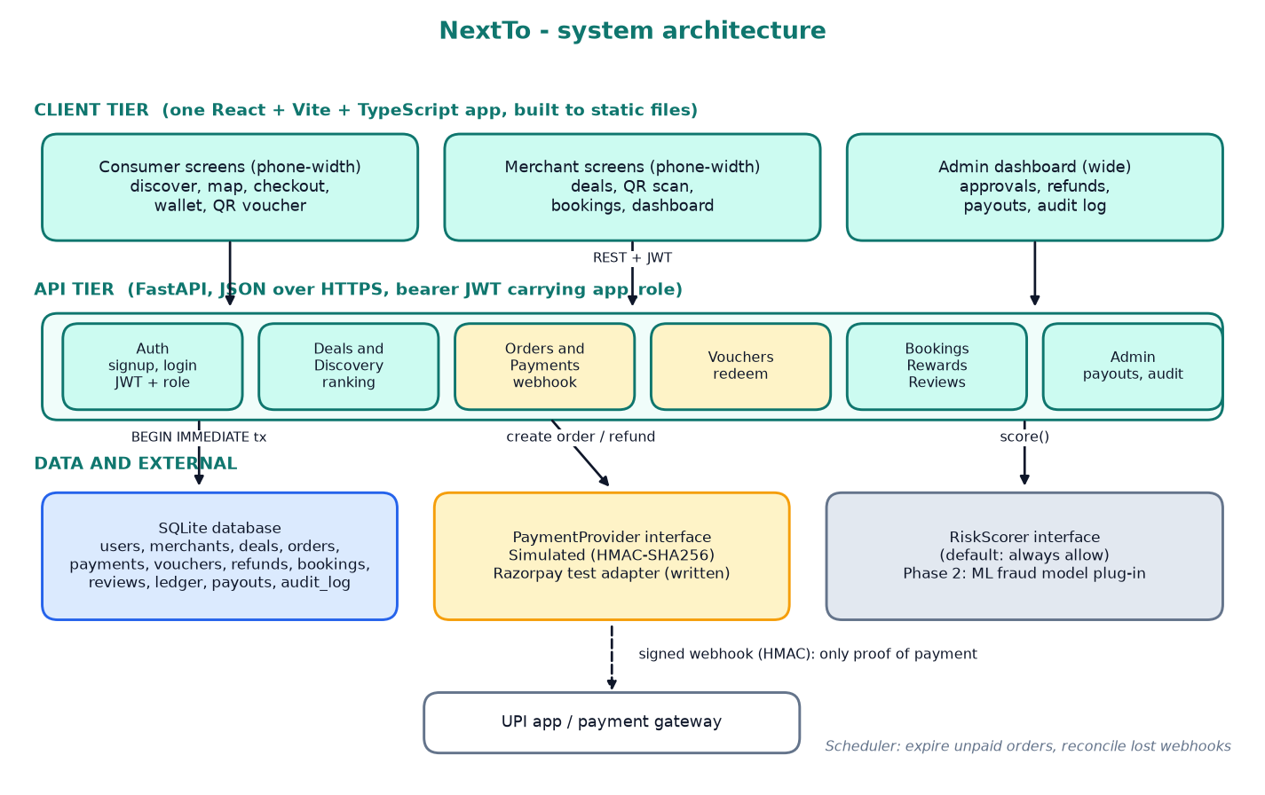
Figure A1 System architecture of NextTo as built (referenced from Section 2.1).
The flowchart, UML and DFD diagrams are in Section 2.2 (Figures 2.1 to 2.5).
Appendix B. How to reproduce the evidence
- Run the app: run.bat (builds the React app and serves everything on http://localhost:8000; a phone on the same Wi-Fi can open the same address in Chrome).
- Tests: cd backend, python -m pytest tests -q (77 tests). End to end: python scripts/e2e_demo.py.
- Demo accounts: kartik@demo.com (consumer), cafe@demo.com (merchant), admin@nextto.dev (admin). Repository: https://github.com/Kartikjarali010/next-to. Live demo: https://nextto.vercel.app (the free host sleeps when idle, so the first load can take up to a minute).
- Android app (APK): https://nextto.vercel.app/NextTo.apk (Android asks to allow installs from this source; the app opens the hosted site and needs internet). Scan the QR code below to download it.
- Hosting: the React app is deployed on Vercel and the FastAPI backend on Render (https://nextto.vercel.app). The hosted database is SQLite on an ephemeral disk, so demo data is reseeded whenever the service restarts; PostgreSQL in Phase 2 makes it permanent.
- Entry points: shoppers use https://nextto.vercel.app (the Android app and the installed phone app open only this shopper side); merchants use /merchant (merchant sign-in) and administrators use /admin (admin sign-in). Each sign-in accepts only its own role, enforced on the server, and each keeps a separate session.
 QR: download the Android app (APK)

