**PRACTICAL ON 🡪 FUNDAMENTAL OF COMPUTER SCIENCE AND INFORMATION TECHNOLOGY**

**[Submitted in partial fulfillment of the requirements for the award of the Degree of Bachelor of Computer Application (BCA) Program HNBGU]**

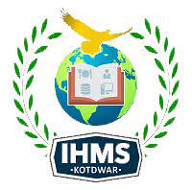

**Submitted to :- MISS PALLAVI Submitted by :- KARTIK KALA**

**BCA: 1st Sem./1st year**

**Roll no.:**

**Enroll No.:**

**(Batch: 2021-2024)**

**Department of CS/IT**

**Institute of Hospitality, Management and Sciences**

**B.E.L. Road, Balbhadrapur, Kotdwara**

**District- Pauri (Garhwal), Uttrakhand - 246149**