BUSINESS REQUIREMENTS DOCUMENT
Client Communication Settings
and WhatsApp Logs
Spectrum Cloud | GST module
Product | Spectrum Cloud
Module | GST
Feature | Client Communication Settings (existing page, new look) and WhatsApp Logs (new)
Document status | Draft v1
Date | 23 October 2026
Prototype | https://kartikkhandelwal-pm.github.io/client-communication-settings/ (sample data only)

1. Overview

1.1 Background
In the GST module, a firm can choose which messages each of its clients receives automatically:
- Scheduled reports, for example the GSTR-2A / 2B report, the Tally data and the 2B Report.
- Update notifications, which tell a client when something happens to their data.
Each can go out by email or by WhatsApp. This is set on the Client Communication Settings page, one client per row. The user can also send a report to one client straight away by clicking the email or WhatsApp icon in that client's row.
The page exists today. WhatsApp messages have no log. The user cannot see how many clients a scheduled WhatsApp run was meant for, how many messages were actually sent, or what happened to them.

1.2 What we are doing
Two things:
- Refresh the look of the Client Communication Settings page. The entry point and all of its functions stay the same. Only the layout, tables and filters are redone.
- Add WhatsApp Logs (new). A page where the user can see every WhatsApp message sent from this page: for a scheduled run, how many clients were targeted, how many messages were sent, and the status of each. A WhatsApp Logs button on the settings page opens it.

1.3 Goals
The user can:
- Keep doing everything they do on the settings page today, with the same entry point.
- See, for every scheduled or update-notification WhatsApp run, how many clients were targeted and what happened to the messages.
- See, before the next scheduled 2B Report goes out, how many clients it will target.
- See the status of every WhatsApp message, and the reason when it did not reach the client.
- Find a particular run, client or message quickly (search, filters, export).

1.4 Scope
- A new look for the Client Communication Settings page. Its functions and its entry point stay the same.
- A WhatsApp Logs page: bulk runs, single messages, and the status of every message.
- On the Bulk messages tab, the next scheduled 2B Report, with the number of clients it will target.
- Search, filters, date range and export (CSV) in the logs.
- The status and the failure reason of each message, taken from Rampwin.
- A WhatsApp Logs button on the settings page.
- Only messages sent from this page are logged. This means the scheduled WhatsApp report, update notifications, and the Send button on this page. WhatsApp messages sent from any other place in Spectrum Cloud are not shown.

2. Key concepts
Read this section first. The rest of the document uses these terms.

2.1 Two groups of settings
Group | What it is | Tab on the settings page
Scheduled reports | A report sent to the client on a schedule. Today: GSTR-2A / 2B (email), Tally data (email), 2B Report (WhatsApp) | Scheduled Reports
Update notifications | A message to the client when something happens (an event). Two settings: Notify on Email, Notify on WhatsApp | Update Notification
Each setting is a switch per client. Clients with no email address cannot get email settings. Clients with no mobile number cannot get WhatsApp settings. Their switch is greyed out.

2.2 Two kinds of WhatsApp messages in the logs
Kind | What it is | Where it shows
Bulk message | One run that goes to many clients together at a scheduled time. Example: the 2B Report that goes to every client whose switch is on | Bulk messages tab. Opening one shows every client's message inside it
Single message | One message to one client. Example: the Send button on the settings page, or an update notification for one client's event | Single messages tab
The rule: sent together to many clients at one time = Bulk. Sent to one client = Single.
A bulk run can have thousands of clients, so each run has its own page.

2.3 Trigger event
Every message is sent because of something. We call this the trigger event: the name of the place or event the message was sent from.
List of all trigger events and their names: {Link to be added by the domain team}
For every trigger event the domain team gives us:
- the trigger event name (shown to the user), and
- whether it is sent as a bulk run (to everyone together at a set time) or as a single message (to one client).
Placeholder. The names on the prototype screens (for example "GSTR-2B data updated", "Return due date reminder", "Payment received") are examples only. Only 2B Report is a real name, because it is on the settings page today. The final list will be added by the domain team.

2.4 IDs the user sees
Users never see Rampwin's codes. They see short IDs made by Spectrum Cloud.
What | Format | Example
Bulk run | WR- + number | WR-200
One message inside a bulk run | run ID + position | WR-200-1, WR-200-2 …
Single message | WS- + number | WS-501

2.5 Numbers and statuses
Numbers for a bulk run
Number | Meaning
Targeted | Clients selected for this run: those whose switch was on when the run started
One count per status | How many messages are in each status (below)
Reached | Delivered + Read, as a percentage of Targeted
The numbers add up: Targeted is the total of all the status counts.
Statuses. The status of every message is taken from Rampwin and shown as Rampwin gives it, in plain words (for example Pending, Sent, Delivered, Read, Failed). The final list follows what Rampwin provides.

3. How the user opens the page
Entry point (unchanged). In the GST module there is a profile drawer. It has a Client Settings tab. Clicking this tab opens the Client Communication Settings page.
WhatsApp Logs (new). A WhatsApp Logs button on the settings page opens the logs. The logs page has a Back to Client Communication Settings link.

4. The Client Communication Settings page
All the functions on this page are the same as today, including saving each switch on its own and editing the contact details in the table. This section describes the page as it is in the prototype, so the team can check that nothing was lost.
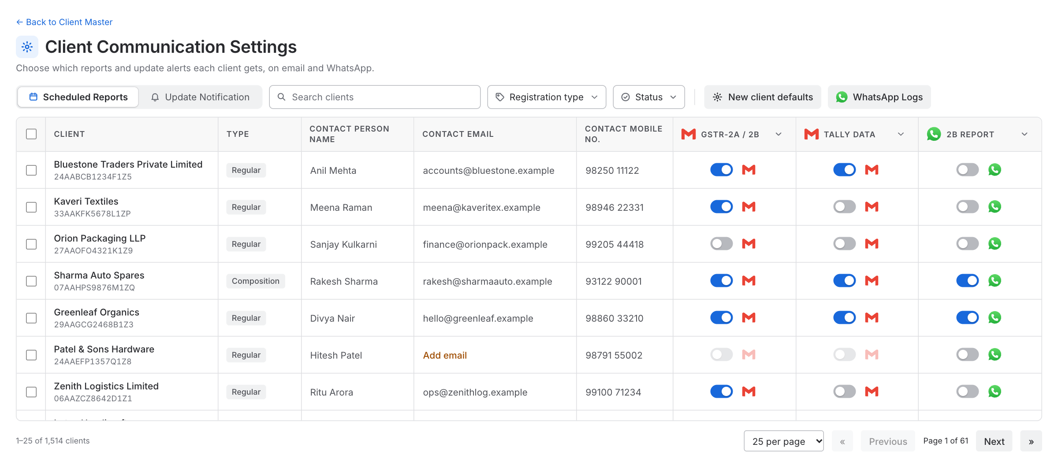
Figure: Scheduled Reports tab

4.1 Toolbar
From left to right:
- Tabs: Scheduled Reports, Update Notification.
- Search: by client name, GSTIN, contact person, email or mobile number.
- Filters: Registration type (every registration type that exists in the system, for example Regular or Composition), and Status (all, something turned on, all turned off, missing email or mobile).
- New client defaults and WhatsApp Logs buttons, after a thin divider. These are action buttons, not filters.
Filters read the same way everywhere: "Status" when nothing is picked, "Status: Read" when something is.

4.2 Table
One row per client.
Column | Notes
Checkbox | Select clients for a bulk change
Client | Name, with the GSTIN below it
Type | The client's registration type, as it is in the system
Contact Person Name | Click to edit
Contact Email | Click to edit. "Add email" in orange when missing
Contact Mobile No. | Click to edit. "Add mobile no." in orange when missing
Scheduled Reports tab: GSTR-2A / 2B (email), Tally Data (email), 2B Report (WhatsApp) | A switch, and a send icon (email or WhatsApp logo)
Update Notification tab: Notify on Email, Notify on WhatsApp | A switch
Switches.
- Each change is saved on its own, with a short "Saved" message.
- The ▾ button in a column title turns that setting on or off for all listed clients.
- Tick one or more clients (the top checkbox ticks all clients on the page). A bar appears above the table: pick a setting, then turn it On or Off for the ticked clients only.
- A client with no email (or no mobile number) has that switch greyed out. Taking away an email turns that client's email settings off.
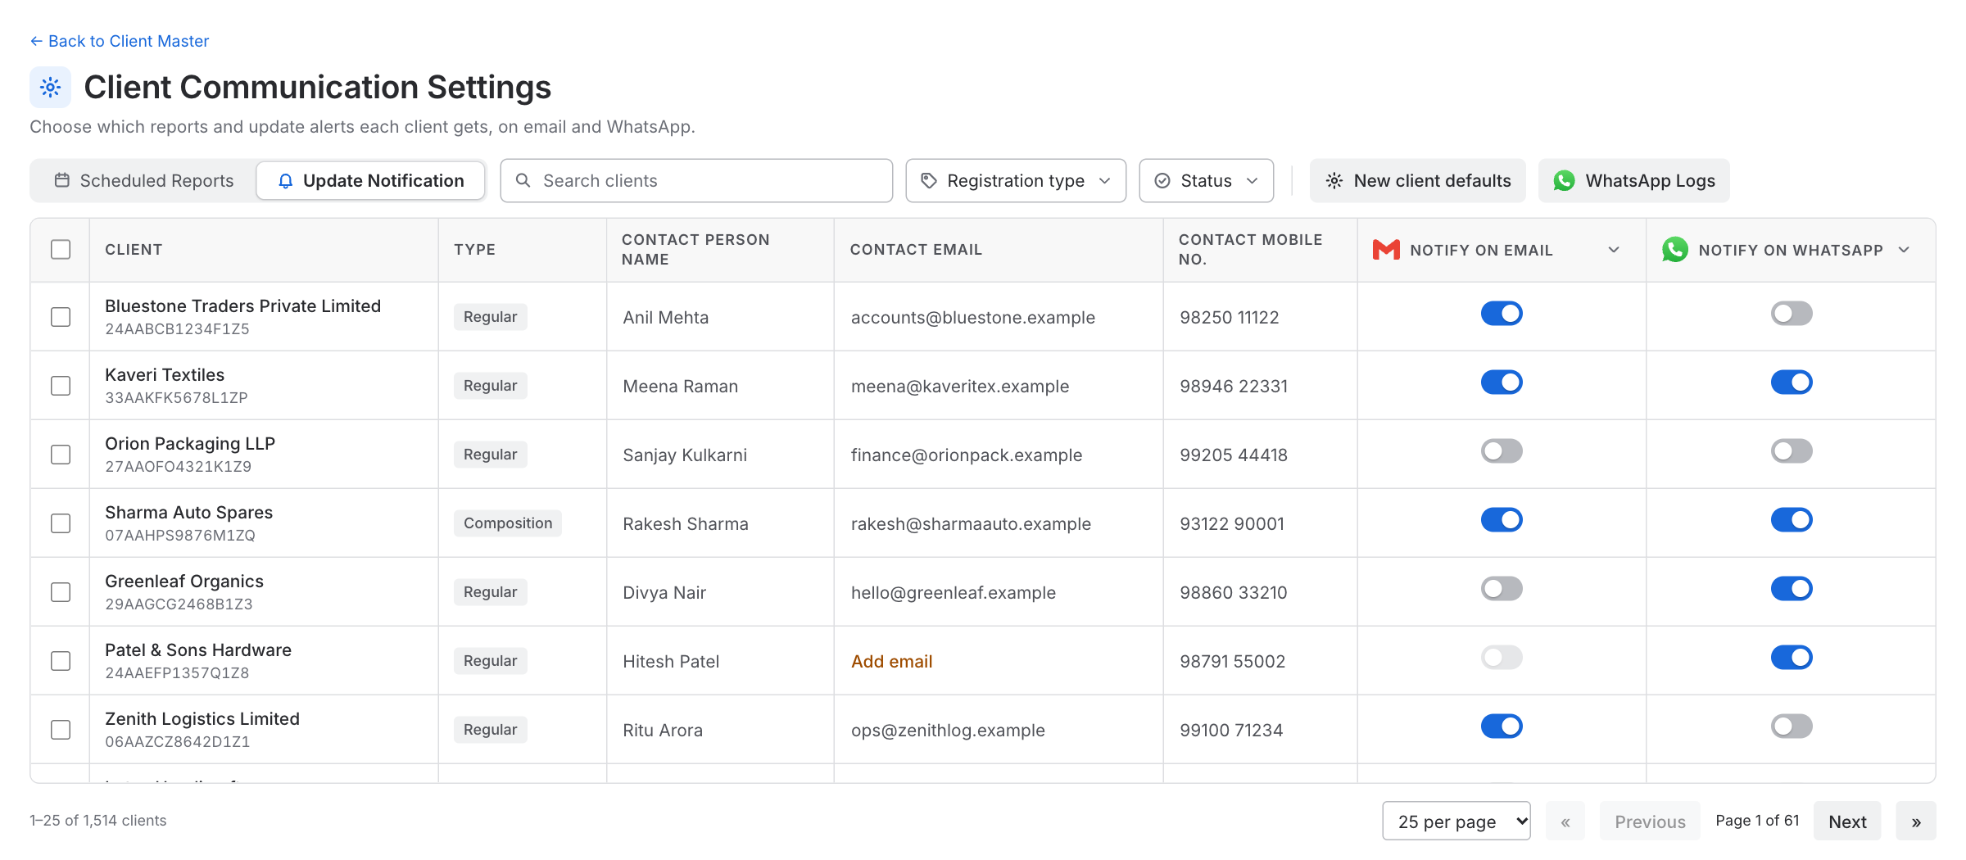
Figure: Update Notification tab

4.3 Send icon (Scheduled Reports tab)
Clicking the email or WhatsApp icon next to a setting sends that report to that client straight away, even when the switch is off. The icon shows a spinner, then a tick, and a message says what was sent and to whom. It is greyed out when the client has no email or mobile number.
A WhatsApp send from this icon is written to the WhatsApp Logs as a Single message (section 5.5).

4.4 New client defaults
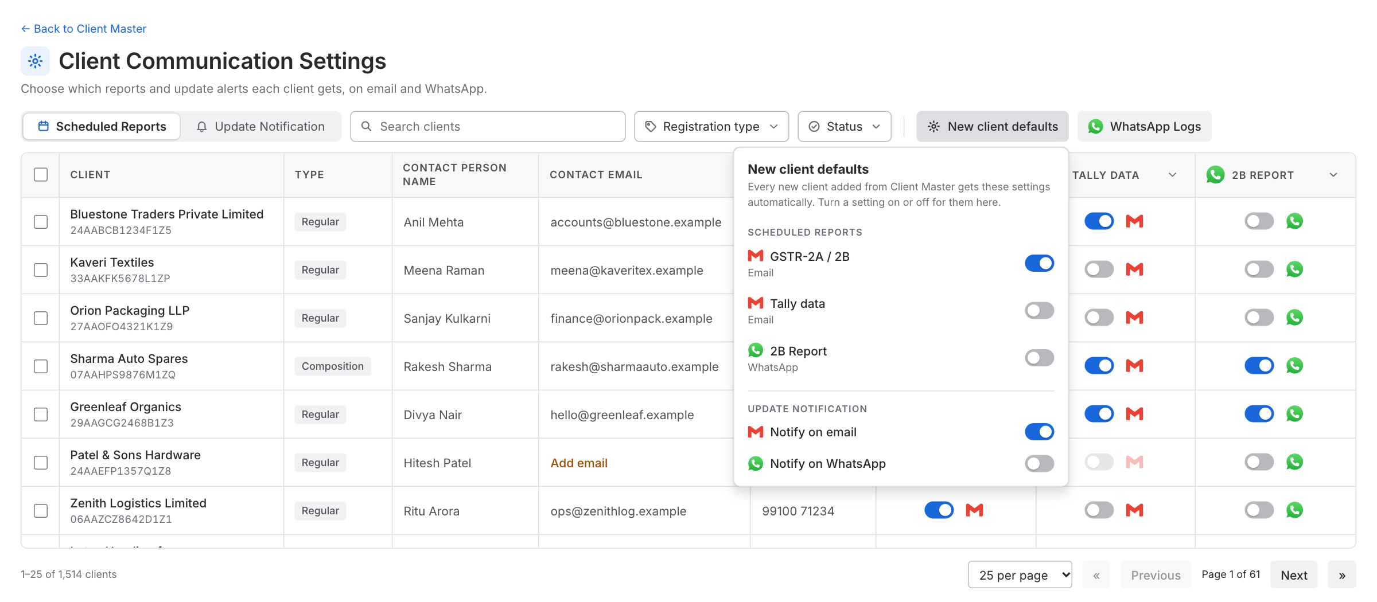
Figure: New client defaults
The user chooses which settings are on for a new client. Every new client added from Client Master gets these settings automatically. Existing clients are not changed.

4.5 Paging
25, 50 or 100 clients per page, with first, previous, next and last page. The page works with thousands of clients: the table scrolls, and the header and first two columns stay in view.

5. WhatsApp Logs (new)

5.1 What it shows
Every WhatsApp message sent from the settings page, in two tabs: Bulk messages and Single messages. Logs are kept for 60 days (a setting that can be changed later).

5.2 Toolbar
- Search: Bulk tab by run ID or trigger event. Single tab by ID, client, GSTIN or trigger event.
- Filters: Trigger event, Status (Single tab only), Date. A filter with 8 or more choices gets a search box.
- Date: Last 60 days, Last 30 days, Last 7 days, Today (since midnight). Cannot go beyond the retention limit.
- Export: downloads what is on screen as a CSV file. The CSV also has the GSTIN as its own column.

5.3 Bulk messages tab
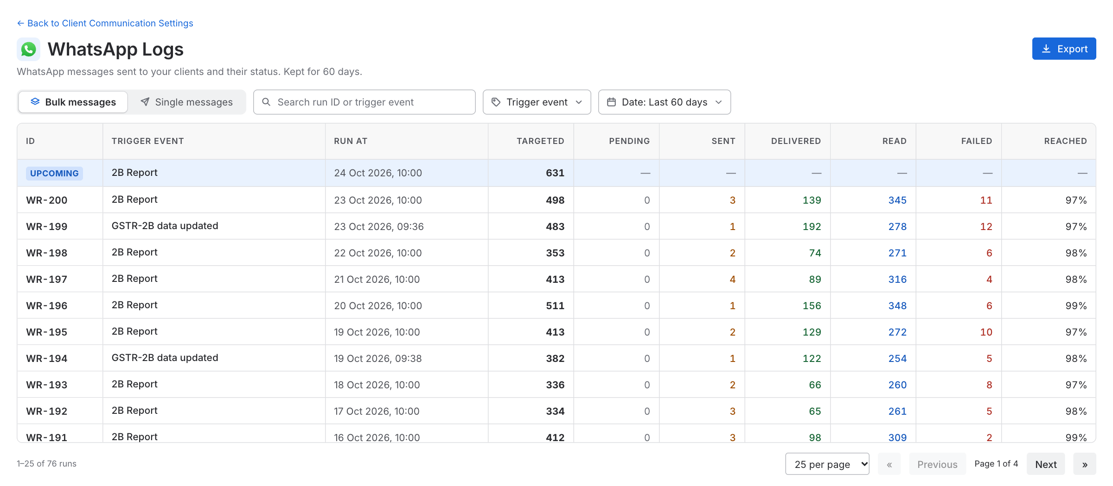
Figure: Bulk messages tab
One row per run (for example, the 2B Report of one day). A run answers: how many clients were targeted that day, and what happened.
Column | Notes
ID | WR-…, or an Upcoming tag on the first row (see below)
Trigger event | From the domain list. Today: 2B Report
Run at | When the run started
Targeted | Clients selected for this run
One column per status | For example Pending, Sent, Delivered, Read, Failed. Follows the statuses Rampwin gives
Reached | Delivered + Read, out of Targeted
Upcoming row. The first row of the list (first page only) is the next scheduled 2B Report. It has an Upcoming tag, shows when it will run, and shows how many clients it will target right now: clients whose 2B Report switch is on and who have a mobile number. The other columns show a dash, because nothing has been sent yet.
- The number follows the switches. If the user turns a switch on or off on the settings page, the number changes.
- When the run starts the number is fixed, and the row becomes a normal run with its results.
- The row is hidden when the user searches or filters for something else (for example another trigger event).

5.4 When the user clicks a run: the run page
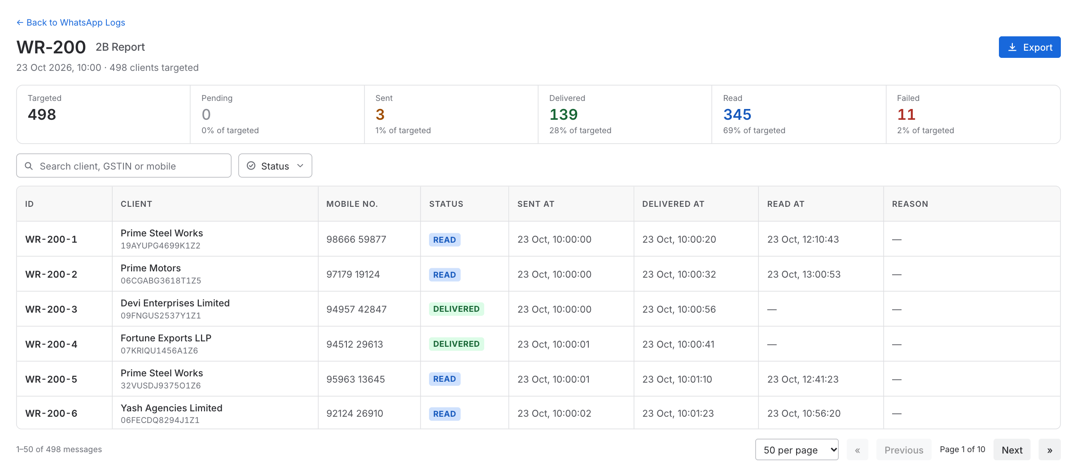
Figure: Run page
A separate page. It shows:
- The run ID, the trigger event, when it ran, and how many clients were targeted.
- Summary cards: Targeted, and one card per status, each with its share of targeted.
- A table with one row per client message, with search and a Status filter.
Column | Notes
ID | WR-200-1 (run ID + position)
Client | Name, with the GSTIN below it
Mobile no.
Status
Sent at
Delivered at
Read at
Reason | The failure reason

5.5 Single messages tab
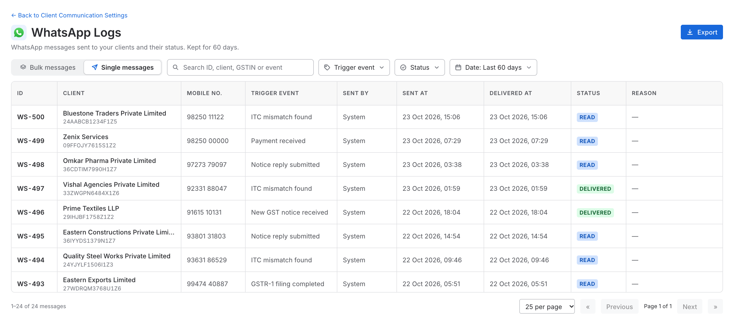
Figure: Single messages tab
One row per message sent to one client.
Column | Notes
ID | WS-…
Client | Name, with the GSTIN below it
Mobile no.
Trigger event | From the domain list. 2B Report when sent with the Send icon
Sent by | A person (Send icon), or System
Sent at
Delivered at
Status
Reason | The failure reason

6. Where the data comes from
We send WhatsApp through Rampwin. The status of every message and its delivery details (delivered time, read time, failure reason) are taken from Rampwin. The user must never see the name Rampwin or its codes.
- Rampwin API reference: https://rampwin-api.readme.io
- Rampwin help docs: https://docs.rampwin.com
What Spectrum Cloud must save when it sends (Rampwin does not know these):
- Our own ID (WR-…, WS-…) next to Rampwin's reference for the message.
- The trigger event, and whether it is a bulk run or a single message.
- For a bulk run: the number of clients targeted and the list of clients, at the moment the run starts. Switches can change later, so this cannot be worked out afterwards.
- For every client: the GSTIN and mobile number used.
- Who sent it (a person, or System), and the time.

7. Rules
- Only messages sent from the settings page are logged. Messages from anywhere else are not.
- A message is logged once, and its status is updated as Rampwin reports it.
- Targeted is fixed when the run starts. Changing a switch afterwards does not change old runs. Before the run starts, the number on the Upcoming row follows the switches.
- The Send icon works whatever the switch says, and its WhatsApp messages appear under Single messages.
- Logs older than 60 days are not shown. The number of days is a setting and can be changed later.

