Session 2025-2026

Vision: To be a well-known centre for pursuing computer education through innovative pedagogy, value-based education and industry collaboration | Mission: To establish learning ambience for ushering in computer engineering professionals in core and multidisciplinary area by developing Problem-solving skills through emerging technologies.

Program Educational Objectives of the program (PEO): (broad statements that describe the professional and career accomplishments)
PEO1 | Preparation | P: Preparation | Pep-CL abbreviation  pronounce as Pep-si-lL easy to recall
PEO2 | Core Competence | E: Environment (Learning Environment)
PEO3 | Breadth | P: Professionalism
PEO4 | Professionalism | C: Core Competence
PEO5 | Learning Environment | L: Breadth (Learning in diverse areas)

Program Outcomes (PO): (statements that describe what a student should be able to do and know by the end of a program)
Keywords of POs:
Engineering knowledge, Problem analysis, Design/development of solutions, Conduct Investigations of Complex Problems, Engineering Tool Usage, The Engineer and The World, Ethics, Individual and Collaborative Team work, Communication, Project Management and Finance, Life-Long Learning

PSO Keywords: Cutting edge technologies, Research

“I am an engineer, and I know how to apply engineering knowledge to investigate, analyse and design solutions to complex problems using tools for entire world following all ethics in a collaborative way with proper management skills throughout my life.” to contribute to the development of cutting-edge technologies and Research.

Integrity: I will adhere to the Laboratory Code of Conduct and ethics in its entirety.

KARTIK GAJANAN PATIL
02/04/2026
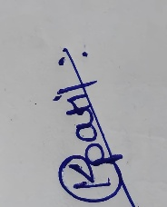

Session | 2025-26 (EVEN) |  | Course Name | JAVA FSD Lab
Semester | 4th |  | Course Code | 2ADS1407
Roll No | 144 AIDS B |  | Name of Student | KARTIK GAJANAN PATIL
Practical Number |  | 04
Course Outcome |  | After performing this practical, students gain a clear understanding of fundamental searching and sorting techniques in Java. They learn how to implement Linear Search and Binary Search, and recognize the importance of sorting data before applying Binary Search. By practicing Bubble Sort and Insertion Sort, students develop the ability to arrange data efficiently in ascending order. This exercise enhances their logical thinking, problem-solving skills, and familiarity with arrays, loops, and functions. Additionally, students become capable of comparing algorithm performance and understanding their real-world applications in data processing.
Aim |  | WAP to implement Searching i) linear search and ii ) Binary Search
Problem Definition |  | WAP to implement Searching i) linear search and ii ) Binary Search Sorting i) Bubble Sort and Insertion in Java for given Array. A =[ 99,7,6,1,100,108] .Arrange in Increasing Order and search for element='1'
Theory  (100 words) |  | The aim of this practical is to understand and implement basic searching and sorting algorithms using Java programming. Searching techniques such as Linear Search and Binary Search are used to locate a specific element in a dataset. Linear Search checks each element sequentially, making it simple but less efficient for large datasets. Binary Search, on the other hand, is more efficient but requires the data to be sorted beforehand.  Sorting techniques like Bubble Sort and Insertion Sort are used to arrange elements in increasing order. Bubble Sort repeatedly compares and swaps adjacent elements, while Insertion Sort builds the sorted list by inserting elements at their correct positions.  Through this practical, students learn the importance of organizing data for efficient searching and develop a strong foundation in algorithm design. It also helps in improving logical thinking and understanding the performance differences between various algorithms.
Procedure and Execution  (100 Words) |  | Algorithm:  Algorithm for linear search  - Start  - Input array A of size n and element key  - Set i = 0  - Repeat while i < n:  - If A[i] == key, print position i and stop  - Else increment i by 1  - If element not found, print “Element not found”  - Stop  Algorithm for binary search  - Start  - Input sorted array A of size n and element key  - Set low = 0, high = n - 1  - Repeat while low <= high:  - Find mid = (low + high) / 2  - If A[mid] == key, print position mid and stop  - If A[mid] < key, set low = mid + 1  - Else set high = mid - 1  - If element not found, print “Element not found”  - Stop
Code:
FOR LINEAR SEARCH :
public class linearsearch {
static int linearSearch(int A[], int key) {
for (int i = 0; i < A.length; i++) {
if (A[i] == key) {
return i;
}
}
return -1;
}
public static void main(String[] args) {
int A[] = {99, 7, 6, 1, 100, 108};
int key = 1;
int result = linearSearch(A, key);
if (result != -1)
System.out.println("Element found at index: " + result);
else
System.out.println("Element not found");
}
}

FOR BINARY SEARCH :
import java.util.Arrays;
public class BinarySearchExample {
static int binarySearch(int A[], int key) {
int low = 0, high = A.length - 1;
while (low <= high) {
int mid = (low + high) / 2;
if (A[mid] == key)
return mid;
else if (A[mid] < key)
low = mid + 1;
else
high = mid - 1;
}
return -1;
}
public static void main(String[] args) {
int A[] = {99, 7, 6, 1, 100, 108};
int key = 1;
Arrays.sort(A);
int result = binarySearch(A, key);
if (result != -1)
System.out.println("Element found at index: " + result);
else
System.out.println("Element not found");
}
}

Output:
FOR LINEAR SEARCH:
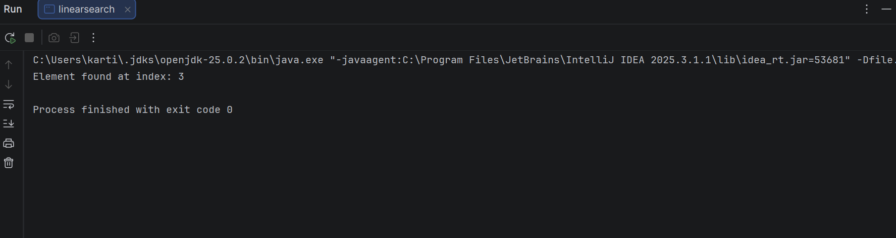

FOR BINARY SEARCH :
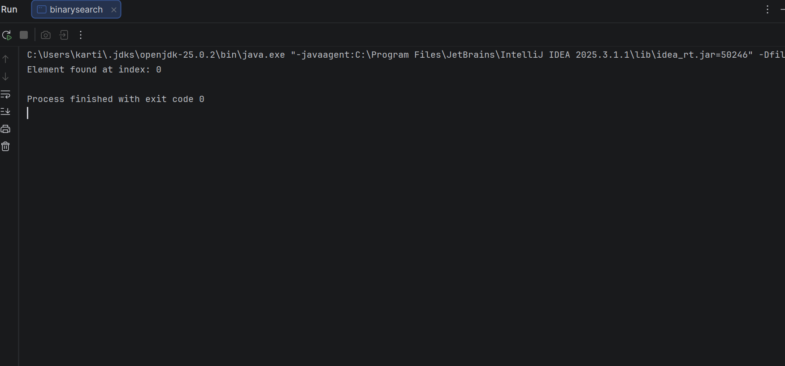
Output Analysis |  | In Linear Search, the element 1 is searched sequentially in the unsorted array [99, 7, 6, 1, 100, 108] and is found at index 3, as the algorithm checks each element one by one. In Binary Search, the array is first sorted to [1, 6, 7, 99, 100, 108], and then the search is performed efficiently by dividing the array. The element 1 is found at index 0 in fewer steps. Thus, Linear Search is simple but slower, while Binary Search is faster but requires a sorted array.
Link of student Github profile where lab assignment has been uploaded |  | https://github.com/Kartikpatil1905/JAVA-PRACTICALS
Conclusion |  | This practical demonstrates the implementation of fundamental searching and sorting algorithms in Java. The given array is successfully arranged in increasing order using Bubble Sort and Insertion Sort, resulting in a sorted sequence [1, 6, 7, 99, 100, 108]. Linear Search is applied to the unsorted array and finds the element 1 at index 3, while Binary Search, performed on the sorted array, locates the same element more efficiently at index 0. This highlights the importance of sorting before applying Binary Search. Overall, the practical enhances understanding of algorithm logic, improves problem-solving skills, and helps compare the efficiency and applicability of different searching and sorting techniques in real-world scenarios.
Plag Report (Similarity index < 12%) |  | 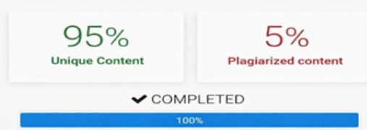
Date |  | 02/04/2026



