Session 2025-2026

Vision: To be a well-known centre for pursuing computer education through innovative pedagogy, value-based education and industry collaboration | Mission: To establish learning ambience for ushering in computer engineering professionals in core and multidisciplinary area by developing Problem-solving skills through emerging technologies.

Program Educational Objectives of the program (PEO): (broad statements that describe the professional and career accomplishments)
PEO1 | Preparation | P: Preparation | Pep-CL abbreviation  pronounce as Pep-si-lL easy to recall
PEO2 | Core Competence | E: Environment (Learning Environment)
PEO3 | Breadth | P: Professionalism
PEO4 | Professionalism | C: Core Competence
PEO5 | Learning Environment | L: Breadth (Learning in diverse areas)

Program Outcomes (PO): (statements that describe what a student should be able to do and know by the end of a program)
Keywords of POs:
Engineering knowledge, Problem analysis, Design/development of solutions, Conduct Investigations of Complex Problems, Engineering Tool Usage, The Engineer and The World, Ethics, Individual and Collaborative Team work, Communication, Project Management and Finance, Life-Long Learning

PSO Keywords: Cutting edge technologies, Research

“I am an engineer, and I know how to apply engineering knowledge to investigate, analyse and design solutions to complex problems using tools for entire world following all ethics in a collaborative way with proper management skills throughout my life.” to contribute to the development of cutting-edge technologies and Research.

Integrity: I will adhere to the Laboratory Code of Conduct and ethics in its entirety.

Name and Signature of Student and Date
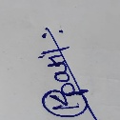KARTIK GAJANAN PATIL 02/04/2026

Session | 2025-26 (EVEN) |  | Course Name | JAVA FSD Lab
Semester | 4TH |  | Course Code | 23ADS1407
Roll No | 144 AIDS B |  | Name of Student | KARTIK GAJANAN PATIL
Practical Number |  | 07
Course Outcome |  | After performing this practical, We will understand the concept of exception handling in Java and how to handle runtime errors using try, catch, and finally blocks. They will learn to manage exceptions effectively to prevent program crashes and ensure smooth execution. This enhances their ability to write robust, reliable, and error-free programs while improving debugging skills and understanding of different types of exceptions in real-world applications.
Aim |  | WAP to demonstrate exception handling in java
Problem Definition |  | Write a program to demonstrate Exception Handling by performing division of two numbers. Handle the  error that occurs when a number is divided by zero using try, catch, and finally.
Theory  (100 words) |  | This practical demonstrates the concept of exception handling in Java by performing division of two numbers and handling errors such as division by zero. In Java, exceptions are runtime errors that can interrupt the normal flow of a program. To manage such situations, the try, catch, and finally blocks are used. The try block contains the code that may generate an exception, such as dividing a number by zero. If an error occurs, control is transferred to the catch block, where the exception (like ArithmeticException) is handled properly without crashing the program. The finally block is executed regardless of whether an exception occurs or not, and is typically used for cleanup operations or important statements.  This practical helps students understand how to write safe and error-free programs, improves debugging skills, and ensures smooth program execution. It also highlights the importance of handling unexpected situations in real-world applications, making programs more reliable, stable, and user-friendly.
Procedure and Execution  (100 Words) |  | Algorithm:  • Start  • Declare two variables a and b  • Assign values to a and b  • Use try block to perform division result = a / b  • If division is successful, display the result  • If division by zero occurs, control goes to catch block  • In catch block, display error message “Cannot divide by zero”  • Execute finally block to display a message (e.g., “Program completed”)  • Stop
Code:
import java.util.Scanner;

public class Main {
public static void main(String[] args) {

Scanner sc = new Scanner(System.in);

System.out.print("Enter first number: ");
int a = sc.nextInt();

System.out.print("Enter second number: ");
int b = sc.nextInt();

try {
int result = a / b;
System.out.println("Result: " + result);
}
catch (ArithmeticException e) {
System.out.println("Error: Cannot divide by zero");
}
finally {
System.out.println("Program completed");
}

sc.close();
}
}
Output:
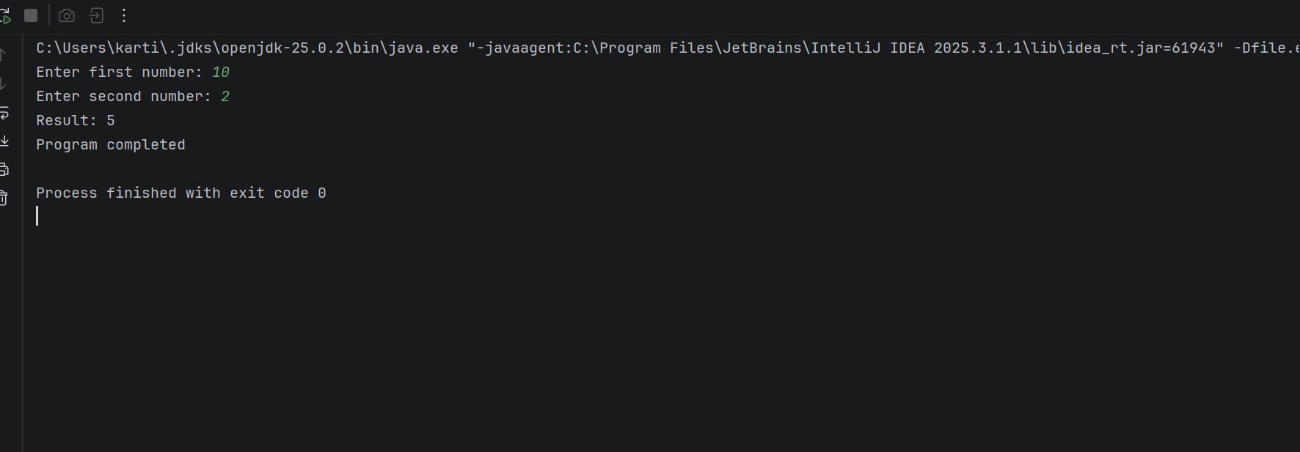
Output Analysis |  | The program takes two numbers as input from the user and performs division inside the try block. If the user enters a non-zero value for the second number, the division is successful and the result is displayed. However, if the user enters 0 as the second number, an ArithmeticException occurs. This exception is caught by the catch block, which displays the message “Cannot divide by zero” instead of terminating the program abruptly. The finally block is executed in both cases, ensuring that the message “Program completed” is always displayed, indicating smooth and controlled execution.
Link of student Github profile where lab assignment has been uploaded |  | https://github.com/Kartikpatil1905/JAVA-PRACTICALS
Conclusion |  | This practical demonstrates the use of exception handling in Java to manage runtime errors effectively. By using try, catch, and finally blocks, the program safely handles division by zero without crashing. It ensures smooth execution and provides appropriate error messages to the user. This helps in writing robust, reliable, and user-friendly programs while improving debugging skills and understanding of handling unexpected situations in real-world applications.
Plag Report (Similarity index < 12%) |  | 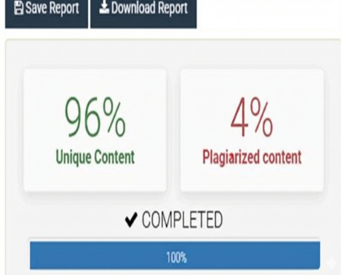
Date |  | 02/04/2026

