User Interface Design Document.

The user interacts with the system using user interface. This document enumerates the design aspects of the UI. There are two parts of the UI which are needed
- Search Interface.
- Monitering Interface.

Search Interface.
This is provided to the user through a web-browser. It allows the user to search documents on the web and view them by giving access to the docs through hyperlinks. Below is the prototype of the UI.

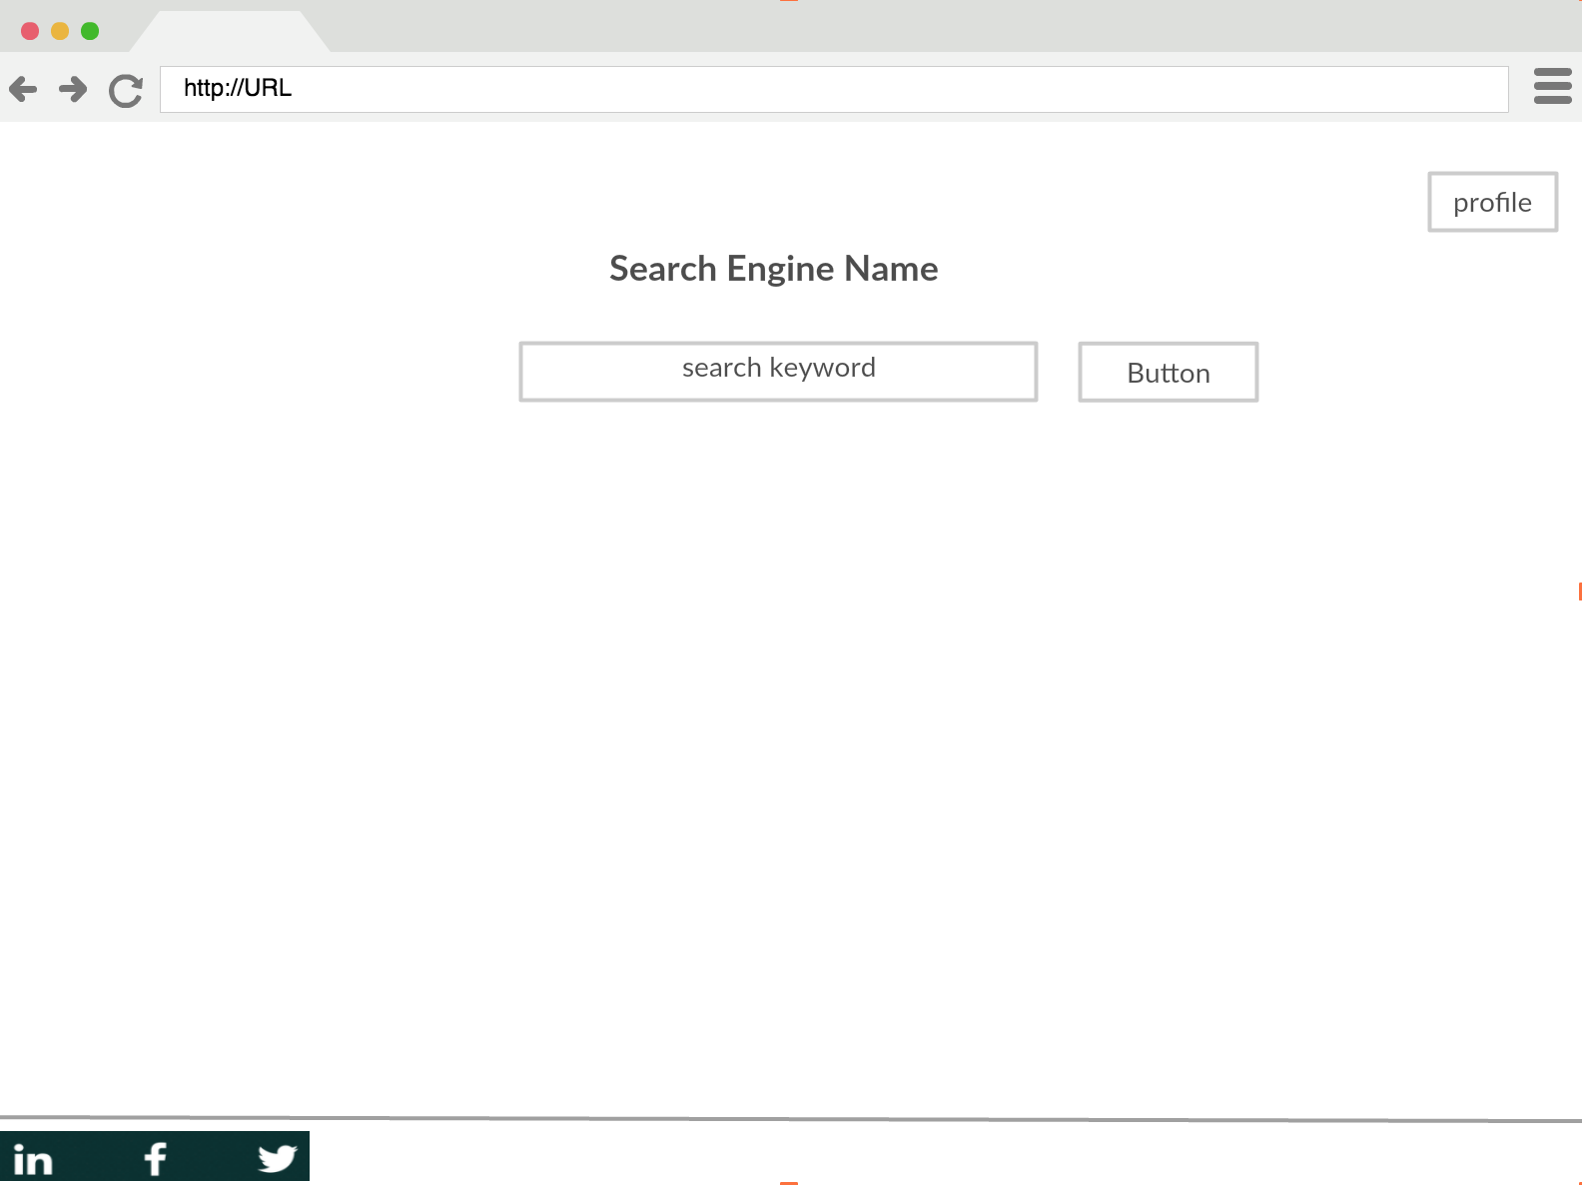

Figure 1. Search Page.

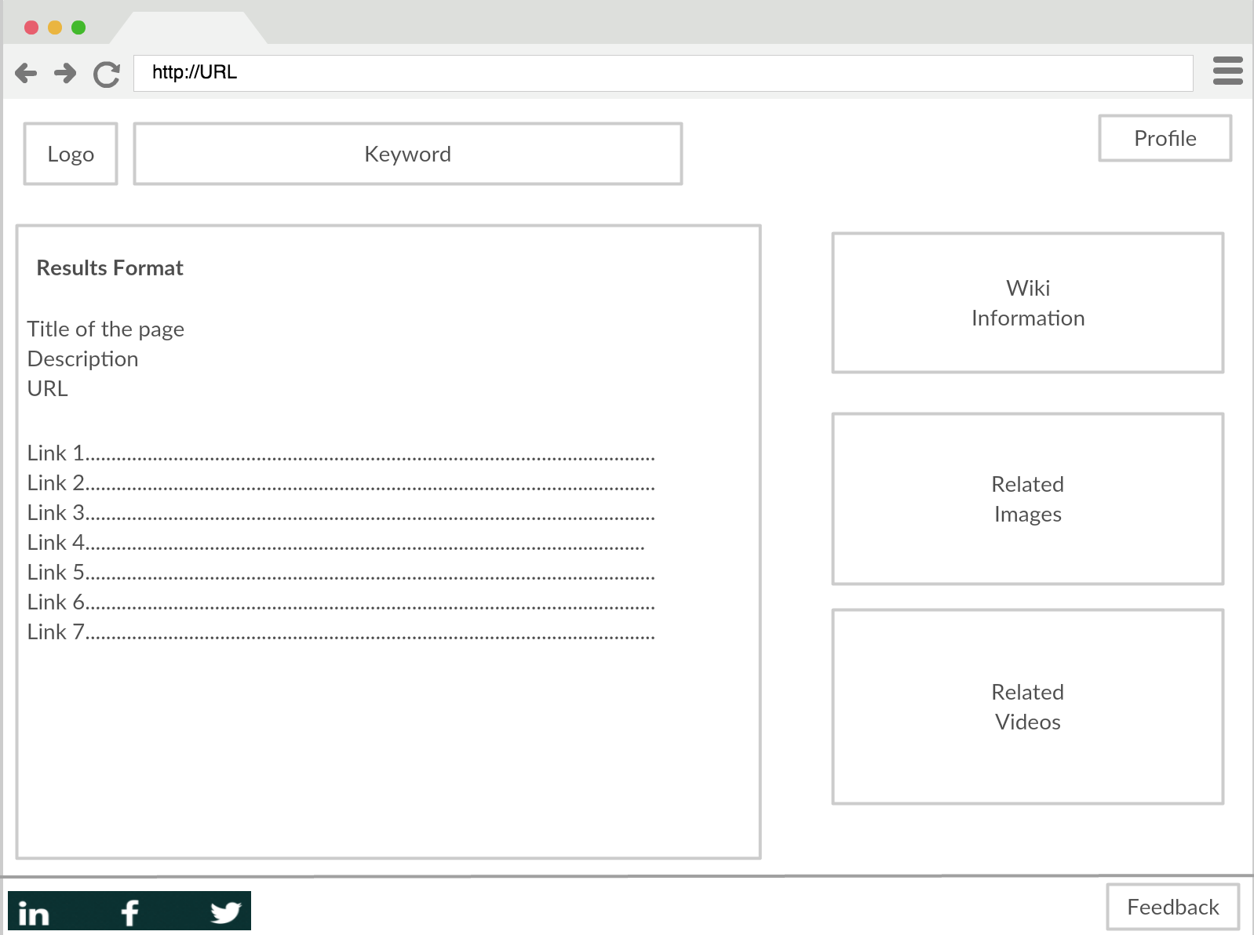

Figure 2. Results Page

How the search works.

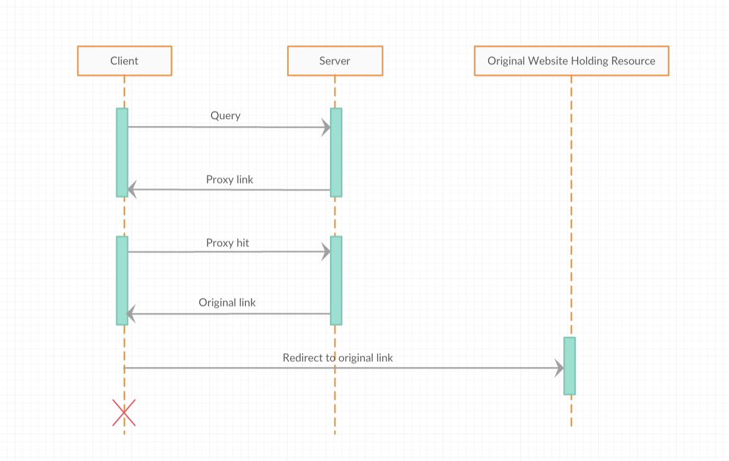

Figure 3. Search process.

UI for Monitering processes.

Requirements.
R1. A software to monitor the processes running on different machines by which we can maintain and debug the system.
R1.1 The system needs to probe the processes periodically and list their status.
R1.2 Allow the user to set the frequency.

Probing PDU.

Request:
{
“method”: “GET”,
“resource”: “status”,
...
}
Response:
{
“status”: “UP”,
“starttime”: “30 Nov 2017”,
“pid”: 123,
“data”: “some extra info for further extension”,
...
}

