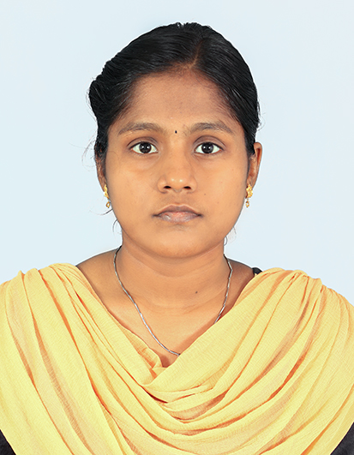Karunya S

C:\Users\750819\AppData\Local\Microsoft\Windows\INetCache\Content.Word\Email_Midnight blue.pngProgrammer Analyst Trainee

[2303842@cognizant.com](mailto:2303842@cognizant.com)C:\Users\750819\AppData\Local\Microsoft\Windows\INetCache\Content.Word\01.png

[9361823820](http://9361823820)

**SUMMARY**

Enhancing skills, optimizing performance, and contributing value to the organization through continuous self-improvement.

**WORK EXPERIENCE**

 **Programmer Analyst Trainee | 21’Sep’2023 – Present** Currently learning Java and Selenium to become a proficient Quality Engineering and Assurance (QEA) professional, gaining valuable technical skills in the process.

**PROFESSIONAL SKILLS**

* Programming: Python, Java and R
* QEA: Selenium, Manual and Automated Testing, TestNG, Cucumber, Jenkins, Apache POI.
* Data Analysis: SQL, Excel, Tableau, Power BI.
* Other Skills: Mathematics, Statics, Natural Language Processing, Salesforce.
* Effective communication
* Quick adaptability

**ACADEMIC QUALIFICATION**

* **K Ramakrishnan College of Technology, Tiruchirappalli.**

BE, Computer Science of Engineering | 2019 – 2023 | CGPA – 8.45

* **Amala Girls Higher Secondary School, Musiri.**

HSC | 2018– 2019 | 66%

* **Amala Girls Higher Secondary School, Musiri.**

SSLC | 2017 – 2018 | 96%

**PROJECT WORKS**

**ACADEMY PROJECT WORKS**

* **Facial Recognition to Detect Mood and Suggest Songs:**

Engineered a music web app with facial expression detection using Haar Cascade, TensorFlow for playlist automation, and Django integrated with OpenCV for image processing.

**Technologies:** Python, TensorFlow, Django, OpenCV.

* **Machine Learning for Accurate Meat Spoilage Detection:**

The device employs machine learning algorithms to distinguish between fresh and damaged meat, as well as gas sensors to measure the level of genetic amines released by raw meat to evaluate its freshness.

**Technologies:** Python, Excel, Machine Learning, K-Nearest Neighbours.

* **Analysed Data in a Model Car Database with MySQL Workbench-Coursera:**

Analysed Mint Classic database, identified sales patterns, and proposed innovative suggestions for strategic improvements and decision-making.

**Technologies:** SQL, MySQL Workbench, Data Analytics.

**QEA PROJECT WORKS**

* **Find the links in Google displayed when searched for Cognizant:**

Employed Java and Selenium, to automate Google searches, extract links, and enhance web presence analysis during my Cognizant training project.

* **Be. Cognizant News Section Validation and Analysis:**

Validated the presence of the "Around Cognizant News" section on the Be. Cognizant website and analysed the news headers and tooltips for accuracy and completeness.

* **E-commerce Website Data Retrieval and Validation:**

Retrieved and printed details of bookshelves under specified criteria, retrieved and printed items under Living sub-menu, and validated gift card customization and submission process.

**Technologies:** Java, Selenium, TestNG, Cucumber, Jenkins, Git, Apache POI, Maven, JSON.

**CERTIFICATIONS**

* Salesforce Certified - Cognizant.
* Google Data Analytics Professional Certificate.
* IBM Data Science Professional Certificate.
* SQL Basics Proficiency Achieved on Hacker Rank.
* Udemy Certified in Manual Software Testing with Agile and Jira (Cognizant).

**LANGUAGE**

* Tamil (Native Proficiency)
* English (Working Proficiency)

**DECLARATION**

I hereby declare that the above-mentioned details are true to my knowledge and belief.



Yours faithfully