WIS Restoration Test Results
Following the testing conducted on the WIS on September 23, 2025, the following issue was identified:
- Final Valuation Not Saving
When a user selects a Project and PAP, then proceeds to PAP Valuation Info, clicking the Save button under the Final Valuation tab returns the error shown below and as a result, values under this same Final Valuation tab are not updated accordingly:
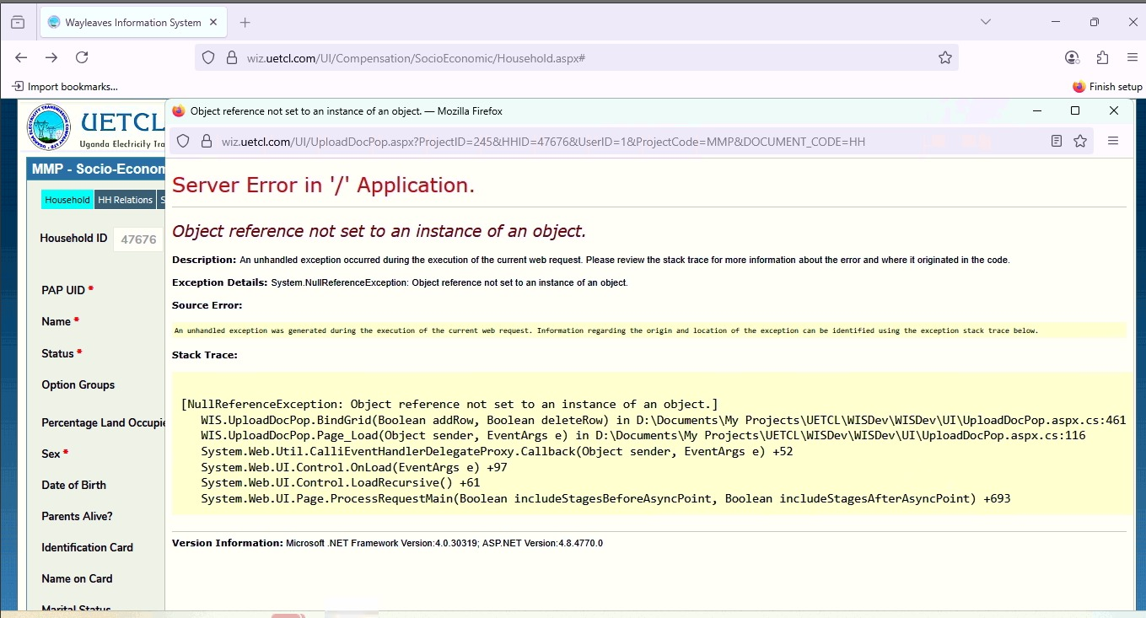
- Within Compensation, under the Project Batch List, the Batch Print Out report does not display the date stamps for the various approvals.
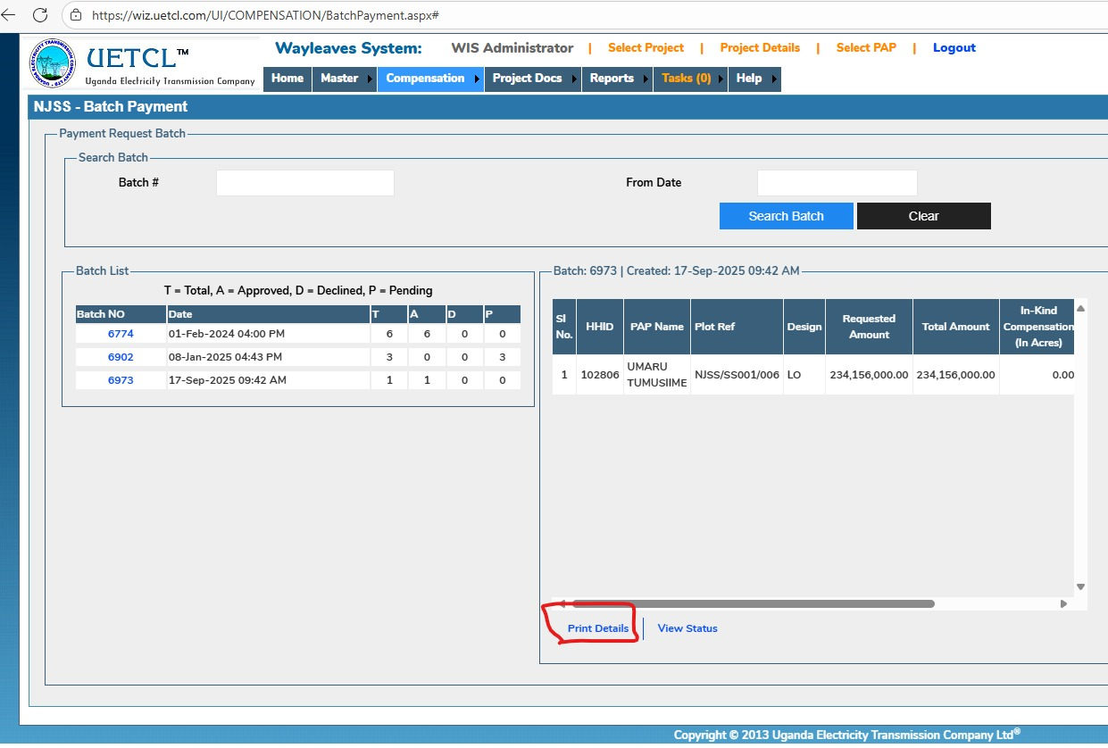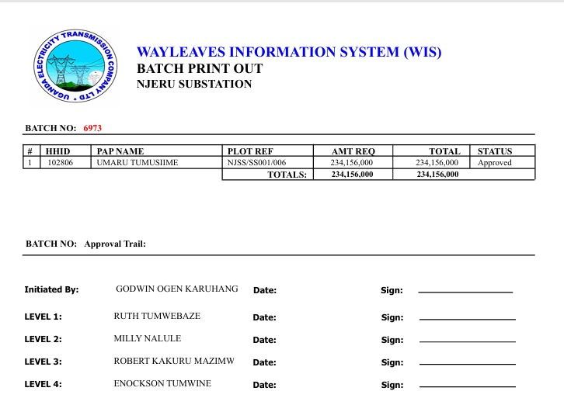
- Within Compensation, under the Project Batch List, the Batch Review Status report is not displaying and it returns the following error:
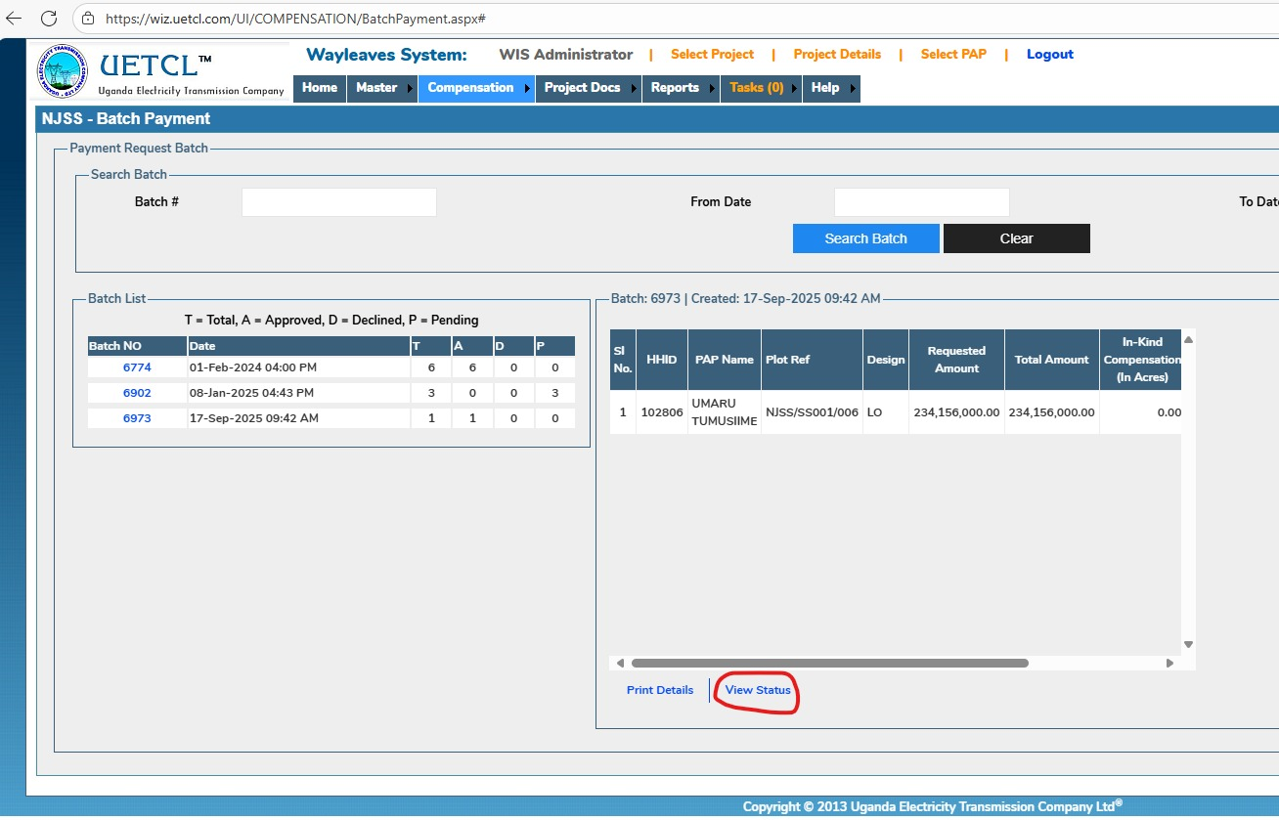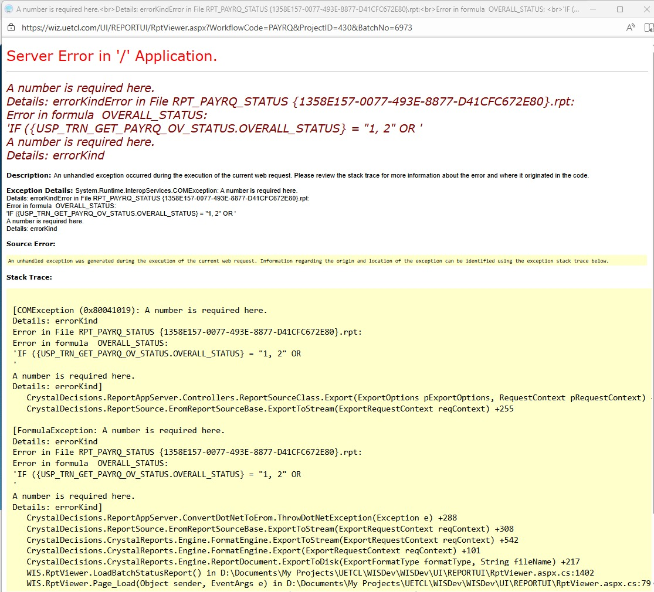
- Within Compensation, under the PAP Fund Request, the History/Status report is not displaying the date stamp on which the batch was made:
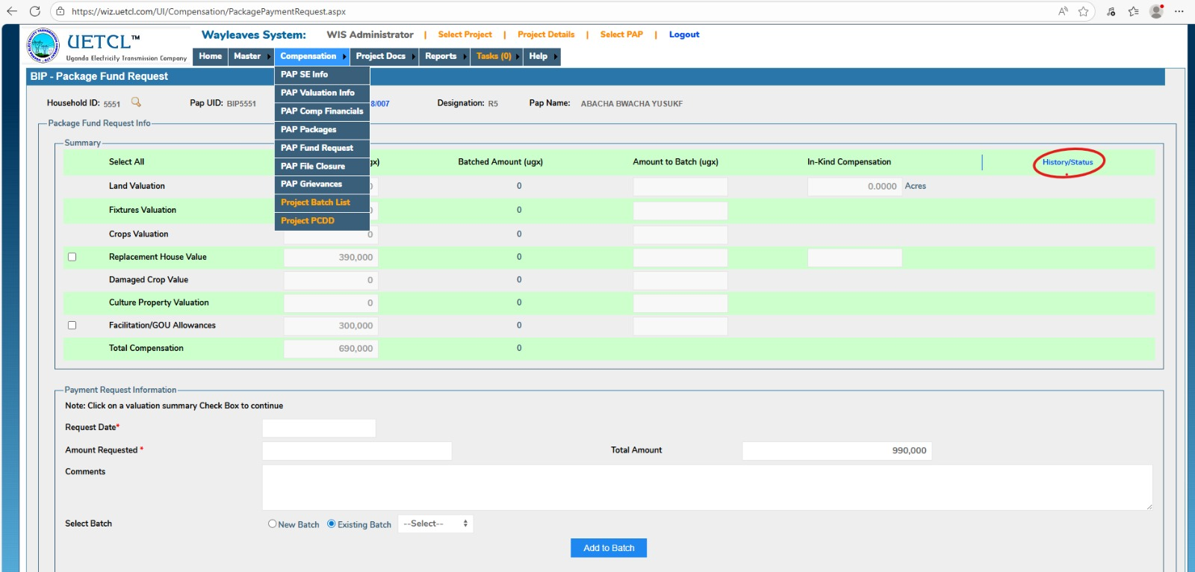
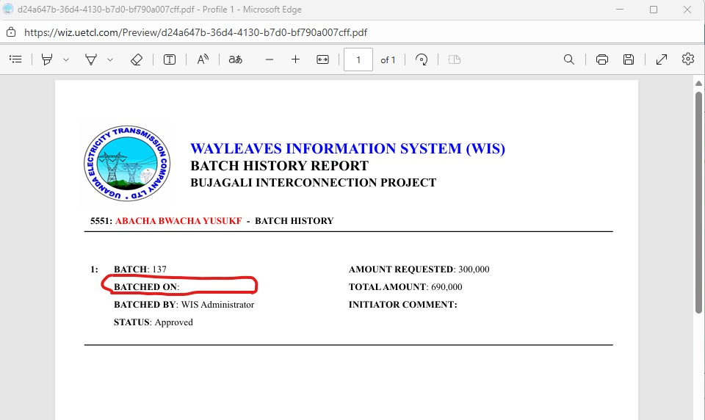
- Within Project Docs, under Forms & Templates, none of the three forms — namely Socio-Economic, Survey, and Valuation — are accessible. Instead, they return the following error: