Attaining the Double bottom line: An Evaluation Using Africa’s Microfinance data

John Karuitha & Kalu Ojah

Monday, May 03, 2021

# Abstract

This article uses data from the World Bank to examine how microfinance institutions (MFIs) in Africa fare in pursuing the double bottom line - meeting financial and social objectives. We capture social performance using the per cent of female borrowers whole operational self-sufficiency proxies financial performance. It also looks into the factors associated with the capacity of MFIs to achieve the double bottom line. The results show that most MFIs in Africa attain the dual objectives, at 35.88% compared to 14.76% who fail in both missions. However, rural banks and NGOs are more likely to achieve the dual goals than banks, NBFIs and credit unions. Age, size, capital markets development, institutional quality, legal tradition, and legal status are the significant determinants of how MFIs fare to attain joint financial and social objectives. The results remain robust after removing outliers.

# Background

Microfinance Institutions (MFIs) set out to reach out to the financially excluded people with little emphasis on making profits in the early stages. However, the rise of neoliberalism has seen an increasing number of MFIs also pursuing a financial return. The argument is that financially sustainable MFIs could better serve the financially excluded without over-reliance on volatile donor funds and uncertain state subsidies (Garmaise and Natividad 2013; D’Espallier, Hudon, and Szafarz 2017, 2013; Armendáriz et al. 2013). Consequently, most modern MFIs globally are hybrid firms that have a dual objective of reaching out to the financially excluded while striving for financial sustainability (D’Espallier et al. 2017). Like most hybrid firms, MFIs face a challenge in striking a balance between the pursuit of profit and the outreach to the poor, their chief social mission (Jia et al. 2016; D’Espallier, Hudon, and Szafarz 2013). For MFIs, when financial goals come at the expense of social goals, they have experienced mission drift (Mersland and Strøm 2010).

While some researchers posit that it is possible to profitably offer financial services to the poor, financially excluded individuals (Kodongo and Kendi 2013), others hold the opposite view (Mersland and Strøm 2010). The opponents argue that offering financial services to indigent clients is a high cost, high-risk business owing to the high costs of administering small loans that afford no economies of scale (Ledgerwood and White 2006). Similarly, the poor, more so in Africa, lack collateral, are often located in remote geographic areas, lack financial literacy, and engage in informal economic activity, making it hard to track finances to assess their creditworthiness. It is against this background that most initial MFIs like the Grameen Bank in Bangladesh ran on the welfare model, emphasising outreach to the poor even at the expense of profitability. MFIs following the welfare approach had substantial backing in donor funds and state subsidies (Armendáriz et al. 2013).

As noted, the rise of neo-liberalism after the cold war led to a paradigm shift towards financial sustainability (Bateman 2010). The transition has accompanied a reduction in the level of donations and subsidies, compelling many MFIs to also strive for financial sustainability (D’Espallier et al. 2017). The shift has forced MFIs to pursue a double bottom line- achieve social goals while ensuring financial viability (Ramus and Vaccaro 2017). The trend has been the conversion of NGO, welfare MFIs to the commercial, profit-oriented microfinance model. As noted, many researchers hold differing viewpoints regarding the suitability of MFIs pursuing the dual objectives. Some researchers argue that seeking profits is detrimental to the social mandate of reaching the unbanked due to the possibility of “mission drift” where MFIs seek profits to the detriment of their social mandate. If MFIs drift from their mission, then they risk the legitimacy that affords them a favourable legal framework from the state and earns goodwill from stakeholders (Market 2019). Other researchers believe that financial sustainability makes MFIs better serve the excluded. Mersland and Strøm (2010) conducted some empirical analysis and concluded that the pursuit of profits by MFIs leads to a lower level of outreach, referred to as “mission drift.” On the contrary, other researchers claim that financially sustainable MFIs reach more financially excluded people, a phenomenon dubbed “mission expansion” (Mersland and Strøm 2010).

In this article, we pursue two issues. First, we explore the levels of combined financial and social performance of MFIs in Africa. Secondly, we examine the factors behind the level of joint financial and social performance of MFIs in Africa. We capture financial performance using the operational self-sufficiency, OSS,[1] while the per cent of female borrowers proxies social performance. The literature shows that the majority of the financially excluded are women and rural dwellers in Africa.[2] Specifically, the study takes MFIs with an OSS of at least one to be financially sustainable. Likewise, MFIs that have at least 50% of female borrowers have succeeded socially in reaching out to the financially excluded. Following Chattopadhyay and Mitra (2017), we develop a matrix to capture the extent to which MFIs achieve the dual objectives shown in Table 1 below.

The article contributes to the existing literature in two main ways. First, the research documents the extent of financial and social performance of MFIs in Africa, contributing to the debate on mission drift versus mission expansion. Secondly and critically, while much research examines the consequences of the transformation of MFIs (Fernando 2004; Hishigsuren 2006; D’Espallier et al. 2017; Ramus and Vaccaro 2017), few delve into the factors that drive the success or failure in the dual missions as this paper does. Instead, much of the research examines the effects of converting on financial sustainability and social missions with each outcome examined in isolation. The other strand examines trade-offs between the financial and social performance of MFIs without delving into the drivers of the extent of the trade-offs. Hence, the research contributes to the existing literature by examining the determinants of the achievement of twin objectives.

While much of the research has dwelt on the trade-offs or synergies between the two schools, little of it investigates why some MFIs would differ in achieving the dual objectives. Quayes and others (2019) is the closest research to our contribution. In that study, they examine the probability of an MFI achieving financial sustainability. The presumption is that financial sustainability is a proxy for social outreach, meaning that the researchers lean towards microfinance’s financial systems approach. The researchers conclude that the probability of financial sustainability positively affects depth of outreach, breadth of outreach, and outreach to women. The researchers do not examine the financial and social objectives together as we do in this study.

The classification in Table 1 shows four categories of MFIs based on achieving both financial and social goals. In class 1, the MFIs have failed both socially and financially. MFIs in this class risk losing legitimacy, fail to attract donations, subsidies, and being loss-making ultimately collapse. There is little literature that envisions a scenario where an MFI fails in the twin objectives reflecting the expectations that an MFI should exhibit positive social influence.

In class 2, the MFIs succeed socially in reaching the unbanked but fail in financial sustainability. The welfare approach (NGO-Model) subscribes to this approach (Kodongo and Kendi 2013). Although some NGOs do turn profits, this class of MFIs is a prime candidate for donations and subsidies and illustrates, as welfarists do, that financial sustainability of MFIs is not compatible with social goals. However, better financial management could allow this class of MFIs to improve their financial sustainability without trading off social goals. The financial sustainability school argues that it is possible to push these MFIs to financial sustainability without losing sight of their social mandate.

In category three, the MFIs succeed financially but fail in the social mission. This category contains MFIs that are subject to mission drift, confirming the welfare school’s view on the incompatibility between profitability and social outreach (Mersland and Strøm 2010; Mia and Lee 2017). The MFIs in this category risk their legitimacy but could survive as they operate a commercial model like mainstream commercial banks. Most cooperatives, NBFIs, and commercial banks in our dataset fall into this category, calling to question the viability of the coexistence of the profit-oriented approach to microfinance and the need to reach out to the financially excluded. NGOs form a small proportion of this group showing their relevance in microfinance. Finally, some MFIs succeed both financially and socially, which is desirable. This category points to MFIs from which mission expansion could arise/ This class presents an ideal scenario for the win-win approach to microfinance that argues for the possibility of pursuing both targets. This class also serves the financial sustainability school well, although its viability is controversial.

The study fits within the agency theory. The entry of private capital into microfinance is bound to raise a conflict between the providing appropriate and affordable financial services to the financially excluded and pursuing profits (**miller2011angel?**).While equity and debt-holders may favour financial inclusion, maximising returns on their investments comes first unless blended finance is a case. Blended finance allows MFIs to use private capital to do social good without an overemphasis on profitability. Even where agency conflicts adversely affect the provision of financial services to the poor, it is hard for MFIs to keep off the financial sustainability push. The institutional theory sheds light here where the institutional environment has a greater influence on the adoption of institutional structures than market pressures. In this respect, pressures from donor agencies may still cause more MFIs to convert to the commercial model even where evidence shows that the conversion may be detrimental to the social goal of availing financial services to the financially excluded.

There exist MFIs that serve different segments of society. For instance, cooperatives serve a limited geographic range, targeting people with a common bond like employment. Rural banks also serve limited geographic areas in remote rural locations. MFIs registered as commercial banks and NBFIs serve relatively better off, but still poor people not served by mainstream intermediaries. Consequently, the argument by Morduch (1999) and Morduch (2000) argumemt that we should allow a broad range of MFIs to exist to serve different market segments appears valid. Supporting this point, Morduch and Ogden (2019) argue that if there were no market failures in the credit market that leaves out a segment of the population unbanked, NGOs would not exist as commercial banks other MFIs would already have filled the gap. It follows, therefore, that the call to do away with NGOs does not augur well for the financially excluded. These viewpoints call to question the validity and relevance of the debate on the pros and cons of microfinance institutions’ transformation across the globe. What is critical is to evaluate factors relevant for MFIs to achieve their financial and social goals as a basis for crafting policy support. Moreover, when the management of MFIs would better adjust their strategies when aware of the issues that hinder or facilitate the achievement of the twin objectives.

The rest of the research proceeds as follows. In the next section, we summarise the study results followed by a description of the econometric model. We then discuss the results of the regression and then conclude.

Classification Matrix: Joint Financial and Social Performance of MFIs

Achieves_Financial_Goals?

Achieves_Financial_Goals?

YES

NO

Achieves_Social_Goals?

YES

Class 4 (SS)

Class 2 (FS)

Achieves_Social_Goals?

NO

Class 3 (SF)

Class 1 (FF)

Source:

Adapted from Chattopadhyay, Manojit, and Subrata Kumar Mitra (2017)

Note

1 In labelling the classes, we start with financial sustainability followed by social performance.

2 The letters F and S stand for Fails (F) and Succeeds (S), respectively.

3 For instance, FS means the MFI fails (F) financially but succeeds (S) socially.

# Summary of Results

Overall, MFIs in Africa achieve both financial goals more than they fail in both objectives at 35.88% and 14.76%, respectively. 25.55% of MFIs succeed financially but fail socially by not reaching out adequately to the financially excluded. This result is indicative of mission drift. Another 23.80% fail financially but fare well in their social mandate of reaching the financially excluded. Broken down further, 48.59% of NGOs and 52.17% of rural banks attain both financial and social goals against 7.34% and 0.72%, respectively, that fail in both. The proportion of banks, NBFIs, and credit unions that succeed financially and socially is 45.72%, 36.87%, and 17.73%. Those that fail in both objectives are 6.3%, 13.51%, and 27.61%, respectively. NGOs have the lowest proportion of MFIs that experience mission drift by meeting financial goals while failing socially at 7.66%. On the other hand, credit unions have the second-highest mission drift at 40.43%, after rural banks at 43.48%.

The regression results show that the significant factors in determining the extent achieving both objectives are age, size, capital markets development, institutional quality, legal tradition, and legal status. Specifically, mature MFIs are less prone to mission drift given they are more likely to fail both financially and socially than succeed in one objective while failing in the other. Larger MFIs, on the other hand, are more likely to succeed financially and fail socially than they are to fail in both objectives. Similarly, large MFIs are more likely to succeed in both goals than to fail. The results are indicative of larger MFIs being more prone to mission drift. A higher level of capital markets development and governance corresponds to a higher chance of failing in both objectives, probably due to low demand for microfinance in countries with well developed mainstream financial systems.

Similarly, MFIs in legal traditions other than common law are more likely to fail in both objectives. The result probably connotes weak legal and infrastructural support that suppresses the development of mainstream and alternative financial systems like microfinance. Finally, the legal status output shows that NGOs are less likely to succeed financially while failing socially. However, NGOs are more likely than other legal forms to fail socially while succeeding financially and succeeding in both objectives. Commercial forms of MFIs are more prone to mission drift.

# The Model

The article uses the multinomial logit model, given that our dependent variable is discrete and error terms may not be normally distributed (Cramer 2002). In the model, NGOs still take a zero code, with commercial banks, NBFIs, credit unions, and Rural Banks taking one, two, three, and four, respectively. The following section lays out and describes the models, variables, and data sources.

## The Model, Variables Description and Data Sources

We run a multinomial logit model on a panel dataset of 705 MFIs in Africa. The multinomial logit model is an extension of the logit model, and hence we start by describing the logit model. Assuming the error term $ϵ$ follows a logistic distribution (Czepiel 2002), we have,

where,

and

for $z_{it}=f(x_{it})$

In the model, $y_{it}$ is the current legal status of the MFI, the dependent variable. The dependent variable is a dummy with NGOs, the base outcome (coded zero), and other legal traditions take a code of one. The symbol $x_{it}$ represents a vector of independent variables- age, size, capital market development, legal tradition, GDP growth rate, and institutional quality. Additionally, we include year dummies to cater to the trends towards commercialisation.

The multinomial logit model extends the binary logit model to more than two unordered levels (discrete choices). The data at hand meets the requirements for running a multinomial logit model as the dependent variable (the legal status of each MFI) has one outcome for each case. Also, the independent variables do not faultlessly predict the dependent variable (Petrucci 2009). Suppose we have a dependent variable $y$ consisting of $K$ choices for $K>=2$. Further, let the independent variables be $x_{1},x_{2},……….x_{n}$, then we can specify the multinomial logit model as follows.

for $k=1⋯K−1$

$y$ is the dependent variable, in this case, one of NGO, commercial bank, NBFI, credit union or rural bank.

$x$ is a vector of independent variables.

If $K>2$, then we have a multinomial logit with $K−1$ set of equations. Where $K=2$, the model is the binary logit model denoted in equation one (1) where we have one equation. Note that in this case, we have arbitrarily assigned the last category (K) as the reference. Any other group can serve as a reference and hence not be part of the equations set.

One of the significant drawbacks of the multinomial logit is the violation of the assumption of the independence of irrelevant alternatives (IIA). Cheng and Long (2007) ) illustrate this assumption using the blue bus- red bus example. If the choice between car transport and a red bus, and given that the probability of choosing a bus is $0.8$, and $0.2$ for a car, then the bus’s odds over car transport is 4. Suppose we introduce a third alternative, the blue bus. If the probabilities of choosing a red bus, blue bus, and car transport are $0.6$, $0.25$, $0.15$, respectively, the assumption holds since the odds of selecting a red bus over a car are still $4$. If the odds are different from $4$, then the model violates the IIA, and the multinomial model is not fit for the data. In our case, we plausibly see the assumption holding because the legal status of an individual MFI is independent of the legal status of other MFIs. Table 1 (next page) describes the variables in detail.

## The Model, Variables Description and Data Sources

The dependent variable is a dummy with four levels that capture how well MFIs achieve financial and social objectives. The firm-level independent variables are the legal status, age and size of the MFIs. The legal tradition, institutional quality, private credit to GDP, stock market to GDP, and GDP growth rates capture country-level macro-factors.

As illustrated in Table 1, we construct the independent variable using the percentage of women borrowers and operational self-sufficiency (OSS). Lending to women proxies the social performance of MFIs, with success being where an MFI has women clients comprising 50% or more of the total borrowers. An OSS of at least one indicates a financially sustainable MFI. We then generate four categories starting from MFIs that succeed in both financial and social metrics on one extreme and those that fail in both on the other. In between are MFIs that succeed in one of the metrics but fail in the other. Apart from the proposition by Chattopadhyay and Mitra (2017), little research has applied this approach to examine the joint financial and social efficiency of MFIs.

As noted, some legal forms of MFIs restrict the capacity of MFIs to emphasise financial or social goals. NGOs are an extreme case where donors and stakeholders expect that they are more socially oriented. Their degree of social orientation is the source of legitimacy and justifies continued donor and state support. In Africa, rural banks serve a niche market that is most prone to financial exclusion and hence expected to focus on social performance over and above financial performance. On the other hand, cooperatives are member-oriented and may not have room to improve their social outlook unless by recruiting more members. In countries and areas where people suffer financial exclusion, joining a cooperative is out of the question given their low-income status, which leads to their financial exclusion in the first place (Demirguc-Kunt et al. 2018). The exception is farmers cooperatives that pool together smallholder farmers to gain scale economies in the procurement of inputs and sale of produce (Porter and Scully 1987). Commercial banks and NBFIs tend to have more external capital, and agency conflicts may arise between managers who want to optimise financial and social objectives and providers of funds who may chiefly focus on financial returns. An exceptional case is that of blended finance, where providers of funds do so knowing that achieving social goals is equally critical.

The age and size of an MFI go together in explaining the firm-level factors that drive the achievement of the twin objectives. Mature MFIs tend to be larger (see Figure 1). Following the institutional theory, large, mature MFIs are less likely to succumb to donors and other stakeholders’ pressures to attain financial sustainability (D’Espallier, Hudon, and Szafarz 2017). Alternatively, larger and more stable MFIs have more resources to afford to offer the poor financial services even as donations subside (D’Espallier, Hudon, and Szafarz 2013). As Mersland and Strøm (2010) argue, such MFIs could offer financial services to the relatively well-off at market rates, allowing them to cross-subsidize services to the financially excluded. In such a scenario, Mersland and Strøm (2010) argue that the conversion of MFIs to the commercial model is likely to lead to “mission expansion” as opposed to “mission drift.”

The country-level factors address the macro-environment. For example, For example, researchers associate the legal tradition with the financial system’s development (Schnyder, Siems, and Aguilera 2018). Common law and civil law traditions dominate in Africa, with the former exhibiting a higher financial development levels (La Porta, Lopez-de-Silanes, and Shleifer 2013). People in countries with higher quality of institutional development are more likely to access to the mainstream financial system (Allen et al. 2013, 2014) and demand fewer microfinance services. Likewise, countries with better institutional quality have better developed financial system, which lowers the demand for microfinance. The country’s level of financial development reflects in the private credit to GDP and stock markets capitalization to GDP. Better developed financial markets imply higher access and use of financial services and lower financial exclusion chances. The result is a lower demand for microfinance resulting in poor financial and social performance by MFIs (Allen et al. 2013, 2014).

Finally, the GDP growth rate reflects the health of the economy. With more output, people are likely to have higher incomes over time, making them demand financial services like savings and credit to smooth consumption (Ahlin, Lin, and Maio 2011; Buera, Kaboski, and Shin 2021). As described in Table (), the data comes from the World Bank. The firms level data is from the MIX market. The country-level data is from three chief sources- the World Development Indicators (WDI), the Worldwide Governance Indicators (WGI), and the Global Financial Development Database (GFDD). Table 2 shows a description of the variables employed in the study.

Description of Variables

Variable_Description

1. Current Legal Status: This is the dependent variable. For logit and probit models, we create a dummy with the MFIs following the NGO Model getting a code of zero, and one in the case of non-bank financial institutions (NBFIs), rural banks, and credit unions/ cooperatives. We assign codes of zero to four for the multinomial logit model for NGOs, Banks, NBFIs, Cooperatives and Rural Banks, respectively. The data are available from the Microfinance Information Exchange, MIX (See source on note 1).
   1. Age: The period in which the MFI has been in operation. MFIs fall into one of three groups: new (1-4 years), young (4-8 years), and mature (over 8 years). The data are available from MIX.
      1. Legal Tradition (Legal): The indicator is a dummy variable with common law countries coded 0, civil law countries 1, and 2 otherwise as per the classification by Oto-Peralías and Romero-Ávila (2014).
         1. Size (Log of Total Assets): We proxy the size of MFI with the natural logarithm of total assets, again using MIX data.
            1. Governance/ Institutional Quality (KKM): We take the first principal component of the WGI developed by Daniel Kaufmann, Aart Kraay and Massimo Mastruzzi (KKM) available on the World Bank’s Worldwide Governance Indicators, WGI (See source on note 3).

Private Credit to GDP: We capture the total amount of credit advanced to the private sector by financial intermediaries as a proxy for capital markets development concerning the banking sector following Ito and Kawai (2018). The data source is the Global Financial Development Database (GFDD) of the World Bank (See note 4).

Stock market capitalisation to GDP: We capture the extent of stock market development using the ratio of stock market capitalisation to GDP to proxy how firms can raise equity capital. Although Africa’s equity markets are thin, some relatively large stock markets like South Africa, Kenya, and Ghana exist. The data are from the GFDD.

GDP annual growth rate (GDP): This is the year on year growth in output adjusted for inflation and sourced from the World Development Indicators (WDI) (See note 2).

Source:

Authors’ construction from the literature

Notes

1 MIX Database on www.themix.org and <https://datacatalog.worldbank.org/dataset/mix-market>

2 WDI on <https://databank.worldbank.org/source/world-development-indicators>.

3 WGI/ KKM on <https://databank.worldbank.org/source/worldwide-governance-indicators>.

4 GFDD on <https://www.worldbank.org/en/publication/gfdr/data/global-financial-development-database>

# Results

In this section, we explore and describe the data followed by a discussion of the output from the regression analysis.

## Exploratory Data Analysis and Data Visualization

### Summary Statistics

Figure 1, Figure 2, and Tables 3 and 4 shows a breakdown of the extent to which MFIs in Africa meet the dual financial and social objectives. Figure 1 shows that most MFIs in the sample achieve both financial goals with only a small proportion failing in both mandates. A marginally higher proportion of MFIs succeed financially while failing socially than those than those that fail financially while succeeding socially. The result could indicate that mission drift is not as widespread and that there is an even chance that an MFI will experience mission drift or not. The result is not for the welfare model of microfinance (D’Espallier et al. 2017). However, a clearer picture emerges when we break down the outcome by the legal status of MFIs in Figure 2.

Panel A and B of Figure 2 show the counts, while panel C and D show the proportions of MFIs and the extent they meet the twin objectives. Tables 3 and 4 show the respective proportions. We base the discussion on Figure 1 panel C and table 4. The results in Panel C show that cooperatives with the lowest proportion of MFIs succeeding financially and socially at 17.7%. Besides, they have the second lowest proportion (after rural banks with 43.5%) of failing socially and succeeding financially at 40.4%. By contrast, they have the lowest highest chance (after rural banks with 3.6%) of failing financially and succeeding socially at 14.2%. Notably, MFIs have the highest chance of failing to meet both objectives at 27.6%. The results illustrate the nature of cooperatives as geographically limited entities whose sole focus is on members who can make savings to qualify for loans (Porter and Scully 1987). Not many financially excluded individuals may join cooperatives due to limited incomes and information and their situation in remote geographical locations.

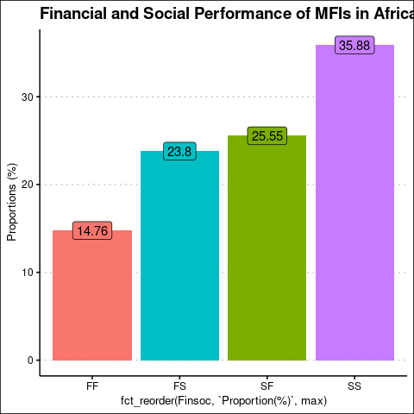

Financial and Social Performance of MFIs in Africa

Joint Financial and Social Performance by Legal Status of MFIs in  
Africa (row-wise)

NGO

Bank

NBFI

Coop

Rural Bank

FF

0.1331

0.0552

0.2521

0.5581

0.0014

SF

0.0802

0.1571

0.2414

0.4722

0.0491

FS

0.4095

0.0923

0.3155

0.1784

0.0044

SS

0.3625

0.1649

0.2832

0.1474

0.0420

Source:

Authors’ construction from MIX data

Note

1 The horizontal (row) values add up to 100%

2 We start with financial sustainability followed by social performance

3 For instance, FS means the MFI fails (F) financially but succeeds (S) socially.

4 The letters F and S stand for Fail and Succeeds, respectively

We turn to NBFIs. NBFIs have the third-highest proportion, after NGOs and commercial banks, of MFIs that meet the twin objectives at 36.9%. However, they have the second-highest chance, after NGOs of failing financially while succeeding socially. Similarly, after NGOs, NBFIs have the second-lowest chance of succeeding financially while failing socially at 27.2%. NBFIs also have the second highest chance after cooperatives of failing to meet the twin objectives at 13.5%. Also, NBFIs have the second-lowest proportion of MFIs that succeed financially while failing socially at 22.4%. In this respect, NBFIs show some degree of social orientation. NBFIs appear to strike a balance between the extremes of failing in both objectives versus succeeding in both objectives.

NGOs have the second-highest instance of succeeding financially and socially at 48.6% in the sample data, after rural banks. NGOs also have the highest proportion of MFIs that fail financially while succeeding financially (36.41%). Again, NGOs have the lowest chance of succeeding financially while failing socially at 36.4%. NGOs have the third-lowest instance (7.3%) of failing both financially and socially after commercial banks (6.3%) and rural banks (0.7%). The results for NGOs illustrating their leaning towards the welfare school of prioritizing outreach over profitability. hese results appear to confirm the welfare school’s concerns that the explicit pursuit of profits is incompatible with the extension of financial services to the financially excluded (D’Espallier et al. 2017).

Commercial banks come second after NGOs in the proportion of MFIs that succeed financially and socially at 45.7%. However, commercial banks have the lowest chance of failing financially while succeeding socially after rural banks and cooperatives. After rural banks and cooperatives, banks are the third least likely to succeed financially while failing to meet their social objectives. However, banks have the second-lowest instance of failing to meet both goals. Lastly, though the sample of rural banks is small, they show the highest likelihood of succeeding financially and socially and failing to achieve the twin objectives. Rural banks have the least instance of succeeding financially while failing socially, and have no instance of failing to meet both objectives. Given that rural banks specifically target the financially excluded in rural areas, it is rare that they would fail in their social mandate.

The observations in the visualisation appear to validate the concerns by the welfare school of microfinance that, indeed, pursuing a financial return is incompatible with outreach to the financially excluded. Except for NBFIs that seem evenly spread between the different classes, the other commercial MFIs- banks, cooperatives, and rural banks, are biased against social outreach. NGOs show a high degree of social orientation, are at the top when it comes to achieving the twin objectives, and come last in the class of MFIs that succeed financially and fail socially. We shall revisit this issue in the regression analysis. Finally, for profit-oriented MFIs like commercial banks, financial performance is a prerequisite achieving social objectives. The result could be due to the lower proportion of donations and subsidies that for-profit MFIs receive (D’Espallier, Hudon, and Szafarz 2013), which forces them to focus on financial sustainability. Only after they achieve some degree of financial sustainability do they turn their attention to achieving social goals. We visualise the data in the next section.

### Data visualization

Figure 3 shows the correlation between the independent numeric variables. The highest correlation is between private credit to GDP and stock market capitalisation to GDP at 0.321. Institutional quality and private credit to GDP follow at -0.265. Overall the correlation between independent variables is not high to raise multicollinearity issues (See Table 14 on variance inflation factors, VIF). Further, Figure 4 shows that smaller MFIs tend to fail financially while the bigger ones succeed. Socially, the smallest MFIs tend to succeed, while larger ones exhibit mixed results. Overall, larger MFIs show greater evidence of mission drift. Panel B shows that MFIs in countries with the more robust institutional quality and higher incomes tend to fail socially, unlike their counterparts in countries with lower institutional quality. As noted, higher institutional quality lowers the demand for microfinance as many people have access to the mainstream financial system (Allen et al. 2014, 2013). However, MFIs in countries with the poorest institutional quality tend to fail financially, while those in jurisdictions with the highest institutional quality succeed. The result shows the high costs of serving financially excluded markets, making it hard to turn a financial return. ITherefore, it is important to examine the circumstances in individual countries before prescribing or discouraging the conversion of MFIs. In relatively well off countries, the transformation of MFIs could be feasible. In impoverished countries where financial exclusion is high, the conversion may fail as MFIs cannot make enough to sustain the extension of financial services to the many financially excluded people.

As with institutional quality, MFIs in countries with high private credit to GDP imply better banking sector development and wealth and have a higher chance of failing socially. With financial inclusion, there is low demand for microfinance in these countries (Huang 2010). The opposite is true for MFIs in countries with low private sector credit to GDP. The link between the financial performance of MFIs and private credit shows mixed results, with MFIs in countries with the highest and lowest private credit tending to fail financially. Stock market development shows a trend opposite of private credit to GDP, with MFIs in countries with high levels of stock market development tending to succeed socially. The link between the financial performance of MFIs and stock market development is also mixed. The results may indicate the weak linkage between the stock markets and the financially excluded financial needs at the base of the income pyramid. Overall, the visualizations show that independent variables may be relevant in explaining the degree of joint financial and social performance of MFIs in Africa.

Joint Financial and Social Performance by Legal Status of MFIs in Africa (Columnwise)

NGO

Bank

NBFI

Coop

Rural Bank

FF

0.0734

0.0630

0.1351

0.2761

0.0072

SF

0.0766

0.3102

0.2238

0.4043

0.4348

FS

0.3641

0.1696

0.2724

0.1423

0.0362

SS

0.4859

0.4572

0.3687

0.1773

0.5217

Source:

Authors’ construction from MIX data

Note

1 The vertical (column) values add up to 100%

2 We start with financial sustainability followed by social performance

3 For instance, FS means the MFI fails (F) financially but succeeds (S) socially.

4 The letters F and S stand for Fail and Succeeds, respectively

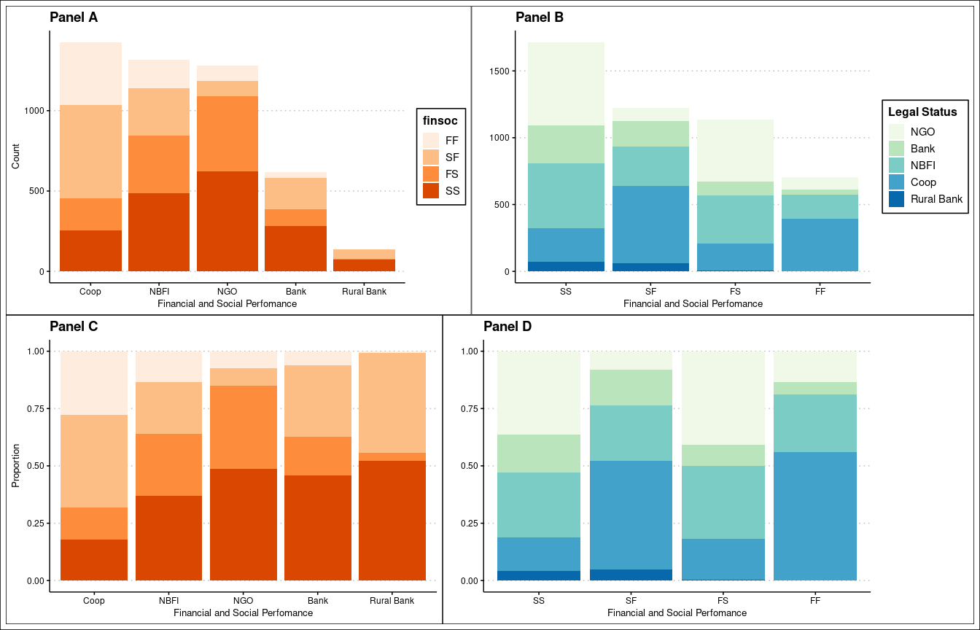

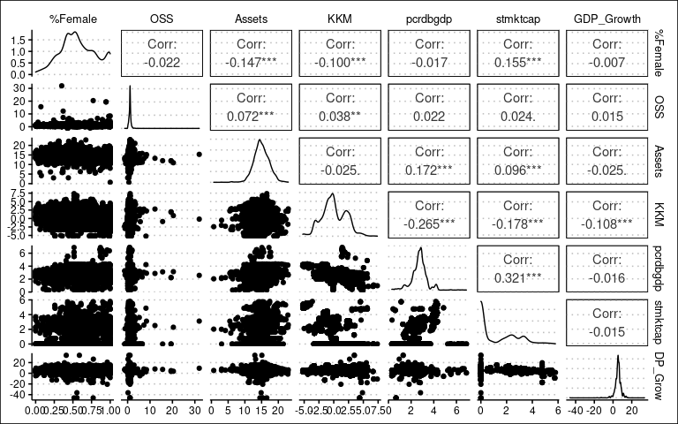

Correlation between Independent Variables

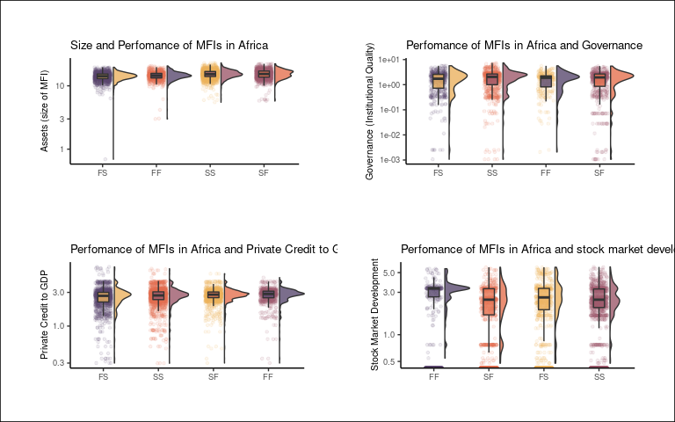

##   
## FF SF FS SS   
## 706 1222 1138 1716

Summary statistics for continous numeric variables

Variable

Mean

SD

Min

Q1

Median

Q3

Max

percent_of_female_borrowers

5.689e-01

2.366e-01

0.0000

0.4206

0.5500

7.478e-01

1.000e+00

operational_self_sufficiency

1.088e+00

8.642e-01

-1.3085

0.8376

1.0534

1.236e+00

3.196e+01

assets

1.495e+01

2.262e+00

0.6931

13.5399

14.8577

1.642e+01

2.298e+01

kkm

2.600e-03

2.006e+00

-5.2332

-1.3041

-0.1137

1.628e+00

7.369e+00

pcrdbgdp

2.719e+00

6.852e-01

0.2981

2.3864

2.7584

3.052e+00

6.881e+00

stmktcap

1.141e+00

1.473e+00

0.0000

0.0000

0.0000

2.428e+00

5.797e+00

gdp_growth_annual

5.311e+00

3.591e+00

-46.0821

4.0000

5.4205

6.723e+00

3.363e+01

donations

8.866e+04

3.154e+05

1.0000

1.0000

3339.0000

6.097e+04

1.042e+07

donations_assets_ratio

4.350e-02

1.472e-01

-0.0033

0.0000

0.0008

1.890e-02

2.598e+00

Source:

Authors’ construction from MIX data

## Results of the Regression Model

The results of the regression model are in tables 7 through 9. Given that we have an unbalanced dataset, we run the regressions separately for the entire data (Table 7), for MFIs with three or more years of data (Table 8), and those with 5 or more years of data (Table 9). Overall, the significant drivers of achieving the dual objectives are age, size, stock market capitalization to GDP, private credit to GDP, institutional quality, legal tradition, and MFI legal status. The GDP growth rate is not a significant driver of the extent which MFIs meet both financial and social objectives. The latter two regressions form a robustness check. We discuss each of the variables basing on Table 7 but referring to Tables 8 and 9 for comparison.

### Age

Age is a categorical variable. New MFIs (that have existed for 0 - 4 years) are the base outcome. The results show that relative to new MFIs, young MFIs (4 -8 years) are less likely to succeed financially and fail socially than failing in both objectives. Put another way; young MFIs are more likely to experience both financial and social failure than they are to succeed financially and fail socially relative to new MFIs. Similarly, compared to new MFIs, young MFIs are less likely to fail financially and succeed in meeting their social goals than failing to meet the twin objectives. However, young MFIs are more likely than new MFIs to meet their financial and social goals than to fail in the dual mission. TThe results imply that young MFIs are more prone to financial and social failure than new MFIs. In other words, compared to new MFIs, young MFIs are more likely to fail to achieve both financial and social goals than they are to achieve social goals and to fail financially and vice versa, and succeeding both financially and socially. However, these relationships are not significant. Age is important given that newer MFIs have fewer resources and hence more reliant on donations which are also uncertain (Armendáriz et al. 2013; D’Espallier, Hudon, and Szafarz 2013). Also, newer smaller firms have difficulties accessing finance (Beck et al. 2008). Thus, age makes newer MFIs more prone to financial and social failure and more prone to mission drift than established MFIs (D’Espallier et al. 2017).

MFI Age and Achievement of Dual Objectives

FF

SF

FS

SS

New

0.1450

0.2400

0.3125

0.3025

Young

0.1445

0.2217

0.2812

0.3525

Mature

0.1501

0.2764

0.1857

0.3878

Source:

Authors’ construction from MIX data

On the other hand, the results show that relative to new MFIs, mature MFIs are significantly less likely to succeed financially and fail socially than fail to meet the dual objectives. Similarly, mature MFIs are considerably less likely than new MFIs to fail financially while meeting their social goals than they are to meet both their goals. Both these results are significant. Also, the regression results show that relative to new MFIs, mature MFIs are less likely to meet the dual objectives than they are to fail in their twin mission. The latter result is not significant. These results illustrate that mature MFIs are more prone to failing in their twin mission than new MFIs. The results imply that as MFIs mature, they are less prone to mission drift. The observation holds, given that in the regression, older MFIs are more likely to fail to achieve both financial and social objectives than succeed in one and fail in the other or succeed in both financial and social goals, compared to new MFIs.

Indeed, Table 3 shows a higher proportion of mature MFIs that fail to attain both objectives compared to new and young MFIs. The table shows that a higher proportion of mature MFIs fail in both objectives. Likewise, a higher proportion of mature MFIs tend to succeed financially while failing socially, although, in the regression, the result is not significant. Financial success coupled with social failure is detrimental to financial inclusion and shows that mature MFIs may be less prone to mission drift when they convert to the commercial model. However, a higher proportion of mature MFIs fail financially while succeeding socially which is also an indicator of mission drift - one that shows that mature MFIs may place social performance over social goals. Lastly, although the result is not significant in the regression, the table shows that mature MFIs that succeed financially also tend to succeed socially.[3]

As noted, the results imply that mature MFIs are less prone to mission drift where success in one dimension (say, financial) accompanies failure in the other dimension (say social), and vice versa. However, when mature MFIs succeed financially, they also tend to fare equally well socially. The result could hold that mature MFIs have a more extensive asset base to draw from, making them able to reach out to the financially excluded with less dependence on donations and subsidies. The larger asset base also means that larger MFIs have established their presence through marketing campaigns and technology such that they have a more extensive client base in diverse geographic locations [Jia et al. (2016); ]. In this case, it is much easier for mature MFIs to attain their social goals, given their greater market share that would allow them to operate even in remote areas with or without donors and state support. Newer MFIs on the other hand, have to legitimize their activities by ensuring that they meet their social goals. Hence, even though mature MFIs receive more donations on aggregate, the relative share of donations is lower than that of newer MFIs.

### Size

As noted, age and size move together. Mature MFIs have more assets on average than younger MFIs. The regression output shows that larger MFIs are significantly more likely to succeed financially while failing socially than they are to fail in both objectives. Specifically, suppose the asset base (the proxy for size) of an MFI rises by one unit. In that case, the MFI is 1.241102 times more likely to fall into the group that succeeds financially and fails socially than to be in the group that fails to meet the dual objectives.

On the contrary, larger MFIs are marginally less likely to fail in meeting their financial goals while succeeding socially. Again, a unit increase in size results in 0.9685066 likelihood of falling into the group of MFIs that fail financially while succeeding socially. With the odds almost equal to one, it appears size is not as crucial in determining whether an MFI fails financially and succeeds socially. Indeed, this outcome is not statistically significant. However, larger MFIs are significantly more likely to meet their dual goals than to fail in both. In this case, a unit increase in MFI size corresponds to 1.192438 odds of achieving both objectives relative to failing in both goals.[4]

The results highlight that size is a critical ingredient in determining whether or not MFIs meet their dual objectives. Larger MFIs have a greater likelihood of achieving both objectives and meeting their financial goals while failing socially. This means that while the size of an MFI is an crucial factor in meeting social goals, it is a factor of greater importance in meeting financial objectives. The results also imply that larger MFIs that meet their financial objectives are in a better position to also meet their social goals. Hence, meeting financial goals is a prerequisite for meeting social goals for larger MFIs relative to smaller, younger MFIs. Larger MFIs use their asset base to generate financial resources that they use to expand outreach to the financially excluded, consistent with the “mission expansion” (Mersland and Strøm 2010). relatively smaller MFIs, on the other hand, are not as reliant on making financial returns to realise their financial goals, making them more reliant on donations and subsidies. In the absence of subsidies

### Capital markets development

This section covers both the stock market development and the debt market development. The regression shows that across all classes, MFIs located in countries with better stock market development are less likely to meet the dual objectives than failing in both goals. Going by the coefficients, a unit increase in stock market capitalisation results in 0.8633 times as likely to meet the twin objectives than to fail in both. Similarly, MFIs located in these countries are less likely to meet their financial goals and fail socially. In this case, a unit increase in stock market development corresponds with a 0.8573 odds of being in the category of MFIs that succeed financially while failing socially than in the class that fails to meet both objectives. Likewise, higher stock market development connotes a higher probability of an MFI succeeding financially while failing in their social mandate than failing in both goals. Here, a unit increase in stock market capitalisation corresponds to 0.8228 odds.

Debt market development, whose proxy is the ratio of private credit to GDP follows a similar pattern. A higher level of debt market development corresponds to higher odds of succeeding financially while failing socially instead of failing in both objectives. The result is not significant, though. However, a higher level of debt market development lowers the odds of an MFI failing financially and succeeding socially. Also, higher debt market development reduces the odds of an MFI succeeding in both objectives versus failing in both. The corresponding odds are 0.7757 and 0.8633, respectively.

Indeed in countries where stock markets are well-developed, the mainstream financial system, including the debt market, is also likely well established, meaning that people can easily access finance. Research shows that a well developed debt market is a precursor to developing a stock market (Nguyen and Hanh 2012; Tsaurai 2018). Under these conditions, then the demand for microfinance is low, meaning that it is hard for MFIs to realise its objectives. The few MFIs that exist in these conditions are more likely to serve a small, underprivileged class, meaning that the possibility of achieving their financial goals are minimal. They, however, almost always meet their social goals.

### Governance/ Institutional quality (KKM)

Institutional quality goes together with better financial sector development (Allen et al. 2014). The regressions results show that a unit increase in the institutions’ quality corresponds with higher odds of succeeding financially while failing socially. The odds are 1.1219. With odds of 0.9231, when institutional goes up by a unit, there is a lower chance of an MFI failing financially and succeeding socially than failing in both goals. These two results are significant. Finally, a unit increase in institutional quality lowers the chances of an MFI meeting both objectives compared to failing in both objectives with odd of 1.0305. The result is, however, insignificant. As is the case for financial sector development, the populace in countries with better quality institutions is more likely to have access to the mainstream financial system, making social goals harder for MFIs given the low demand for microfinance (Butkiewicz and Yanikkaya 2006). Given a low demand for microfinance, it is also harder for MFIs to succeed financially.

### Legal Tradition

The common law legal tradition is the base outcome for this variable. The results show that, relative to MFIs in common law countries, MFIs in civil law countries are less likely to succeed financially while failing socially than fail in both objectives. The odds are 0.2753. Similarly, MFIs in civil law countries are less likely than MFIs in common law countries to fail financially while succeeding socially than they are to fail in both objectives with an odds of 0.386. Also, MFIs operating in civil law countries are less likely than those in common law countries to succeed in both objectives than to fail in both objectives. The odds are 0.2982. The odds are strikingly low, showing the high likelihood of MFIs in civil law countries to fail in both financial and social goals compared to those in common law countries.

For MFIs in other legal traditions (neither common law nor civil law), the results are similar to those for civil law countries. The odds are lower (at 0.3679) that an MFI in a country with other legal traditions, compared to common law countries, will succeed financially and fail socially instead of failing in both objectives. The odds for failing financially while succeeding socially and succeeding in both goals are 0.5337 and 0.3946, respectively. Table () confirms that indeed, MFIs in civil law countries and other legal traditions are more likely to fail to meet both objectives than those in common law countries. Also, MFIs in common law countries have the highest instance of succeeding socially. Civil law and other legal tradition countries have a lower capital markets development level than common law countries (Schnyder, Siems, and Aguilera 2018; Kaidi, Mensi, and Amor 2019).

Consequently, we would expect that MFIs find it easier to meet social goals in civil law countries. These results could point to poor reception of financial services in these countries (La Porta, Lopez-de-Silanes, and Shleifer 2013). Additionally, lack of a supportive legal framework, inadequate financial and physical infrastructure could also make it difficult for MFIs to meet their social mandate even when the demand for microfinance is potentially high.

Legal Traditions and Achievement of Dual Objectives

FF

SF

FS

SS

Common

0.0671

0.2270

0.2589

0.4470

Civil

0.2131

0.2731

0.2147

0.2991

Other

0.1761

0.2756

0.2415

0.3068

Source:

Authors’ construction from MIX data

### MFI legal status

For legal status, the NGO model is the base outcome. Compared to NGOs, commercial banks are more likely to succeed financially while failing socially than they are to fail in both objectives. The results show that microfinance’s commercial banking model is likely to put profits before outreach to the financially excluded. Similarly, commercial banks are less likely than NGOs to fail financially while succeeding socially than failing in both objectives. The result may highlight that for commercial banks to succeed socially, they have to be financially self-sustainable, without which they tend to fail in both objectives. Likewise, relative to NGOs, commercial banks are less likely to achieve both financial and social goals than fail in both goals. Again this shows the importance of financial success in determining the attainment of social objectives by commercial banks compared to NGOs.

The other MFI legal forms- NBFIs, cooperatives, and rural banks show a pattern similar to that of commercial banks. Overall, the results confirm the results of exploratory data analysis that show that NGOs are less prone to social failure than the commercial forms of MFIs (Jia et al. 2016; Mia and Lee 2017). The result confirms the welfare school’s concerns that the transformation of MFIs is likely to cause mission drift (D’Espallier et al. 2017). Also, it implies that for commercial MFIs to prioritize social goals, they should first realize financial success which may be hard to come by unless with some form of support from the state and donors, at least in the initial stages of transformation.

## Overall Model Fit: Confusion Matrix

his section uses the regression model in Table 9 to generate a confusion matrix that shows how well the model predicts that an MFI will fall into one of the four financial vs social performance classes. The results are in Table 12 and Table 13. In Table 12, while the model has low accuracy and sensitivity, it has a substantial specificity of about 80%. The results mean that the model can accurately predict that an MFI will not fall into a given category given that it does not fall into that category. However, the model is not significantly more accurate than guessing the most likely outcome. In this case, an MFI succeeds financially and socially, with an accuracy of 46.9% against a no-information rate of 52.9%. Table 13 shows that, for instance, the model accurately predicts that 141 MFIs would fail in attaining both financial and social goals. However, 706 fail to meet both objectives.[5] This presents a poor prediction accuracy of 0.19971671388102 %. However, the model does well to predict MFIs that succeed in both objectives, getting it right 1202 instances. In this case, the overall accuracy is high at 0.7004662004662 %. The second (SF) and third categories (FS) accuracy are 0.414075286415712 % and 0.347978910369069 %, respectively. The model quickly picks out MFIs that succeed in both objectives better than it does the other categories.

63 122 396 557

Confusion Matrix and Statistics for the Multinomial Logit Model

FF

SF

FS

FF

Accuracy

0.4690

0.469

0.4690

0.469

NoInformationRate

0.5290

0.529

0.5290

0.529

Kappa

0.2430

0.243

0.2430

0.243

sensitivity

0.4040

0.466

0.4859

0.475

specificity

0.8725

0.806

0.8130

0.772

PosPredValue

0.1997

0.414

0.3480

0.700

NegPredValue

0.9490

0.837

0.8850

0.566

Prevalence

0.0730

0.227

0.1704

0.529

DetectionRate

0.0295

0.106

0.0828

0.251

DetectionPrevalence

0.1476

0.256

0.2380

0.359

BalancedAccuracy

0.6383

0.636

0.6494

0.623

Source:

Authors’ construction

Notes:

1 Accuracy > NoInformationRate is significant at 1% confidence level, p = 0.0000

Confusion Matrix Table for the Multinomial Logit Model

FF

SF

FS

SS

FF

141

242

99

224

SF

90

506

77

549

FS

63

122

396

557

SS

55

216

243

1202

Source:

Authors’ construction

## Regression Diagnostics

In this section, we do robustness checks on the regression for extreme values, multicollinearity and linearity. Note that we base the checks on the model in table 7 that utlizes the entire dataset.

### Extreme Values

In the regression model, we winsorize the data by removing the top and bottom 10% and re-run the analysis. The results of the regression are in Table 14 below. Extreme values do not affect the results do not change except for the expected changes in the coefficients.

### multicollinearity

This section checks for multi-collinearity among the dependent variables by generating the variance inflation factors (VIFs). In this case, except for the year, the mainstream variables do not have exceptional variance inflation. The VIFs are in table 15. However, the inclusion of year effects is vital in the regressions, given their panel structure.

Variance Inflation Factors for Logit Model

GVIF

Df

GVIF^(1/(2*Df))

age

-3.299e+06

2

* assets
* 1.533e+02
* 1
* 12.382
* stmktcap
* -2.785e+04
* 1
  + pcrdbgdp
  + -3.387e+05
  + 1
    - kkm
    - -2.117e+03
    - 1
      * gdp_growth_annual
      * 1.192e+01
      * 1
      * 3.453
      * legal_tradition
      * -2.165e+07
      * 2
        + currentlegalstatus
        + -1.961e+10
        + 4

factor(year)

-1.034e+23

20

Source:

Authors’ construction

## Conclusion

This article examines the extent that MFIs in Africa achieve their dual objectives - financial and social goals. Although most MFIs tend to succeed financially and socially, a substantial number also fails in both goals. In between, there is an even split between MFIs that achieve one objective and fail in the other. The factors that drive the extent to which MFIs achieve joint financial and social goals include age, size, legal status of the MFI, and country-level indicators like stock market capitalisation and institutional quality. However, rural banks and NGOs are more likely to achieve the dual objectives than banks, NBFIs and credit unions. Thus, the commercial model of microfinance could be more prone to mission drift than NGOs. Also, commercial microfinance MFIs that succeed socially tend to have a degree of financial success. For age, older, more established MFIs tend appear less prone to mission drift than the relatively younger MFIs, which again underlines the need to support young MFIs in the early stages of transformation. Size shows a similar result, with larger MFIs less prone to mission drift. The implication is that MFIs need financial support to allow them to MFIs to attain financial sustainability in the early stages of transformation while also fulfilling their social obligations. The country-level drivers of attaining financial and social objectives are capital markets development, institutional quality and legal tradition are the significant determinants. MFIs in countries with better institutions and capital markets see lower demand for microfinance, suppressing both financial and social goals. However, MFIs in countries following civil law and other legal tradition are likely to fail in both financial and social goals relative to those in common law countries. The results remain robust after removing extreme values.

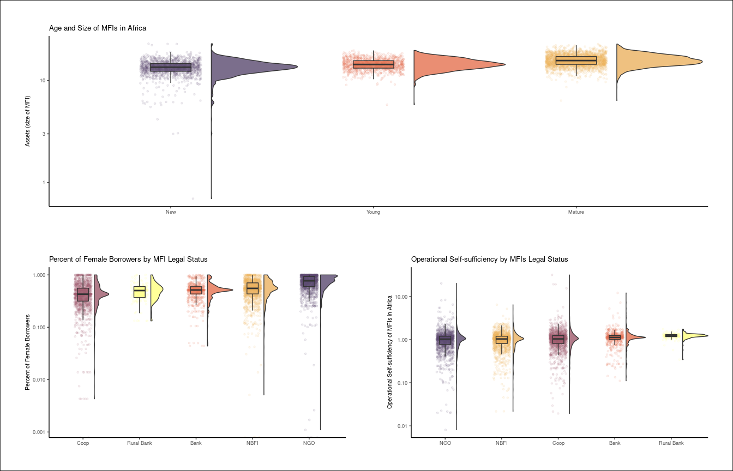

Size and Age of Microfinance Institutions in Africa

## References

Ahlin, Christian, Jocelyn Lin, and Michael Maio. 2011. “Where Does Microfinance Flourish? Microfinance Institution Performance in Macroeconomic Context.” *Journal of Development Economics* 95 (2): 105–20.

Allen, Franklin, Elena Carletti, Robert Cull, Jun ‘QJ’Qian, Lemma Senbet, and Patricio Valenzuela. 2014. “The African Financial Development and Financial Inclusion Gaps.” *Journal of African Economies* 23 (5): 614–42.

Allen, Franklin, Elena Carletti, Robert Cull, Jun Qian, Lemma Senbet, and Patricio Valenzuela. 2013. *Resolving the African Financial Development Gap: Cross-Country Comparisons and a Within-Country Study of Kenya*. The World Bank.

Armendáriz, Beatriz, Bert D’Espallier, Marek Hudon, and Ariane Szafarz. 2013. “Subsidy Uncertainty and Microfinance Mission Drift.” *Available at SSRN 1731265*.

Bateman, Milford. 2010. *Why Doesn’t Microfinance Work?: The Destructive Rise of Local Neoliberalism*. Zed Books Ltd.

Beck, Thorsten, ASLI Demirguc-Kunt, Luc Laeven, and Ross Levine. 2008. “Finance, Firm Size, and Growth.” *Journal of Money, Credit and Banking* 40 (7): 1379–1405.

Buera, Francisco J, Joseph P Kaboski, and Yongseok Shin. 2021. “The Macroeconomics of Microfinance.” *The Review of Economic Studies* 88 (1): 126–61.

Butkiewicz, James L, and Halit Yanikkaya. 2006. “Institutional Quality and Economic Growth: Maintenance of the Rule of Law or Democratic Institutions, or Both?” *Economic Modelling* 23 (4): 648–61.

Chattopadhyay, Manojit, and Subrata Kumar Mitra. 2017. “Applicability and Effectiveness of Classifications Models for Achieving the Twin Objectives of Growth and Outreach of Microfinance Institutions.” *Computational and Mathematical Organization Theory* 23 (4): 451–74.

Cheng, Simon, and J Scott Long. 2007. “Testing for IIA in the Multinomial Logit Model.” *Sociological Methods & Research* 35 (4): 583–600.

Cramer, Jan Salomon. 2002. “The Origins of Logistic Regression.”

Czepiel, Scott A. 2002. “Maximum Likelihood Estimation of Logistic Regression Models: Theory and Implementation.” *Available at Czep. Net/Stat/Mlelr. Pdf*, 1825252548–564645290.

D’Espallier, Bert, Jann Goedecke, Marek Hudon, and Roy Mersland. 2017. “From NGOs to Banks: Does Institutional Transformation Alter the Business Model of Microfinance Institutions?” *World Development* 89: 19–33.

D’Espallier, Bert, Marek Hudon, and Ariane Szafarz. 2013. “Unsubsidized Microfinance Institutions.” *Economics Letters* 120 (2): 174–76.

———. 2017. “Aid Volatility and Social Performance in Microfinance.” *Nonprofit and Voluntary Sector Quarterly* 46 (1): 116–40.

Demirguc-Kunt, Asli, Leora Klapper, Dorothe Singer, Saniya Ansar, and Jake Hess. 2018. *The Global Findex Database 2017: Measuring Financial Inclusion and the Fintech Revolution*. The World Bank.

Fernando, Nimal A. 2004. *Micro Success Story?: Transformation of Nongovernment Organizations into Regulated Financial Institutions*. Asian Development Bank.

Garmaise, Mark J, and Gabriel Natividad. 2013. “Cheap Credit, Lending Operations, and International Politics: The Case of Global Microfinance.” *The Journal of Finance* 68 (4): 1551–76.

Hishigsuren, Gaamaa. 2006. “Transformation of Micro-Finance Operations from NGO to Regulated MFI.” *IDEAS, USA*.

Huang, Yongfu. 2010. “Political Institutions and Financial Development: An Empirical Study.” *World Development* 38 (12): 1667–77.

Jia, Xiangping, Robert Cull, Pei Guo, and Tao Ma. 2016. “Commercialization and Mission Drift: Evidence from a Large Chinese Microfinance Institution.” *China Economic Review* 40: 17–32.

Kaidi, Nasreddine, Sami Mensi, and Mehdi Ben Amor. 2019. “Financial Development, Institutional Quality and Poverty Reduction: Worldwide Evidence.” *Social Indicators Research* 141 (1): 131–56.

Kodongo, Odongo, and Lilian G Kendi. 2013. “Individual Lending Versus Group Lending: An Evaluation with Kenya’s Microfinance Data.” *Review of Development Finance* 3 (2): 99–108.

La Porta, Rafael, Florencio Lopez-de-Silanes, and Andrei Shleifer. 2013. “Law and Finance After a Decade of Research.” In *Handbook of the Economics of Finance*, 2:425–91. Elsevier.

Ledgerwood, Joanna, and Victoria White. 2006. *Transforming Microfinance Institutions: Providing Full Financial Services to the Poor*. The World Bank.

Market, MIX. 2019. “Global Outreach & Financial. Performance Benchmark Report-2017-2018.” Recuperado de http://www. themix. org/mixmarket/publications/2014-global ….

Mersland, Roy, and R Øystein Strøm. 2010. “Microfinance Mission Drift?” *World Development* 38 (1): 28–36.

Mia, Md Aslam, and Hwok-Aun Lee. 2017. “Mission Drift and Ethical Crisis in Microfinance Institutions: What Matters?” *Journal of Cleaner Production* 164: 102–14.

Morduch, Jonathan. 1999. “The Microfinance Promise.” *Journal of Economic Literature* 37 (4): 1569–1614.

———. 2000. “The Microfinance Schism.” *World Development* 28 (4): 617–29.

Morduch, Jonathan, and Timothy Ogden. 2019. “The Challenges of Social Investment Through the Lens of Microfinance.” In *A Research Agenda for Financial Inclusion and Microfinance*. Edward Elgar Publishing.

Nguyen, Phan Dinh, and Vo Thi Ha Hanh. 2012. “Determinants of Stock Market Development in Southeast Asian Countries.” *Journal of Economics and Development* 44 (1): 101–12.

Petrucci, Carrie J. 2009. “A Primer for Social Worker Researchers on How to Conduct a Multinomial Logistic Regression.” *Journal of Social Service Research* 35 (2): 193–205.

Porter, Philip K, and Gerald W Scully. 1987. “Economic Efficiency in Cooperatives.” *The Journal of Law and Economics* 30 (2): 489–512.

Quayes, Shakil, and others. 2019. “Probability of Sustainability and Social Outreach of Microfinance Institutions.” *Economics Bulletin* 39 (2): 1047–56.

Ramus, Tommaso, and Antonino Vaccaro. 2017. “Stakeholders Matter: How Social Enterprises Address Mission Drift.” *Journal of Business Ethics* 143 (2): 307–22.

Schnyder, Gerhard, Mathias Siems, and Ruth V Aguilera. 2018. “Twenty Years of ‘Law and Finance’: Time to Take Law Seriously.” *Socio-Economic Review* 00 (0): 1–30.

Tsaurai, Kunofiwa. 2018. “What Are the Determinants of Stock Market Development in Emerging Markets?” *Academy of Accounting and Financial Studies Journal* 22 (2): 1–11.

1. OSS is the ratio of operating revenue and expenses on funding, loan loss provisions, and operations (Market 2019)
2. We did not include MIX data on lending to rural dwellers as it had a large proportion of missing values.
3. Note that the interpretation of Table 3 differs from the interpretation of the regression. The regression examines the relative likelihood. For instance, how likely are mature MFIs, as compared to new MFIs, to succeed in both objectives than fail in both objectives. The Table gives absolute values.
4. We exponentiate the coefficients to get the odds. Odds greater than one indicate greater likelihood. Odds less than one indicate less likelihood, while one indicates equal likelihood.
5. This figure is the row sum of the first row.