Transformation of Microfinance Institutions and Financial Inclusion in Africa

John Karuitha & Kalu Ojah

Tuesday, December 08, 2020

# Abstract

The shift from the not-for-profit microfinance has seen the rise of commercial MFIs ranging from commercial banks to rural banks to credit unions in addition to non-governmental organisations (NGOs). The shift arose partly due to neo-liberalism and the need for microfinance institutions (MFIs) to reach the financially excluded sustainably. In this article, we examine how the shift has affected financial inclusion in Africa. We utilise data from the Microfinance Information Exchange (MIX). The analysis shows that the change from the NGO model to the commercial models could negatively affect the depth of financial outreach given that NGOs have better outreach to women and advance smaller loans on average. Also, NGOs have a higher breadth of outreach compared to other legal forms except for credit unions/ cooperatives. The results are robust after removing outliers and controlling for factors that affect the ability of MFIs to offer financial services to the poor.

# Background

In 1992, PRODEM, a micro-finance institution (MFI) in Bolivia converted from a non-governmental organisation (NGO) to a commercial bank, adopting the name BANCOSOL. In the nearly almost three decades that have passed numerous NGO MFIs across the globe have adopted the commercial approach (Table 1). In this article, we examine how the conversion of MFIs to the commercial model affects financial inclusion in terms of outreach to the financially excluded. Specifically, we examine the way the conversion typically affects average loan sizes, gross loans, and outreach to women. The study focuses on Africa, a continent that is the epicentre of financial exclusion despite remarkable economic progress in the last 4 decades (Beck and Cull 2014; Allen, Otchere, and Senbet 2011). Evaluating the effects of transformation using global metrics is likely to mask regional heterogeneity given that these effects could manifest differently in varying settings (D’Espallier et al. 2017).

Sample of transformed MFIs across the globe (selected cases)

|  |  |  |  |
| --- | --- | --- | --- |
| Institution | Country | Year | Converted_to |
| Finansol | Colombia | 1993 | Commercial Finance Company |
| OIBM | Malawi | 2002 | NBFI |
| PRIDE | Tanzania | 2009 | NBFI |
| Kenya Women Finance Trust | Kenya | 2010 | NBFI |
| Faulu | Kenya | 2010 | NBFI |
| OI-SASL | Ghana | 2013 | NBFI |

Most pioneer microfinance institutions adopted a not-for-profit model (Dichter 1996), operating mainly as non-governmental organisations (NGOs). However, neo-liberalism has seen many donors scale back and push MFIs to strive for financial sustainability (Bateman 2010). The arguments for the commercial approach to microfinance revolve around sustainability. Financial sustainability school posits that MFIs can best serve the financially excluded when they have a degree of financial self-sufficiency (Kodongo and Kendi 2013).

For instance, profit-oriented MFIs could serve the relatively well-off at market rates and use the proceeds to subsidise services to the poor sustainably, causing mission expansion (Mersland and Strøm 2010; Louis, Seret, and Baesens 2013). Also, donor funds are volatile and subject to prevailing political and economic conditions (Garmaise and Natividad 2013; D’Espallier, Hudon, and Szafarz 2017). As a case in point, Frank et al. (2008), found that adopting a commercial model led to a higher client outreach, higher growth in the loan portfolio, and higher product diversification. More importantly, they established that conversion allowed more women customers to access services, although the overall percentage of women receiving the services declined. Subsequent research by supports this position (Bos and Millone 2015; D’Espallier, Hudon, and Szafarz 2013; Hartarska and Mersland 2012).

The proponents point to the possibility of mission drift where MFI reduce focus on providing financial services to the financially excluded in favour of making profits which some researchers have found to be the case (Louis, Seret, and Baesens 2013). The theory underlying mission drift is the profit-incentive theory arising from the agency relationship between managers and providers of capital, chiefly, shareholders. Agency theory postulates that managers act in their self-interest to the detriment of shareholders which forces shareholders to undertake actions to safeguard their interests. In the presence of a third objective like social performance, it is likely that managers could focus on meeting their interests while satisfying the requirements of the shareholders, meaning that social performance would suffer. The assumption is that shareholders prioritise financial gain over the social performance of the MFIs where they have invested the funds. The assumption fails where we have investors who also give weight to social performance as is the case with blended finance investors- private financial investment for social good.

As noted, research on the effects of the transformation of microfinance institutions is mixed. () plausibly argues that if commercial MFIs could sustainably achieve both financial sustainability while also reaching the poor, then NGOs would not exist. The most important question relates to the way the transformation of MFIs would affect their core mission of providing financial services to the financially excluded. The issue is important not only due to the legitimacy that MFIs derive from serving the financially excluded but also because financial inclusion is central to alleviating poverty and achieving inclusive growth and is a key dimension of financial development. In this article, we use data from the Microfinance Information Exchange (MIX) to evaluate the way transformation of MFIs affects financial inclusion in Africa.

We capture the extent of financial inclusion of Africa using three metrics; the percent of female borrowers, average loan balance per borrower and gross loan portfolio to assets of the MFI. The first two proxy the depth of outreach with greater outreach to women an indicator of more depth. Higher average loan balance per borrower corresponds to lower depth of outreach. The presumption is that financially excluded people usually borrow in smaller denominations which has drawn reservations from some researchers who argue poor people could progressively demand bigger loans as they get better off. Also, MFIs regularly use progressive lending where people who successfully pay off loans qualify for a higher loan. We have organised the rest of the study as follows. Section 2 presents a summary of the results, followed by the methodology. Next, in section 4, we presents the methods adopted in the study. We then present the results and conclude.

# Theory and Empirical Literature

The extent to which transformation of MFIs affects financial inclusion has been subject to substantial empirical literature. However, there is a lack of consensus. Theories underlying aspects of the transformation of MFIs are the agency theory (Jensen and Meckling 1976) and institutional theory(Powell and DiMaggio 2012). Agency theory in this case implies that entry of commercial capital, a consequence of transformation, is likely to motivate managers to target financial return at the expense of social return so as to satisfy shareholders and debt-holders. From this perspective, transformation implies that mission drift is inevitable. Indeed, (Morduch and Ogden 2019) argues if mission drift is not an issue in microfinance, then NGOs would not exist, meaning that not-for-profit MFIs exist to fill a gap that commercial MFIs cannot fill.

The institutionalists weigh in on the way certain organisational structures dominate and ultimately decline and get discarded (Powell and DiMaggio 2012). Institutionalists note that in certain situations, people adopt given structures without critical scrutiny to merely fit in the prevailing institutional environment. This argument could partly explain the prevalence of NGOs at the early stages of microfinance evolution and the current rise of MFI commercialisation. However, the pressure to change takes several forms, with the most notable one being coercive pressure where stakeholders put overt or covert pressure for MFIs to convert. In the case of MFIs, the pressure to adopt commercial model came with the rise of neo-liberalism (Bateman 2010), with major donors like USAID signalling their expectation that MFIs be more financially sustainable (D’Espallier, Hudon, and Szafarz 2013). The problem for MFIs that transform is how best to balance between social goals of reaching the poor and the commercial goals that come with commercial capital and decline of donor funding.

Thornton (2002) and Thornton, Ocasio, and Lounsbury (2015) note that “the meaning and legitimacy of various sources of organisational identity, strategy and structure are shaped by a prevailing institutional logic.” The management of transformed MFIs have the option of identifying with microfinance as a social pursuit by emphasising social goals over profits or they may view microfinance as a financial venture by placing profits over social outreach. The former corresponds to the welfare model of microfinance which posits that the social mission of microfinance is incompatible with the profit motive. The latter is the financial sustainability model which views financial returns as a precondition for sustainable pursuit of financial goals of reaching the financially excluded. The third model, the win-win approach attempts to reconcile the welfare and sustainability approach, proposing that financial and social performance are not always substitutes but are complementary each other. Different researchers have availed evidence in support of either school as described next.

# Summary of Results

Overall, we find that the conversion from NGO, not-for-profit model in Africa is harmful to both the depth and breadth of outreach. NGOs consistently outperform the commercial oriented MFIs regarding the outreach to women borrowers. Additionally, NGOs have the lowest average loan balance per borrower, an indicator that they reach out to the poorest, presumably more financially excluded people. Turning to gross loans to assets, NGOs come second to credit unions/ cooperatives. The trend indicates that MFIs that are profit oriented do suffer a degree of mission drift. Noting that serving poor, financially excluded people is costly, and given that profit orientation implies the presence of interest on debt and dividends on equity, the results are no surprise. What is odd is that NGOs could be lending more in terms of gross loans than most commercial oriented MFIs, though it turns out the both cooperatives and NGOs hold the fewest assets relative to other legal types. The other important drivers of financial inclusion are age of MFI, operating expense to assets ratio, donations to assets ratio, capital-assets ratio, asset structure, size, education and profit margin. In the next section, we highlight the results of the study.

# Method

We run fixed and random effects models dependent on the results of the Hausmann Tests. Specifically, we fit the following model.

$y_{it}=\hat{a}+\hat{b}x_{it}+e_{it}$ <equation 1>

Where $y_{it}$ is the independent variable; one of percent of female borrowers, average loan balance per borrower, and gross loan portfolio to total assets. The first two metrics capture financial depth while gross loans captures the breadth of outreach. $x_{it}$ is a matrix of independent variables. The variable of interest in our case is the current legal status that enters the model as a dummy representing NGOs, NBFIs, commercial banks, rural banks and credit unions/ cooperatives. The other control variables include age dummy, a dummy for region, operating expenses to assets ratio, donations to assets ratio, equity capital to assets ratio, asset structure, size (logarithm of total assets), education, and profit margin. $e_{it}$ is the error term. In the next section, we present the results.

# Results

In this section, we begin by visualising the variables followed by summary statistics for the data. We then run and discuss the results of the regression model.

## Data Visualization

We start by visualising the numeric variables against the current legal status of MFIs. We use the median of the variables to stand for the variables. Figure () shows that NGOs exhibit the highest median operating expense to assets ratio followed by NBFIs while credit unions trail. As we see later in the analysis, operating expenses positively relate with the depth of outreach- percent of female borrowers and depth of outreach in terms of gross loans to assets. As expected NGOs receive the highest share of donations followed by, surprisingly, credit unions and NGOs while commercial banks receive the least donations. The result is not surprising given that NGOs have a rooting in the welfare model of microfinance and that most donors are likely to channel their funds to MFIs that place social performance over profits.

Donations do not prevent NGOs and NBFIs from raising capital as they have the highest capital to assets ratio- which captures equity injections. Commercial banks, credit unions and rural banks follow in that order. However, the equity capital NGOs may attract may be preferential in terms of expected returns, as is the case with blended finance. For asset structure (tangibility), credit unions lead followed by commercial banks, NGOs, NBFIs, and rural banks. We capture the size of MFI by the logarithm of assets. Commercial banks have the highest asset base, followed by NBFIs while NGOs and cooperatives come last. Finally, NGOs fare worst in profitability while rural banks and commercial banks lead.

Overall, the pattern indicates that while NGOs spend the most in operating expense to reach the financially excluded, these efforts come at the expense of profitability. on the contrary, profit-oriented MFIs are keen to manage expenses which improves profitability, presumably at the expense of outreach to the financially excluded. It is worth noting that NGOs have a relatively low asset base and hold relatively fewer non-current assets to total assets. The observation could mean that NGOs do not invest heavily in brick and mortar branches or serve a relatively limited geographic range. Finally, despite the push towards commercial capital, NGOs have the highest capital (equity) to asset ratio- of which much could be from investors keen on social performance and not profits.

We now turn to figure (). The first graph shows that commercial banks are the largest in terms of total assets, while NGOs and cooperatives are the smallest in that order. Banks tend to have a much broader geographic presence and hence attract more clients which, in turn means more assets. Again, capital adequacy requirements by central banks have implications on the assets that banks hold. Turning to profitability, we find that rural banks and commercial banks post the highest median profits, while NBFIs and NGOs trail. The result probably partially illustrates the emphasis on social performance versus financial perfromance that management take- with NGOs more likely to favor the social aspect.

Turning to gross loans, commercial banks have the highest while NBFIs and NGOs trail. The argument is that a smaller average loan size is indicative of better depth of outreach, a position that is contested. In this case, it means that banks tend to reach relatively well off clients that are unlikely to be financially excluded leaving NBFIs and NGOs to serve the marginalised. After commercial banks, the other legal forms that exhibit highest average loan balances are credit unions and rural banks, respectively. Lastly, NGOs appear to have the highest median gross loans, which is surprising given their relatively smaller size. On the other hand, banks and rural banks, respectively have the lowest gross loans to assets meaning they are less efficienct in converting their assets into credit. Again, it goes to show, at least in the case of Africa that breadth and depth of financial outreach are not always mutually exclusive.

Figure () shows the relationships between the numeric variables. First, there is high skewness exhibited by donations to assets ratio, average loan balance per borrower and gross loans to assets ratio. It means that relatively few firms account for a huge chunk of the donations received, in this case among NGOs, cooperatives and NBFIs. The highest correlation exists between operating expenses to assets ratio and donations to assets ratio, meaning that donor funded MFIs have more operating expenses probably because they are less constrained by profit/ interest seeking shareholders and debt holders. Taken together, this observation may imply that if it is expensive to administer and monitor small loans, then the profit oriente model is not good for financial inclusion as it constrains the ability to spend. The summary statistics in Table 2, Table 3, and Table 4 highlight the discussed issues but offer a wider array of statistical measures inclusing the mean, standard deviation and the quantiles.

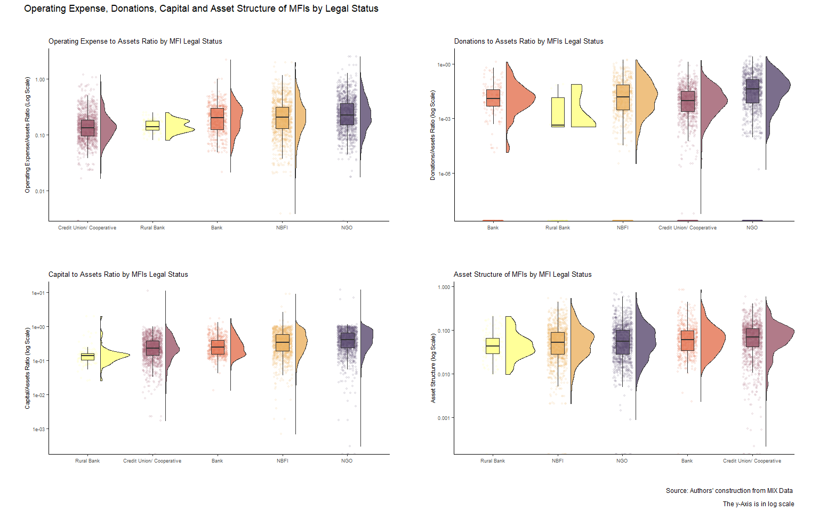

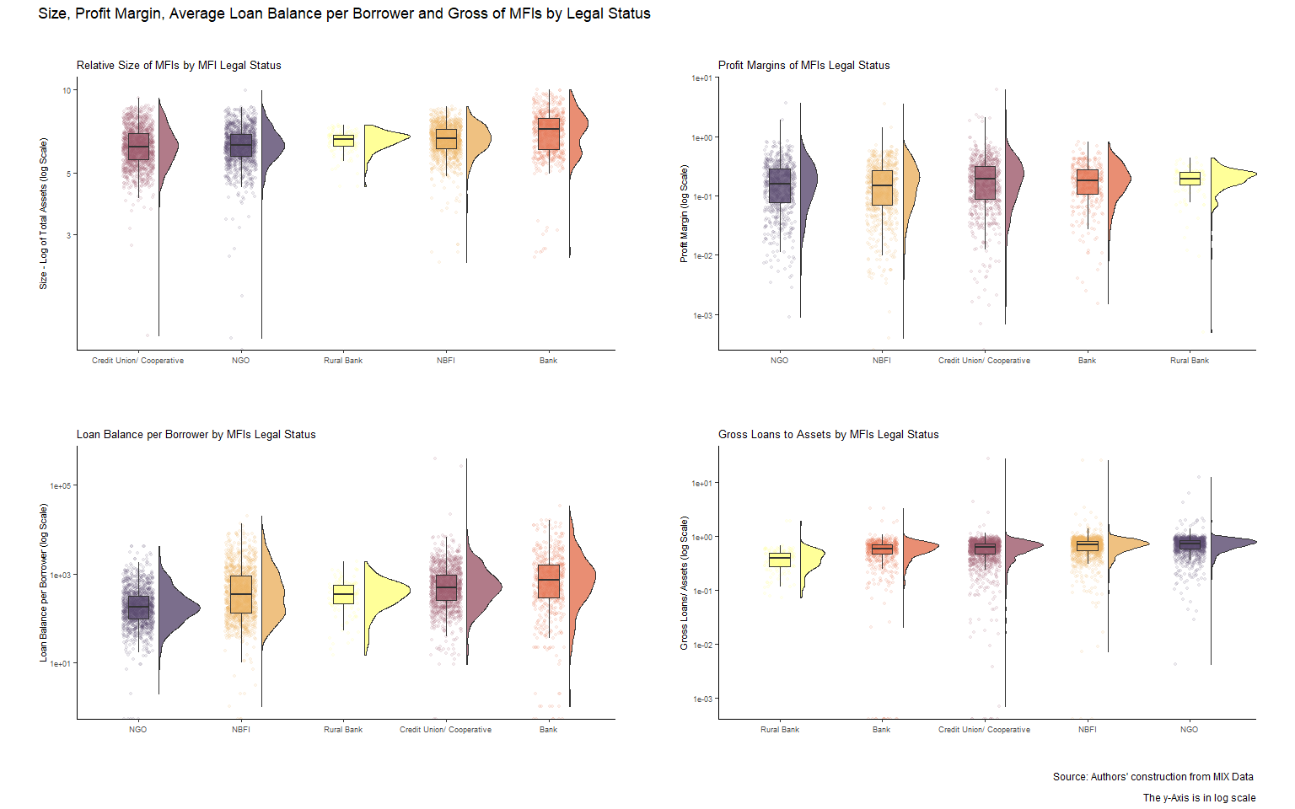

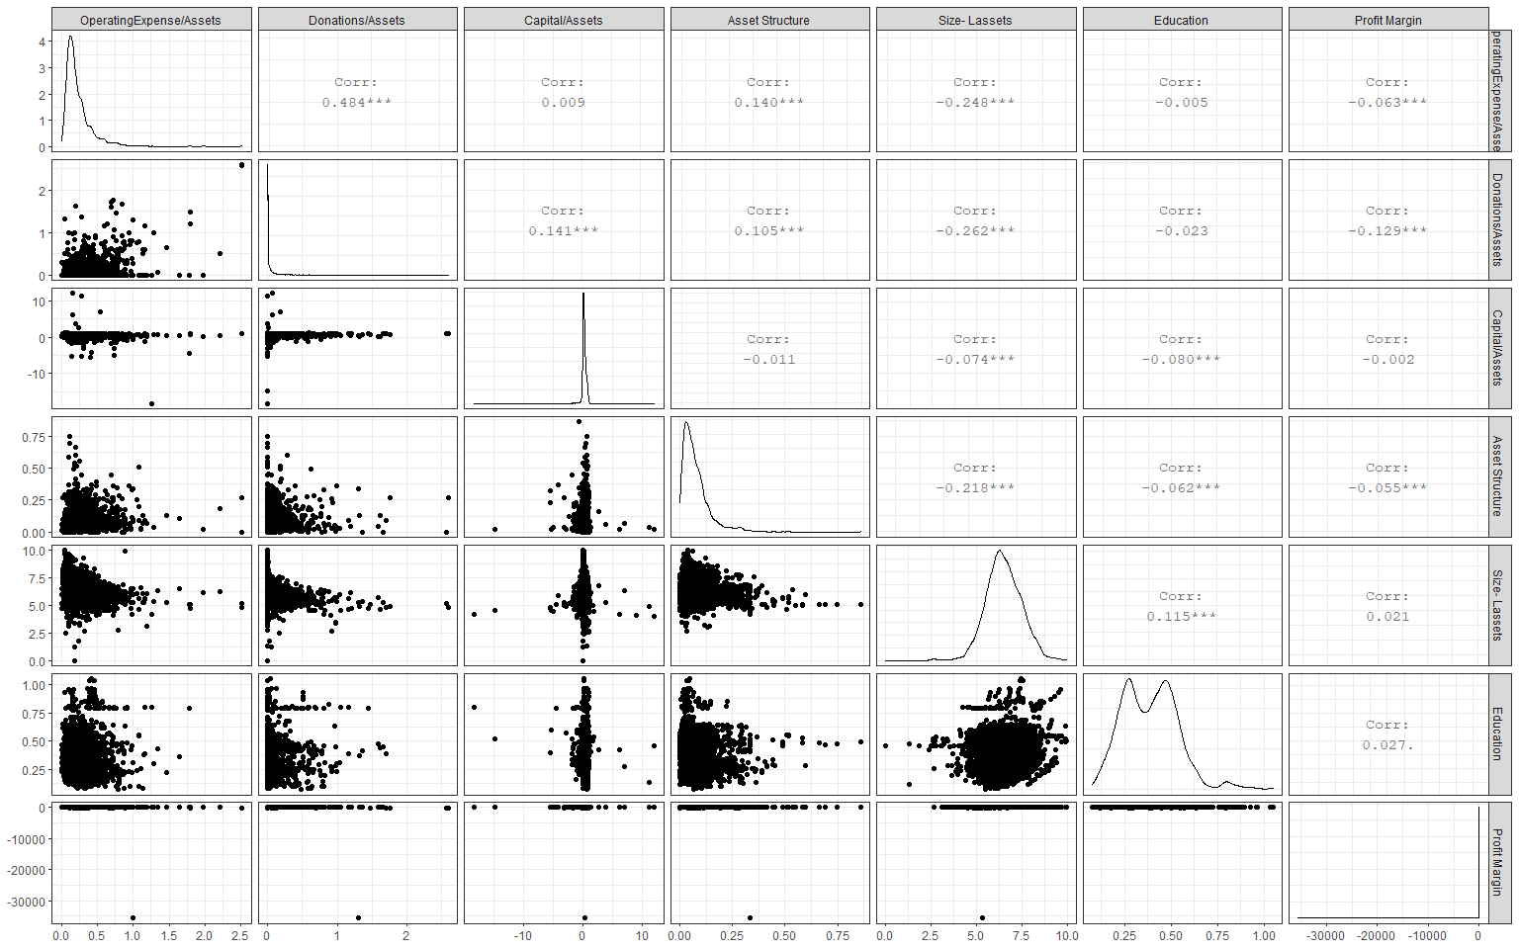

## Descriptive Statistics

Summary Statistics for Dependent Variables

|  |  |  |  |  |  |  |  |  |
| --- | --- | --- | --- | --- | --- | --- | --- | --- |
| Variable | currentlegalstatus | Mean | SD | Min | Q1 | Median | Q3 | Max |
| percent_of_female_borrowers | NGO | 0.73 | 0.23 | 0.00 | 0.60 | 0.77 | 0.94 | 1.00e+00 |
| percent_of_female_borrowers | Bank | 0.52 | 0.20 | 0.04 | 0.37 | 0.52 | 0.60 | 1.00e+00 |
| percent_of_female_borrowers | NBFI | 0.56 | 0.23 | 0.00 | 0.40 | 0.55 | 0.72 | 1.00e+00 |
| percent_of_female_borrowers | Credit Union/ Cooperative | 0.46 | 0.24 | 0.00 | 0.28 | 0.43 | 0.61 | 1.00e+00 |
| percent_of_female_borrowers | Rural Bank | 0.50 | 0.19 | 0.13 | 0.37 | 0.50 | 0.60 | 1.00e+00 |
| average_loan_balance_per_borrower | NGO | 286.23 | 391.15 | 0.00 | 96.00 | 174.00 | 316.00 | 4.19e+03 |
| average_loan_balance_per_borrower | Bank | 1573.01 | 2801.56 | 0.00 | 275.25 | 712.50 | 1584.00 | 3.40e+04 |
| average_loan_balance_per_borrower | NBFI | 819.69 | 1443.97 | 0.00 | 130.75 | 338.00 | 897.25 | 1.99e+04 |
| average_loan_balance_per_borrower | Credit Union/ Cooperative | 1316.29 | 13562.13 | 0.00 | 250.75 | 490.50 | 933.25 | 4.01e+05 |
| average_loan_balance_per_borrower | Rural Bank | 410.19 | 302.19 | 15.00 | 210.00 | 351.00 | 561.00 | 1.88e+03 |
| gross_loan_portfolio_to_total_assets | NGO | 0.72 | 0.43 | 0.00 | 0.59 | 0.72 | 0.83 | 1.22e+01 |
| gross_loan_portfolio_to_total_assets | Bank | 0.57 | 0.27 | 0.00 | 0.45 | 0.58 | 0.70 | 3.28e+00 |
| gross_loan_portfolio_to_total_assets | NBFI | 0.71 | 0.99 | 0.00 | 0.55 | 0.69 | 0.81 | 2.50e+01 |
| gross_loan_portfolio_to_total_assets | Credit Union/ Cooperative | 0.61 | 0.76 | 0.00 | 0.47 | 0.62 | 0.73 | 2.74e+01 |
| gross_loan_portfolio_to_total_assets | Rural Bank | 0.40 | 0.23 | 0.07 | 0.28 | 0.39 | 0.50 | 1.87e+00 |

Summary Statistics for Categrical Independent Variables

|  |  |  |
| --- | --- | --- |
| Variable | Completeness | Counts |
| currentlegalstatus | 1 | Cre: 1427, NBF: 1318, NGO: 1280, Ban: 619 |
| age | 1 | Mat: 2558, New: 1200, You: 1024 |

Summary Statistics for Continous Independent Variables

|  |  |  |  |  |  |  |  |  |
| --- | --- | --- | --- | --- | --- | --- | --- | --- |
| Variable | currentlegalstatus | Mean | SD | Min | Q1 | Median | Q3 | Max |
| operating_expense_assets | NGO | 0.29 | 0.24 | 0.00 | 0.15 | 0.23 | 0.37 | 2.52 |
| operating_expense_assets | Bank | 0.23 | 0.16 | 0.02 | 0.12 | 0.20 | 0.30 | 2.21 |
| operating_expense_assets | NBFI | 0.26 | 0.21 | 0.00 | 0.13 | 0.20 | 0.31 | 1.98 |
| operating_expense_assets | Credit Union/ Cooperative | 0.16 | 0.11 | 0.00 | 0.10 | 0.13 | 0.18 | 1.19 |
| operating_expense_assets | Rural Bank | 0.15 | 0.04 | 0.08 | 0.12 | 0.14 | 0.17 | 0.25 |
| donations_assets_ratio | NGO | 0.10 | 0.23 | 0.00 | 0.00 | 0.01 | 0.09 | 2.60 |
| donations_assets_ratio | Bank | 0.02 | 0.09 | 0.00 | 0.00 | 0.00 | 0.00 | 1.30 |
| donations_assets_ratio | NBFI | 0.04 | 0.13 | 0.00 | 0.00 | 0.00 | 0.02 | 1.71 |
| donations_assets_ratio | Credit Union/ Cooperative | 0.02 | 0.08 | 0.00 | 0.00 | 0.00 | 0.01 | 1.62 |
| donations_assets_ratio | Rural Bank | 0.00 | 0.01 | 0.00 | 0.00 | 0.00 | 0.00 | 0.08 |
| capital_asset_ratio | NGO | 0.42 | 0.76 | -18.35 | 0.22 | 0.38 | 0.64 | 12.15 |
| capital_asset_ratio | Bank | 0.31 | 0.23 | -0.57 | 0.15 | 0.24 | 0.39 | 1.70 |
| capital_asset_ratio | NBFI | 0.39 | 0.48 | -1.78 | 0.18 | 0.32 | 0.57 | 9.05 |
| capital_asset_ratio | Credit Union/ Cooperative | 0.20 | 0.67 | -14.82 | 0.11 | 0.21 | 0.36 | 11.27 |
| capital_asset_ratio | Rural Bank | 0.18 | 0.24 | -0.13 | 0.10 | 0.14 | 0.16 | 1.98 |
| asset_structure | NGO | 0.08 | 0.08 | 0.00 | 0.03 | 0.06 | 0.10 | 0.75 |
| asset_structure | Bank | 0.08 | 0.09 | 0.00 | 0.03 | 0.06 | 0.10 | 0.86 |
| asset_structure | NBFI | 0.07 | 0.07 | 0.00 | 0.03 | 0.05 | 0.09 | 0.55 |
| asset_structure | Credit Union/ Cooperative | 0.08 | 0.07 | 0.00 | 0.04 | 0.07 | 0.11 | 0.60 |
| asset_structure | Rural Bank | 0.06 | 0.04 | 0.00 | 0.03 | 0.04 | 0.07 | 0.21 |
| lassets | NGO | 6.31 | 0.93 | 0.00 | 5.76 | 6.29 | 6.87 | 9.93 |
| lassets | Bank | 7.07 | 1.24 | 2.50 | 6.08 | 7.19 | 7.89 | 9.98 |
| lassets | NBFI | 6.62 | 0.82 | 2.39 | 6.13 | 6.64 | 7.19 | 8.68 |
| lassets | Credit Union/ Cooperative | 6.28 | 0.98 | 1.30 | 5.58 | 6.21 | 6.93 | 9.33 |
| lassets | Rural Bank | 6.52 | 0.55 | 4.48 | 6.25 | 6.61 | 6.86 | 7.43 |
| education | NGO | 0.42 | 0.16 | 0.07 | 0.29 | 0.42 | 0.50 | 1.05 |
| education | Bank | 0.41 | 0.15 | 0.08 | 0.28 | 0.46 | 0.51 | 0.96 |
| education | NBFI | 0.38 | 0.14 | 0.10 | 0.26 | 0.36 | 0.48 | 0.96 |
| education | Credit Union/ Cooperative | 0.34 | 0.12 | 0.12 | 0.25 | 0.31 | 0.44 | 0.60 |
| education | Rural Bank | 0.48 | 0.04 | 0.46 | 0.46 | 0.47 | 0.49 | 0.69 |
| profit_margin | NGO | -0.51 | 3.43 | -49.12 | -0.30 | 0.03 | 0.17 | 3.62 |
| profit_margin | Bank | -70.78 | 1584.24 | -35495.62 | -0.07 | 0.11 | 0.23 | 0.81 |
| profit_margin | NBFI | -0.36 | 1.99 | -45.36 | -0.26 | 0.04 | 0.18 | 3.56 |
| profit_margin | Credit Union/ Cooperative | -0.35 | 2.36 | -50.43 | -0.23 | 0.05 | 0.21 | 6.20 |
| profit_margin | Rural Bank | 0.16 | 0.23 | -1.89 | 0.14 | 0.19 | 0.25 | 0.43 |

## Regression Analysis

In this section, we run the Hausmann test for the choice between fixed effects and random effects model.Also, we check for the choice between pooled OLS and random effects models. Finally, we present the output from the regression analysis.

### *The Hausmann Test*

Table () shows the results of the Hausmann test. The test favours the fixed effects model given that the null hypothesis is the random effects.

Results of the Hausmann Test for Fixed versus Random Effects

|  |  |  |  |  |
| --- | --- | --- | --- | --- |
| Dependent_variable | Statistic | P.value | Parameter | Alternative |
| Percent of Female Borrowers | 61.9 | 0 | 30 | one model is inconsistent |
| Average Loan Balance per Borrower | 239.1 | 0 | 30 | one model is inconsistent |
| Gross Loan Portfolio to Total Assets | 429.1 | 0 | 30 | one model is inconsistent |

Fixed Effects Regressions- Standard errors in brackets(***1%, **5%, *1%)

|  |  |  |  |  |  |  |  |  |  |
| --- | --- | --- | --- | --- | --- | --- | --- | --- | --- |
| Variables | Percent_female | Percent_female | Percent_female | Average_loan | Average_loan | Average_loan | Gross_loans | Gross_loans | Gross_loans |
|  | Full data | >=3 years | >= 5 years | Full data | >=3 years | >= 5 years | Full data | >=3 years | >= 5 years |
|  | (1) | (2) | (3) | (4) | (5) | (6) | (7) | (8) | (9) |
| Legal_status: Credit Union | 0.099 | 0.099 | 0.098 | 1654.000 | 1657.000 | 1768.000 | 0.052 | 0.052 | 0.065 |
|  | (0.124) | (0.124) | (0.127) | (1520.000) | (1568.000) | (1856.000) | (0.248) | (0.252) | (0.254) |
| Age: Young | -0.009 | -0.009 | -0.010 | -1,138.000*** | -1,143.000*** | -1,238.000*** | 0.117*** | 0.118*** | 0.131*** |
|  | (0.013) | (0.013) | (0.014) | (347.000) | (350.000) | (387.000) | (0.031) | (0.031) | (0.034) |
| Age: Mature | -0.005 | -0.005 | -0.005 | -1,533.000** | -1,537.000** | -1,657.000** | 0.163*** | 0.164*** | 0.176*** |
|  | (0.018) | (0.018) | (0.019) | (600.000) | (607.000) | (648.000) | (0.040) | (0.040) | (0.044) |
| Operating expense to assets | 0.067* | 0.067* | 0.072* | 1,775.000 | 1,787.000 | 2,205.000 | 0.279*** | 0.280*** | 0.306*** |
|  | (0.036) | (0.036) | (0.037) | (1,844.000) | (1,872.000) | (1,978.000) | (0.090) | (0.091) | (0.097) |
| Donations to assets ratio | -0.012 | -0.012 | -0.016 | 1663.000 | 1662.000 | 1478.000 | -0.315*** | -0.316*** | -0.324*** |
|  | (0.031) | (0.032) | (0.034) | (1,227.000) | (1,237.000) | (1,338.000) | (0.100) | (0.101) | (0.105) |
| Capital to assets ratio | -0.004 | -0.004 | -0.007 | 797.000*** | 797.000*** | 1,049.000*** | 1.100*** | 1.100*** | 1.260*** |
|  | (0.007) | (0.007) | (0.010) | (244.000) | (247.000) | (339.000) | (0.034) | (0.035) | (0.047) |
| Asset structure | 0.081 | 0.083 | 0.076 | 478.000 | 558.000 | -1,137.000 | -0.730*** | -0.722*** | -1.050*** |
|  | (0.081) | (0.081) | (0.088) | (3,930.000) | (4,074.000) | (4,311.000) | (0.218) | (0.226) | (0.250) |
| Size (Lassets) | 0.011 | 0.011 | 0.012 | 7,398.000*** | 7,412.000*** | 7,832.000*** | -0.087*** | -0.088*** | -0.047 |
|  | (0.014) | (0.014) | (0.015) | (868.000) | (877.000) | (945.000) | (0.034) | (0.034) | (0.037) |
| Education | 0.192** | 0.193** | 0.205** | -2,370.000 | -2,355.000 | -2,604.000 | 0.008 | 0.007 | -0.029 |
|  | (0.090) | (0.090) | (0.093) | (3,472.000) | (3,506.000) | (3,708.000) | (0.189) | (0.191) | (0.212) |
| Profit Margin | 0.02 | 0.02 | 0.03 | -159.000*** | -160.000*** | -160.000*** | 0.015*** | 0.016*** | 0.014*** |
|  | (0.002) | (0.002) | (0.002) | (39.500) | (40.000) | (39.900) | (0.004) | (0.004) | (0.004) |
| r.squared | 4.26e-02 | 4.27e-02 | 4.47e-02 | 7.52e-02 | 7.54e-02 | 7.97e-02 | 0.517 | 0.518 | 0.527 |
| adj.r.squared | -8.83e-02 | -8.33e-02 | -6.31e-02 | -5.68e-02 | -5.03e-02 | -2.61e-02 | 0.444 | 0.451 | 0.473 |
| statistic | 4.23*** | 4.21*** | 4.13*** | 8.02*** | 7.98*** | 7.84*** | 108.395*** | 106.966*** | 101.779*** |
| nobs | 3240 | 3210 | 2950 | 3380 | 3340 | 3030 | 3497 | 3405 | 3056 |

Random Effects and Pooled OLS Regressions- Standard errors in brackets(***1%, **5%, *1%)

|  |  |  |  |  |  |  |
| --- | --- | --- | --- | --- | --- | --- |
| Variables | Percent_female | Percent_female | Average_loan | Average_loan | Gross_loans | Gross_loans |
|  | Random_Effects | Pooled_OLS | Random_Effects | Pooled_OLS | Random_Effects | Pooled_OLS |
|  | (1) | (2) | (3) | (4) | (5) | (6) |
| Legal status: Bank | -0.214*** | -0.182*** | 276.000 | 276.000 | -0.013 | -0.061 |
|  | (0.044) | (0.043) | (585.000) | (585.000) | (0.053) | (0.046) |
| Legal status: NBFI | -0.181*** | -0.178*** | 152.000 | 152.000 | 0.027 | -0.008 |
|  | (0.030) | (0.029) | (379.000) | (379.000) | (0.038) | (0.034) |
| Legal statusCredit Union | -0.260*** | -0.236*** | 872.000** | 872.000** | 0.088** | 0.043 |
|  | (0.030) | (0.030) | (388.000) | (388.000) | (0.039) | (0.035) |
| Legal status: Rural Bank | -0.241*** | -0.214*** | 112.000 | 112.000 | -0.119 | -0.185** |
|  | (0.061) | (0.050) | (570.000) | (570.000) | (0.078) | (0.073) |
| Age: Young | -0.010 | -0.011 | -314.000 | -314.000 | 0.077*** | 0.049* |
|  | (0.012) | (0.017) | (305.000) | (305.000) | (0.028) | (0.029) |
| Age: Mature | -0.010 | -0.024 | -641.000* | -641.000* | 0.117*** | 0.077** |
| regionAfrica | 0.098* | 0.088 | 456.000 | 456.000 | -0.060 | -0.034 |
|  | (0.054) | (0.059) | (650.000) | (650.000) | (0.081) | (0.068) |
| Operating expense/assets | 0.098*** | 0.295*** | 403.000 | 403.000 | 0.208*** | 0.121 |
|  | (0.034) | (0.062) | (1,083.000) | (1,083.000) | (0.070) | (0.076) |
| Donations/assets_ratio | -0.007 | 0.028 | 374.000 | 374.000 | -0.383*** | -0.474*** |
|  | (0.032) | (0.053) | (619.000) | (619.000) | (0.094) | (0.099) |
| Capital/asset_ratio | 0.002 | 0.048*** | 95.400 | 95.400 | 0.924*** | 0.777*** |
|  | (0.007) | (0.015) | (154.000) | (154.000) | (0.029) | (0.028) |
| Asset_structure | 0.035 | -0.168 | 1,901.000 | 1,901.000 | -0.787*** | -0.828*** |
|  | (0.077) | (0.131) | (1,387.000) | (1,387.000) | (0.164) | (0.168) |
| Size(lassets) | -0.001 | -0.022 | 1,013.000*** | 1,013.000*** | -0.024 | -0.005 |
|  | (0.011) | (0.014) | (197.000) | (197.000) | (0.017) | (0.017) |
| Education | 0.188*** | 0.172** | 305.000 | 305.000 | 0.115 | 0.128 |
|  | (0.071) | (0.079) | (962.000) | (962.000) | (0.094) | (0.089) |
| Profit_margin | 0.002 | 0.001 | -31.200 | -31.200 | 0.011*** | 0.008** |
|  | (0.002) | (0.003) | (20.800) | (20.800) | (0.003) | (0.004) |
| r.squared | 0.111 | 0.288 | 0.026 | 0.026 | 0.472 | 0.413 |
| adj.r.squared | 0.101 | 0.280 | 0.0161 | 0.0161 | 0.467 | 0.407 |
| statistic | 273*** | 38.1*** | 89.4*** | 2.63*** | 3017.027*** | 71.499*** |
| nobs | 3240 | 3240 | 3380 | 3380 | 3497 | 3497 |

### *Percent of Women Borrowers*

The legal status of an MFI is a significant driver of outreach to women, with NGOs faring better. Other positive drivers of outreach to women include education, operating expenses to assets ratio, profit margin and capital-to-assets ratio. Region is also important as North Africa fares worse than Sub-Sahara Africa despite the fact that it is represented entirely by NGOs in the sample. Table () of the fixed effects model shows that NGOs outperform other legal forms of MFIs in reaching out to women. The result implies that the transformation of MFIs has the potential to negatively impact on financial inclusion efforts as commercial MFIs are less keen to reach the financially excluded, which contradicts some previous research (Joann Ledgerwood 1998; Joanna Ledgerwood and White 2006; Hartarska and Mersland 2012; Bos and Millone 2015).

The results gain more credence when we examine operating expenses to assets ratio. There is a positive and significant relationship between operating expense to assets ratio on the one hand and percent of women borrowers on the other. It means that an MFI has to spend more to reach financially excluded clients, which in turn means fewer profits at a given level of revenue. As expected, the conversion of MFIs from NGOs to the commercial model could lead to a reduction in operating expenses in the quest for profits in line with the profit incentive arising from the agency theory (Eisenhardt 1989).

Hence, it follows that a quest for profit is bad for financial inclusion by causing mission drift in line with prior research (Wagenaar 2012; Roberts 2013; Lopatta and Tchikov 2016; Mia and Lee 2017). Except in the unlikely scenario where MFIs generate profits by raising revenue without lowering costs, Africa should rethink the case for transformation of MFIs. Indeed profitability has a positive relationship albeit insignificant effects on the percent of women borrowers. With this hindsight it would appear like the viable explanation for the profitability-operating expense-financial inclusion issue is that for commercial MFIs, a reduction in operating expenses in the short run is warranted if this translates into higher profits that allow the MFIs to reach more financially excluded clients while cross subsidising them in the median and long term. However, (D’Espallier et al. 2017) note that for transformed MFIs, profits tend to drop in the short term but not necessarily in the long term, although operating expenses generally drop.The drop in profitability is driven by transformed MFIs charging lower interest rates, a contentious issue in micro-finance. It would be interesting to examine the dynamics between profitability, operating expense and financial inclusion for MFIs over a longer period.

The significant control variables are education and region. Education varies positively with outreach to women as does region. A country in Northern Africa has lower outreach to women than an otherwise similar country in Sub-Sahara Africa which could be due to religious beliefs that harm financial inclusion for women (Hassan, Hossain, and Unsal 2018). It is notable that North Africa has only NGOs in the sample meaning that cultural and religious inclinations play a bigger role in driving financial inclusion than the operating model of MFIs. Education also appears to play a key role in financial inclusion arising from its empowerment in terms of women joining the formal labour market and financial literacy that allows for better financial decision making (Zins and Weill 2016; Chikalipah 2017).

The observed relationships largely hold even when we winsorise the data (see table ()). The only exception is capital to assets ratio and profit margin which turn out to have a significant positive relationships with outreach to women. These results suggest that larger firms are more likely to experience mission drift after conversion. However, even after winsorising the data, NGOs still do better at financing women in line with research from the welfare approach to microfinance (Kodongo and Kendi 2013). To sum this up, the quest improve outreach to women would best be achieved by targeting NGOs with capital funding, especially with the rise of blended finance - commercial capital for social projects, ceteris paribus. The other variables in the model are not significant but are worth mentioning. For instance, older firms have lower levels of outreach to women which could imply that firms loose focus on financial inclusion as they mature and get financially independent. Next, we examine average loan balance per borrower.

### *Average Loan Balance per Borrower*

Like the percent of female borrowers, average loan balance per borrower captures how deep an MFI goes to reach the financially excluded, who typically would demand smaller loans. Thus, the smaller the average loan balance the better the outreach. The major criticism of the average loan balance per borrower as an indicator of financial inclusion is that a larger average loan balance could result from progressive lending or arise as clients get better off (Abeysekera, Oguzoglu, and Le 2014). Again, researchers could be wrongly proclaiming mission drift for MFIs operating in countries that have relatively fewer indigent clients (Armendáriz et al. 2013). Importantly, the presence of some extremely high loans granted to some clients could tilt the average loan balance upwards (Market 2015). Despite these shortcomings, it is a useful metric as it is easily quantifiable and data readily available.

The key observation is that NGOs consistently offers smaller average loan sizes compared to other legal forms of MFIs, although the result is only significant for credit unions/ cooperatives. Consistent with the outreach to women, the observation would suggest that NGOs reach the financially excluded better than do commercial forms of MFIs. It would then imply that the conversion of MFIs from NGOs to legal forms is harmful to financial inclusion as the welfare school argues. Indeed, D’Espallier et al. (2017) and Mia and Lee (2017), using a global dataset of MFIs find that after transformation, average loan balances go up which is consistent with our finding. Accordingly Peck Christen and Cook (2001) argue that commercial logic has, over time, displaced the welfare approach to addressing financial exclusion.

Furthermore, Older MFIs have lower average loan balance per borrower relative to newer ones. The relationship could hold as older firms tend to reach out to more financially excluded clients given their stable financial base, operational experience, and linkage to donors who emphasise social performance []. However, the larger the MFIs asset base, the higher the average loan balance, meaning that it is older but relatively smaller firms that better focus on their mission. Overall, it would imply that the growth of an MFI comes at the expense of outreach to the financially excluded. The insignificant drivers of average loan balance per borrower include region, operating expense to assets ratio, donations to assets ratio, capital to assets ratio, asset structure, education and profit margin. More profitable firms also have lower average loan balances which is a good indicator of financial inclusion. However, capital-asset ratio and the size of an MFI vary positively with average loan balance meaning that they hurt financial inclusion. The results remain robust even after removing extreme values (see table ). The next section examines the breadth of outreach captured using gross loans to assets ratio.

### *Gross Loans to Assets Ratio*

Gross loans capture the breadth of outreach, that is the number of people reached and the volume of credit that an MFI disburses. While it is desirable for MFIs to enhance their depth of outreach by reaching female borrowers and micro-borrowers, the sheer scale of such lending also matters. In the best case scenario, we should have an MFI that reaches the most financially excluded borrowers but that also offers more gross loans, meaning that it reaches more of the financially excluded. Gross loans to assets ratio exhibits a much stronger relationship with the independent variables with a coefficient of determination (adjusted R-Squared) of 0.467. The significant variables are MFI legal status, age, operating expenses to assets, donations to assets, capital-asset ratio, asset structure, size, and profit margin.

Although the legal status of an MFI is marginally significant in driving gross loans, NGOs have the greatest loans portfolios than all other legal forms except credit unions/ cooperatives and NBFIs. Hence, although NGOs exhibit more depth, it is not at the expense of breadth. Cooperatives have the highest gross loans which may reflect their closed nature serving a limited geographic region or people with common interests who opt to pool their savings. NBFIs, unlike NGOs, have the advantage of having access to commercial equity and capital which as we see later positively drives breadth of outreach in terms of gross loans.

As expected, older firms have more gross loans to assets given their longer presence in the market implying a greater market share. Size is weakly negatively related to gross loans, meaning that older firms greater gross loans to assets is a result of better intermediation probably arising from management experience and expertise. Operating expenses to assets ration also positively relate to gross loans. MFIs that have a higher spending capacity give out more loans, probably due to their greater market share. Capital to assets ratio and profit margin also positively relate to gross loans. In this respect, it appears that breadth of outreach would best be achieved via commercial organisations that aim to maximise profits. Also, to broaden outreach, equity capital plays a positive role, meaning that commercialisation could aid the expansion of gross loans.

On the other hand, donations are negatively related to gross loans. In this case, it appears that donors may not be keen on breadth but rather emphasise depth that research shows is best done through not-for-profit MFIs like NGOs. MFIs that are more dependent on donations are most likely small and young and hence the low gross loans to assets. Again, asset structure have a significant negative relationship with gross loans. In this case, MFIs that tie a lot of their resources in physical assets have less breadth of outreach which is a case for the adoption of technology in place of brick and mortar branches. As noted, the size of an MFI is weakly negatively related to the gross loan portfolio to assets ratio.

A final important aspect is the way gross loans to assets relate to measures of depth of outreach. Figure () below captures the relationship. While gross loans appear to weakly correlate negatively with average loan balance per borrower, there is a substantial positive correlation between gross loans and percent of female borrowers. But examining the scatter plots shows that outliers drive the little correlation between these variables. Hence it is possible for MFIs to pursue both financial inclusion depth and breadth without trade-offs.

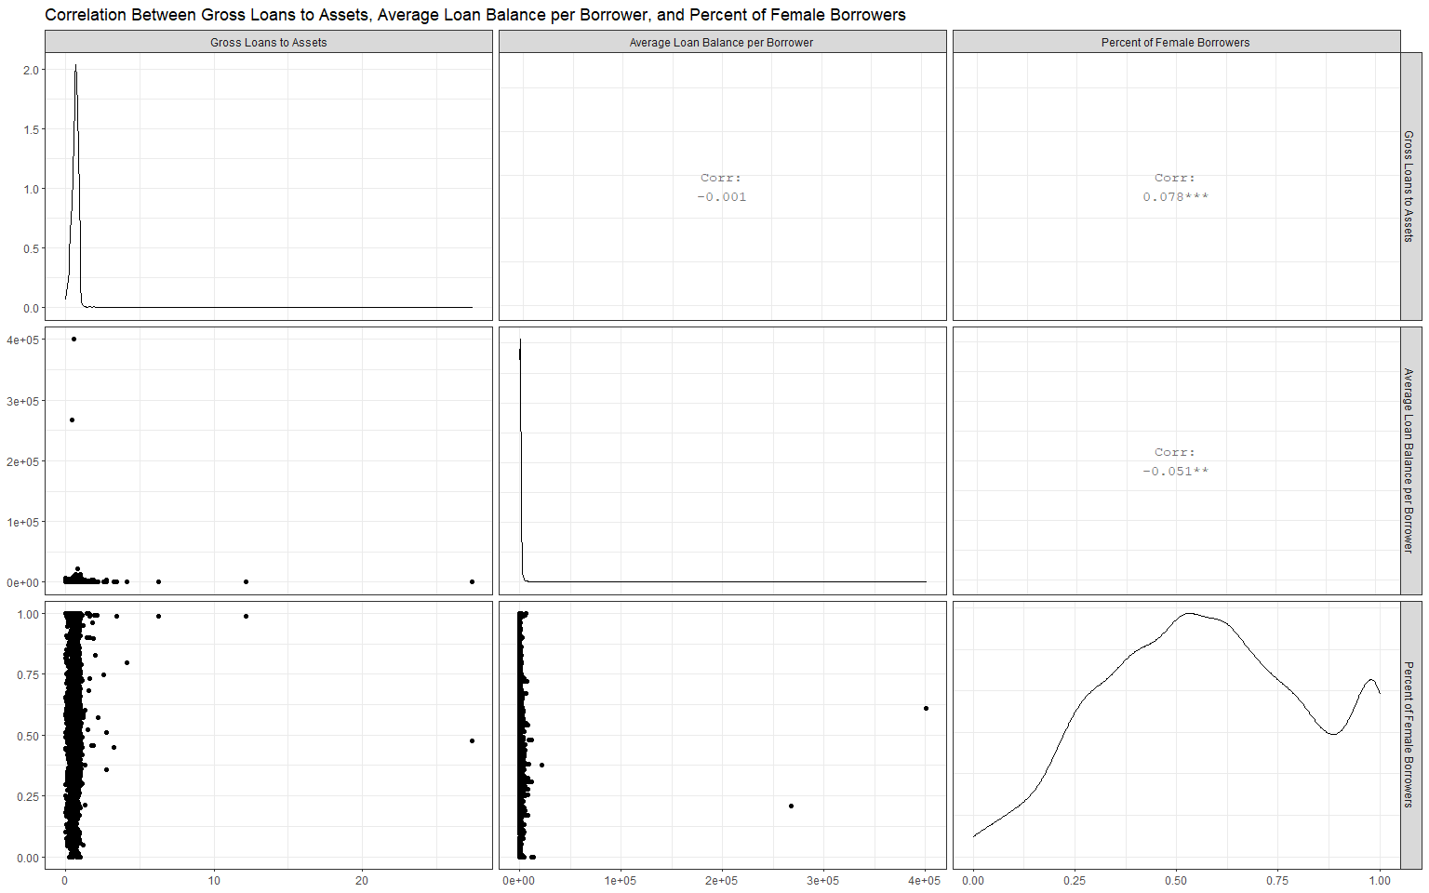

### *Single Difference Approach*

### *Robustness Checks*

Our robustness checks encompass three matters. First, the study employs three financial metrics to capture financial inclusion - percent of women borrowers, average loan balance per borrower and gross loans to assets ratio. The second aspect relates to outliers which could affect the regression estimates. To control for outliers, we run regressions using winsorised data. Precisely, we remove the top 10% and the bottom 10% of the data and run the random effects, fixed effects and pooled OLS. Overall, the results remain largely robust to extreme values. Lastly, we correct the standard errors for cross-sectional dependence and serial correlation by presenting panel corrected standard errors (PCSE) to cater for serial correlation and cross-sectional dependence, a common issue in panel data.

# Conclusion

This article examined the transformation of microfinance institutions in Africa and its potential effects on financial inclusion. We found that NGOs perform best in measures of financial depth- percent of women borrowers and average loan balance per borrower. Although banks lead in terms of financial breadth - the gross loans to assets ratio, NGOs do not perform poorly either and, in fact, exhibit higher median gross loans to assets ratio than other legal forms. The result suggest that transformation could adversely affect financial inclusion in Africa if allowed to occur without appropriate interventions and support. Capital positively drives all aspects of financial inclusion but is significant for gross loans only. Hence, microfinance institutions- including those that are not NGOs- could fare well in financial inclusion if affordable capital is available. Interestingly, profitability is positively related to gross loans although MFI do not need to transform to make profits. Operating expenses also positively drive depth and breadth of outreach and hence targeted tax breaks could allow MFIs to incur costs of reaching the financially excluded clients without a severe dent on profitability. Donations, negatively impact breadth of outreach while education and region are only important regarding depth - the percent of female borrowers. Asset structure, donations, and size of an MFI negatively relate to gross loans.

# References

Abeysekera, Sarath, Umut Oguzoglu, and Thanh Tam Le. 2014. “Sustainability and Mission Drift: Do Microfinance Institutions in Vietnam Reach the Poor?” In *Microfinance Institutions*, 99–118. Springer.

Allen, Franklin, Isaac Otchere, and Lemma W Senbet. 2011. “African Financial Systems: A Review.” *Review of Development Finance* 1 (2): 79–113.

Armendáriz, Beatriz, Bert D’Espallier, Marek Hudon, and Ariane Szafarz. 2013. “Subsidy Uncertainty and Microfinance Mission Drift.” *Available at SSRN 1731265*.

Bateman, Milford. 2010. *Why Doesn’t Microfinance Work?: The Destructive Rise of Local Neoliberalism*. Zed Books Ltd.

Beck, Thorsten, and Robert Cull. 2014. “SME Finance in Africa.” *Journal of African Economies* 23 (5): 583–613.

Bos, Jaap WB, and Matteo Millone. 2015. “Practice What You Preach: Microfinance Business Models and Operational Efficiency.” *World Development* 70: 28–42.

Chikalipah, Sydney. 2017. “What Determines Financial Inclusion in Sub-Saharan Africa?” *African Journal of Economic and Management Studies*.

D’Espallier, Bert, Jann Goedecke, Marek Hudon, and Roy Mersland. 2017. “From NGOs to Banks: Does Institutional Transformation Alter the Business Model of Microfinance Institutions?” *World Development* 89: 19–33.

D’Espallier, Bert, Marek Hudon, and Ariane Szafarz. 2013. “Unsubsidised Microfinance Institutions.” *Economics Letters* 120 (2): 174–76.

———. 2017. “Aid Volatility and Social Performance in Microfinance.” *Nonprofit and Voluntary Sector Quarterly* 46 (1): 116–40.

Dichter, Thomas W. 1996. “Questioning the Future of NGOs in Microfinance.” *Journal of International Development* 8 (2): 259–69.

Eisenhardt, Kathleen M. 1989. “Agency Theory: An Assessment and Review.” *Academy of Management Review* 14 (1): 57–74.

Garmaise, Mark J, and Gabriel Natividad. 2013. “Cheap Credit, Lending Operations, and International Politics: The Case of Global Microfinance.” *The Journal of Finance* 68 (4): 1551–76.

Hartarska, Valentina, and Roy Mersland. 2012. “Which Governance Mechanisms Promote Efficiency in Reaching Poor Clients? Evidence from Rated Microfinance Institutions.” *European Financial Management* 18 (2): 218–39.

Hassan, M Kabir, Shadiya Hossain, and Omer Unsal. 2018. “Religious Preference and Financial Inclusion: The Case for Islamic Finance.” *Management of Islamic Finance: Principle, Practice, and Performance*, 93.

Jensen, Michael C, and William H Meckling. 1976. “Theory of the Firm: Managerial Behavior, Agency Costs and Ownership Structure.” *Journal of Financial Economics* 3 (4): 305–60.

Kodongo, Odongo, and Lilian G Kendi. 2013. “Individual Lending Versus Group Lending: An Evaluation with Kenya’s Microfinance Data.” *Review of Development Finance* 3 (2): 99–108.

Ledgerwood, Joann. 1998. *Microfinance Handbook: An Institutional and Financial Perspective*. The World Bank.

Ledgerwood, Joanna, and Victoria White. 2006. *Transforming Microfinance Institutions: Providing Full Financial Services to the Poor*. The World Bank.

Lopatta, K, and M Tchikov. 2016. “Do Microfinance Institutions Fulfil Their Promise? Evidence from Cross-Country Data.” *Applied Economics* 48 (18): 1655–77.

Louis, Philippe, Alex Seret, and Bart Baesens. 2013. “Financial Efficiency and Social Impact of Microfinance Institutions Using Self-Organising Maps.” *World Development* 46: 197–210.

Market, MIX. 2015. “Global Outreach & Financial. Performance Benchmark Report-2015.” Recuperado de http://www. themix. org/mixmarket/publications/2014-global ….

Mersland, Roy, and R Øystein Strøm. 2010. “Microfinance Mission Drift?” *World Development* 38 (1): 28–36.

Mia, Md Aslam, and Hwok-Aun Lee. 2017. “Mission Drift and Ethical Crisis in Microfinance Institutions: What Matters?” *Journal of Cleaner Production* 164: 102–14.

Morduch, Jonathan, and Timothy Ogden. 2019. “The Challenges of Social Investment Through the Lens of Microfinance.” In *A Research Agenda for Financial Inclusion and Microfinance*. Edward Elgar Publishing.

Peck Christen, Robert, and Tamara Cook. 2001. “Commercialisation and Mission Drift: The Transformation of Microfinance in Latin America.” The World Bank.

Powell, Walter W, and Paul J DiMaggio. 2012. *The New Institutionalism in Organizational Analysis*. University of Chicago press.

Roberts, Peter W. 2013. “The Profit Orientation of Microfinance Institutions and Effective Interest Rates.” *World Development* 41: 120–31.

Thornton, Patricia H. 2002. “The Rise of the Corporation in a Craft Industry: Conflict and Conformity in Institutional Logics.” *Academy of Management Journal* 45 (1): 81–101.

Thornton, Patricia H, William Ocasio, and Michael Lounsbury. 2015. “The Institutional Logics Perspective.” *Emerging Trends in the Social and Behavioral Sciences: An Interdisciplinary, Searchable, and Linkable Resource*, 1–22.

Wagenaar, Kim. 2012. “Institutional Transformation and Mission Drift in Microfinance.” *Centre of Development Studies, University of Cambridge*.

Zins, Alexandra, and Laurent Weill. 2016. “The Determinants of Financial Inclusion in Africa.” *Review of Development Finance* 6 (1): 46–57.

# Appendix

Regressions Using Winsorized Data with se in parenthesis

|  |  |  |  |  |  |  |  |  |  |
| --- | --- | --- | --- | --- | --- | --- | --- | --- | --- |
| Variables | Percent_female | Percent_female | Percent_female | Average_loan | Average_loan | Average_loan | Gross_loans | Gross_loans | Gross_loans |
|  | Random | Within | Pooling | Random | Within | Pooling | Random | Within | Pooling |
|  | (1) | (2) | (3) | (4) | (5) | (6) | (7) | (8) | (9) |
| Legal status: Bank | -0.144*** |  | -0.131*** | -71.500 |  | -71.500 | -0.069 |  | -0.088* |
|  | (0.049) |  | (0.049) | (712.000) |  | (712.000) | (0.056) |  | (0.051) |
| Legal status: NBFI | -0.172*** |  | -0.163*** | 188.000 |  | 188.000 | -0.0002 |  | -0.013 |
|  | (0.033) |  | (0.031) | (444.000) |  | (444.000) | (0.039) |  | (0.036) |
| Legal status: Credit Union | -0.211*** | 0.113 | -0.193*** | 1,116.000** | 1,684.000 | 1,116.000** | 0.021 | -0.015 | 0.008 |
|  | (0.035) | (0.130) | (0.034) | (518.000) | (1,971.000) | (518.000) | (0.043) | (0.103) | (0.040) |
| Legal status: Rural Bank | -0.209*** |  | -0.167*** | -140.000 |  | -140.000 | -0.317*** |  | -0.341*** |
|  | (0.059) |  | (0.052) | (732.000) |  | (732.000) | (0.093) |  | (0.089) |
| Age: Young | -0.022 | -0.019 | -0.043** | -43.300 | -939.000*** | -43.300 | 0.069 | 0.082* | 0.066 |
|  | (0.016) | (0.016) | (0.020) | (265.000) | (360.000) | (265.000) | (0.050) | (0.047) | (0.052) |
| Age: Mature | -0.023 | -0.017 | -0.052* | -184.000 | -1,220.000** | -184.000 | 0.112** | 0.127*** | 0.099* |
|  | (0.021) | (0.022) | (0.029) | (339.000) | (610.000) | (339.000) | (0.051) | (0.048) | (0.054) |
| Region: Africa | 0.086 |  | 0.092 | 468.000 |  | 468.000 | -0.110 |  | -0.091 |
|  | (0.058) |  | (0.058) | (763.000) |  | (763.000) | (0.068) |  | (0.062) |
| Operating_expense/assets | 0.162** | 0.086 | 0.471*** | 2,567.000 | 2,858.000 | 2,567.000 | 0.539*** | 0.938*** | 0.436*** |
|  | (0.072) | (0.078) | (0.114) | (1,683.000) | (3,080.000) | (1,683.000) | (0.143) | (0.226) | (0.140) |
| Donations/assets_ratio | 2.230 | 1.410 | 10.700*** | -93,698.000* | 141.000 | -93,698.000* | -5.840 | 0.884 | -7.750* |
|  | (1.500) | (1.500) | (2.620) | (50,487.000) | (63,343.000) | (50,487.000) | (4.160) | (4.540) | (4.210) |
| Capital/asset_ratio | 0.077*** | 0.069** | 0.110** | 358.000 | 3,893.000*** | 358.000 | 0.147** | 0.107 | 0.160** |
|  | (0.029) | (0.029) | (0.047) | (766.000) | (1,292.000) | (766.000) | (0.069) | (0.083) | (0.068) |
| Asset_structure | 0.105 | 0.215 | -0.397* | 3,622.000 | -342.000 | 3,622.000 | -1.150*** | -0.977* | -1.140*** |
|  | (0.136) | (0.143) | (0.232) | (3,607.000) | (7,163.000) | (3,607.000) | (0.337) | (0.525) | (0.320) |
| Size (lassets) | -0.008 | 0.008 | -0.032* | 797.000*** | 7,756.000*** | 797.000*** | -0.069*** | -0.258*** | -0.054** |
|  | (0.014) | (0.018) | (0.017) | (247.000) | (1,188.000) | (247.000) | (0.023) | (0.043) | (0.022) |
| Education | 0.215*** | 0.229** | 0.202** | 1,113.000 | -3,770.000 | 1,113.000 | -0.078 | -0.114 | -0.047 |
|  | (0.082) | (0.102) | (0.091) | (1,353.000) | (4,209.000) | (1,353.000) | (0.104) | (0.176) | (0.104) |
| Profit_margin | 0.049** | 0.042** | 0.089*** | -24.100 | -1,824.000* | -24.100 | 0.230*** | 0.221*** | 0.239*** |
|  | (0.019) | (0.020) | (0.033) | (609.000) | (1,008.000) | (609.000) | (0.054) | (0.058) | (0.055) |
| Constant | 0.602*** |  | 0.687*** | -6,091.000*** |  | -6,091.000*** | 0.982*** |  | 0.923*** |
|  | (0.118) |  | (0.143) | (2,078.000) |  | (2,078.000) | (0.204) |  | (0.203) |
| r.squared | 0.116 | 0.0549 | 0.308 | 0.0274 | 0.0674 | 0.0274 | 0.0437 | 0.037 | 0.0557 |
| adj.r.squared | 0.104 | -0.0596 | 0.299 | 0.0149 | -0.0471 | 0.0149 | 0.0315 | -0.0818 | 0.0437 |
| Statistic | 247*** | 4.59e*** | 34.3*** | 74.7*** | 5.75*** | 2.20*** | 124*** | 3.09*** | 4.65*** |