John Karuitha

Karatina University,

School of Business, Karatina, Kenya.

Phone: +254 736 917 717

Email: [diakingathia2005@gmail.com](mailto:diakingathia2005@gmail.com)

Website: [www.linkedin.com/in/karuitha/](http://www.linkedin.com/in/karuitha/)

29 August 2022

The Deputy Vice-Chancellor,

Planning, Finance and Administration,

Karatina University,

Karatina, Kenya.

Through: The Dean, School of Business.

Through: The Head of department, Business & Economics.

Dear Sir,

**RE: REQUEST FOR FINANCING - DATA ANALYTICS TRAINING**

I am writing to request funding to support my attendance of ISACA Kenya Chapter ***Data Analytics: Analyzing and Visualizing Data with Excel*** training from 12-16th September 2022 in Mombasa, Kenya.

I am a member of ISACA (Kenya Chapter), which requires participation in continuous professional education to retain membership. ISACA is a global Information technology body with a mission to:

*“help business technology professionals and their enterprises around the world*

*realize the positive potential of technology. . . (by) inspiring confidence*

*that enables innovation through technology”.*\* see https://www.isaca.org/why-

isaca/about-us

I also teach two finance and accounting courses that have substantial Ms Excel content; ***BBM 419: Financial Statements Analysis*** and ***BBM 450: Practical Accounting Data Processing.*** Hence, this training will contribute directly to my teaching.

Yours Sincerely,

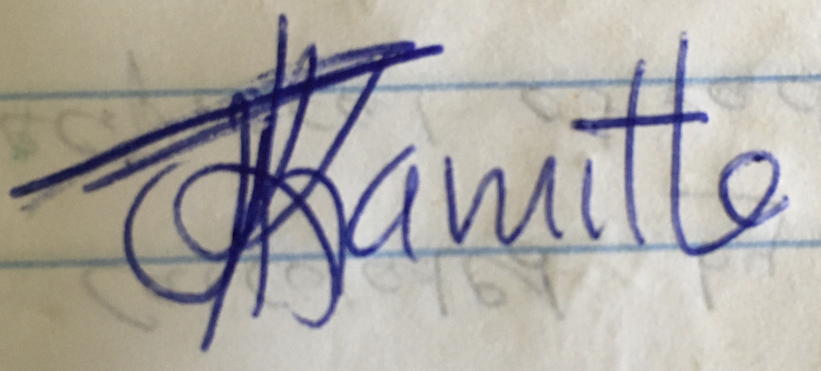

John Karuitha.

PF: 0266

Enclosures: Training Program & Budget.