John Karuitha

Karatina University,

School of Business,

Department of Business and Economics,

Karatina, Kenya.

Phone: +254 736 917 717

Email: diakingathia2005@gmail.com

Website: www.linkedin.com/in/Karuitha/

29 August 2022

The Deputy Vice-Chancellor,

Planning, Finance and Administration,

Karatina University,

Karatina, Kenya.

Through: The Head of Department,

Department of Business & Economics

Dear Sir,

**RE: APOLOGY FOR LATE SUBMISSION OF STAFF APPRAISAL FORM**

Kindly receive my sincere apologies for being late in the submission of the staff appraisal form.

I could not submit it on time because got some extended dental health issues that could not allow me to submit in time.

Dental issues aside, I realize the delay has inconvenienced your office. However, I do not foresee such a delay recurring in the future.

I have filled out the correct form. Kindly accept the document attached to this letter.

Yours Sincerely,

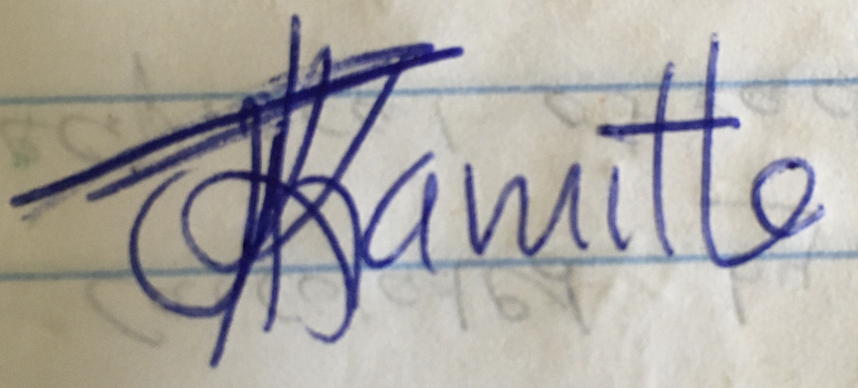

John Karuitha.

PF: 0266

Enclosures: Staff Appraisal Form