Research Article

Dorothy Miruka

# **Research Questions**

The research seeks to answer the following questions:

1. Is there a relationship between working from home and employee motivation?
2. Is there a relationship between working from home and job satisfaction?
3. Is there a relationship between employee motivation and job satisfaction?
4. How do technological skills affect the relationship between employee motivation and job satisfaction when working from home?

# **Data**

We collected the data using an online survey of Wits University staff members. The survey captured data for 41 variables of interest that covered constructs for job satisfaction, employee motivation, technology, and demographic and personal data. The description of the variables is in the appendix.

The sampling frame consisted of all () staff members of the university in 2021. The survey resulted in 201 questionaires for a desired sample size of 354. To make up for the defficiency, we bootstrapped the data to represent 354 observations. The rest of the analysis draws from these 354 observations.

## **Data Reliability**

As noted in the methodology section, we used a virtual questionaire to collect the data from the administrative staff of University of the Witwatersrand, Johannesburg. In this ection, we examine the reliability of the data using the Cronbach’s Alpha. The Cronbach’s Alpha is useful for quantifying reliability of the data by measuring the internal consistency of the data.

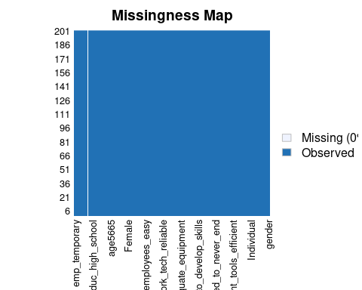

Cronbach's alpha for the 'my_data' data-set  
  
Items: 56  
Sample units: 201  
alpha: 0.198  
  
Bootstrap 95% CI based on 1000 samples  
 2.5% 97.5%   
0.126 0.266

The Cronbach’s $$ lies between 0.4 and 0.57 which may indicate poor response. For instance, most of the respondents are female and relatively older. However, the data does lie in the acceptable region.

## **Exploring the Data**

We start this section by exploring the data set through visualizations. Figure 1 contains the profiles of employees in the sample and that responded to the survey. In Panel C, for instance, 84% of the respondents were female and 16% male. This response profile is problematic given that the sampling frame is different as the University has about 50% male employees []. Even more extreme is the profile for permanent versus part time employees at 93% and 7% (see Panel A), respectively, although this closely follows employee job categories at the University. The profiles for other employee categories including age, experience, marital status, and education level do not possess these extreme qualities. In the regression analysis, we control for the gender of the respondents (see section ()).

|  |
| --- |
| Respondents Profile (% of Total Count) |

We also examine each of the categories of questions in the questionaire that covered the following areas.

* Motivation.
* Job Satisfaction.
* Working from home.
* Technology.

### Motivation

Table () below shows the summary statistics of the responses capturing motivation of employees. On a scale of 1 (strongly disagree) to 7 (strongly agree), most respondents (102) strongly disagreed that they had no time to work when working from home (see the median od the variable motiv_no_time_to_work in the table). The other variables have a similar interpretation.

< table of extent 0 >

Summary: Variables Capturing Motivation

| Variable | Mean | SD | Min | Q1 | Median | Q3 | Max |
| --- | --- | --- | --- | --- | --- | --- | --- |
| motiv_enough_time_to_work | 3.22 | 2.09 | 1 | 2 | 2 | 5 | 7 |
| motiv_work_clearly_explained | 3.79 | 2.22 | 1 | 2 | 4 | 6 | 7 |
| motiv_comfortable_working_hours | 5.08 | 1.88 | 1 | 4 | 6 | 6 | 7 |
| motiv_satisfied_career_progress | 4.54 | 1.88 | 1 | 3 | 5 | 6 | 7 |
| motiv_equipment_tools_efficient | 4.74 | 1.86 | 1 | 3 | 5 | 6 | 7 |
| motiv_adequate_working_area | 5.15 | 1.81 | 1 | 4 | 6 | 6 | 7 |
| motiv_interest_what_i_did | 6.13 | 1.23 | 1 | 6 | 6 | 7 | 7 |
| motiv_lighting_ventilation_workplace | 5.34 | 1.89 | 1 | 4 | 6 | 7 | 7 |
| motiv_comfortable_work_environment | 5.50 | 1.77 | 1 | 5 | 6 | 7 | 7 |

|  |
| --- |
| Correlation Between Motivation Indicators |

### Job satisfaction

Table () summarises the responses capturing job satisfaction. As an example, when the researcher posed the question “My day never seemed to end”, most respondents strongly disagreed, implying a high degree of job satisfaction.

1 2 3 4 5 6 7   
28 28 19 45 14 43 24

Summary: Variables Capturing Motivation

| Variable | Mean | SD | Min | Q1 | Median | Q3 | Max |
| --- | --- | --- | --- | --- | --- | --- | --- |
| js_day_seemed_to_never_end | 4.07 | 1.98 | 1 | 2 | 4 | 6 | 7 |
| js_work_disturbed_family_life | 4.26 | 2.13 | 1 | 2 | 5 | 6 | 7 |
| js_work_affected_family_respo | 4.48 | 1.99 | 1 | 3 | 5 | 6 | 7 |
| js_private_life_positive_effect_work | 5.80 | 1.29 | 1 | 5 | 6 | 7 | 7 |
| js_institution_impt_to_me | 5.60 | 1.38 | 1 | 5 | 6 | 6 | 7 |
| js_adequate_opp_to_develop_skills | 5.18 | 1.57 | 1 | 4 | 6 | 6 | 7 |
| js_could_communicate_all_levels | 4.74 | 1.78 | 1 | 3 | 5 | 6 | 7 |
| js_work_affected_private_tasks | 3.64 | 1.85 | 1 | 2 | 4 | 6 | 7 |
| js_postpone_job_tasks_due_to_family_respo | 2.10 | 1.28 | 1 | 1 | 2 | 2 | 7 |

|  |
| --- |
| Correlation Between Job Satisfaction Indicators |

### Working from Home

Again, Table () below summarises the responses for employees regarding remote work. Most respondents, for instance,strongly agreed that daily and weekly job objectives were clearly stated.

1 2 3 4 5 6 7   
 3 15 14 19 17 81 52

Summary: Variables Capturing Work from Home

| Variable | Mean | SD | Min | Q1 | Median | Q3 | Max |
| --- | --- | --- | --- | --- | --- | --- | --- |
| wfh_job_objectives_clear_daily_weekly | 5.40 | 1.60 | 1 | 4 | 6 | 7 | 7 |
| wfh_adequate_equipment | 4.82 | 1.89 | 1 | 3 | 6 | 6 | 7 |
| wfh_remote_productivity_office_productivity_equal | 5.38 | 1.91 | 1 | 4 | 6 | 7 | 7 |
| wfh_work_from_home_cannot_be_improved | 3.22 | 1.79 | 1 | 2 | 3 | 4 | 7 |
| wfh_remote_work_support_growth | 5.40 | 1.56 | 1 | 4 | 6 | 7 | 7 |
| wfh_online_physical_meetings_equivalent | 5.59 | 1.59 | 1 | 5 | 6 | 7 | 7 |
| wfh_remote_work_tech_reliable | 5.32 | 1.80 | 1 | 5 | 6 | 7 | 7 |
| wfh_good_focus_remote_work | 5.44 | 1.69 | 1 | 4 | 6 | 7 | 7 |
| wfh_not_miss_social_interactions | 4.47 | 1.95 | 1 | 3 | 5 | 6 | 7 |
| wfh_prefer_remote_work | 5.13 | 1.83 | 1 | 4 | 6 | 7 | 7 |

|  |
| --- |
| Correlation Between Working from Home Indicators |

### Technology

In this section, I visualize the variables that capture the use of technology by employees while working from home. As an example, most employees disagreed that they had problems communicating with colleagues virtually.

< table of extent 0 >

Summary: Variables Capturing Technology

| Variable | Mean | SD | Min | Q1 | Median | Q3 | Max |
| --- | --- | --- | --- | --- | --- | --- | --- |
| tech_communication_employees_easy | 4.79 | 1.68 | 1 | 4 | 5 | 6 | 7 |
| tech_acess_work_related_info_hard | 5.16 | 1.67 | 1 | 4 | 6 | 7 | 7 |
| tech_not_miss_impt_info | 2.84 | 1.76 | 0 | 1 | 2 | 4 | 7 |
| tech_not_hinder_work | 4.98 | 1.99 | 1 | 4 | 6 | 6 | 7 |
| tech_remote_help_available_incase_digital_hitches | 5.53 | 1.30 | 1 | 5 | 6 | 6 | 7 |

|  |
| --- |
| Correlation Between Working from Home Indicators |

## **Data Analysis and Discussion of Results**

In this section, we will examine the research questions in greater detail.

### *Principal Components Analysis*

To start with, we create aggregate metrics to capture the four variables;

* Motivation.
* Job Satisfaction.
* Working from Home.
* Technology.

To construct these variables from the responses in the questionaires, we apply Principal Components Analysis (PCA). We label these variables motiv for motivation, js for job satisfaction, wfh for working from home, and tech for technology. In each PCA analysis, we extract the first principal component. This first principal component proxies the corresponding metric in answering the research questions.

The output below shows the contributions of each of the components for motivation. The first principal component constitutes 39% of total variance.

Importance of components:  
 PC1 PC2 PC3 PC4 PC5 PC6 PC7 PC8  
Standard deviation 1.762 1.170 0.984 0.952 0.8862 0.8234 0.7479 0.622  
Proportion of Variance 0.345 0.152 0.108 0.101 0.0873 0.0753 0.0621 0.043  
Cumulative Proportion 0.345 0.497 0.605 0.705 0.7926 0.8679 0.9301 0.973  
 PC9  
Standard deviation 0.4921  
Proportion of Variance 0.0269  
Cumulative Proportion 1.0000

For job satisfaction, the first principal component constitutes 40% of total variance.

Importance of components:  
 PC1 PC2 PC3 PC4 PC5 PC6 PC7 PC8  
Standard deviation 1.807 1.213 1.171 0.9432 0.7731 0.7299 0.6606 0.553  
Proportion of Variance 0.363 0.163 0.152 0.0988 0.0664 0.0592 0.0485 0.034  
Cumulative Proportion 0.363 0.526 0.678 0.7773 0.8437 0.9029 0.9514 0.985  
 PC9  
Standard deviation 0.3629  
Proportion of Variance 0.0146  
Cumulative Proportion 1.0000

For the wfh variable the first principal component contributes 29% of the total variability.

Importance of components:  
 PC1 PC2 PC3 PC4 PC5 PC6 PC7 PC8  
Standard deviation 1.917 1.242 1.008 0.9153 0.849 0.800 0.7303 0.6501  
Proportion of Variance 0.367 0.154 0.102 0.0838 0.072 0.064 0.0533 0.0423  
Cumulative Proportion 0.367 0.522 0.623 0.7069 0.779 0.843 0.8962 0.9385  
 PC9 PC10  
Standard deviation 0.6189 0.4819  
Proportion of Variance 0.0383 0.0232  
Cumulative Proportion 0.9768 1.0000

Lastly, first principal component for technology contributes 52% of the total variability.

Importance of components:  
 PC1 PC2 PC3 PC4 PC5  
Standard deviation 1.645 0.880 0.834 0.7048 0.570  
Proportion of Variance 0.541 0.155 0.139 0.0994 0.065  
Cumulative Proportion 0.541 0.696 0.836 0.9350 1.000

The graphs below shows the contributions of each principal component to the total variability.

|  |
| --- |
| Contribution of the Principal Components |

#### Visualizing the First Principal Components

In this section, we examine the correlation between the proxies for motivation, job satisfaction, technology, and working from home. Again, these proxies are the first principal components of the measures for motivation, job satisfaction, working from home and technology computed in the previous section.

Figure () shows a significant correlation between the variables. For instance, there is very high positive correlation between the motivation and job satisfaction on the one hand and technology and job satisfaction on the other. However, there appears to be a non-linear relationship between the variables making the correlations less useful.

### *Remote work and employee motivation?*

Figure () below shows the relationship between employee motivation and working from home. The relationship is negative at the initial levels but turns positive at higher levels. In the regression analysis in section () below, we examine the significance of the relationship between employee motivation and working from home in the presence of other related variables.

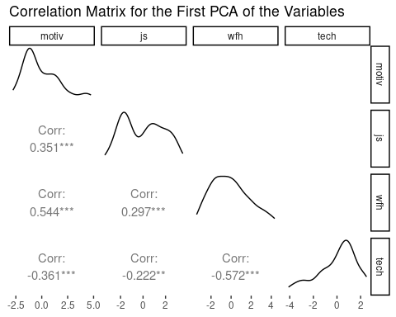

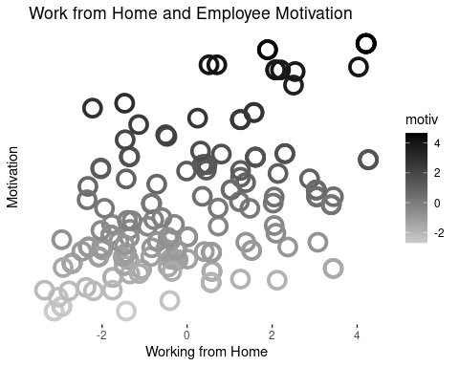

### *Remote work and and job satisfaction?*

Figure () below shows the relationship between job satisfaction and working from home. The relationship is negative at the initial levels but flattens at higher levels. This observation goes against the theory. In the regression analysis in section () below, we examine the significance of this relationship in the presence of other related variables.

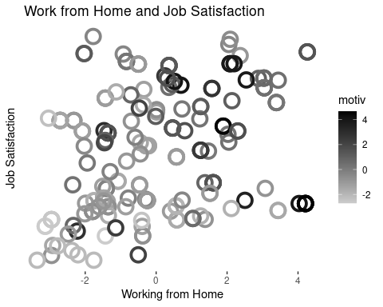

### *Employee motivation and job satisfaction?*

As expected, Figure () below shows the positive relationship between employee motivation and job satisfaction. In line with the theory, higher employee motivation corresponds to higher job satisfaction. Again , we examine the significance of this relationship in the regression analysis section below.

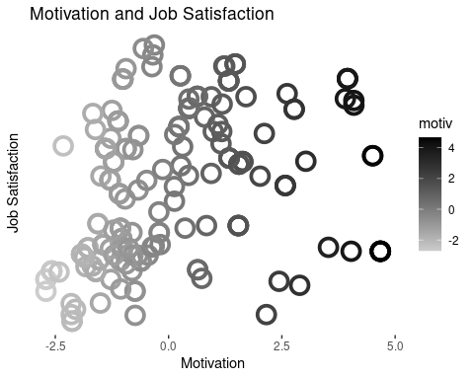

### *Technological skills, employee motivation and job satisfaction in remote work*

Overall, there is a positive relationship between the employee motivation and job satisfaction (see Figure () below). The figure also indicates that employees with better technology skills have higher motivation. However, job satisfaction does not appear to have a significant relationship with the technology. The implication here is that the positive relatonship between the employee motivation and job satisfaction arises from other factors beyond profficiency in technology. We discuss some of these other factors in the regression analysis in the next section.

|  |
| --- |
| Respondents Profile (% of Total Count) |

We run a regression analysis of the following form;

$motivation=β_{0}+β_{1}job_{s}atisfaction+β_{n}controls+error_{t}erm$

Where motivation and job_satisfaction are variables that captures employee motivation and job satisfaction, respectively. The controls include gender, age group, marital status, education level, employment category, experience, and whether or not the employee worked from home. We also include an interaction of technology and job satisfaction. The interaction is the outcome of interest in this section. The summary of the regression analysis is in the table below.

The regression confirms the outcome of Figure () above. While the relationship between job satisfaction and motivation is positive and significant, the relationship between motivation and the interaction of job satisfaction and technology is not. What are the additional variables that affect the levels of motivation among employees?

The regression table shows that the level of motivation among employees is a function of other variables. These variables include working from home (wfh), age group, marital status, education level, experience. Notably, both technology and job satisfaction are not a significant driver of the level of motivation among employees. However, the flexibility to work from home does positively affect the level of motivation.

Divorced employees had a greater motivation than married or single employees in the sample. Employees with certificate level education had less motivation compared to employees with higher levels of education. Part-time employees have a greater motivation motivation than parmanent employees which is a suprising outcome from the analysis.

Compared to employees with 1-5 years of experience, employees with experience between 6 and 20 years have a greater motivation. On the other hand, employees with experience of 21-25 years have significantly less motivation. Critically, working from home has a significant relationship with employee motivation. Hence, management could explore mechanisms to allow employees to choose remote work where possible.

Note that we do not include age in the regression as it is highly correlated with experience. The regression disagnostics plot in Figure () indicates a mild level of multicollinearity. However, the model is significant with the independent variables explaining 77% of the variation in the dependent variable with a significant F-statistic.

Call:  
lm(formula = motiv ~ wfh + tech + wfh:tech + age_group + gender +   
 marital + education + employment_category, data = final_data)  
  
Residuals:  
 Min 1Q Median 3Q Max   
-3.552 -0.952 -0.080 0.819 4.207   
  
Coefficients:  
 Estimate Std. Error t value Pr(>|t|)   
(Intercept) -0.000935 1.482805 0.00 0.9995   
wfh 0.418882 0.070240 5.96 1.2e-08 ***  
tech -0.079085 0.079262 -1.00 0.3197   
age_group26-35 -0.210003 1.449179 -0.14 0.8849   
age_group36-45 -0.360835 1.454906 -0.25 0.8044   
age_group46-55 0.299721 1.463210 0.20 0.8379   
age_groupOver 55 -0.171695 1.464010 -0.12 0.9068   
genderMale 0.403278 0.229911 1.75 0.0811 .   
maritalmarried -0.370610 0.278494 -1.33 0.1849   
maritalsingle -0.103865 0.335418 -0.31 0.7572   
maritalwith parents -0.497062 1.060098 -0.47 0.6397   
educationGraduate -0.442886 0.269890 -1.64 0.1025   
educationHigh School -0.006066 0.403029 -0.02 0.9880   
educationPostgrad 0.757241 0.271056 2.79 0.0058 **   
employment_categorytemporary 0.058653 0.377519 0.16 0.8767   
wfh:tech -0.079755 0.029572 -2.70 0.0076 **   
---  
Signif. codes: 0 '***' 0.001 '**' 0.01 '*' 0.05 '.' 0.1 ' ' 1  
  
Residual standard error: 1.39 on 185 degrees of freedom  
Multiple R-squared: 0.421, Adjusted R-squared: 0.374   
F-statistic: 8.98 on 15 and 185 DF, p-value: 1.79e-15

Call:  
lm(formula = js ~ wfh + motiv + motiv:wfh + tech + age_group +   
 gender + marital + education + employment_category, data = final_data)  
  
Residuals:  
 Min 1Q Median 3Q Max   
-4.055 -1.193 -0.196 1.125 3.876   
  
Coefficients:  
 Estimate Std. Error t value Pr(>|t|)   
(Intercept) -0.0604 1.6610 -0.04 0.97102   
wfh 0.1831 0.0865 2.12 0.03566 *   
motiv 0.3223 0.0855 3.77 0.00022 ***  
tech -0.1038 0.0904 -1.15 0.25200   
age_group26-35 -0.0526 1.6249 -0.03 0.97421   
age_group36-45 -0.1128 1.6306 -0.07 0.94493   
age_group46-55 -0.7928 1.6403 -0.48 0.62944   
age_groupOver 55 -0.2984 1.6411 -0.18 0.85591   
genderMale 0.8781 0.2611 3.36 0.00094 ***  
maritalmarried 0.5691 0.3015 1.89 0.06068 .   
maritalsingle 0.4465 0.3745 1.19 0.23470   
maritalwith parents 1.2552 1.1907 1.05 0.29319   
educationGraduate -0.4290 0.3049 -1.41 0.16109   
educationHigh School -0.3729 0.4519 -0.83 0.41032   
educationPostgrad 0.0697 0.3106 0.22 0.82270   
employment_categorytemporary -0.5291 0.4226 -1.25 0.21216   
wfh:motiv -0.0974 0.0330 -2.95 0.00360 **   
---  
Signif. codes: 0 '***' 0.001 '**' 0.01 '*' 0.05 '.' 0.1 ' ' 1  
  
Residual standard error: 1.56 on 184 degrees of freedom  
Multiple R-squared: 0.313, Adjusted R-squared: 0.253   
F-statistic: 5.23 on 16 and 184 DF, p-value: 5.36e-09

Call:  
lm(formula = motiv ~ wfh + wfh:tech, data = final_data)  
  
Residuals:  
 Min 1Q Median 3Q Max   
-2.960 -1.065 -0.338 1.019 3.978   
  
Coefficients:  
 Estimate Std. Error t value Pr(>|t|)   
(Intercept) -0.1079 0.1155 -0.93 0.352   
wfh 0.4668 0.0565 8.27 1.9e-14 ***  
wfh:tech -0.0601 0.0284 -2.11 0.036 *   
---  
Signif. codes: 0 '***' 0.001 '**' 0.01 '*' 0.05 '.' 0.1 ' ' 1  
  
Residual standard error: 1.47 on 198 degrees of freedom  
Multiple R-squared: 0.311, Adjusted R-squared: 0.304   
F-statistic: 44.7 on 2 and 198 DF, p-value: <2e-16

Call:  
lm(formula = js ~ wfh + explained + age_group + tech + gender +   
 marital + education + employment_category, data = final_data)  
  
Residuals:  
 Min 1Q Median 3Q Max   
-3.393 -1.175 -0.203 1.342 4.278   
  
Coefficients:  
 Estimate Std. Error t value Pr(>|t|)   
(Intercept) -0.2445 1.7162 -0.14 0.88688   
wfh 0.8871 0.2903 3.06 0.00258 **   
explained -1.1432 0.5687 -2.01 0.04588 *   
age_group26-35 -0.3094 1.6759 -0.18 0.85373   
age_group36-45 -0.3151 1.6825 -0.19 0.85167   
age_group46-55 -0.8256 1.6921 -0.49 0.62620   
age_groupOver 55 -0.5182 1.6930 -0.31 0.75989   
tech -0.0933 0.0917 -1.02 0.30999   
genderMale 1.0427 0.2659 3.92 0.00012 ***  
maritalmarried 0.6661 0.3221 2.07 0.04001 *   
maritalsingle 0.5824 0.3879 1.50 0.13497   
maritalwith parents 1.3145 1.2259 1.07 0.28498   
educationGraduate -0.5738 0.3121 -1.84 0.06758 .   
educationHigh School -0.3497 0.4661 -0.75 0.45405   
educationPostgrad 0.3420 0.3135 1.09 0.27671   
employment_categorytemporary -0.4975 0.4366 -1.14 0.25598   
---  
Signif. codes: 0 '***' 0.001 '**' 0.01 '*' 0.05 '.' 0.1 ' ' 1  
  
Residual standard error: 1.61 on 185 degrees of freedom  
Multiple R-squared: 0.264, Adjusted R-squared: 0.204   
F-statistic: 4.41 on 15 and 185 DF, p-value: 4.51e-07

% Table created by stargazer v.5.2.3 by Marek Hlavac, Social Policy Institute. E-mail: marek.hlavac at gmail.com % Date and time: Fri, Feb 03, 2023 - 20:56:32

**Regression output**

|  |  |  |  |  |
| --- | --- | --- | --- | --- |
|  | | | | |
|  | *Dependent variable:* | | | |
|  |  | | | |
|  | motiv | js | motiv | js |
|  | (1) | (2) | (3) | (4) |
|  | | | | |
| wfh | 0.419*** | 0.183** | 0.467*** | 0.887*** |
|  | (0.070) | (0.087) | (0.056) | (0.290) |
|  |  |  |  |  |
| motiv |  | 0.322*** |  |  |
|  |  | (0.086) |  |  |
|  |  |  |  |  |
| explained |  |  |  | -1.140** |
|  |  |  |  | (0.569) |
|  |  |  |  |  |
| tech | -0.079 | -0.104 |  | -0.093 |
|  | (0.079) | (0.090) |  | (0.092) |
|  |  |  |  |  |
| age_group26-35 | -0.210 | -0.053 |  | -0.309 |
|  | (1.450) | (1.620) |  | (1.680) |
|  |  |  |  |  |
| age_group36-45 | -0.361 | -0.113 |  | -0.315 |
|  | (1.460) | (1.630) |  | (1.680) |
|  |  |  |  |  |
| age_group46-55 | 0.300 | -0.793 |  | -0.826 |
|  | (1.460) | (1.640) |  | (1.690) |
|  |  |  |  |  |
| age_groupOver 55 | -0.172 | -0.298 |  | -0.518 |
|  | (1.460) | (1.640) |  | (1.690) |
|  |  |  |  |  |
| genderMale | 0.403* | 0.878*** |  | 1.040*** |
|  | (0.230) | (0.261) |  | (0.266) |
|  |  |  |  |  |
| maritalmarried | -0.371 | 0.569* |  | 0.666** |
|  | (0.278) | (0.302) |  | (0.322) |
|  |  |  |  |  |
| maritalsingle | -0.104 | 0.447 |  | 0.582 |
|  | (0.335) | (0.375) |  | (0.388) |
|  |  |  |  |  |
| maritalwith parents | -0.497 | 1.250 |  | 1.310 |
|  | (1.060) | (1.190) |  | (1.230) |
|  |  |  |  |  |
| educationGraduate | -0.443 | -0.429 |  | -0.574* |
|  | (0.270) | (0.305) |  | (0.312) |
|  |  |  |  |  |
| educationHigh School | -0.006 | -0.373 |  | -0.350 |
|  | (0.403) | (0.452) |  | (0.466) |
|  |  |  |  |  |
| educationPostgrad | 0.757*** | 0.070 |  | 0.342 |
|  | (0.271) | (0.311) |  | (0.313) |
|  |  |  |  |  |
| employment_categorytemporary | 0.059 | -0.529 |  | -0.497 |
|  | (0.378) | (0.423) |  | (0.437) |
|  |  |  |  |  |
| wfh:tech | -0.080*** |  | -0.060** |  |
|  | (0.030) |  | (0.028) |  |
|  |  |  |  |  |
| wfh:motiv |  | -0.097*** |  |  |
|  |  | (0.033) |  |  |
|  |  |  |  |  |
| Constant | -0.001 | -0.060 | -0.108 | -0.244 |
|  | (1.480) | (1.660) | (0.116) | (1.720) |
|  |  |  |  |  |
|  | | | | |
| Observations | 201 | 201 | 201 | 201 |
| R2 | 0.421 | 0.313 | 0.311 | 0.264 |
| Adjusted R2 | 0.374 | 0.253 | 0.304 | 0.204 |
| Residual Std. Error | 1.390 (df = 185) | 1.560 (df = 184) | 1.470 (df = 198) | 1.610 (df = 185) |
| F Statistic | 8.980*** (df = 15; 185) | 5.230*** (df = 16; 184) | 44.700*** (df = 2; 198) | 4.420*** (df = 15; 185) |
|  | | | | |
| *Note:* | *p<0.1; **p<0.05; ***p<0.01 | | | |

|  |
| --- |
| Regression Diagnosis |

# References

# Appendix