Weight and Sleeping Patterns in the UK

John Karuitha

Sunday, April 25, 2021

Table of Contents

## Background

With the advent of sedentary lifestyles, weight gain has become a major health issue across the globe. Overweight individuals have a higher risk of developing heart disease, stroke, cancer, kidney disease, among others (Shah et al. 2021), which places additional strain on health facilities and state financial resources. Consequently, a lot of research goes into tracking obesity, mapping out possible health complications associated with obesity, establishing the factors contributing to obesity, and designing approaches to minimizing prevalence of obesity (Fruh 2017; Malik, Willett, and Hu 2013; Lopez 2007). In this project, we explore the link between age, sleep, and body mass index in a sample of individuals from the United Kingdom.

## Read in the data  
weight_data <- read_csv("dataset.csv") %>%   
   
## Clean names by removing special characters and capital letters  
 janitor::clean_names()

## Objective

The broad objective of the project is to explore the relationship between age, sleeping patterns and the weight of individuals, as captured using the body mass index (BMI).

## Data Description and Validation

In this section, we briefly describe the data, including the steps taken to validate the data.

### The general structure of the dataset

The data consists of 4 variables. The first variable is the ID which serves as an identifier of the respondents. The second is age in years that has been discretized by rounding off to the nearest whole number. similarly, the third variable, sleep in hours, has been discretized into a whole number. The last variable is the body mass index, the ratio of weight in kilograms to height in metres squared. Further there are 153 observations. The following two tables confirm the structure of the data.

##Get the first six rows of the dataset  
head(weight_data) %>%   
   
## Convert the row names to upper case  
 set_names(names(.) %>% str_to_upper()) %>%   
  
## Make a table  
 knitr::kable(booktabs = TRUE,   
  
## Insert table title   
 caption = "The First Six Rows of the BMI-Sleep-Age Data set from the UK") %>%   
   
 kableExtra::kable_styling(full_width = TRUE, bootstrap_options = "striped")

The First Six Rows of the BMI-Sleep-Age Data set from the UK

ID

AGE

SLEEP

BMI

1

24

8

23.6

2

26

7

24.1

3

28

8

25.3

4

29

6

26.7

5

33

8

26.2

6

28

10

25.4

str(weight_data)

## spec_tbl_df[,4] [153 × 4] (S3: spec_tbl_df/tbl_df/tbl/data.frame)  
## $ id : num [1:153] 1 2 3 4 5 6 7 8 9 10 ...  
## $ age : num [1:153] 24 26 28 29 33 28 19 27 18 36 ...  
## $ sleep: num [1:153] 8 7 8 6 8 10 6 6 6 8 ...  
## $ bmi : num [1:153] 23.6 24.1 25.3 26.7 26.2 25.4 22.7 25.4 19.7 28.2 ...  
## - attr(*, "spec")=  
## .. cols(  
## .. ID = col_double(),  
## .. Age = col_double(),  
## .. Sleep = col_double(),  
## .. BMI = col_double()  
## .. )

## Exploring the data

In this section we explore the data first by visualizing it and then computing some summary statistics. The central hypothesis in this case is whether there is a relationship on the one side, and age and hours of sleep among the respondents on the other.

### Data validation

To validate the data, I check for two issues.

* Missing values.
* Unreasonable observations and extreme values.
* Duplicates or repeated values.

The data has no missing values, as the table below shows.

sapply(weight_data, is.na) %>%   
   
 colSums() %>%   
   
 tibble(Variables = names(weight_data), missing_values = .) %>%   
   
 mutate(Variables = (Variables %>% str_to_upper())) %>%   
   
 knitr::kable(booktabs = TRUE, caption = "Missing Values") %>%   
   
 kableExtra::kable_styling(full_width = TRUE, bootstrap_options = "striped")

Missing Values

Variables

missing_values

ID

0

AGE

0

SLEEP

0

BMI

0

Next, I generate a summary of the data and inspect it for unreasonable values. For instance, we do not expect that an individual sleeps for more than 24 hours in a day. Typically, a value that lies too far off the average sleep hours and age in the dataset is a potential error or otherwise an outlier.

summary(weight_data)

## id age sleep bmi   
## Min. : 1.0 Min. :18.0 Min. : 5.00 Min. :18.0   
## 1st Qu.: 36.0 1st Qu.:22.0 1st Qu.: 6.00 1st Qu.:24.4   
## Median : 71.0 Median :28.0 Median : 8.00 Median :26.1   
## Mean : 72.1 Mean :27.7 Mean : 7.37 Mean :26.8   
## 3rd Qu.:109.0 3rd Qu.:33.0 3rd Qu.: 8.00 3rd Qu.:29.6   
## Max. :147.0 Max. :39.0 Max. :10.00 Max. :36.5

The ID column shows 147 observations, yet there are 153 rows in the dataset. Thus the ID column has a discrepancy. Otherwise, there are repeated individuals in the dataset.

weight_data %>%   
   
 filter(duplicated(.)) %>%   
   
 knitr::kable(booktabs = TRUE, caption = "Duplicate Values") %>%   
   
 kableExtra::kable_styling(full_width = TRUE, bootstrap_options = "striped")

Duplicate Values

id

age

sleep

bmi

10

36

8

28.2

11

32

6

31.1

12

18

8

22.0

41

34

9

24.8

42

33

7

34.8

43

18

8

24.7

It appears that individuals coded by IDs 10, 11, 12, 41, 42, and 43 appear twice in the dataset. These 6 extra observations are the source of the discrepancy.

We examine whether the repeated observations are duplicates. It turns out all are duplicates as the table below shows.

weight_data %>%   
   
 filter(id %in% c(10, 11, 12, 41, 42, 43)) %>%   
   
 arrange(id) %>%   
   
 knitr::kable(booktabs = TRUE, caption = "Duplicate Values") %>%   
   
 kableExtra::kable_styling(full_width = TRUE, bootstrap_options = "striped")

Duplicate Values

id

age

sleep

bmi

10

36

8

28.2

10

36

8

28.2

11

32

6

31.1

11

32

6

31.1

12

18

8

22.0

12

18

8

22.0

41

34

9

24.8

41

34

9

24.8

42

33

7

34.8

42

33

7

34.8

43

18

8

24.7

43

18

8

24.7

We clean the data by removing all the duplicates to get a clean dataset.

weight_data <- weight_data %>%   
   
 filter(!duplicated(.))

Now we have a clean dataset with 147 observations. In the next section, we visualize the data.

### Descriptive Statistics

The table blow shows the summary statistics for the variables, except for the ID.

weight_data %>%   
   
 select(-id) %>%   
   
 skimr::skim_without_charts() %>%   
   
 select(-complete_rate, -skim_type) %>%   
   
 rename(Variable = skim_variable, Mean = numeric.mean,   
   
 SD = numeric.sd, Missing = n_missing,  
   
 Min = numeric.p0, Q1 = numeric.p25, Median = numeric.p50,   
   
 Q3 = numeric.p75, Max = numeric.p100) %>%   
   
 mutate(Variable = (Variable %>% str_to_upper())) %>%   
   
 knitr::kable(booktabs = TRUE, caption = "Summary Statistics") %>%   
   
 kableExtra::kable_styling(full_width = TRUE, bootstrap_options = "striped")

Summary Statistics

Variable

Missing

Mean

SD

Min

Q1

Median

Q3

Max

AGE

0

27.680

6.215

18

22.00

28.0

33.0

39.0

SLEEP

0

7.354

1.364

5

6.00

8.0

8.0

10.0

BMI

0

26.717

3.697

18

24.25

26.1

29.5

36.5

Next, I convert sleep to an ordinal categorical variable.

weight_data <- weight_data %>%   
   
 mutate(sleep = factor(sleep, ordered = TRUE, levels = c("5", "6", "7", "8", "9", "10")))

I then Produce make a frequency table for the variable “Sleep.”

table(weight_data$sleep) %>%   
   
 knitr::kable(booktabs = TRUE, caption = "Frequency Table for Sleep") %>%   
   
 kableExtra::kable_styling(full_width = TRUE, bootstrap_options = "striped")

Frequency Table for Sleep

Var1

Freq

5

11

6

39

7

23

8

43

9

23

10

8

### Data Visualization

#### Age vs BMI

Produce a scatter plot using ggplot2 package for the following:

* Age vs. BMI, adjust the transparency (alpha) for the points to 0.5.
* Use white background theme (theme_bw).
* Add title for the graph and coordinates.
* Describe the relationship between the two variables.

weight_data %>%   
   
 ggplot(aes(x = bmi, y = age)) +   
   
 geom_point() +   
   
 theme_bw() +   
   
 labs(x = "BMI", y = "Age", title = "Scatterplot of Age vs BMI")

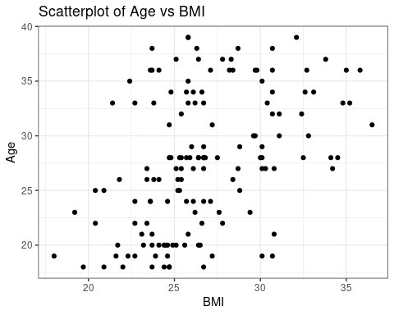

There appears to be a substantial positive correlation between age and BMI, with older people more likely to have higher BMI.

#### BMI vs Sleep

Produce a boxplot using ggplot2 package for the following:

* BMI factored over the variable Sleep.
* Use white background theme.
* Add title for the graph and coordinates.
* Describe the graph provided.

weight_data %>%   
   
 ggplot(aes(x = fct_reorder(sleep, bmi, median), y = bmi, fill = sleep)) +   
   
 geom_boxplot(show.legend = FALSE) +   
   
 labs(x = "Sleep", y = "BMI", title = "BMI vs Sleep in Hours") +   
   
 theme_bw()

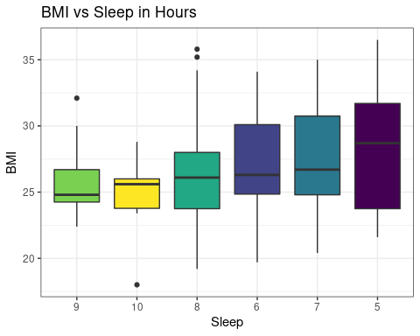

More hours of sleep appear to correlate with lower levels of BMI. Individuals who sleep 5 to 7 hours of sleep have a higher likelihood of high BMI.

#### Age vs BMI

Produce a scatter plot using ggplot2 using the following:

* Age vs. BMI factored over the variable Sleep.
* Adjust transparency to 0.6.
* Add linear models to graphs without the standard error area.
* Use white background.
* Add title for the graph and coordinates.
* Describe the graph produced.

weight_data %>%   
   
 ggplot(aes(x = bmi, y = age, col = sleep)) +   
   
 geom_point(alpha = 0.6) +   
   
 geom_smooth(se = FALSE, method = "lm") +   
   
 labs(x = "BMI", y = "Age", title = "BMI vs Age Faceted by Sleep") +   
   
 theme_bw()

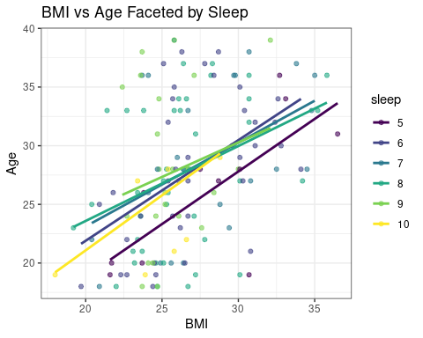

Although there is a relationship between age and BMI, the effect varies by sleep habits. For people who sleep 10 hours and those that sleep 5 hours, there is a notably higher chance of having a greate BMI.

## References

Fruh, Sharon M. 2017. “Obesity: Risk Factors, Complications, and Strategies for Sustainable Long-Term Weight Management.” *Journal of the American Association of Nurse Practitioners* 29 (S1): S3–14.

Lopez, Russ P. 2007. “Neighborhood Risk Factors for Obesity.” *Obesity* 15 (8): 2111–19.

Malik, Vasanti S, Walter C Willett, and Frank B Hu. 2013. “Global Obesity: Trends, Risk Factors and Policy Implications.” *Nature Reviews Endocrinology* 9 (1): 13–27.

Shah, Paras P, Tammy M Brady, Kevin EC Meyers, Michelle M O’Shaughnessy, Keisha L Gibson, Tarak Srivastava, Jarcy Zee, et al. 2021. “Association of Obesity with Cardiovascular Risk Factors and Kidney Disease Outcomes in Primary Proteinuric Glomerulopathies.” *Nephron* 145 (3): 245–55.