Module 2- R Markdown Document

John Karuitha

5/7/2021

# This is a level 1 header

### This is a level 3 header

Here is a link to [GOOGLE](https://www.google.com/)

Here is a word in **bold** and another word in **bold**.

Here is a word in *italics* and another word in *italics*.

When we compile our document, we are using the rmarkdown package.

Here are some example R commands:

2+2  
mean(c(1,2,3,4,5))

Here is an example of a non-numbered list:

* Breakfast
  + food
    - eggs
    - toast
    - bacon
  + drink
    - apple juice
* Lunch
  + taco
* Dinner
  + baked chicken
  + broccoli
  + rice

Here is an example of a numbered list:

1. Breakfast
   1. food
      1. eggs
      2. toast
      3. bacon
   2. drink
      1. apple juice
2. Lunch
   1. taco
3. Dinner
   1. baked chicken
   2. broccoli
   3. rice

Here is an example of a block quote:

This is a block quote. This paragraph has two lines.

1. This is a list inside a block quote.
2. Second item.

Here is an example of a nested block quote:

This is a block quote. This paragraph has two lines.

This text is nested

Here is an example of code in a block quote (five spaces):

2+2  
mean(c(1,2,3,4,5))

## Figures Tables and Equations

data1 <- pressure  
plot(data1)

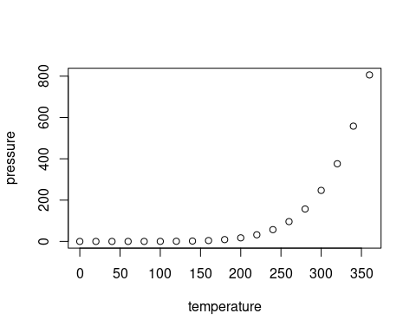

## Tables

knitr::kable(head(cars), caption = "Top six rows of Cars dataset")

Top six rows of Cars dataset

|  |  |
| --- | --- |
| speed | dist |
| 4 | 2 |
| 4 | 10 |
| 7 | 4 |
| 7 | 22 |
| 8 | 16 |
| 9 | 10 |

## Equations

$y=β_{0}+β_{1}X$