UI Technologies Index

Day1->10-07-2024

HTML- Hyper Text Markup Language

Exp1-Myname.html

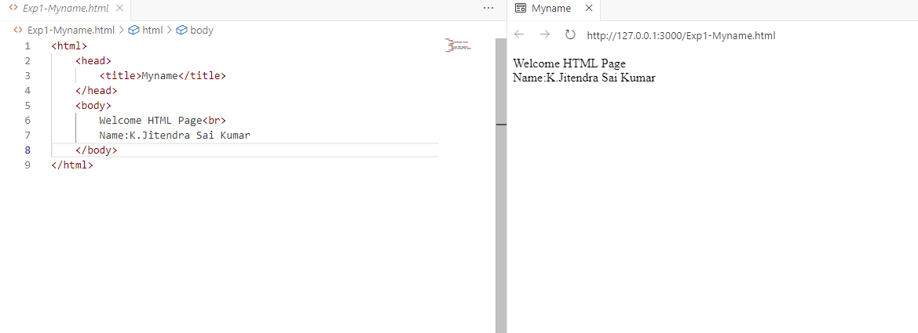

Exp2-Header.html

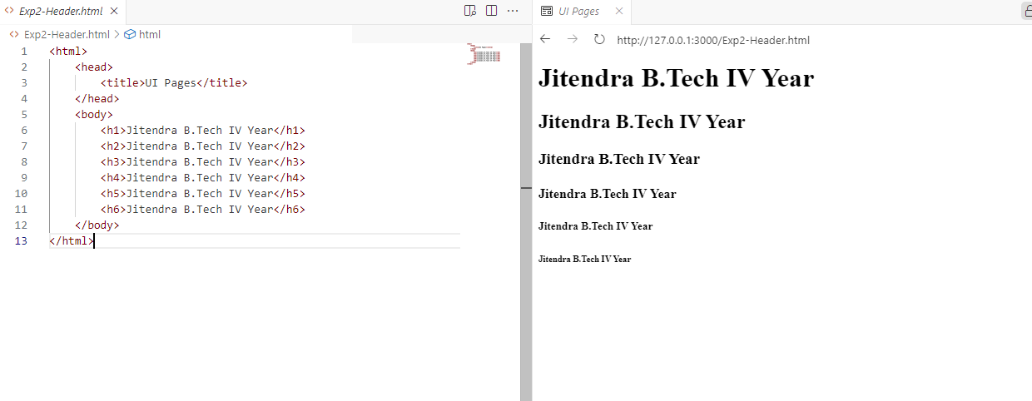

Exp3-href.html

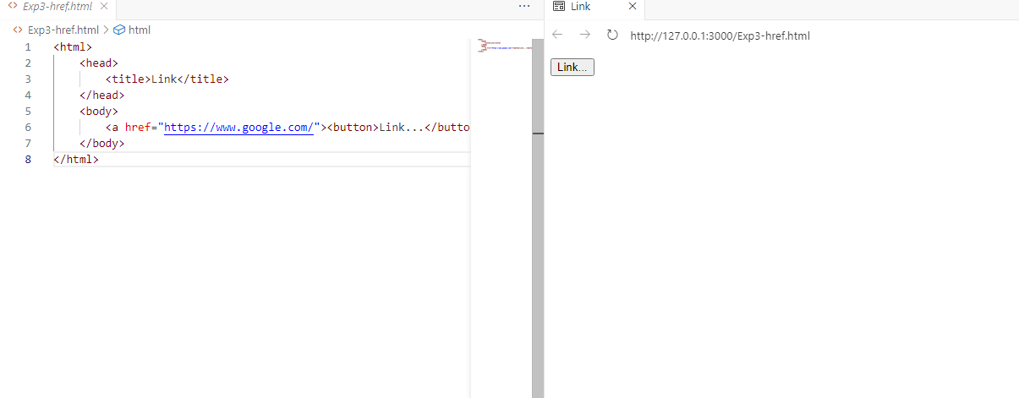

Exp4-images.html

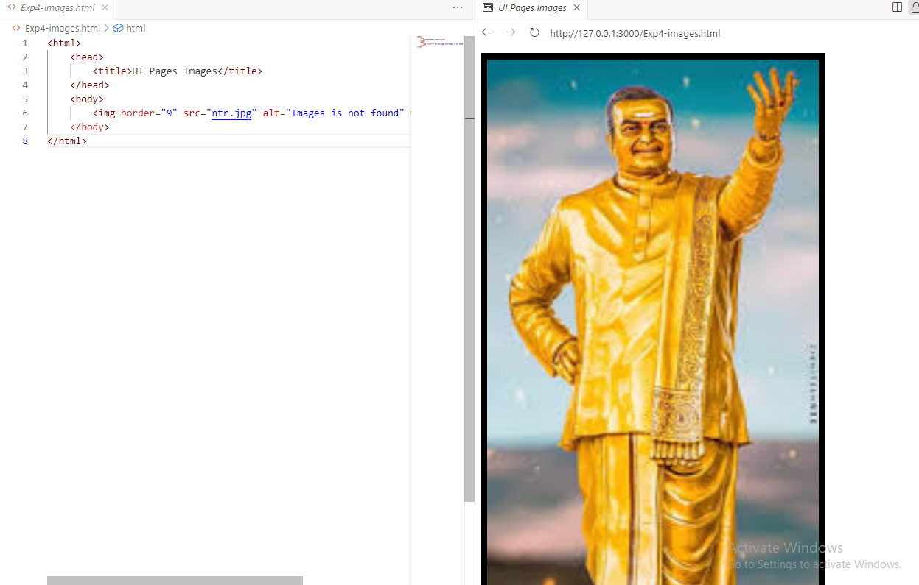

Exp5-Underline.html

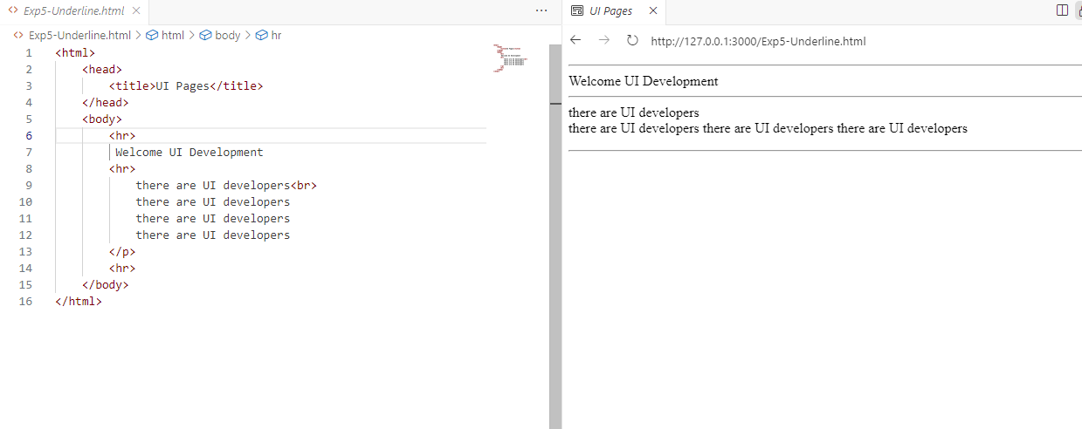

Exp6-FontSize.html

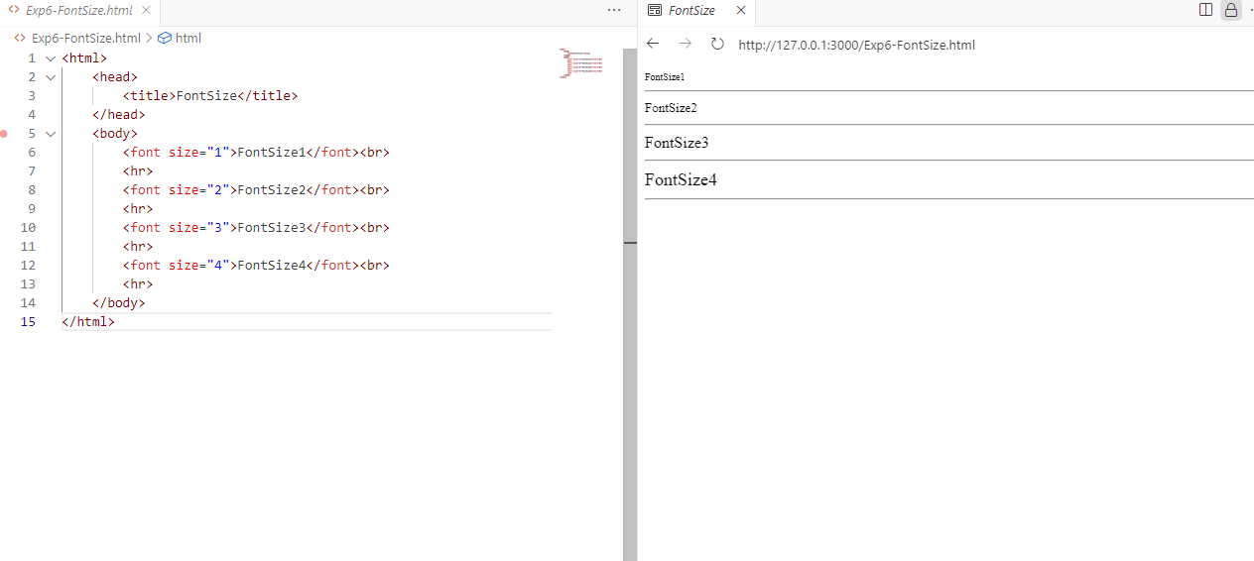

Exp7-Radio.html

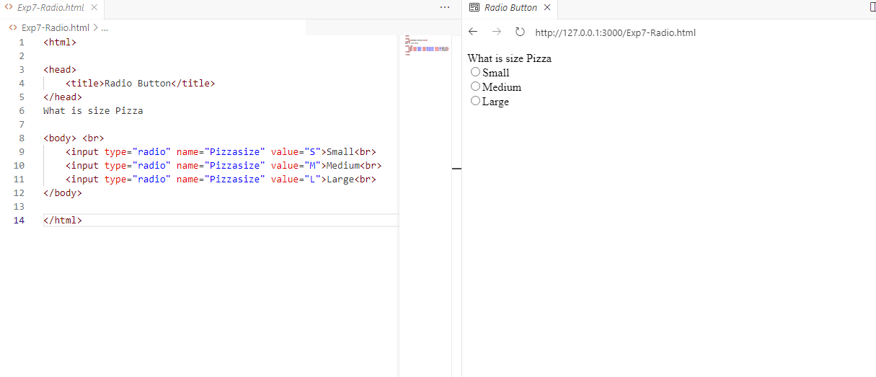

Exp8-Table.html

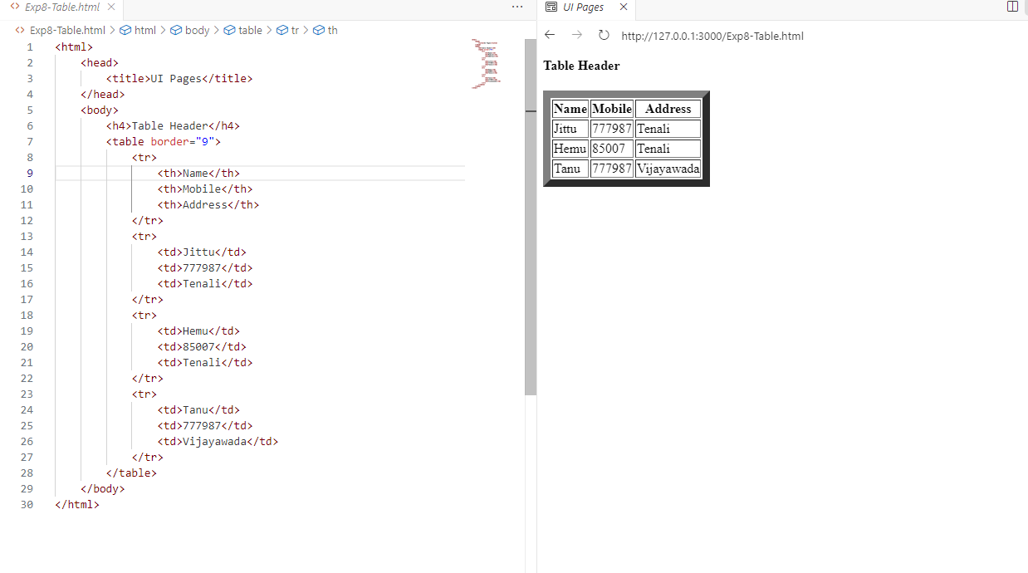

Exp9-Checkbox.html

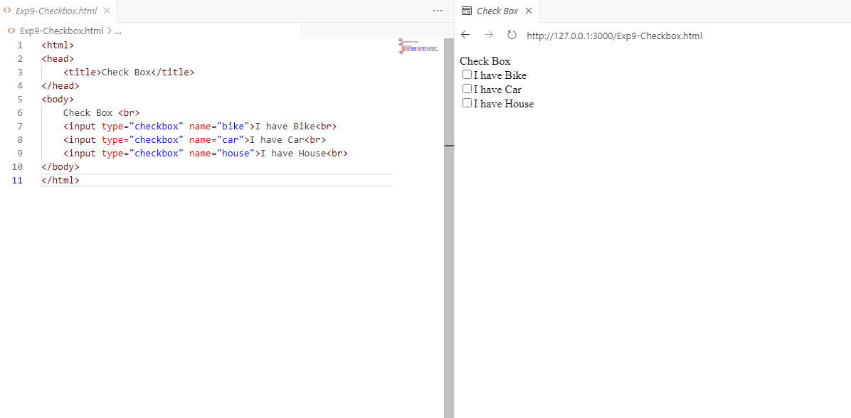

Exp10-Textarea.html

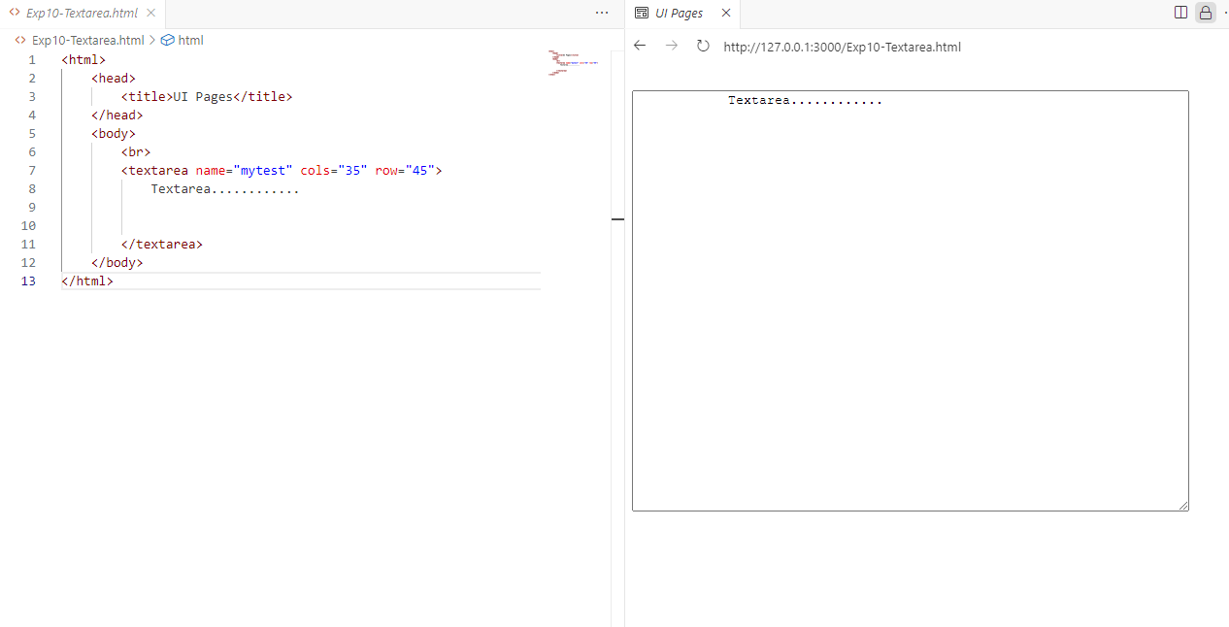

Exp11-Dropdownlist.html

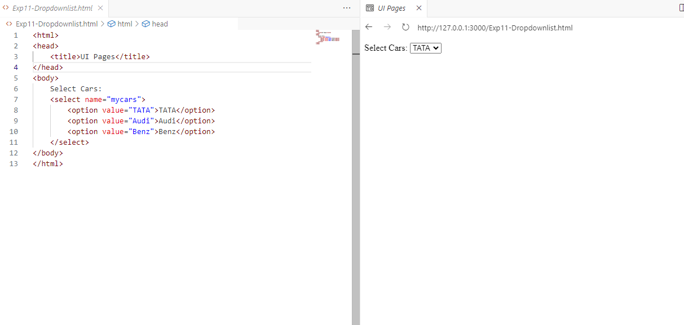

Exp12-LoginPage.html

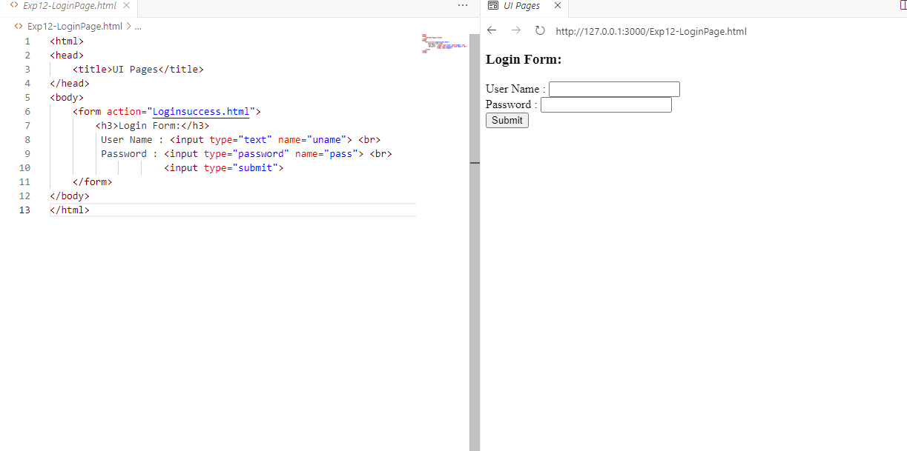

Loginsuccess.html

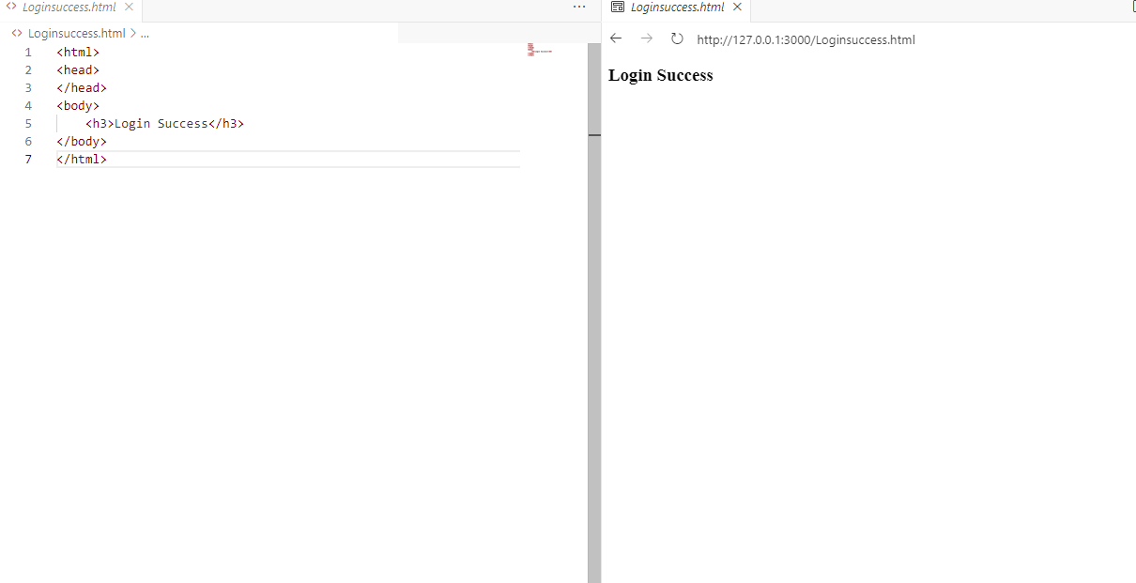

Exp13-Divtag.html

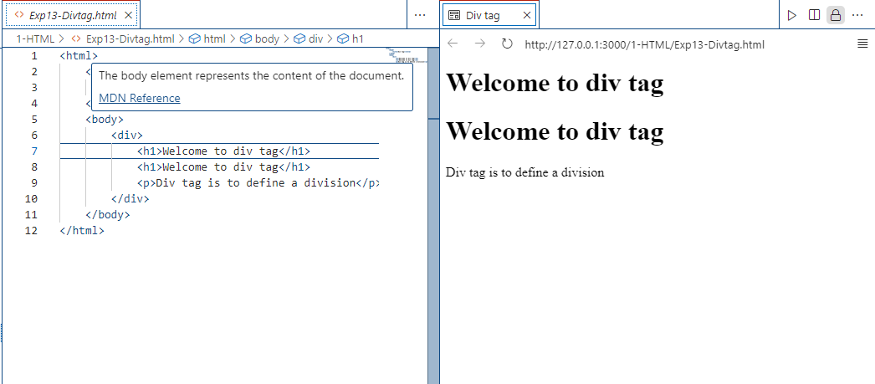

Exp14-Orderlist-Unorderlist.html

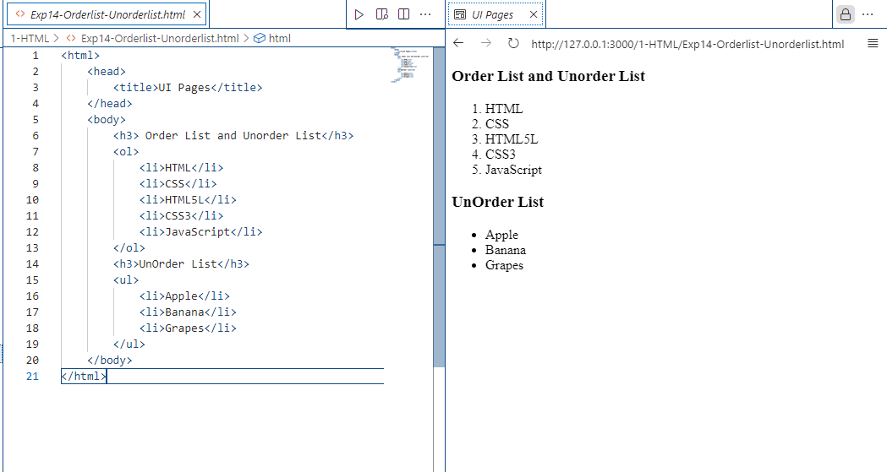

Exp15&Task1-Registrationform.html

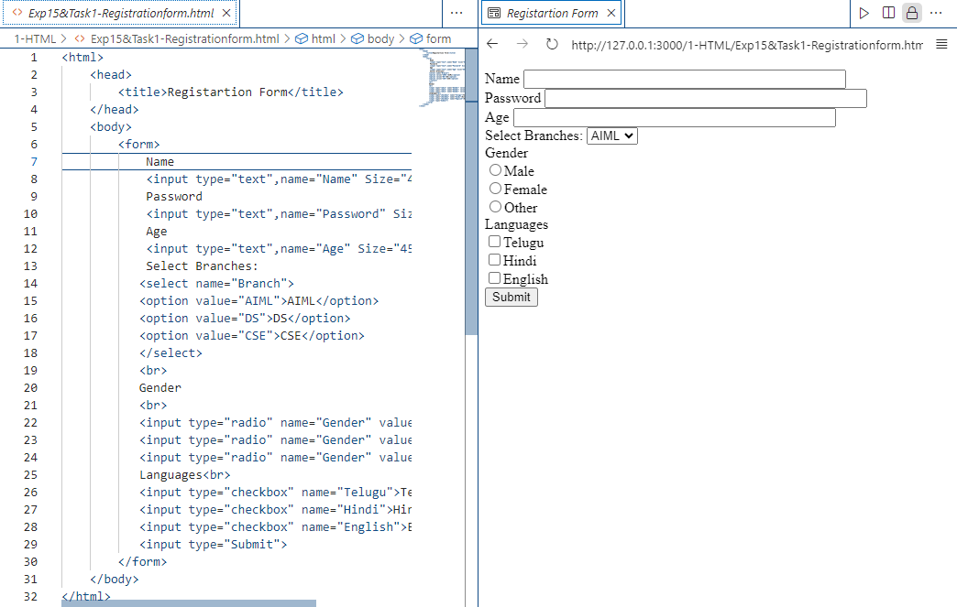

Project-1-Student-no

Tech : HTML

1.Registartion->Page Click

2.Login page->Page Click

3.Login Success….

Project-1-218A1A4251.html

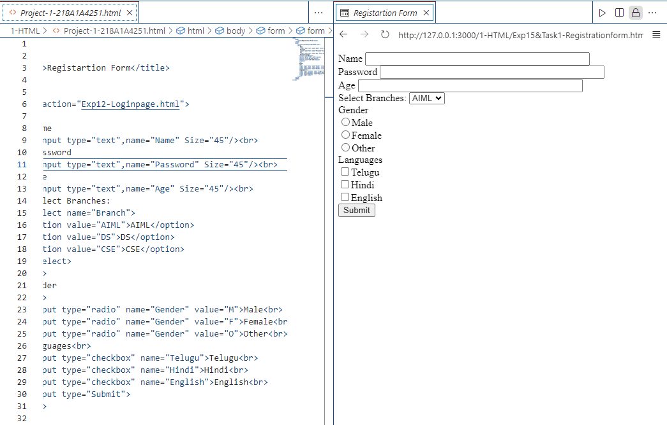

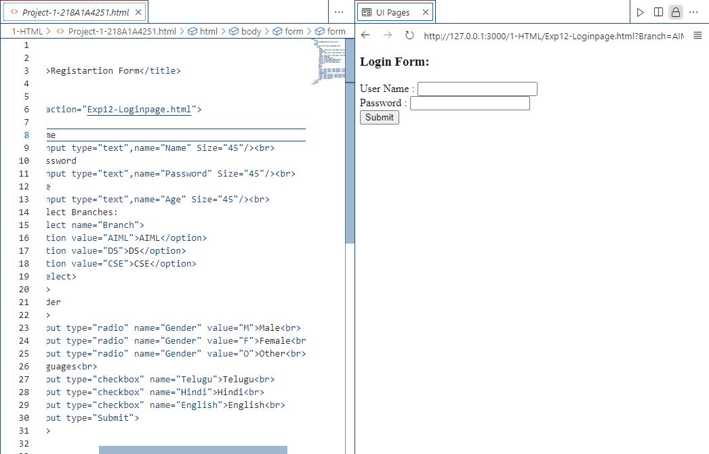

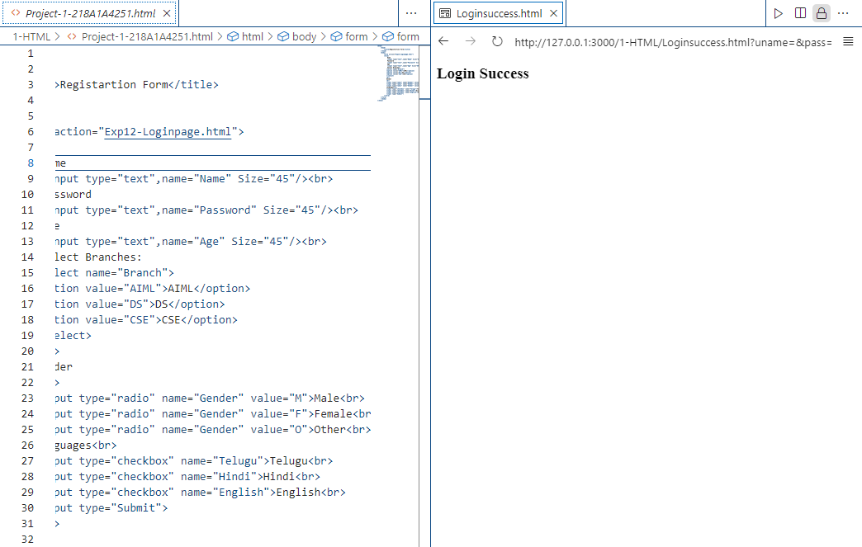

Day2-11-07-2024

CSS-Cascading Style Sheets

Exp1-CSS.html

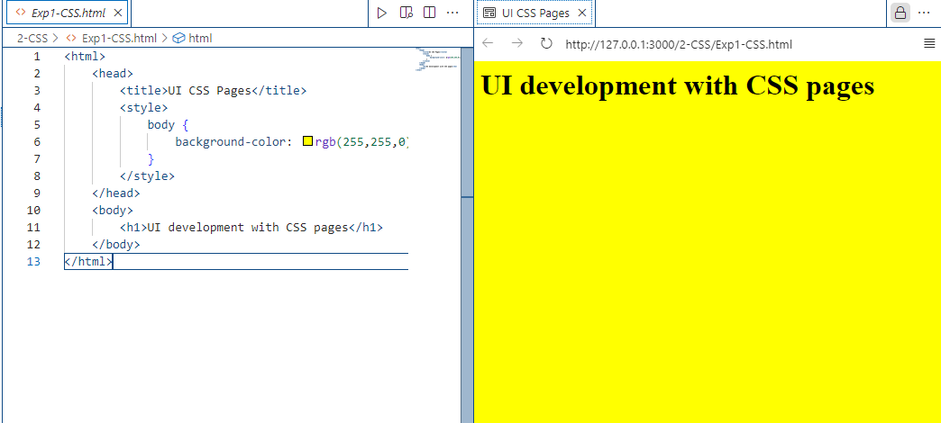

Exp2-CSS.html

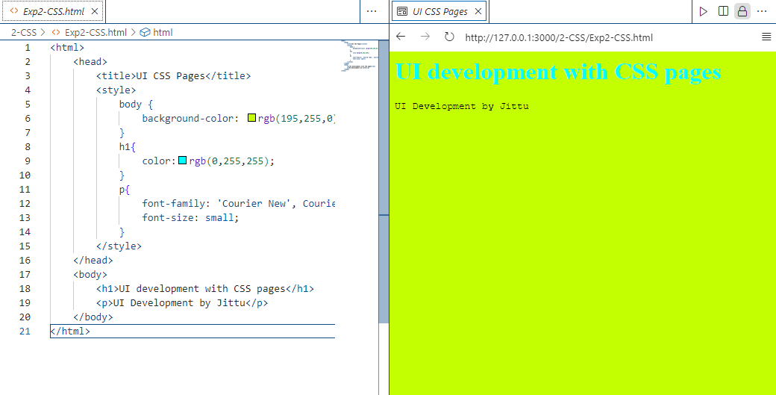

Exp3-CSS-inline.html

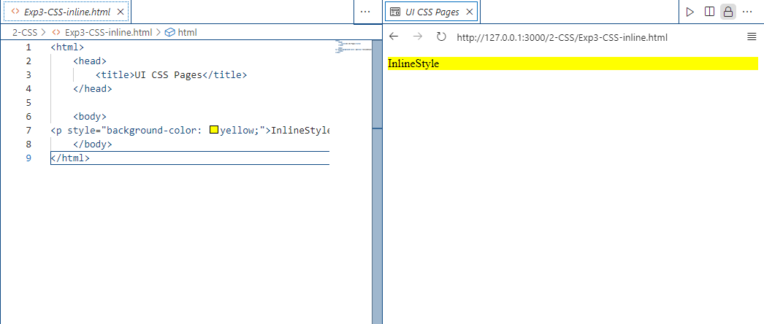

Exp4-BackgroundImg.html

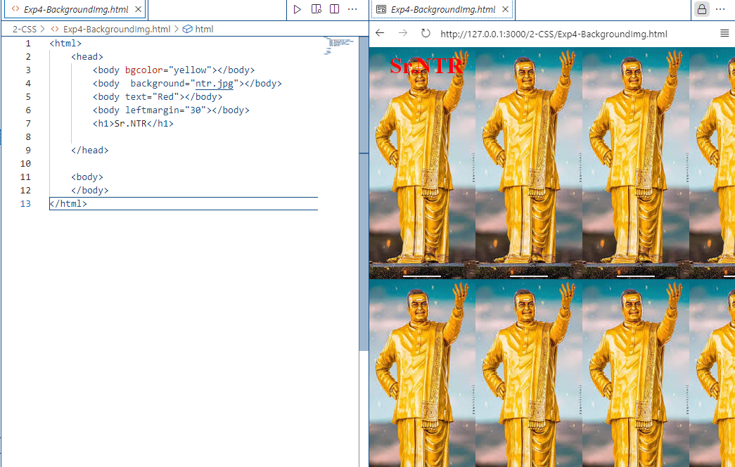

Exp5-Div-CSS.html

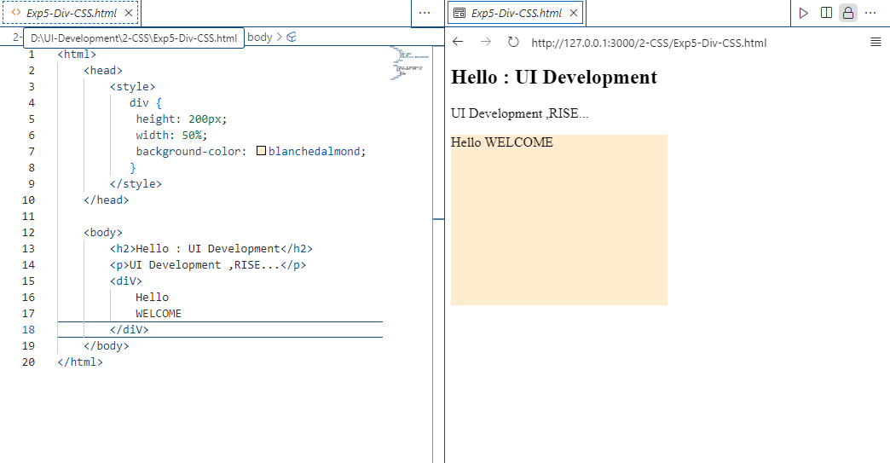

Exp6-CSS-Test.html

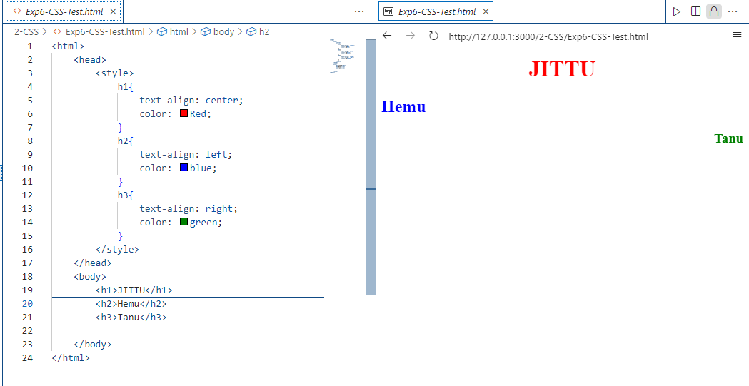

Exp7-CSS-TableBordercolors.html

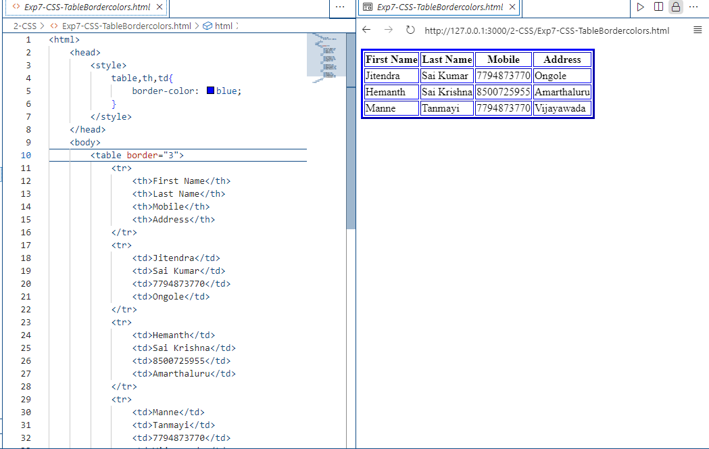

Exp8-Padding.html

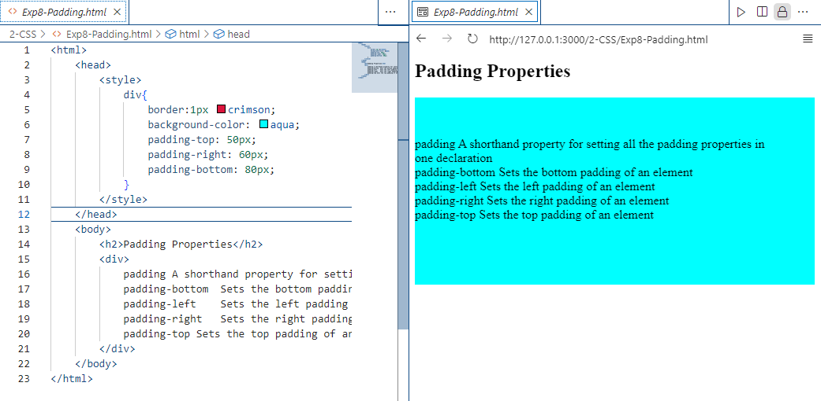

Exp9-CSS-Links.html

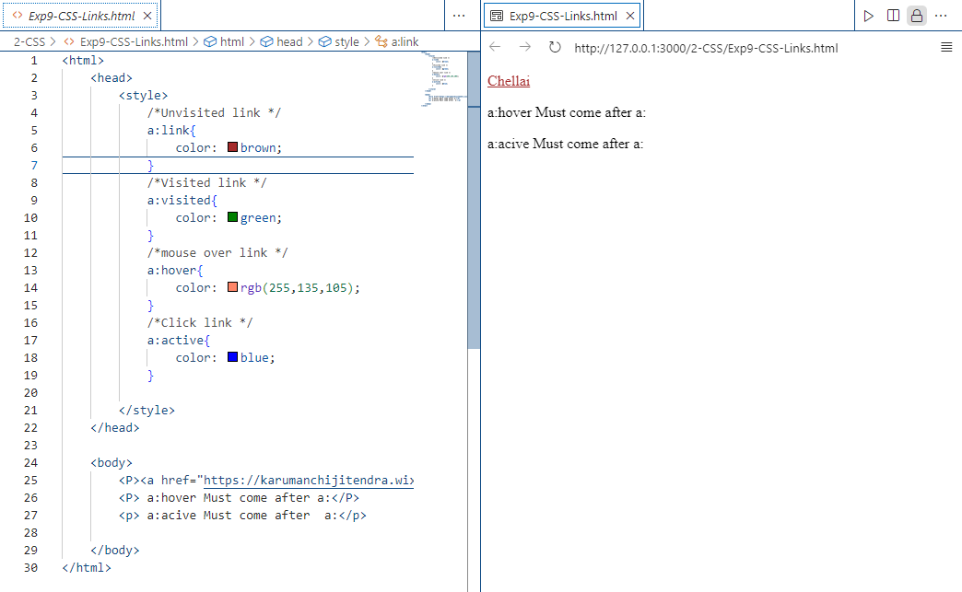

Exp10-RGB-Colors.html

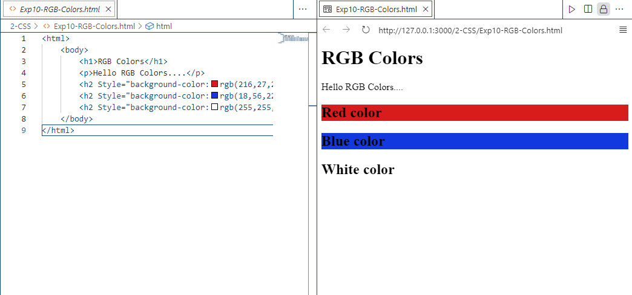

Exp11-CSS-class.html

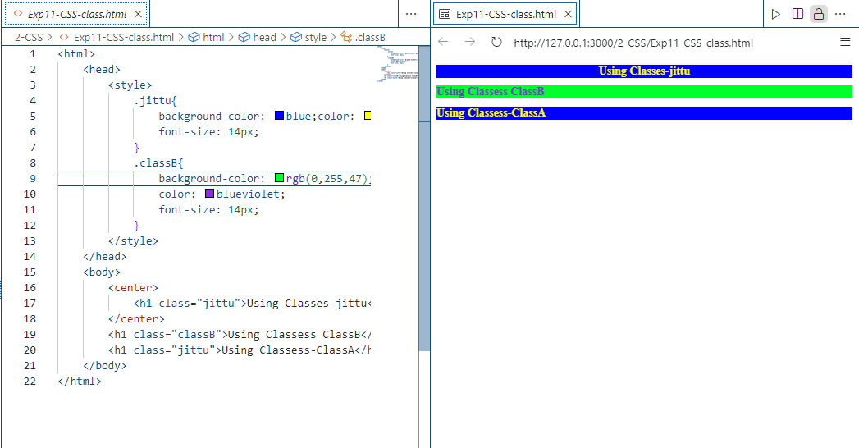

Exp12-Import-cssfile.html

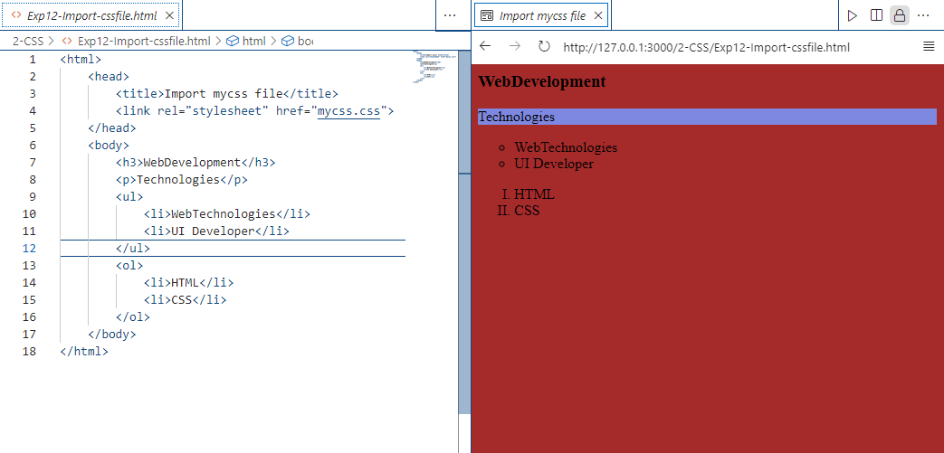

Exp13-HTML-CSS—Website.html

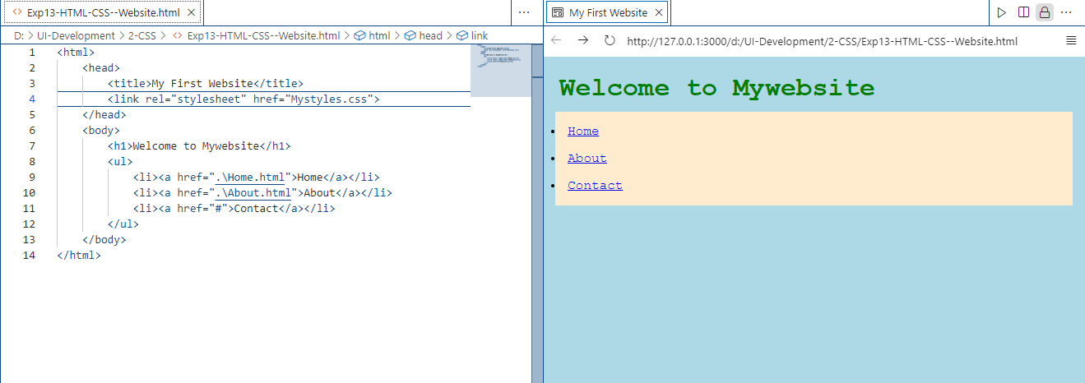

Exp14-SpanTag.html

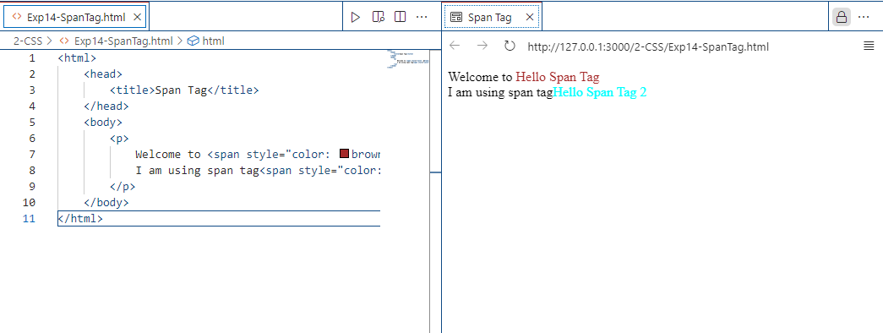

Project-2-Student-no(Small website)

Tech : HTML,CSS

1.HTML-CSS-Website.html

2.Home.html

3.About.html

4.Contactus.html

5.Registration.html->page click->Login.html

6.Login.html

Project-2-218A1A4251(Small Website).html

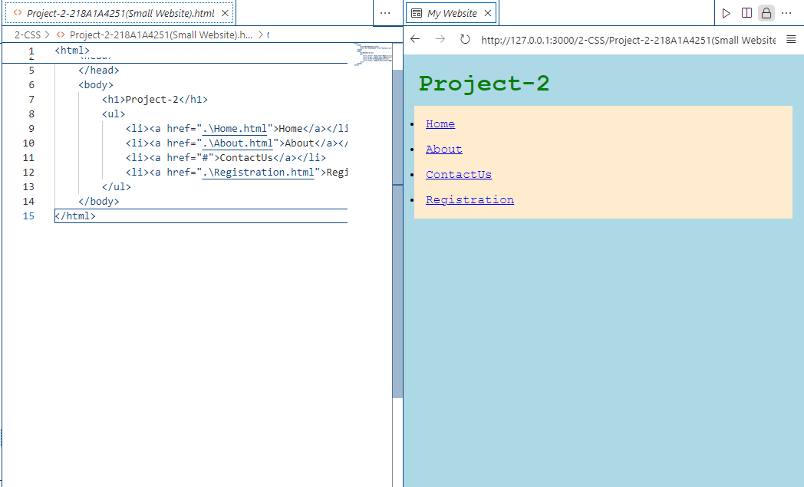

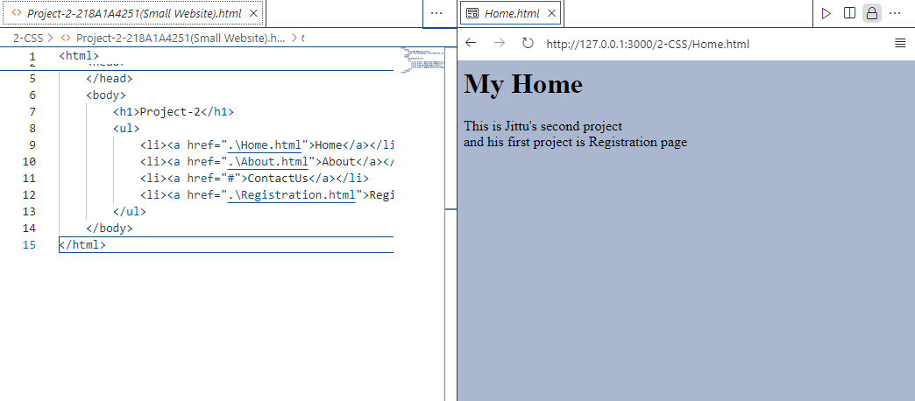

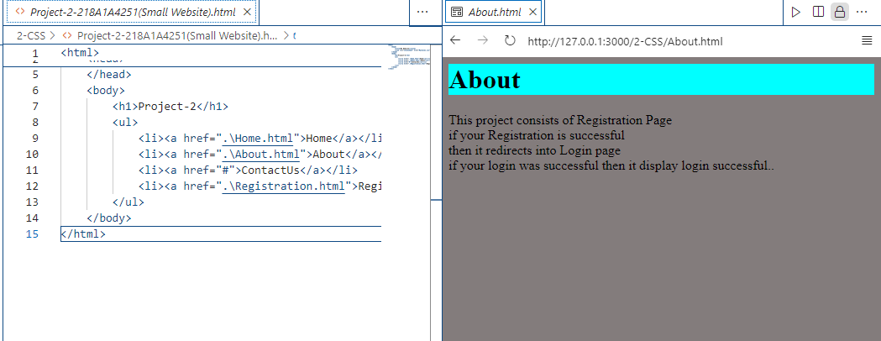

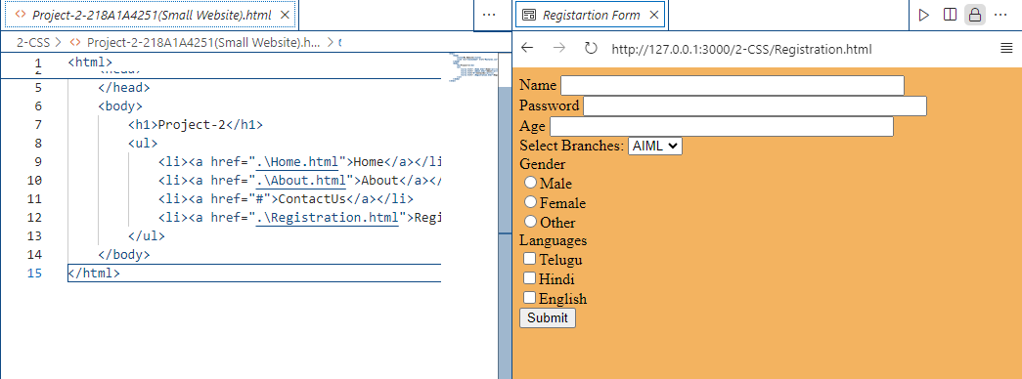

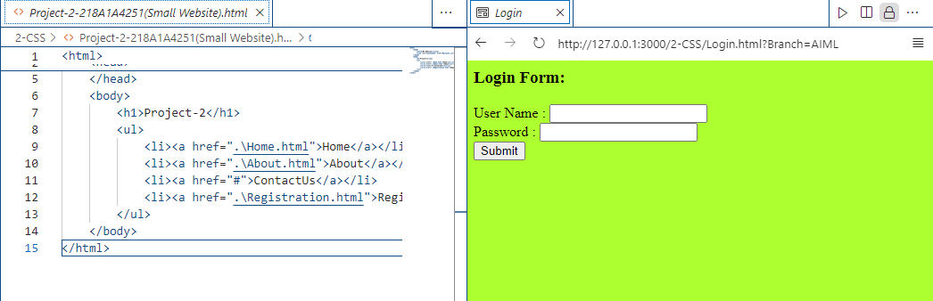

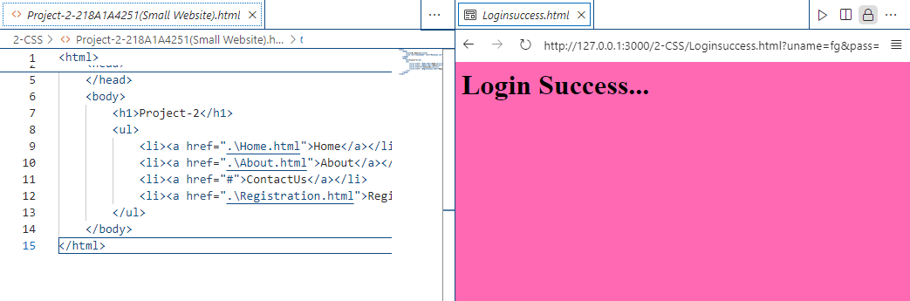

Day3-12-07-2024

HTML5

Exp1-Number.html

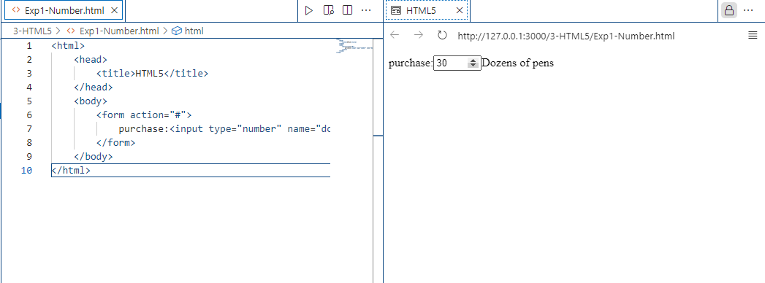

Exp2-Date.html

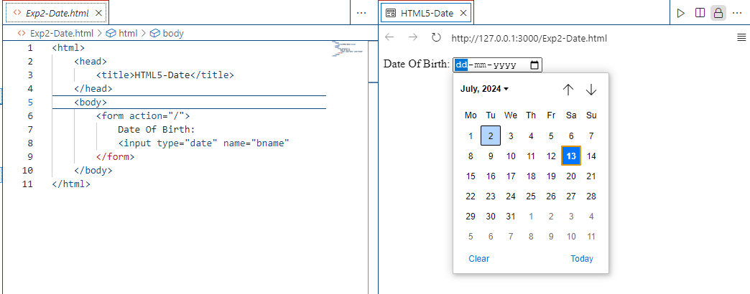

Exp3-Week.html

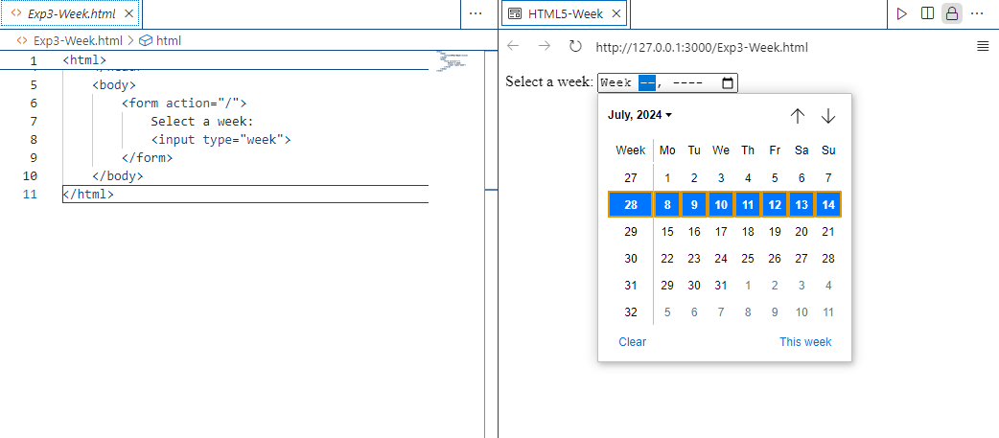

Exp4-Month.html

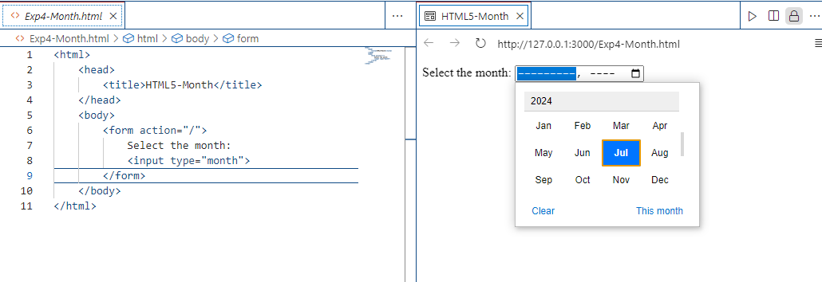

Exp5-Email.html

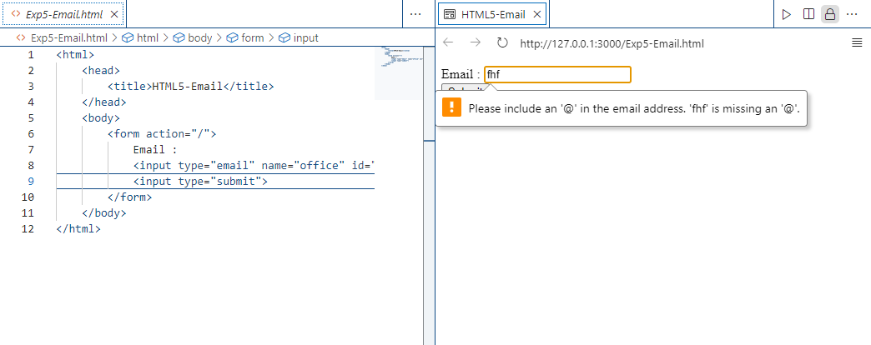

Exp6-Patternmobile.html

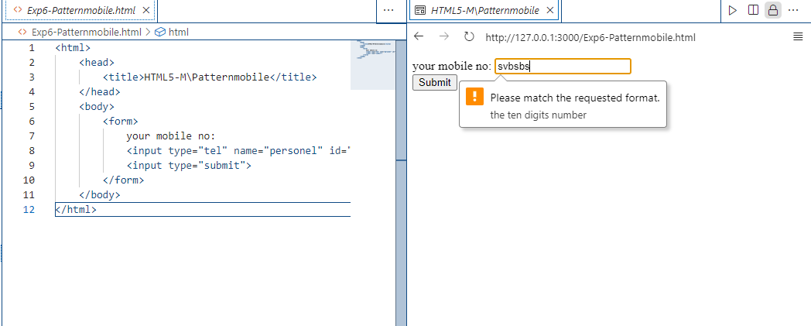

Exp7-DataList.html

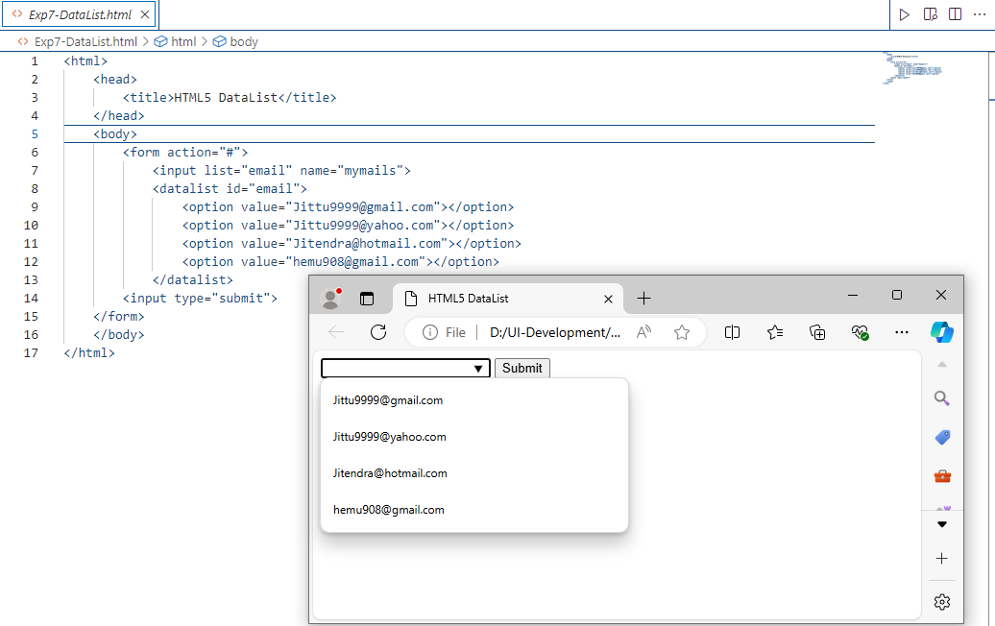

Exp8-Audio.html

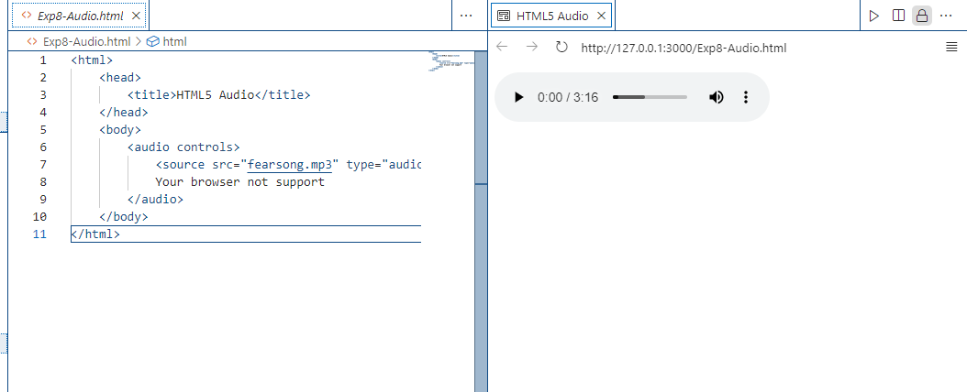

Exp9-Video.html

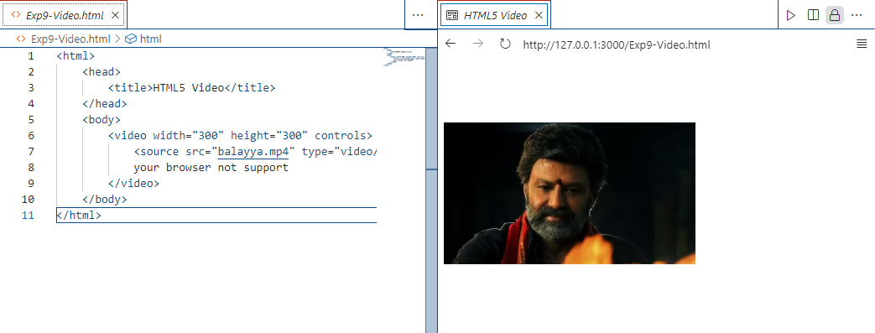

Exp10-Autofocus.html

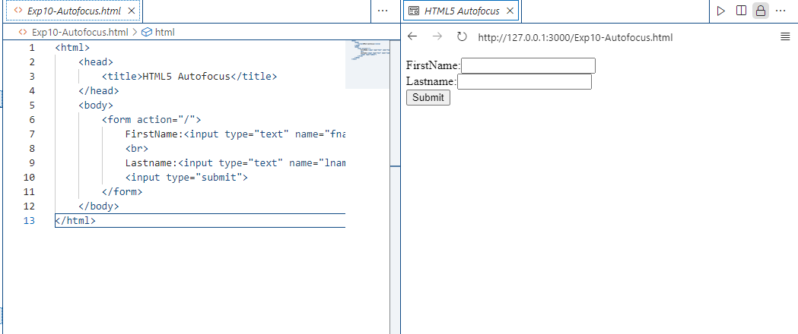

Exp11-PlaceHolder.html

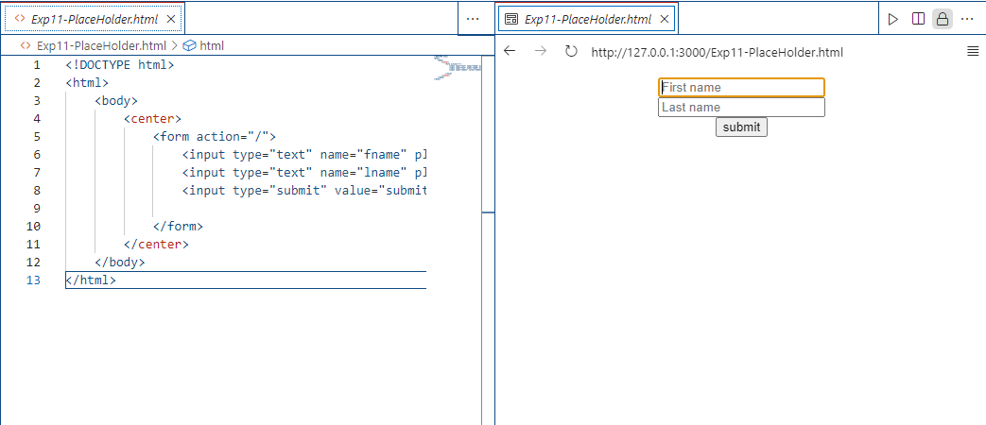

Exp12-Downloading.html

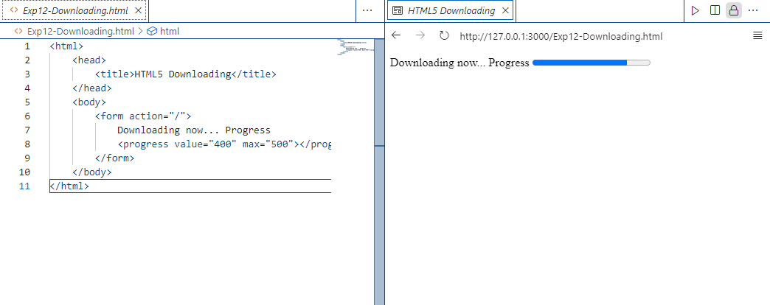

Exp13-NavExample.html

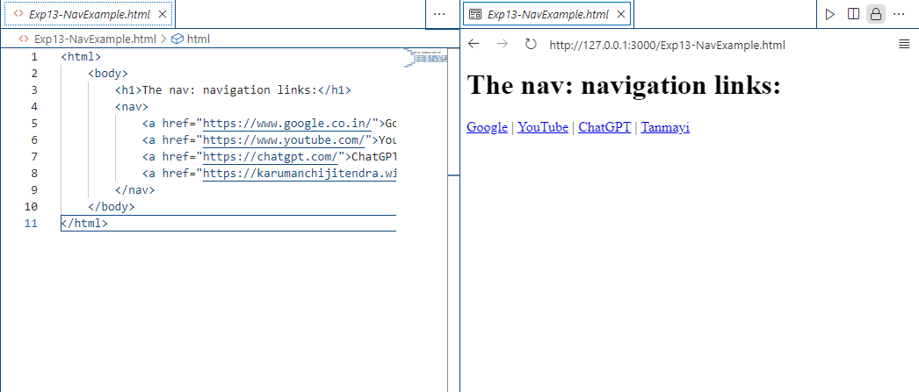

Exp14-MyWebsite1.html

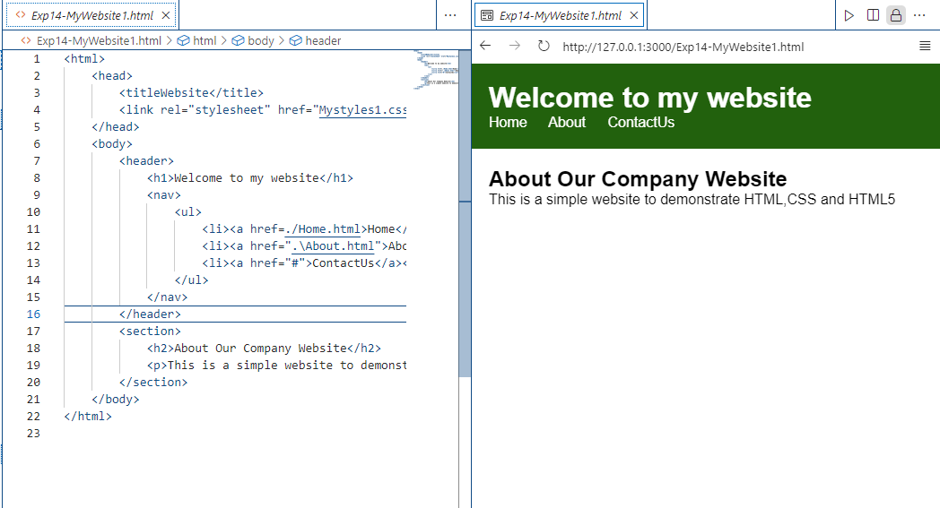

Exp15-NavMyWebsite2.html

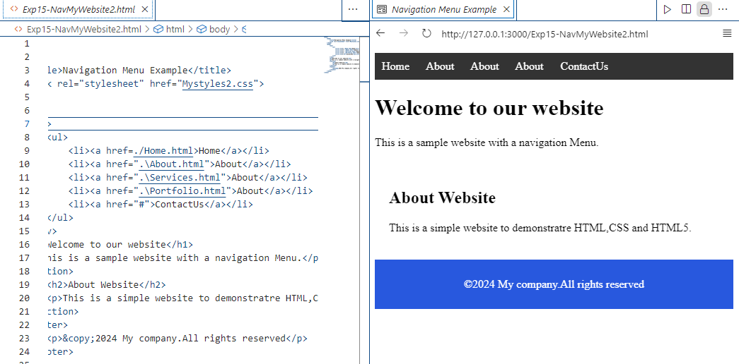

Web Project-3

Day4->13-07-2024

CSS3

Exp1-RGBA-Color.html

