

LA GRANDEE INTERNATIONAL COLLEGE

**Simalchaur, Pokhara, Nepal**

A Project Proposal

On

**“Parabook”**

**Submitted to:**

**Bachelor of Computer Application (BCA) Program**

In partial fulfilment of the requirements for the degree of BCA under Pokhara University

**Submitted by:**

|  |  |  |  |
| --- | --- | --- | --- |
| Name: | Course | Semester | P.U. Registration Number |
| Sarad Adhikari | BCA | 6th | 2022-1-53-0142 |
| Anish Poudel | BCA | 6th | 2022-1-53-0118 |
| Karun Sunuwar | BCA | 6th | 2022-1-53-0125 |
| Sabin Pandey | BCA | 6th | 2022-1-53-0139 |

Date: May 11, 2024

# Project Summary

The project "Paragliding Booking System" also known as Parabook using HTML, CSS, JS, PHP and MYSQL aims to automate various operational tasks within a company, enhancing efficiency and guest satisfaction. The system provides comprehensive features to manage different possibilities of the company such as booking flights, Customer Relationship Management (CRM), Weather Monitoring, Billing, and Invoicing.

The purpose of this project is to develop an intuitive interface that enhances the regular operations that could held in paragliding companies. For those companies that rely on a file-based system, implementing this application will significantly elevate their daily routines. Besides assistance in daily routines, it also provides statistics on company performance to gain valuable insights.

To conclude, the project Paragliding Booking System. It is specifically aimed to reduce manual tasks and streamline booking processes for both companies and customers.

# Table of Contents

Project Summary ii

Table of Contents iii

Abbreviations v

1.0 Introduction 1

2.0 Problem Statement 2

3.0 Objectives 3

3.1 For Companies: 3

3.2 For Passengers: 3

4.0 Requirement 4

4.1 Functional Requirements: 4

4.2 Non-Functional Requirements: 4

5.0 Methodology 5

Fig 5.1 Waterfall Model 5

Feasibility Study: 5

Requirement Analysis: 5

Design: 5

Coding: 5

Testing: 5

Maintenance: 5

6.0 Dataflow Diagram (DFD) 6

Fig 6.1 DFD Level 0 6

Fig 6.2 DFD Level 1 7

7.0 Flowchart 8

Fig 7.1 Flowchart of Login/Sign up 8

Fig 7.2 Flowchart of Booking/Flights 9

8.0 ER Diagram 10

Fig 8.1 ER Diagram 10

9.0 Tools/System 11

Visual Studio Code: 11

MS Word: 11

MS PowerPoint: 11

ClickCharts: 11

Online Gantt: 11

10.0 Gantt Chart 12

Fig: 10.1 Gantt Chart 12

11.0 Deliverables 13

# Abbreviations

|  |  |
| --- | --- |
| Parabook | Paragliding Booking System |
| BCA | Bachelor of Computer Application |
| VS Code | Visual Studio Code |
| MS | Microsoft |
| MySQL | My Structured Query Language |
| HTML | Hyper Text Markup Language |
| ER | Entity Relationship |
| DFD | Dataflow Diagram |
| JS | JavaScript |
| CSS | Cascading Style Sheets |
| PHP | Hypertext Preprocessor |

# 1.0 Introduction

Paragliding is an aerial sport where we can fly using a lightweight, foot-launched glider called a paraglider. It is the only medium through which a pilot and passenger can soar in the sky. Paragliding has been vogue in Nepal since 1995 and the sport is getting even more popular.

To meet the needs of this growing industry, we present **ParaBook**, a user-friendly paragliding booking system developed using HTML, CSS, JS, Mysql and PHP. ParaBook goes beyond traditional booking methods by offering a **centralized, secure data repository.** This repository stores essential information for both company and passengers, including names, addresses, contact details, nationalities and others possible datas. Besides assistance in the database, our application **ParaBook** will also give insightful statistics about a company's performance.

**"ParaBook"** is a comprehensive data management system that simplifies flight procedures for paragliding companies.

# 2.0 Problem Statement

Paragliding companies in Nepal predominantly rely on manual booking methods such as forms and phone calls which results in inefficiency. Additionally, it's hard to keep track of everything because the information is scattered.

Customers face difficulties in making instant bookings which results in inconvenience and poor customer experiences. A time-consuming booking process can discourage potential passengers and create negative impressions, ultimately affecting the company's reputation.

Furthermore, the absence of data analytics capabilities from manual booking methods limits the ability of paragliding companies to make informed decisions regarding pricing strategies, marketing efforts, and operational costs.

To address these challenges and empower paragliding companies, a robust paragliding booking system must be integrated for booking processes and provide valuable data analytics capabilities to drive business growth and overcome existing challenges.

# 3.0 Objectives

The main objective of the project PBS is to transform a physical file-based recording system into a computerized repository. Below are the classified objectives for companies and passengers:

## 3.1 For Companies:

* Automating reservations, and communication with customers.
* A user-friendly platform for employees to easily book flights, access information, and manage bookings.
* Generate statistics on flights, revenue, and company performance.

## 3.2 For Passengers:

* Allow passengers to book, schedule, and shift flights easily.
* Provide clear information about flights.

# 4.0 Requirement

4.1 Functional Requirements: Functional requirements for PBS define the specific actions and functionalities a system or its components must perform. They essentially describe **what** the system should do, outlining the features and functionalities that users will interact with.

* Booking Management
* Account Management
* Information Access
* Reporting and Analytics

By defining functional requirements, we can ensure the system is built to meet user needs and deliver the expected functionalities.

4.2 Non-Functional Requirements: Non-functional requirements define the qualities or characteristics of a system, rather than its specific actions. They essentially describe **how** the system should perform. Here are the non-functional requirements:

* Usability
* Performance
* Availability
* Security
* Maintainability

By defining non-functional requirements, we can ensure the developed system meets the desired quality standards and delivers a positive user experience.

# 5.0 Methodology

For the development of the “Parabook” web application, we’ll be using the Agile methodology, a flexible and iterative approach to software development. Agile focuses on delivering a small, functional pieces of the application through continuous planning, development, and testing. It promotes collaboration, adaptability to change, and frequent delivery of working software.

Agile methodology is particularly well-suited for projects like this that require regular updates evolving features, and client feedback. Development is broken into short cycles known as iterations or sprints (usually 1-3 weeks), where each sprint delivers usable features such as booking modules, admin controls or transaction tracking.

In a nutshell, Agile requires the following key roles and practices:

1. A product Owner defines and prioritizes the features in the Product Backlog.
2. The Development team selects items from the backlog to build each iteration
3. At the end of each sprint, the team reviews and tests the new functionality
4. Repeat

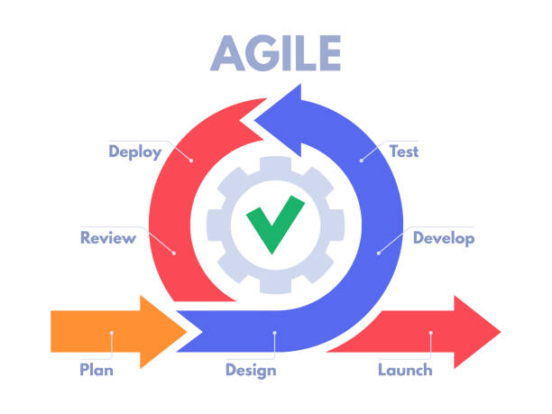

# 6.0 Dataflow Diagram (DFD)

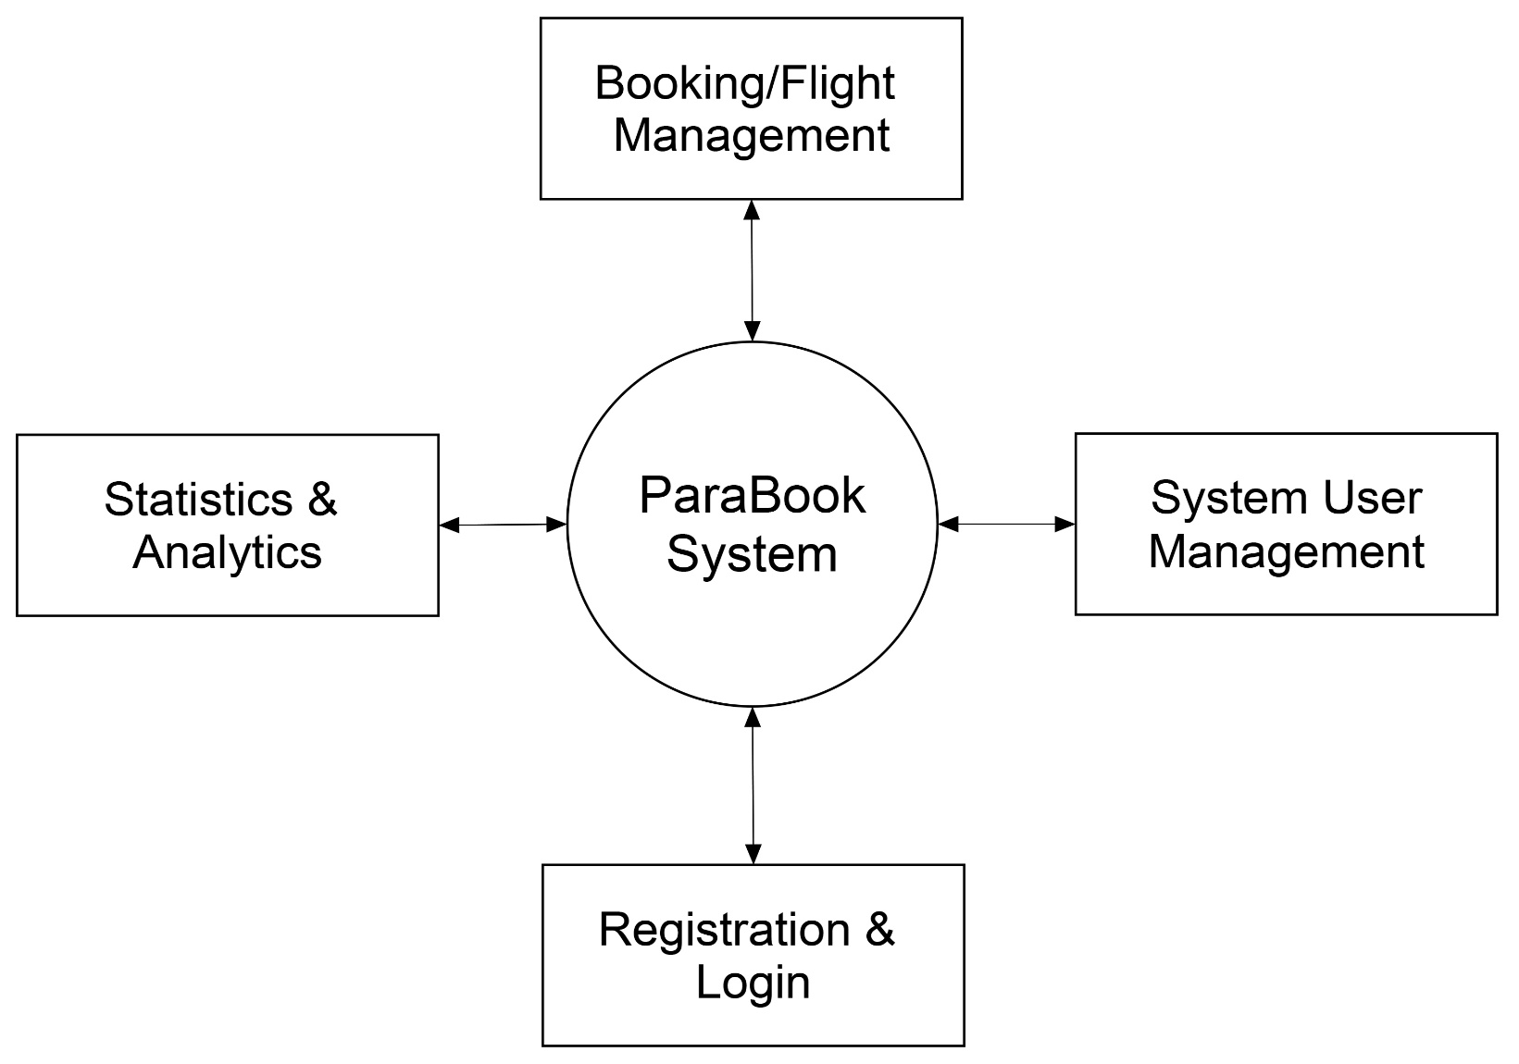

## Fig 6.1 DFD Level 0

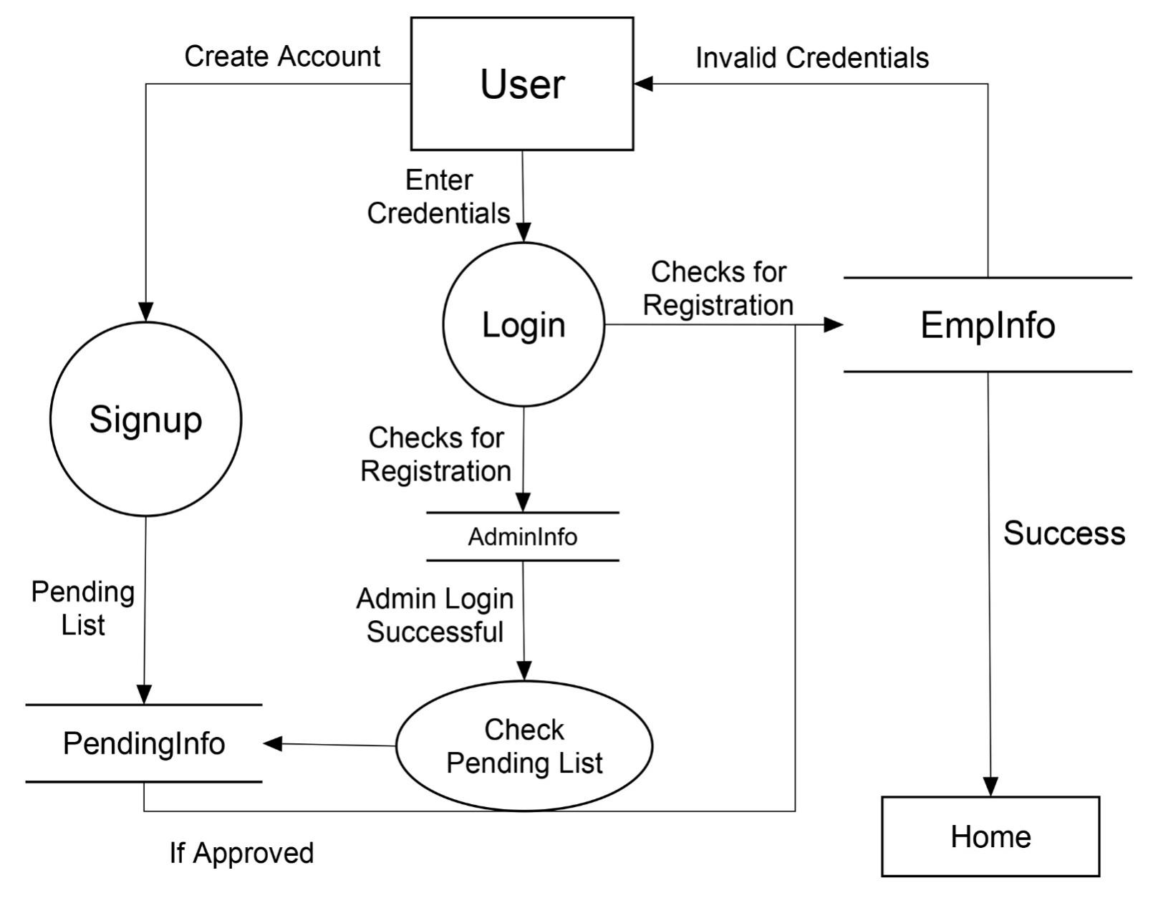

## Fig 6.2 DFD Level 1

# 7.0 Flowchart

## Fig 7.1 Flowchart of Login/Sign up

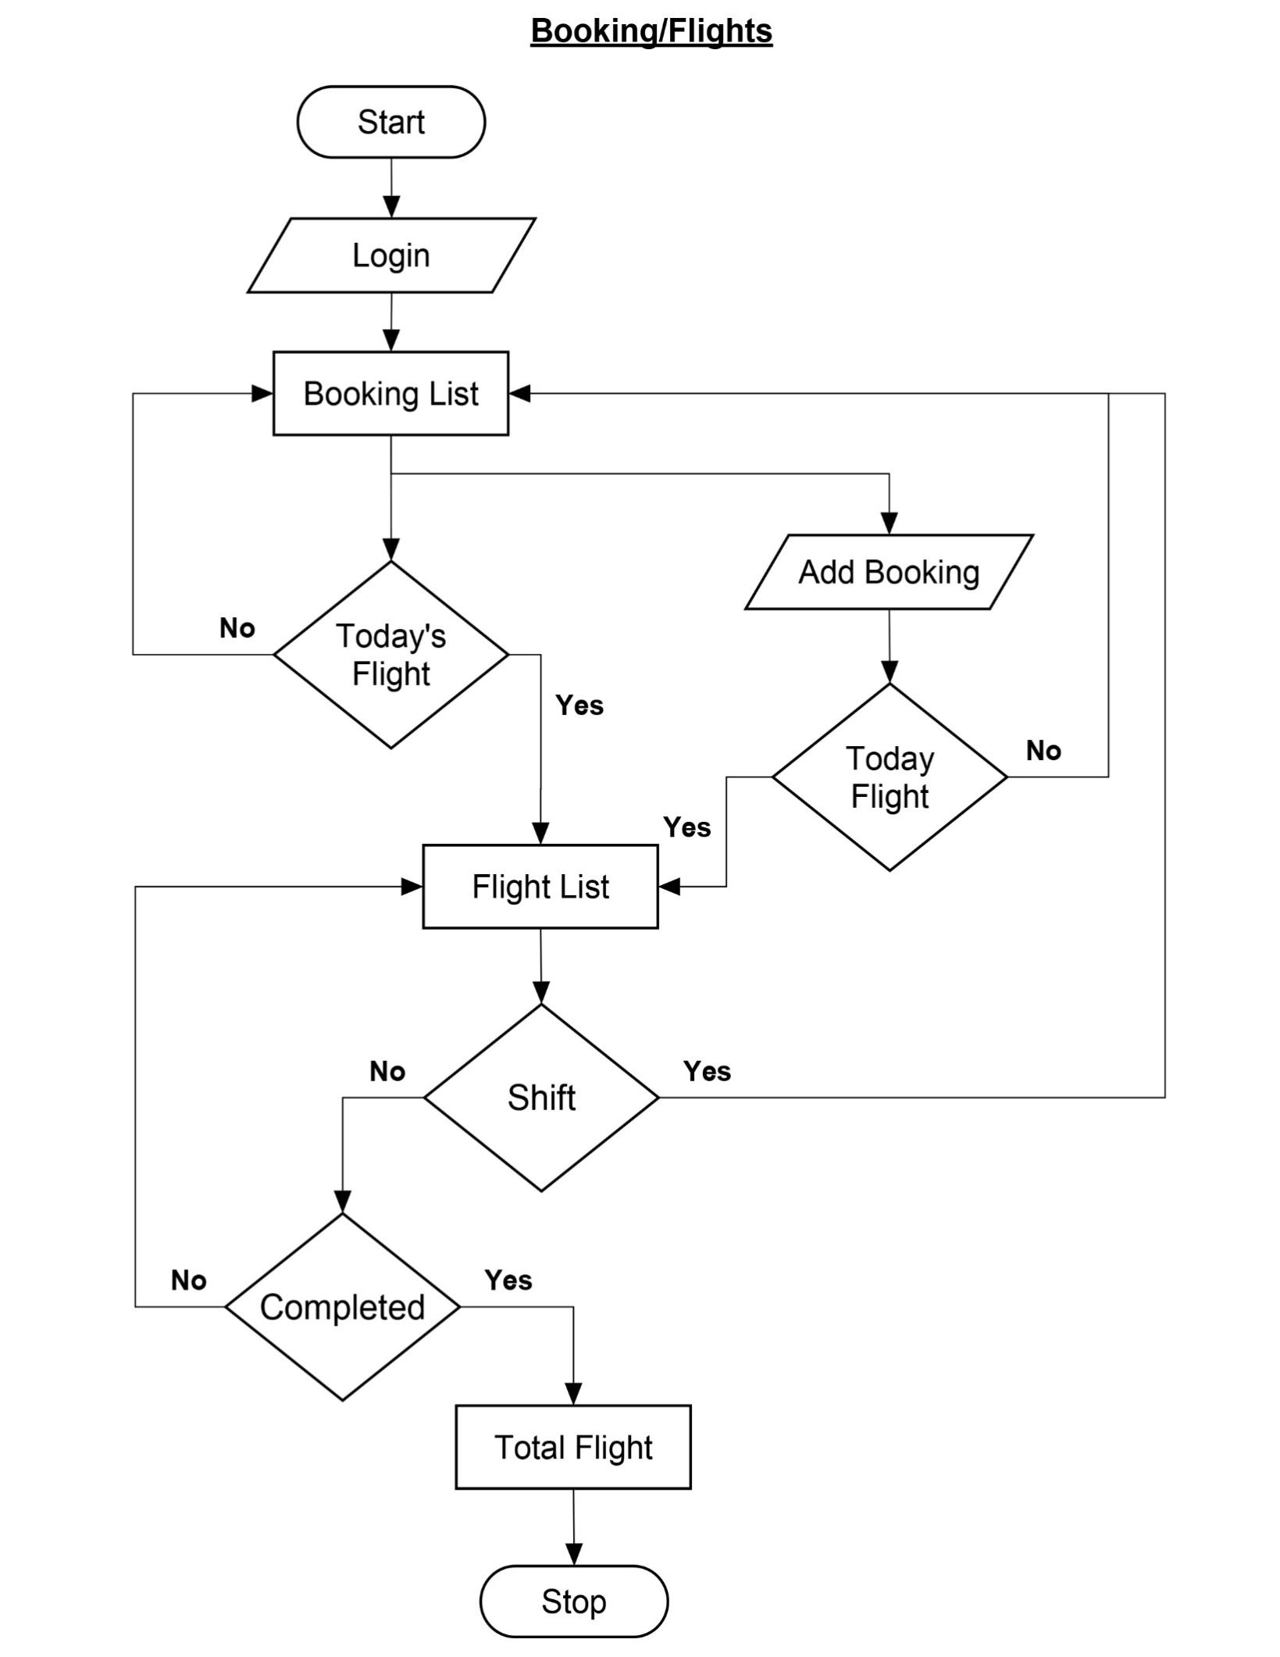

## Fig 7.2 Flowchart of Booking/Flights

## 

# 8.0 ER Diagram

## Fig 8.1 ER Diagram

# 9.0 Tools/System

Visual Studio Code: The most comprehensive IDE for Web developers on Windows for building web, cloud, desktop, mobile apps, services, and games.

MS Word: Microsoft Word is a word-processing software developed by Microsoft. We used MS Word to create and edit documents and reports.

MS PowerPoint: Microsoft PowerPoint is a Microsoft Office suite presentation software. We used MS PowerPoint to create clean slideshow presentations.

Photoshop: Photoshop is a raster-based graphical software developed by Adobe. We've used Photoshop for image manipulation, editing, and converting to grayscale images.

Illustrator: Illustrator is a vector-based graphical software developed by Adobe. We've used Illustrator to create icons for the ParaBook interface.

ClickCharts: It is an application that provides an interface to create flowcharts, data flow diagrams, and Entity Relationship diagrams. It lets users generate insights on how data flows.

Online Gantt: It is a free online web application to create a Gantt Chart and let users save it for further modification.

# GanttChart10.0 Gantt Chart

### Fig: 10.1 Gantt Chart

# 11.0 Deliverables

This project aims to develop a paragliding booking system using HTML, CSS, JS, MySQL and PHP that assists daily operations for companies and enhances the customer experience. Below are the deliverables that we will provide on the completion of this project:

* A fully functional paragliding booking system web application developed using HTML, CSS, JS and PHP, MySQL.
* User registration and login for companies using secure authentication methods.
* Admin dashboard with options to view, add, edit, and cancel bookings, update flight schedules, and generate reports.
* A user-friendly guide explaining how to navigate the booking system, manage bookings, and add pilot's and passenger's information.