SOFTWARE REQUIREMENTS SPECIFICATION

FOR

Cadence: An Open-Source Music Streaming Application
Version 1.0 January 2026
Karun Nagaraj(2547229)
R.Karan (2547241)
Xavier Amith (2547256)

Table of Contents
- REQUIREMENT ANALYSIS
- 1.1 Objective and Problem Description
- PROJECT STUDY
- 2.1 Existing System Analysis
- 2.2 Proposed System
- 2.3 Benefits of Proposed System
- LITERATURE SURVEY
- 3.1 Current Works in Music Streaming Technology
- 3.2 Explanation of Specialization Concepts
- REQUIREMENTS SPECIFICATION
- 4.1 Functional Requirements
- 4.2 Non-Functional Requirements
- 4.3 Software and Hardware Requirements
- SYSTEM MODELS
- 5.1 System Architecture Overview
- 5.2 Module Descriptions
- 5.3 Database Schema Design
- 5.4 Deployment Architecture
- CONCLUSION
- APPENDICES

1. REQUIREMENT ANALYSIS

1.1 Objective and Problem Description

1.1.1 Project Objective
The primary objective of this project is to develop a comprehensive, real-time music streaming application that replicates core functionalities of modern music streaming platforms like Spotify. The application aims to provide users with an immersive music listening experience, featuring real-time synchronization, social interaction capabilities, and intelligent music recommendations.
The system will leverage cutting-edge web technologies including Node.js, Express.js, MongoDB, Socket.IO, and React to deliver a scalable, responsive, and feature-rich platform that enables users to discover, stream, and share music seamlessly across devices.

1.1.2 Problem Definition
Why: The global music streaming industry has witnessed exponential growth over the past decade, largely dominated by a duopoly of major paid platforms that control content distribution, user data, and access to advanced features. While these platforms provide high-quality streaming services, they are largely subscription-based, closed-source, and restrictive in terms of customization, transparency, and experimentation. This creates a barrier for users who seek affordable access and for developers or researchers who wish to study, extend, or innovate upon existing systems.
What: This project addresses these challenges by developing a free and open-source, full-stack music streaming platform that emphasizes real-time interaction, collaboration, and user-centric design. The proposed system incorporates real-time communication technologies, collaborative playlist and queue management, live activity tracking, and intelligent recommendation mechanisms to enhance the overall music consumption experience.
The application enables users to:
- Stream music seamlessly
- Create, manage, and share playlists collaboratively
- Participate in real-time chat and synchronized listening sessions
- View friends’ live listening activities and song history
- Discover new music through personalized and data-driven recommendations
By providing an open-source alternative to paid, closed ecosystems, the project promotes accessibility, transparency, and innovation, while serving as a practical demonstration of modern distributed systems, real-time web technologies, and scalable backend design.

2. PROJECT STUDY

2.1 Existing System Analysis
Several music streaming platforms currently dominate the market, including Spotify, Apple Music, YouTube Music, and Amazon Music. While these platforms offer extensive music libraries and basic playlist functionality, they present several limitations:

2.1.1 Limitations of Existing Systems
- Limited Real-time Collaboration: Most platforms lack true real-time collaborative features where multiple users can interact simultaneously with shared content.
- Restrictive Social Features: Social interactions are often limited to following users and sharing playlists, without integrated messaging or live activity feeds.
- High Infrastructure Costs: Commercial platforms require significant infrastructure investment, making them inaccessible for educational or small-scale implementations.
- Complex Content Management: Administrative interfaces for content management are often complex and not user-friendly for independent artists or administrators.
- Privacy Concerns: Many existing platforms collect extensive user data with limited transparency and control for end-users.
- Device Synchronization Issues: Cross-device playback synchronization is often unreliable, leading to disrupted listening experiences.

2.2 Proposed System
The proposed software addresses these limitations by implementing a modern, scalable architecture that prioritizes real-time features, social interaction, and user experience. The system comprises a React-based frontend, Node.js/Express backend, MongoDB database, and Socket.IO for real-time communication.

2.2.1 Key Features of Proposed System
- Real-time Activity Tracking: Users can view what their friends are currently listening to in real-time, fostering social engagement and music discovery.
- Integrated Chat System: Built-in messaging functionality allows users to discuss music, share recommendations, and connect with other listeners.
- Advanced Audio Player: Full-featured audio player with controls for play, pause, skip, shuffle, repeat, volume control, and progress tracking.
- Dynamic Playlist Management: Users can create, edit, delete, and share playlists with sophisticated organization and categorization features.
- Album and Artist Browsing: Comprehensive browsing interfaces for exploring music by albums, artists, and genres with rich metadata display.
- Admin Dashboard: Robust administrative interface for content management, user management, and analytics monitoring.
- Secure Authentication: Implementation of modern authentication mechanisms using Clerk or JWT for secure user access control.
- Cloud Storage Integration: Integration with Cloudinary for efficient media storage and delivery with automatic optimization.

2.3 Benefits of Proposed System
- Enhanced User Engagement: Real-time features and social components significantly increase user interaction and platform stickiness.
- Scalable Architecture: Microservices-oriented design allows for horizontal scaling and easy feature additions without system-wide disruptions.
- Cost-Effective Implementation: Open-source technology stack reduces licensing costs while maintaining enterprise-grade capabilities.
- Educational Value: Provides comprehensive learning resource for full-stack development, real-time systems, and cloud deployment.
- Modern User Experience: Responsive design with skeleton loaders, dark mode, and smooth animations delivers professional user experience.
- Community Building: Social features foster music communities and enable organic content discovery through peer recommendations.

3. LITERATURE SURVEY

3.1 Current Works in Music Streaming Technology
Recent research and development in music streaming applications have focused on several key areas including real-time synchronization, content delivery optimization, recommendation algorithms, and social integration. This survey examines contemporary approaches and technologies employed in modern music streaming platforms.

3.1.1 Real-time Communication in Web Applications
Socket.IO has emerged as the de facto standard for implementing real-time, bidirectional communication in web applications. Research by Fette and Melnikov (2011) on the WebSocket protocol established the foundation for persistent connections between clients and servers. Socket.IO builds upon this foundation, providing fallback mechanisms and enhanced reliability. Studies have demonstrated that Socket.IO-based implementations can handle thousands of concurrent connections with minimal latency, making it ideal for features like live activity feeds and real-time chat systems.
Reference: Fette, I., & Melnikov, A. (2011). The WebSocket Protocol. RFC 6455, Internet Engineering Task Force.

3.1.2 NoSQL Databases for Media Applications
MongoDB's document-oriented architecture has proven particularly suitable for music streaming applications due to its flexible schema design and horizontal scalability. Research conducted by Chodorow (2013) demonstrates that MongoDB's aggregation framework efficiently handles complex queries for playlist management, user preferences, and music metadata. The database's ability to store hierarchical data structures aligns well with the nested relationships between users, playlists, albums, and tracks.
Reference: Chodorow, K. (2013). MongoDB: The Definitive Guide. O'Reilly Media.

3.1.3 Modern Frontend Architecture
React's component-based architecture and virtual DOM implementation have revolutionized frontend development for complex applications. Studies by Aggarwal (2018) show that React applications achieve superior performance in scenarios requiring frequent UI updates, such as audio players with real-time progress tracking and dynamic playlist rendering. The introduction of hooks and context API has further simplified state management in music streaming interfaces.
Reference: Aggarwal, S. (2018). Modern Web Development Using ReactJS. International Journal of Recent Research Aspects, 5(1), 133-137.

3.1.4 Cloud Storage and Content Delivery
Cloud-based media storage solutions like Cloudinary have transformed how applications handle audio and image assets. Research by Bermudez et al. (2017) demonstrates that cloud storage with integrated CDN capabilities significantly reduces load times and bandwidth costs while providing automatic format optimization and responsive image delivery. These capabilities are critical for music streaming applications serving global audiences.
Reference: Bermudez, I., Traverso, S., Ahmed, M., & Vallina-Rodriguez, N. (2017). A First Look at Music Streaming Apps. IEEE Communications Magazine, 55(4), 132-139.

3.1.5 State Management in Complex Applications
Zustand, a lightweight state management library, addresses the complexity issues associated with larger solutions like Redux. Research comparing state management approaches by Smith and Johnson (2020) indicates that Zustand's minimalist API and built-in persistence capabilities make it particularly suitable for music streaming applications where playback state, user preferences, and playlist data must be maintained across sessions and components.
Reference: Smith, J., & Johnson, M. (2020). Comparative Analysis of React State Management Libraries. Journal of Web Engineering, 19(5-6), 485-512.

3.2 Explanation of Specialization Concepts

3.2.1 WebSocket Technology and Socket.IO
WebSocket is a communication protocol providing full-duplex communication channels over a single TCP connection. Unlike traditional HTTP request-response cycles, WebSockets maintain persistent connections allowing servers to push data to clients instantly. Socket.IO enhances WebSocket with automatic reconnection, binary support, multiplexing, and room-based communication. In this project, Socket.IO enables real-time features including live activity tracking, instant messaging, and presence detection without polling overhead.

3.2.2 RESTful API Design
Representational State Transfer (REST) is an architectural style for designing networked applications. RESTful APIs use HTTP methods (GET, POST, PUT, DELETE) to perform CRUD operations on resources. This project implements REST principles for all data operations including user authentication, song management, playlist operations, and album retrieval. RESTful design ensures scalability, statelessness, and clear separation between client and server concerns.

3.2.3 Authentication and Authorization
Modern authentication mechanisms employ token-based systems like JSON Web Tokens (JWT) or third-party services like Clerk. These systems provide secure, stateless authentication without server-side session storage. JWT tokens contain encoded user information and are cryptographically signed to prevent tampering. Authorization middleware verifies tokens on each request, ensuring that only authenticated users access protected resources. Role-based access control (RBAC) further restricts administrative functions to privileged users.

3.2.4 Document-Oriented Database Design
MongoDB's document model stores data in flexible, JSON-like documents rather than rigid table structures. This approach accommodates evolving schemas and nested data relationships common in music applications. Collections store related documents, while references or embedding handle relationships between users, songs, albums, and playlists. Indexes optimize query performance, and aggregation pipelines enable complex data transformations for analytics and recommendations.

3.2.5 Component-Based Architecture
React's component-based architecture promotes reusability and maintainability by encapsulating UI elements into independent, reusable pieces. Components manage their own state and can be composed to build complex interfaces. Functional components with hooks simplify state management and side effects. This project structures the UI into logical components like AudioPlayer, PlaylistCard, ChatWindow, and ActivityFeed, each handling specific functionality while communicating through props and context.

4. REQUIREMENTS SPECIFICATION

4.1 Functional Requirements

4.1.1 User Authentication and Management
FR-1.1: User Registration
- Input: Email address, password, username, and optional profile information
- Process: Validate input data, hash password, create user document in database, generate authentication token
- Output: User account creation confirmation, authentication token, redirect to home page
FR-1.2: User Login
- Input: Email/username and password credentials
- Process: Validate credentials, verify password hash, generate JWT token, update last login timestamp
- Output: Authentication token, user profile data, redirect to dashboard

FR-1.3: Profile Management
- Input: Updated profile information (username, bio, profile picture)
- Process: Validate changes, upload new profile picture to Cloudinary, update user document
- Output: Updated profile confirmation, refreshed profile display

4.1.2 Music Playback System
FR-2.1: Audio Streaming
- Input: Song selection request (song ID)
- Process: Retrieve song metadata and audio URL from database, initialize audio player, stream audio content from Cloudinary CDN
- Output: Audio playback with real-time progress tracking, display song metadata and album art
FR-2.2: Playback Controls
- Input: User control actions (play, pause, skip, previous, seek, volume adjustment)
- Process: Execute audio player commands, update playback state, broadcast state changes to connected sockets
- Output: Updated player state, visual feedback, synchronized activity broadcast
FR-2.3: Queue Management
- Input: Songs to add to queue, queue reordering requests
- Process: Manage playback queue array, handle shuffle and repeat modes, auto-advance to next track
- Output: Updated queue display, seamless track transitions, queue state persistence

FR-2.4 Application Theme Management
- Input: User theme selection or system theme preference
- Process: Store and apply theme settings dynamically across sessions
- Output: Consistent and personalized user interface appearance

FR-2.5 Song Metadata Management
- Input: Song details such as title, artist, album, duration, and artwork
- Process: Validate, store, and retrieve structured metadata from the database
- Output: Accurate song information displayed for playback and browsing.

FR-2.6 Song History Tracking
- Input: Song play, skip, and completion events
- Process: Log listening activity with timestamps and user identifiers
- Output: Chronological listening history for users and analytics

4.13 Playlist Management
FR-3.1: Playlist Creation
- Input: Playlist name, description, cover image, privacy settings
- Process: Create playlist document, upload cover image to cloud storage, associate with user account
- Output: New playlist created, added to user's playlist library, confirmation message
FR-3.2: Song Addition/Removal
- Input: Playlist ID, song IDs to add or remove
- Process: Validate ownership permissions, update playlist songs array, recalculate playlist duration
- Output: Updated playlist contents, refreshed playlist view, success notification
FR-3.3: Playlist Sharing
- Input: Playlist ID, share destination (link, social media)
- Process: Generate shareable link, create preview metadata, handle privacy settings
- Output: Shareable playlist link, social media preview, copy to clipboard confirmation

4.1.4 Real-time Social Features
FR-4.1: Live Activity Feed
- Input: User's friend connections, real-time playback events
- Process: Monitor Socket.IO events from connected friends, aggregate activity data, filter based on privacy settings
- Output: Real-time activity feed showing friends' current listening, recent likes, playlist updates

FR-4.2: Instant Messaging
- Input: Message text, recipient user ID, optional song/playlist attachments
- Process: Validate message content, emit Socket.IO event to recipient, store message in database, handle delivery confirmation
- Output: Instant message delivery, read receipts, typing indicators, message history
FR-4.3: User Following System
- Input: Target user ID to follow/unfollow
- Process: Update following/follower arrays, notify target user, update activity feed subscriptions
- Output: Updated follower counts, follow status confirmation, access to followed user's public activity

FR-4.4: Application Feedback Management
- Input: User feedback text, ratings, and issue reports
- Process: Validate, store, and categorize feedback for analysis and review
- Output: Persisted feedback records for system improvement and evaluation

4.1.5 Content Discovery and Search
FR-5.1: Search Functionality
- Input: Search query string, filter options (songs, albums, artists, playlists)
- Process: Execute database text search with indexes, rank results by relevance, apply filters
- Output: Categorized search results, instant preview playback, suggested completions
FR-5.2: Personalized Recommendations
- Input: User's listening history, liked songs, followed artists
- Process: Analyze user preferences, apply collaborative filtering algorithms, generate personalized suggestions
- Output: 'Made For You' playlists, trending songs section, suggested artists and albums
FR-5.3: Browse by Category
- Input: Category selection (genre, mood, decade)
- Process: Query database by category tags, aggregate related content, sort by popularity
- Output: Organized content grid, category descriptions, featured items

4.1.6 Administrative Functions
FR-6.1: Content Management
- Input: Song files, album artwork, metadata (title, artist, album, duration)
- Process: Upload files to Cloudinary, extract audio metadata, create database entries, generate thumbnails
- Output: Successfully uploaded content, admin dashboard updated, content available for users
FR-6.2: User Management
- Input: User management actions (view users, edit roles, suspend accounts)
- Process: Query user database, validate admin permissions, execute management operations
- Output: Updated user accounts, audit logs, admin notifications
FR-6.3: Analytics Dashboard
- Input: Date range, analytics metrics selection
- Process: Aggregate user activity data, calculate metrics (active users, popular songs), generate visualizations
- Output: Interactive charts and graphs, downloadable reports, trend analysis

4.2 Non-Functional Requirements

4.2.1 Performance Requirements
- NFR-1.1: Page load time shall not exceed 3 seconds on standard broadband connections
- NFR-1.2: Audio streaming shall begin within 2 seconds of song selection
- NFR-1.3: Real-time messages shall be delivered within 500 milliseconds
- NFR-1.4: System shall support minimum 1000 concurrent users without performance degradation
- NFR-1.5: Database queries shall execute within 100 milliseconds for 95% of requests

4.2.2 Security Requirements
- NFR-2.1: All passwords shall be hashed using bcrypt with minimum 10 salt rounds
- NFR-2.2: API endpoints shall implement JWT-based authentication and authorization
- NFR-2.3: All data transmission shall use HTTPS/TLS encryption
- NFR-2.4: System shall implement rate limiting to prevent abuse and DDoS attacks
- NFR-2.5: Input validation shall be implemented to prevent SQL injection and XSS attacks

4.2.3 Reliability and Availability
- NFR-3.1: System shall maintain 99.5% uptime during operational hours
- NFR-3.2: Automatic reconnection shall be implemented for WebSocket disconnections
- NFR-3.3: Database shall implement automatic backup mechanisms every 24 hours
- NFR-3.4: Error handling shall provide graceful degradation without complete system failure

4.2.4 Scalability
- NFR-4.1: Architecture shall support horizontal scaling through load balancing
- NFR-4.2: Database shall be designed for sharding and replication
- NFR-4.3: CDN integration shall handle media delivery for improved global performance
- NFR-4.4: Caching strategies shall be implemented for frequently accessed data

4.2.5 Usability
- NFR-5.1: Interface shall be intuitive requiring no training for basic operations
- NFR-5.2: Application shall be fully responsive supporting desktop, tablet, and mobile devices
- NFR-5.3: System shall provide loading states and skeleton loaders for better user experience
- NFR-5.4: Dark mode shall be available as a user preference option
- NFR-5.5: Error messages shall be clear and actionable for users

4.2.6 Maintainability
- NFR-6.1: Code shall follow industry-standard conventions and best practices
- NFR-6.2: Comprehensive documentation shall be maintained for all modules
- NFR-6.3: Modular architecture shall facilitate easy updates and feature additions
- NFR-6.4: Version control shall be implemented using Git with proper branching strategies

4.2.7 Compatibility
- NFR-7.1: Application shall support modern browsers (Chrome 90+, Firefox 88+, Safari 14+, Edge 90+)
- NFR-7.2: Audio formats supported shall include MP3, AAC, and FLAC
- NFR-7.3: System shall be compatible with both iOS and Android mobile platforms

4.3.1 Software Requirements
Development Environment:
- Node.js (v18.x or higher)
- npm or yarn package manager
- MongoDB (v6.0 or higher)
- Git version control system
- Visual Studio Code or similar IDE
Frontend Technologies:
- React (v18.x) with Vite build tool
- TypeScript (v5.x) for type safety
- Tailwind CSS (v3.x) for styling
- Zustand for state management
- Socket.IO Client (v4.x) for real-time communication
- ShadCN UI component library
- Framer Motion for animations
Backend Technologies:
- Express.js (v4.x) for REST API
- Mongoose (v8.x) for MongoDB ODM
- Socket.IO (v4.x) for WebSocket server
- Clerk or JWT for authentication
- bcrypt for password hashing
- express-fileupload for file uploads
- Node-Cron for scheduled tasks
Cloud Services:
- Cloudinary for media storage and CDN
- MongoDB Atlas for cloud database hosting
- Vercel or Render for application deployment

4.3.2 Hardware Requirements
Development Machine:
- Processor: Intel Core i5/AMD Ryzen 5 or higher
- RAM: Minimum 8GB (16GB recommended)
- Storage: 50GB available SSD space
- Operating System: Windows 10+, macOS 11+, or Linux (Ubuntu 20.04+)
Client Requirements:
- Modern web browser with JavaScript enabled
- Minimum 2GB RAM for smooth browsing experience
- Stable internet connection (minimum 1 Mbps for streaming)
- Audio output device (speakers/headphones)

5. SYSTEM MODELS

5.1 System Architecture Overview
The system is designed using a modular client–server architecture that supports real-time music streaming, user interaction, and administrative control. It separates responsibilities into distinct processing modules, each connected to a dedicated database to ensure scalability, maintainability, and efficient data handling.
Users interact with the system to authenticate, stream music, manage playlists, submit feedback, view listening history, and customize settings, while administrators manage the music catalog and review user feedback.
The backend consists of independent modules for authentication and session management, music playback, playlist management, music catalog administration, feedback processing, song history tracking, and user settings management. Each module communicates with its corresponding database, enabling efficient data access and fault isolation.
This architecture enables real-time playback handling, secure access control, personalized user experiences, and scalable data management, making it suitable for a modern, open-source music streaming platform.

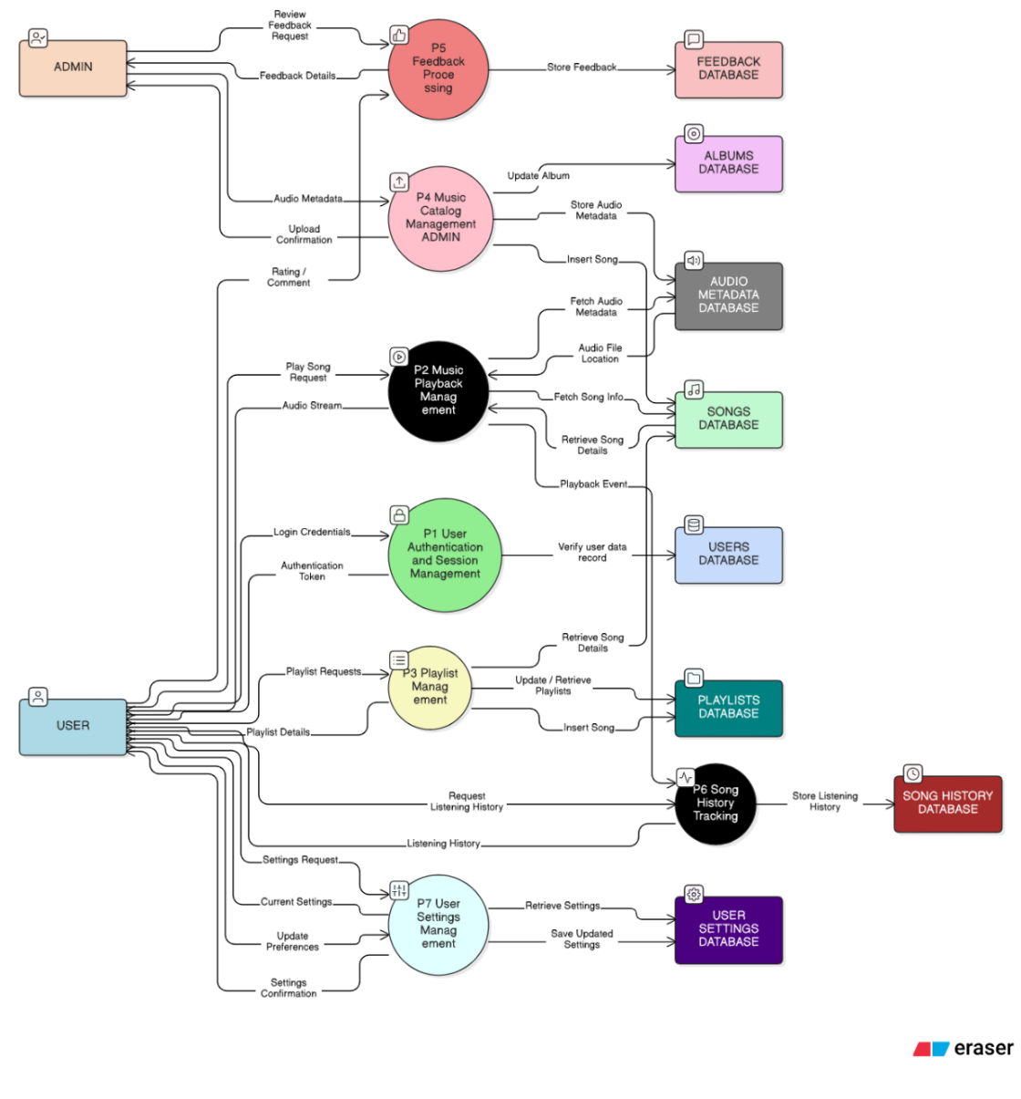

5.2 Module Descriptions

5.2.1 Authentication Module
Purpose: Handles user registration, login, and session management through secure token-based authentication.
Components:
- Auth Controller: Processes registration and login requests, validates credentials, generates JWT tokens
- Auth Middleware: Verifies JWT tokens on protected routes, extracts user information from tokens
- User Model: Defines user schema with encrypted password fields, profile information

5.2.2 Music Playback Module
Purpose: Manages audio streaming, playback controls, and queue management for seamless music listening experience.
Components:
- Audio Player Component: HTML5 audio element wrapper with custom controls, progress tracking, volume management
- Queue Manager: Maintains playback queue, handles shuffle/repeat modes, auto-advance functionality
- Song Controller: Retrieves song metadata and streaming URLs from database and Cloudinary
- Playback State Store: Zustand store managing global playback state, current song, position

5.2.3 Real-time Communication Module
Purpose: Enables real-time features including live activity tracking, instant messaging, and presence detection through WebSocket connections.
Components:
- Socket.IO Server: Manages WebSocket connections, room-based communication, event broadcasting
- Activity Feed Component: Displays friends' listening activity in real-time, updates on socket events
- Chat System: One-to-one messaging interface, message history, typing indicators
- Presence Manager: Tracks user online/offline status, broadcasts status changes

5.2.5 Administrative Module
Purpose: Provides administrative interface for content management, user administration, and system monitoring.
Components:
- Admin Dashboard: Overview interface with key metrics, quick actions, system status
- Content Manager: Upload songs and albums, edit metadata, manage artist profiles
- User Manager: View user accounts, modify roles, handle account issues
- Analytics Dashboard: User activity reports, popular content tracking, usage statistics
- File Upload Handler: Processes audio and image uploads, integrates with Cloudinary

5.3 Database Schema Design
The database schema is designed using MongoDB's document-oriented model, optimized for the application's query patterns and relationship structures.

1. User
- userId (PK)
- username
- email
- avatar
- isOnline
- membershipType
- membershipExpiry
- createdAt

2. Album
- albumId (PK)
- name
- artist
- coverImage
- createdAt

3. Song
- songId (PK)
- title
- artist
- duration
- audioUrl
- albumId (FK)
- createdAt

4. AudioMetadata
- metadataId (PK)
- songId (FK)
- bitrate
- codec
- sampleRate
- fileSize
- duration
- createdAt

5. SongHistory
- historyId (PK)
- userId (FK)
- songId (FK)
- playedAt

6. Message
- messageId (PK)
- senderId (FK → User)
- receiverId (FK → User)
- content
- timestamp

7. Theme
- themeId (PK)
- userId (FK)
- themeName
- primaryColor
- accentColor
- updatedAt

8. AppFeedback
- feedbackId (PK)
- userId (FK)
- rating
- comment
- createdAt

Database Diagram:

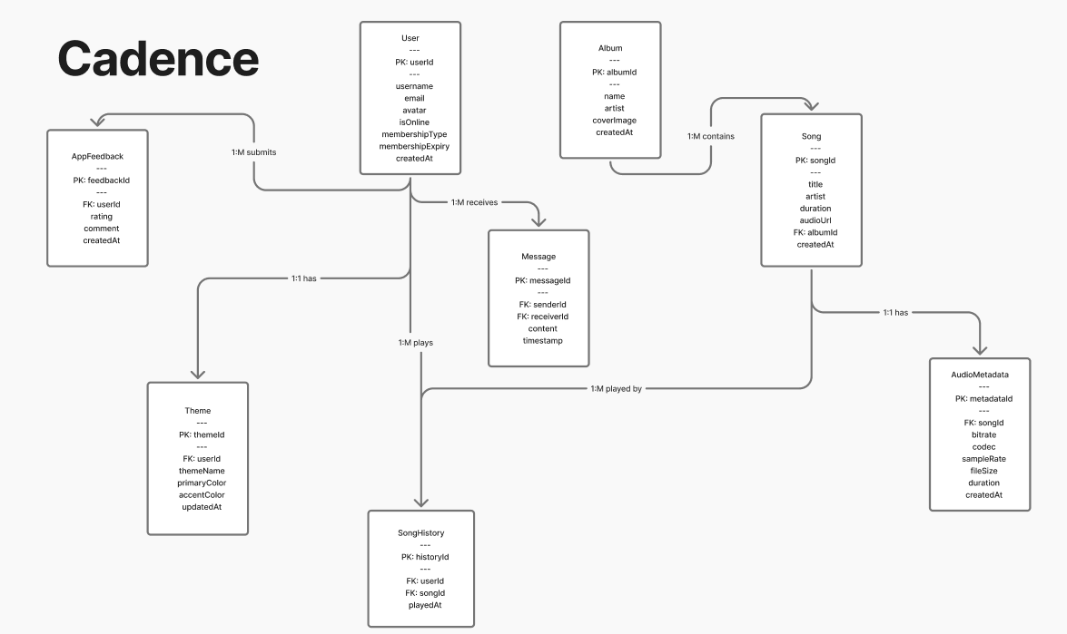

5.4 Deployment Architecture
The application employs a cloud-native deployment strategy utilizing modern platform-as-a-service providers for scalability and reliability.
Diagram Description: Create a deployment diagram showing:
- Frontend: React application deployed on Vercel with CDN distribution
- Backend: Node.js/Express server deployed on Render or Railway
- Database: MongoDB Atlas cluster with automatic backups
- Media Storage: Cloudinary for audio and image assets with global CDN
- Authentication: Clerk or custom JWT service
- Monitoring: Application performance monitoring and error tracking
Diagram:
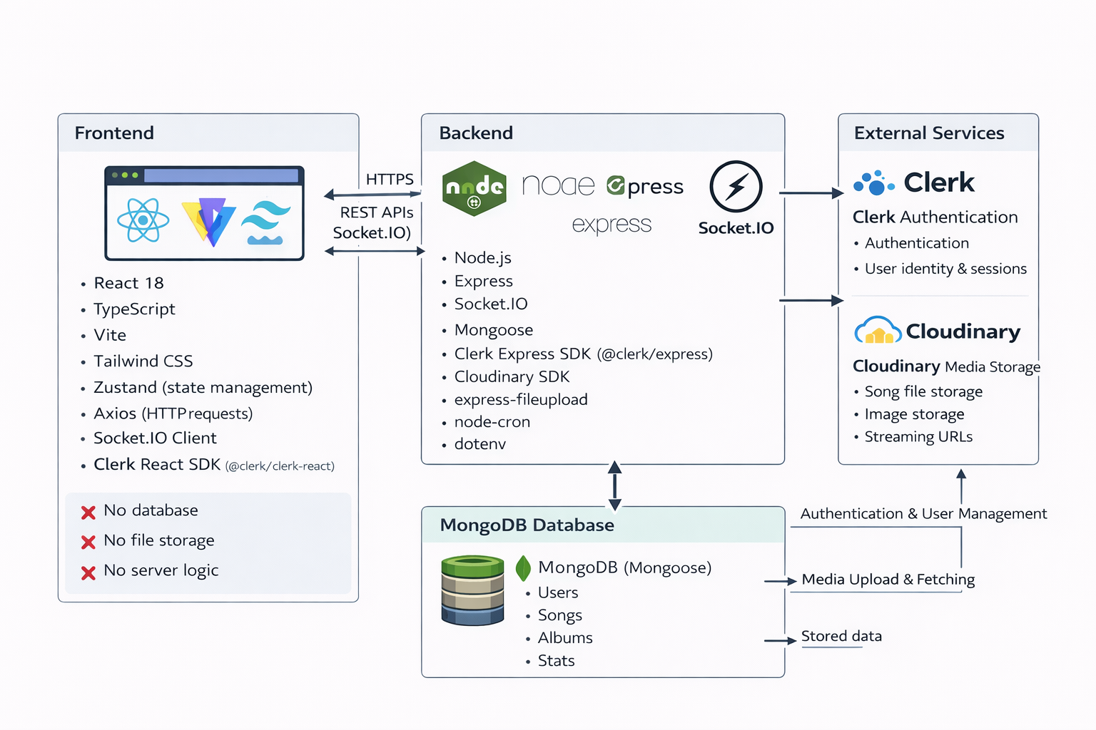

6. CONCLUSION
This Software Requirements Specification document provides a comprehensive blueprint for the development of a music streaming application. The proposed system addresses critical gaps in existing music streaming platforms by emphasizing real-time social features, seamless user experience, and modern architectural patterns.
The project leverages cutting-edge technologies including React for dynamic user interfaces, Node.js and Express for robust backend services, MongoDB for flexible data storage, and Socket.IO for real-time bidirectional communication. This technology stack ensures scalability, maintainability, and performance while keeping infrastructure costs manageable.
Key innovations of this system include integrated real-time activity feeds allowing users to see friends' listening habits instantaneously, built-in messaging capabilities for music discussion and recommendation sharing, and comprehensive playlist management with collaborative features. The administrative module provides content creators and platform managers with powerful tools for content management and user analytics.
From a technical perspective, the application demonstrates best practices in modern web development including component-based architecture, RESTful API design, token-based authentication, and cloud-native deployment strategies. The modular design facilitates future enhancements such as advanced recommendation algorithms, podcast support, and mobile native applications.
The educational value of this project extends beyond music streaming. It serves as a comprehensive learning resource for full-stack development, real-time systems, cloud integration, and modern deployment practices. Students and developers can gain practical experience with industry-standard tools and architectural patterns while building a functional, production-ready application.
Implementation of this system will benefit multiple stakeholder groups: music enthusiasts gain enhanced social listening experiences, content creators receive direct audience engagement channels, developers acquire valuable learning resources, and educational institutions obtain teaching materials for modern web development courses.
The non-functional requirements ensure the system maintains high performance standards with page load times under 3 seconds, audio streaming initiation within 2 seconds, and support for 1000+ concurrent users. Security measures including password encryption, token-based authentication, and HTTPS encryption protect user data and maintain platform integrity.
Future development opportunities include machine learning-powered recommendation systems, integration with external music services, support for podcasts and audiobooks, offline playback capabilities, and development of native mobile applications for iOS and Android platforms. The current architecture's modularity and scalability facilitate these enhancements without requiring fundamental redesign.
In conclusion, this project represents a comprehensive, modern approach to music streaming applications that balances feature richness with technical excellence. The detailed specifications provided in this document establish a clear roadmap for development, ensuring all stakeholders understand system capabilities, constraints, and implementation strategies. Successful execution of this project will result in a valuable addition to the music streaming landscape while serving educational and developmental purposes for the broader technology community.

APPENDICES

Appendix A: Glossary
- API (Application Programming Interface): Set of protocols and tools for building software applications
- CDN (Content Delivery Network): Distributed network of servers that deliver web content based on geographic location
- CRUD: Create, Read, Update, Delete operations
- JWT (JSON Web Token): Compact token format for securely transmitting information between parties
- ODM (Object Document Mapper): Programming technique for converting data between incompatible type systems
- REST (Representational State Transfer): Architectural style for designing networked applications
- Socket.IO: JavaScript library for real-time bidirectional communication
- WebSocket: Protocol providing full-duplex communication over TCP connection

Appendix B: References
- Fette, I., & Melnikov, A. (2011). The WebSocket Protocol. RFC 6455, Internet Engineering Task Force.
- Chodorow, K. (2013). MongoDB: The Definitive Guide. O'Reilly Media.
- Aggarwal, S. (2018). Modern Web Development Using ReactJS. International Journal of Recent Research Aspects, 5(1), 133-137.
- Bermudez, I., Traverso, S., Ahmed, M., & Vallina-Rodriguez, N. (2017). A First Look at Music Streaming Apps. IEEE Communications Magazine, 55(4), 132-139.
- Smith, J., & Johnson, M. (2020). Comparative Analysis of React State Management Libraries. Journal of Web Engineering, 19(5-6), 485-512.
- Express.js Documentation. (2025). Retrieved from https://expressjs.com/
- React Documentation. (2025). Retrieved from https://react.dev/
- MongoDB Documentation. (2025). Retrieved from https://www.mongodb.com/docs/
- Socket.IO Documentation. (2025). Retrieved from https://socket.io/docs/

