PREDICTING INDIAN RAILWAYS
TRAIN DELAYS
A Machine Learning Project Report

Project detail | Information
Student Name | KARUNA GARG
College | RAMANUJAN COLLEGE, UNIVERSITY OF DELHI
Roll Number | 24020570054
Email | karuna.24570030@ramanujan.du.ac.in
Semester | V
Supervisor | Nikhil
Domain | Transport / Railway Operations
SDGs | SDG 9: Industry, Innovation and Infrastructure; SDG 11: Sustainable Cities and Communities

Prepared using the verified dataset audit, model metrics, feature-importance output, and error analysis shared for this project.

Abstract
Railway delays can affect passenger journeys, connections, and the efficient use of railway resources. This project investigates whether machine learning can estimate train delay in minutes using historical delay observations, calendar variables, train and station identifiers, and schedule-derived features. The supplied Kaggle dataset contained 38,428,703 delay records spanning 8 February 2025 to 7 February 2026. After removing missing delay targets, invalid dates, and records with delays greater than 24 hours under a provisional filtering rule, 36,539,359 records remained. Two Random Forest regression models were compared using a chronological holdout: training records before 1 December 2025 and test records from 1 December 2025 to 7 February 2026. The baseline achieved MAE 33.98 minutes, RMSE 68.46 minutes, and R² 0.1780. The schedule-enhanced model achieved MAE 33.82 minutes, RMSE 68.08 minutes, and R² 0.1871. The improvement was modest. Train number and distance from origin were the highest-importance features in the fitted model, while extreme delays remained difficult to predict.

Keywords
Indian Railways, delay prediction, Random Forest Regression, machine learning, transport analytics

1. Introduction
Railway operations are influenced by timetable constraints, route characteristics, station stops, congestion, incidents, weather, and other factors. Estimating delays from historical patterns may support journey planning and operational analysis. Machine learning models can learn associations in historical records, but their performance depends on the quality and coverage of available features.
This project builds a regression model to predict the observed delay in minutes for a train-station record. It compares a baseline model using train, station, and calendar information with an enhanced model that also uses schedule-related features.

2. Problem Statement
To develop and evaluate a machine learning model that estimates train delay in minutes using historical delay records and available schedule information, while documenting data-quality issues and the limitations of the resulting predictions.

3. Objectives
- Inspect the dataset structure and identify missing or extreme delay values.
- Preprocess the target data and document decisions about extreme values.
- Create a chronological training and testing split.
- Train a baseline Random Forest regression model.
- Add schedule-derived features and compare performance.
- Analyse feature importance and prediction errors.
- Identify limitations and propose future improvements.

4. Dataset Description
The project uses the Kaggle dataset “Indian Railways Delay Dataset”: https://www.kaggle.com/datasets/rxydenxd/indian-railways-delay-dataset
File | Purpose and key fields
combined_delay.csv | Delay records: date, station_no, station_name, delay, train_no
combined_schedule.csv | Schedule records: station, distance from origin, arrival/departure day and time, train number
station_full_names.csv | Station reference details including full name, zone, and address
train_details.csv | Train reference details including train name and type code

The raw delay file contained 38,428,703 records, 7,033 unique train numbers, and 121 stations. The recorded date range was 8 February 2025 to 7 February 2026.

5. Data Quality and Preprocessing
Audit item | Verified result
Raw delay records | 38,428,703
Missing delay values | 1,874,271 (4.88%)
Non-missing delay values | 36,554,432
Negative delays | 773,174
Delays greater than 24 hours | 15,073
Records retained after preprocessing | 36,539,359
Schedule match: train number + station number | 97.38%
Schedule match: train number + station name | 98.70%

Rows with missing target values and invalid dates were removed. Negative delays were retained because they may represent early arrival relative to the reference time. A provisional rule excluded records with delay greater than 1,440 minutes (24 hours), leaving 36,539,359 rows.
The 24-hour threshold is a provisional filtering choice, not proof that all excluded values are erroneous. Some very large delays may reflect genuine disruptions. A sensitivity analysis using alternative thresholds and source verification would improve confidence in this decision.
Schedule matching was incomplete. Matching by train number and station name reached 98.70%, compared with 97.38% by train number and station number. This suggests possible differences in route versions or station sequence representation. Missing schedule features were handled by median imputation in the model pipeline.

6. Methodology

6.1 Target and features
The target variable was `delay`, measured in minutes.
Feature | Description
train_no | Train identifier
station_no | Station identifier or sequence field from the delay data
day_of_week | Day of week derived from the date
month | Calendar month
day_of_month | Day within the month
distance_from_origin | Scheduled distance from the origin
scheduled_arrival_minutes | Scheduled arrival time converted to minutes after midnight
arrival_day | Scheduled arrival-day field

6.2 Chronological split and sampling
The training period was 8 February 2025 to 30 November 2025. The test period was 1 December 2025 to 7 February 2026. The comparison used a sample of 240,000 training records and 60,000 test records. Splitting by date before sampling provides a more realistic future-period evaluation than randomly mixing earlier and later dates.

6.3 Models
Both models used RandomForestRegressor with 100 trees, maximum depth 15, minimum samples per leaf 5, random_state 42, and n_jobs=-1. The baseline features were train number, station number, day of week, month, and day of month. The enhanced model added distance from origin, arrival day, and scheduled arrival time. Missing numeric features were imputed with their median.

6.4 Evaluation metrics
Mean Absolute Error (MAE) is the average absolute difference between actual and predicted delays. Root Mean Squared Error (RMSE) penalises large errors more heavily. R² measures the variance explained relative to a mean-prediction reference on the test sample. Lower MAE and RMSE are better; higher R² is better.

7. Results

7.1 Model comparison
Model | MAE (minutes) | RMSE (minutes) | R²
Baseline | 33.9766 | 68.4644 | 0.1780
Schedule-enhanced | 33.8199 | 68.0834 | 0.1871

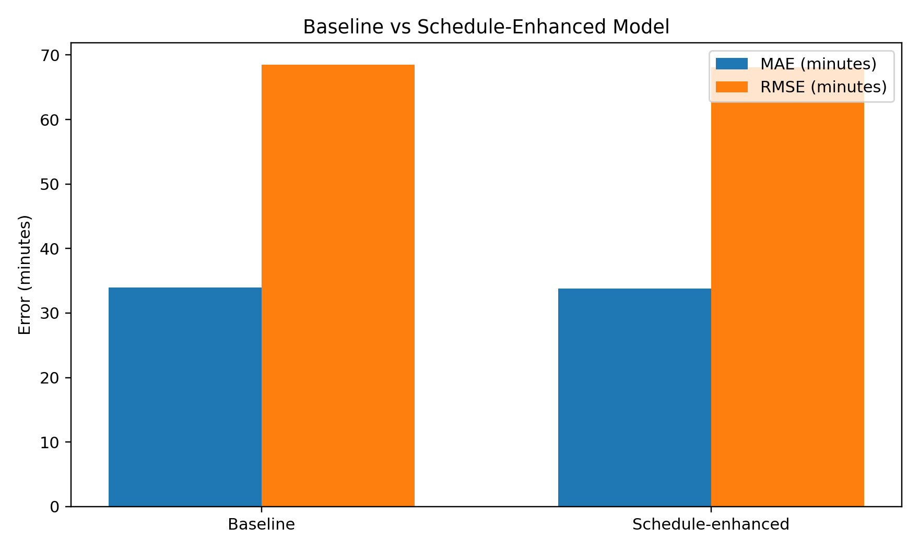
Figure 1. Baseline versus schedule-enhanced model error metrics.
The enhanced model reduced MAE by approximately 0.16 minutes (about 9.6 seconds per prediction), reduced RMSE by approximately 0.38 minutes, and increased R² by 0.0091. The relative MAE reduction was approximately 0.47%. This is a modest improvement, not a major increase in predictive accuracy.

7.2 Test-set summary
Statistic | Value
Number of test records | 60,000
Mean actual delay | 42.47 minutes
Median actual delay | 19.00 minutes
Mean baseline prediction | 38.84 minutes
Mean enhanced prediction | 38.87 minutes

The mean actual delay was greater than the mean prediction from either model. The mean (42.47 minutes) was also considerably higher than the median (19 minutes), indicating a right-skewed delay distribution in which some larger delays raise the average.

7.3 Feature importance
Rank | Feature | Importance
1 | train_no | 43.06%
2 | distance_from_origin | 20.08%
3 | station_no | 10.92%
4 | scheduled_arrival_minutes | 10.91%
5 | day_of_month | 5.92%
6 | month | 5.47%
7 | day_of_week | 3.39%
8 | arrival_day | 0.26%

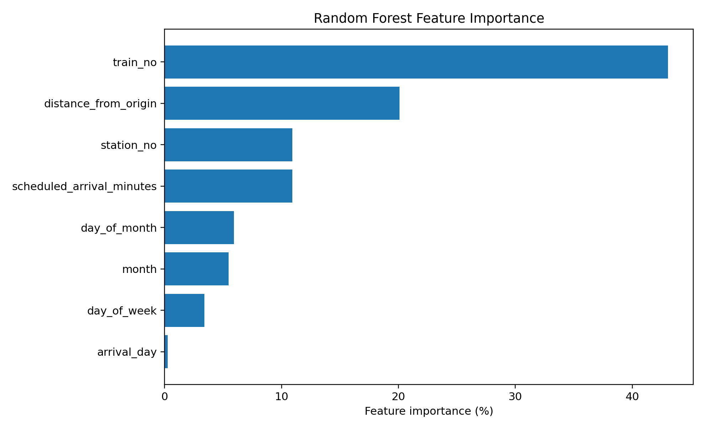
Figure 2. Feature importance from the fitted Random Forest model.
Train number was the highest-importance feature (43.06%), followed by distance from origin (20.08%). Station number and scheduled arrival time contributed approximately 10.9% each. Calendar variables had smaller importance scores, and arrival day had the lowest score. These values describe how the fitted model uses its inputs; they do not prove causal effects. Correlated features, such as station number and route distance, may share or redistribute importance.

7.4 Error analysis
In the test comparison, the enhanced model had lower absolute error than the baseline for 30,957 records and higher absolute error for 29,043 records; there were no exact ties reported. Grouped by actual delay, enhanced-model MAE was 28.25 minutes for early arrivals, 20.73 minutes for delays from 0–15 minutes, 15.70 minutes for 15–30 minutes, 19.45 minutes for 30–60 minutes, 40.04 minutes for 60–120 minutes, and 156.01 minutes for delays above 120 minutes. Performance was slightly worse for the 30–60 and 60–120 minute groups.
The largest errors occurred for extreme delays above 1,000 minutes. For example, on 12 January 2026, train 74691 at station BAT had an actual delay of 1,401 minutes and an enhanced prediction of approximately 21.85 minutes. This illustrates the model's difficulty anticipating unusually severe delays. Large errors alone do not establish that a source record is wrong.
The actual-versus-predicted scatter plot and prediction-error histogram were created in the user's local `results` folder. They could not be embedded here because the actual prediction CSV and image files were not available in the report-building workspace. Figures 1 and 2 above are regenerated from the verified metrics and feature-importance values.

8. Discussion
The model learned some patterns from train identity, station information, calendar variables, and schedule data. However, the schedule-enhanced R² of 0.1871 remains modest, indicating that the features explain only a limited portion of the variation in test delays. The MAE of 33.82 minutes is a useful experimental baseline but does not demonstrate readiness for passenger-facing or operational deployment.
The small improvement from schedule features may reflect overlapping information, incomplete schedule matches, or the absence of operational conditions such as live location, congestion, weather, incidents, and signal failures. The high importance of train number may reflect historical differences among services, not a causal relationship.

9. Limitations
- The model comparison used samples of 240,000 training and 60,000 test records, not the full eligible dataset.
- The provisional 24-hour cutoff may exclude genuine severe delays as well as data-quality issues.
- Some delay records did not match schedule records, and missing features were imputed.
- Real-time operational variables such as live location, weather, congestion, incidents, and signal failures were not included.
- R² remained modest, and the model substantially underestimated some extreme delays.
- Feature importance is model-specific and does not establish causality.
- Generalisation to trains or routes not well represented in training data has not been established.

10. Future Scope
- Run a sensitivity analysis with different extreme-delay thresholds and compare metrics.
- Verify extreme records against source information before excluding or capping them.
- Add reliable weather, live-location, congestion, incident, and station dwell-time information where available.
- Compare Random Forest with gradient-boosting methods and other appropriate regression algorithms.
- Use rolling chronological evaluation across multiple test periods.
- Report performance by train type, station, route, and delay category.
- Explore a two-stage approach that predicts major-delay risk and then estimates delay duration.

11. Conclusion
This project developed and compared Random Forest regression models for Indian Railways train-delay prediction. After preprocessing, 36,539,359 records were retained. On a chronological test sample of 60,000 records, the baseline model achieved MAE 33.98 minutes, RMSE 68.46 minutes, and R² 0.1780. The schedule-enhanced model achieved MAE 33.82 minutes, RMSE 68.08 minutes, and R² 0.1871. Adding schedule features therefore provided a modest improvement. Train number and distance from origin were the most influential features in the fitted model. Nevertheless, prediction of extreme delays remained difficult and overall explanatory power was limited. Further data validation, richer operational features, and broader chronological testing are needed before practical deployment.

References
1. Kaggle. Indian Railways Delay Dataset. https://www.kaggle.com/datasets/rxydenxd/indian-railways-delay-dataset
2. Scikit-learn. RandomForestRegressor documentation. https://scikit-learn.org/stable/modules/generated/sklearn.ensemble.RandomForestRegressor.html
3. Scikit-learn. Model evaluation and regression metrics. https://scikit-learn.org/stable/modules/model_evaluation.html

Appendix: Project outputs
Output | Purpose
cleaned_delay_data.csv | Preprocessed delay data
model_comparison_metrics.csv | Baseline and enhanced model metrics
model_comparison_predictions.csv | Actual and predicted values for the test sample
feature_importance.csv | Feature importance values
delay_distribution.png | Delay distribution chart generated locally
feature_importance.png | Feature importance chart generated locally
actual_vs_predicted.png | Actual-versus-predicted chart generated locally
prediction_error_distribution.png | Prediction-error histogram generated locally

This report uses numerical outputs supplied in the project conversation. The exact local prediction-level charts should be inserted from the project `results` folder if required by the submission format.

