**Three things that yahoo search engine can do that google cannot.**

1. **Get Lyrics of any song or your favorite artist.**

Type **madonna lyrics** (for lyrics of Madonna songs) or **madonna material girl lyrics** (for lyrics of a particular song)

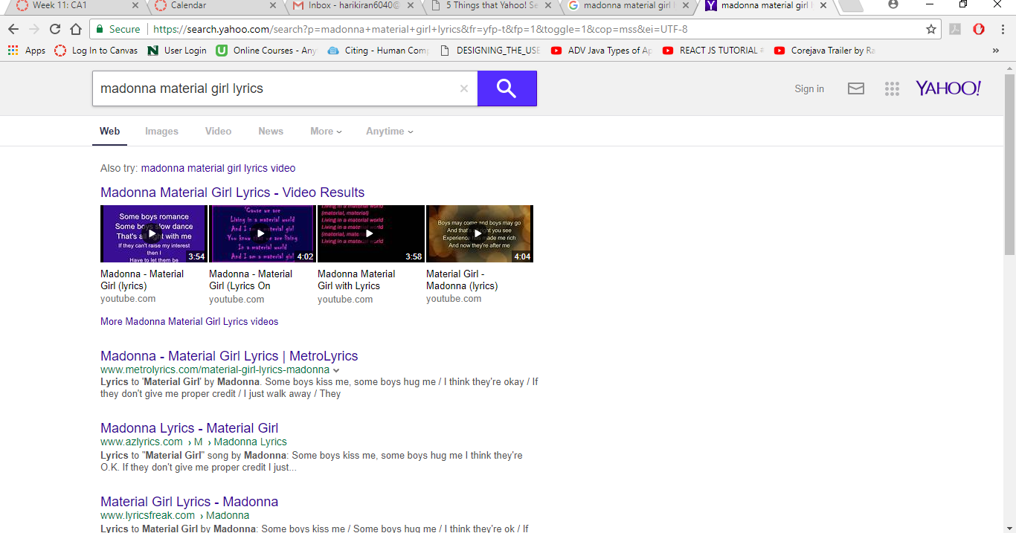

1. **Specifiy the order of search keywords in queries**

Say you want only web pages where word x comes before y but not vice versa, then just put the search query in Square Brackets. An example: **[Sylvester Stallone]** – will only return web pages where the word Sylvester appear before Stallone.

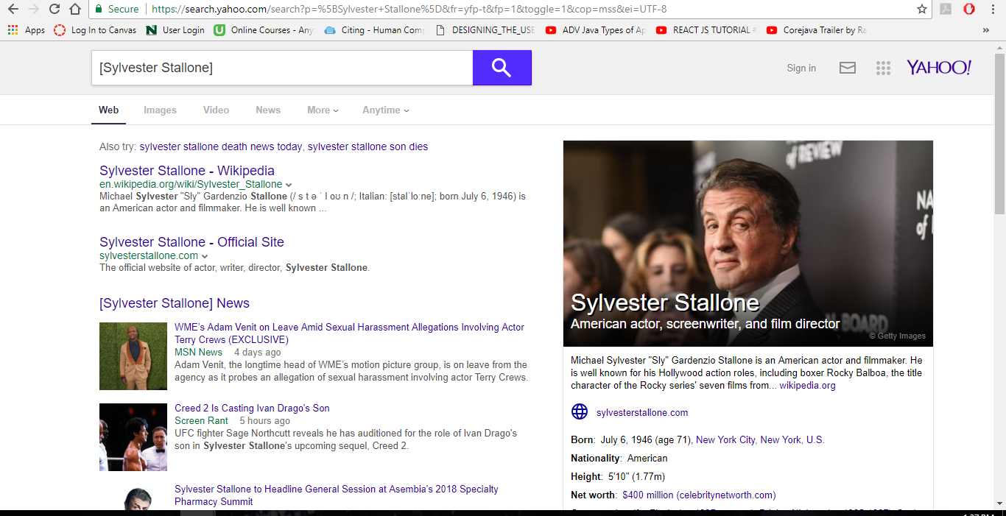

1. **Search your favorite websites from Yahoo! itself.**

For instance, type **!wiki google** in Yahoo! search box to search Google in Wikipedia.com. Other popular shortcuts are **!ebay, !amazon, and !flickr**. You can also execute these from the [Firefox search box](http://labnol.blogspot.com/2006/03/firefox-search-bar-hacks.html) without changing the default search engine.

