**Development of page of** <https://www.nwmissouri.edu/graduate/index.htm>  **using Angular JS**

Our team “Disenadores” as part of second workshop has developed this application. It has been constructed using Angular JS, which is one of the front-end application development framework.

**Screenshots displaying the webpage:**

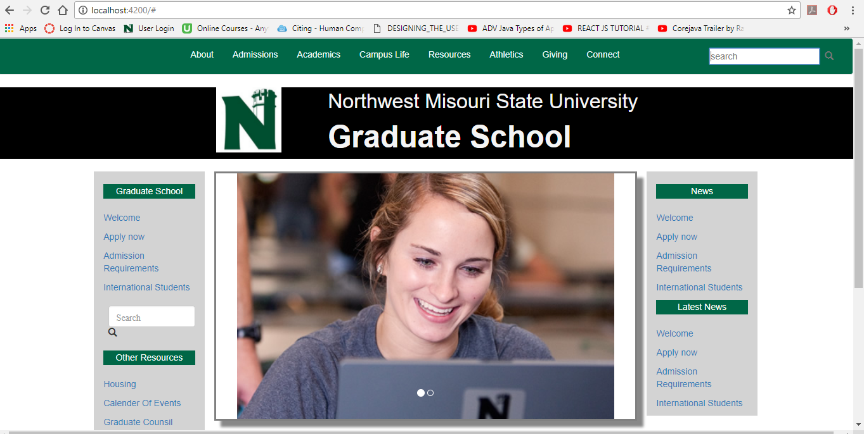

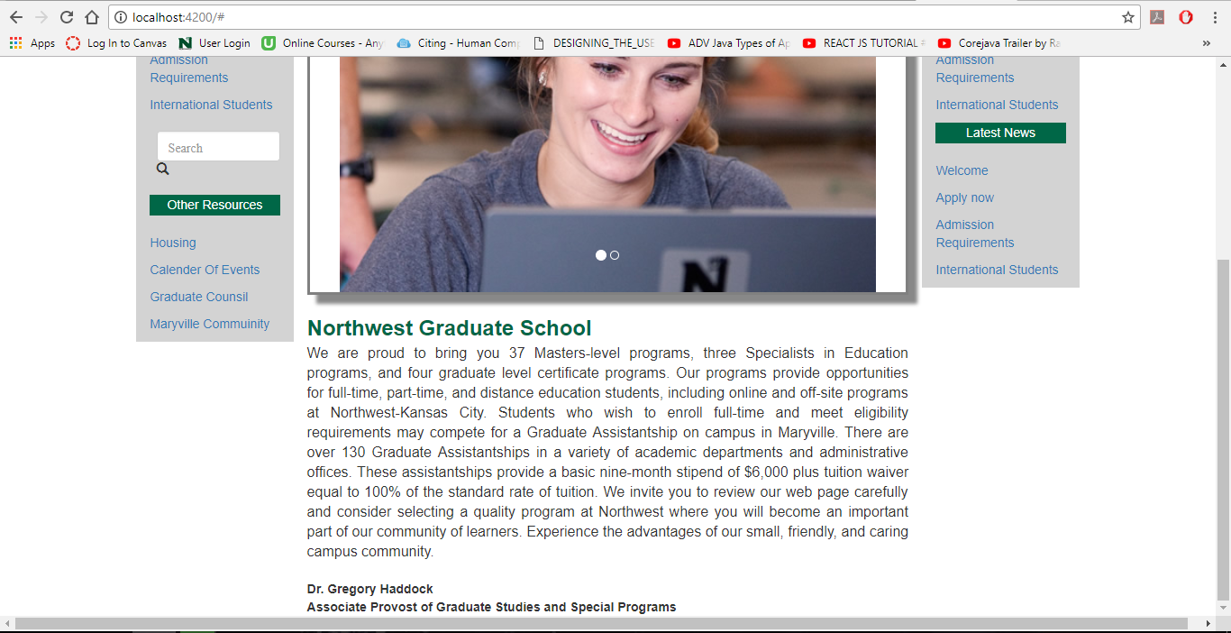

**Contribution of our Team members:**

**Bharadwaj Ambati:** Initiated the application by creating a normal page and have developed the header toggle bar for the page.

**Abhinav Ekka:** Introduced and explained the framework Angular JS to our team members. Also took part in the development process by adding search bar and other components such as “Graduate School” and “Other Resources”.

**Hari Kiran Akunuri:** Dealt with the components like, “News”, and “Latest News” .In addition he has collaborated the CSS of all components for a perfect single page application.

**Karuna Reddy Gangidi:** Added image views and introduction about the “Graduate School”. Have also worked on the presentation.

**Jagadeesh Gudavalli:** Worked on the document by gathering work from every team member and worked for some part of presentation.