NUTRI FIT: DIET RECOMMENDATION SYSTEM USING AI

KANITHA.S. A  
 Department of Information Technology  
 Sri Sivasubramaniya Nadar College of Engineering  
 Tamil Nadukanitha2110808@ssn.edu.in

RADHA N   
 Department of Information Technology  
 Sri Sivasubramaniya Nadar College of Engineering  
Tamil Nadu  
 [radhan@ssn.edu.in](mailto:radhan@ssn.edu.in)

KARTHICK.V  
 Department of Information Technology  
 Sri Sivasubramaniya Nadar

College of Engineering  
 Tamil Nadu[karthick2110566@ssn.edu.in](mailto:karthick2110566@ssn.edu.in)

SWATHIKA R   
 Department of Information Technology  
 Sri Sivasubramaniya Nadar College of Engineering  
Tamil Nadu  
 [swathikar@ssn.edu.in](mailto:swathikar@ssn.edu.in)

KARUNAGARAN.R  
 Department of Information Technology  
 Sri Sivasubramaniya Nadar College of Engineering  
 Tamil NaduKaruna2110596@ssn.edu.in

**Abstract—** This paper introduces NutriFit, an advanced Diet Recommendation System powered by artificial intelligence for personalized weight management. Enriched with fuzzy-logic algorithms within a knowledge-based system, NutriFit aims to provide precise strategies for weight loss. The user-centric design features dedicated "eat" and "fit" pages, aligning food recommendations and exercise routines with individual diet plans. The core modules, including User Input, Fuzzy Logic Algorithm, Diet Plan Generation, Workout Recommendation, Nutrition and Diet Management, Workout Plan Management, and Recipe and Steps Details, form the foundation of NutriFit. The primary objective is to establish a seamless and user-friendly web interface with accurate fuzzy logic processing and adaptable modifications. Beyond weight loss, NutriFit aspires to serve as a comprehensive lifestyle guide, promoting a healthy and balanced life through personalized nutrition and fitness guidance. Deliverables encompass a fully functional web application, integration of fuzzy logic algorithms, a knowledge-based system, dynamic meal and workout recommendations, detailed recipe suggestions and a responsive UI.

**I. Introduction**

In today's fast-paced lifestyle, characterized by limited time for health prioritization, individuals face challenges such as inadequate nutrition and a lack of structured workout routines. Recognizing the paramount importance of health and wellness, there is a growing need for a comprehensive diet and workout recommendation application. Addressing this need, the presented design employs a knowledge-based system with fuzzy-logic algorithms to offer personalized weight loss strategies. Fuzzy logic, chosen for its adaptability in handling imprecise information, forms the backbone of the system’s processing capabilities. By integrating user input and employing fuzzy logic algorithms, the system tailors diet and workout plans with precise validation, accurately assessing each individual's current state.

A key focus of the design is to provide a weight-loss plan tailored for the obese category, featuring a dynamic diet regimen with three different types of daily eating (low, moderate, and high car) aligned with the user's specific requirements. Complementing this, the workout plan incorporates a mix of cardio and gym exercises tailored to optimize weight loss based on the individual's state. The system further enhances user engagement with dedicated pages for recommended foods ("Nutrition" page) and personalized exercise routines ("Workout" page), ensuring precision in performing the recommended exercises.

This innovative system goes beyond conventional weight loss applications by introducing a dynamic and personalized approach to diet and workout recommendations. The core philosophy revolves around tailoring plans according to individual height, weight, and fitness levels, acknowledging the uniqueness of each user's health journey. With a focus on adaptability and precision, the fuzzy-logic algorithm plays a pivotal role in determining personalized weight loss strategies, ensuring that users receive recommendations aligned with their specific requirements and conditions.

As the system integrates seamlessly into users' lives, it becomes a reliable companion in their pursuit of a healthier lifestyle. Through an intuitive user interface and a database rich in diverse meals, recipes, and workout details, the application empowers users to make informed decisions about their health. The responsive UI allows for dynamic modifications, triggering automatic updates to diet and workout plans, providing users with an interactive and engaging experience.

In the subsequent sections, we delve into the key features of the system, the methodology behind its development, and the validation of its effectiveness. The integration of fuzzy logic, database management, responsive UI, and visual representation collectively positions this system as a pioneering tool in the realm of personalized health and weight management. Through this innovative approach, we aim to empower individuals to take control of their well-being, fostering a healthier and more balanced lifestyle in the face of the challenges posed by modern living.

**II. Related Works**

The comprehensive literature survey begins with a thorough examination of existing AI-based health applications, covering those specifically designed for physical activity monitoring, exercise, and diet recommendations. Pivotal studies such as [1] employs fuzzy logic modeling for the optimization of nutritional requirements, specifically in the context of menu planning for Croatian boarding schools catering to students aged 14 to 19. Fuzzy logic is applied due to its suitability for systems, like human nutrient requirements, that cannot be precisely defined. The study uses fuzzy membership functions to describe nutrient intake ranges and establishes 23 fuzzy sets, including those for menu cost, meal preference, and amounts of energy and nutrients. A computer program in Wolfram Research Mathematica is developed for modeling and optimizing nutrient and energy intake.

Moreover, the exploration extends to research such as [2]**,** growing awareness of health and the impact of seasonal variations on the human body. It emphasizes the concept of "Prakriti," a type of energy that influences an individual's physical and mental well-being. The paper proposes a method to recommend personalized diets based on a person's Prakriti and the current season. Data is gathered from various websites where dieticians recommend plans for different Prakritis. The proposed method utilizes Fuzzy Logic to handle uncertainty, and an Ontology is integrated with fuzzy logic to represent food knowledge. The results demonstrate the efficiency and accuracy of diet recommendations using fuzzy logic.

In[3], It Explores the use of technology, specifically text messaging, as a means to enhance meal planning and dietary intake in response to the increasing prevalence of obesity in the United States. The study focuses on the effectiveness of sending weekly nudges via a Facebook group to encourage individuals to plan and prepare meals at home rather than opting for fast food. The findings suggest that sending weekly nudges with specific dietary goals significantly impacts meal planning, leading to improved dietary intake. The results have implications not only for promoting healthier lifestyles but also for addressing motivation and needs in situations such as weight loss. Key terms include text messaging, nudges, meal planning, and dietary intake.

In [4], The proposes a diet planning application that utilizes a sophisticated algorithm to create personalized diet plans based on user information such as height, weight, age, gender, and activity level. Emphasizing the importance of a balanced diet for overall health, the paper highlights the role of nutrient-dense foods in maintaining good nutritional status and reducing the risk of illness. Unlike existing food recommender systems, the focus here is on creating meal plans that align with macronutrient recommendations, aiming to address a gap in the field of dietetics and nutrition. The research suggests the development of a tailored meal-planning program to meet individual user requirements.

In [5], It introduces an innovative system at the intersection of health, fitness, and technology. It utilizes the Mediapipe Pose Estimation Model for body movement tracking, ensuring proper exercise execution. The system counts repetitions, provides audio instructions for correct form, and integrates user-specific data for personalized guidance, including monitoring calorie intake. The holistic approach combines exercise tracking, guidance, and dietary advice, offering a comprehensive tool for individuals aiming to maintain a healthy lifestyle.

In[6], "Plan-Cook-Eat," a web-based meal planner app, employs a parallel-iterative design method and undergoes validation by six Registered Nutritionists-Dietitians and testing by 24 users. The study reveals the app's efficacy in tailoring personalized diet plans to meet individual macronutrient needs. User feedback highlights the app's potential, with suggestions for technical enhancements, positioning it as a promising virtual nutrition assistant that ensures optimal macronutrient consumption.

In [7], the paper addresses the demand for personalized nutrition solutions in urban lifestyles by proposing a tailored meal recommendation system. It identifies the shortcomings of generic meal planning apps and introduces a system that learns users' preferences, aligns with nutritional guidelines, and helps achieve fitness goals. The paper details the system's design, implementation, architecture, and evaluation, providing a comprehensive solution for maintaining physical fitness in busy urban environments.

The literature survey examines AI-based health applications, laying the groundwork for a comprehensive personalized health app. [1] and [2] focus on fuzzy logic for nutritional optimization, [3] explores text messaging for healthier meal planning, and [4] proposes an advanced algorithm for personalized diet plans. Furthermore, [5] integrates the Mediapipe Pose Estimation Model for precise exercise tracking, [6] showcases a web-based meal planner's efficacy, and [7] proposes a personalized meal recommendation system for urban lifestyles. These studies collectively inform the development of a knowledge-based system, addressing challenges in nutrition and exercise for a modern, fast-paced lifestyle.

These Related Works findings collectively inform the development of a knowledge-based system with fuzzy logic algorithms, addressing challenges related to poor nutrition and inconsistent workout routines. The resulting software seamlessly incorporates user input, applies fuzzy logic processing, and crafts personalized diet and workout plans for weight loss. The dynamic diet regimen and customized exercise routines cater to individual needs, providing a user-centric approach for achieving and maintaining a healthy and balanced life in the fast-paced modern world.

**III. Methodology**

The primary aim is to facilitate weight loss plan recommendation using the advanced technologies and AI-algorithm. The diet and workout recommendation model is designed to implement dynamic plan generation according to the requirements. For the different combinations of height and weight and fitness level of the individual the algorithm determines the body type approximately and helps to give personalized weight loss plans. This approach aligns with the goal of employing cutting-edge technology for dynamic plan generation.

**A. Dataset**

The SQLite database file used in this Application has a Diverse collection of meals, recipes and workouts.

The Database encompasses a total of over 500 meal and recipes and over hundreds of workouts and their Demonstration videos. This diverse data about Diet and Workout further enriches the Application aligning with the goal of Generating Tailored diet plan and workout plan.

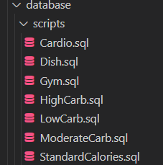

**B. Workflow**

The workflow involves seamless navigation through pages for dish and exercise searches, enabling dynamic input modification triggering automatic plan updates, and displaying comprehensive details for chosen items (dishes and exercises) while maintaining persistent input across pages for an interactive and responsive user experience.

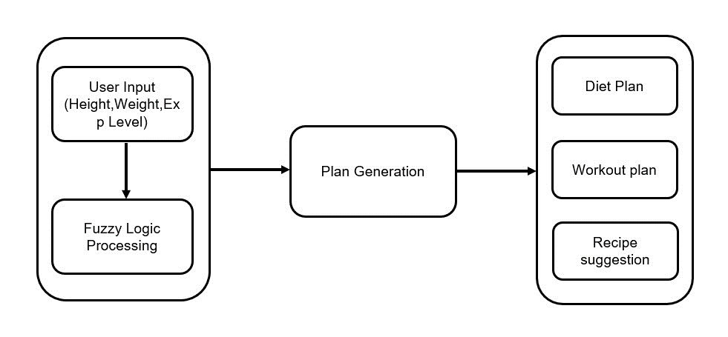

**C. Fuzzy logic Algorithm**

Fuzzy logic enables handling uncertainty by employing

linguistic variables and approximate reasoning in decision-making processes. The utilization of a fuzzy algorithm in plan generation involves leveraging its inherent flexibility to account for uncertainties or imprecise inputs, allowing for adaptable and nuanced decision-making. In the context of plan generation, fuzzy logic enables the creation of personalized plans by considering varying factors or conditions. This algorithm facilitates the formulation of plans tailored to individual needs, such as diet plans, workout routines, or financial strategies, by accommodating imprecise data and preferences. Additionally, in various contexts beyond plan generation, fuzzy logic finds application in control systems, pattern recognition, artificial intelligence, and decision-making processes where the handling of uncertain or ambiguous information is crucial for effective analysis and action. Its ability to handle vague or incomplete information makes it a valuable tool for devising strategies, optimizing systems, and making informed decisions across diverse domains.

**Initialization**

The algorithm defines membership functions for height and weight, dividing them into fuzzy sets (like short, average, tall, light, average weight, heavy) based on certain thresholds.

**Fuzzification of heights and weights**

Membership values for each fuzzy set are determined based on the input values (height and weight). These membership values indicate the degree to which the input belongs to each fuzzy set.

Fuzzification of Height:

For Male:

Short :

Membership_value[0]=1

Medium:

membership_value[0]=1−2×height−320/15,

membership_value[1]=2×height−320/15  
Tall:

membership_value[1]=1−2×height−335/15​,

membership_value[2]=2×height−335/15

Very Tall:

membership_value[2]=1 if height ≥175

For female:

Short:

membership_value[0]=1

Medium:

membership_value[0]=1−2×height−300/15

membership_value[1]=2×height−300/15

Tall:

membership_value[1]=1−2×height−315/15​,

membership_value[2]=2×height−315/15​

Very Tall:

membership_value[2]=1 if height ≥165.

Fuzzification of Weight:

For Male:

Light:

membership_value[0]=1

Medium:

membership_value[0]=1−2×weight−100/20,

membership_value[1]=2×weight−100/20

Heavy:

membership_value[1]=1−2×weight−120/20

membership_value[2]=2×weight−120/20

Very Heavy:

membership_value[2]=1 if weight ≥70

For Female:

Light:

membership_value[0]=1

Medium:

membership_value[0]=1−2×weight−90/10,

membership_value[1]=2×weight−90/10

Heavy:

membership_value[1]=1−2×weight−100/10

membership_value[2]=2×weight−100/10

Very Heavy:

membership_value[2]=1 if weight ≥55

**Fuzzy Interface**

Each value in the table represents the index of the resulting body type category after combining membership values from height and weight fuzzification. For instance: These rules are stored in FUZZY_RULES_TABLE.

|  |  |  |
| --- | --- | --- |
| Body Type Category Index | Weight Fuzzy Set Index | Height Fuzzy Set Index |
| 1 | 0 | 0 |
| 2 | 1 | 1 |
| 4 | 3 | 2 |

[1, 0, 0]: Indicates the influence of membership values for different body types based on fuzzy sets of weight and height. Here, the first row suggests that for the first category of body types, the primary contribution comes from the first fuzzy set of weight (0) and the first fuzzy set of height (0).[2,1,1]: Specifies the combination of fuzzy sets contributing to the second category of body types. In the second row, the second category's determination involves a combination of the second fuzzy set of weight (1) and a blend of the first and second fuzzy sets of height (0 and 1). The third row indicates that the third category's membership value is primarily influenced by the third fuzzy set of weight (2) and a blend of the first and third fuzzy sets of height (0 and 2).

**Membership values Table**

The membership values table captures the compatibility between height and weight memberships, derived from fuzzification. Guided by the FUZZY_RULES_TABLE, which outlines how these memberships should combine, the algorithm computes resulting memberships for decision variables. These computations, based on predefined rules, synthesize the memberships from height and weight.

In this table, rows correspond to weight fuzzy sets, and columns correspond to height fuzzy sets, reflecting how a particular height and weight combination belongs to different fuzzy set.

Let us see membership function calculation For 160<= height < 167.5.

P1=152xheight-320/15

P0=1-P1

Membership values=[P0,P1]

**Membership Values Table:**

|  |  |  |  |
| --- | --- | --- | --- |
| Height /  Weight | Height Fuzzy Set 0 | Height Fuzzy Set 1 | Height Fuzzy Set 2 |
| Weight Fuzzy Set 0 | 0 | 0 | 0 |
| Weight Fuzzy Set 1 | 0 | 0 | 0 |
| Weight Fuzzy Set 2 | 0.2 | 0.8 | 0 |

The non-zero values present for the weight fuzzy set 2 and height fuzzy set 1 (0.8) and weight fuzzy set 2 and height fuzzy set 0 (0.2). This indicates that in this system, particular weight and height combinations belong significantly to these fuzzy sets and less or not at all to others. This information contributes to the decision-making process in the Fuzzy Logic system

**Defuzzification**

Fuzzified decisions are made by iterating the rules defined in the fuzzy_rules_table. For each rule, it computes the maximum value between the current membership value in **membership_values_table** and the existing value in **fuzzified decision.**

**Fuzzified Decision:**

|  |  |  |  |  |
| --- | --- | --- | --- | --- |
| Body Type 0 | Body Type 1 | Body Type 2 | Body Type 3 | Body Type 4 |
| 0 | 0 | 0 | 0.8 | 0.2 |

Each column in this matrix represents a different body type or a decision. The values in each column indicate the membership or confidence level associated with that specific body type based on the fuzzy inference. For the given Fuzzified Decision matrix, the fourth body type (Index 3) likely represents the final decision on the body type, as it has a higher membership value (0.8) compared to the fifth body type

**Final decision on body type**

Finally, the algorithm selects the maximum value from the fuzzified decisions as the final decision on the body type. The index of this maximum value corresponds to a specific body type in the decision-making process.

**Final Decision on Body :3**

**Integration and usage**

The integration and usage of the fuzzy logic algorithm in the system involve determining the body state based on height and weight inputs and providing personalized diet plans from the database containing hundreds of dishes and workout details according to the body type.

**Validation and testing**

Conducting Testing with various inputs for the heights and weights to validate the algorithms efficiency for decision making.

This Fuzzy Logic approach effectively categorizes users into specific body types and provides tailored dietary guidance for effective weight management.

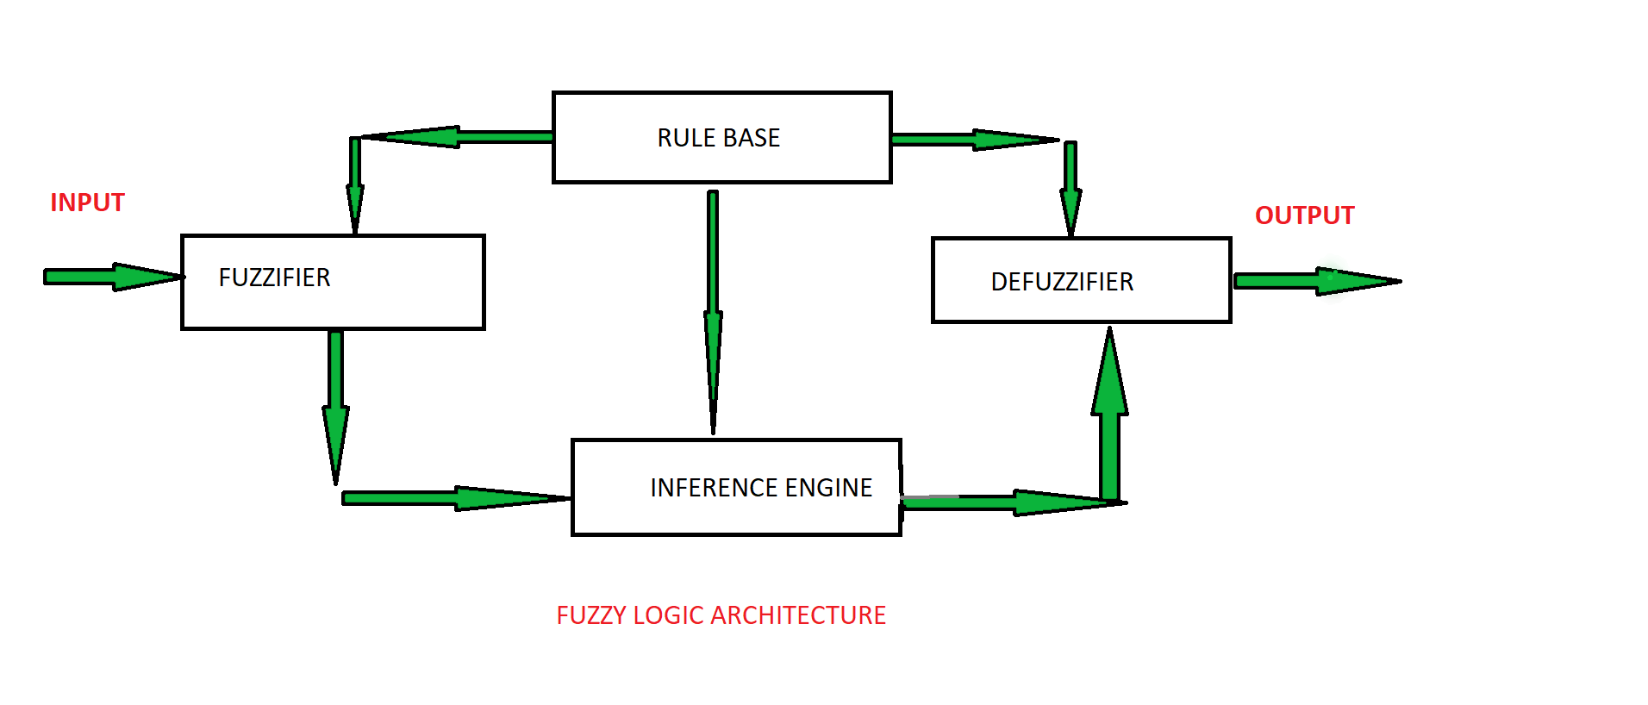

**IV. Result and discussion**

Our testing with different user inputs for height and weight confirms that the fuzzy-logic system is effective in accurately figuring out a user's body type. The personalized weight-loss plans, which include different diet days and optimized workouts, show that the app can adapt to different user needs. The "Nutrition" and "Workout" pages provide detailed information on recommended foods and clear exercise instructions, enhancing the user experience. The app's ability to handle uncertainty with fuzzy logic contributes to reliable results for users looking for personalized health advice. The Fig shows its dynamic modifications, comprehensive information on nutrition and exercises, and a seamless user interface, offering an engaging and efficient fitness experience. The Fig shows that the diet emphasizes carb cycling with specific nutritional details for each phase, while the workout plan integrates cardio and gym exercises targeting upper and lower body strength. The figure outlines a sample day for each diet phase, providing clarity on meals. This holistic approach ensures a structured and adaptable strategy for users.

Top of Form

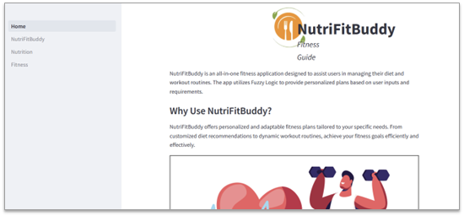

Fig.1

The Fig.1 represents the home page of this website describing various features of this User-Friendly Web application.

Fig.2

In Fig.2 the breakdown of the diet plan emphasizes the strategic distribution of carbohydrate intake across different days to facilitate weight reduction. The plan structures the week into three distinctive types of eating days: Low Carb, Moderate Carb, and High Carb. Each category represents a specific range of carbohydrate intake relative to the total energy consumed. Low Carb Days, constituting 3 days per week, involve a diet comprising less than 26% of the total energy intake from carbohydrates. Moderate Carb Days, allocated for 3 days a week, encompass a carbohydrate intake ranging between 26% and 45% of the total energy intake. Lastly, the plan designates 1 day per week for High Carb Days, where the carbohydrate intake surpasses 45% of the total energy intake.

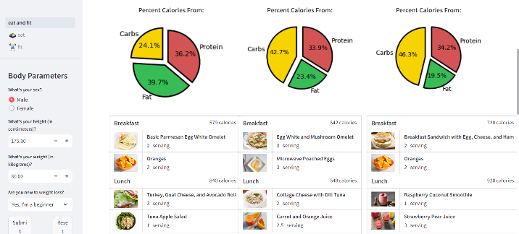

Fig.3

The Fig.3 represents the flowchart for the Distribution of macronutrients for the given Diet plans for three different days. It further suggests Dishes to follow the diet plan with ease. The dishes are suggested as Meal plan for 3 different days where the dishes information is retrieved from the database using the Decision made in the fuzzy logic.

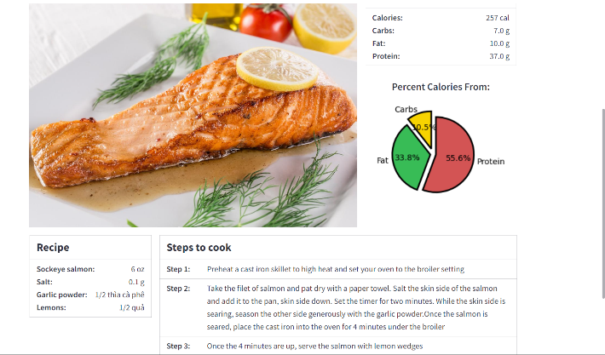

Fig.4

The Fig.4 shows that it is offering both nutritional information and a step-by-step recipe. Users can quickly assess the calorie content, macronutrient distribution, and the percentage of calories from different sources. The accompanying recipe includes simple steps and ingredients, facilitating easy preparation.

In discussing the app's features, it's important to highlight its holistic approach. By considering both diet and exercise, the app recognizes the connection between nutrition and physical activity in effective weight loss. The variety of diet days in the plan allows users to choose a plan that suits their preferences, while the mix of cardio and gym exercises ensures a well-rounded fitness routine, promoting long-term health benefits.

**V.Conclusion**

In wrapping up, our health and wellness system, which uses a smart Nutrifit system with fuzzy logic, looks promising for dealing with the health challenges of our busy lives. The personalized weight-loss plans it provides, including customized diets and workouts, could make a significant impact on individual health. The fuzzy logic we've integrated helps the app make smart and personalized suggestions based on user inputs. In a world where we often put health on the back burner, this app offers a valuable tool to help people take charge of their well-being.

##### 

##### **References**

[1] jasenka gajdoš kljusurić*, želimir kurtanjek(2012). Fuzzy logic modeling in nutrition planning -Application on meals in boarding schools 36(3), 1453–1464.

[2] shital v. chavan; s. s. sambare; aniruddha joshi;Diet recommendation based on Prakriti and season using Fuzzy ontology and Type-2 Fuzzy Logic(2016)

[3]Alexa Lauren Kuziel- The Utilization of technology as an approach to improve meal planning and dietary intake improve meal planning and dietary intake (2019)-10.13023.

[4], Shraddha Mithbavkar;-Diet Planner Using Deep Learning (2023)E2104

[5], Gourangi Taware; Reena Kharat; Pratik Dhende; Prathamesh Jondhalekar; Rohit Agrawal. (2016) “AI-Based Workout Assistant and Fitness Guide”

[6] Plan-Cook-Eat: A Meal Planner App with Optimal Macronutrient Distribution of Calories Based on Personal Total Daily Energy Expenditure-Manuel B. Garcia-2019

[7]chamodi.lokuge;gamage.upeksha,ganegoda: Implementation of a personalized and healthy meal recommender system in aid to achieve user fitness goals-2021

[8] Effects of a Personalized Fitness Recommender System Using Gamification and Continuous Player Modeling: System Design and Long-Term Validation Study by Katherine

[9] Rashidi, P., & Mihailidis, A. (2013). A Survey on Ambient-Assisted Living Tools for Older Adults. IEEE Journal of Biomedical and Health Informatics, 17(3), 579–590.

[10] Exercise recommendation based on knowledge concept prediction by Zhengyang Wu , Ming Li , Yong Tang, Qingyu Liang

[11]Megan C. Kelley;The Impact of Fitness Technology on Health Outcomes-2014

[12]Amaryllis Mavragani,Liz Quintana, Anne-Sophie,Brazeau, and Yuen Ling Leung; Personalized Flexible Meal Planning for Individuals With Diet-Related Health Concerns: System Design and Feasibility Validation Study-2023

[13]Thomas Pikes,Robert Adams;Computational Nutrition: An Algorithm to Generate a Diet Plan to Meet Specific Nutritional Requirements Meet Specific Nutritional Requirements-2016

[14], AI-Driven Meal Planning in the FoodTech Industry -Victor M˚artensson,Master’s thesis-2021:E24

[15], j. bulka; a. izworski; j. koleszynska; j. lis; i. wochlik

Automatic meal planning using artificial intelligence algorithms in computer aided diabetes therapy (2009) 978-1-4244-2712-3.