BLOCKCHAIN IN AGRICULTURAL

SUPPLY CHAIN

PURUSHOTHAMAN.P  
 Department of Information Technology  
 Sri Sivasubramaniya Nadar College of Engineering  
 Tamil Nadupurushotaman2110796@ssn.edu.in

KARUNAGARAN.R  
 Department of Information Technology  
 Sri Sivasubramaniya Nadar College of Engineering  
 Tamil Nadukaruna2110596@ssn.edu.in

Dr.N.SRIPRIYA  
Department of Information

Technology  
 Sri Sivasubramaniya Nadar College of Engineering  
Tamil Nadu  
sripriyan@ssn.edu.in

**Abstract—** This project proposes the development of a custom blockchain-based solution for the agricultural supply chain, aiming to address inefficiencies and enhance transparency. The system focuses on eliminating middlemen by directly connecting farmers, consumers, retailers, and validators in a decentralized platform. A new **Proof of Quality (PoQ)** consensus mechanism will be used to encourage farmers to grow high-quality crops, with tokens awarded according to quality parameters set beforehand.The platform will make transactions automatic, with transparency and fairness in pricing. The solution not only increases traceability of products from farm to consumer but also encourages sustainable farming while lowering costs for consumers and enhancing farmers' profits. Proof of Quality (PoQ) consensus mechanism, in which farmers are encouraged to grow high-quality produce by rewarding them with tokens as per predetermined quality parameters.

**Keywords—** Blockchain, Agricultural Supply Chain, Proof of Quality (PoQ), IoT Integration, Decentralized Marketplace, Crop Quality Assessment, Traceability

**I.Introduction**

A. Overview

The integration of blockchain technology into the agricultural sector has the potential to revolutionize the way we perceive and participate in farming and food supply chains. With blockchain, we can develop an open and reliable platform that captures the entire life cycle of agricultural activities, providing farmers with a useful tool to enhance their practices and interactions. Agricultural value chains are critical to global food security and economic stability but are very inefficient and opaque, especially in the developing world. Farmers usually experience poor pricing, supply chain manipulation, and poor market access, which affect their livelihoods tremendously. Conventional agriculture trade relies heavily on intermediaries, which result in high costs for consumers and lower farmer incomes. In addition, the transparency gap in supply chain management hinders tracing the source and quality of agricultural produce, leading to food fraud, mislabeling, and consumer skepticism. Blockchain technology has become a revolutionary solution to overcome these inefficiencies by creating a decentralized, immutable, and transparent system for agricultural trade. Through the use of blockchain, this project seeks to improve traceability, automate transactions via smart contracts, and provide a trusted platform for farmers, consumers, and retailers. The system proposed combines a Proof of Quality (PoQ) consensus mechanism with IoT-based quality monitoring to ensure secure transactions and high-quality produce verification across the supply chain.

B.Motivation

Agriculture remains the backbone of many economies, yet small-scale farmers are always at a disadvantage because of market inefficiencies, price manipulation, and lack of access to larger markets. The existing system unduly benefits middlemen, who dictate prices and distribution, hence constraining farmers' returns while raising the cost of food for consumers. Existing agricultural tracing techniques are also manual, time-consuming, and subject to errors, hence making it hard to trace product quality, sustainability practices, and authenticity. Blockchain technology provides a new solution to these issues by providing trustless and tamper-proof transactions, where all the stakeholders in the supply chain have equal access to verified and unalterable records. With the use of IoT sensors, real-time monitoring of crop health becomes possible, so that farmers are paid based on objective quality measures instead of speculative pricing. The PoQ consensus mechanism also encourages high-quality farm production since farmers are rewarded in tokens for ensuring the best product quality. The impetus for this study comes from the increasing worldwide demand to upgrade agricultural supply chains and empower farmers throughdecentralized market and financial access. Through the use of blockchain, this project seeks to close the gap between consumers and farmers, facilitate fair trade, and enhance sustainability in farming practices.

C.Problem Definition

In spite of progress in agriculture and supply chain management, a number of key challenges continue to face the industry. Transparency and trust are still significant issues since consumers do not have many ways of ensuring the quality and origin of agricultural produce, whereas farmers receive limited information about how their produce is sold and distributed, thereby exposing them to market exploitation. Second, the involvement of intermediaries incurs additional costs for consumers and reduces farmers' profits, and the model becomes unsustainable economically. Third, without real-time verification of quality, it becomes harder to ensure consistency in product quality since manual checking for food quality is time-consuming, subjective, and error-prone. In addition, small-scale farmers are usually unable to obtain equal pay as a result of price manipulation, market opacity, and unavailability of financial services. Mislabeling of organic products, adulteration, and counterfeiting are prevalent, leading to a lack of trust among consumers and possible health risks. The absence of an efficient and clear quality verification mechanism does not help in distinguishing high from low-quality products, in the end leaving little incentive for farmers to adopt higher production levels. All of this calls for a strong decentralized, automated mechanism free of market inefficiencies that enhances product tracing and fair trading through an optimal blockchain-based implementation.

D. Proposed Solution

To resolve the inefficiencies in place in the agri-supply chain, this study suggests a blockchain-based framework that uses smart contracts, IoT-backed quality tracking, and a Proof of Quality (PoQ) consensus algorithm to improve fair price, quality authentication, and transaction security. The system suggested here removes intermediaries by facilitating direct transactions between farmers and consumers, making pricing mechanisms fair and transparent. The PoQ consensus mechanism incentivizes farmers in real-time quality measurement based on quality assessments, as IoT sensors read temperature, humidity, soil, and freshness data for verifiable proof of quality on the blockchain. Smart contracts execute payment settlements, impose contracts, and confirm transactions, resulting in fraud-proof, highly efficient processes. By holding a clear and tamper-proof record book, the suggested system facilitates end-to-end traceability in the agricultural supply chain such that all market participants can retrieve safe and provable transaction histories. Moreover, since blockchain technology is decentralized in nature, all the participants receive an equal chance of accessing markets, which brings down economic imbalances and creates financial inclusion for smallholder farmers. The use of smart contracts and decentralized finance (DeFi) solutions also allows farmers to obtain micro-loans and access financial resources without the intervention of conventional banking institutions. The suggested framework not only maximizes agricultural supply chain management but also establishes the basis for a sustainable, equitable, and technology-based agricultural ecosystem.

**II. Related Works**

The extensive literature review starts with evaluating research on supply chain management in blockchain, keeping in mind implementation in agriculture.In[1], Agriledger, a solution based on blockchain, aims at removing inefficiency due to the involvement of middlemen in farming transactions through enabling transparent records as well as farmers-consumer direct interaction. In this paper, "Agriculture Supply Chain Management Based on Blockchain Architecture and Smart Contracts" [1] presents a blockchain system that utilizes smart contracts to enforce supply chain transactions automatically, maintaining data integrity and security by way of a decentralized ledger. The immutability of the blockchain guarantees that agricultural information, like environmental factors collected through IoT sensors, is safely stored, allowing transparency and traceability to permeate the food supply chain.

In[2] Kim and Laskowski discuss the use of blockchain technology in agriculture, with a focus on sustainable approaches to food supplychain, financing, and local economies. They present blockchain-based systems that increase transparency in food supply chains through real-time tracking of origin from farm to fork. The research also mentions smart contracts to automate and avoid corruption, especially for small farmers in developing countries. The research also points to the use of blockchain in enabling sustainable agriculture, allowing local cooperatives to capture more value and enhance market access. Generally, the blockchain platform is set as a revolutionary means of transforming agricultural supply chains in the modern era.

In[3]identifies the minimal digitalization of agriculture, which hinders data transfer and analysis between farms and other stakeholders. The article reiterates that agriculture is behind in the implementation of digital technologies, which may enhance data-based decision-making and transparency. Blockchain technology is advocated as a way to enhance trust, traceability, and the quality and safety of agricultural produce by offering a decentralized system for managing data. It has the ability to streamline the supply chain by minimizing uncertainty and compliance with standards throughout the whole process, from production to the market. The research discusses how blockchain has the potential to overcome these challenges and brings advantages such as enhanced accountability, efficiency, and security in agricultural supplychain management.

In[4], It Investigates the use of technology, particularly text messaging, to increase meal planning and diet intake as a response to the growing rates of obesity in the United States. The research is aimed at the efficiency of sending a weekly nudge through a Facebook group to prompt people to plan and cook meals at home instead of having fast food. The findings indicate that sending weekly nudges with specific dietary goals significantly affects meal planning, resulting in better dietary intake. The results have implications not only for promoting healthier lifestyles but also for addressing motivation and needs in scenarios such as weight loss. Key terms are text messaging, nudges, meal planning, and dietary intake.

In [5],blockchain is introduced as an agricultural transformational tool that provides transparency and trust throughout the supply chain.The research highlights that blockchain lowers the cost of transactions by cutting out middlemen and facilitating secure peer-to-peer interactions between consumers and farmers. Additionally, smart contracts allow for timely, automated payments through real-time information from IoT devices, enhancing both efficiency and traceability. The decentralized system also helps solve food quality, safety, and agriculture insurance problems by offering a credible method of recording and verifying transactions. However, their integration into such systems continues to be problematic with the requirements for technological infrastructure and access.

Blockchain technology is used in [6] as one of the best solutions for overcoming traceability problems in supply chains for agriculture.The research emphasizes the technology's most important characteristics, including reliability, transparency, and immutability, that enable it to be useful in tracing the origins of food products. The increasing demand for such traceability systems is a result of widespread concern about harmful farming practices, such as excessive use of pesticides and fertilizers. In addition, consumer pressure for better-quality products has fueled interest in blockchain use in agriculture. But the research suggests that although blockchain has immense potential, its deployment is in its nascent stages with very few actual implementations. China, the United States, and Italy are at the forefront of blockchain research for agriculture, but more work needs to be done to achieve its full potential in the industry.

In[7], Research on blockchain technology in agri-food supply chains has received prominent interest in the past few years, especially about how it may be used to increase trust, safety, and quality.Different studies have identified the efficiency of blockchain in enhancing traceability, thus solving essential problems like food safety and fraud in high-value products such as wine and olive oil. For example, recent studies show that blockchain can ensure open record-keeping, enabling stakeholders to confirm the authenticity and origin of products, which is vital in preventing fraudulent activities. In addition, literature reviews highlighted the scattered character of previous work and indicated an imperative for unifying knowledge about blockchain's implementation in various geographic areas and commodities. In particular, while a significant improvement of the wine industry in the utilization of blockchain applications has been achieved, the case of olive oil is less well researched, signaling a lacuna in the existing literature. This collection of work highlights the need to embed environmental and social considerations in the design of blockchain technologies in order to not only enhance operational effectiveness but to also enhance sustainability and minimize waste in agri-food supply chains. These pertinent works discuss the prospects of blockchain in many areas, with agriculture in particular.

Blockchain technology provides transparency, traceability, and security via decentralized peer-to-peer networks, solving problems like double-spending (Bitcoin, Nakamoto) and enhancing supply chain traceability in agriculture (Hang Xiong, Sandeep Kumar). Blockchain facilitates tracking the origin of agricultural products, ensuring data integrity, and facilitating smart farming through IoT integration. Smart contracts also allow for automated transactions and secure payments between consumers and farmers. Yet, the study observes that blockchain uses remain in their nascent phase, with more adoption needed to reap their full potential

**III. Methodology**

**A. Development of a Custom Blockchain for Agricultural SupplyChain:**  
To establish a secure, transparent, and decentralized food supply chain, a bespoke blockchain will be built. In contrast to conventional supply chain systems that are based on centralized authorities, the suggested blockchain architecture will allow direct interactions between farmers, consumers, retailers, and validators, with immutable record-keeping and decentralized traceability. All transactions, such as produce submissions, quality checks, and purchases, will be stored on-chain, preventing fraud, price manipulation, and data tampering. The blockchain will also hold critical product metadata like origin, quality parameters, validation status, and history of transactions to maintain complete transparency from farmer to consumer.

**B. Proof of Quality (PoQ) Consensus Mechanism:** A new Proof of Quality (PoQ) consensus mechanism will be used to reward high-quality crop production. In contrast to conventional blockchain consensus algorithms that depend on mining or staking, PoQ rewards farmers according to objective quality factors like freshness, organic certification, and pesticide-free status. These quality factors will be verified using IoT sensor data and human inspection to ensure only authenticated high-quality produce is fed into the supply chain. Farmers who produce higher-quality products will be given more market confidence and improved economic rewards, thus encouraging more sustainable farming practices.

**C. Direct Farmer-to-Consumer Transactions:** One of the key goals of the suggested system is to remove intermediaries so that farmers can deal directly with consumers through a blockchain-based marketplace. Conventional agricultural supply chains have several middlemen, which results in lower profits for farmers and higher prices for consumers. In the suggested model, smart contracts will execute trade agreements automatically, providing equitable pricing and secure transactions without the involvement of third parties. The blockchain shall store all dealings, such as pricing contracts, quality of products, and payments settlement, ensuring absolute accountability. The system does not use the cryptotoken mechanism like typical cryptocurrencies but depends on direct dealing through fiat or digital payment methods, which is secured and proven on-chain.

**D. Quality Verification Through IoT and Blockchain:**  
For verifiable quality assurance, the system will include IoT sensors for tracking environmental and production conditions. The sensors will capture real-time data like temperature, humidity, soil, and freshness levels and upload them to the InterPlanetary File System (IPFS) for storage off-chain. The IPFS hash alone will be stored on-chain, avoiding wasteful use of data and preserving data integrity and transparency. Food inspectors will also confirm the quality of produce by manual checks, with their findings being eternally documented on the blockchain, ensuring authenticity and trust.

**E. Dynamic Validator Assignment and Queue Management:** Transactions are automatically assigned to multiple validators based on their reputation and current queue capacity. This dynamic assignment ensures that one validator does not become a bottleneck, which improves the responsiveness and efficiency of the system. By load-balancing the validators, the system can process more transactions and still achieve high throughput. This approach also increases the fairness in task distribution, allowing validators to participate based on their capacity and reliability, ultimately enhancing the network's robustness and performance.



**F.Transaction Pool and Voting Mechanism:** The transaction pool is a holding space for submissions of produce until they are validated as necessary. Every transaction must be signed off on by at least 50% of validator assignments or an override from an AI to be finalized. This consensus-driven method ensures only transactions that satisfy quality requirements are put onto the blockchain. Collective decision-making with the voting mechanism makes the validation process more secure. It is also a form of deterrent to fraudulent behavior, since several validators are required to agree on whether a transaction is valid or not, thus protecting the system from possible manipulation.

**G.AI-Based Quality Check Fallback:** In situations where validator votes fall short of the threshold, a quality check by AI serves as insurance. It examines IoT sensor data and physical sample data to make the final judgment. Through this AI-based method, continuity of operations is ensured through a dependable backup to human validation. The AI system is able to recognize patterns and inconsistencies that human validators may miss, providing an unbiased analysis of produce quality. This increases the accuracy and dependability of the validation process so that only high-quality produce is certified.

**H.Integration with IPFS for Off-Chain Data Storage:** IoT sensor data and physical sample data are submitted to IPFS, and only their hash references are stored in transactions. Such an off-chain data storage mechanism lightens the data burden on the blockchain, and hence, the blockchain becomes lighter and more efficient. Through the use of IPFS, the system provides decentralized and tamper-proof storage of vital data, which can be checked at any point. Such integration provides improved data integrity and scalability so that the system can process large amounts of information without losing efficiency.

**I.Automatic Mining Trigger:** A background process routinely scans the transaction pool and automatically triggers mining in the presence of approved transactions. Automation eliminates much of the human intervention required, and it also speeds up the incorporation of valid transactions into the blockchain. Ongoing updates maintained by the system provide real-time synchronization and boost the efficiency of blockchain operations.

**J.Incentivization of Validators:** Validators such as food inspectors, cooperatives, and agricultural authorities are important in maintaining quality standards in the system. While cryptotokens will not be utilized for incentivization, validators will be incentivized through a reputation-based system. Their performance will be measured on the accuracy and integrity of their validations, with high-reputation validators having priority in transaction assignments and more influence in resolving disputes. This reputation-based incentive scheme guarantees that only the most trustworthy validators stay online.It ensures a high level of trust and accountability within the network.

**K.Merkle Tree Verification:** A Merkle tree is built from block hashes to ensure the integrity of the entire blockchain. The structure makes it easy to quickly check whether transactions in a block have been altered. The Merkle tree is able to manage large sets of transactions in an efficient way, offering a scalable solution to ensuring data integrity throughout the blockchain. This process not only improves security but also helps the system to process and verify transactions at scale.

**L.State Synchronization via Pub/Sub Mechanism:** A Pub/Sub system propagates updates to all nodes in real time, so all participants see the most recent state of the network. This mechanism encourages consistency and minimizes data inconsistency, allowing reliable communication in a distributed system. Through synchronized states between nodes, the system guarantees that all participants are able to make decisions based on the most recent data.

**IV. Workflow Diagram**

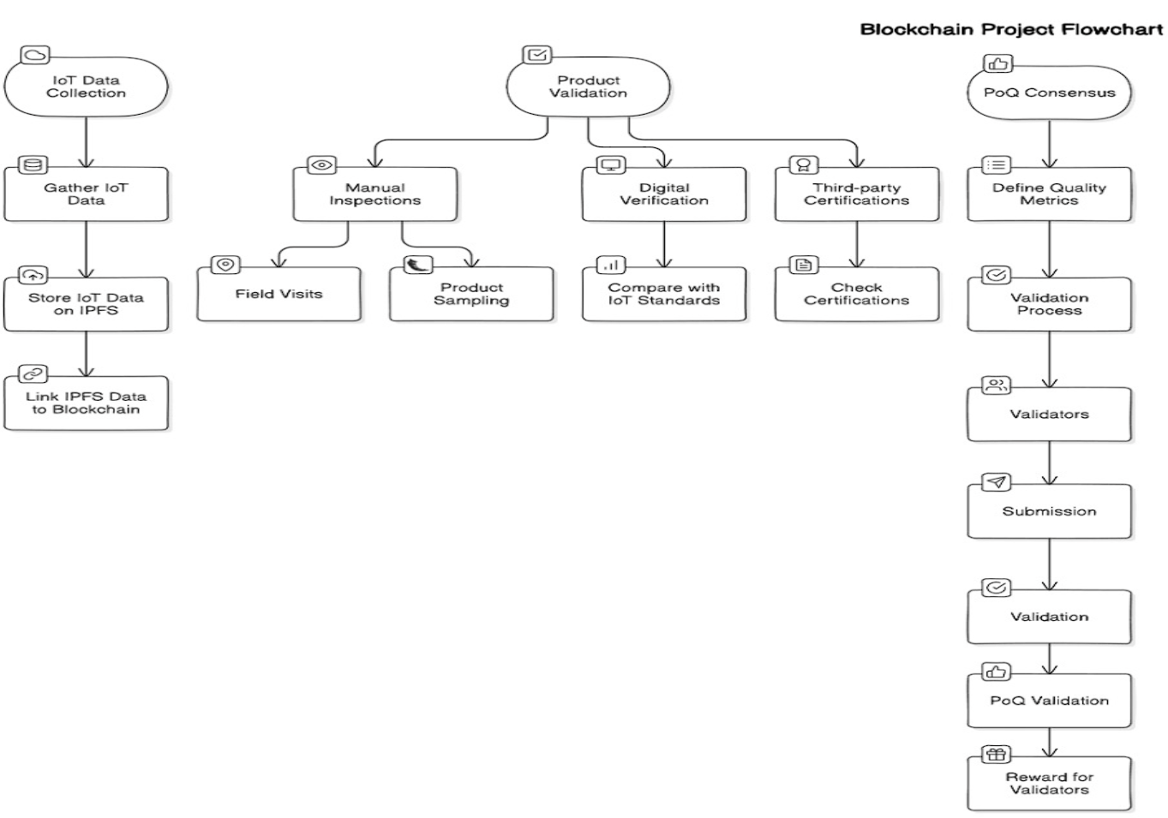

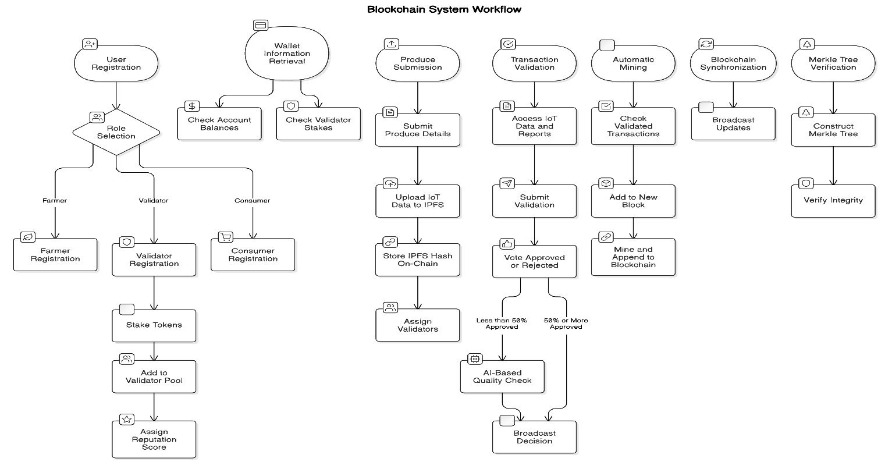

**V.CONCLUSION**

The application of blockchain technology to the agricultural supply chain offers a revolutionary solution to long-standing inefficiencies like transparency deficiency, price manipulation by middlemen, and inconsistent quality verification processes. This study suggests a tailored blockchain-based solution that utilizes Proof of Quality (PoQ) consensus mechanism, IoT-based quality monitoring, and smart contracts to establish a reliable, decentralized, and effective marketplace for farmers, consumers, and retailers. By cutting out intermediaries and facilitating direct farmer-to-consumer transactions, the system provides equal pricing, greater traceability, and better financial inclusion for smallholder farmers.

The deployment of PoQ incentivizes quality crop production by remunerating farmers according to factual quality indicators that are authenticated via IoT sensor reads and manual auditing. The support for QR code authentication enables detailed product histories for consumers, securing trust and assurance in the supply chain. Also, off-chain IPFS storage effectively handles high volumes of IoT data while providing data integrity and security.

##### **VI.References**

[1] Agriculture Supply Chain Management Based on Blockchain Architecture and Smart Contracts- Adil El Mane; Volume 2022, Article ID 8011525, <https://onlinelibrary.wiley.com/doi/epdf/10.1155/2022/8011525>

[2] AGRICULTURE ON THE BLOCKCHAIN Sustainable Solutions for Food, Farmers, and Financing Henry Kim and Marek Laskowski York University December 2017

[3]Applying Blockchain in Agriculture: A Study on Blockchain Technology, Benefits, and Challenges

January 2021;DOI: [10.1007/978-3-030-60265-9_11](http://dx.doi.org/10.1007/978-3-030-60265-9_11)

Sandeep Kumar M,Maheshwari Venkat

[4], Blockchain Technology for Agriculture: Applications and Rationale; Hang Xiong1*Tobias Dalhaus2Puqing Wang3Jiajin Huang4,5

[5], Blockchain and agricultural supply chains traceability: research trends and future challenges**;** panelGiovanni Mirabelli a, Vittorio Solina-2020

[6] Exploring the role of blockchain technology in modern high-value food supply chains: global trends and future research directions; Giulia Chiaraluce, Deborah BentivogJj@**-**2019

[7] S. Viriyasitavat, and A. Hoonsopon, “Blockchain in the

Supply Chain Management: A Review and Research Frame

work,” Logistics, vol. 3, no. 1, pp. 1-20, 2019.

[8]4] H. Lin, and N. Zhu, “Exploring the Potential of Block

chain in Agriculture: A Literature Review,” Journal of Agri

cultural Studies, vol. 6, no. 2, pp. 48-60, 2018.

[9] J. Zhao, X. Fan, and J. Yan, "Blockchain Technology in Agri-Food Value Chain Management: A Synthesis of Applications, Challenges, and Future Research Directions," Computers in Industry, vol. 109, pp. 83-99, 2019.

[10] L. Tian, "A Blockchain-Based Evaluation Approach for Sustainable Agri-Food Supply Chains," Sustainability, vol. 11, no. 18, pp. 4985-5002, 2019.

[11] M. Caro et al., "Blockchain in the Food Industry:

A Review of Potentials, Challenges and Future Research

Directions," Logistics, vol. 4, no. 1, pp. 1-23, 2020.

[12] A. Kamilaris, A. Fonts, and F. X. Prenafeta-Boldú,

"The Rise of Blockchain Technology in Agriculture and

Food Supply Chains," Trends in Food Science &

Technology, vol. 91, pp. 640-652, 2019.

[13] R. Casino, T. K. Dasaklis, and C. Patsakis, "A

Systematic Literature Review of Blockchain-Based

Applications: Current Status, Classification and Open

Issues," Telematics and Informatics, vol. 36, pp. 55-81, 2019.