**FITFLEX: YOUR PERSONAL FITNESS COMPANION**

**(FITNESS TRACKER)**

**NAANMUDHALVAN PROJECT REPORT** Submitted by

**TEAM LEADER**

**KARUNAKARAN .A (222209319) a.karunakarana1btm@gmail.com**

**TEAM MEMBERS**

**KARTHICK .M (222209318) karthick18022005@gmail.com**

**KAVI BARATHY .G (222209320) bkavi276@gmail.com**

**PRITHIVIRAJ .S (222209327) rajprithivi881@gmail.com**

**DEPARTMENT OF COMPUTER SCIENCE**

**TAGORE COLLEGE OF ARTS AND SCIENCE**(Affiliated to the University of Madras)

CLC WORKS ROAD, CHROMPET, CHENNAI – 600 044

**MARCH - 2025**

| **S.NO** | **CONTENT** | **PAGE.NO** |
| --- | --- | --- |
| **1** | **ABSTRACT** |  |
| **2** | **INTRODUCTION**  2.1. Objective  2.2. Scope  2.3. Target Audience  2.4. Key Benefits |  |
| **3** | **SYSTEM OVERVIEW**  3.1. Overview  3.2. Technology Stack  3.3. Architecture |  |
| **4** | **FEATURES**  4.1. Overview  4.2. Key Features |  |
| **5** | **UI/UX DESIGN**  5.1. Overview  5.2. Design Principles  5.3. User Journey Flow  5.4. Visual Design Elements  5.5. Mobile & Desktop Responsiveness |  |
| **6** | **DATABASE SCHEMA**  6.1. Overview  6.2. Core Collections & Schema Structure  6.3. Relationships & Indexing  6.4. Security & Data Integrity |  |
| **7** | **IMPLEMENTATION**  7.1. Overview  7.2. Authentication & User Management Endpoints  7.3. Workout Endpoints  7.4. Nutrition & Meal Planning Endpoints  7.5. Progress & Tracking Endpoints  7.6. Hydration Tracking Endpoints  7.7. Notification Endpoints  7.8. Security & Authentication |  |
| **8** | **SECURITY & PERFORMANCE**  8.1. Overview  8.2. Backend Implementation  8.3. Frontend Implementation  8.4. Real-Time Features  8.5. Testing & Optimization  8.6. Deployment & DevOps  8.7. Testing & Quality Assurance |  |
| **9** | **TESTING & DEBUGGING**  9.1. Overview  9.2. Unit Testing  9.3. Integration Testing  9.4. End-to-End (E2E) Testing  9.5. Debugging Strategies  9.6. Error Handling & Logging  9.7. Continuous Testing & CI/CD Integration |  |
| **10** | **DEPLOYMENT & HOSTING**  10.1. Overview  10.2. Backend Deployment  10.3. Frontend Deployment  10.4. Database Deployment  10.5. Continuous Integration & Deployment (CI/CD)  10.6 Monitoring & Logging |  |
| **11** | **FUTURE ENHANCEMENTS**  11.2. AI-Driven Personalized Workouts  11.3. Advanced Gamification & Social Features  11.4. Wearable Device & IoT Integration  11.5. Voice & Gesture Control Features  11.6. Augmented Reality (AR) & Virtual Reality (VR) Workouts  11.7. Block chain-Based Health Data Security  11.8. Expanded Accessibility & Multilingual Support  11.9. Smart Diet & Nutrition Planner  11.10. Cloud-Native Microservices Architecture  11.11. Community & Live Training Expansion |  |
| **12** | **VISUAL ILLUSTRATIONS** |  |
| **13** | **CONCLUSION** |  |

**1. ABSTRACT**

The Shape Up App is a full-stack fitness application built using the MERN (MongoDB, Express.js, React, Node.js) stack, designed to provide users with a seamless and engaging workout experience. This project integrates modern web technologies, cloud-based deployment, and AI-driven features to create a highly personalized fitness journey for users of all levels.

The application offers a comprehensive set of functionalities, including workout tracking, exercise recommendations, real-time progress monitoring, and wearable device integration. A robust backend ensures secure data management, while the intuitive frontend delivers an immersive user experience. Advanced gamification features, such as challenges, leaderboards, and achievement badges, further enhance motivation and engagement.

Security and performance optimizations have been implemented through data encryption, role-based access control, and cloud-native infrastructure. Additionally, planned enhancements such as AR/VR-based training, AI-powered coaching, and blockchain-secured health data storage will further elevate the application’s capabilities.

By leveraging cutting-edge technologies and a user-centric approach, the Shape Up App aims to redefine digital fitness experiences, making personalized workouts accessible, efficient, and engaging for users worldwide.

**2. INTRODUCTION**

**2.1. Objective:**

Shape Up is a comprehensive fitness tracking web application designed to help users take control of their health and wellness. The application offers an interactive and user-friendly platform for setting fitness goals, tracking progress, and exploring workouts and nutrition plans.

**2.2. Scope:**

The Shape Up App integrates advanced fitness functionalities, including user authentication, diet profiling, meal planning, hydration tracking, workout exploration, nutritional analysis, and BMR calculation. By leveraging a MERN stack architecture, it ensures scalability, performance, and seamless user experience.

**2.3. Target Audience:**

Shape Up is designed for fitness enthusiasts, beginners, and health-conscious individuals who want a structured way to monitor and enhance their fitness journey. It caters to users seeking personalized workout and meal plans tailored to their fitness goals.

**2.4. Key Benefits:**

* Personalized fitness tracking with real-time progress updates.
* A comprehensive workout database with structured exercise routines.
* Goal-oriented meal and hydration planning to support overall wellness.
* Easy-to-use interface that simplifies fitness management.
* Secure user authentication and data storage.

**3. SYSTEM OVERVIEW**

**3.1. Overview:**

The Shape Up App is a modern fitness tracking platform built using the MERN (MongoDB, Express.js, React.js, Node.js) stack. It offers a seamless user experience with robust backend support, ensuring efficiency, security, and scalability. By integrating real-time data updates and API-driven content, Shape Up provides an interactive and engaging fitness solution.

**3.2. Technology Stack:**

* **Frontend:** React.js with Redux for state management and responsive UI.
* **Backend:**   
  Node.js with Express.js, ensuring a RESTful API structure.
* **Database:**   
  MongoDB for scalable and flexible data storage.
* **Authentication:**   
  JWT-based authentication for secure user sessions.
* **APIs:**   
  Fitness and nutrition APIs to provide real-time exercise and diet data.

**3.3. Architecture:**

The Shape Up App follows a micro services-based architecture, ensuring modularity and scalability. The key components include:

* **User Authentication Module:** Handles login, registration, and profile management.
* **Workout Module:** Stores and retrieves exercise routines and personalized plans.
* **Meal Planner Module:** Assists users in managing their nutrition goals.
* **Tracking & Progress Module:** Records user performance, weight, and fitness milestones.
* **Notification System:** Alerts users about workout schedules and hydration reminders.
* **Key Functionalities:**
* Secure user authentication with encrypted data storage.
* Dynamic fitness content retrieval from integrated APIs.
* A structured backend with a RESTful API design.
* Modular React components for an interactive UI.
* Real-time data updates with optimized API calls.
* **Scalability & Performance:** Shape Up is designed for high performance with:
* **Load Balancing:** Distributing user requests efficiently across multiple servers.
* **Database Optimization:** Indexing and caching to enhance response time.
* **Cloud Integration:** Deployment on scalable cloud services like AWS or Vercel.
* **Security Measures:**
* **Data Encryption:** Protecting sensitive user information.
* **Role-Based Access:** Ensuring different permission levels.
* **Secure API Endpoints:** Preventing unauthorized access and data breaches.

**4. FEATURES**

**4.1. Overview:**

Shape Up App is designed with a rich set of features that enable users to track and manage their fitness journey effectively. From personalized workout plans to detailed progress tracking, the app provides a holistic approach to health and wellness.

**4.2. Key Features:**

1. **User Authentication & Profile Management:**
   * Secure sign-up and login with JWT authentication.
   * Personalized user dashboard with fitness goals and stats.
2. **Workout Module:**
   * Access a vast database of workouts categorized by type and difficulty.
   * Customize personal workout routines and track completed exercises.
3. **Meal Planning & Nutrition Tracking:**
   * Plan meals based on dietary preferences and fitness goals.
   * Check nutrition details, calorie intake, and recommended diet plans.
4. **Water Intake Logging:**
   * Track daily water consumption and set hydration reminders.
   * Visual insights on hydration trends over time.
5. **Progress Tracking & Analytics:**
   * Monitor weight, BMI, and calorie expenditure.
   * Visual graphs to analyze progress and trends.
6. **BMR & Calorie Calculator:**
   * Calculate Basal Metabolic Rate to determine daily caloric needs.
   * Get AI-based recommendations for calorie intake based on goals.
7. **Notifications & Reminders:**
   * Stay on track with push notifications for workouts and meals.
   * Receive reminders for hydration and daily progress updates.
8. **Social & Community Features:**
   * Connect with other fitness enthusiasts and share achievements.
   * Join challenges, set fitness goals, and compete with friends.
9. **API Integration & Real-time Updates:**
   * Fetch live workout and diet data from trusted fitness APIs.
   * Ensure seamless data synchronization across devices.

**5. UI/UX Design**

**5.1. Overview:**

Shape Up App prioritizes an intuitive and engaging user experience, ensuring seamless navigation and interaction. The UI/UX design follows a user-centric approach, integrating modern aesthetics with functional efficiency to enhance usability.

**5.2. Design Principles:**

* **Simplicity:** A clutter-free interface focusing on ease of access.
* **Consistency:** A uniform design language across all screens.
* **Accessibility:** Optimized for different devices and user needs.
* **Engagement:** Interactive visuals and real-time feedback for a dynamic experience.

**5.3. User Journey Flow:**

1. **Onboarding:**
   * Users are guided through an introductory walkthrough of the app’s features.
   * Account setup with fitness goals and personal preferences.
2. **Dashboard:**
   * A centralized hub displaying user stats, progress, and upcoming tasks.
   * Quick access to workouts, meals, hydration tracking, and notifications.
3. **Workout & Meal Planning:**
   * Dedicated sections for workout selection, custom routine creation, and meal planning.
   * Easy navigation with search filters and categorized exercise lists.
4. **Tracking & Analytics:**
   * Graphical representation of user progress, including weight trends, calorie intake, and workout stats.
   * Interactive feedback on achieved goals and pending tasks.
5. **Notifications & Reminders:**
   * Push notifications for workout sessions, hydration, and goal reminders.
   * Daily progress summaries to keep users engaged.

**5.4. Visual Design Elements:**

* **Color Palette:**
  + A mix of calming blues and energizing greens to encourage motivation.
* **Typography:**
  + Clean, modern fonts ensuring readability across devices.
* **Iconography:**
  + Intuitive icons representing workouts, meals, hydration, and progress tracking.
* **Animations & Transitions:**
  + Smooth micro-interactions for enhanced user experience.

**5.5. Mobile & Desktop Responsiveness:**

* Fully optimized for various screen sizes.
* Adaptive layouts for seamless transitions between mobile, tablet, and desktop views.

**6. DATABASE SCHEMA**

**6.1. Overview:**

The Shape Up App's database is designed to efficiently store and manage fitness-related data, ensuring seamless user experiences and secure data handling. Built on MongoDB, the schema follows a structured, NoSQL approach that supports scalability and flexibility.

**6.2. Core Collections & Schema Structure:**

1. **Users Collection:**
   * Stores user account details, authentication data, and fitness goals.
   * Schema Fields:
     + _id: Unique identifier (ObjectId)
     + name: String
     + email: String (Unique)
     + password: String (Hashed)
     + age: Number
     + gender: String
     + weight: Number
     + height: Number
     + goal: String (e.g., weight loss, muscle gain, maintenance)
     + createdAt: Timestamp
     + updatedAt: Timestam
2. **Workouts Collection:**
   * Stores predefined and custom workout routines.
   * Schema Fields:
     + _id: ObjectId
     + userId: Reference to Users (_id)
     + workoutName: String
     + exercises: Array of exercise objects (name, reps, sets, duration)
     + category: String (e.g., cardio, strength, flexibility)
     + difficulty: String (easy, medium, hard)
     + createdAt: Timestamp
3. **Nutrition Collection:**
   * Manages dietary plans and meal tracking.
   * Schema Fields:
     + _id: ObjectId
     + userId: Reference to Users (_id)
     + mealType: String (breakfast, lunch, dinner, snack)
     + foodItems: Array (name, calories, protein, carbs, fats)
     + totalCalories: Number
     + createdAt: Timestamp
4. **Progress Tracking Collection:**
   * Stores user progress over time.
   * Schema Fields:
     + _id: ObjectId
     + userId: Reference to Users (_id)
     + weight: Number
     + bodyFatPercentage: Number
     + bmi: Number
     + exercisePerformance: Array (exercise name, progress metrics)
     + recordedAt: Timestamp
5. **Hydration Tracking Collection:**
   * Monitors water intake and hydration levels.
   * Schema Fields:
     + _id: ObjectId
     + userId: Reference to Users (_id)
     + waterIntake: Number (ml)
     + targetIntake: Number (ml)
     + recordedAt: Timestamp
6. **Notifications Collection:**
   * Manages reminders and alerts for users.
   * Schema Fields:
     + _id: ObjectId
     + userId: Reference to Users (_id)
     + notificationType: String (reminder, alert, update)
     + message: String
     + status: Boolean (read/unread)
     + createdAt: Timestamp

**6.3. Relationships & Indexing:**

* Users are linked to workouts, meals, and progress records via userId.
* Indexed fields for fast retrieval include email in Users, userId in all collections, and created At timestamps for chronological tracking.

**6.4. Security & Data Integrity:**

* **Encryption:** User passwords are hashed before storage.
* **Validation:** Data schemas enforce strict typing and constraints.
* **Access Control:** Role-based permissions ensure restricted data access.

**7. API Endpoints**

**7.1. Overview:**

The Shape Up App utilizes a RESTful API architecture to facilitate seamless communication between the frontend and backend. The API is built using Express.js and Node.js, ensuring efficiency, scalability, and security in handling requests. Each endpoint follows proper authentication and validation mechanisms.

**7.2. Authentication & User Management Endpoints:**

1. **Register User** (POST /api/users/register)
   * Registers a new user with name, email, password, and fitness goals.
   * Request Body: { name, email, password, age, gender, weight, height, goal }
   * Response: { message, userId }
2. **Login User** (POST /api/users/login)
   * Authenticates user and returns a JWT token.
   * Request Body: { email, password }
   * Response: { token, user }
3. **Get User Profile** (GET /api/users/profile)
   * Fetches user details (requires authentication).
   * Response: { userId, name, email, age, gender, weight, height, goal }

**7.3. Workout Endpoints:**

4. **Get Workouts** (GET /api/workouts)

* Retrieves all available workout routines.
* Response: [{ workoutId, workoutName, category, exercises }]

1. **Add Workout** (POST /api/workouts)
   * Allows users to add custom workout routines.
   * Request Body: { workoutName, category, exercises }
   * Response: { message, workoutId }
2. **Delete Workout** (DELETE /api/workouts/:id)
   * Removes a workout based on ID.

**7.4. Nutrition & Meal Planning Endpoints:**

7. **Get Meal Plans** (GET /api/nutrition)

* Fetches available meal plans for users.
* Response: [{ mealType, foodItems, totalCalories }]

1. **Log Meal Intake** (POST /api/nutrition)
   * Logs a user’s meal intake.
   * Request Body: { mealType, foodItems, totalCalories }
   * Response: { message, logId }

**7.5. Progress & Tracking Endpoints:**

9. **Log Progress** (POST /api/progress)

* Records user weight, BMI, and workout performance.
* Request Body: { weight, bmi, exercisePerformance }

1. **Get User Progress** (GET /api/progress/:userId)
   * Fetches user’s fitness progress over time.

**7.6. Hydration Tracking Endpoints:**

11. **Log Water Intake** (POST /api/hydration) - Logs daily water intake. - Request Body: { waterIntake }

1. **Get Hydration Logs** (GET /api/hydration/:userId)
   * Fetches hydration data for analysis.

**7.7. Notification Endpoints:**

13. **Get Notifications** (GET /api/notifications) - Retrieves user notifications.

1. **Mark Notification as Read** (PUT /api/notifications/:id)
   * Updates notification status to read.

**7.8. Security & Authentication:**

* **JWT Authentication**: All protected endpoints require a valid JWT token.
* **Data Validation**: Request data is validated before database operations.
* **Role-Based Access**: Admins have additional privileges for managing workouts and meal plans.

**8. IMPLEMENTATION**

**8.1. Overview:**

The Shape Up App follows a well-structured MERN (MongoDB, Express.js, React, Node.js) stack implementation. This section provides an in-depth look at the backend, frontend, and integration strategies, ensuring a seamless experience for users.

**8.2. Backend Implementation:**

1. **Framework & Architecture:**
   * The backend is built using **Node.js** with **Express.js**, enabling efficient request handling.
   * Follows the MVC (Model-View-Controller) architecture for scalability.
2. **Database Handling:**
   * Uses **MongoDB** as a NoSQL database for flexibility and performance.
   * Mongoose ORM is used for schema validation and query optimization.
3. **Authentication & Security:**
   * Implements **JWT (JSON Web Token)** for secure authentication.
   * Passwords are encrypted using **bcrypt** for security.
   * Role-based access control is implemented for user and admin management.
4. **API Development:**
   * RESTful APIs are created to handle workouts, nutrition, hydration, and progress tracking.
   * Follows best practices with proper **middleware, error handling, and validation**.

**8.3. Frontend Implementation:**

1. **Framework & Component Structure:**
   * The frontend is built using **React.js** with a modular component-based structure.
   * Uses **Redux** for state management, ensuring efficient data handling.
2. **UI/UX Design:**
   * Styled using **Tailwind CSS** for responsiveness and minimal styling complexity.
   * Follows a **mobile-first approach** for optimal user experience across devices.
3. **Integration with Backend:**
   * Uses **Axios** for API calls, ensuring smooth data fetching.
   * Implements **React Query** for efficient API data caching and synchronization.
4. **Client-side Security:**
   * Protects routes using **React Router Guards** for authentication.
   * Stores authentication tokens securely in **HTTP-only cookies**.

**8.4. Real-Time Features:**

* Uses **WebSockets** for real-time notifications and workout tracking.
* Implements **cron jobs** for scheduled reminders and progress reports.

**Deployment & DevOps:**

1. **Backend Hosting:**
   * Deployed using **AWS EC2** or **Heroku** with auto-scaling.
   * Uses **Docker** for containerized deployments.
2. **Frontend Hosting:**
   * Deployed on **Vercel** or **Netlify** for high-performance delivery.
   * Uses **CDN caching** for optimized asset loading.
3. **Database Management:**
   * Hosted on **MongoDB Atlas** with automated backups.
   * Implements **sharding & indexing** for efficient query performance.

**8.5. Testing & Optimization:**

1. **Unit & Integration Testing:**
   * Uses **Jest & Mocha** for automated backend tests.
   * **React Testing Library** ensures UI stability.
2. **Performance Optimization:**
   * Implements **lazy loading** and **code splitting** in React.
   * Uses **Redis caching** for frequently accessed API calls.

**8.6. Deployment & DevOps:**

1. **Backend Hosting:**
   * Deployed using **AWS EC2** or **Heroku** with auto-scaling.
   * Uses **Docker** for containerized deployments.
2. **Frontend Hosting:**
   * Deployed on **Vercel** or **Netlify** for high-performance delivery.
   * Uses **CDN caching** for optimized asset loading.
3. **Database Management:**
   * Hosted on **MongoDB Atlas** with automated backups.
   * Implements **sharding & indexing** for efficient query performance.

**8.7. Testing & Quality Assurance:**

1. **Unit & Integration Testing:**
   * Uses **Jest & Mocha** for automated backend tests.
   * **React Testing Library** ensures UI stability.
2. **Continuous Integration & Deployment (CI/CD):**
   * Uses **GitHub Actions** for automated testing and deployments.
   * Implements **Docker containers** to standardize development environments.

**9. TESTING & DEBUGGING**

**9.1. Overview:**

Testing and debugging are critical components of the development lifecycle in the Shape Up App. A comprehensive testing strategy ensures that the application remains robust, secure, and performs optimally across different environments. This section outlines unit testing, integration testing, end-to-end testing, debugging methodologies, and error-handling mechanisms.

**9.2. Unit Testing:**

1. **Backend Testing:**
   * Uses **Jest & Mocha** for testing Node.js and Express.js functions.
   * Ensures API routes return expected responses using **Supertest**.
   * Tests authentication logic, database queries, and business logic functions.
2. **Frontend Testing:**
   * Uses **React Testing Library** for testing React components.
   * Validates UI components, state changes, and user interactions.
   * Mocks API requests using **MSW (Mock Service Worker)** for predictable responses.

**9.3. Integration Testing:**

1. **API Endpoint Validation:**
   * Uses **Postman** and **Supertest** to verify API endpoints.
   * Ensures database interactions work as expected.
   * Tests middleware functionality such as authentication and data validation.
2. **Database Testing:**
   * Uses **MongoDB in-memory server** to test database operations without affecting live data.
   * Checks schema validation, indexing, and query performance.
3. **Component Interaction Testing:**
   * Ensures that UI components interact correctly with API responses.
   * Uses **Jest mock functions** to simulate different states and user interactions.

**9.4. End-to-End (E2E) Testing:**

1. **User Flow Validation:**
   * Uses **Cypress** for automated testing of complete user journeys.
   * Simulates real-world interactions such as login, workouts, progress tracking, and profile updates.
2. **Cross-Browser & Device Testing:**
   * Tests on multiple browsers including Chrome, Firefox, and Safari.
   * Uses **BrowserStack** or **Lighthouse** for mobile responsiveness checks.

**9.5. Debugging Strategies:**

1. **Backend Debugging:**
   * Uses **Winston & Morgan** for structured logging of API requests and errors.
   * Implements **Node.js debugger** to step through execution flow and identify issues.
   * Uses **Postman & Insomnia** to manually test and debug API responses.
2. **Frontend Debugging:**
   * Uses **Chrome Developer Tools** for inspecting React components and network requests.
   * Utilizes **Redux DevTools** to track state changes and actions.
   * Enables error boundaries in React to catch UI crashes and handle errors gracefully.

**9.6. Error Handling & Logging:**

1. **Centralized Error Handling:**
   * Uses Express.js error-handling middleware for structured API error responses.
   * Categorizes errors into **client errors (4xx)** and **server errors (5xx)**.
2. **Logging & Monitoring:**
   * Implements **Winston** for storing logs and tracking user interactions.
   * Uses **Sentry or LogRocket** for frontend error tracking.
   * Monitors real-time application performance using **Prometheus & Grafana**.
3. **Fallback & Recovery Mechanisms:**
   * Implements retry logic for failed API calls to ensure resilience.
   * Uses **graceful degradation** techniques to maintain partial functionality during failures.

**9.7. Continuous Testing & CI/CD Integration:**

1. **Automated Testing Pipelines:**
   * Uses **GitHub Actions** or **Jenkins** to automate testing in CI/CD workflows.
   * Runs test suites before merging pull requests to prevent regressions.
2. **Load & Stress Testing:**
   * Uses **JMeter** or **K6** to test API performance under high traffic.
   * Simulates concurrent users and monitors system behavior under load.

**10. DEPLOYMENT & HOSTING**

**10.1. Overview:**

Deployment and hosting are crucial for making the Shape Up App accessible to users worldwide. This section covers backend and frontend hosting strategies, database deployment, continuous integration and delivery (CI/CD), and monitoring for performance and security.

**10.2. Backend Deployment:**

1. **Hosting Platform:**
   * The backend is hosted on **AWS EC2** for scalability and flexibility.
   * Alternatives like **Heroku, DigitalOcean, or Render** can be used for simplified deployments.
2. **Containerization & Orchestration:**
   * Uses **Docker** to package backend services into lightweight containers.
   * Implements **Kubernetes** for auto-scaling and efficient resource management.
3. **API Gateway & Load Balancing:**
   * Uses **NGINX or AWS API Gateway** to manage API requests and load balancing.
   * Implements **Cloudflare or AWS Route 53** for DNS management and traffic routing.
4. **Security Measures:**
   * Enforces **SSL/TLS encryption** for secure API communication.
   * Implements **IAM roles & security groups** to restrict unauthorized access.

**10.3. Frontend Deployment:**

1. **Hosting Services:**
   * Deployed using **Vercel or Netlify** for optimized frontend performance.
   * Uses **CDN (Content Delivery Network)** to serve static assets efficiently.
2. **Build Optimization:**
   * Implements **Tree Shaking & Code Splitting** for performance improvements.
   * Uses **Lazy Loading** to load only required components dynamically.
3. **Caching & Performance Enhancements:**
   * Implements **Service Workers** for Progressive Web App (PWA) capabilities.
   * Uses **Gzip & Brotli Compression** for reducing load times.

**10.4. Database Deployment:**

1. **Database Hosting:**
   * Uses **MongoDB Atlas** for cloud-based database management.
   * Implements **read and write replicas** for improved performance and availability.
2. **Backup & Recovery:**
   * Schedules **automated backups** for disaster recovery.
   * Implements **Point-in-Time Recovery (PITR)** for restoring data when needed.
3. **Security Measures:**
   * Enables **IP whitelisting** to restrict unauthorized database access.
   * Uses **Role-Based Access Control (RBAC)** for data protection.

**10.5. Continuous Integration & Deployment (CI/CD):**

1. **Automated Deployment Pipeline:**
   * Uses **GitHub Actions, CircleCI, or Jenkins** for automated testing and deployment.
   * Ensures zero-downtime deployments using **Blue-Green or Canary Deployment** strategies.
2. **Version Control & Rollbacks:**
   * Uses **GitHub/GitLab** for source code management.
   * Implements **automated rollback mechanisms** to revert to stable versions.
3. **Infrastructure as Code (IaC):**
   * Uses **Terraform or AWS CloudFormation** to automate cloud resource provisioning.

**10.6 Monitoring & Logging:**

1. **Performance Monitoring:**
   * Uses **Prometheus & Grafana** to track server health and API response times.
   * Implements **Google Lighthouse** for frontend performance audits.
2. **Error Tracking & Alerts:**
   * Uses **Sentry or LogRocket** to track real-time errors and exceptions.
   * Implements **Slack or Email notifications** for critical error alerts.
3. **Security Audits:**
   * Conducts **regular penetration testing** to identify vulnerabilities.

**11. FUTURE ENHANCEMENTS**

**11.1. Overview:**

As technology and user expectations evolve, the Shape Up App is committed to continuous improvement. This section highlights future enhancements aimed at refining user experience, optimizing performance, and integrating innovative features.

**11.2. AI-Driven Personalized Workouts:**

* Implement **machine learning models** to analyze user behavior and suggest tailored workout plans.
* Utilize **real-time AI coaching** to provide instant feedback on exercise form and performance.
* Enable **adaptive workout intensity adjustments** based on user progress and preferences.

**11.3. Advanced Gamification & Social Features:**

* Introduce **achievement badges, leaderboards, and progress tracking** to motivate users.
* Implement **community workout challenges** and peer-to-peer fitness competitions.
* Enhance **social sharing capabilities** to allow users to share progress and engage with fitness communities.

**11.4. Wearable Device & IoT Integration:**

* Support seamless connectivity with **Apple Watch, Fitbit, Garmin, and other smart devices**.
* Enable **real-time biometric tracking** for heart rate, calories burned, and oxygen levels.
* Incorporate **haptic feedback** for exercise guidance and performance tracking.

**11.5. Voice & Gesture Control Features:**

* Implement **voice-activated commands** for hands-free workout control using Siri, Google Assistant, or Alexa.
* Enable **gesture-based navigation** for interacting with the app during workouts.
* Introduce **audio-guided workouts** with real-time coaching and motivation.

**11.6. Augmented Reality (AR) & Virtual Reality (VR) Workouts:**

* Develop **AR-based posture correction** for real-time feedback on exercise form.
* Introduce **immersive VR fitness environments** for guided workouts and interactive training.
* Enable **virtual personal training sessions** with AI-generated fitness instructors.

**11.7. Block chain-Based Health Data Security:**

* Store fitness records securely using **block chain technology** to prevent data breaches.
* Enable users to **control and monetize their health data** with decentralized access.
* Implement **smart contracts** to manage fitness rewards and achievements securely.

**11.8. Expanded Accessibility & Multilingual Support:**

* Introduce **screen reader compatibility** and other accessibility improvements.
* Support **multiple languages** to cater to a global user base.
* Implement **voice-to-text and text-to-speech** features for improved inclusivity.

**11.9. Smart Diet & Nutrition Planner:**

* Develop an **AI-powered nutrition assistant** to generate meal plans based on fitness goals.
* Integrate with **grocery delivery services** for easy access to recommended foods.
* Provide **real-time macronutrient adjustments** based on workout intensity and progress.

**11.10. Cloud-Native Microservices Architecture:**

* Transition to a **microservices-based backend** for better scalability and flexibility.
* Implement **serverless computing** for cost-efficient resource allocation.
* Utilize **real-time data streaming** for instant updates on user activity.

**11.11. Community & Live Training Expansion:**

* Introduce **live workout sessions** with certified trainers and fitness influencers.
* Enable **peer-to-peer coaching** where experienced users can guide beginners.
* Create a **community-driven content hub** for user-generated workout plans and fitness tips.

**12. VISUAL ILLUSTRATIONS**

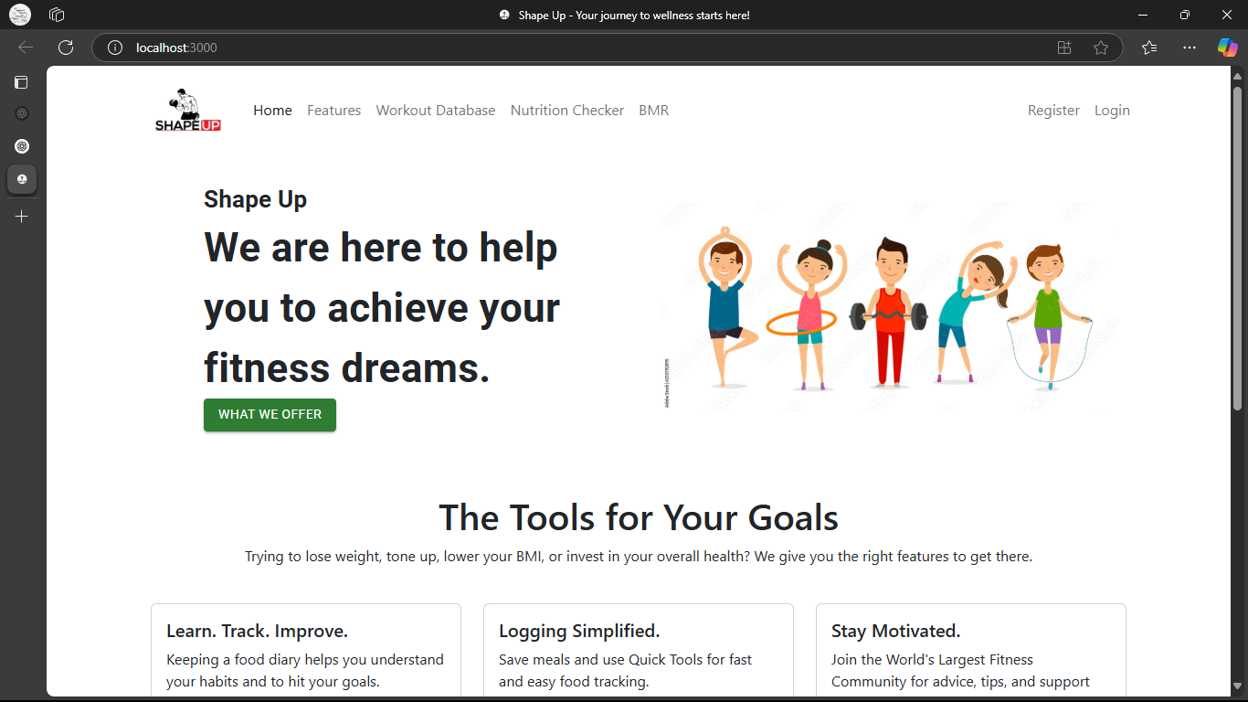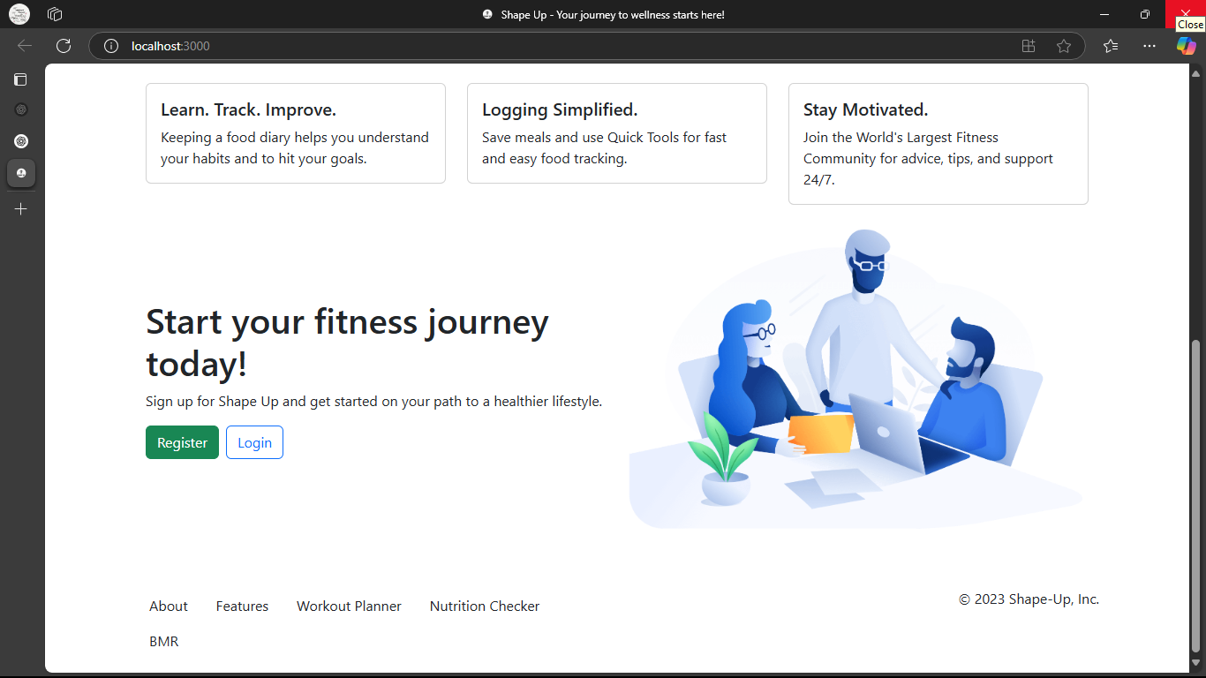

***12.1 Figure 1: Home Screen***

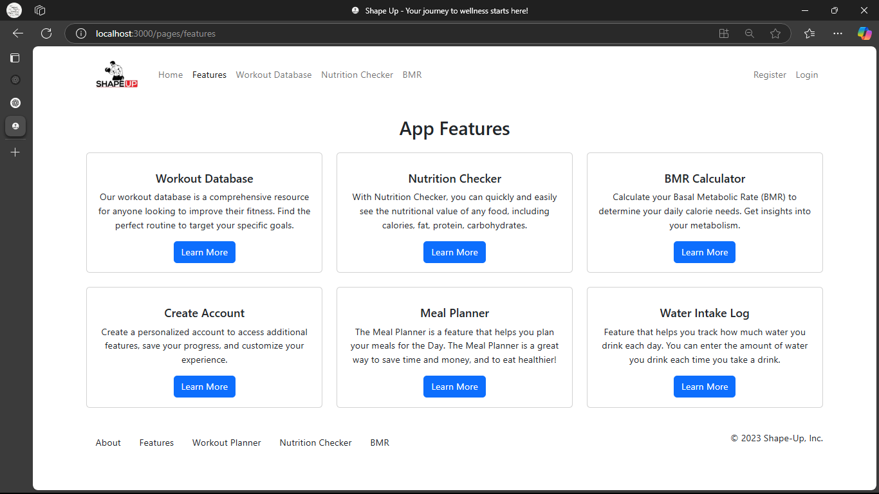

***12.2 Figure2: Features Screen***

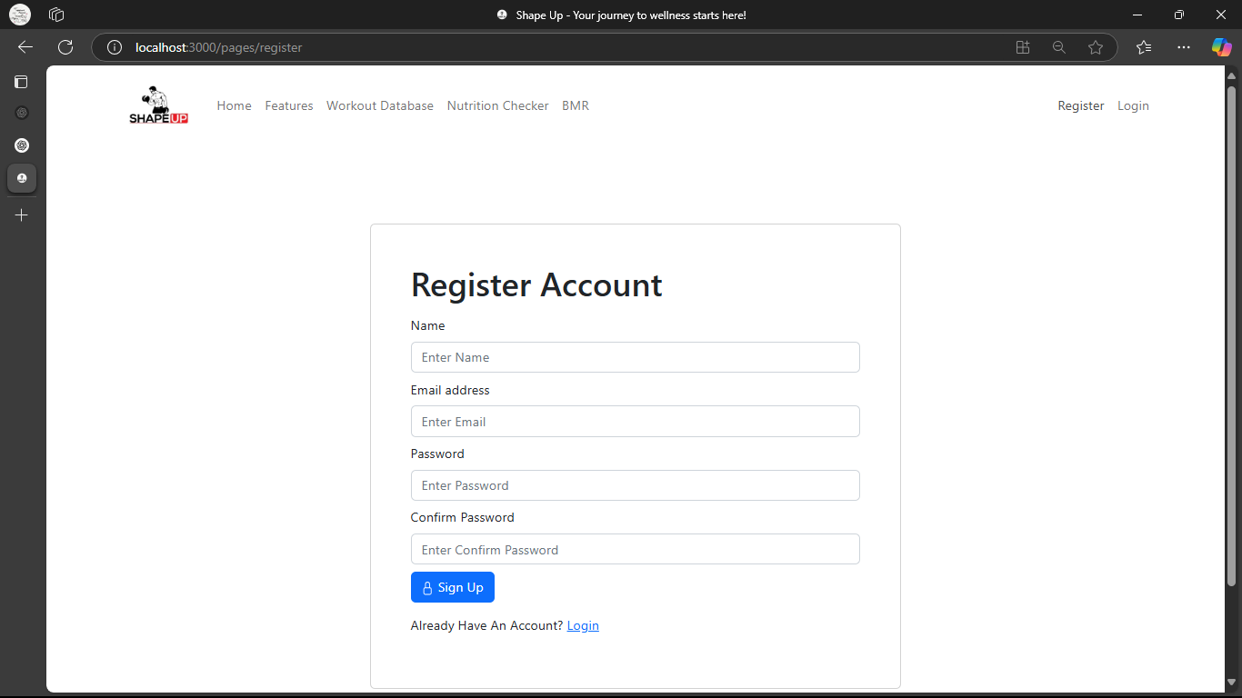

***12.3 Figure 3: Account Register Screen***

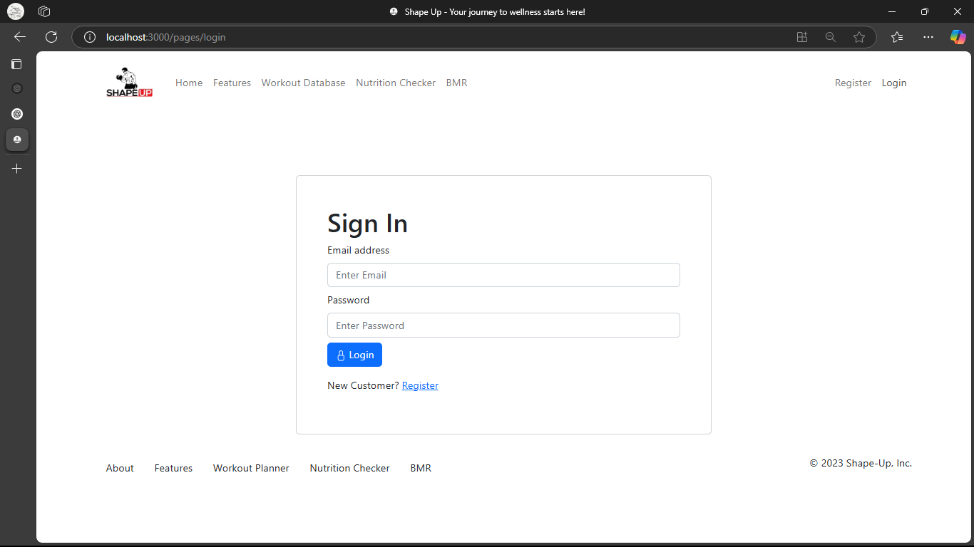

***12.4 Figure 4: Account Login Screen***

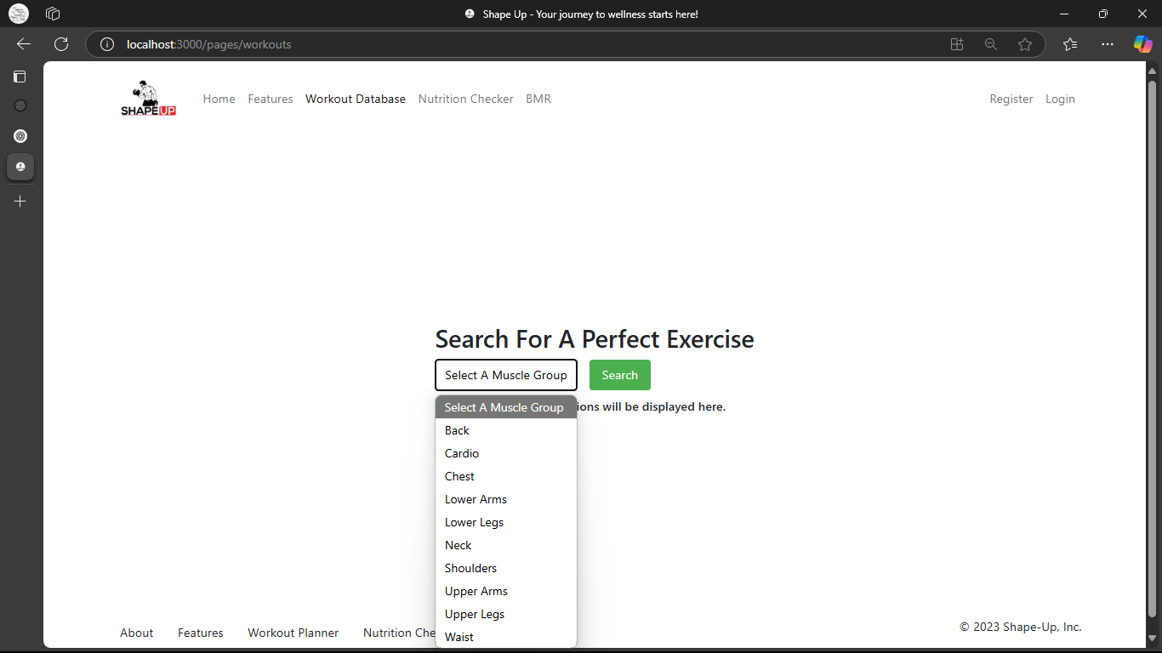

***12.5 Figure 5: Workout Database Screen***

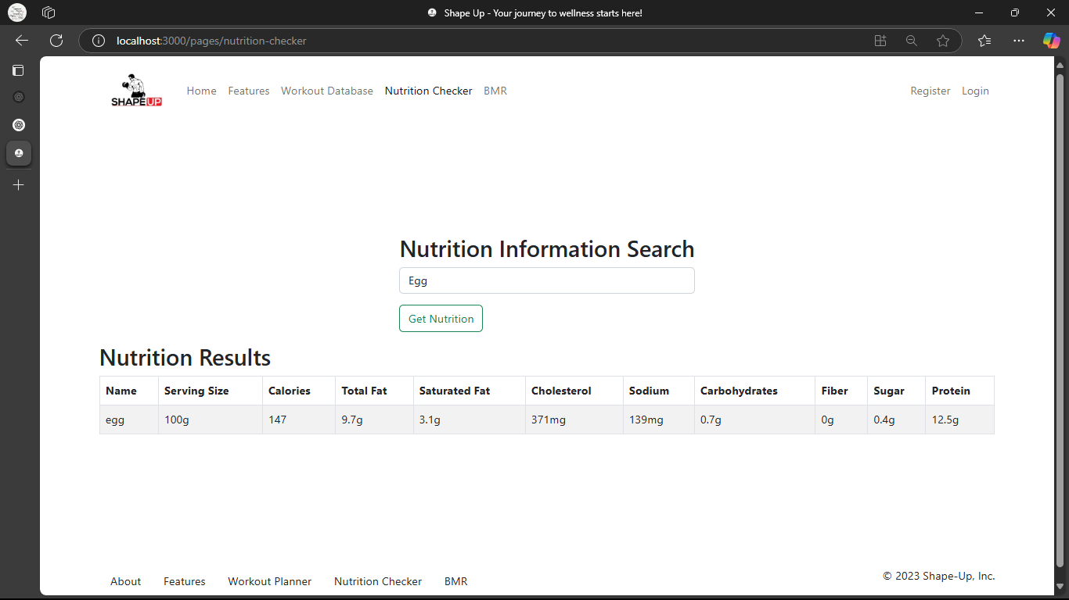

***12.6 Figure 6: Nutrition Checker Screen***

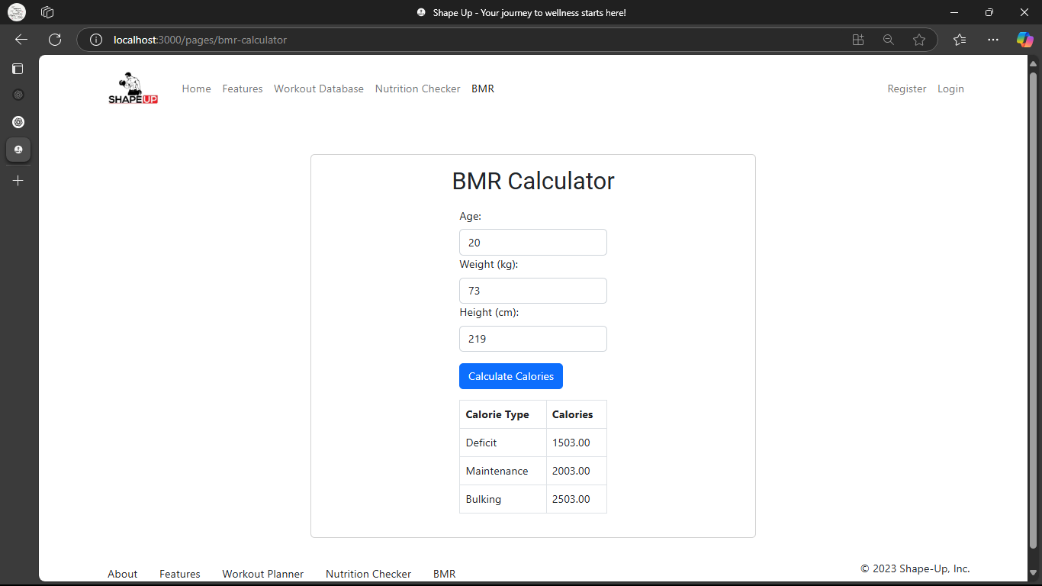

***12.7 Figure 7: BMR Calculator Screen***

***12.8 Figure 8: About Application Screen***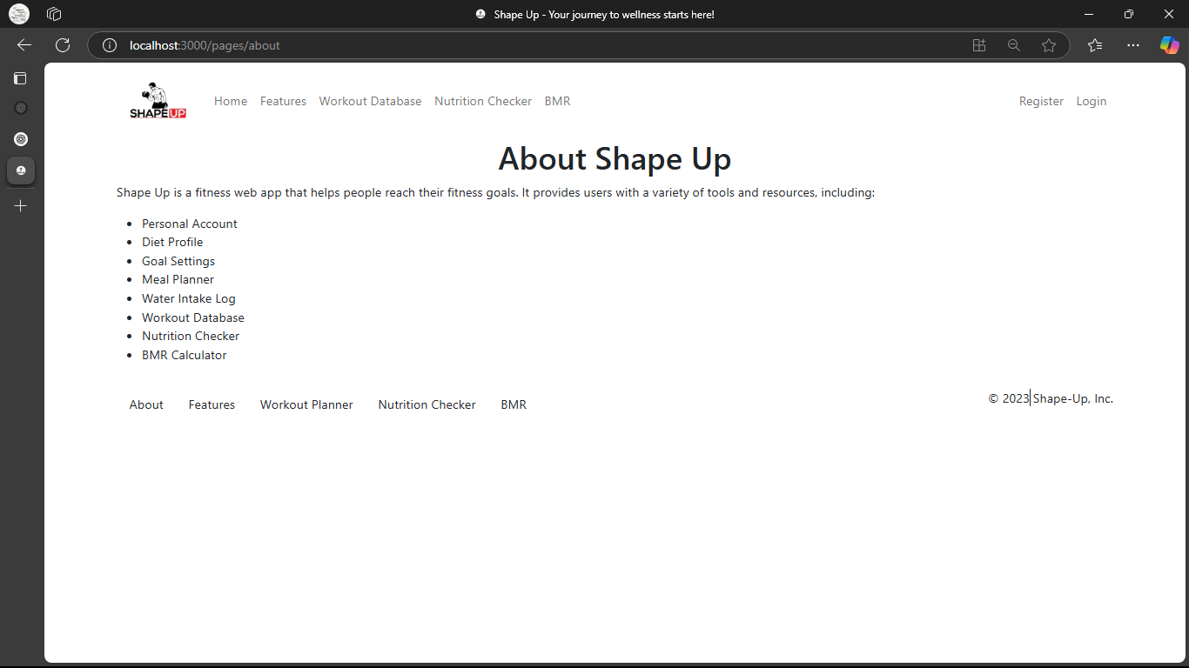

**13. CONCLUSION**

* The Shape Up App has been developed as a comprehensive fitness solution, combining cutting-edge technology with user-centric design. By leveraging the MERN stack, cloud computing, and modern security measures, the application provides an intuitive, scalable, and efficient platform for fitness enthusiasts of all levels.
* Through features like AI-driven workout personalization, seamless wearable device integration, and real-time health tracking, the app enhances user engagement and motivation. The robust backend architecture ensures high performance, data security, and smooth API interactions, while the sleek UI/UX design creates a seamless fitness experience.
* Looking ahead, the planned future enhancements, including AR/VR workouts, blockchain-based security, and advanced gamification elements, will further elevate the platform. By continuously evolving with new technologies and user feedback, the Shape Up App is poised to become a leading digital fitness companion.
* In conclusion, this project serves as a testament to the power of modern web development in revolutionizing the health and fitness industry. By focusing on innovation, scalability, and user experience, the Shape Up App paves the way for a smarter and more interactive fitness journey for users worldwide.