**RECOGNITION OF CROP DISEASE WITH DEEP LEARNING BASED ON LEAF IMAGES**

Bindu Samudrala - 700744928

Shanmukha Laxmi Pasumarthi - 700756736

Deekshith Athmakur - 700743388

Karunakar Reddy Chittepu - 700734065

**ABSTRACT**

Agricultural diseases and insect pests pose significant threats to global food production, necessitating efficient and timely detection methods to mitigate economic losses. This paper explores the application of a convolutional neural network (CNN) for the automatic identification of crop diseases, utilizing a dataset derived from the AI Challenger Competition in 2018. The dataset encompasses 27 images depicting diseases across 10 different crops.

The chosen model for training is the Inception-ResNet-v2, an architecture known for its exceptional performance in image recognition tasks. To enhance the model's capabilities, the paper introduces innovations such as cross-layer direct edges and multi-layer convolutions within the residual network unit. Following the combined convolution operation, the model's activation is achieved through the Rectified Linear Unit (ReLu) function. Experimental results showcase a commendable overall recognition accuracy of 86.1%, underscoring the efficacy of the proposed enhancements.

Beyond the theoretical developments, the research extends its impact by translating the trained model into a practical tool. A WeChat applet for crop diseases and insect pests’ recognition is designed and implemented. Through real-world testing, the system demonstrates its prowess in accurately identifying crop diseases and providing.

relevant guidance. This practical application bridges the gap between theoretical advancements and on-the-ground agricultural challenges, showcasing the tangible benefits of the developed model. The significance of this research lies in its contribution to sustainable agriculture by offering a reliable and automated method for early pest and disease detection. The integration of advanced neural network architectures and innovative features such as cross-layer direct edges exemplifies a commitment to pushing the boundaries of model performance. The successful deployment of the WeChat applet underscores the real-world applicability of the developed solution, providing farmers with a user-friendly tool to safeguard their crops.

In conclusion, this paper not only advances the field of agricultural disease and pest detection through the utilization of a CNN but also demonstrates the practical implementation of the model via a WeChat applet. The dual focus on theoretical advancements and real-world applicability positions this research as a valuable contribution to the ongoing efforts to secure global food production.

窗体顶端

**KEYWORDS**

Deep learning, Convolutional neural network, Plant diseases and pests, Classification, Object detection, Segmentation.

**INTRODUCTION**

As a superpower with more than 20% of the world’s total population, China has been facing the problem of insufficient arable land resources.

According to the survey data of the Ministry of Agriculture, the proportion of cultivated land in China is even less than 10% of China’s land area.

According to statistics data, the mountainous area accounts for about

two-thirds of the total land area in China, while the plain area accounts for only

one-third. About one third of the country’s agricultural population and arable land are in mountainous areas. This situation has resulted in the relatively poor production conditions of agriculture, forestry and animal husbandry in China.

According to the statistics of the Food and Agriculture Organization of the

United Nations, the per capital cultivated land area in China is less than half of the world average level, and shows a decreasing trend year by year. Once the natural disasters cause agricultural production reduction, it will seriously affect the output of agricultural products and agricultural development. So how to develop agriculture stably, especially in the complex environment, is extremely important for China.

Although with the development of science and technology, agricultural

production is progressing. But due to various natural factors and non-natural

factors, the yield of crops has not been greatly improved. Among the various

factors, the largest proportion is the problem of crop diseases and insect pests. According to statistics, the area of crops affected by pests and diseases in China is as high as 280 million km2 every year, and the direct yield loss is at least 25 billion kg [1]. In recent years, this problem is on the rise and seriously threatens the development of planting industry. Timely diagnosis and prevention of crop

diseases has become particularly important. At present, agricultural workers often use books and network, contact local experts and use other methods to protect and manage crop diseases. But for various reasons, misjudgments and other problems often occur, resulting in agricultural production is deeply affected.

At present, the research on crop diseases is mainly divided into two directions. The first one is the traditional physical method, which is mainly based on spectral detection to identify different diseases. Different types of diseases and insect pests cause different leaf damage, which leads to different spectral absorption and reflection of leaves eroded by diseases and healthy crops. The other one is to use computer vision technology to identify images. That is to say, the characteristics of disease images are extracted by using computer related technology, and the recognition is carried out through the different characteristics of diseased plants and healthy plants.

In recent years, the rapid development of artificial intelligence has made life more convenient, and AI has become a well-known technology. For example, Alpha Go defeated the world champion of Go. Siri and Alexa as voice assistants of Apple and Amazon are all applications of artificial intelligence technology represented by deep learning in various fields. As the key research object of computer vision and artificial intelligence, image recognition has been

greatly developed in recent years. In agricultural applications, the goal of image recognition is to identify and classify different types of pictures, and analyze the types of crops disease types, severity. Then we can formulate corresponding countermeasures to solve various problems in agricultural production in a timely and efficient manner. So as to further ensure and improve the yield of crops and help the better development of agriculture. With the rapid development of deep learning, especially in image recognition, speech analysis, natural language processing and other fields, it shows the uniqueness and efficiency of deep learning. Compared with the traditional methods, deep learning is more efficient in the diagnosis of crop diseases in the field of agricultural production. The deep learning model can monitor, diagnose and prevent the growth of crops in time. Image recognition of crop diseases and insect pests can reduce the dependence on plant protection technicians in agricultural production, so that farmers can solve the problem in time. Compared with artificial identification, the speed of intelligent network identification is much faster than that of manual detection. And the recognition

accuracy is getting higher and higher in the continuous development. The

establishment of a sound agricultural network and the combination of Internet

and agricultural industry can not only solve the problems related to crop yield

affected by diseases and insect pests, but also be conducive to the development.

of agricultural information.

However, due to the rugged terrain of the mountain environment, the surrounding interference factors are greater. Therefore, the image acquisition is more difficult than the general environment.In addition, the camera and network transmission needed for image recognition and processing will also have a certain impact.Therefore, it is more difficult to carry out intelligent recognition in mountainous areas. This paper tries to build the Internet of Things platform in the complex environment of mountainous areas, and carry out the research on the identification model of crop diseases and insect pests.The purpose of this model is to improve agricultural information, deal with the harm of pests and diseases to crops, and improve crop yield.

**MOTIVATION**

The motivation for conducting research on a recognition model for crop diseases and insect pests based on deep learning in harsh environments, particularly in mountainous areas, is deeply rooted in the pressing challenges faced by China's agricultural sector. With less than 10% of the country's land being cultivated and a significant portion of this located in mountainous terrains, there is a critical need to find innovative solutions to maximize agricultural productivity. The limited arable land in China underscores the urgency of developing effective tools for identifying and mitigating crop diseases and pest infestations, which can significantly impact crop yields.

The stakes in agricultural production are exceptionally high for China, given that agriculture is a fundamental pillar of its economy and a primary source of sustenance for its vast population. The threat posed by crop diseases and insect pests, leading to substantial yield losses, has prompted a concerted effort to explore advanced technologies that can provide timely and accurate solutions. Deep learning, with its rapid advancements in image recognition, emerges as a promising avenue to revolutionize the identification and management of crop diseases and pests.

The escalating challenge of crop diseases and pests in China, with an annual direct yield loss of at least 25 billion kg, further emphasizes the need for proactive measures. Traditional methods often fall short in harsh environments, necessitating the exploration of cutting-edge technologies to overcome the unique challenges presented by mountainous terrain. The efficiency and speed of deep learning make it particularly well-suited for the swift and accurate identification of crop diseases, providing an opportunity to revolutionize agricultural practices. Additionally, the integration of an Internet of Things (IoT) platform in challenging environments aligns with the broader trend of incorporating technology into agriculture. This not only facilitates crop disease recognition but also contributes to the overall development of agricultural information systems. By addressing challenges specific to harsh environments, the research aims to enhance the resilience of agriculture, providing farmers with tools that can navigate the complexities of mountainous terrains and contribute to sustained agricultural development.

In conclusion, the motivation for researching a recognition model based on deep learning in harsh environments arises from the urgency to address the unique challenges faced by China in its agricultural landscape. The potential benefits include increased agricultural productivity, economic stability, and food security through the application of advanced technologies in crop disease and pest management.

**MAIN CONTRIBUTIONS & OBJECTIVES**

* The primary objective is to design and implement advanced recognition models based on deep learning techniques specifically tailored for the challenging and harsh environments of mountainous areas.
* The research aims to contribute to the improvement of agricultural productivity by providing farmers with reliable tools for early detection and management of crop diseases and insect pests.
* The objective is to develop recognition models that can effectively overcome the unique challenges presented by mountainous terrains, such as rugged landscapes and higher interference factors. This includes addressing difficulties in image acquisition and minimizing the impact of surrounding environmental factors on model accuracy.
* The research seeks to integrate the developed recognition models into an Internet of Things (IoT) platform, enhancing the overall connectivity and efficiency of agricultural information systems in harsh environments. This integration aims to facilitate real-time monitoring and data-driven decision-making for farmers and agricultural practitioners.
* The primary aim is to reduce the dependence on traditional manual detection methods by providing an automated and intelligent solution for identifying crop diseases and insect pests.
* The research has a broader objective of contributing to sustainable agriculture by mitigating the impact of crop diseases and pests on agricultural production. Through the development and implementation of advanced recognition models, the aim is to foster resilience in farming practices, promoting long-term sustainability in the face of environmental challenges.

**RELATED WORK**

The identification and prevention of crop diseases and insect pests is a continuous research topic. With the development of technology, many sensor networks and automatic monitoring systems have been proposed.A method of detection of specific disease in grapes is proposed .

Downy mildew pest/disease can be detected by the real time system with weather data. The central sever provide forecast service of weather condition and disease. Another kind of solution related of monitoring traps which are used to capture pest is with the help of image sensors .

In , he authors designed and implemented a low power consumed system which is based on wireless image sensors and powered by battery. The frequency of capturing and transferring trap images of sensors can be set and remote adjusted by trapping application.

Acoustic sensors are also used in monitoring system. In, the authors give a solution to detect red palm weevil (abbr. RPW) with them. With the help of acoustic device sensor, the pest’s noise can be captured automatically. When the noise level of pest increases to some threshold, the system will notify the client that the infestation is occurring in the specific area.It helped farmers to be economical of time and energy to check every part of cropland by themselves and increase the labor efficiency.

All acoustic sensors will be connected to base stations and each one will report the noise level if the predefined threshold value is surpassed. Machine learning also had been applied in the agricultural field, such as investigation of plant disease and pests and so on.

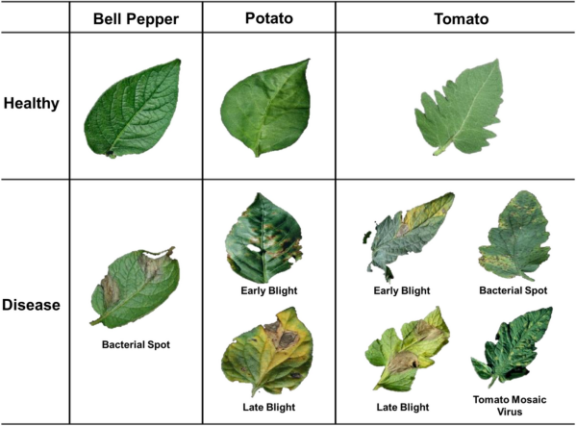

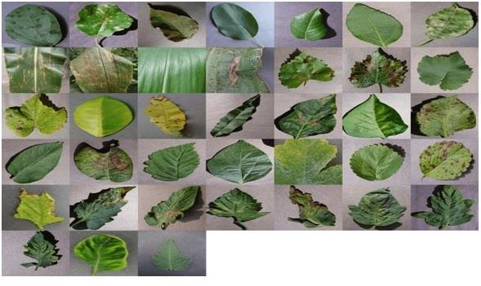

Plenty of techniques of machine learning had been widely used to solve the problem of plant disease diagnosis. In, a Neural Network based method of estimating the health of potato with leaf image datasets is proposed.

Additionally, the experimental research in was carried out, which aimed to implement a system of recognizing plant disease with images. In order to distinguish wheat stripe rust from wheat leaf rust and grape downy mildew from powdery mildew, four different types of neural networks were trained based on color, shape and texture features extracted from disease image dataset.

The work showed that neural network based on image processing can increase the effectivity of diagnosing plant disease. What’s more, scab disease of potato could be also detected by the image processing methods.

Firstly, the images from various potato fields were collected. After image enhancement, image segmentation was carried out to acquire target region. At last, a histogram-based approach to analyses the target was applied, so that the phase of the disease could be found.

窗体顶端

**PROPOSED FRAMEWORK**

Framework Overview: The proposed system introduces a deep learning-based framework for crop disease and pest recognition in harsh agricultural environments.

Model Architecture: Utilizing advanced deep learning algorithms, the proposed system aims to create models capable of accurate and rapid identification of diverse crop threats.

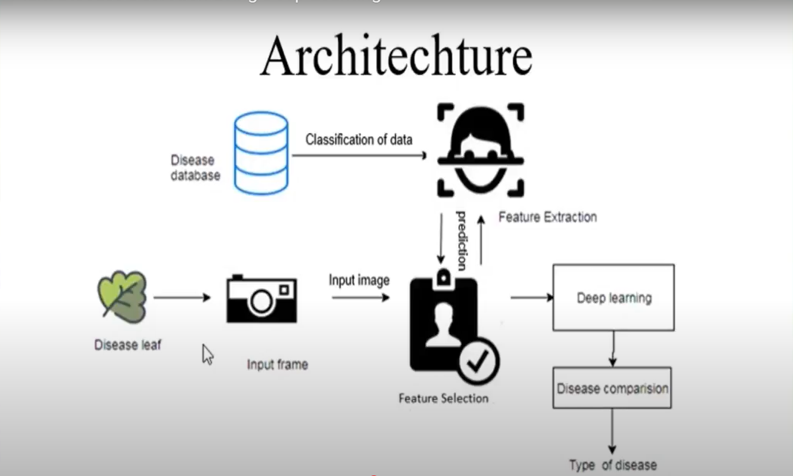

Many scientists did much research on deep learning algorithms in the past, and a few were in progress. It is a continuous process where we use some prediction techniques to get the output beforehand. Usage of deep learning and artificial intelligence has been increasing for a few years as the technology related to computer science is becoming more dominant in coming days.  
  
As shown in the figure, deep learning is mainly classified into two categories which are supervised and unsupervised deep learning. This project was implemented using some of the supervised deep learning techniques. Neural networks have an edge on accuracy compared to other traditional algorithms used for prediction. Deep learning has been progressing concerning fame among the students. It has been from the degrees of hypothetical scholastics to applications and exploration in ventures. Benefits have been acquired with continually arising calculations and frameworks to handle gigantic level information and complex calculations. With recently planned, what is more, improved equipment accessible today, the field of profound Learning is raising its bar. Profound learning structures are being tweaked and summed up to advance effectively with exact models. Below is the graph of the performance of deep neural networks and traditional machine learning.

Deep learning is chosen over machine learning not only for its accuracy, but it is easily accessible if there are any changes in data or the dataset. Also, if the data is increased in machine learning, it increases the burden on the classifiers used in machine learning.

**NEURAL NETWORK**

Neural network is one of the most used deep learning models as it stores and transfers a lot of information and is also used in many applications. Neurons are typical elements that process the data by receiving through their dendrites and transfer the information among them through synapse.

**CONVOLUTIONAL NEURAL NETWORK**

Convolutional neural networks are one of the finest technologies developed for predictions. In the current digital world, convolutional neural networks created their own identity in deep learning. Processing data is the essential and critical part of training and executing the model, in which CNN plays an important role.

In this convolutional neural network, many neurons are connected through their synapses, pass the data through it, and then transfer it to the subsequent layers without losing information. Basic CNN consists of an input layer, a few hidden layers, and an output layer. The essential information is processed through the input layer, and later the output will come through the output layer.

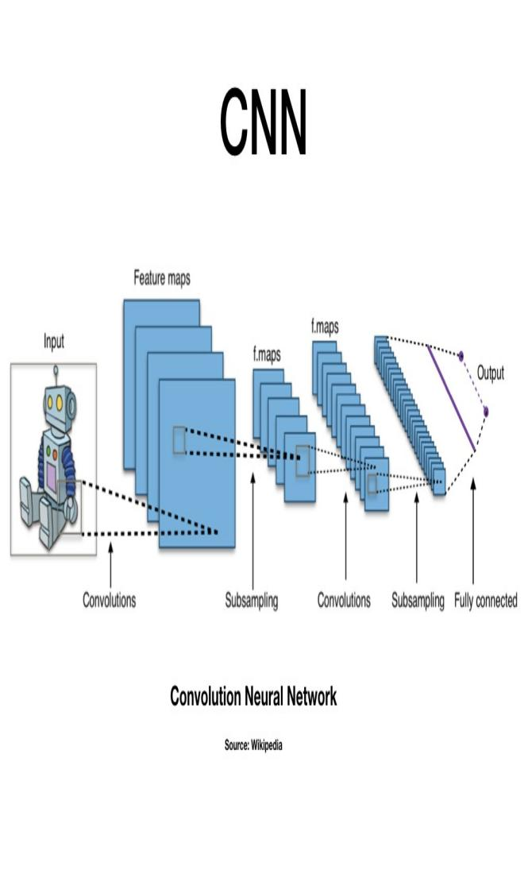

**CONVOLUTIONAL LAYER**

The convolutional layer is one of the most important parts in convolutional neural networks. In this convolutional layer, the neuron in the neural network takes out some features from the input image. The convolution kernel of a certain size is moved  
around the input image and we get another image which is called a feature map. The number of feature maps produced will be equal to the number of neurons as one neuron contains one feature of the input image. This process is further implemented using kernels such that there will be only one output image at last. From the source image, we make use of the input of a neuron which contains features of the input image which is like a 3x3 filter, and it looks at different patches and finally produces an output image. This is the convolution which is frequently used in image processing and in deep learning for well-defined inputs. These convolutional kernels (weights) are ones which we are trying to learn and work about with the process of training.

**FULLY CONNECTED LAYER**

This fully connected layer works as a mediator between the convolutional neural networks and the output. The output generated by the convolutional neural network is further processed as an input to the fully connected layer which in turn is processed for further classification. The purpose of a fully connected layer is to apply the results of convolution and pooling operations to the classification of pictures into labels. The development of the convolution and pooling procedures is processed and flattened into a single vector of values, representing the likelihood that a particular feature will be included in the label. For example, if the image is of a cat, the qualities and features exhibiting things like whiskers or fur would have a higher probability of being labeled "cat." CNN's Fully Connected Layers use a backpropagation approach to establish the weights with the highest accuracy. Weights assigned to each neuron in the network signify principal components. Finally, the neurons conduct a probability-based vote on each label, with the winner referred to as the categorization decision.

**DATA DESCRIPTION**

DATASET

The data set used in this paper is from the data set used in the Crop

Disease Recognition Competition of the 2018 Artificial Intelligence Challenger

Competition. The datasets includes 47363 images of 27 diseases related to 10 crops (mainly tomatoes, potatoes, corn, etc.). The data set is divided into three parts: 70% for training set, 10% for validation set and 20% for test set. Each picture contains only the leaves of a single crop. Some sample pictures are

Shown.

IMAGE PREPROCESSING

The purpose of image preprocessing is to eliminate the interference of

useless information in data set to model recognition, and to expand the data set

to a certain extent. The neural network can achieve better training effect. In this

way, the recognizably of the image can be effectively improved, so that the

recognition accuracy of the model can be improved. At present, the commonly

used preprocessing methods include geometric space transformation and pixel color transformation. The former includes flip, crop, rotate, zoom and so on. The latter includes changing contrast, adding Gaussian noise, color dithering

and so on. Because of the uneven distribution of data sets, so in this paper, we mainly take the method of light transformation and random clipping. Enhance the feature information of the picture and the scale of the data set itself. The influence of the background factor and the data quantity problem on the model is weakened. It can make the model produce better learning effect and increase the stability of the model.

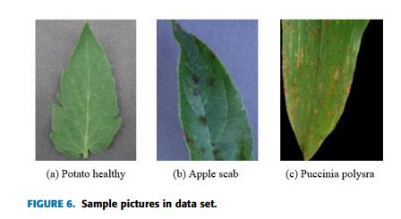

Initially, this paper does not train the neural network by transfer learning

method. In the end, although the training set has reached 90% accuracy.

However, according to the loss trend and the final test set results, it can be

clearly seen that there is an over-fitting phenomenon. After analysis, the most

likely reason is that the data set is relatively small. Although data enhancement alleviates the problem of uneven distribution to some extent, it does not completely solve the problem of over-fitting. Thereafter, this paper uses transfer learning on this data set. It is to use the standard network for training, only need to modify the model slightly and train here can get very good training effect. To sum up, transfer learning can bring higher initial accuracy, faster convergence

speed and more accurate approximation accuracy for the model.

NORMALIZED PROCESSING

After that above steps are complete, the picture of the data set will be

normalized. Normalization can be considered to be an indispensable and

important part of the convolutional neural network. It scales the characteristics of each dimension to the same range. On the one hand, it is convenient to calculate data and improve the efficiency of operation. On the other hand, the association between different features is eliminated. Therefore, the ideal model training result can be obtained.

**RESULTS**

In order to enable farmers to identify and detect pests and diseases conveniently and quickly, this paper establishes a system based on WeChat applet. The program can identify the disease on the leaves of crops with diseases, which is convenient for farmers to understand the situation of diseases and insect pests and to obtain expert guidance. The system first uploads the image, and then transmits the image data to the back end for processing through the network front-end. Image preprocessing is mainly to optimize the incoming image. First of all, the image is zoomed to meet the requirements of the model input, too large image will seriously affect the efficiency of recognition. Secondly, in order to achieve higher recognition efficiency, the image is cut randomly, and the pixels are optimized. Finally, the name and status of the crop with the highest matching degree will be given after the recognition is completed.

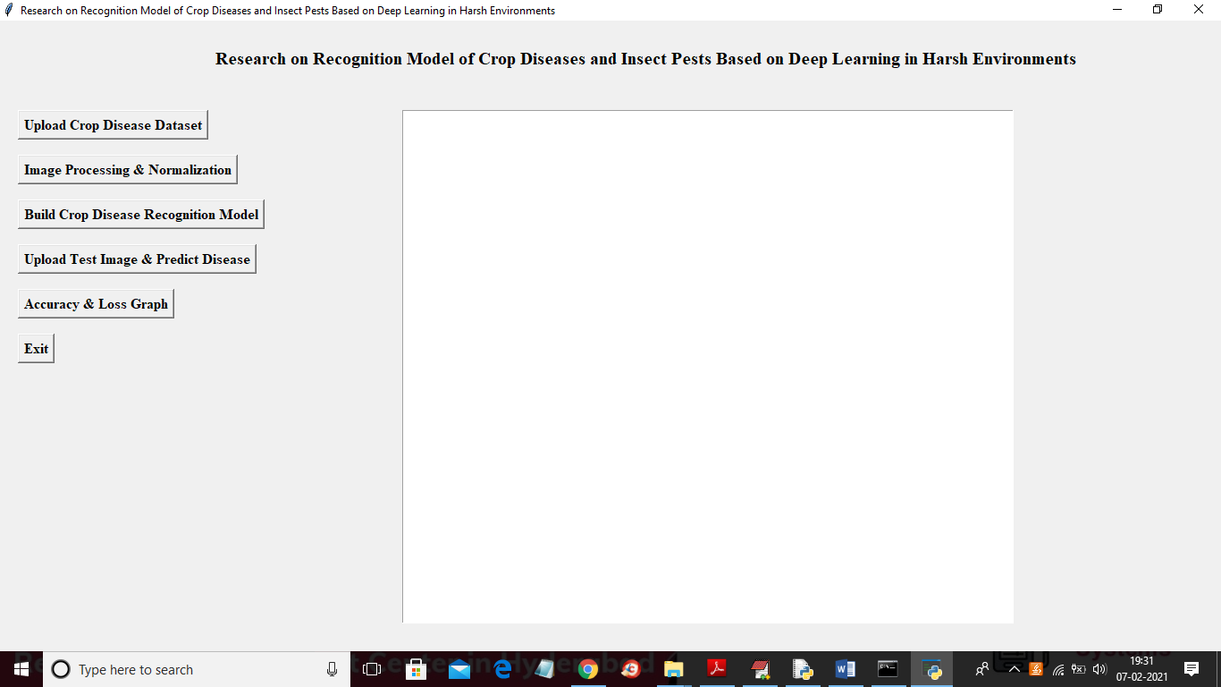

Without disease

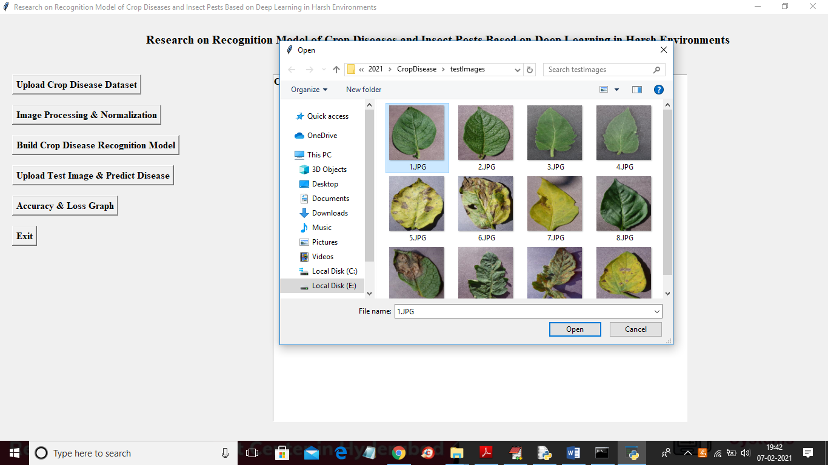

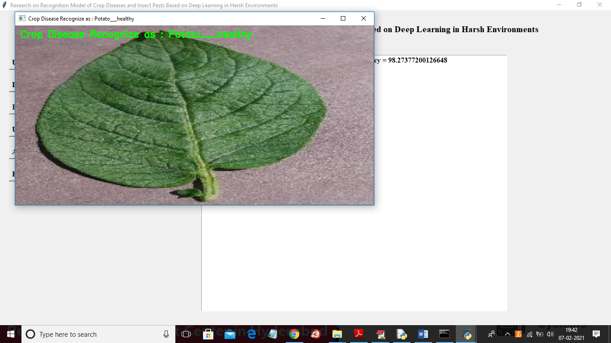

With Disease

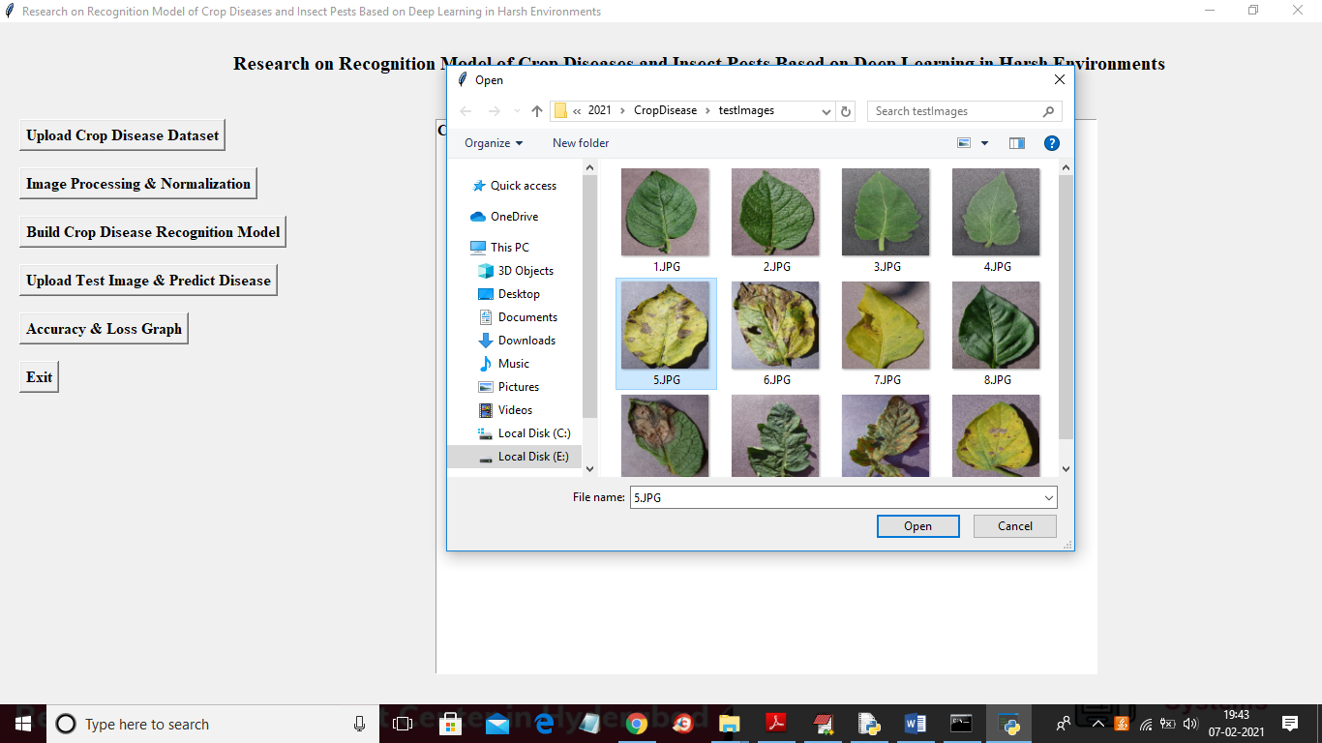

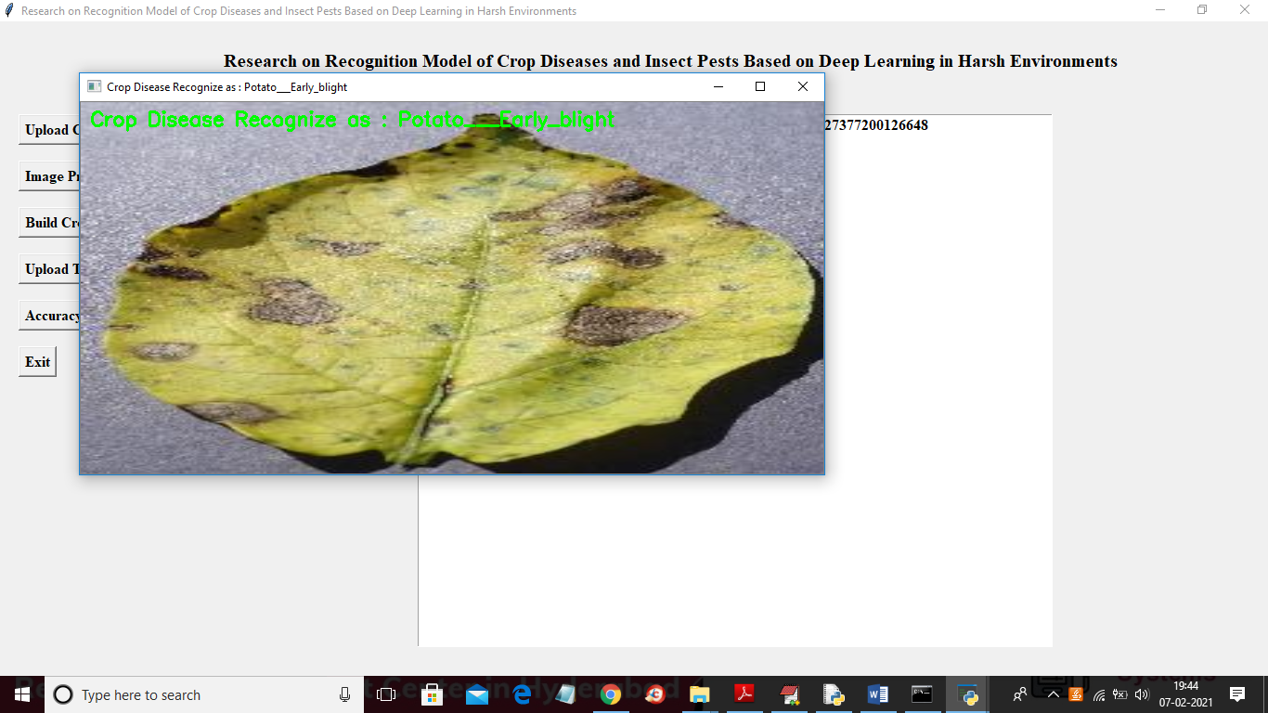

In this paper, 27 kinds of disease recognition of 10 kinds of crops were

studied. The Inception-ResNet-v2 model is constructed by using deep learning

theory and convolution neural network technology. Experiments show that the

model can effectively identify the data set, and the overall recognition accuracy

is as high as 86.1%. The results show that the recognition accuracy of this hybrid network model is relatively higher than the traditional model, and it can be effectively applied to the identification and detection of plant diseases and

insect pests.

In the future work, there are two directions should be improved:

1) Extended data set. In this paper, only 27 diseases of 10 crop species were

studied, and other species and diseases were not involved, such as rice and

wheat, and their related diseases. Therefore, the next step is to obtain more crop

species and disease images for research.

2) Optimize the model. Through the experiment of this paper, we can see that

Inception-resnet-v2 this kind of mixed network has absorbed the corresponding

advantage. This model has achieved good recognition accuracy, and is worthy

of further study and optimization. At the same time, we should design a network

model which can classify crop images with higher accuracy

**REFERENCES**

[1] J. Schmid Huber, ‘‘Deep learning in neural networks: An overview,’’ Neural

Netw., vol. 61, pp. 85–117, Jan. 2015.

[2] A.-R. Mohamed, G. E. Dahl, and G. Hinton, ‘‘Acoustic modeling using deep

belief networks,’’ IEEE Trans. Audio, Speech, Lang. Process., vol. 20, no.1,

pp. 14–22, Jan. 2012.

[3] Y. Bengio and O. Delalleau, ‘‘On the expressive power of deep

architectures,’’ in Proc. 14th Int. Conf. Discovery Sci. Berlin, Germany, 2011,

no. 1, pp. 18–36.

[4] L. Deng, O. Abdel-Hamid, and D. Yu, ‘‘A deep convolutional neural

network using heterogeneous pooling for trading acoustic invariance with

phonetic confusion,’’ in Proc. IEEE Int. Conf. Acoust., Speech Signal Process.,

May 2013, pp. 6669–6673.

[5] S. Datir and S. Wagh, ‘‘Monitoring and detection of agricultural disease

using wireless sensor network,’’ Int. J. Comput. Appl., vol. 87, no. 4, pp. 1–5,

Feb. 2014. [6] O. López, M. Rach, H. Migallon, M. Malumbres, A. Bonastre, and J. Serrano, ‘‘Monitoring pest insect traps by means of low-power image sensor technologies,’’ Sensors, vol. 12, no. 11, pp. 15801–15819, Nov. 2012.

[7] N. Srivastav, G. Chopra, P. Jain, and B. Khatter, ‘‘Pest Monitor and control

system using WSN with special reference to acoustic device,’’ in Proc. 27th ICEEE, Jan. 2013, pp. 92–99.

[8] G. Athanikar and M. P. Badar, ‘‘Potato leaf diseases detection and

classification system,’’ Int. J. Comput. Sci. Mobile Comput., vol. 5, no. 2, pp.

76–88, 2016. **80**[9] H. Wang, G. Li, Z. Ma, and X. Li, ‘‘Application of neural networks to image recognition of plant diseases,’’ in Proc. Int. Conf. Syst. Informat. (ICSAI), May 2012, pp.

[10] D. Samanta, P. P. Chaudhury, and A. Ghosh, ‘‘Scab diseases detection of

potato using image processing,’’ Int. J. Comput. Trends Technol., vol. 3, no. 1,

pp. 109–113, 2012.

[11] A. Krizhevsky, I. Sutskever, and G. E. Hinton, ‘‘ImageNet classification

with deep convolutional neural networks,’’ in Proc. Int. Conf. Neural Inf.. Syst. Red Hook, NY, USA: Curran Associates, 2012, pp. 1097–1105.

[12] K. He, X. Zhang, S. Ren, and J. Sun, ‘‘Deep residual learning for image

recognition,’’ in Proc. IEEE Conf. Comput. Vis. Pattern Recognit., Jun. 2016, pp. 770–778.

[13] E. C. Too, L. Yujian, S. Njuki, and L. Yingchun, ‘‘A comparative study of

fine-tuning deep learning models for plant disease identification,’’ Comput.

Electron. Agricult., vol. 161, pp. 272–279, Jun. 2019.

[14] S. P. Mohanty, D. P. Hughes, and M. Salathé, ‘‘Using deep learning for

image-based plant disease detection,’’ Frontiers Plant Sci., vol. 7, p. 1419, Sep.

2016.

[15] S. Sladojevic, M. Arsenovic, A. Anderla, D. Culibrk, and D. Stefanovic,

‘‘Deep neural networks-based recognition of plant diseases by leaf image classification,’’ in Proc. Comput. Intell. Neurosci., May 2016, Art. no.

[16] M. Dyrmann, H. Karstoft, and H. S. Midtiby, ‘‘Plant species classification

using deep convolutional neural network,’’ Biosystems Eng., vol. 151, pp. 72– 80, Nov. 2016.

[17] I. Sa, Z. Ge, F. Dayoub, B. Upcroft, T. Perez, and C. McCool, ‘‘DeepFruits:

A fruit detection system using deep neural networks,’’ Sensors, vol. 16, no. 8, p. 1222, Aug. 2016.

[18] S. Ren, K. He, R. Girshick, and J. Sun, ‘‘Faster R-CNN: Towards realtime

object detection with region proposal networks,’’ in Proc. Neural Inf. Process.

Syst., 2015, pp. 91–99.

[19] Y. Lecun, L. Bottou, and Y. Bengio, and P. Haffner, ‘‘Gradient-based

learning applied to document recognition,’’ Proc. IEEE, vol. 86, no. 11, pp. 288–319, Nov.

[20] S. G. Salve and K. Jondhale, ‘‘Shape matching and object recognition using shape contexts,’’ in Proc. 3rd Int. Conf. Comput. Sci. Inf. Technol., Jul. 2010, pp. 483–507.