**Topics: Descriptive Statistics and Probability**

1. Look at the data given below. Plot the data, find the outliers and find out $μ, σ, σ^{2}$

|  |  |
| --- | --- |
| **Name of company** | **Measure X** |
| Allied Signal | 24.23% |
| Bankers Trust | 25.53% |
| General Mills | 25.41% |
| ITT Industries | 24.14% |
| J.P.Morgan & Co. | 29.62% |
| Lehman Brothers | 28.25% |
| Marriott | 25.81% |
| MCI | 24.39% |
| Merrill Lynch | 40.26% |
| Microsoft | 32.95% |
| Morgan Stanley | 91.36% |
| Sun Microsystems | 25.99% |
| Travelers | 39.42% |
| US Airways | 26.71% |
| Warner-Lambert | 35.00% |

Pie Chart Box Plot

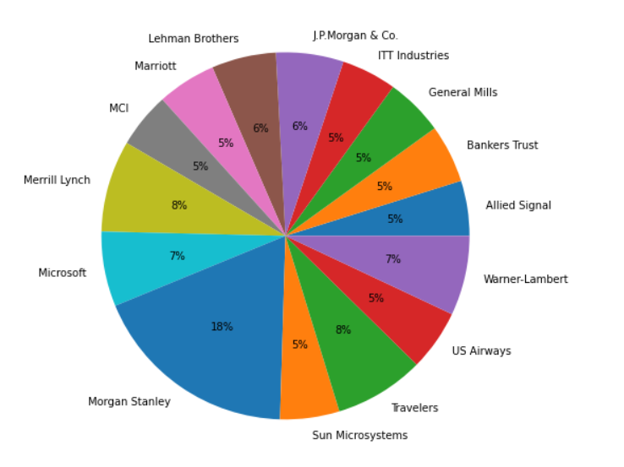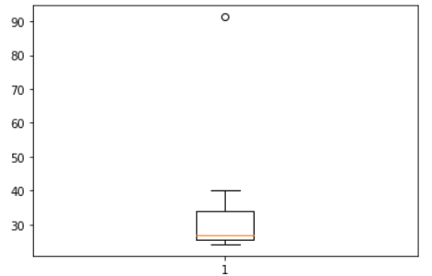

Mean $μ$ =33.271

Standard deviation, $σ$ = 16.945

Variance, $σ^{2}$ =287.146



Answer the following three questions based on the box-plot above.

1. What is inter-quartile range of this dataset? (please approximate the numbers) In one line, explain what this value implies.

Ans: Q1=5, Q2=7, Q3=12

IQR= Q3-Q1 =12-5 = 7

1. What can we say about the skewness of this dataset?

Ans: Right Skewness median is towards left side

1. If it was found that the data point with the value 25 is actually 2.5, how would the new box-plot be affected?

Ans: Right Skewness. Mean > Median > Mode



1. Answer the following three questions based on the histogram above.
2. Where would the mode of this dataset lie?

Ans: The most of data lies between the values of 4 and 8

1. Comment on the skewness of the dataset.

Ans: Right skewed

1. Suppose that the above histogram and the box-plot in question 2 are plotted for the same dataset. Explain how these graphs complement each other in providing information about any dataset.

Ans: From these above graphs, both are right skewed and both having outliers that can visualized in box plot where as in Histogram mode is more visible

1. AT&T was running commercials in 1990 aimed at luring back customers who had switched to one of the other long-distance phone service providers. One such commercial shows a businessman trying to reach Phoenix and mistakenly getting Fiji, where a half-naked native on a beach responds incomprehensibly in Polynesian. When asked about this advertisement, AT&T admitted that the portrayed incident did not actually take place but added that this was an enactment of something that “could happen.” Suppose that one in 200 long-distance telephone calls is misdirected. What is the probability that at least one in five attempted telephone calls reaches the wrong number? (Assume independence of attempts.)

Ans:

one in 200 long-distance telephone calls is misdirected

probability of call misdirecting p = 1/200

Probability of call not Misdirecting = 1 - 1/200 = 199/200

No of calls = 5

n=5

p=1/200

q=199/200

At Least one in five attempted telephone calls reached the wrong number

=1 – none of the call reaches the wrong number

= 1- P (0)

= 1- ⁵C₀ (1/200) ⁰ (199/200) ⁵⁻⁰

= 1- (199/200) ^5

= 0.02475

**Probability that at least one in five attempted telephone calls reaches the wrong number = 0.02475**

1. Returns on a certain business venture, to the nearest $1,000, are known to follow the following probability distribution

|  |  |
| --- | --- |
| x | P(x) |
| -2,000 | 0.1 |
| -1,000 | 0.1 |
| 0 | 0.2 |
| 1000 | 0.2 |
| 2000 | 0.3 |
| 3000 | 0.1 |

1. What is the most likely monetary outcome of the business venture?

Ans: The most likely monetary outcome of the business venture is $2000 as it has maximum Probability of 0.3

1. Is the venture likely to be successful? Explain

Ans: Yes, The venture is Successful that x is positive. i.e. X is 1000,2000,3000 and its total Probability is 0.6.

1. What is the long-term average earning of business ventures of this kind? Explain\

Ans: The long-term average earning of business ventures $800

1. What is the good measure of the risk involved in a venture of this kind? Compute this measure

Ans:  The good measure of the risk involved in a venture of this kind depends on the Variability in the distribution. Higher Variance means more chances of risk Var (X) = E(X^2) –(E(X)) ^2 = 2800000 – 800^2 = 2160000