SYSTEM DESIGN
DOCUMENTATION
for
INTEGRATED FITNESS & RESOURCE
MANAGEMENT SYSTEM(IFRMS)
Version 1.0

Prepared by :
Group No : CS03_4
Name | Roll No | Email
N.Jatin | B240250CS | nalli_b240250cs@nitc.ac.in
K.D.Karun Lakshman | B240213CS | kodeti_b240213cs@nitc.ac.in
A.N.S.Thanush Reddy | B240133CS | ambati_b240133cs@nitc.ac.in
J.Manish Reddy | B240200CS | jakka_b240200cs@nitc.ac.in

Instructor: Dr. A. Sudarshan Chakravarthy
Course: Database Management System(CS2011E)
Date :23/03/2026
CONTENTS

CONTENTS ...2
1. PURPOSE …3
1.1 Document Objectives …3
1.2 Intended Audience and Document Overview …3
1.3 Definitions, Acronyms and Abbreviations …4
1.4 References …4

2. ASSUMPTIONS AND CONSTRAINTS ...5
2.1 Assumptions …5
2.2 Constraints …5

3. DATABASE-WIDE DESIGN DECISIONS …6
3.1 Behaviour …6
3.1.1 Login or Register …6
3.1.2 Member …6
3.1.3 Trainer …6
3.1.4 Admin …6
3.2 DBMS Platform …7
3.3 Security Requirements …7
3.4 Performance and Availability …7

4. DATABASE ADMINISTRATIVE FUNCTIONS …8
4.1 Entity-Relation Model …8
4.2 Relational Schema …9
4.3 Normalization …9
4.4 Schema Description & Data Formats …10

1. PURPOSE

This document presents the system design for the Integrated Fitness & Resource Management System (IFRMS). It describes the database architecture, entity relationships, and key design decisions derived from the Software Requirements Specification (SRS).
The system is designed to support efficient gym management by handling operations such as member registration, workout planning, equipment tracking, session scheduling, and report generation.
1.1 Document Objectives
This document specifies the overall design, functionality, and database structure of the IFRMS. The system aims to enhance gym operations by organizing data efficiently, reducing manual effort, and improving overall management and monitoring capabilities.
This document covers the following:
- System objectives and functionalities.
- Assumptions and constraints.
- Database-wide design decisions, including behaviour, security, and performance considerations.

1.2 Intended Audience and Document Overview
The System Design Document is intended for the following audience:
- Developers : Developers use this document to understand how the system should be implemented. It provides details about database structure, relationships, and system behavior, helping them build backend APIs, integrate the database, and ensure that all functional requirements are correctly implemented and to design and optimize the database schema.
- Project Evaluators : Project evaluators refer to this document to assess whether the system design aligns with the SRS requirements. They verify correctness of the ER model, relational schema, normalization, and overall database design quality.
- System Administrators : They use this document to understand database structure, manage backups, monitor performance, handle user access control, and ensure system availability and security.
- Gym Owner / Manager : The gym owner or manager is a key stakeholder who uses the system for operational decision-making.It allows them to evaluate whether the system meets business needs and improves efficiency in gym operations.

1.3 Definitions, Acronyms, and Abbreviations
SL.NO | ABBREVIATIONS | DEFINITIONS
1 | IFRMS | Integrated Fitness & Resource Management System
2 | DBMS | Database Management System
3 | ADMIN | System administrator with full access to all functionalities
4 | TRAINER | User responsible for creating workout plans and managing training sessions
5 | MEMBER | Registered user who enrolls in fitness programs and tracks progress
6 | API | Application Programming Interface
7 | GUI | Graphical User Interface
8 | CRUD | Create ,Read, Update, Delete operations
9 | SQL | Structured Query Language
10 | JWT | JSON web token used for authentication

1.4 References
- Fundamentals of Database Management Systems and relational models
- MySQL relational database concepts and operations
https://www.w3schools.com/mysql/mysql_rdbms.asp
- Database design and normalization concepts
https://www.geeksforgeeks.org/dbms/database-design-in-dbms/
- Backend development using Node.js and Express (official docs)
https://expressjs.com/
- Modern web application framework (Next.js documentation)
https://nextjs.org/docs
- Software Requirements Specification Document of IFRMS.
- Discussions with Gym owner and Mangers.

2. ASSUMPTIONS AND CONSTRAINTS

2.1 Assumptions
- The system will be used by registered users categorized as members, trainers, and admins.
  - Each user interacts with the system based on predefined roles and permissions.
- The application will be web-based and accessible through standard browsers.
  - Users can access the system without installing additional software.
- Users will have basic knowledge of using web applications.
  - Minimal training is required for system usage.
- The system will use PostgreSQL as the backend database.
  - Ensures reliability, scalability, and structured data management.
- Internet connectivity is required for accessing the system.
  - All operations such as login and scheduling depend on online access.
- Data entered by users is assumed to be valid and accurate.
  - Reduces complexity of handling incorrect or malicious inputs.

2.2 Constraints
- Role-Based Access Control (RBAC) must be enforced.
  - Users can only access features permitted for their role (member, trainer, admin).
- Passwords must be stored securely using hashing techniques.
  - Prevents unauthorized access even if database is compromised.
- The system must support multiple users simultaneously.
  - Ensures smooth operation during peak usage without performance issues.
- Database consistency and integrity must be maintained.
  - Prevents data anomalies during concurrent operations.
- The system must follow RESTful API architecture.
  - Ensures standardized communication between frontend and backend.
- Equipment status must always reflect real-time updates.
  - Avoids conflicts in resource usage and maintenance tracking.
- Scheduling conflicts must be prevented.
  - Ensures that no two sessions overlap for the same trainer or member.
- Sensitive user data must be protected from unauthorized access.
  - Maintains privacy and complies with security requirements.
- The UI should be intuitive for both technical and non-technical users.

3. DATABASE – WIDE DESIGN DECISIONS

3.1 BEHAVIOUR

3.1.1 Login or Register
- Users (members, trainers, and admins) must register with valid credentials.
- Upon registration, user details are securely stored in the database.
- Passwords are stored using hashing techniques for security.
- The system verifies login credentials before granting access.
- Users are redirected to their respective dashboards based on their role.
- Invalid login attempts will display an error message: “Invalid Credentials”.

3.1.2 Member
- Members can register and manage their profile information.
- Members can view available fitness programs and enroll in them.
- Members can view assigned workout plans created by trainers.
- Members can track their fitness progress over time.
- Members can view their membership details and session schedules.

3.1.4 Trainer
- Trainers can log in and manage their profile information.
- Trainers can create and assign workout plans to members.
- Trainers can track and update member fitness progress.
- Trainers can schedule training sessions for members.
- Trainers can view schedules and assigned members.

3.1.3 Admin
  - Admins have full access to all system functionalities.
  - Admins can manage member and trainer records.
  - Admins can add, update, or remove gym equipment.
  - Admins can monitor equipment status and maintenance.
  - Admins can generate reports on system usage and activities.

3.2 DBMS Platform
- PostgreSQL / MySQL Database: Used for storing and managing all system data such as user details, workout plans, fitness progress, equipment information, schedules, and reports. It ensures data consistency, reliability, and efficient query processing.
- Node.js & Express Backend: Used to handle application logic, process user requests, manage database interactions, and implement authentication and authorization mechanisms. It provides RESTful APIs for communication between frontend and database.
- Next.js / Basic Web Frontend: Used to create a user-friendly interface where members, trainers, and admins can interact with the system. It communicates with the backend through API calls to display and update data.

3.3 Security Requirements
- Role-Based Access Control (RBAC)
- Password hashing
- Authentication using JWT
- Data protection against unauthorized access

3.4 Performance and Availability
- The system shall execute database queries within a short response time (typically under 2 seconds) to ensure smooth user interaction.
- The system shall support multiple concurrent users (members, trainers, and admins) without performance degradation.
- The system shall use efficient indexing and normalized database design to optimize data retrieval and storage.
- The system shall provide real-time updates for scheduling, workout tracking, and equipment status to maintain consistency.
- The system shall ensure high availability with minimal downtime during regular operations.
- The system shall handle increasing data volume and user load without affecting system performance.

4. DATA ADMINISTRATIVE FUNCTIONS
4.1 Entity-Relation Model

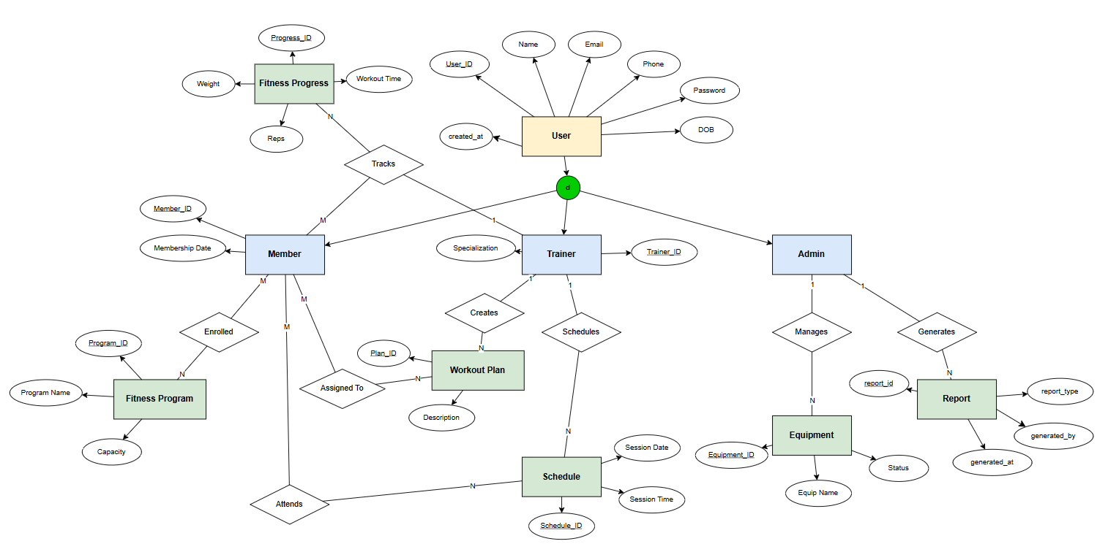
*created in draw.io software

Chen’s model ER Diagram of
Integrated Fitness & Resource Management System

4.2 Relational Schema

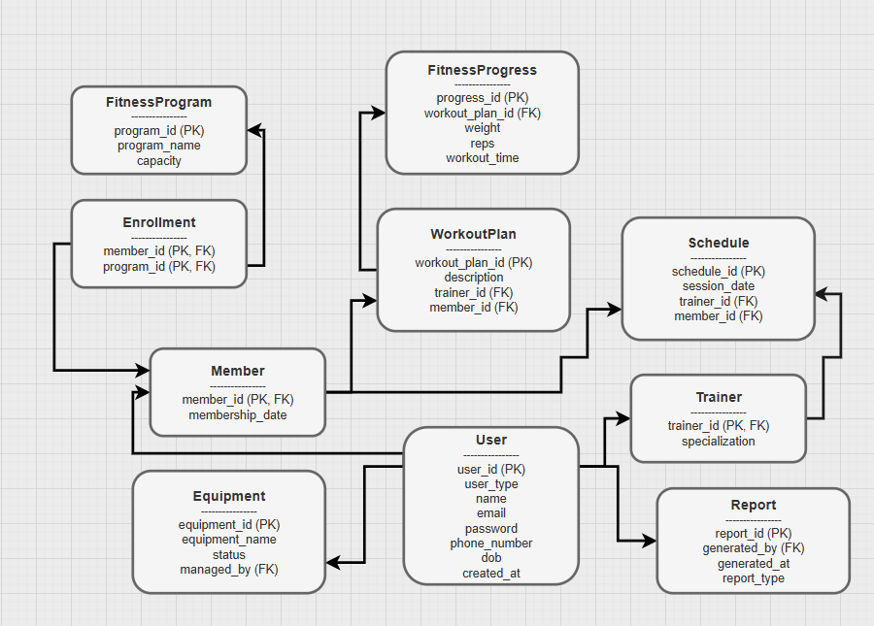
*created in draw.io software
4.3 Normalization

- 1NF (First Normal Form) : The database tables conform to 1NF as all attributes store indivisible (atomic) values. There are no repeating groups or multivalued attributes, and each record is uniquely identifiable. Hence, the schema satisfies First Normal Form.

- 2NF (Second Normal Form) : Since the tables are already in 1NF, the design ensures that no partial dependencies exist. Every non-key attribute is fully dependent on the entire primary key rather than a subset of it. Therefore, the schema satisfies Second Normal Form.

- 3NF (Third Normal Form) : Building on 2NF, the schema eliminates transitive dependencies. Non-key attributes depend only on the primary key and not on other non-key attributes. Thus, the database design satisfies Third Normal Form

4.4 Schema Description & Data Formats

User Table
Attribute | Data Type | Description
user_id | SERIAL (PK) | Unique identifier for each user
user_type | VARCHAR(20) | Type of user (member, trainer, admin)
name | VARCHAR(100) | Full name of the user
email | VARCHAR(100) | Unique email address
password | VARCHAR(255) | Hashed password for authentication
phone_number | VARCHAR(15) | Contact number of user
dob | DATE | Date of birth
created_at | TIMESTAMP | Account creation timestamp

Member Table
Attribute | Data Type | Description
member_id | INT (PK, FK) | References User(user_id)
membership_date | DATE | Date when member joined

Trainer Table
Attribute | Data Type | Description
trainer_id | INT (PK, FK) | References User(user_id)
specialization | VARCHAR(100) | Area of expertise (e.g., Yoga, Cardio)

FitnessProgram Table
Attribute | Data Type | Description
program_id | SERIAL (PK) | Unique identifier for program
program_name | VARCHAR(100) | Name of the fitness program

Enrollment Table
Attribute | Data Type | Description
member_id | INT (FK) | References Member(member_id)
program_id | INT (FK) | References FitnessProgram(program_id)

WorkoutPlan Table
Attribute | Data Type | Description
workout_plan_id | SERIAL (PK) | Unique identifier for workout plan
workout_description | TEXT | Details of exercises and routines
trainer_id | INT (FK) | References Trainer(trainer_id)
member_id | INT (FK) | References Member(member_id)

FitnessProgress Table
Attribute | Data Type | Description
progress_id | SERIAL (PK) | Unique identifier for progress record
workout_plan_id | INT (FK) | References WorkoutPlan(workout_plan_id)
weight | FLOAT | Recorded weight of member
reps | BIGINT | Number of repetitions performed
workout_time | INT | Duration of workout session

Equipment Table
Attribute | Data Type | Description
equipment_id | SERIAL (PK) | Unique identifier for equipment
equipment_name | VARCHAR(100) | Name of the equipment
equipment_status | VARCHAR(20) | Status (Available, In Use, Maintenance)
managed_by | INT (FK) | References User(user_id) (admin managing equipment)

Schedule Table
Attribute | Data Type | Description
schedule_id | SERIAL (PK) | Unique identifier for schedule
session_date | TIMESTAMP | Date and time of session
trainer_id | INT (FK) | References Trainer(trainer_id)
member_id | INT (FK) | References Member(member_id)

Report Table
Attribute | Data Type | Description
report_id | SERIAL (PK) | Unique identifier for report
generated_by | INT (FK) | References User(user_id)
generated_at | TIMESTAMP | Time when report is generated
report_type | VARCHAR(50) | Type of report (usage, progress, etc.)

