
End-to-End Sales Analytics
From Raw Data to Business Intelligence
Project report and README
Prepared by: Simisola Karunwi
Prepared for: Premierhub Innovation Center
Purpose: Senior Tech Facilitator assessment: Data Analytics
Date: 5 November 2026
Repository: github.com/Karunwisimi/premier_interview_practice
Contents
1. Executive summary
2. Project overview
3. The dataset and what each field means
4. Method: what I did and why
5. Business rules and metric definitions
6. Results
7. Insights and recommendations
8. Assumptions, limitations and real-world questions
9. How to reproduce this work
Appendix A: SQL | Appendix B: DAX measures

1. Executive summary
This report explains how I took a raw sales file with deliberate data problems and turned it into a dashboard and two recommendations that management can act on. It covers what I did at each step, why I did it, and what the numbers show. I used Excel to profile and clean the data, MySQL to build a database and query it, and Power BI to model the data and build the dashboard. Python is shown as the way the same cleaning would scale to a larger file.
The file has 80 rows covering July to September 2026, with amounts in naira. After cleaning, 79 rows remain. Because pending and cancelled orders are not earned revenue, net sales counts completed and valid orders only.
Measure | Result | What it tells us
Net sales | ₦33,881,750 | Money from completed, valid orders
Completed orders | 55 | Orders that count as revenue
Average order value | ₦616,032 | Net sales divided by completed orders
Cancel rate | 15.6% | Share of valid orders that were cancelled
Units sold | 248 | Units in completed, valid orders

Recommendation 1. Cancellations are concentrated. Abuja cancels 26.7% of its orders against 5.9% in Lagos, so order confirmation and stock availability there should be reviewed, starting with Monitors and External SSDs.
Recommendation 2. Revenue depends on very little. Kora Stores is 33% of net sales and Laptops are 51%, so a key-account owner and a wider customer and product base would reduce the risk.

2. Project overview

2.1 Objective and business question
The assignment was to profile the data, handle its quality issues, demonstrate an analytical query, calculate a business metric, present a chart or dashboard, and state two evidence-based insights. The question I used to guide everything was: where does our revenue come from, and where are we losing it?

2.2 Tools and why I used each
Tool | Role in this project | Why
Excel | Profiling and cleaning | Fastest way to see and fix a small dataset
Python | Cleaning at scale (shown, not used for the main run) | Repeatable for large files
MySQL | Database, view and queries | Shows I can query data where companies store it
Power BI | Data model, measures and dashboard | Where management reads the results
PowerPoint | Wireframe and presentation | Agree the layout first, then present

2.3 What this project contains
- The raw file, kept untouched, and a cleaned Excel version.
- A CSV prepared for SQL import, and the SQL queries.
- The Power BI report (.pbix) and the dashboard wireframe.
- The presentation slides and this report.
- Everything is stored in the GitHub repository on the front page.

3. The dataset and what each field means
The dataset is synthetic. It has 80 rows and 11 columns, and it contains data-quality problems on purpose. Each row is one sales transaction. The table below follows the data dictionary supplied with the file and adds what I watched for in each column.
Field | Meaning | What I watched for
transaction_id | Identifier of the transaction | Duplicate IDs are included on purpose
transaction_date | Date of the sale | Mixed date formats
customer | Customer or organisation | Missing names
region | Sales region | Missing or inconsistent labels
product | Product sold | Used for product analysis
quantity | Units sold | Text, negative and extreme values
unit_price_ngn | Price per unit in naira | Missing prices
discount_rate | Discount as a decimal (0.10 = 10%) | Values above 1
payment_method | How the customer paid | Inconsistent labels
sales_rep | Sales representative | Missing names
order_status | Completed, Pending or Cancelled | Inconsistent labels

4. Method: what I did and why

4.1 Preparation
I skimmed the file first, then saved a copy and worked only on the copy. The original stays untouched, so there is always a clean record of what the client sent. I then put the copy into an Excel table, which gives filters, banded rows and a clear overview for cleaning.

4.2 Data profiling: what I found and decided
I found problems in every category the assignment listed. I did not ignore any of them. Each was fixed, converted or flagged, and the reason is recorded below.
Issue | Transaction | What was wrong | Decision and reason
Duplicate | TXN-0010 | Exact copy of another row | Removed the copy. Nothing is lost because the rows are identical.
Duplicate ID | TXN-0021 | Same ID twice, with 4 and 99 units | Kept both and flagged. I cannot tell which is correct, so I would ask the owner. The 99-unit row is excluded from revenue.
Missing customer | TXN-0061 | Customer blank | Filled with Unknown.
Missing region | TXN-0006 | Region blank | Filled with Unknown.
Missing price | TXN-0025 | Unit price blank | Recovered from the same product, because each product has one price.
Missing sales rep | TXN-0079 | Sales rep blank | Filled with Unknown. Reps are not tied to one region, so it cannot be inferred.
Text quantity | TXN-0019 | Quantity written as three | Converted to 3, which is unambiguous.
Negative quantity | TXN-0052 | Quantity was -2 | Changed to 2 as an assumption. With a real client I would ask first.
Invalid discount | TXN-0032 | Discount of 1.25 | Flagged and excluded from revenue. A discount cannot exceed the price.
Inconsistent status | TXN-0045 | complete instead of Completed | Standardised to Completed.
Inconsistent payment | TXN-0071 | Bank Transfer instead of Transfer | Standardised to Transfer.
Extra space | TXN-0039 | Region written as Lagos with a trailing space | Trimmed, so Lagos is not split in two.
Date format | TXN-0013 | 07/19/2026 among year-first dates | Converted to a proper date.

4.3 Cleaning in Excel
- Converted the data to an Excel table.
- Used Remove Duplicates to remove the exact copy.
- Used Home, Find & Select, Go To Special, Blanks to select empty cells, then typed Unknown and pressed Ctrl+Enter.
- Filtered by product to read the standard price and fill the missing one.
- Corrected labels by hand. On a larger file I would use Find & Replace with Match entire cell contents ticked, because without it, replacing complete would turn Completed into Completeded.
- Set the data types: numbers as numbers, dates as dates, and the price column as naira currency.
Why I flag instead of deleting. Deleting is permanent and flagging is not. Where I cannot be sure which value is right, such as the two TXN-0021 rows, I keep the record, mark it, and take it out of the calculation. In a real engagement I would ask whether duplicate IDs were deliberate, whether the ID is a primary key, and which record is correct.

4.4 Cleaning at scale with Python
I cleaned the data in Excel because the file is small. For a large file I would not click through it. The same rules written in Python (pandas) are repeatable and can be rerun on any new file. I tested this snippet on the raw data:
import pandas as pd
df = pd.read_csv("sales_transactions_raw.csv")
df = df.drop_duplicates() # exact copies only
df["region"] = df["region"].str.strip().fillna("Unknown")
df["order_status"] = df["order_status"].replace({"complete": "Completed"})
df["payment_method"] = df["payment_method"].replace({"Bank Transfer": "Transfer"})
df["quantity"] = pd.to_numeric(df["quantity"].replace({"three": 3}))
df["transaction_date"] = pd.to_datetime(df["transaction_date"], format="mixed")
df["net_sales"] = df.quantity * df.unit_price_ngn * (1 - df.discount_rate)

4.5 SQL: database, view and queries
I used SQL to show that I can work where companies store their data. Before importing, I prepared the cleaned file for the database: I removed the currency symbols, wrote discounts as decimals instead of percentages, set the date format, and saved a CSV.
- Created a database and a table in MySQL Workbench.
- Imported the CSV with the Table Data Import Wizard.
- Checked the load with SELECT *, which is enough for a file this small.
- Created a view holding the business rules, so every query uses the same definition of revenue.
- Ran queries for net sales by region and for each region's share of the total.
The view calculates net sales as quantity × unit price × (1 − discount), and keeps only completed orders with a sensible quantity and discount. The 99-unit row and the 1.25 discount are therefore excluded.
CREATE VIEW completed_sales AS
SELECT *, quantity * unit_price_ngn * (1 - discount_rate) AS net_sales
FROM sales_excel_clean
WHERE order_status = 'Completed'
AND quantity BETWEEN 1 AND 50
AND discount_rate BETWEEN 0 AND 1;

SELECT region, SUM(net_sales) AS net_sales,
ROUND(100 * SUM(net_sales) / (SELECT SUM(net_sales) FROM completed_sales), 1) AS pct_of_total
FROM completed_sales
GROUP BY region ORDER BY net_sales DESC;

The result is ₦33,881,750 from 55 completed orders, which matches the Excel and Power BI totals.

4.6 Power BI: model, measures and dashboard
Loading and transforming. I imported the cleaned Excel table and used Power Query to add two columns. net_sales is quantity × unit price × (1 − discount). is_valid is 1 when the quantity is between 1 and 50 and the discount is between 0 and 1, otherwise 0. The flag keeps the rule in one place, so impossible rows are excluded from every visual instead of being hidden one chart at a time.
Data model. I added a separate Calendar table as a dimension and joined it to the sales table, the fact, with a one-to-many relationship in a single direction. This is a simple star schema with one dimension and one fact. I did it because real data grows, new tables will bring their own dates, and one central date table makes year-on-year comparisons possible. I marked it as the date table, sorted month name by month number, and hid the helper columns so they do not clutter the report.
Explicit measures. I wrote measures in DAX instead of dragging columns into visuals. A dragged column gives an implicit sum of everything, including cancelled and pending rows. My measures contain the Completed and valid conditions, so every visual follows the same rule.
Measure | Definition
Net Sales | Sum of net_sales where status is Completed and is_valid = 1
Completed Orders | Count of rows where status is Completed and is_valid = 1
Avg Order Value | Net Sales divided by Completed Orders
Cancel Rate | Cancelled valid orders divided by all valid orders
Units Sold | Sum of quantity for completed, valid orders

Wireframe and dashboard design. Before building any chart I made a wireframe in PowerPoint using the colours of the Premier Hub logo, and set the Power BI page to the same 1280 × 720 size. A wireframe lets a client approve the layout before time is spent building visuals, shows what deserves the top of the page, and keeps spacing and branding consistent. It is cheaper to move a box than to rebuild a visual.

Figure 1. The dashboard wireframe: title bar, five KPI boxes, filter panel and six chart frames.
The dashboard has five KPI cards, four filters (region, product, sales rep and customer), and visuals for net sales by month, order status mix, cancel rate by region, net sales by region, net sales by product and net sales by customer. I used Times New Roman throughout. Cancel Rate is shown in red on purpose: it is the number management wants to reduce, so red draws the eye to it. Chart titles stay short because units and currency already appear in the data labels.

5. Business rules and metric definitions
Net sales counts completed and valid orders only. A pending order is still in process and could be cancelled, so it has not been earned. A cancelled order never produced money. A row with an impossible value, such as a 99-unit quantity or a discount above 100%, cannot be trusted until the owner confirms it. Adding any of these would overstate sales, so I report them as separate figures instead.
Discounts. The discount is applied to each order line, so net sales is quantity × unit price × (1 − discount).
Duplicates. Exact copies are removed. Duplicate IDs with different values are kept and flagged, and an invalid row is excluded from revenue.

6. Results

6.1 Order status
Status | Valid orders | Net value
Completed (counts as revenue) | 55 | ₦33,881,750
Pending (pipeline) | 10 | ₦4,982,900
Cancelled (lost sales) | 12 | ₦7,886,750

Two rows were excluded as invalid, so 77 of the 79 rows are valid. The cancel rate is 12 cancelled out of 77 valid orders, which is 15.6%.

6.2 By region
Region | Net sales | Share | Cancel rate
Lagos | ₦8,598,600 | 25.4% | 5.9%
Port Harcourt | ₦8,359,400 | 24.7% | 18.8%
Abuja | ₦7,871,500 | 23.2% | 26.7%
Kano | ₦5,281,300 | 15.6% | 9.1%
Ibadan | ₦3,390,950 | 10.0% | 17.6%
Unknown | ₦380,000 | 1.1% | 0.0%

Lagos, Port Harcourt and Abuja together bring in about 73% of net sales. Abuja has the highest cancel rate by a wide margin. Unknown is the one order with no region recorded.
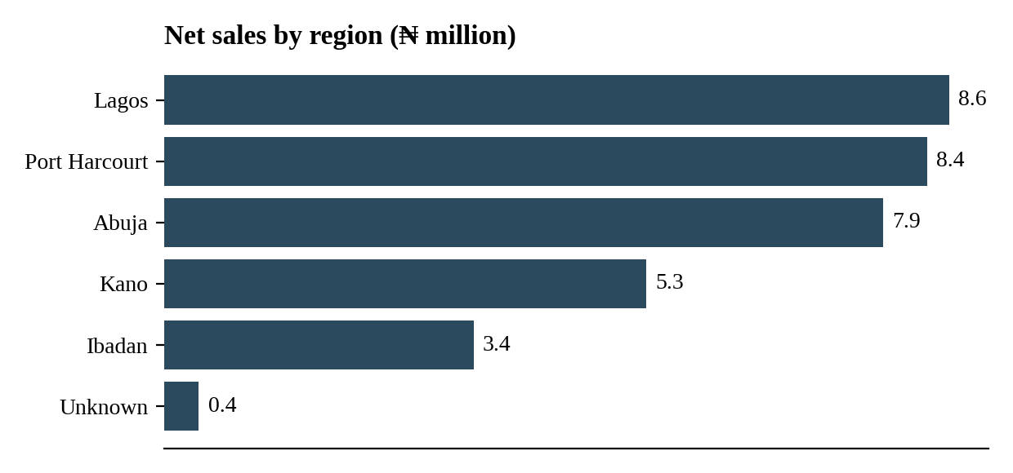
Figure 2. Net sales by region.
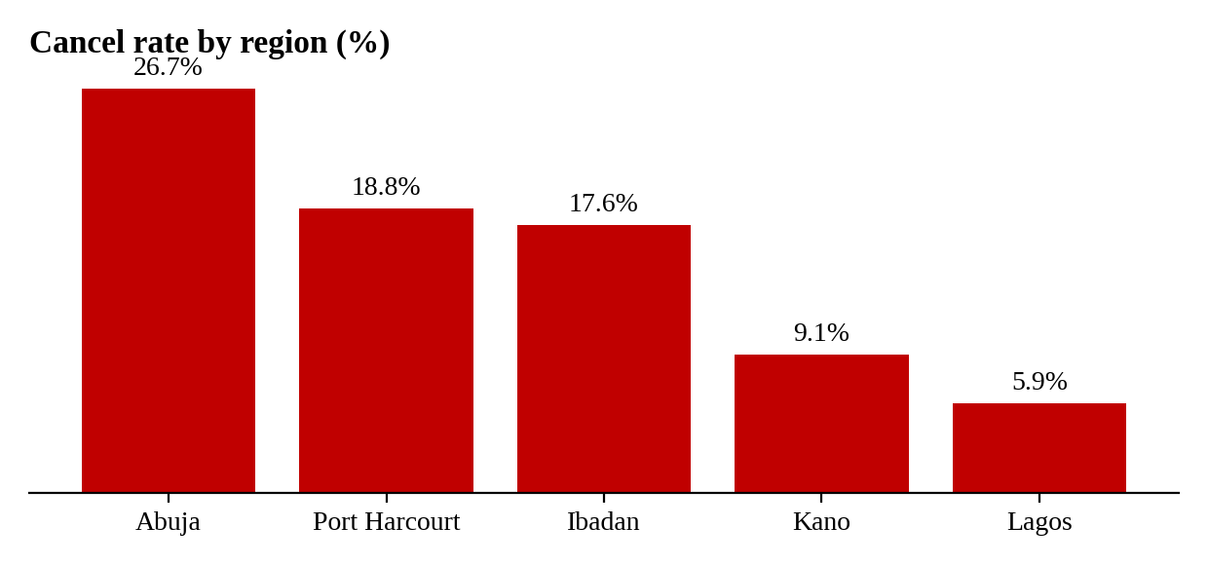
Figure 3. Cancel rate by region.

6.3 By month
Month | Net sales | Cancel rate
July | ₦17,083,100 | 12.5%
August | ₦8,553,800 | 5.3%
September | ₦8,244,850 | 26.9%

Net sales halved from July to August and stayed flat in September. September also had the highest cancel rate of the quarter.
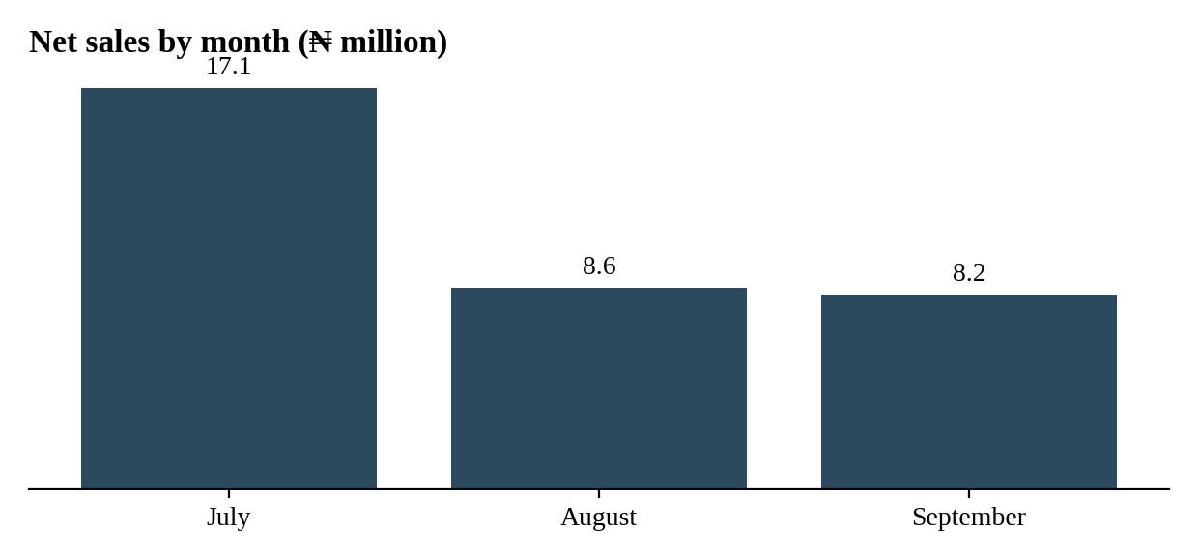
Figure 4. Net sales by month.

6.4 By product
Product | Net sales | Share | Cancel rate
Laptop | ₦17,225,000 | 50.8% | 10.0%
Router | ₦7,571,500 | 22.3% | 8.7%
Monitor | ₦5,143,000 | 15.2% | 30.0%
External SSD | ₦2,324,400 | 6.9% | 27.3%
Keyboard | ₦1,132,600 | 3.3% | 21.4%
Mouse | ₦485,250 | 1.4% | 0.0%

Laptops are half of revenue and cancel at a low rate. Monitors and External SSDs cancel most, at 30% and 27%, although they are smaller lines.

6.5 Top five customers
Customer | Net sales | Share
Kora Stores | ₦11,297,000 | 33.3%
Apex Consult | ₦5,408,100 | 16.0%
Greenfield Hub | ₦4,904,000 | 14.5%
Northstar School | ₦4,564,850 | 13.5%
Sunrise Clinic | ₦3,395,800 | 10.0%

7. Insights and recommendations

Insight 1: cancellations are concentrated
Evidence. Abuja cancels 26.7% of its valid orders, Port Harcourt 18.8% and Ibadan 17.6%, while Lagos cancels 5.9%. September reached 26.9%, up from 5.3% in August. Monitors cancel 30% of orders and External SSDs 27%.
Recommendation. Review order confirmation and stock availability in Abuja, starting with Monitors and External SSDs. Cancelled orders cost ₦7,886,750 in the quarter, so even a partial reduction matters.

Insight 2: revenue depends on very little
Evidence. Kora Stores is 33.3% of net sales, and Laptops are 50.8% of revenue.
Recommendation. Give Kora Stores a key-account owner and build a pipeline of other customers and products, so that losing one customer or one product does not damage results.
Also worth watching. Net sales fell by half from July to August. The data covers only three months, so this needs more history before drawing a conclusion.

8. Assumptions, limitations and real-world questions

Assumptions I made
- Revenue is completed and valid orders only.
- Each product has one standard price, so a missing price can be recovered from the same product.
- A quantity of -2 was changed to 2 (TXN-0052). This adds ₦56,000 to net sales, about 0.2%.
- A valid quantity is between 1 and 50, and a valid discount is between 0 and 1.

Limitations
- The data is synthetic, has 79 usable rows and covers three months, so findings are leads to investigate, not firm conclusions.
- There is no cost or profit data, so I can only analyse revenue.
- A few rows have Unknown region, customer or sales rep, which understates those groups slightly.

What I would ask a real client
- Were the duplicate transaction IDs deliberate, and is the ID a primary key?
- Which TXN-0021 record is correct?
- Why is there a discount of 1.25, and what does a negative quantity mean? Is it a return or a typing error?
- Is Pending expected to convert to Completed, and how often?

9. How to reproduce this work
- Open the raw CSV and save a copy. Never edit the original.
- Apply the cleaning decisions in section 4.2 in Excel, or run the Python snippet in section 4.4.
- Export the cleaned data as a CSV with decimals for discounts, no currency symbols and a year-first date.
- In MySQL, create a database and table, import the CSV, then run the SQL in Appendix A.
- Open the Power BI file, point it at the cleaned Excel table and refresh.
- Check the totals: net sales ₦33,881,750, 55 completed orders and a cancel rate of 15.6%.

Appendix A: SQL
CREATE DATABASE IF NOT EXISTS sales_demo;
USE sales_demo;

CREATE TABLE sales_excel_clean (
transaction_id VARCHAR(10), transaction_date DATE,
customer VARCHAR(50), region VARCHAR(30), product VARCHAR(30),
quantity INT, unit_price_ngn DECIMAL(12,2), discount_rate DECIMAL(5,2),
payment_method VARCHAR(20), sales_rep VARCHAR(30), order_status VARCHAR(15)
);

-- Import sales_clean CSV with the Table Data Import Wizard, then verify:
SELECT COUNT(*) FROM sales_excel_clean; -- expect 79

-- View with the business rules (section 4.5), then:
SELECT region, SUM(net_sales) AS net_sales
FROM completed_sales GROUP BY region ORDER BY net_sales DESC;

Appendix B: DAX measures
Net Sales =
CALCULATE (
SUM ( sales_model[net_sales] ),
sales_model[order_status] = "Completed",
sales_model[is_valid] = 1
)

Completed Orders =
CALCULATE (
COUNTROWS ( sales_model ),
sales_model[order_status] = "Completed",
sales_model[is_valid] = 1
)

Avg Order Value = DIVIDE ( [Net Sales], [Completed Orders] )

Cancel Rate =
DIVIDE (
CALCULATE ( COUNTROWS ( sales_model ), sales_model[order_status] = "Cancelled", sales_model[is_valid] = 1 ),
CALCULATE ( COUNTROWS ( sales_model ), sales_model[is_valid] = 1 )
)

Units Sold =
CALCULATE (
SUM ( sales_model[quantity] ),
sales_model[order_status] = "Completed",
sales_model[is_valid] = 1
)

